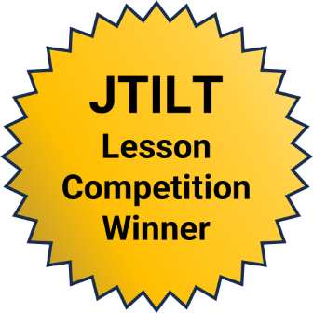
Building Vocabulary with Canva:
Digital Storytelling for 3rd and 4th
Grade English Language Learners
  - Claire Sanderlin, Auburn University at Montgomery
This lesson won the 2025 JTILT Technology-Rich Lesson Plan Competition. It was not peer reviewed.

Overview
This lesson helps 3rd–4th grade English Language Learners (ELLs) build academic vocabulary through digital storytelling using Canva. Students create digital books that integrate visuals, text, and narration, providing authentic contexts for language use. The lesson engages students by allowing them to work collaboratively, create stories, and receive feedback. Canva’s multimodal features uniquely support academic vocabulary. Students search images to represent words, type sentences with differentiated frames, and record oral narrations with opportunities for re-recording. This process deepens semantic understanding, builds syntax, and develops oral fluency in academic register, offering support beyond traditional instruction. Assessments like rubrics and peer feedback track progress and improve language skills and digital communication.
Topics: Story Telling, Vocabulary Development, Communication
Time: Three 30-minute in-class sessions.

MATERIALS
- Laptops or tablets with internet access
- Free Canva accounts (instructor sets up class “team” for students)
- Sample Canva Slides
- Projector/interactive whiteboard for modeling
- Headphones with microphones for recording
- Instructor-prepared vocabulary slides/word wall cards
- Assignment rubric

Context-at-a-Glance
Setting
In-person English Language Learner (ELL) pull-out group with 4-6 students in the United States
Modality
Face-to-face
Class Structure
The lesson used a small-group setting with 30-minute sessions. The classroom was arranged for flexible grouping, allowing pairs of students to collaborate on digital storytelling projects.
Organizational Norms
The school emphasizes equitable access to technology and language development, providing laptops, internet access, and professional support for instructors.
Learner Characteristics
Learners included 3rd and 4th grade ELLs with diverse cultural and linguistic backgrounds, with similar WIDA proficiency levels (2.0 - 3.0).
Instructor Characteristics
The instructor, an ELA instructor, was experienced in sheltered instruction and comfortable integrating digital tools into language lessons.
Development Rationale
The lesson was designed to improve vocabulary development, oral fluency, and collaboration through Canva. Backward design (Wiggins & McTighe, 2005) informed its development, ensuring that technology was meaningfully aligned with pedagogy and content.

Setup
To prepare for this lesson, the instructor created a Canva template with 3–5 blank slides, each containing placeholders for an image, sentence frame, and expectation for an audio recording. Figure 1 shows an example of the template students used to complete this project. Providing a template for students reflects principles of cognitive load theory in multimedia learning (Mayer, 2009), reducing cognitive processing so students can focus on vocabulary without being distracted by layout or navigation. Vocabulary visuals and sentence frames were displayed on the classroom word wall and projected at the front, providing extra scaffolding for students.
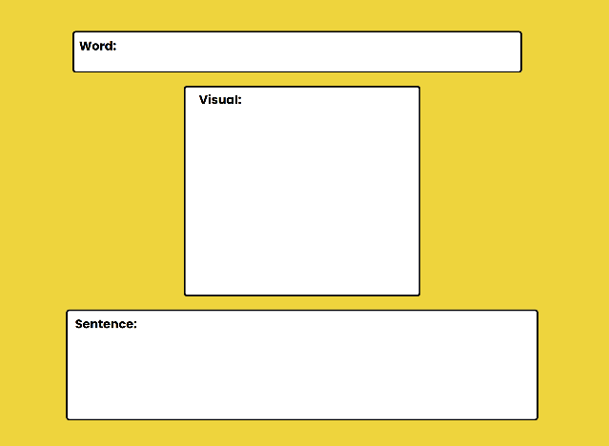
Figure 1. Canva template.
The design also aligns with Backward Design (Wiggins & McTighe, 2005), ensuring that supports and tools directly scaffold the targeted vocabulary objectives. Before the lesson, all devices were charged and connected to the internet in advance. Students were previously taught how to log into a shared Canva classroom space to minimize technical delays, reflecting the importance of advance organizers in instructional planning (Ausubel, 1960). Headphones with microphones were distributed to each pair.
The instructor modeled expectations by presenting a sample Canva mini-book that demonstrated how to insert an image, type a sentence, and record narration, which is an application of the gradual release of responsibility model (Pearson & Gallagher, 1983). The classroom was arranged with flexible seating to support collaboration, emphasizing the social construction of knowledge in line with sociocultural theory (Vygotsky, 1978).
Finally, digital safety and responsible use were discussed to ensure a safe learning environment. These preparations created a structured yet supportive environment, ensuring that learners could engage productively with technology while focusing on their language objectives.

Standards

WIDA ELD Standards (2020)
Language for Social and Instructional Purposes; Language for Language Arts; Key Uses—narrate, inform, explain.

ISTE Standards for Students (2016)
6. Creative Communicator – Students create original works or responsibly repurpose digital resources to express ideas.

CCSS.ELA-Literacy
The following Common Core State Standard also aligns to this lesson: “Vocabulary Acquisition and Use; Speaking and Listening Standards” (National Governors Association Center for Best Practices & Council of Chief State School Officers, 2010).

Context and Setting
This learning representation was implemented in a suburban public elementary school in Alabama, where the ELL program serves a growing population of English Language Learners from diverse cultural and linguistic backgrounds. The lesson took place in a small-group pull-out classroom setting, which allowed the instructor to work closely with four to six students in grades 3 and 4. This setting was significant because the smaller class size made it possible to provide differentiated scaffolds and direct support for learners at WIDA levels 2.0 - 3.0. Instruction was conducted face-to-face in 30-minute sessions, with flexible seating arranged for pairs to collaborate on digital projects.
The school context strongly influenced design decisions. The district has invested in equitable technology access, supplying devices and reliable internet connectivity, which made the use of Canva feasible. The district also purchased educational licenses for instructor and student Canva use and collaboration. Organizational norms emphasized both language development and technology integration, aligning with broader district goals of preparing all students for digital literacy. These priorities encouraged the instructor to integrate a creative technology platform that would promote vocabulary development and oral fluency while also building 21st-century communication skills.
The instructor’s background also shaped the design. As an experienced ESL instructor with training in sheltered instruction and comfort with digital tools, the instructor was able to scaffold language objectives through visual and audio supports while guiding students in using Canva to represent their learning. Backward design was applied to ensure that technology use was purposeful, aligned with content and language standards, and responsive to the learners’ needs. Ultimately, the combination of a supportive organizational culture, diverse learner needs, and available technological resources made Canva a strategic choice for engaging students in multimodal vocabulary practice.

LEARNING REPRESENTATION

DAY 1

Introduction
The instructor began by introducing 6 target vocabulary words connected to a thematic unit (character traits and emotions). Visuals, realia, and gestures were used to support comprehension. Words were displayed on a word wall and projected for whole-group reference. Students chorally repeated the words and then identified them in pictures, building oral confidence and recognition.

Content Presentation
The instructor modeled the use of Canva by displaying a pre-prepared sample project on the projector. As shown in Figure 2, the demonstration included inserting an image, typing a sentence using a sentence frame, and recording an audio narration of the sentence. The instructor completed this with the students. The instructor highlighted the multimodal supports (text, image, and voice) that helped communicate meaning. This illustrated for students how technology uniquely integrates multimodal vocabulary practice: visuals reinforced meaning, typed text provided written context, and audio recordings built oral fluency. Digital safety expectations were also reviewed, including avoiding personal photos.
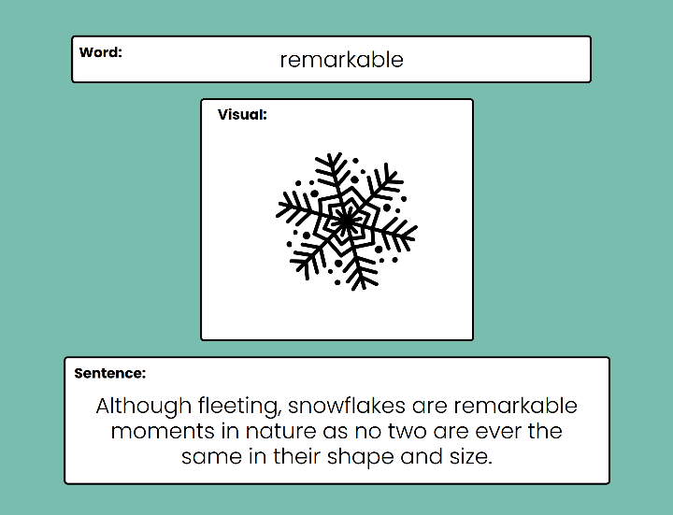
Figure 2. Instructor guided example.

Guided Practice
The instructor modeled the Canva project by inserting an image, writing a sentence with a scaffolded frame, and recording narration. This phase reflected gradual release of responsibility (Pearson & Gallagher, 1983).

DAYS 2-3

Collaborative Practice
Students were placed in pairs, combining different proficiency levels for peer support. Pairs created 3–5 Canva slides for target vocabulary words. For each word, students selected or searched for an image within Canva’s library that best illustrated the term, typed a sentence using a differentiated frame, and recorded an oral narration. The design process required them to discuss and justify which image best represented the vocabulary word, encouraging semantic precision. Audio features allowed multiple re-recordings, giving students repeated oral practice with immediate feedback from peers and the instructor. This process leveraged Canva’s multimodal features to support vocabulary depth. For example, image selection reinforced conceptual understanding, text production built syntax, and audio recording strengthened oral language. Figure 3 shows how students searched and selected an image to represent the term.
Figure 3. Students selecting an image on Canva.
The instructor circulated, provided individualized support, offered additional sentence starters, assisted with spelling, and encouraged multiple recordings for pronunciation practice. Headphones with microphones allowed ELLs to rehearse without distraction and prepare for ACCESS testing.

DAY 3

Assessment
Formative assessment occurred as the instructor observed student participation, accuracy of vocabulary use, and oral production during guided and collaborative practice. Each pair’s Canva project was reviewed against a rubric/checklist evaluating correct vocabulary usage, completion of slides, and oral narration. Peer assessment was incorporated during sharing, with students identifying vocabulary words they heard in classmates’ projects.

Examples
- Student Example 1
- Student Example 2
- Student Example 3
- Student Example 4

Closure
The class came together, and pairs shared their Canva projects either on the projector or in small groups. Students reflected orally by answering: “What is one new word you learned today?” The instructor recorded responses as anecdotal evidence of learning and uses them to inform future vocabulary instruction.

Critical Reflection
This learning representation was implemented twice with small groups of elementary ELL students during pull-out sessions. Each session included 4–6 learners ranging from WIDA Levels 2.0 - 3.0. The lesson was able to meet its intended goals: students successfully used target vocabulary in context, created multimodal slides that paired images with text, and recorded oral narrations. Peer collaboration supported language development, as more proficient students modeled sentence frames and pronunciation for newcomers. The activity also aligned well with the larger instructional context of the ELL program, which emphasizes building academic vocabulary and oral fluency through interactive, student-centered activities.
Several important lessons emerged. First, the Canva template with placeholders was critical. Without it, some students would have struggled with layout and navigation. Second, typing was a barrier for some students, and providing sentence starters along with dictation features reduced frustration. Time management was also a challenge; while most pairs completed three slides, very few finished five, and even fewer had time for narration. In future implementations, I would extend the activity into four or five sessions or reduce the required number of slides.
Overall, Canva proved to be an engaging tool that supported language objectives and lowered affective barriers by allowing students to re-record their voices. Future modifications could include providing differentiated sentence frames based on proficiency levels, pre-assigning collaborative roles (designer/speaker), and integrating student reflection into the final share-out. This lesson demonstrated high student engagement and oral practice but could benefit from better pacing and typing scaffolds. These reflections will guide improvements to strengthen the activity in future lessons and ensure technology use remains a meaningful support rather than an obstacle.

References
Ausubel, D. P. (1960). The use of advance organizers in the learning and retention of meaningful verbal material. Journal of Educational Psychology, 51(5), 267–272. https://doi.org/10.1037/h0046669
International Society for Technology in Education. (2016). ISTE standards: For students. https://www.iste.org/standards/iste-standards-for-students
Mayer, R. E. (2009). Multimedia learning (2nd ed.). Cambridge University Press.
National Governors Association Center for Best Practices & Council of Chief State School Officers. (2010). Common Core State Standards for English language arts and literacy in history/social studies, science, and technical subjects.
Pearson, P. D., & Gallagher, M. C. (1983). The gradual release of responsibility model of instruction. Contemporary Educational Psychology, 8(3), 112–123.
WIDA Consortium. (2020). WIDA English language development standards framework, 2020 edition. Board of Regents of the University of Wisconsin System.
Wiggins, G. P., & McTighe, J. (2005). Understanding by design (Expanded 2nd ed.). Pearson Education, Inc.
Vygotsky, L. S. (1978). Mind in society: The development of higher psychological processes. Harvard University Press.

About the Author
Claire Sanderlin is an ELL teacher with seven years of experience supporting elementary English Language Learners. Her work focuses on academic vocabulary development, oral fluency, and equitable access to learning through technology integration. Skilled in sheltered instruction and data-informed practice, she designs lessons that embed digital tools to create multimodal pathways for language growth. Claire’s professional interests center on advancing ELL achievement through innovative instructional design, Universal Design for Learning, and technology-enhanced collaboration. She may be contacted at csanderl@aum.edu.

Sharing & Modification Permissions
Unless otherwise noted, this article and its resources are published under a Creative Commons Attribution-NonCommercial-ShareAlike 4.0 International license:

You can freely share the article and its resources if you indicate the original authors, identify the Creative Commons license, and use them non-commercially.
You may also make and share modifications by:
- Identifying the original authors.
- Using the resources non-commercially.
- Licensing modifications under the CC BY-NC-SA 4.0 license (and including a link to it).
- Indicating what modifications were made.

