
Digital Fingerprints: A Technology-
Enhanced Forensic Investigation
  - Rocky Elmore, Auburn University at Montgomery
This lesson won the 2025 JTILT Technology-Rich Lesson Plan Competition. It was not peer reviewed.

Overview
This forensic science lesson engages 11th – 12th grade students in authentic fingerprint analysis using technology-enhanced collaborative data collection. Students use iPads to capture and analyze fingerprint patterns, first sampling their classroom, then expanding across multiple classrooms to explore how sample size affects data reliability. Through real time collaboration using shared Excel spreadsheets, students aggregate fingerprint pattern distributions, calculate percentages, and evaluate the validity of their findings. This technology-rich experience transforms traditional fingerprinting labs by enabling large-scale data collection and analysis that would be impossible with paper-based methods. Students apply scientific methodology to forensic evidence, assess how sample size impacts conclusions, and develop data literacy skills that are essential for criminal investigations.
Topics: fingerprints, reliability, validity, sample size, percentages, forensic science
Time: Two 86-minute Block Periods

Materials
The following are materials needed for this lesson:
- Fingerprint analysis student handout
- Pencils
- Ink pads
- Hand sanitizer
- Calculators
- Student iPads (with camera access)
- Reference slide presentation
- Student generated shared Excel spreadsheet

Context-at-a-glance
Setting
Suburban public high school in Alabama, USA.
Modality
Face-to-face
Class Structure
Part 1: single 86-minute block in home classroom. Part 2: single 86-minute block across eight classrooms for expanded, diverse data collection
Organizational Norms
Students have 1:1 district issued iPads and experience with collaborative learning. Phones and personal devices were recently banned.
Learner Characteristics
Across all sections, approximately 15% were English Language Learners (primarily Spanish), 4 students had 504 plans, and 5 had Individual education plans.
Instructor Characteristics
The instructor is in their tenth year of education, with a background in Physics and Biology. This is their fourth consecutive year teaching all Forensic Science courses. They are comfortable with technology integration and cross-curricular collaboration.
Development Rationale
This activity demonstrates how sample size impacts data reliability and validity. By expanding data collection schoolwide, students experience how larger samples yield more representative results.
Design Framework
Backwards design (Wiggins & McTighe, 2005) integrated with the science and language framework (Lee et al., 2019) based on Next Generation Science standards and constructivist approaches.

Setup
Prior to the lesson, create a shared Excel spreadsheet with columns for finger pattern data (arch, whorl, loop) and share the link with all students through the learning management system, ensuring edit permissions are enabled. An example of how to set up a data table within the shared Excel spreadsheet is provided in Figure 1. Prepare the classroom by setting up three distinct work areas: A fingerprinting station with handouts and pencils, a data entry station with 3-4 iPads logged into the shared spreadsheet, and a reference station where the fingerprint pattern examples are displayed on the main screen. Schedule and confirm classroom visits with participating teachers at least one day in advance, noting available times on the classroom visit checklist. Test all iPads to verify they can access the shared spreadsheet and that cameras function properly for capturing fingerprint images. Place hand sanitizer at the fingerprint station for hygiene between samples. The complete setup takes approximately 30 minutes the day before implementation and 5 minutes the day of the activity to display materials and distribute handouts.
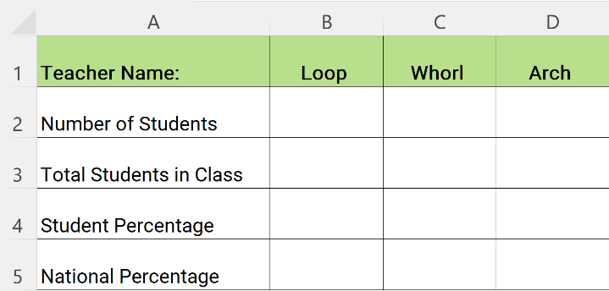
Figure 1. Data Table from the Shared Excel Spreadsheet

Standards
Alabama CTE Law, Public Safety, Corrections, and Security (2020)
- CTE20.LPS.FSCS.26 Develop fingerprints and classify characteristics for identification by using distinguishing features.

Context and Setting
This lesson was implemented in a Forensic Science and Criminal Investigation course at a suburban public high school in West Alabama. Students within this school have access to a district issued iPad to complete schoolwork and conduct activities during the school day. A significant portion of the student population is classified as ELL students with Spanish language backgrounds. While these students may have deficiencies in spoken or written English, they demonstrate basic digital literacy skills and are proficient with district-issued iPads used throughout the school day.
The lesson framework adapts the conceptual work of Lee et al., (2019), which synthesized ideas from the Next Generation Science Standards (NGSS) and A Framework for K-12 Science Education. This framework argues that both science and language learning have shifted from discrete skill acquisition towards constructivist approaches emphasizing authentic practice and social collaboration. Scientists develop understanding through collaborative efforts; similarly, language learners acquire proficiency through authentic social engagement with peers rather than text-based study alone.
This lesson employs backwards design (Wiggins & McTighe, 2005), beginning with the desired understanding that sample size affects data reliability and validity. Rather than starting with an activity idea, I identified what students should understand, designed assessments to measure that understanding, then created learning experiences to reach those goals. The authentic scientific methodology – where students encounter real investigative challenges – proved central to this idea.
In Part 1, students independently recognized limitations in their classroom only sample. In Part 2, they discovered a critical validity flaw: self-reported fingerprint identifications may be inaccurate. This student-driven problem discovery, emerging from genuine data analysis rather than teacher direction, exemplifies backwards design’s power. Students reached the desired understanding through intellectual need, not compliance. This approach served both the forensic science content objectives and the ELL language development goals, as students used scientific terminology to describe problems they had authentically encountered.
The framework informed two critical design decisions. First, ELL students conduct scientific experiments rather than simply reading about them. Secondly, students communicate scientific ideas with peers to learn scientific language within practical contexts. Both ELL and native English-speaking students practice scientific experimentation and communication – first qualitatively with peers, then quantitatively through data collection and analysis.
The lesson occurs after students complete notes for the fingerprinting analysis unit. Students have been introduced to basic fingerprint pattern terminology but have not yet applied this knowledge through hands-on investigation. The classroom emphasizes collaborative learning and student autonomy, with students accustomed to working in groups and using technology for data collection. Strategic grouping supports ELL students by pairing them with peers who can assist with language needs while maintaining their active participation.

Learning Representation

Learning Objectives
By the end of this lesson, students will:
- Identify and classify the three basic human fingerprint patterns using proper scientific terminology
- Conduct a complete scientific investigation including forming questions, following procedures, collecting data, analyzing results, and drawing evidence-based conclusions
- Explain how sample size affects data reliability and validity
- Communicate scientific findings both qualitatively and quantitatively
- Compare experimental results to national averages and explain sources of variation

Part 1: Classroom Data Collection

Fingerprint Collection (40 minutes)
Distribute pages 1-2 of handouts and fingerprint ink pads. The instructor demonstrates proper fingerprinting technique using his own right thumb, circulating to show quality examples. Students create their right thumbprint in the designated box (See Figure 1). Then, they assist each student in identifying their pattern type (loop, whorl, or arch) and have them record it. Once all students are correctly identified, students clean up and return materials.

Data Collection (20 minutes)
The instructor explains that multiple strategies exist for collecting class data and allows student autonomy in determining their method. Students typically progress through individual polling (walking around asking peers), an emergent whole-class strategy (one student leads counting by having peers raise hands for each pattern), and refinement (conducting 2-3 counting cycles for accuracy). Students record class data in their tables.

Analysis & Discussion (26 minutes)
Students calculate class percentages for each fingerprint pattern as a group. The instructor displays national average percentages for comparison. Students complete analysis questions addressing most/least common patterns in class data, comparison between class and national data, and potential explanations for differences. The instructor facilitates a discussion: "How could we improve our data?" Then, the instructor introduces the concept of sample size, explaining that the class represents a small sample compared to national data. Use this discussion to transition to Part 2.

Part 2: Schoolwide Data Collection

Group Formation and Role Assignment (10 minutes)
The instructor divides students into groups of six and distributes handout pages 3-4 to groups. The six roles for data collection are explained: Data Recorder 1 enters data into the shared Excel spreadsheet, Data Recorder 2 assists with data verification, Reference Guides use the presentation for print identification, Pollster 1 asks students to identify their patterns, Pollster 2 assists with counting and verification, and Timekeeper/Navigator manages time and tracks classroom visits.
After discussing objectives and behavioral expectations, groups determine role assignments. The instructor ensures Data Recorders can access the spreadsheet and Reference Guides can access the presentation. Groups then discuss who will visit each classrooms before hall passes are distributed.

School-Wide Data Collection
(60 minutes)
The instructor accompanies groups needing additional support while other groups work independently. Groups visit their assigned classrooms, introduce themselves and the activity, then systematically collect fingerprint pattern data using their designated roles. Students enter teacher names and data into the shared Excel spreadsheet and check which classrooms other groups already visited to avoid duplication. Groups continue visiting classrooms until they complete their assigned list. Figures 2, 3, and 4 depict students going to classrooms to poll their peers and identify their fingerprints.
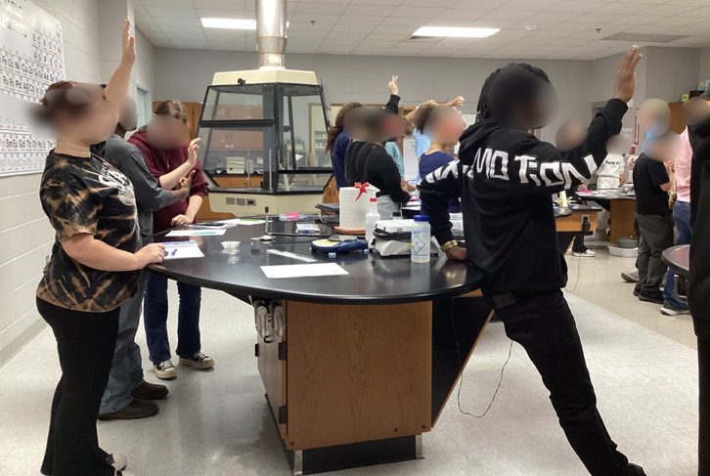
Figure 2. A group of Chemistry students being counted.
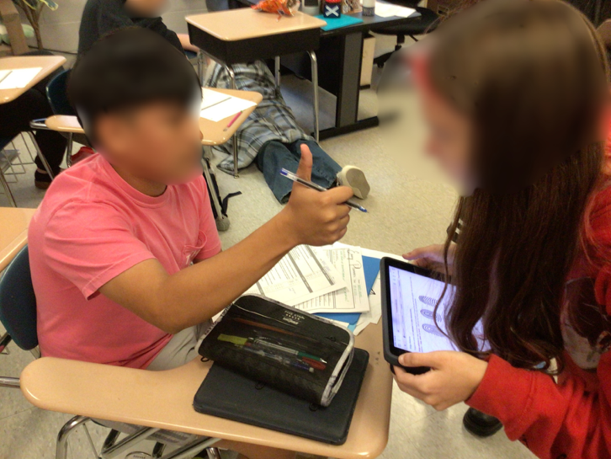
Figure 3. A student inspects the thumb print of another student.
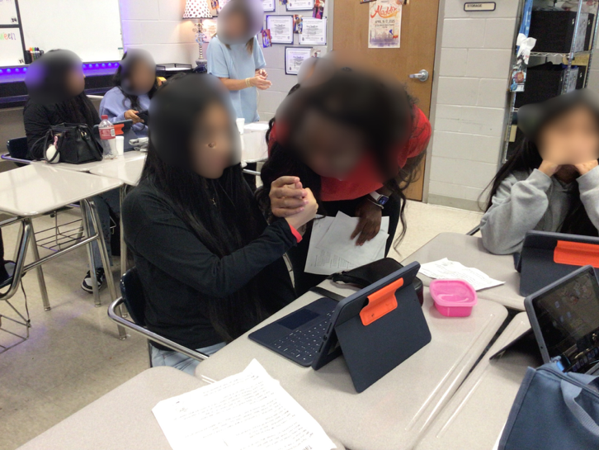
Figure 4. A student inspects the thumbprint of another student.

Analysis and Final Discussion
(21 minutes)
All students then return to the forensic science classroom. Working in their groups, students combine individual datasets to calculate new sample totals representing the school-wide data. The instructor reviews the sample size concept (introduced in Part 1) and facilitates discussion about how the expanded sample improved data reliability. Students calculate new percentages and record them on the board for comparison.
The final discussion addresses several key points:
- How Part 1 classroom data compared to Part 2 school-wide data
- How their combined data compared to national averages
- Potential sources of error in their collection methods
- Procedural improvements for future implementations
Students reflect on how increasing sample size affects their results and conclusions.

Assessment
The following endeavors are useful for capturing assessment data:

Formative Assessment
- Observations during fingerprint identification
- Monitoring of data collection strategies and collaboration
- Analysis question responses on handouts
- Participation in discussions about sample size

Summative Assessment
- Data table completion with accurate calculations
- Written responses comparing class, school-wide, and national data
- Evidence-based conclusions about fingerprint pattern distribution
- Demonstration of understanding regarding sample size and reliability

Adaptations
For ELL Students: Strategic grouping with native speakers for language support; visual reference guides (presentation) available throughout; hands-on experiential learning to reduce language barriers; teacher proximity during Part 2 for groups with multiple ELL students; collaborative roles that allow contributions based on strengths.
For Students with Academic/Behavioral Concerns: Teacher accompanies specific groups during Part 2; clear role definitions to provide structure; visual models and demonstrations; multiple opportunities for clarification.

Critical Reflection
This lesson was implemented three times across three different Forensic Science courses. Each implementation revealed insights about student learning, technology integration, and lesson design.

Successes
ELL Student Engagement: Strategic grouping proved highly effective. ELL students successfully communicated scientific concepts with peers and demonstrated understanding through hands-on activities, achieving the Lee et al. (2019) framework goals. Pairing ELL students with supportive peers while maintaining active participation created authentic language learning opportunities.
Experiential Learning: Students authentically experienced how sample size affects data reliability. The transition from classroom-only to school-wide data provided concrete evidence that larger samples produce results closer to national averages—more impactful than lecture-based instruction.
Student Autonomy: Allowing students to determine data collection strategies in Part 1 resulted in creative problem-solving. Students independently discovered that whole-class counting was more efficient than individual polling, demonstrating metacognitive awareness.

Backward Design in Practice
The lesson was structured around the backward design principle of beginning with the end goal: students should understand how sample size influences validity. Every instructional choice, from whole-class data collection to school-wide polling, was intended to make this concept visible. Assessment data, including class discussions and student-generated graphs, confirmed this outcome: students not only articulated why larger samples improve reliability but also critiqued flaws in their own methodology. When students identified inaccuracies in peer self-reporting, they engaged in authentic scientific reasoning, demonstrating that even unexpected challenges reinforced the targeted learning objective.

Challenges and Solutions
Technology Failures (Implementation 2): The shared Excel spreadsheet failed to update in real-time, preventing live coordination. Lesson learned: maintain paper-based backup systems.
Data Validity Concerns: Students noted that self-identified thumbprint patterns could be inaccurate, revealing a fundamental methodological flaw. While problematic, this demonstrated critical scientific thinking.
Network Limitations: Older iPads and high traffic in afternoon classes caused delays. Identifying school- wide device capacity as a constraint emphasized the need for contingency planning.

Future Implementation
Based on student identified concerns, future implementations will shift from self-reporting to iPad photography of thumbprints during classroom visits. Prints will then be classified back in the Forensic Science classroom, improving accuracy while retaining collaborative data collection. Pre-assigned classroom lists, trial runs, and paper backups will mitigate coordination issues, while timing the activity during low-traffic blocks will reduce network strain.

References
Alabama State Department of Education. (2020). 2020 Alabama course of study: Law, public safety, corrections, and security. https://www. alabamaachieves.org/wp-content/uploads/2023/ 11/CTE-Final-2020-Law-and-Public-Safety-COS.pdf
Lee, O., Llosa, L., Grapin, S., Haas, A., & Goggins, M. (2019). Science and language integration with English learners: A conceptual framework guiding instructional materials development. Science Education, 103(2), 317-337. https://doi.org/ 10.1002/sce.21498
Wiggins, G. P., & McTighe, J. (2006). Understanding by design (Expanded 2nd ed.). Pearson.

About the Author
Rocky Elmore is a Forensics Science teacher in the Tuscaloosa County School System. He has been working as a Forensics teacher exclusively for 3 years and been a teacher within the system for 10 years. He can be reached at relmore@aum.edu.

Sharing & Modification Permissions
Unless otherwise noted, this article and its resources are published under a Creative Commons Attribution-NonCommercial-ShareAlike 4.0 International license:

You can freely share the article and its resources if you indicate the original authors, identify the Creative Commons license, and use them non-commercially.
You may also make and share modifications by:
- Identifying the original authors.
- Using the resources non-commercially.
- Licensing modifications under the CC BY-NC-SA 4.0 license (and including a link to it).
- Indicating what modifications were made.

