Modeling Sampling Distributions in an
Advanced Placement Statistics Lesson
  - Colin Ferreira, Dallas Independent School District

Overview
This lesson demonstrates how technology can support teaching and learning in an 11th Grade Advanced Placement (AP) Statistics lesson designed by an empirically tested and effective model (FETL Model; see Ferreira, 2025). Simulation software (including Stapplet) was used to promote conceptual understanding of the abstract concept of sampling distributions and gamification technology (e.g., Wayground) was used for the formative assessment. Students worked in pairs to simulate sampling distributions and then individually to complete a quiz on Wayground. At the conclusion of the lesson, students engaged in reflective practices by anonymously reporting their experiences in Padlet.
Topics: Sampling Distributions, Statistics, High School
Time: 83 minutes

Materials
- Chromebooks or similar device.
- Padlet or sticky notes.
- Anchor Charts (Sampling Methods, Distribution Shapes, Bias Types).
- Mini Flipcharts with: Red (I need help, and I can’t Keep working), Yellow (I need help, but I can keep working), and Green (I’m working fine!).
- Assessment entered on Wayground or Khahoot!
- Stapplet Applet (Sampling Distribution for Population Mean Simulator)
- Final Polls in Two Battleground States Video (CNN, 2024)
- Promethean Board or projector and whiteboard.
- Scientific Calculators (e.g., TI-nspire CX II).
- Notebooks and pencils/pens.
- Dry-erase mini whiteboards.
- FETL Model (Ferreira, 2025) or alternative.

Context-at-a-glance
Setting
An 11th Grade AP Statistics class in an urban public high school located in the South-Central United States.
Modality
Face-to-face
Class Structure
This 83-minute lesson was designed and delivered using the FETL Model which included watching a YouTube video, class discussions, and the integration of technology for simulation (Stapplet Applet), gamification (Wayground), and reflective exercises (Padlet).
Organizational Norms
The district prioritizes high-quality instruction, student achievement, and technology integration. Artificial intelligence (AI) is used for personalized instruction, assessments, intelligent tutoring, natural language processing, and progress monitoring.
Learner Characteristics
Twenty-five 11th Grade students (80% Hispanic and 20% African American) participated in this lesson.
Instructor Characteristics
The instructor is a Distinguished Mathematics Teacher with 30+ years of international teaching experience. He uses technology extensively to build automaticity, fluency, and conceptual understanding.
Development Rationale
This lesson was developed to introduce the FETL Model’s effectiveness in fostering conceptual understanding in an AP Statistics lesson using technology and pedagogical best practices.
Design Framework
The FETL Model (Ferreira, 2025)

Setup
Set up your classroom before students enter. As shown in Figure 1, desks were arranged in side-by-side pairs to allow think-pair-share, cooperative, and collaborative learning experiences. This was a simple setup which took about 10 minutes for a class size of 25 students. The spacious classroom was fully equipped with technology including a large Promethean Board, high speed internet, 30 Chromebooks (each student had a computer with reliable and stable Wi-Fi connection), 30 n-spire CX II calculators, anchor charts, collaborative seating, and writing materials. All student materials were placed on desks, including Chromebooks, mini flipcharts, markers, whiteboards, calculators, pencils, and notebooks (see Figure 2).
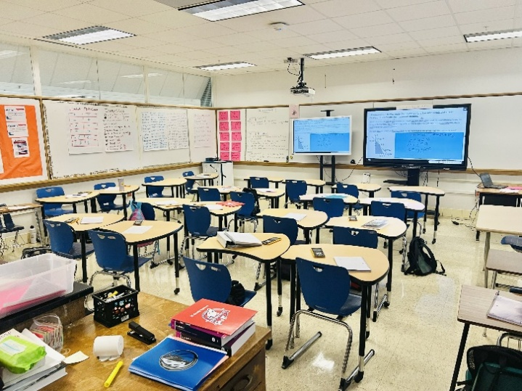
Figure 1. Seating arrangement for think-pair-share
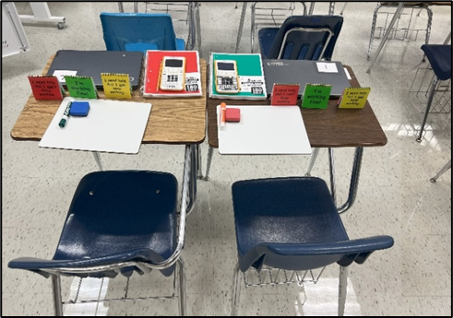
Figure 2. Learning environment equipped for innovative teaching and learning with Chromebooks, mini flipcharts, notebooks, pencils, whiteboards, markers, and calculators.

Standards
This lesson was designed for Unit 5: Sampling Distributions and Section 5.4: Biased and Unbiased Point Estimates of the College Board’s AP Statistics curriculum (College Board, 2019, Unit 5, Section 5.4).

Context and Setting

Learning Objectives
Students will be able to: (1) distinguish between parameter and statistic; (2) distinguish between biased and unbiased estimators; (3) evaluate claims about populations using sampling distributions; (4) describe the relationship between sample size and variability.
Success Criteria: Students I Can Statements:
- I can distinguish between parameter and statistic giving two concrete examples.
- I can distinguish between biased and unbiased estimators using two real-world scenarios.
- I can assess claims about population parameters using simulations of sampling distributions.
- I can explain the relationship between sample size and variability using concrete examples.

Demonstration of Learning
Given a computer-based (Wayground) 10-question quiz on Sampling Distributions, students should be able attain at least 70% accuracy.
The Advanced Placement (AP) Statistics course was launched in 1997. It allows students to gain college credit based on their College Board examination scores (Roberts et al., 1999). The curriculum consists of four main topics including data exploration, study design, probability distributions through simulation, and inference (Roberts et al., 1999). AP Statistics is one of the most challenging high school subjects to teach because the curriculum and examination focus heavily on conceptual understanding and problem solving (Haines, 2015; Roberts et al., 1999).
Technology and pedagogy (e.g., gamification, simulation, and critical reflection) play a critical role in increasing active engagement, motivation, and conceptual understanding of abstract concepts in AP Statistics. Gamification has revolutionized traditional methods of engagement especially in education (Christopoulos & Mystakidis, 2023). At the secondary school level, gamification fosters critical thinking, strategic planning, and informed decision making (Christopoulos & Mystakidis, 2023). In addition, gamification is an effective tool for stimulating attention, focus, and investment (Arnold, 2014). There has been a growing call for Mathematics teachers to employ computer-based technology in their classrooms (Findley et al., 2019). Computer models and simulations are effective tools for motivational and visual aids (Berkova & Kulicka, 2015).
It is important to note that despite the district prioritizing high-quality instruction, student achievement, and technology integration where Artificial intelligence (AI) is used for personalized instruction, assessments, intelligent tutoring, natural language processing, and progress monitoring, AI was not used in this lesson. However, Wayground was used to foster engagement through gamification, where students completed the assessment in a competitive, virtual game-like environment with badges, music, customized avatars, bonus points, and leaderboard game elements.
Most of the students in this class were considered Hispanic (80%) and the remainder were African American (20%). The face-to-face AP Statistics lesson on Sampling Distributions was designed and delivered in accordance with the FETL Model to a public high school’s 11th Grade advanced academic students in an urban city in the South-Central Region of the United States. As it related to prerequisite knowledge and mastery topics, and prior to this lesson, students completed the following concepts: (a) Describing Distributions (Shape, Center, Spread, and Outliers), (b) Normal Distributions, (c) Central Limit Theorem, (d) Law of Large Numbers, (e) Samples and Populations, (f) Sampling and Surveys (Simple Random Sampling, Cluster, Systematic, and Stratified), and (g) Bias (Nonresponse, Response, and Sampling).
The students use whiteboards and mini-flip charts daily in their Mathematics classes to indicate their progress on problems and share their solutions. Students had no prior experience with simulation applets that were used in this lesson. Sentence stems were used to differentiate the reflective exercises for the emergent bilingual students.
The instructor is a highly qualified and experienced teacher with more than 30 years of teaching experience in high school mathematics courses including Algebra, Geometry, Pre-Calculus, AP Statistics, and AP Calculus. The FETL Model is a framework that was developed and empirically tested to respond to the demand for modern and effective teaching methods for 21st Century classrooms. See Ferreira (2025) for a detailed explanation of the components of the FETL Model.
AP Statistics is a challenging course to teach because the examinations and content are primarily based on conceptual understanding and problem solving which requires innovative teaching methods and technology integration for simulating complex and abstract concepts, increasing active engagement, reflective practices, and providing opportunities for the 4C’s (communication, critical thinking, creativity, and collaboration). Education for Sustainable Development (ESD) demands pedagogical best practices that engender transformative learning, which include reflective and active learning, experiential, collaborative, and learner-centered activities (Howell, 2021).

Learning Representation

Summary of Items Used: FETL Model Components
The FETL Model works in a cyclical way with the teacher serving as a facilitator of the learning process. It starts with the teacher using the five drivers to inform the lesson planning process. Appropriate instructional and assessment best practices are selected from instructional and assessment toolkits. The introduction is stimulating, and four modes of instruction are employed (whole class, small groups, one-to-one, and AI stations for personalized learning). Lesson evaluations are done at the end of instruction, guided practice, and independent exercises. Both teacher and student engage in reflective practices about the learning experiences. The cyclical process will begin again with the assessment data, student reflections, and the five drivers being used to inform the subsequent lesson planning process. The following list summarizes the processes used in this lesson:
- External Environments: Politics (2024 Presidential Elections).
- Technology (Simulation, Gamification, and communication software).
- Internal Environments (ESL and Special Education Teachers and Supports).
- Assessment Data (data from previous lessons’ formative assessments informed this lesson).
- Student Profiles (All necessary supports were incorporated for varying academic abilities, ESL and Special Needs students, and cultural backgrounds).
- Curricula and Standards (College Board Advanced Placement Statistics curriculum and syllabus).
- Introduction Strategies (One minute viewing time for a CNN YouTube video on the population of likely voters in North Carolina and Georgia that have Kamala Harris and Donald Trump as Choice for President (CNN, 2024) to stimulate interests and engagement for the new lesson objectives).
- Development and Execution Stage (uses several pedagogical best practices taken from the Instructional and Assessment Toolkits including scaffolding, differentiation, inquiry-based learning, Blooms Taxonomy, simulation using Stapplet applet for conceptual understanding, writing in the content area, gamification using Wayground, experiential learning, quantitative and qualitative assessments, and the 4Cs. Teacher will incorporate the four instructional strategies: whole class, small group, one-to-one, and ICT and AI stations.
- Conclusion and Reflection Stage (both teacher and students will engage in reflective practices at the end of the lesson using Padlet or stick notes to reflect on their learning experiences.

Do Now Activity (5 Minutes)

Teacher Actions
Prior to students entering the classroom, the teacher arranged the desks for collaboration and placed all resources on the desk. To activate prior knowledge, the teacher posted one question on the Promethean board as the Do Now Activity and set a timer for five minutes on the board:
- Write one example each for when a simple random sample (SRS), stratified, and cluster sample are most suitable.
As the facilitator of the lesson, the teacher circulated the classroom to observe students’ responses, clarified misconceptions, and provided feedback as students worked in their groups and independently.

Student Actions
Students wrote their responses on dry-erase whiteboards and referenced the anchor charts when needed to review the definitions for the types of sampling methods. Students displayed their mini flipcharts to indicate their progress on the assigned task and raised their dry-erase whiteboards at the end of the five minutes.

Introduction (10 Minutes)

Teacher Actions
The Teacher ensured that all 540 Plans, individualized education programs (IEPs), and English as a Second Language (ESL) supports were incorporated into the lesson plan, learning activities, and assessments. The teacher introduced the lesson with a short CNN YouTube video titled “See results of CNN’s final polls in two key battleground states” (CNN, 2024).
Using the think-pair-share questioning strategy, the teacher posted the following questions on the board and set a timer for nine minutes:
  - Identify the type of sampling method (s) used in the exit polls.
  - Identify the type (s) of bias that may exist in exit poll samples.
  - What percentage of the population of likely voters in North Carolina have Kamala Harris and Donald Trump as Choice for President?
  - Can we trust the results of the exit polls or are the results reliable? Justify your answers using Statistical reasoning and theorems. We will revisit this question after the guided and independent practice segments.
As the facilitator of the lesson, the teacher circulated the classroom to observe students’ responses and discussions, clarified misconceptions, and provided feedback as students worked in their groups and independently. Groups of students were randomly selected to share their answers with the class. The teacher commented accordingly on students’ answers to clarify misconceptions and explanations.

Student Actions
Students watched one minute of the CNN YouTube video, answered each question independently on their whiteboards, and shared answers with their partners. They displayed their mini flipcharts to indicate their progress on the assigned task. Afterwards, they shared their answers with the class by raising their whiteboards once selected by the teacher.

Development and Execution Stage
(48 Minutes)

Teacher Actions
The teacher introduced new concepts with definitions and led discussions on real-world examples (see question posted below by the teacher on the survey of 670 students:
- Parameter – a calculated value that describes a characteristic of the population such as the mean (μ) or proportion (ρ).
- Statistic – a calculated value that describes a characteristic of the sample such as the mean ($\overline{x}$) or proportion ($\hat{p}$).
- Sampling Distribution – a probability distribution of a statistic consisting of all samples of the same size taken from the same population.
- Unbiased Estimator ($μ_{\hat{ρ }}=ρ, μ_{\overline{x }}=μ$)– a statistic is unbiased if the mean of its sampling distribution is equal to the population mean, where $\hat{p}$ (sample proportion) is the population proportion (parameter) estimator and $\overline{x}$ (sample mean) is the population mean (parameter) estimator.
- Sampling variability – the sample statistic will vary from sample to sample when samples of the same size are taken from the sample population.
The teacher provided scenarios for students to identify the population, parameters, sample, and statistics including:
- From the 670 students in the school, the principal conducted a survey with a random sample of 120 students and found that 80 (66.7%) of the sampled students are in favor of school dances once per month. Identify the population, sample, parameter, and statistic.
The teacher set the timer on the Promethean board for 3 minutes. As the facilitator of the lesson, the teacher circulated the classroom to observe students’ responses, clarified misconceptions, and provided feedback as students worked in their groups and independently.
To acquire a concrete definition of Sampling Distributions and foster a conceptual understanding of this abstract concept, students completed a Guided Practice (15 minutes). The teacher posted the activity instructions on the Promethean board and set the timer to 15 minutes:
- There are 25 pieces of paper in the bag which are fictitious weights (in pounds) of 25 high school student: 120, 145, 148, 150, 158, 160, 166, 169, 170, 172, 175, 175, 178, 180, 183, 185, 195, 199, 200, 201, 205, 210, 220, 220, 230. Each student will randomly select three pieces of paper, write down the weights in notebooks, calculate the mean, and then record the mean on the dot plot displaced on the Promethean board.
- Students then return the pieces of paper to the bag. The next student thoroughly shakes the bag before selecting three pieces of paper. This continues until all students have randomly selected three weights, calculated the mean, and recorded the mean weight in their notebooks and on the dot plot.
- Each calculated mean must be rounded to the nearest pound. For example, (120 + 170 + 180) / 3 = 157.
- All students will calculate the mean of sample means and the population mean.
The following questions were posted on the board:
- Is the mean of the sample means a biased or unbiased estimate of the population? Justify your answer using Statistical reasoning and theorems.
- Do you think increasing the sample size and repeating the process for 100, 1000, or 100000 samples would result in an unbiased estimator?
- How is the Central Limit Theorem and the Law of Large Numbers relevant to this activity?
The teacher simulated this process for a population with a mean of 10 and standard deviation of 2. The teacher demonstrated using 100 simple random samples (SRSs) of sizes 10, 20, 30 and asked students to describe the relationship between sample size and variability of a statistic. Students also explained whether the statistic is an unbiased estimator of the population parameter (See Figures 3-5; Simulating Sampling Distributions, n.d.).
A timer on the Promethean board was set for 15 minutes. Students worked in pairs to select the number of their SRSs and sample size (n) to simulate, record the statistic, and write their observations.
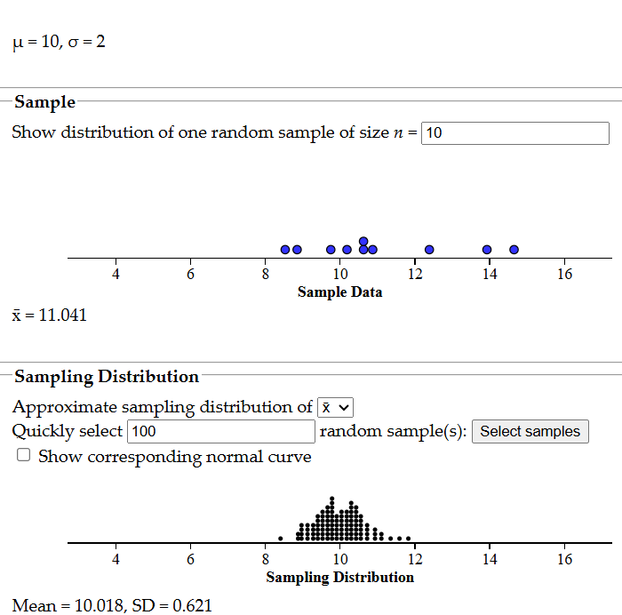
Figure 3. Simulation with 100 SRSs of size 10
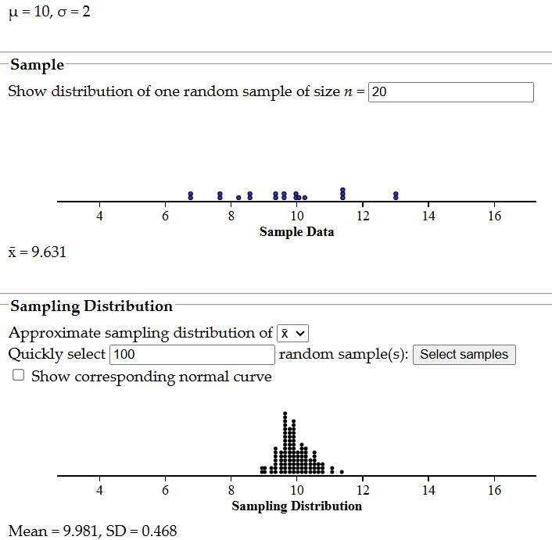
Figure 4. Simulation with 100 SRSs of size 20
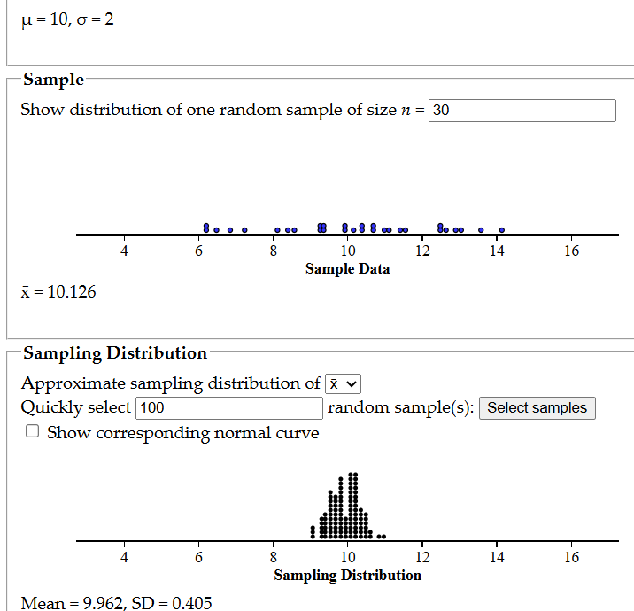
Figure 5. Simulation with 100 SRSs of size 30

Student Actions
Students used think-pair-share and answered the questions shown on the Promethean board using their dry-erase whiteboards. Students randomly selected three pieces of paper, wrote down the three weights in their notebooks, and placed the three pieces of paper back into the bag.
As shown in Figure 6, students calculated the mean of their three selected weights and recorded it on the dot plot shown on the Promethean board. The 25 calculated means were: 143, 156, 181, 182, 159, 177, 198, 153, 173, 200, 188, 158, 149, 181, 163, 196, 201, 178, 179, 189, 186, 146, 162, 190, and 203.
Students calculated the mean of the sample means and the population mean. The mean of the sample means was 176 and the population mean was 181. Working in pairs, students described the shape, spread, and center of each of the distributions with size of 10, 20, and 30 (See Figures 3-6). Working on Chromebooks, student pairs analyzed each dot plot and then described what happened to the variability in the dot plots as the samples increased in size.
Students displayed their mini flipcharts to indicate their progress on the assigned task. For assessment or lesson evaluation, students individually completed a ten-question quiz on Wayground (15 minutes).
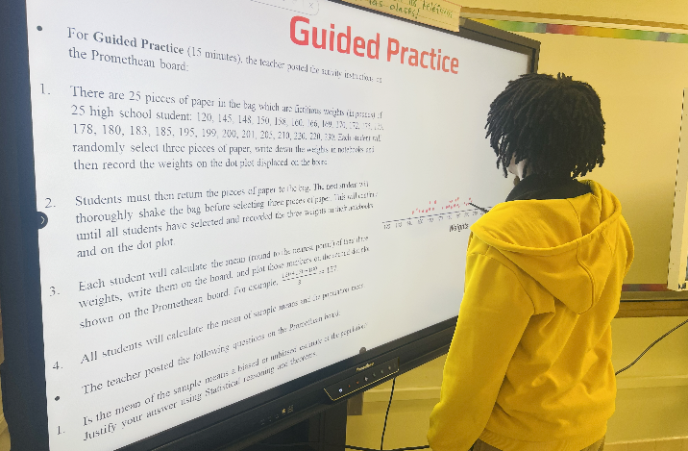
Figure 6. Students acquire a concrete and conceptual understanding of sampling distribution by randomly selecting three weights and calculating and recording their means on the dot plot displayed on the promethean board.

Conclusion and Reflection Stage
(20 Minutes)

Teacher Actions
The teacher set the timer on the Promethean board for 20 minutes and randomly asked five students (and allowed three volunteers) to restate the lesson’s learning objectives and important discoveries (including the relationship between sample size and variability and why sample size matters in estimating parameters of populations). Three minutes were allocated for this phase.
Students were then informed to return to Question 3 from the introduction section (Can we trust the results of the exit polls or are the results reliable? Justify your answers using Statistical reasoning and theorems) and share with the class whether their initial thoughts changed or remained the same. Three minutes were allocated for this phase.
Afterwards, the teacher instructed students to confirm their responses with a simulation of 100 SRSs of sizes 20, 30, and 100 using the applet called Proportion Sampling Distribution Simulator (2025) to simulate Kamala Harris’ 48% likely voters Choice of President.
The teacher then instructed students to compare the proportions with sample sizes of 20, 30, and 100 and asked:
- What sample size is large enough?
Ten minutes was allocated to this phase.
The teacher then instructed students to write a summary of the lesson using Padlet (Four minutes were allocated for this phase.). The teacher provided sentence stems for students, especially the emergent bilingual students:
- I understood ….
- I did not understand ….
- I need more examples, explanations, and practice on ….
The teacher engaged in reflective practices on the lesson delivery, student engagement, checks for understanding responses, and areas for improvement.

Student Actions
Students simulated the scenario using the applet before attempting to answer Question 3 from the Introduction video on the CNN Presidential Election poll. More specifically, students simulated Kamala Harris’ 48% likely voters for Choice for President using 100 SRSs of sizes 20, 30, and 100 (see Figure 7). Students compared the proportions with sample sizes of 20, 30, and 100 and then answered the question “What sample size is large enough?” on their whiteboards.
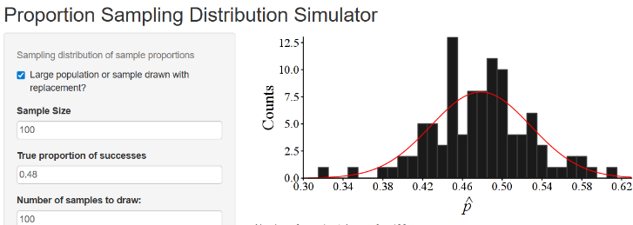
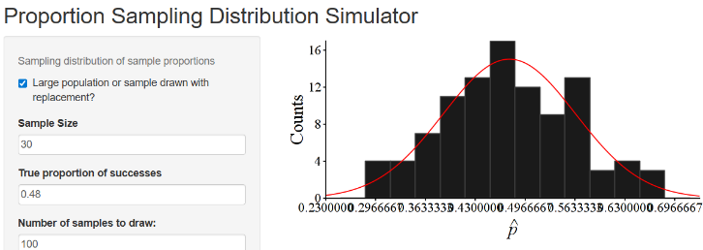
Figure 7. The simulation of the population proportion for the CNN Presidential Elections Exit Poll with sample sizes of 100 and 100 SRSs and 30 and 100 SRSs for Kamala Harris 48% likely voters Choice of President.
Eight students verbally restated the learning objectives and important discoveries (e.g., the relationship between sample size and variability and why sample size matters in calculating statistics of populations). Students reflected on their learning by anonymously stating what they understood well, what they did not understand, and what they needed further practice and explanations on using Padlet.

Critical Reflection
Based on lesson observations, assessment data, and student reflections, the four learning goals of the lesson on Sampling Distribution were met. Most (approximately 80%) of the students understood the relationship among sample size, number of samples taken, variability, Central Limit Theorem (CLT), and Law of Large Numbers in their solutions and reflections. The technology integration and hands-on simulations led to conceptual understanding of the power of random samples in accurately predicting population parameters. Students were able to confirm that the CNN Poll on likely voters for Kamala Harris in North Carolina was accurate based on the simulations. The students concluded that a sample size of at least 30 is sufficient and connected it to the CLT and Law of Large Numbers. The reflections provided rich data that helped explain the quantitative data (assessment scores), which informed targeted instruction for students who scored less than 70%.
The areas of the lesson that went well included sustained active engagement in the learning activities, enthusiastic participation in cooperative and collaborative tasks, students’ positive attitudes towards the integration of technology for the simulation exercises, reflective exercises, gamification with Wayground, and the hands-on approach used. To address the 20% of students who got Question 9 incorrectly (misconceptions), higher-order questions would have enhanced students’ conceptual understanding on the relationship among sample size, number of samples taken, variability, Central Limit Theorem (CLT), and Law of Large Numbers in their solutions and reflections.
The whiteboards and mini flipcharts were effective tools for gauging students’ understanding and identifying misconceptions in the moment so corrective actions could be taken, including. small group, one-on-one, and whole class reteach. A small group reteach was done for five students who were unable to correctly identify the sampling method used in the CNN Poll and the population, parameters, sample, and statistics in the Introduction and Development and Execution stages, respectively. Further, using a timer for each activity kept students on task and maximized instructional and learning time.
The areas of the lesson that can improve include adding higher-order questions (I added Question 11 to the revised DOL Assessment which is a higher-order question that falls into Applying and Analyzing) because most of the questions seem to fall in the Remembering and Understanding stages of Bloom’s Taxonomy. Another area for improvement could be strategic pairing of students (high with low performing students) instead of random assignments into groups. This pairing would have allowed opportunities for peer teaching. Research has shown that peer teaching is an effective method to foster student engagement and academic success (Oloo et al., 2016). In addition, based on the time students spent on each question, more time should have been allotted for the assessment so students could carefully read and solve the problems. It was clear that some students rushed through the assessment.
Notwithstanding that fictitious weights were used in the lesson; body weights remain a sensitive issue for teenagers and students might be unwilling or embarrassed to measure and record their actual body weights or even talk about their body weights for fear of being teased or told they are obese or overweight. Therefore, teachers can use height instead to replicate this lesson.
Setting up the classroom with all required materials before students enter the classroom will prevent loss of instructional time because students will be actively engaged from the time they enter classroom. Since not all schools have fully equipped classrooms with the technology and other resources used in this lesson, teachers are encouraged to use the substitutes and alternative materials listed in the material sections. The FETL Model implementation fostered inclusive instruction, meaningful and relevant learning activities, conceptual understanding, reflective practices, and active engagement.

References
Arnold, B. J. (2014). Gamification in education. Proceedings of the American society of Business and Behavioral Sciences, 21(1), 32-39. Retrieved December 8, 2025 from https://asbbs.org/files/ASBBS2014/PDF/A/ArnoldB(P32-39).pdf
Berkova, A., & Kulicka, J. (2015). Modelling and simulation in teaching of future teachers of mathematics. In ICERI2015 Proceedings (pp. 7525-7533). International Academy of Technology, Education, and Development.
Christopoulos, A., & Mystakidis, S. (2023). Gamification in education. Encyclopedia, 3(4), 1223-1243. https://doi.org/10.3390/ encyclopedia3040089
CNN. (2024, October 21). See results of CNN’s final polls in two key battleground states [Video] YouTube. https://youtu.be/4F6GGZxcICE
College Board. (2019). AP statistics course and exam description. Retrieved December 8, 2025 from https://apcentral.collegeboard.org/media/pdf/ap-statistics-course-and-exam-description.pdf
Ferreira, C. (2025). Impact of use of FETL model in mathematics lessons on student achievement and attitudes in secondary schools and postsecondary institutions in Guyana. European Journal of Teaching and Education, 7(3), 71–99. https://doi.org/10.33422/ejte.v7i3.1618
Findley, K., Whitacre, I., Schellinger, J. & Hensberry, K. (2019). Orchestrating Mathematics Lessons with Interactive Simulations: Exploring Roles in the Classroom. Journal of Technology and Teacher Education, 27(1), 37-62. https://www.learntechlib.org/p/184666.
Haines, B. (2015). Conceptualizing a Framework for Advanced Placement Statistics Teaching Knowledge. Journal of Statistics Education, 23(3). https://doi.org/10.1080/10691898.2015. 11889747
‌Howell, R. A. (2021). Engaging students in education for sustainable development: The benefits of active learning, reflective practices and flipped classroom pedagogies. Journal of Cleaner Production, 325, https://doi.org/10.1016/ j.jclepro.2021.129318
Oloo, E. A., Mutsotso, S. N., & Masibo, E. N. (2016). Effect of peer teaching among students on their performance in mathematics. International Journal of Scientific Research and Innovative Technology, 3(12) 10-24.
Proportion Sampling Distribution Simulator. (2025). Cpm.org. https://stats.cpm.org/propsamples/
‌Roberts, R., Scheaffer, R., & Watkins, A. (1999). Advanced Placement Statistics—Past, Present, and Future. The American Statistician, 53(4), 307–320. https://doi.org/10.1080/00031305. 1999.10474482
Simulating Sampling Distributions. (n.d.). Www.stapplet.com. https://www.stapplet.com/sampdist.html

About the Author
Dr. Colin Ferreira is currently a district and state Distinguished Mathematics Teacher at the high school level in Texas, USA, with more than 30 years of international teaching experiences in Guyana, Bahamas, North Carolina (USA), and Texas (USA). He is also an adjunct Mathematics and Education Professor at Dallas College (USA) and University of Guyana. His research interests include innovative pedagogies, K-12 Mathematics education, teacher preparation programs, and collaborating with teachers and leaders on a global level to contribute towards transforming the teaching and learning landscapes to foster equity-based and technology-driven instruction and assessment in K-12 classrooms. Correspondence concerning this article should be emailed to colinferreira01@gmail.com

Sharing & Modification Permissions
Unless otherwise noted, this article and its resources are published under a Creative Commons Attribution-NonCommercial-ShareAlike 4.0 International license:

You can freely share the article and its resources if you indicate the original authors, identify the Creative Commons license, and use them non-commercially.
You may also make and share modifications by:
- Identifying the original authors.
- Using the resources non-commercially.
- Licensing modifications under the CC BY-NC-SA 4.0 license (and including a link to it).
- Indicating what modifications were made.

