Youth-Led Experiential Research by First-
Year Undergraduates: Investigations into
Youth, Technology, and Society
  - Joan E. Hughes¹, Anna R. Oliveri², and Michelle Read³, ¹The University of Texas at Austin,
²Salve Regina University, ³Southern California University of Health Sciences

Overview
This unit positions first-year undergraduates as youth researchers who investigate technology in youth society. The learners are guided through five phases of research inquiry: ideation, focusing in, planning, doing, and sharing. Throughout the process, learners develop presentation, library research, data collection and analysis, and writing skills through digital scaffolds (see Materials). Students share their results orally and within an APA-style research report.
Topics: Youth-Led Research, Information and Media Literacy, Academic Writing and Speaking
Time: 16, 75-minute classes

Materials
- Ripped from headlines presentation template
- Research project pitch template
- Research project description
- Assessment rubrics
- Asset, skills, and values handout
- Team contract handout
- NoodleTools setup and citations
- What to pay attention to and write about handout
- Developing research questions handout
- Research project focus handout
- Research plan template
- Research and ethics handout
- Consent form template
- Writing at university presentation
- Summarized writing guide
- Data analysis preparation template
- Team research report template
- Academic library databases
- Learning management system
- Word processing, presentation, and survey apps

Context-at-a-glance
Setting
First-year undergraduate seminar at a large, urban, public, research 1 university in the United States.
Modality
Face-to-face class sessions.
Class Structure
14-week course meeting twice per week (75 minutes each). Mobile tables and chairs, 3 whiteboards, and Canvas LMS. Instructor lectern with computer, display, document camera, room audio and projector.
Organizational Norms
In this required first-year seminar, students develop college-level skills in research, writing, speaking, and discussion through interdisciplinary, collaborative, experiential, and contemporary experiences.
Learner Characteristics
Students enroll by interest, requirement, or schedule.
Instructor Characteristics
Joan Hughes holds a Ph.D. in Educational Psychology: Cognition and Technology and has taught 30 years collegiately and 3 years in K-12. Anna Oliveri holds a Ph.D. in Curriculum and Instruction: Learning Technologies and has taught 6 years collegiately and 3 years in K-12.
Development Rationale
The instructors shifted from leading students to read and write about others’ research to guiding students in doing their own research with youth peers.
Design Framework
Youth Participatory Action Research; Backward Design

Setup
This 8-week unit occurs within a technology-rich, face-to-face course. Instructors should review the supplemental materials, adopt or revise, and sequence them in alignment with instructor goals.

Context and Setting
This university is a mixed undergraduate/graduate-doctorate large, research 1 institution (Carnegie Foundation, 2025). An Office of Undergraduate Research facilitates student engagement in research and creative activity by helping students find independent research opportunities and sponsoring several support initiatives (e.g., information sessions, database of research opportunities, poster design workshops, and competitions).

Youth-Led Research
The first author teaches one section of a required undergraduate course for first-year students. Each section is a small seminar in which the topic of the course is defined by the professor, but the structure must include several requirements set by the Undergraduate College, including:
- The course is writing intensive in which students must write, receive feedback, and have chances for revision.
- Students must have chances to present orally.
- The course should highlight university “gems,” such as unique resources, places, or experiences.
- Students must attend a university lecture.
The first author’s in-person course is entitled “The role of technology among youth in society and education” and has been offered for more than ten years. While course topics and readings have changed across time, the course always included two large units of study and assessment:
- A self-study of digital technology use yielding an essay comparing the self to national and international use trends
- A research-based synthesis regarding a course topic yielding a scholarly-literature-rich essay
In 2023, the first and second author redesigned the second unit to be more collaborative and experiential and were inspired by youth participatory action research (YPAR). Participatory action research involves people affected by a problem working with researchers to understand and address it. YPAR positions youth as the researchers working with other youth affected by a problem or issue. Students engage in collaborative learning experiences that are youth-driven, participatory, democratizing, systematic, critical, action-oriented, and empowering (Ozer, 2016). We reconceptualized the latter unit so these new undergraduate students might experience research rather than merely read about it. We felt this research experience at the outset of their undergraduate experience might dovetail with other university efforts to support undergraduate participation in research and creative endeavors.
This redesigned curriculum unit enables undergraduate students (a) to become active, empowered learners (b) who share greater responsibility for their learning through a shift in typical teacher-student hierarchy and power (c) when students lead, co-plan, and co-research with their peers (d) as authentic youth researchers.
The timeframe of eight weeks prevents a close implementation of YPAR methodologies especially related to (a) action in which findings yield practical changes that can be followed in subsequent cycles of research and (b) social justice/critical perspectives in which inquiries center issues of power. While we are inspired by YPAR, our implementation did not explicitly center social justice nor facilitate ongoing action on the explored issues; thus, we refer to it as youth-led research. Nonetheless, the YPAR methodologies (Community Futures, Community Lore, n.d.; University of California, n.d.) are used as a guide for this youth-led research unit.
Throughout the unit, students are guided in doing their own research with other youth affected by an issue/problem. Students generate community-based issues of concern for youth (ages 5-22) related to our technological society, form a research team, choose an issue of focus, learn a range of research skills, conduct a study, create and share results in multiple formats (text, multimodal) to multiple audiences (academic, community), and outline future actions and advocate for change. The broad learning goals for this innovation in teaching included:
- Increased educational empowerment
- Increased research knowledge and skills
- Broadened use of educational technology resources
- Expanded views of themselves as technological users, as researchers, and as creators
Reflecting these goals and the YPAR methodology, we designed intended learning outcomes, identified the evidence and assessment approaches to measure the outcomes, and planned learning activities to match (Wiggins and McTighe, 2011).

Learner Characteristics
First-year students at this university typically rank in the top 6% of their high school class (Dey, 2024). In 2023, 42,444 undergraduates enrolled: 56.3% women, 43.6% men, 23% first-generation (University of Texas, 2023). Figure 1 shows the racial/ethnicity demographics of these undergraduate students.
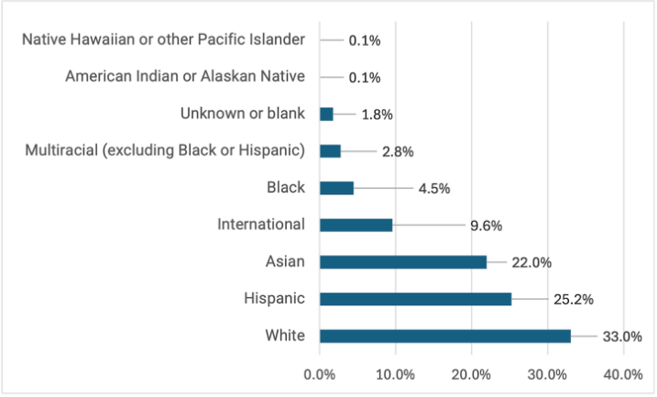
Figure 1: Race/ethnicity of 2023 undergraduate students
We have additional information about the specific students enrolled in our course during the three semesters in which we taught the redesigned unit (Fall 2023 and Spring and Fall 2024). Figure 2 shows the enrolled students’ declared majors.
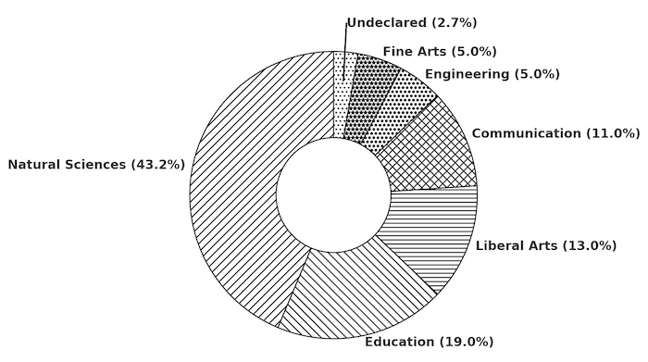
Figure 2: Distribution of major/field of study for students
An early assignment in this course asked students to reflect on their research experience. Their definitions of research often focused on fact-finding—searching the internet, reading books, or asking knowledgeable people. A student wrote, “research requires the participant to open up textbooks, search the internet, and read articles, papers, and biographies authors have written to inform readers about their field of knowledge” (Participant#2024-01-23, 2024). The students showed a basic understanding of research as fact-finding, including online databases such as JSTOR, Gale, or EBSCO, but only a few understood or had conducted research as active, disciplined investigations yielding novel discoveries.
Most students reported that digital technology was central to their high school learning, especially during the COVID-19 shift to online classes. Many were issued Chromebooks and used tools like Canvas, Schoology, Google Docs, and Zoom. Very few took computer science or statistics, using tools like Python, R Studio, or Excel.
Based on a self-assessment and reflection of digital competency (Vuorikari, Kluzer, & Punie, 2022) that students conducted at the beginning of the semester, Figure 3 shows the weighted mentions of various technology tools they used.
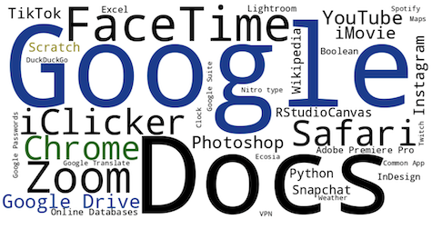
Figure 3: Reported technologies used by students
More specifically, students used tools like DuckDuckGo, Google Scholar, and Boolean search techniques. Some identified credible sources by checking dates, authors, and domain types. Emergency Remote Teaching (ERT) boosted their use of tools like Canvas, Teams, and Google Docs for group work. Some produced school projects like videos, infographics, and memes, and used social media personally. Knowledge and experience gaps involved spotting bias and AI-generated content, managing their online presence and privacy, being data insecure, and solving technical problems.

 | Ideation  (Weeks 1-3) | Focusing In  (Week 4) | Planning  (Week 5) | Doing  (Weeks 6-7) | Sharing  (Week 8) | Final Paper Submission
Main Goals & Activities | Building Background Knowledge  Identifying Questions | Team Formation  Introduction to Research Design | Literature Search  Understanding Research Ethics and Methods | Conducting Research  Preparing for Data Analysis  Writing | Analyzing Data  Presenting Findings  Writing | Sharing Findings
Assignments | “Ripped From the Headlines” Presentation  Research Pitches | Team Contract  Research Project Focus | Literature Summaries  Research Plan | Literature Review Draft  Data Analysis Plan  Data Collection | Methods Section Draft  Research Presentation | Team Research Report
Table 1: Overview of the unit

Learning Representation
This unit is broken down into five phases: ideation, focusing in, planning, doing, and sharing (see Table 1). Students move through the phases across the eight weeks that are dedicated to the youth-led research projects. Below we describe the activities completed in each of the phases that lead to the culminating research presentations and papers.

Ideation
Ideation spans the first three weeks. This phase guides students to generate and acknowledge societal issues involving youth and technology and transform these issues into curiosities and wonderings, phrased as questions. Student outcomes include two oral presentations: Ripped from the Headlines and Research Project Pitch.

Week One (Ripped From The Headlines)
At the beginning of this project, each student develops a “Ripped from the Headlines” presentation in which they identify, read, and summarize a contemporary issue related to technology and youth currently explored in a general news media resource (e.g., newspaper article, blog post, magazine, television, etc.).

Learning Objectives
After this week students will be able to:
- Create and execute a research strategy to find a headline source from mass media.
- Effectively develop and express ideas through oral and visual communication modes via a presentation.
This presentation assignment provides a gentle entry to identifying research topics or issues by situating students to consider and read general mass media sources. It also contributes to information literacy by helping students eventually discern the difference between mass media and peer-reviewed research resources.

Resources and Activities
In a prior class session, the instructors orally present several examples of the “Ripped from Headlines” Presentation to serve as a guide and familiarize students with this assignment. The students then prepare their presentations ahead of class.
We provide a “Ripped from Headlines” Presentation Template from which students create four slides:
- Title Slide: Your title with APA formatted reference and a hotlink to the news source.
- Summary Slide: Add pictures, text, tables graphics to illustrate/highlight important aspects of the story in the news media source as they orally summarize.
- Key Topic List: Summarize the article by listing the topics that are linked to this news media source. These could be simply key words or short phrases (akin to what you might use as search terms if conducting searches for more information).
- Questions This Spurs: List questions that the article investigated AND list new questions that you have about this topic that relate but might be slightly different or a new avenue of inquiry.
Students’ presentation headline topics have included issues such as “social media literacy is the key to adolescent online safety, not bans,” “teens are finding sneaky and clever ways to outsmart their parents’ location tracking apps,” and “baby’s first social media handle” (see Figure 4).
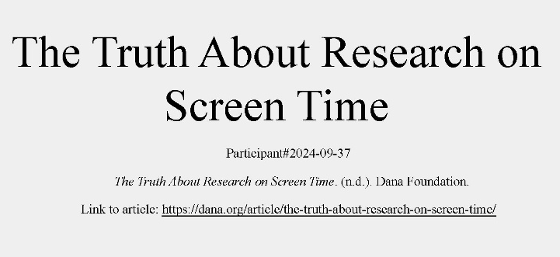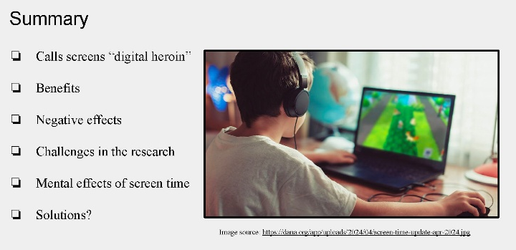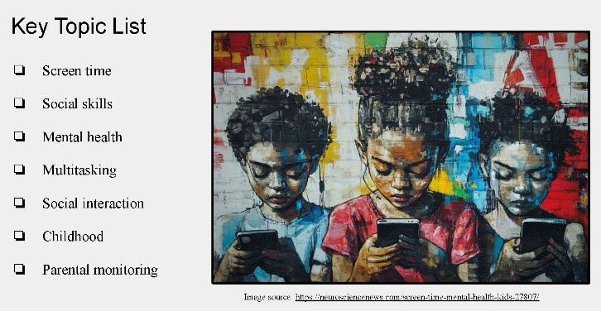

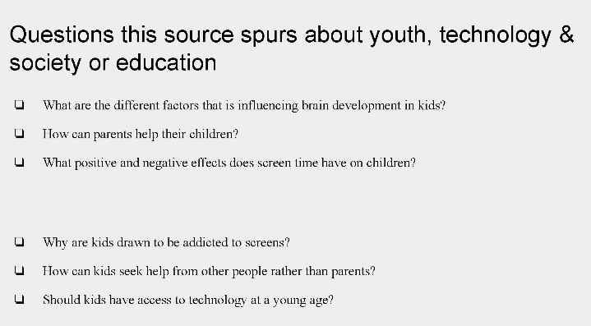
Figure 4: A Ripped from the Headlines presentation
Presentations occur over the course of two class sessions. While their classmates present, the rest of the class is responsible for generating questions that each presentation spurs for them, submitting them using a Google Form. Students are provided with the following guiding questions to support their submissions:
- What questions does this news story raise?
- What connections do you have to this topic?
- What is something you learned?
This allows the audience to engage with each presentation and expand upon the initial ideas expressed by each presenter. After the presentations, the instructors amass The Key Topics (#3 slide from template) and Questions This Spurs (#4 slide from template) and Audience Questions and Comments (bullet above) into a Compilation Spreadsheet (see Table 2) from which students can consult for the next activities in Weeks Two and Three.

Assessment
After each student presents, instructors use an assessment rubric to provide feedback in terms of topic fluency (high fluency with topic, explicitly connected to mass media, maximizes content coverage) and presentation fluency (well-practiced, eye contact, polished supporting materials).

Week Two (Building Background)
After presenting their headlines, students spend the next week building their background knowledge on youth-led research and how to use the university’s library resources to gather relevant literature to build their research pitches that occur in Week Three.

Title/ Presenter | Presenter’s Topic Keywords | Presenter’s Questions This Spurs | Audience Questions & Connections
Navigating Childhood Friendships in a Digital World.  Participant#2023-09-08 | - Mental health  - Smartphones  - Social Media impacts  - Parenting  - Socialization  - Youth Friendships  - Negative and dangerous content  - Media restrictions  - Online vs. in person communication | - How can parents help their children navigate their friendships in the digital world?  - What developing factors are harmed by social media. Use?  - How do kids feel FOMO in online settings?  - What types of systems are implemented by tech companies specifically for youth?  - How does online popularity affect these friendships?  - How greatly have social skills been impacted?  - How specifically is physical health impacted from media use in friendships? | - Why do teens feel the need to share their friendships online?  - Do most teens feel anxious about their friendship with a certain person when they are posted less on social media by that certain person? Or are they confident in the friendship they have because of the in-person interactions they have?  - How can friendships being posted on social media have a positive or negative effect on mental health?  - Is there a way for parents to help their children navigate their first phones? Are parents willing to set aside time for introducing kids to their first phones?  - Is cyberbullying easily traceable back to anonymous accounts?
How Artificial Intelligence Affects Media Consumption  Participant#2024-09-30 | - TikTok AI Transparency  - Content Credentials  - Digital Watermarking  - Deepfakes  - AI misinformation  - 2024 U.S. Election  - Meta Data  - TikTok U.S. Ban Threat  - Social Media misinformation | - How does TikTok’s platform influence consumption of AI-generated content among its younger use bases?  - What are the potential risks of AI-generated misinformation on platforms heavily used by. Youth, such as TikTok?  - How does the increasingly prevalence of AI-generated content affect critical thinking skills among youth, especially regarding media literacy and the ability to discern fact from fiction?  - What are the long-term societal consequences of growing up in a media environment where AI-generated content is pervasive, and how should education systems adapt to these challenges? | - How are kids able to distinguish that some of this content isn’t real?  - Can AI recognition technology help protect the population from harmful AI replications?  - I have seen a lot of AI content on social media, especially. AI art and video. How can this be protected against on social media? Should social media ban all AI generated content?  - Questions that this topic raised for me are what can users do to ensure if what they are seeing is real and why do people want to spread false information?  - An additional question I have is how will they limit this use of AI and how will they be held accountable?
Table 2: Excerpt from a compilation spreadsheet

Learning Objectives
After this week students will be able to:
- Critically evaluate information shared in example youth-led research studies.
- Create an initial research strategy.
- Develop approaches to searching the academic databases at the library.
- Conduct library research in databases on an individual topic.
- Clarify the differences between popular literature and research literature.

Resources and Activities: Youth-Led Research
To build a background understanding on youth-led research, students read about examples of youth-led research projects ahead of class, including “St. Thomas and Cristo Rey work to improve experience of first-generation students” (The Newsroom, 2016), two short synopses of projects in California: “Hmong youth for education” (2003) and “New side generation” (2009). Students also respond to a discussion forum ahead of class answering the question: What surprises or inspires you in these shared stories?
In class, students discuss the example research project from Minnesota, given its greater depth of content, including what was investigated, how they investigated, and what their recommendations and actions were based on what they discovered.
Students also explore and share their experiences with research through an interactive Agree/Disagree activity that we adapted from a lesson within YPAR Basics (Getting started, n.d.). Students are invited to stand up in the center of the classroom, with tables moved to edges. The instructor shows and reads one statement after which students physically move to an AGREE or DISAGREE side of the room based on their response. Then, instructors offer a question to discuss with those ‘on your side’ of the room for one to three minutes, ending with a student orally sharing out the pulse of discussion. The instructor asks each student to share out at least once during this activity. Students are provided with the following statements and discussion prompts in a projected slide deck:
- I have done research before.
  - Agree: What kinds of “research” have you done?
  - Disagree: What contexts might have prevented you, so far, from engaging in “research”?
- I like research.
  - Agree: Why?
  - Disagree: Why not?
- Talking to people is research.
  - Agree: How and why is it research?
  - Disagree: How, where, why doesn’t it count?
- I have strong feelings after reading about topics that relate to me and my life experiences.
  - Agree: What types of feelings do you have? Why do you react (even if it’s just in your head)?
  - Disagree: What are you thinking during/after reading?
- Researchers and academics (like professors) have the best insights about issues that face our society.
  - Agree: Why?
  - Disagree: Why?
- I am curious about how and why the world works in the way it does.
  - Agree: What drives your curiosity?
  - Disagree: What contexts or presumptions might reduce your curiosity?
- People who conduct research should have no personal connection to the issue that’s being studied.
  - Agree: Why? What are some personal connections that might exist? How might that impact the research?
  - Disagree: Why? What are some personal connections that could exist? How might that connection impact the research?
- Research findings can lead to calls for change in local and/or societal contexts.
  - Agree: Why or how does this happen? What are examples?
  - Disagree: What prevents this from happening?
These questions allow students to reflect on their own perspectives and experiences with research and learn from one another. They also allow instructors to learn more about the experiences that students bring to their projects.

Resources and Activities: Library Research
The next class occurs at the university library with a university librarian. In advance of the session, students are asked to review the youth-led research project assignment description; review the Compilation Spreadsheet instructors prepared that includes the Ripped Headline topics, keywords, resource questions, and audience questions; and identify and submit two preliminary Research Topic Ideas. The research topic submission requires the following elements:
- Either state the research/inquiry topic or write a question that captures the essence of what you'd like to investigate about youth, technology, and society or education?
- List several keywords that may relate to this topic.
The instructors provide a Research Topic submission example in the assignment:
- How do university students and university faculty use ChatGPT?
- Keywords: AI, artificial intelligence, higher education, technology use, coursework, instruction
The university librarian teaches the difference between popular and scholarly literature resources. The librarian then teaches students how to develop search strategies for university library databases, to execute a search, and to review and interpret results from searches. Students practice searching by using one of their submitted project ideas to find articles in support of their “Research Pitch” that they will prepare for the next week. The university librarian works closely with the course and is available to students for individual meetings. The librarian also creates a course-specific webpage with videos, links, and reminders of shared activities and content.

Assessment
The instructors provide written feedback on the Research Topic Submission regarding its completion, its alignment with the course topic (technology, youth, society, education), and occasionally offer ways to narrow or broaden the topic, if desired. This submission has no point/grade value.

Week Three (Research Pitches)
After learning about how to conduct searches within university library databases, students develop an oral “Research Pitch” presentation during week Three.

Learning Objectives
After this week, the students will be able to:
- Engage in creative and innovative thinking to generate potential areas of study.
- Practice effective communication (written and oral) at the college level.
- Identify a creative, focused, and manageable research question or topic for inquiry.

Resources and Activities
Using the “Ripped from the Headlines” Compilation Spreadsheet and their Research Topic ideas from the library session, students identify an issue or topic to pitch to the class as a possible research avenue for a team project. They are also encouraged to find one or more peer-reviewed resources to inform their pitch.
Once ready, students develop an oral pitch using a one-slide Research Pitch Template that must include the research question (item #2 below) and anything else they would like (see Supplemental Files). Their presentation should do the following:
- Explain the problem or gap that drives their proposed inquiry. What is known? What is still unknown? What do you want to understand? Why do you want to know more about this topic?
- What is your research question? This should be written as a question.
- Who is involved in your research inquiry? What types of people need to be involved to help you answer your question?
  - For example, would you need to involve parents of young children; 7th graders; high school seniors; college students; people with specific characteristics; those who use this or that technology?
- So what? Why is it important to know the answer to this question? How could your proposed study lead to change in the world - anywhere from the smallest to the largest impact? Who might be interested in hearing what you learn?
All students orally pitch their research idea for two minutes in front of the class. After everyone has presented their pitch, printed posters of each pitch slide are taped on the walls. Students engage in a voting process to narrow down the topics to approximately six (for groups of three students). At the beginning of this voting process, highly similar topics are merged. Students put their names on two sticky notes and physically place them near the posters/topics of most interest to them. Students are given control of the process. Therefore, students are asked to discuss with one another and decide if/when to remove topics, such as those that have no sticky notes (i.e., no interest). In our class case, students voted once, withdrew their stickies, and revoted with one sticky to further narrow groups. Topics with three stickies become a group. Other topics with more or fewer stickies involved students negotiating with each other, recruiting, or moving topics until six teams of three students were formed.

Assessment
After each student pitches their idea, instructors use an assessment rubric to provide feedback in terms of topic fluency (e.g., high fluency with topic, explicitly connected to mass media, maximized content coverage) and presentation fluency (e.g., well-practiced, eye contact, polished supporting materials).

Focusing In

Week Four (Team Formation and Identification of Research Focus)
Week Four prepares students to work together in a small group; begin finding, reading, and interpreting scholarly resources; and honing research questions to guide the group inquiry.

Learning Objectives
After this week, the students will be able to:
- Engage in inquiry, analysis, evaluation, and synthesis of information.
- Create and begin a research strategy and critically evaluate information.
- Identify a creative, focused, and manageable research question or topic for inquiry.
- Work with small groups to find solutions to ill-defined inquiries.

Resources and Activities: Team Formation
To build a productive research team, students first identify their personal assets, skills, and values. Before class, students consult an Asset, Skills, and Values handout. Then, they create an asset map that represents the strengths they bring to the group, such as a) academic skills, b) values, c) team and people skills, and d) personal and other skills. Instructors encourage creative asset representations, such as mind maps, drawings, images, word clouds, or tables and words. Students also review a Team Contract handout.
Building on their library research session in Week Three, students follow detailed pre-class instructions to set up individual NoodleTools accounts. One team member creates a team NoodleTools project folder and shares the folder with team members and the instructors. NoodleTools is provided for free by the university libraries. It is a citation tool where students can track sources, take notes, create outlines, collaborate with classmates, and format bibliographies. Students can add sources to their accounts for initial review and share vetted sources to the team project. Before class, students use their library search skills to locate and read at least two relevant sources and add them in NoodleTools.
During the class session, research teams meet to share their asset maps. They also discuss and begin the Team Contract, due at the end of the week.
Instructors review a pre-class handout: What to Pay Attention to and Write about from Research Resources. This handout offers questions to guide students’ reading. The functions for scholarly literature that the librarian introduced are reiterated. In this class session, emphasis is placed on how literature can assist students in developing a research focus for their project by reading into what others have done or not done. In working towards a review of applicable literature (see Week Six), each student will find, read, review, and summarize at least four scholarly resources. When completed, notes are added to NoodleTools, linked to each source item.
Then, the teams discuss and fill out the Developing Research Questions handout. Students identify their interest, commitments, and background knowledge related to their research topic, including any ideas from the two initial library resources they identified. Questions in the handout scaffold the team toward identifying an important, actionable, and researchable issue and writing that issue as a research question.
Class ends with the instructors fielding questions about NoodleTools functions and/or searching academic library databases.

Resources and Activities: Research Focus
The next class focuses on crafting answerable research questions through focused research design. In preparation for class, students watch a 10-minute Introduction to Research Design video (Jensen & Laurie, 2017), accessible through the university library subscriptions and embedded in Canvas. Instructors ask students to pay close attention to the role of research questions in the process of doing research. Students also watch a five-minute Overview of Data Collection Methods video (Scribbr, 2021), embedded in Canvas. Finally, they reflect in a class discussion board on the question “What are one or two important strategies you want to remember from these videos on research design and data collection approaches as you focus on your research inquiry?"
This class session offers an experiential introduction to data collection methods and resulting data. The instructors provide a short review of six methods to investigate issues: observation, interviews, focus groups, survey, measure or test, and artifacts. Then students experience each approach by cycling through six pre-created activities explained on six Canvas pages:
- Experiencing the Interview: Each student pair take turns interviewing the other person using a provided question “Tell me what it’s like at UT Austin” and optional follow up questions.
- Experiencing the Focus Group: A group of four to six students choose one person to be the interviewer. The others are respondents. The interviewer conducts the interview, asking the main question (“Tell me what your favorite study space is like”) to the group and using any optional follow up questions. They try to cultivate participation across all respondents.
- Experiencing the Observation: Students observe people in a public student lounge to understand how people use digital technologies or are exposed to digital technologies in a public space. In written notes, they describe through their senses what and how people are using digital technologies and the ambient digital environment within the lounge.
- Experiencing a Survey: Students take a survey about their privacy and personal information in online contexts. The survey questions source from Pew Research Center (2023), an organization from which students have already read reports.
- Experiencing a Measure: Students take a survey that measures Fear of Missing Out (FOMO) (Przybylski et al., 2013), a concept that students already read about.
- Experiencing Artifacts: Students identify three artifacts that represent how they use technology for educational purposes. They screenshot or upload these artifacts to a folder.
The instructors remind students to move to another activity every six minutes. Following the six activities, the class examines what the resulting data looks like using their actual data results or pre-created data for interviews.
The class then shifts into teams to talk through their inquiry topic and any changes they might want to propose based on reviewed literature or ideas regarding research design and data collection. Each group submits a Research Project Focus–a summary of their research question, suggested target participants (subjects), and possible data source(s) they might use. This is a very preliminary set of ideas. The instructors conclude class by sharing the Research Plan Template handout/assignment as an advance guide for Week Five.

Assessment
The instructors provide written feedback on each team’s Research Project Focus and their Team Contract in advance of Week Five. At this stage, feedback typically involves suggestions for narrowing the scope of the inquiry and considering access to human participants they might want to involve. Students receive one point for each product submission.

Planning

Week Five (Research Plan Development)
In Week Five, students gather the most applicable perspectives from the literature to guide their research inquiry and collaboratively decide how they will investigate their research issue.

Learning Objectives
After this week, the students will be able to:
- Revise, as necessary, a literature research strategy, critically evaluate information, and track citations and references.
- Identify and synthesize existing knowledge and research relevant to their inquiry topic.
- Draw from one or more disciplinary perspectives to design a methodology for answering their research question or pursue their inquiry.
- Work with small groups to find solutions to ill-defined inquiries.

Resources and Activities
In advance of the first class, students (re)searched, (re)read, and annotated scholarly literature that related to their research inquiry. Students are reminded to use the What to Pay Attention to and Write about from Research Resources handout from Week Four to scaffold their reading and annotation notes that they append to each source in NoodleTools. By class time, each student has:
- Identified four applicable scholarly sources
- Exported/added the citation from the library database to NoodleTools (see NoodleTools Citations Guide)
- Annotated each source by capturing the important concepts in a note appended to the NoodleTool source
- Added each applicable source into the NoodleTools Team Project so all team and instructors can review
In class, the instructors (re)introduce the Research Plan Template, a handout and assignment guide developed by the instructors to align with the Introduction to Research Design video (Jensen & Laurie, 2017) viewed during Week Four. The plan guides teams to develop a research design, including:
- Develop research questions
- Operationalize key ideas
- Select research method(s)
- Choose a framework or key concepts
- Weigh risks and opportunities
- Self-assess research skills and team assets
- Anticipate data analysis
Each plan section includes guiding questions and advice for teams to consider. Teams complete the Research Plan by the end of Week Five.
Since students complete research as a class activity, the university Institutional Review Board (IRB) considers the activity “class research,” which allows the instructors to guide ethical research practices. Therefore, the instructors provide a Research and Ethics handout and use it to introduce key research terminology and activities. They also provide a Consent Form template that each team uses for any human participants. While the data and research from these class projects are not usable for publication, instructors guide students in all ethical practices and the consent form clarifies this work as “class research.”
Teams then have time to discuss instructor feedback from the Research Project Focus submission from Week Four and the ideas gleaned from the reviewed scholarly literature, with a focus on refining their research focus and question. In particular, instructors draw students’ attention to two areas of the Research Plan Template: Develop Research Question(s) and Operationalize Key Ideas. Changes are expected and most groups need narrowing of focus.
In advance of the second class this week, students review a Canvas Module called “Research Methods Resources: Ways of Investigating” to review different strategies and recommendations to build an investigation with specific types of data. Resources in this module are compiled from various university and published resources and align with the data types introduced in Week Four: surveys, interviews, focus groups, artifacts, measures, and observations. The module also includes links to free university tools: Qualtrics, Box, and Zoom. Teams are expected to start building their Research Plan, which includes their research methods, data collection materials, and consent form.
In class, the teams focus their energies on their Research Plan, while instructors cycle through teams to answer questions and provide guidance. Prior to the end of class, each team quickly shares:
- What is your research question?
- Who are your target people?
- What is your method of investigation (data collection tool)?

Assessment
The instructors review the Literature Summaries (i.e., annotations in the team’s NoodleTools projects) to ensure there are at least 12 (four from each student); they are applicable to the topic; the notes have identified concepts, methods, and/or findings that are helpful to the team’s research inquiry; and notes distinguish verbatim (quoted) versus paraphrased material. Students earn 8 points when all 12 summaries are complete and appropriate; revisions may be requested.
The instructors review the Research Plan and its consent form and data collection materials (e.g., a survey or interview questions). Written feedback may request further narrowing the scope of inquiry, refinement of research questions, and considerable suggestions for data collection methods. Most research plan materials are revised by teams and reviewed by instructors several times, spanning into Week Six. Students earn 4 points when the plan is aligned and doable.

Doing
During the Doing phase, students move between writing draft sections of the final research paper and completing data collection and analysis. Therefore, the week-by-week breakdown includes overlapping tasks as students receive feedback, work on revisions, and build upon planned research activities.

Week Six (Writing Literature Review and Data Collection)
In Week Six, teams learn to write a literature review and work towards approval to collect data.

Learning Objectives
After this week, the students will be able to:
- Critically evaluate information from data collection and research articles.
- Identify and synthesize existing knowledge and research relevant to their inquiry topic.
- Gather, evaluate, synthesize, or create relevant evidence, knowledge, or other elements to reveal insights about their topic.
- Respond effectively to the writing of others in the fields and/or professions in which they studied.

Resources and Activities
In advance of the first class in the Doing phase, students read the introduction and chapter one from the text They Say, I Say (Graff & Birkenstein, 2021). They also view a presentation (University Writing Center, n.d.) about the purpose and approach to writing a literature review; read a handout (The Writing Center, n.d.) explaining what literature reviews are; review the course assignment for the Literature Review draft; and in a Canvas Discussion Board contribute “an example of ONE term (with its definition), prominent theme, debated topic, unexplored question, or method from the literature your team read and reviewed. You likely will need to review your literature notecards in NoodleTools to do this.”
The Literature Review Draft assignment asks teams to use the literature they have annotated in Weeks Four and Five to now write a literature review of about 250-500 words to define important terms, synthesize earlier research, and explain prominent themes or issues that are already known. They essentially answer the question, "What do we already know about our topic, based on past research?" We encourage them to think of it as a way into the conversation about the topic because they are conducting research in this topical area. The review is about ideas, themes, or patterns the team notices across what they read. They use the literature review, citing their sources as they write this, to do any of the following:
- Define terms important to the research study,
- Introduce common or prominent themes across the research that has already been conducted,
- Introduce themes or topics where the research diverges/does not agree,
- Identify yet unexplored questions related to your research issue (what we often call "research gaps"),
- Describe methods (ways of investigating) that past researchers have implemented,
- Rationalize your research question, target, or method in relation to past research.
In class, instructors first introduce the Team Research Report, which is an APA-formatted research report template prepared by the instructors, adapted from University of Wisconsin at Whitewater (n.d.). This document is a guide and a template for students’ final report, but through formative assignments, instructors scaffold the teams to focus on one section (i.e., Literature Review) at a time.
Instructors continue in class, presenting Writing at University and a Summarized Writing Guide to help students conceptualize the literature review as entering a conversation with researchers who have come before them and connect the sentence templates to the communication tasks in the review, see bullets above (Graff & Birkenstein, 2021). Each student returns to their pre-class discussion board submission and revises their idea using the introduced sentence templates and verbs. Then, each shares their contribution with their team who consider its applicability for inclusion in their review. With any remaining class time, teams request help finalizing their data collection methods (if not already complete) and discuss writing goals for the literature review draft (due at beginning of Week Seven).
In advance of the second class session, teams revise and seek approval for data collection methods (as needed) and start their data collection processes. They also start writing their Literature Review. The second class meeting is dedicated time for teams to seek help from the instructors and make progress.

Assessment
The Discussion Board posts are reviewed prior to the first Week Six class session, with feedback provided on completion and the applicability of submitted content. Students earn 1 point for an applicable contribution.
The instructors continue to work with any teams that may be revising aspects of their Research Plan (e.g., their data collection processes, consent form etc.) with the aim for teams to begin data collection prior to the week’s end.

Week Seven (Data Collection and Analysis; Writing Methods)
In Week Seven, teams submit a draft of their literature review, start or monitor data collection, consider data analysis techniques, and learn to write a Methods section.

Learning Objectives
After this week, the students will be able to:
- Identify and synthesize existing knowledge and research relevant to their inquiry topic.
- Gather, evaluate, synthesize, or create relevant evidence, knowledge, or other elements to reveal insights about their topic.
- Respond effectively to the writing of others in the fields and/or professions in which they studied.

Resources and Activities
In advance of the first class session, teams work on the literature review draft; start or continue to collect data (all teams have chosen to use interview, surveys, or both); and review a Canvas Module Research Methods Resources: Ways of Analyzing Data that contains fundamental analysis information, guides, and skills from the university and YouTube, such as: descriptive statistics, correlation, regression, qualitative thematic analysis (already taught in first half of course) and Qualtrics. We ask them to note techniques they may use to analyze their data to discuss with their teams.
As we gather in the first class session, teams meet to touch base about their literature review draft, due the following day. Then instructors field and answer any questions about their writing, the process, or assignment.
Next, instructors (re)introduce the concept of data analysis. Students already engaged in qualitative thematic analysis for an assignment that preceded this curriculum. In the team’s Research Plan (see Week Five), they already considered if their data was qualitative or quantitative and what approaches to analyzing the data they might use, such as calculations or statistics or coding data for significant insights and identifying themes. We review these concepts, homing in on the approaches most likely to be used based on the teams’ research questions and our discussions with them. We then introduce a Data Analysis Preparation – Template handout which aims to guide each team to create a data analysis plan by logging collected data (e.g., a survey or interview question), deciding what needs to be done to it (cleaning, analysis), and determining what it will yield (hypothetical finding). The completed analysis log forms a “how to” guide for each team’s analysis and ensures they are using all their data and answering their research questions. The teams then meet to discuss their data analysis.
In advance of the next class, teams submit their literature review draft for review, begin filling out the Data Analysis Preparation handout – with consultation access to the Canvas Module Research Methods Resources: Ways of Analyzing Data, and monitor their continued data collection.
In the second class of Week Seven, we review the Methods section of the Team Research Report and explain how this section describes what they did to conduct their study. The report template includes the following sections: (a) Participants, (b) Design, (c) Materials, (d) Procedures, and (e) Analysis. We show them how content they have already written in the Research Plan and the Data Analysis Preparation handout from the previous class assist in completing the Methods section. We encourage them to copy and revise any of this previous work to satisfy the Methods section. The Methods draft is due in the middle of Week Eight.
We conclude the class by allowing teams to meet. The instructors review each team’s Data Analysis Preparation and provide specific suggestions for data analysis to each group based on their inquiry. Common suggestions include descriptive statistics (averages), qualitative coding, correlation, and scoring of a pre-created measure.
All teams end data collection (if not done so already) and begin data analysis.

Assessment
At the close of Week Seven, the instructor reviews each team’s Literature Review Draft and provides considerable feedback regarding the content (apt and enough literature), argument (apt use of ‘They say, I say’ templates), language use, writing style, and correct citations and formatting, referencing applicable areas of the Team Research Report’s Assessment Rubric. Students earn four points for the completed draft.
In class, instructors review each team’s Data Analysis Preparation Log to ensure they have an adequate plan for analysis once their data collection is complete. If needed, instructors continue to assist teams individually through Canvas messaging. For example, teams who have developed research questions requiring a correlation analysis often need more statistical assistance than others. This is an in-class assignment that does not earn points.

Sharing

Week Eight (Analysis and Sharing Findings)
In Week Eight, teams write and submit a Methods section draft, analyze their data, draw conclusions, and present the findings of their inquiry to peers, instructors, and librarians.

Learning Objectives
After this week, the students will be able to:
- Gather, evaluate, synthesize, or create relevant evidence, knowledge, or other elements to reveal insights about their topic.
- Present a conclusion or creative work that logically follows from the inquiry findings.
- Effectively express ideas through written, oral, and visual communication.

Resources and Activities
In advance of Week Eight, teams continue to write their Methods draft and continue data analysis using their Data Analysis Preparation log as a guide. They also review the Team Research Presentation assignment and have access to a set of guides and suggestions for oral presentations prepared by the university’s Public Speaking Center. They are also encouraged to meet with this Center because it offers free consultations and practice.
The teams culminate their inquiry work through a Research Presentation for the class and selected guests (i.e., the librarians). Each team develops an eight-minute oral presentation sharing their research inquiry, with specific focus on the findings from the research. We conceptualize the presentation as a draft submission of the findings, and includes at least the following:
- the research inquiry focus (topic) and any related connections of that topic to youth, society, and/or education (answering: what is this about? and why is it important?)
- your research question (verbatim)
- the method (answering: what did you do in your research?)
- the findings (answering: what did you learn from the data you collected? how did that answer your research question?)
- the future actions (answering: based on your findings, what future actions might this inspire by people, institutions, government, any related entities etc.)
Instructors provide an empty slidedeck for teams to add their slides but unlike earlier presentations, we do not scaffold the slide formats with a template. Instead, teams design their presentation in the way that best fits their project.
The first class session of Week Eight allows the teams to meet in-person to work on any of the following tasks: Methods draft, data analysis, or research presentation. Instructors connect with all teams to answer questions and help with all tasks. Teams submit the Methods draft the day after this session.
The second class session hosts the team research presentations for the class and the university librarians who support these undergraduate courses, Teams orally present for eight minutes and then the audience may ask questions or provide comments for about four minutes.

Assessment
Prior to the last class session of Week Eight, the instructor reviews each team’s Methods draft and provides considerable feedback regarding the content (accurate and detailed), language use, writing style, and correct citations and formatting (if any), referencing applicable areas of the Team Research Report’s Assessment Rubric. Students earn four points for the completed draft.
Instructors provide ample feedback on the Research Presentation immediately after the second class session. Instructors use a Team Research Presentation Rubric to assess teams’ fluency with their topic, content coverage, and presentation fluency. They consider the findings shared in the presentation as formative, so they offer feedback and suggestions, especially if teams could bolster claims with additional analysis.

Submission of Final Paper
Final submission of the Team Research Report is due about five to seven days after the end of Week Eight. Since instructors teach this in the latter half of a semester, the report is due just prior to Finals week.
The Team Research Report is the APA-style research report template provided by the instructors. At this point, teams have received formative feedback on drafts of the Literature Review and the Methods and the oral presentation of Findings. It is expected that the teams will read and consider instructor feedback and revise earlier drafts for inclusion in the final report. Often students do not realize that the formative assignments they have worked on fit into the final report (despite instructor explanations of such in earlier weeks). Remaining writing involves the Discussion, Conclusion, References, and Introduction. The template narrates expectations for these sections, and teams can export an accurate Reference list from the NoodleTools Team Project for inclusion in the report. Students (and instructors) are impressed with the final research reports produced.

Assessment
As a summative evaluation, instructors use an assessment rubric to provide broad feedback since teams do not revise the Team Research Report. Feedback focuses on setting the purpose (well-developed focus with connections to youth and society and establishes the issues at stake), connecting to the past and situating the current inquiry (thoughtful treatment of the literature review, statements are backed by supporting information in the research data and/or appropriate citations from at least 12 sources), communicating the consequences (indications of what could/should change as a result of this research), organization (contains strong topic sentences and builds upon the argument suggested in the introduction and literature review; clear transitions connect ideas both on the paragraph level and the sentence level), and mechanics (mastery over the basics in sentence completeness, structure, variety, word choice, and punctuation; APA format).

Critical Reflection
This youth-led research curriculum has been implemented three times (Fall 2023, Spring 2024, Fall 2024). Institutionally, it fits within the scope of the required undergraduate first-year seminar to develop college-level skills in research, writing, speaking, and discussion through interdisciplinary, collaborative, experiential, and contemporary experiences. It also fits my course theme of exploring youth, technology, and society and also facilitates developing these college students’ digital literacies, such as: survey development and administration in Qualtrics, citation management in NoodleTools, data analysis in spreadsheets and documents, team collaboration with Google Drive, content creation in Google Slides and Docs, and asynchronous meetings via video conferencing tools, such as Google Meets and Zoom. Many students specifically reported the value of learning how to do academic library research, the surprising pleasure of learning about other people’s experiences through original research, and amazement with their resulting research reports (especially the length and formal writing style). We felt the learning objectives were met week by week, and ultimately the unit drew these undergraduates into the research enterprise at the earliest moment in their undergraduate academic career.
In terms of practical implementation, the unit is quite fast-paced. After the first implementation, we added another instructional week after Week Five (for a total of nine weeks), but with no additional content or assignments, to allow more team time and instructor assistance for development of research measures, data collection, and analysis. Since many students have no experience conducting original research, the instructors provide significant scaffolding and support especially in the development of research designs and analysis strategies. Simple descriptive statistics and qualitative coding with themes is completely acceptable. Some teams pursue questions requiring more complex analyses (e.g., correlation) that require more assistance from instructors because this is not a statistical analysis course. To reduce the risk of cognitive overload for the students, the class worked on one component of their project at a time with supportive templates and clear guidance of what was required to simplify the content and expectations. Adding in an additional week allows for more time for this individualized support to occur. To reduce the risk of cognitive overload for the instructors, the instructors closely monitored student projects to ensure that they were not too large of an undertaking for the timeframe (i.e., requiring too much data collection, ambitious statistical analysis, etc.).
While we provide significant guidance, scaffolds, and examples, this unit requires all students in these teams to engage in work outside the class sessions (i.e., homework) that involve novel creative and critical thinking and production. Some students expressed frustration with or dislike of the ill-structured nature of research tasks and preferred a “lecture and test” pedagogy/curriculum. To support this shift to a new course structure, the instructors emphasized that the process of learning about and conducting research can be flexible and multimodal; therefore, each group worked at their own pace throughout the process.
While many students loathe group projects, we have not experienced discontent. We designed several strategies to distinguish individual and team efforts for both the instructors and students. First, instructors watched and worked with teams so deeply during class that they understood in-class and some out-of-class individual efforts. As needed, the instructor would intervene and discuss inequities with individual students or with the whole team. Second, in each submission, team members clarified their roles. For example, “With your submission, each team member should note exactly what and how they contributed to the content of this Literature Review Draft.” Third, at the end of the unit, students completed a survey (see Assessment in Supplemental Files) where they clarified their individual contributions and described their team members’ contributions. Using this survey information, the assignment submission information, and observations in class, the instructor assigned each person from the team an individual contribution score. This score (20 points) was high enough to impact the overall course grade if a student ‘rode the coattails’ of their team members’ efforts.
While we are inspired by YPAR, our implementation did not explicitly center social justice nor facilitate ongoing action on the explored issue; thus, we refer to it as youth-led research. With more time and/or in another context likely outside a traditional semester format, it would be rewarding for the inquiries to be approved IRB studies that allow the youth teams to present their findings to public audiences that are impacted by the topics and also to publish their research.
Several institutional changes impact our unit. First, the Public Speaking Center that offered student and team support for oral presentations was shuttered after Fall 2023. In 2024, we directed students to the university’s Writing Center that allows consultations on presentations. Second, in 2025, the university removed the explicit requirement for writing and opportunities for peer review, instructor review, and revisions within these courses. The university still expects writing as an element of the course, but the amount of and process of writing is at the discretion of the instructor. Given this change, we are questioning if and how to continue this ambitious research project with significant writing responsibilities given that some students had already felt our course was “more work” comparatively to their friends’ sections of the course.

References
Carnegie Foundation. (2025.) 2025 public data file. [Website.] https://carnegieclassifications. acenet.edu/wp-content/uploads/2025/04/2025-Public-Data-File.xlsx
Community Futures, Community Lore (CFCL): An online resource to support youth participatory action research (YPAR). (n.d.). University of California, Davis [Website]. https://ypar.cfcl.ucdavis.edu/
Dey, S., (2024, September 16). UT-Austin tightens automatic hold admission threshold to 5% of Texas’ top high schoolers. The Texas Tribune. https://www.texastribune.org/2024/09/16/ut-austin-top-five-percent-threshold/
Getting started. (n.d.). YPAR Hub. Retrieved November 27, 2025 from https://yparhub.berkeley.edu/getting-started
Graff, G. & Birkenstein, C. (2021). They say, I say (5th ed.). W. W. Norton & Company.
Hmong youth for education. (2003). Community Futures Community Lore. https://ypar.cfcl. ucdavis.edu/CSHmongYouth.html
Jensen, E., & Laurie, C. (Academics). (2017). An
introduction to research design [Video]. Sage Research Methods. https://doi.org/10.4135/9781473992306
New side generation. (2009). Community Futures Community Lore. https://ypar.cfcl.ucdavis.edu/ CSNewSide.html
Ozer, E. J. (2016). Youth-led participatory action research. In L. A. Jason & D. S. Glenwick (Eds.), Handbook of methodological approaches to community-based research: Qualitative, quantitative, and mixed methods (pp. 263–272). Oxford University Press.
Pew Research Center. (2023, October 18). How Americans View Data Privacy. https://www.pewresearch.org/internet/2023/10/18/how-americans-view-data-privacy/
Przybylski, A. K., Murayama, K., DeHaan, C. R., & Gladwell, V. (2013). Motivational, emotional, and behavioral correlates of fear of missing out. Computers in Human Behavior, 29(4), 1841–1848. https://doi.org/10.1016/j.chb.2013.02.014
Scribber (2021). Research design: Choosing your data collection methods [Video]. Youtube. https://youtu.be/q17s84ADGfA?si=33jvo2GWSrRUkSQc
The Newsroom. (2016, October 24). St. Thomas and Cristo Rey work to improve experience of first-generation students. Newsroom. https://news. stthomas.edu/st-thomas-cristo-rey-work-improve-experience-first-generation-students/
The University of Texas. (2023). Facts & figures. [Website]. https://www.utexas.edu/about/facts-and-figures
University of California Berkeley. (n.d.). Berkely YPAR Hub. [Website.] https://yparhub.berkeley.edu/ home
University of Wisconsin at Whitewater (n.d.). APA 7th ed. Template Document [Website]. https://libguides.uww.edu/apa/format
University Writing Center. (n.d.). Writing literature reviews [Google Slides Presentation]. https://docs.google.com/presentation/d/1-MJi6V9TOFb7kn4VkLL_1qGOybk_68F8D4Cd9AQJI8M/present#slide=id.p
Vuorikari, R., Kluzer, S., and Punie, Y. (2022). DigComp 2.2: The digital competence framework for citizens - with new examples of knowledge, skills and attitudes, EUR 31006 EN, Publications Office of the European Union, Luxembourg, ISBN 978-92-76-48882-8, doi:10.2760/115376, JRC128415.
Wiggins, G. & McTighe, J. (2011). The Understanding by Design guide to creating high-quality units. Alexandria, VA: ASCD.
The Writing Center. (n.d.). Literature reviews. Available: https://writingcenter.unc.edu/tips-and-tools/literature-reviews/

About the Authors
Joan E. Hughes is an Associate Professor of Learning Technologies at The University of Texas at Austin with research interests in how K12 teachers and students use technologies in-and-outside the classroom for subject area learning and how school leaders support classroom technology integration. She also teaches doctoral-level qualitative research methods. Prior to the professoriate, she was an elementary and middle school computer teacher. She can be contacted at joanh@austin.utexas.edu.
Anna R. Oliveri is an Assistant Professor of Education at Salve Regina University. She is a former elementary classroom teacher who is passionate about bridging research and practice through her work at the intersections between pre-service and in-service teacher professional learning, technology, and equity. Dr. Oliveri teaches in an educator preparation program, as well as coaches and mentors pre-service and early career teachers. She can be contacted at anna.oliveri@salve.edu.
Michelle Read is an instructional designer at Southern California University of Health Sciences. Additionally, she is a certified faculty developer concentrating on salient issues to online learning, including accessibility, copyright, technology integration, student interaction and engagement. Her research focuses on faculty professional development and instructor change. Dr. Read is a former elementary classroom teacher and technology integration specialists in Texas public schools, and has taught both pre-service and in-service K12 teachers, including supervising student teachers in their intern semester. She can be contacted at michelleread@scuhs.edu.

Acknowledgements
We appreciate University of Texas doctoral student Frances Lopez sharing their insight on academic writing with the students in this course. They provided permission to share their slides and handout as supplemental files.
The initial revision of this unit and in-class teaching assistance was supported by a small grant for Supplemental Course Development for Signature Courses from The University of Texas School of Undergraduate Studies.

Sharing & Modification Permissions
Unless otherwise noted, this article and its resources are published under a Creative Commons Attribution-NonCommercial-ShareAlike 4.0 International license:

You can freely share the article and its resources if you indicate the original authors, identify the Creative Commons license, and use them non-commercially.
You may also make and share modifications by:
- Identifying the original authors.
- Using the resources non-commercially.
- Licensing modifications under the CC BY-NC-SA 4.0 license (and including a link to it).
- Indicating what modifications were made.

