Team Research Report Template
  - Joan E. Hughes, The University of Texas at Austin

This Team Research Report Template is set up in APA 7.0 format to guide students’ final report creation. Therefore, the template begins on page 2 of this file and does not contain JTILT journal headers and footers to maintain the APA 7.0 formatting.
It is adapted from The University of Wisconsin at Whitewater.

This Is Your Descriptive but Succinct Title

Name1, Name 2, Name 3
University Name
Course Name
Professor Name
Date Submitted

This Is Your Descriptive but Succinct Title
This is your introduction paragraph. The introduction should be about five or six sentences and provide some background or context for your topic. When appropriate, include recent events relating to the topic. For example, you might include summary of news stories from our Ripped From Headlines presentations or other resources to set the context for your topic. Often you will introduce the paper topic, provide any background information that might be needed by the reader, such as definitions. You might introduce your team’s research inquiry topic. Be sure to use in-text citations to reference any resources you use throughout this entire paper.

Literature Review (This is a Level 1 Heading)
Your paragraphs are indented .5” as you can see in this paragraph and all paragraphs in this paper. Summarize, synthesize, and/or critique the important research on this topic that has gone before you. Define subject-specific vocabulary or related theory or laws or policies that might relate to your topic.

What is the Literature Review? (This is a Level 2 Heading, which is a subtopic of the Level 1 Header above)
The literature review section of your paper allows you to define important terms, synthesize what research has come before you, and explain prominent themes or issues that are already known. You essentially are answering the question, "What do we already know about our topic, based on past research?" You are also using it as a way into the conversation about the topic because you are conducting research in this topical area. So, often the literature inspires the direction of your own research work. You can explain that connection in this space as well. Your review should be about ideas, themes, or patterns you notice across what you read. It is not a summary of one source after another, though you can summarize past research when it helps you do the following. Your literature review could do any of the following:
- define terms important to your research study
- introduce common or prominent themes across the research that has already been conducted
- introduce themes or topics where the research diverges/does not agree
- identify yet unexplored questions related to your research issue (what we often call "research gaps")
- describe methods (ways of investigating) that past researchers have implemented
- rationalize your research question, target, or method in relation to past research
All of the above are accomplished through connection with the research literature (articles your team collected in NoodleTools) you have read. So you will cite your sources (see in-text citation handouts in the Canvas Module: Writing & Library Research Resources), you may summarize some research, you may paraphrase some parts of research, and you may do some limited quoting of research - but all toward the goal of synthesizing what has occurred in the research you read (reviewed).
You can write up to 500 words (about two pages) for your Literature Review. You do not need to use Level 2 Headers, but you are welcome to if it helps you organize your writing. Remember to write one paragraph per main idea. You can have as many paragraphs as you deem necessary to communicate what the literature has revealed to you that is important to know for understanding your research study (see the bullets above for the kinds of ways you might write about the literature).

Present Study (Level 2 Header)
End your literature review with the research question you sought to answer. You can write something like: Given the [summary of patterns/gaps/issues you wrote about above], we chose to examine “x[insert topic].” We were guided by the following research question: [type your research question in a question format with a question mark at end]?

In-Text Citation (This is a Level 2 Heading if Needed)
Let’s talk about in-text citations. Anytime you summarize what someone else has said, you must always include the author’s last name and year either in the text narration (see next paragraph) or in parentheses at the end. Most in-text citations should look something like this, with the period after the parentheses (Ramirez, 2017). If you include any direct quotes from someone else, “include the author’s last name, year, and page number in parentheses at the end” (Ramirez, 2017, p. 26). If a work has three or more authors, the in-text citation includes only the first author’s last name and then “et al.,” like this: (Stein et al., 2019). et al. is a Latin term meaning “and others.”
If you would rather not have so many parentheses breaking up the flow of your text, you can also work the in-text citation into what you are writing. For example, you can explain in your narration how Pavlov et al. (2019, p. 5) are known for their research into classical conditioning with animals, while Skinner and Ferster (1957) studied reinforcement of behavior in children. These represent summaries in which you are paraphrasing what these researchers did or discovered.
The purpose of in-text citations is so your reader can find the correct source in your References, so if you include any authors or titles in-text, they absolutely must match up with a corresponding citation in your References.
Each main point of your paper should start its own paragraph with a strong first sentence. Remember to introduce quotations with who said it and/or why it is important. Make sure quotes fit seamlessly in your paper. Include short quotations (40 words or less) in-text with quotation marks. Use ellipsis (...) when omitting sections from a quote and use four periods (....) (i.e., an ellipsis plus the period) if omitting the end section of a quote.
This is a longer quote, which is 40 or more words, called a blockquote. Indent the quote a half-inch from the left margin and double-space it with no quotation marks. In parentheses, include the author’s last name, year, and page number at the end, but no period after the citation. (Smith, 2017, p. 45)
Add at least one sentence that interprets what the reader should learn from the longer quote (above). Since you are interpreting the meaning of the quote, this paragraph is formatted flush-left (no indent) because it is continuing the same paragraph as before the blockquote.

Method (This is a level 1 heading)

Participants (Level 2 Header)
Describe the participants in your study, noting as much information that you have about them, such as: total number, age, race/ethnicity, type or group (e.g, UT or college attendees or freshman or seniors).

Design (Level 2 Header)
Describe the type of study you created. Is it a quantitative (using numbers to represent the data) or qualitative (using interviews, open-ended, or creative media to represent as data) or mixed methods (a little bit of both approaches) research study? If there were particular variables or concepts of interest, state what these are, defining them, and how they were incorporated into your design.

Materials (Level 2 Header)
Describe the data you collected and any specific materials you used to collect it, such as a survey or interview questions or focus group or observations. For each specific material you used, describe what it captured/collected by providing an overall focus of the material. For example, if you used a survey, how many questions were in the survey and who/how was it created. If you used pre-created questions from another source be sure to acknowledge where those questions came from. Include the full measure, exactly as used, as an Appendix at the end of the paper. You can write something like: The interview questions are shown in Appendix A. The survey is shown in Appendix B.

Procedures (Level 2 Header)
Describe the step-by-step procedures you followed to collect your data, starting with recruiting participants. How and who did you recruit participants? How did you gain consent from them? What did the participants and/or you do in your study? For how long or how many times, if applicable?

Analysis (Level 2 Header)
Describe how you analyzed your data. If your study was quantitative, what statistical analyses did you undertake? For example, you might have performed statistics to find the average scores or distributions of responses. Perhaps you conducted correlation analyses to find relationships. If your study was qualitative, you likely did some form of coding and thematic analyses. Describe your approach to coding - what were you looking for and how did you translate that into codes? What were the codes? If you mixed both quantitative and qualitative analyses, describe both.

Findings (This is a level 1 heading)
Describe what you discovered as a result of your analyses described above. You must ensure that the content in your Findings section answers the research question (and any sub-questions if applicable) you posed for this study. You may use tables, graphs, or narrative description with quotes from the qualitative data to depict the results. Again, use paragraphing to separate one finding at a time. Use sub-heads (Level 2 heads) if desired to organize longer or more complex findings. An example graph is shown below, and note that it is labeled in the text as a “Figure” with a number corresponding to the order of any other figures in the paper, an italicized title, using the format shown. The actual chart or graph must be completely understandable without any other information, so vertical and horizontal axes need labeling and data explained with a legend if necessary for the data.
Figure 1
A comparison of team success across two periods
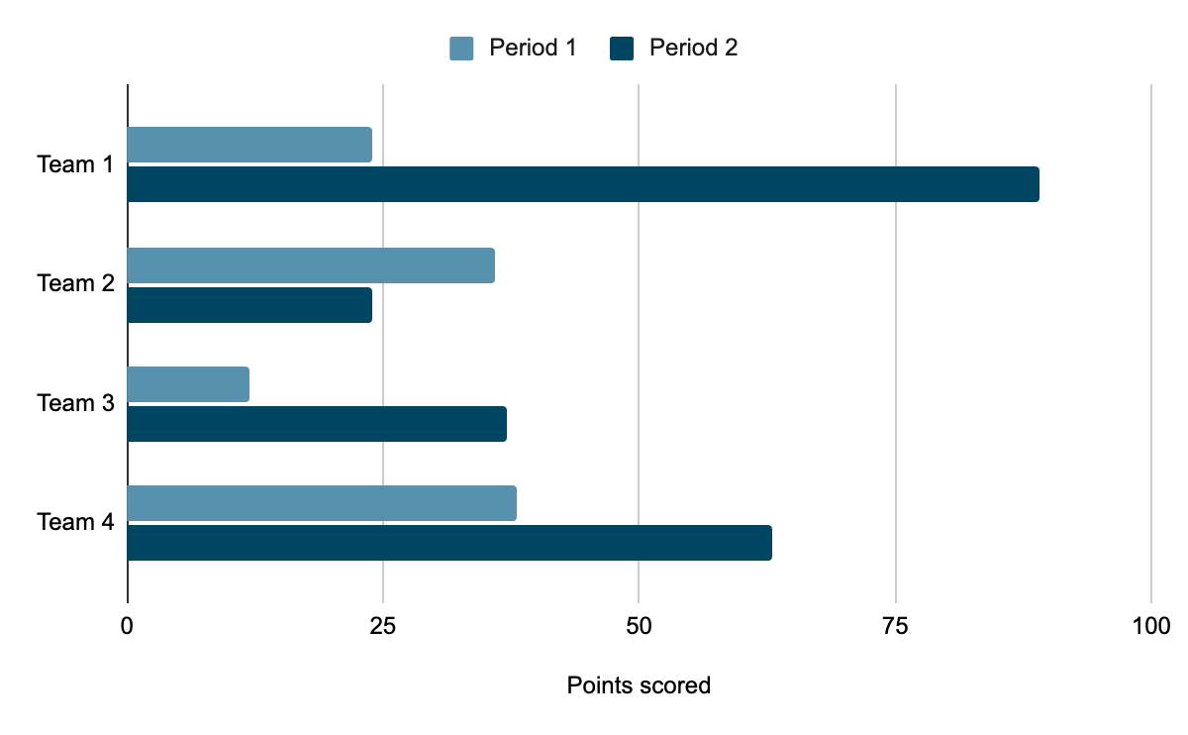
If you choose to use a table, you use a “Table” label with a number, corresponding to the order of other tables in the entire text, followed by a descriptive title. Boldface any header information within your table to help the reader.
Table 1
FOMO Scores by Participant (Title is Italicized and Title Case)
Participant | Age | Grade | FOMO Score
Samantha | 19 | Sophomore | 15
Juan | 18 | Freshman | 7

Discussion (Level 2 Header)
The discussion is where you can make connections between what your research study discovered and what was found in the research done before you. If you found similar findings to past studies, you can explain that here. If you found new, different or even surprising findings, you can make a statement to that effect, while noting with what past research it contrasts.
You may also note any limitations to your study, such as ways your findings might be limited due to the methods you chose, the types of people who participated, or the questions you asked.
You are also asked to identify near and far-action steps that could be taken by you or your focal audience or other related young people that relate to the topic of your research inquiry. Essentially, you are answering the question, “as a result of our findings about ‘x’, what actions could or should be taken and by whom and toward what effect?”

Conclusion (Level 2 Header)
The conclusion restates the research inquiry topic and summarizes the main arguments or findings of your paper, so that your reader could just read the conclusion to generally understand the paper. What is important to learn from reading your paper? If your team has identified areas related to this topic that need further study in the future, mention them here. After this paragraph, there is a page break that forces References onto its own page: You will want to keep it there.

References (This is a level 1 Header)
[More References examples for your assistance here]
American Psychological Association. (year). Article title: Capital letter also for subtitle. Name of Journal, volume#(issue#), pg#-pg#.
Author(s) of essay or chapter. (year). Title of essay or chapter. In F. M. Lastname (Ed.), Book title (pages of essay or chapter). Publisher. https://doi.org/10.xx.xxxxxxxxxx
Freud, S. (year). Article title. Name of Journal, volume(issue), pages. https://doi.org/10.xx.xxxxxxxxxx
Pavlov, I., Jung, C., & Freud, S. (year of last update, month day). Webpage title. Source or hosting webpage. https://www.someurl.com/full/address
Ramirez, A. T. (year). Book title. Publisher. https://doi.org/10.xx.xxxxxxxxxx
Skinner, B. F., & Ferster, C. B. (year). Article title: Capital letter also for subtitle. Name of Journal, volume#(issue#), pg#-pg#. https://doi.org/10.xx.xxxxxxxxxx
Stein, D. J., Friedman, M. J., & Blanco, C. (Eds.). (year). Book title (edition, Vol. #). Publisher. https://doi.org/10.xx.xxxxxxxxxx

Appendix A (This is a Level 1 Header)
Interview Questions
or
Survey
or
Observation Techniques
or
Artifacts Samples

