How to Export Citations to NoodleTools
  - Joan E. Hughes, The University of Texas at Austin

Three Ways to Add a Source's Citation into your NoodleTools Project
Learn the three ways to add a source's citation information into your project

Manual Addition
Review this help page to understand how to add a reference citation manually to your NoodleTool project: https://noodletools.freshdesk.com/support/solutions/articles/6000244949-how-to-create-and-edit-a-source-citation
- You will enter information about a promising source into your individual project in NoodleTools by clicking on the green button "New Source" in upper right of NoodleTools and follow the guiding questions and inserting the correct information.

QuickCite
Review this help page to understand how to add a reference citation using a QuickCite using preformatted citation information : https://noodletools.freshdesk.com/support/solutions/articles/6000244671
- You will an already APA-formatted reference for a promising source into your individual project in NoodleTools by clicking on the green button "New Source" in upper right of NoodleTools and then choosing “Quick cite: Copy & Paste a citation”

Export from Database
Review this help page to understand how to import a reference citation directly from a UT Library database: https://noodletools.freshdesk.com/support/solutions/articles/6000244529
To assist this process (the information on how to do this is a bit scarce), please follow these aids.
- Please ensure that you are logged in to your NoodleTools account prior to trying to export from a library database.
- Once you've found an article of interest in the UT database, look to the right and find the Tools, and choose to Export.
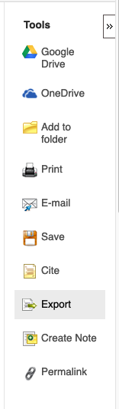

- The Export Manager will come up and you should choose "Direct Export to Noodle Tools."
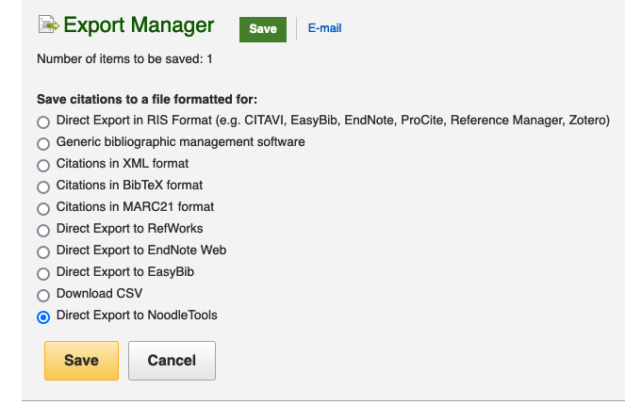
- Please ensure that you are logged in to your NoodleTools account. A window, shown below, will appear where you can check the citation information. If you are logged into NoodleTools, it will default to the last used project. (If no projects appear, you need to refresh your NoodleTools account so it recognizes you as logged in.) If you have multiple projects, choose to use the project folder for this class. Click on "Import." Refresh your NoodleTool page and your reference will be in your project.

