NoodleTools Setup Instructions
  - Joan E. Hughes, The University of Texas at Austin

Task 1: Get NoodleTools Set Up for Your Individual Work
Set up and use NoodleTools to support your research project in the following steps:
- Go to: https://guides.lib.utexas.edu/citesources/noodletools
  - Register and set up an account
  - Follow the "How to create a new project" link at the above linked Guide to go through the three steps in creating a project for the research inquiry. You will choose the "advanced" settings, and you will use APA format for citations.
  - Create a project folder for yourself where you will put materials of interest to your project but that is just for you, not your team. Name it with your last name and your project name (because you will share it with me). For example, the name, if it were mine, could be: UGS302_Hughes_SocialMedia
  - Within your NoodleTool project area, click on the "Research question/thesis statement" (see picture below) to fill out the research question your team has chosen (so far) (you can edit this if your direction starts to change after you start your research).
    - 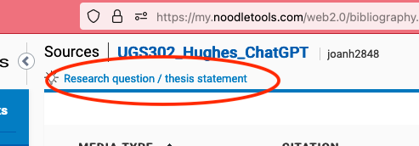

  - Find the 'sharing' link and share your project with me (my NoodleTool id is: [insert])
    - 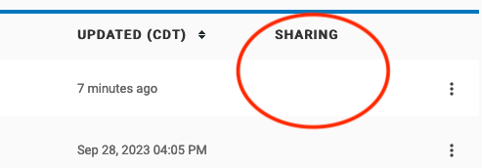

Task 2: Get NoodleTools Set Up for Your Group Project Work
One person in your team should follow the same steps as above to create a Team Project. This is ONE NoodleTools project that is shared with all three team members and me.
- Who is the one person on your team that is doing this? If you don't know, ask your team members who will create the team project.
- Create one project folder for the team where you will put materials of interest to the whole team (after you have read and decided resources are applicable and important). Name it with UGS302, your project name, and "Team" and the 3 first names of team members. For example, if three students were studying social media, they might name the project: UGS302_SocialMedia_TeamBobKeeshaLim.
- Find the 'sharing' link again (see picture above) and share your team project with your two other team members and me (my NoodleTool id is: [insert])

