Creating and Sharing Zines with
Video Tools for Online Humanization
  - Alexandra J. Reyes and Lucas John Jensen, Georgia Southern University

Overview
This activity is built around the creation and online sharing of culture zines via video-sharing tools, demonstrating content knowledge while humanizing an online course. Using crafting and repurposed materials, students in an asynchronous, graduate education course created zines—essentially handmade magazines—showcasing aspects of their culture. Students shared their finished zines by recording and posting short videos and responded to their classmates’ work. They then wrote reflections about the entire experience. By engaging with each other’s zines, students expanded their understanding and appreciation of other cultures. This activity highlights the potential for community building, creative assessment, cultural expression, and humanizing the learning process within an asynchronous online course.
Topics: Creative Assessment, Culture, Humanization, Video Sharing Tools, Zines
Time: Two weeks

Materials
- Zine-making materials (e.g., newspapers, magazines, paper, fabric, photos, printed art, stickers, markers, tape, glue, scissors)
- Internet access for instructor and students
- Computer with a mic and camera for each student
- Video capturing/screen casting tool for each student (e.g., Canva, ScreenPal, Screencastify)
- Video-sharing platform for instructor and students (e.g., Padlet, Screencastify)
- Culture Zine Assignment Instructions
- Intro to Zines Presentation
- Illustrated 8-Page Zine Instructions
- Creating Zines Resource Padlet
- Evaluation Rubric

Context-at-a-glance
Setting
A graduate course about Cultural Diversity and Teaching English to Speakers of Other Languages (TESOL) at a large, comprehensive university in the Southeastern United States.
Modality
Asynchronous online
Class Structure
A 3-credit, 16-week course with biweekly modules.
Organizational Norms
Thematic modules include readings, discussions, and application-based and reflection assignments designed to provide background knowledge (i.e., historical, theoretical, pedagogical) that can be applied to the learners’ teaching contexts.
Learner Characteristics
The graduate learners are practicing P–12 teachers, spanning grade levels and content areas and come from various geographic regions and experiences.
Instructor Characteristics
The instructor and collaborator have 20+ years combined experience with online teaching. The instructor prepares teachers to work with diverse and multilingual learners and has implemented arts-integrated pedagogies since she taught P–12. The collaborator, an instructional technology educator, previously worked as an instructional designer.
Development Rationale
Create an opportunity for learners to engage culture while humanizing the online classroom. This fulfilled a desire for greater technology integration and creative assessment in the course.
Design Framework
Social Presence Theory

Setup
Note: This assignment was originally conducted using the video-based discussion website Flip, formerly (and more commonly) known as Flipgrid. Unfortunately, Flip was sunsetted by Microsoft in July 2024, shortly after this project ended. Another video-based discussion tool (e.g., Padlet, Screencastify) can be used.
This activity is part of a 2-week module on identity and culture, situated toward the beginning of the semester. Resources (i.e., assigned readings, presentations, videos, and guiding documents) should be organized in a learning management system (LMS) so learners can easily access them asynchronously. The module readings provide background knowledge on identity and culture, while the additional resources elaborate on these topics and provide guidance on the activity. A description of the readings, resources, and activity sequence is provided in the Activity Structure: Culture Zine section.
Instructors and students must have a method to record and save video, whether via smartphone, tablet, or computer. They must also have access to a video-sharing site and a central discussion board. The authors suggest tools like Screencastify, ScreenPal, or Canva for screen recording and Padlet or Screencastify for hosting video-sharing discussions. In the wake of the sunsetting of Flip, several platforms are stepping in to try to fill the void.
To create their zines, students may use any combination of newspapers, magazines, paper, fabric, printed images/text, photographs, drawn art, stickers, markers, pens, tape, glue, and any other crafting supplies. They would create these analog zines at home (asynchronously). See figure 1 for an example culture zine.
Video recording tools are used to make short explainers, in which learners show their analog zines and describe their meaning. The video sharing/discussion tool is used to post, view, and respond to others’ work.

Standards
This course is the first in a three-course series that leads to a state English to Speakers of Other Languages (ESOL) teaching endorsement. The ESOL endorsement requires teacher candidates to be prepared around five standards: (a) knowledge about language, (b) language and culture, (c) planning and implementing instruction, (d) assessment and evaluation, and (e) professionalism and leadership.
In addition to alignment with state and national standards related to initial teacher preparation for Teaching English to Speakers of Other Languages (TESOL International Association [TESOL], 2019), this activity aligns with international standards related to technology education (a) for students and (b) for educators (International Society for Technology in Education [ISTE], 2016, 2017). Specifically, the following standards are addressed in this assignment:
- TESOL (2019) Standard 2: ELLs in the Sociocultural Context (2a; 2c)
- ISTE (2016) Standard 1: For Students (1.2.b; 1.4.a; 1.6.b; 1.6.c; 1.6.d; 1.7.a)
- ISTE (2017) Standard 2: For Educators (2.4.d; 2.5.a; 2.5.b; 2.6.a; 2.6.d; 2.7.a)
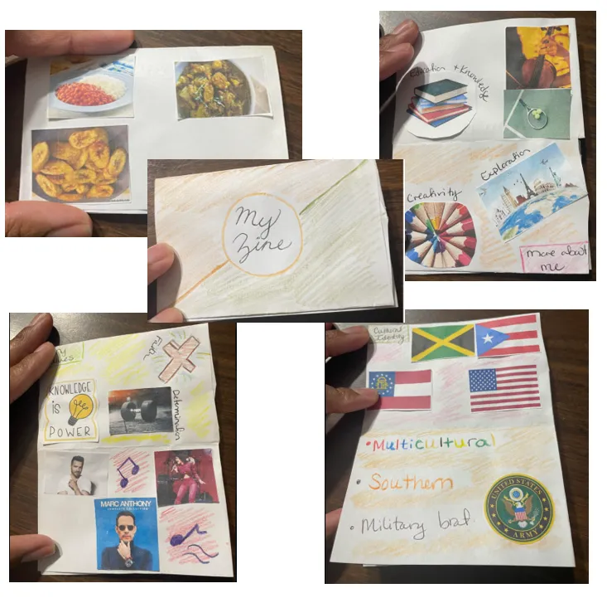
Figure 1. An example student culture zine.

Context and Setting
The Culture Zine Activity was implemented in a 16-week asynchronous online graduate course in a College of Education. The course is an introduction to teaching culturally and linguistically diverse students, with an emphasis on contextual and educational factors that impact English learners (ELs). On average, 20 students enroll in each course section.
The Cultural Diversity and TESOL course is not only part of the ESOL endorsement but is also a requirement for most of the college’s initial certification education programs. This means that learners in the course have varying experience with, interest in, and commitment to working with ELs and multilingual students. Learners in the course engage with a variety of readings, multimedia resources, video lectures, discussions, interviews, and creative assignments.
The course explores identity, culture, and language, and is organized in three parts: historical context, theoretical perspectives, and pedagogical application. Each part is further organized into two-week modules (M), as follows:
- M1-Who Are We?
- M2-Identity & Culture*
- M3-Who Are ‘Americans’?
- M4-Education vs. Schooling
- M5-Historical Access to Schooling
- M6-Responding to CLD Students
- M7-Supporting CLD Students
- M8-Creating Meaningful Instruction
*The Culture Zine activity is an M2 assessment.
In Spring 2024, the instructor taught the Cultural Diversity and TESOL course, teaching it once before. Based on their previous experience, the instructor recognized the unique challenge of creating community in asynchronous online learning spaces. The course instructor reached out to their colleague for guidance on developing assignments that would engage the learners’ humanity and creativity through technology-integrated assessments. The two collaborated on a set of creative projects that addressed the need for humanization and connection online, while meeting course objectives.

Social Presence Theory
Social Presence Theory attempts to understand how technology-mediated communication creates social presence, giving communicators the feeling of being and interacting with “real” people on the other end of technology (Kear et al., 2014; Short et al., 1976; Weidlich et al., 2018). Online courses often communicate little in the way of socio-emotional information, meaning that the feeling of human interaction can be diminished (Kear et al., 2014; Weidlich et al., 2018). The more social presence, the more a learner feels that they are a real person interacting with other real people, which might have motivating factors for learners in a classroom (Jensen & Kim, 2024; Yang et al., 2016).
This activity attempts to humanize online classes by increasing the social presence of learners through sharing their culture zines in a video discussion. Online courses, particularly asynchronous ones, often struggle with building a community online, leading students to feel dehumanized and isolated, potentially leading to higher attrition rates (Jensen & Kim, 2024; Phirangee & Malec, 2017). Because so much of asynchronous online education is text-based, students might miss these humanizing interactions that provide socio-emotional information necessary for building social presence and community (Kear et al., 2014; Weidlich et al., 2018).

Learning Representation: Culture Zine
The culture zine activity described here was implemented in a 16-week asynchronous online graduate course and can be easily adapted to work in other instructional modalities (e.g., synchronous online, hybrid, face-to-face) and applied to a range of content matter and learning contexts. For example, students in a science class might be tasked with creating a zine that explores the solar system, or social studies students might make a zine that elaborates upon a significant historical event. The instructor has used a zine creation assignment twice in addition to the implementation detailed here: previously in an in-person undergraduate Elementary Arts Integration course, and afterward in a hybrid undergraduate version of the Culture/TESOL course.

Course Module Alignment
Each module includes multiple items (i.e., course pages, links, and PDFs. The first item in each module is the Module Overview page that introduces the module by situating it within the larger course context. In addition to introducing and contextualizing the module, the overview page provides objectives and a task list. Discussion prompts, assignment details, assignment rubric(s), and supporting materials are included with relevant details within the module.

Prior Learning (M1 Description)
Before engaging in the deep interrogation of culture in Module 2, learners explored identity and were introduced to culture in Module 1 (M1).
In Module 1: Who Are We?, learners explored identity and culture broadly and interrogated their own identities. First, they read three book chapters—one from Kohls (1996; Chapter 6) and two from Takaki (2012). Learners also read a web article (Why identity matters, n.d.) and watched embedded videos. Then, they watched a video lecture in which the instructor presents a social identity wheel graphic and describes how identity is multidimensional. The instructor also provided guidance and examples of the Identity Constellation assessment for Module 1.
After completing all assigned readings from M1, learners were prompted to respond in the asynchronous LMS discussion board. Learners identified two things from the readings they found interesting or surprising, made one connection between the readings and a personal experience, and posed one question that they had about the readings. Students were instructed to use direct quotes and APA citations where appropriate. Examples of response frames were provided.
Learners were then tasked with creating an Identity Constellation that illustrated the various dimensions of identity, making use of color, size, and distance to indicate relationships. These were shared on an asynchronous discussion board, where learners could view and comment on their classmates’ work. After sharing their work in the discussion area, learners uploaded a written reflection along with an image of their Identity Constellation to the assignment dropbox.

M2: Identity & Culture (Description)
After exploring identity in M1, learners were introduced to Funds of Knowledge (Moll et al., 1992), levels of culture (as described in Hammond, 2015, Chapters 1 and 2), and provided historical context for the cultural diversity in U.S. schools. They were then challenged to interrogate their own cultures through the creation and video-sharing of, and reflection on, analog culture zines. As the course progresses, learners build on their knowledge of identity and culture to gain understanding of how historical, theoretical, and pedagogical perspectives inform students’ schooling experiences.
The following describes Module 2 in detail. The text in italics represents the course content, as presented to learners. A step-by-step guide for instructors follows in the Activity Structure: Culture Zines section.

M2 Overview: Identity & Culture
In Module 1, we explored identity and began to learn about culture. In M2, we will continue to explore what identity and culture are, and how we understand our own cultures. We will also explore how identity and culture are engaged in educational settings.

Learning Objectives
At the completion of this learning module, you will be able to:
- Define culture.
- Differentiate between identity and culture.
- Describe your own culture.
- Analyze how different aspects of culture inform how we understand identity.
- Identify issues that may arise due to cultural misunderstandings.
- Design, create, and share a zine that represents your culture or some aspect of your culture.
- Draw connections between course readings and relate them to your own experiences.

Task List
For Module 2, please do the following:
- Read Hammond (2015), Chapters 1–2.
- Read Takaki (2012), Chapters 2–4.
- Read Moll et al. (1992) “Funds of Knowledge”.
- Read Clark et al. (2018) Green Card Youth Voices (a.k.a. GCYV), introduction–p. 37.
- Review additional M2 materials and resources.
- Post a reading response to the M2 discussion area. See the discussion area for the prompt.
- Create a zine that showcases your culture or some aspect of your culture. See the assignment description and rubric for details.

Readings, Resources, & Discussion
Learners were assigned varied theoretical, empirical, and pedagogical readings about culture (e.g., Hammond, 2015; Moll et al., 1992). They were assigned chapters from ongoing readings on the U.S. as a multicultural society (Takaki, 2012) and K–12 students’ recent immigration experiences (Clark et al., 2018). Learners also reviewed additional resources (e.g., instructor-recorded video presentation about zines, assignment rubric) to gain an understanding of zines and their utility for expression.
Learners then responded to the following prompt, using the LMS discussion area:
After completing all assigned readings from M2, respond to the following.
- Connect one quote from Hammond (2015; see Chapters 1 and 2) to a quote from one of the other M2 readings. Use direct quotes and/or specific examples in your response.
- Explain why you chose these particular quotes and/or examples and how you see the quotes and/or /examples connecting to each other, to personal experience, or to other course content.
Please use direct quotes and APA citations as appropriate (see example below). Post your responses by 11:59 pm on Sunday.

Culture Zine Instructions
Now that we have explored the concepts of identity and culture, let’s share our cultures with each other by creating culture zines! For this assignment you will:
- Create a physical (analog) zine that showcases your culture or some aspect of your culture.
- Record a video and post it to the class Flip. Show your entire zine and explain what you included on each page. [link to Flip.]
- Watch your classmates’ Flips and respond to at least one.
- Upload an image of your zine and a written reflection to the assignment dropbox. In your reflection:
  - Explain your creative process, curation choices, and the significance of the zine content.
  - Discuss your feelings during creation and video recording, as well as your feelings about viewing your classmates’ work.
  - Connect this project to identity, culture, and course readings/content.
  - Use APA (7th ed.) citations and references as appropriate.
- Refer to the assignment rubric for evaluation criteria.

Activity Structure: Culture Zine
Instructors can follow this general structure while conducting this activity:
Video-Sharing Discussion Board
Designate a platform for the sharing of culture zine videos between classmates. Students should have access to this space, so they can add their own videos, plus comment on their peers’ submissions. Providing a commenting system is essential for this activity’s success in terms of developing an online community. The authors created a refresher video on how to use the video-sharing tool and posted it in the module.
Note: The authors used the tool Flip in the implementation of this activity. Because Flip is no longer readily accessible, we recommend something like a Padlet board or a tool like Screencastify, though you can use the video uploading tools and sharing tools within your Learning Management System.
Teach About Zines
Provide students with resources to learn about zines (e.g., Todd & Watson, 2006). Review the Illustrated 8-Page Zine Instructions (DOCX) attachments. The instructor recorded a video elaborating on the Intro to Zines Presentation (PPTX). The authors also created a Resource Padlet that provides history, context, ideas, visual instructions, and resources about creating and sharing zines (see Creating Zines Resource Padlet, DOCX).

Assign the Zine Activity
After assigning readings about culture and providing an introduction to zines, assign the culture zine activity. Task the learners with creating a culture zine that will be shared with the rest of the class. Provide them with instructions and the grading rubric so they know how their work is being evaluated (see Culture Zine Assignment Instructions, DOCX; Evaluation Rubric, DOCX). Assure them that you are not judging their artistic ability, but the content and effort of their work. Post examples of zines for inspiration (see Figures 2 and 3 for examples).
Encourage learners to use any number of art and crafting supplies and repurposed media to make an 8-page zine, representing some aspect of their culture. This zine might focus on something like the food, art, or history of a culture. The students might use various types of paper, printouts, photographs, fabric, text, magazine/newspaper cutouts, stickers, markers, pens, and much more to create their zine.
Direct learners to the platform where they will post 3-5-minute videos showing and explaining their zines. Remind students to capture legible footage of the zines on camera, so that their classmates can see what they look like. They must watch all the videos posted and comment on at least one.

Evaluate Zine Activity Using Rubric
Use a rubric to evaluate student learning (see Evaluation Rubric, DOCX). The rubric criteria should focus on the culture zine (content, form, and sharing) and the written reflection (content and form & mechanics), rather than perceived artistic talent.
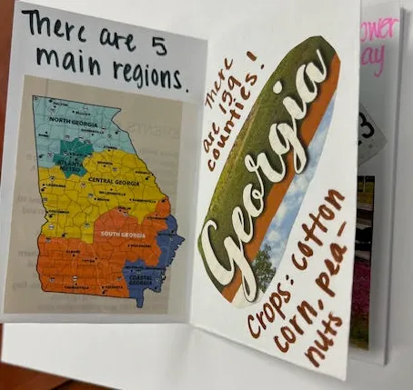
Figure 2. An example student culture zine.
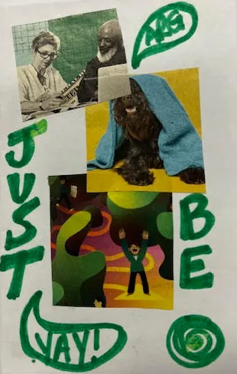
Figure 3. An example student culture zine.

Critical Reflection
The zine activity was implemented in the second learning module of an asynchronous TESOL graduate course in Spring 2024 at a large public regional university. Students participated using the tool Flip, sharing their homemade culture zines with each other via short videos and providing feedback via the Flip comment section. Since initially implementing this activity, we have co-presented professional development workshops on zine-making to TESOL practitioners at two different events. We have also presented our initial zine study findings at a national conference, and the first author has refined and adapted the activity for use with an in-person undergraduate course. Here, we reflect on the online learners’ responses, technology integration element, subsequent work, and the overall experience.

The Online Learners’ Responses
Students were excited to share aspects of their culture. The zines themselves often featured topics that were extremely personal and significant to the students, highlighting aspects of their culture like food, faith, language, social justice, and more. The students’ videos of their zines, however modest in construction, displayed warmth and personality.
One student commented in their written reflection, “I loved watching my other classmates’ zine videos and getting the opportunity to better understand them as a whole!” This indicates that the combination of the project (creating a culture zine) and presentation format (recording a video explanation) humanized learners to one another. Another learner reflected that the activity “gave [them] a sense of connection” through “learning about the other students.” This suggests an increase in social presence and feelings of being “real” to others in this digital environment.

The Technology Integration Element
As far as the technology integration itself, we felt that integrating video into the classroom helped humanize the students, as it gave an added dimension to their communication that wasn’t there before. Teaching online can often mean teaching to a list of names on a screen, so this was a video reminder that our students are human beings with cultures to share. The goal of this technology integration was to increase social presence through these technology-mediated discussions. We felt that the power of student-recorded video, at least for us, increased that sense of feeling in an online community that comes from social presence (Tu & McIsaac, 2002). Video-sharing tools available to online educators facilitate these discussions.
Students felt comfortable using video-sharing tools, and it helped some overcome anxiety about sharing videos of themselves. One student reported they “get nervous when [they] have to video” and “started to notice hives on [their] neck.” They reflected, “[the assignment] brought me out of my comfort zone...I think that it allowed me to feel a sense of happiness.” This experience speaks to the humanization aspect of using video sharing in online classrooms.
There was nothing the authors could have done about Microsoft’s surprise sunsetting of the tool Flip on July 1, 2024, which happened just after the semester ended. It remains a deep and significant pedagogical loss for this course, as Flip was in perfect alignment with this assignment. This left the authors looking for alternatives, which we have found, for now, in other third-party tools like Padlet and Screencastify. Neither is a perfect analogue, but they both allow for the easy making and posting of videos to a central discussion board. Furthermore, both platforms regularly add new features that bring them closer to the Flip experience. Whatever tool you choose, it is important that you know the tool beforehand, so that you might troubleshoot it more effectively should issues arise.
More recently, the authors have volunteered to pilot Harmonize, an external learning tool which the university is considering for adoption. We are hopeful that this technology may fill the void.

Subsequent Work around Zines
The instructors originally developed the culture zine activity because of its accessibility and low demand for resources. In addition to allowing learners to connect their learning about culture to their personal lives, it created the opportunity to connect with one another. We also hoped that learners would feel empowered to use zine-making in their own teaching, after having done so themselves.
With this wide application in mind, the authors presented this activity in a professional development format at a regional TESOL conference. After a brief introduction to zines, education professionals constructed zines onsite using old magazines and crafting supplies. The educators created their zines while discussing the potential for using zines for communication and instruction and learning about zine-sharing tools. This activity was positively received, and the authors were invited to present on this topic at a subsequent symposium.
The authors also presented initial findings at a national conference from a research study on the data collected from the initial graduate course implementation of this activity. Across multiple contexts, the concept of zines alone proved attractive to educators, students, and scholars alike. Because of the relatively low expense of making zines, zines democratize student creativity and expression, which appealed to the educators in attendance.

The Overall Experience
Overall, we felt that this activity was a success, both pedagogically and logistically. One student even mentioned on the end-of-course evaluation that the zine activity was their favorite assignment.
The low-cost, democratized nature of zine creation meant that learners could easily participate, which they did enthusiastically. The Flip tool made it easy to implement the activity in a virtual, asynchronous setting. The students and instructors learned from the sharing of cultures, and the activity succeeded in humanizing the online learners and increasing social presence. The integration of hi-fi video-sharing technology and lo-fi zines worked well. With a few suggested changes, gained upon reflection, the activity could be even more successful.

Areas of Improvement
One area for improvement would be to include more specific parameters for the assignment. For example, the instructor could specify a video length (minimum and maximum) and include more detail in the individual rubric criteria. After implementing the culture zine activity, we determined that we would like to encourage more discussion and engagement between the learners. While student engagement was generally effusive and inquisitive, the overall discussion could have been richer in quantity and depth. An effective way to accomplish this would be to increase the minimum response requirements (i.e., greater expectations for the quantity and quality of replies to one another), as detailed in the assignment rubric. We might encourage video replies to amplify interactions, if the tool allowed this feature.
An additional place for improvement would be in the prompt for the written reflection. We would add language to the prompt that explicitly encouraged students to connect the culture zine activity and their own classroom practice. While one learner wrote in their reflection that they “actually made zines with [their] class this past week to use for their visual vocabulary, and they enjoyed it as well, ” the prompt did not explicitly ask learners to describe how zines might be used in their own teaching. The instructors could have directed learners in the class to identify ways they might use zines in their own classroom practice as a means for student self-expression and an alternative assessment on a chosen subject (e.g., all students make zines on the Great Depression).
This activity provided a rich opportunity for exploration and creative thought, for the authors, the online learners, and the later workshop attendees. The zine activity is unique in its accessibility, applicability, and adaptability. Though this lesson was initially targeted toward graduate students who were practicing PK-12 teachers, it can be easily modified to work in many instructional settings around any subject. Educators of any type might use zines in their classrooms, whether online, hybrid, or face-to-face, as they are low-cost and can be made with fairly commonplace and inexpensive supplies. Zines are a malleable format, and we have had students create zines for subjects as diverse as sandwiches and Shaquille O’Neal. Whether used to build social presence, practice communication skills, develop creativity, or demonstrate learning, zines can add a humanizing element to any learning context.

References
Clark, T., R., Rodriguez, D. X., & Smith-Sitton, L. (2018). Green card youth voices: Immigration stories from an Atlanta high school. Green Card Voices.
Critical Media Project. (n.d.). Why identity matters. Critical Media Project. https://criticalmedia project.org/why-identity-matters/
Hammond, Z. (2015). Culturally responsive teaching and the brain: Promoting authentic engagement and rigor among culturally and linguistically diverse students. Corwin.
International Society for Technology in Education. (2017). ISTE standards: Educators. https://www. iste.org/standards/iste-standards-for-teachers
International Society for Technology in Education. (2016). ISTE standards: Students. https://iste.org/standards/students
Jensen, L. J., & Kim, J. H. (2024). Humanizing online instruction with AI-powered chatbots and multimedia introduction: Empirical advice for online college classrooms. In Humanizing Online Teaching and Learning in Higher Education (pp. 247-262). IGI Global.
Kear, K., Chetwynd, F., & Jefferis, H. (2014). Social presence in online learning communities: The role of personal profiles. Research in Learning Technology, 22. https://doi.org/10.3402/rlt.v22.19710
Kohls, L. R. (1996). Survival kit for overseas living: For Americans planning to live and work abroad (3rd ed.). Intercultural Press, Inc.
Moll, L. C., Amanti, C., Neff, D., & Gonzalez, N. (1992). Funds of knowledge for teaching: Using a qualitative approach to connect homes and classrooms. Theory Into Practice, 31(2), 132–141. https://doi.org/10.2307/1176576
Phirangee, K. & Malec, A. (2017). Othering in online learning: An examination of social presence, identity, and sense of community. Distance Education, 38(2), 160-172. https://doi.org/ 10.1080/01587919.2017.1322457
Short, J., Williams, E., & Christie, B. (1976). The social psychology of telecommunications. London: Wiley. p. 65-66
Takaki, R. (2012). A different mirror for young people: A history of multicultural America. Seven Stories Press.
TESOL International Association. (2019). Standards for Initial TESOL Pre-K–12 Teacher Preparation Programs. https://www.tesol.org/media/v33fe wo0/2018-tesol-teacher-prep-standards-final.pdf
Todd, M., & Watson, E. (2006). Whatcha mean, what's a zine?: The art of making zines and minicomics. Houghton Mifflin Harcourt.
Tu, C. H., & McIsaac, M. (2002). The relationship of social presence and interaction in online classes. American Journal of Distance Education, 16(3), 131-150. https://doi.org/10.1207/S15389286AJDE1603_2
Weidlich, J., Kreijns, K., Rajagopal, K., & Bastiaens, T. (2018, June 25). What social presence is, what it isn’t, and how to measure it: A work in progress. In EdMedia+ Innovate Learning (pp. 2142-2150). Association for the Advancement of Computing in Education (AACE).
Yang, J. C., Quadir, B., Chen, N. S., & Miao, Q. (2016). Effects of online presence on learning performance in a blog-based online course. The Internet and Higher Education, 30, 11-20. https://doi.org/10.1016/j.iheduc.2016.04.002

About the Authors
Alex Reyes is an Associate Professor at Georgia Southern University and serves as the ESOL endorsement coordinator. She holds an M.Ed. in Bilingual and Multicultural Education from Northern Arizona University and a Ph.D. in Education (Culture, Curriculum, and Change) from the University of North Carolina at Chapel Hill. Her research focuses on the intersections of language, culture, and identity, and how they inform learning experiences for multilingual and other marginalized communities in informal and formal settings. She is also interested in arts-integrated pedagogies. She can be contacted at areyes@georgiasouthern.edu.
Lucas John Jensen is an Associate Professor of Instructional Technology at Georgia Southern University. He earned M.Eds in Social Science Education and Instructional Design and Development and a Ph.D. in Learning, Design, and Technology from the University of Georgia. He teaches on subjects such as instructional design, trends and issues in instructional technology, and multimedia design. His research focuses on games and education, teacher perspectives of online education in the pandemic, and educational social media use, among others. He can be contacted at ljensen@georgiasouthern.edu.

Sharing & Modification Permissions
Unless otherwise noted, this article and its resources are published under a Creative Commons Attribution-NonCommercial-ShareAlike 4.0 International license:

You can freely share the article and its resources if you indicate the original authors, identify the Creative Commons license, and use them non-commercially.
You may also make and share modifications by:
- Identifying the original authors.
- Using the resources non-commercially.
- Licensing modifications under the CC BY-NC-SA 4.0 license (and including a link to it).
- Indicating what modifications were made.

