Biomimicry and Human Design: Observing
Bird Structures and Functions to Create
Flying Machines with Artificial Intelligence
  - Heejung An¹, Triada Samaras², and Woonhee Sung³,
¹William Paterson University, ²Kean University, ³University of Texas at Tyler

Overview
Using the 5E model, this lesson engages fifth graders in exploring biomimicry and flying machines to inspire original designs. Students build design thinking and observation skills through bird observation using photos, videos, and audio, followed by discussion, sketching, brainstorming, testing, revising, and artistic creation. An artificial intelligence (AI) image generator supports visual inspiration. The lesson concludes with students sharing and reflecting on their flying machines. Hands-on activities and technology are integrated throughout to enhance engagement and interaction.
Topics: Artificial Intelligence, Biomimicry, Design Thinking, Flying Machine, Observant Thinking
Time: The lesson sequence takes about 5 days to complete based on daily 40-minute classes. In keeping with differentiated instruction, teachers can speed up or slow down the sequence as they wish, following the lead of the students.

Materials
- Multiple photographs of owls and hummingbirds
- Internet-connected devices for students (e.g., laptops, iPads, Chromebooks)
- Projector or interactive whiteboard
- Student access to OpenAI’s (n.d.) DALL-E platform or similar AI image generation tool
- Biomimicry Rubric
- Art materials (e.g., paper, pencils, markers, scissors, rubber bands, straws, string, hole punchers, popsicle sticks, glue sticks, glue, tape)

Context-at-a-Glance
Setting
Fifth graders at an urban, public, elementary school in the Mid-Atlantic region of the United States.
Modality
In-person instruction
Class Structure
A flexible classroom setup with options for small-group arrangements to encourage collaboration (e.g., seating three to five students at small tables to foster discussion, teamwork, and a sense of community).
Learner Characteristics
Fifth graders from predominantly Hispanic backgrounds. Students have a basic knowledge of birds and work with their hands to create artwork. Students are familiar with computers and have used art supplies before. Students are enthusiastic about art making and the use of AI image generators to learn more about owls and hummingbirds. Some students do not speak English well.
Instructor Characteristics
Teachers should be familiar with an AI image generator tool to guide students through. Co-teaching with an art teacher is recommended.
Development Rationale
Elementary students will have a unique opportunity to encourage observant thinking, creativity, and innovation while engaging in hands-on learning with an AI image generator, which fosters design thinking in the study of biomimicry.
Design Framework
5E Model of Instruction (Bybee, 2015)

Setup
This lesson sequence spans about five days. During the five lessons, students work in small groups. It should take 10-15 minutes to set up the environment each day. Each group receives the following materials:
- Day One: No materials are needed. Students might stand and use their bodies and, therefore, need adequate physical space to do so.
- Day Two: Owl and hummingbird hand-outs are placed on each table. Each student is provided with one 8½ x 11” sheet of paper and a pencil.
- Day Three, Part A: Each student is provided with two 8½ x 11” sheets of paper and a pencil, one sheet for sketching and one sheet to write prompts.
- Day Three, Part B: Each student (or student pair) receives a laptop computer with DALL-E ready to use.
- Day Four: Each student (or student pair) receives a laptop computer with DALL-E ready to use.
- Day Five: A variety of art materials are placed on the table, including light-weight white construction paper, white printer paper, markers, scissors, rubber bands, light white paper, straws, string, hole punchers, glue sticks or glue, tape and popsicle sticks.

Standards
ISTE Standards for Students:
- 1.4.a “Students know and use a deliberate design process for generating ideas, testing theories, creating innovative artifacts, or solving authentic problems” (International Society for Technology in Education [ISTE], 2016).
National Core Arts Standards:
- Anchor Standard 1: “Generate and conceptualize artistic ideas and work” (National Coalition for Core Arts Standards [NCCAS], 2014).
- 5th VA: CR1.1.5.a: “Combine ideas to generate an innovative idea for art-making” (NCCAS, 2014).
- Anchor Standard 2: “Organize and develop artistic ideas and work” (NCCAS, 2014).
- 5th VA: Cr2.1.5.a: “Experiment and develop skills in multiple art-making techniques and approaches through practice” (NCCAS, 2014).

Context and Setting
Leonardo da Vinci wrote, “Human subtlety will never devise an invention more beautiful, more simple or more direct than does nature because in her inventions nothing is lacking, and nothing is superfluous.” (da Vinci, 1970, p. 126)
da Vinci’s drawings of airplanes and parachutes, drawn long before humanity conceived of these inventions, continue to fascinate us after all these years. For example, in 1505, he discussed the fundamental concepts of gravity and birds lifting their wings to introduce the idea of flying (da Vinci, 1970). His keen observational skills have helped generations of thinkers reimagine what’s possible. Indeed, many innovations throughout history have been inspired by analyzing the behavior of birds, fish, insects, and other animals.
This field, known as biomimicry, is defined as the “design and production of materials, structures, and systems that are modeled on biological entities and processes” (Arizona State University Online, 2022, para 1). In other words, humans apply nature-inspired designs, emulating biological forms, processes, patterns, and systems in engineering and invention to solve human problems (Kennedy, 2017).
Making meaning from observed natural phenomena requires detailed observation, creative problem-solving based on observation, and design thinking. In this process, sketching or drawing can be used to visualize and scaffold observations, which then lead to creative and innovative problem-solving and creation. Biomimicry promotes this sensibility grounded in our surroundings, which is essential for creators, producers, or designers. Design thinking is fundamental to this creative problem-solving process by fostering innovation that harnesses sensibility and methods (Eklund et al., 2022). As such, biomimicry is an effective booster for design thinking, using designers’ sensibilities and techniques to create things that meet people’s needs and develop into values (Brown, 2008; Micheli et al., 2019). Nature can inspire designers and other creators to develop new and usable inventions. For example, the flexible ribs on the sides of a leaf informed the design of the hollow ribbed structure of the Crystal Palace
Conservatory in Hyde Park, London (Figure 1; Goss, 2009).
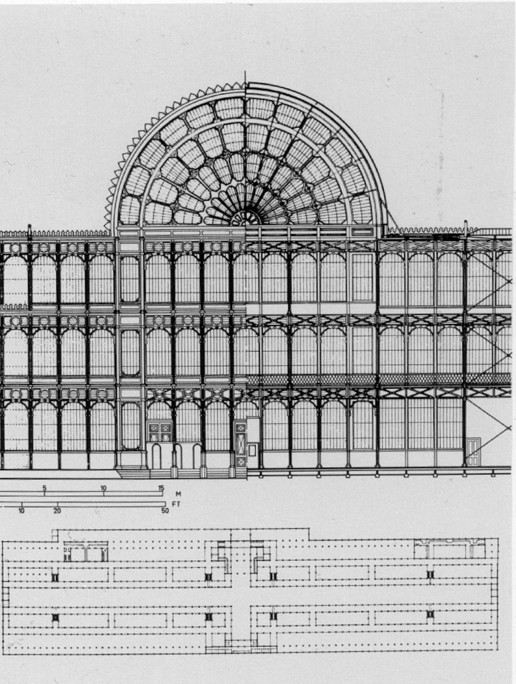
Figure 1. Crystal Palace Conservatory by Sir Joseph Paxton (1803-1865) Note. Self-scanned; public domain.
https://bit.ly/42ou5hW
In recent years, design thinking has increasingly become emphasized in the K-12 curriculum as a necessary 21st-century skill. For example, some states, such as New Jersey, embrace design thinking as part of students’ learning standards (see New Jersey Student Learning Standards, 2020), making it a critical area to teach today’s students. In this context, biomimicry has a unique advantage as a vehicle for fostering design thinking and creating a flying machine, particularly for interdisciplinary aspects of arts and technology-integrated lessons and projects.
An important skill of design thinking is journey mapping (also known as “experience maps”), which visualizes the progression of work over time (Howard, 2014; Stobierski, 2022). One of the tools that might help students visualize unknown things is an artificial intelligence (AI) image generator. One such AI image generator, DALL-E ( https://chatgpt.com/g/g-2fkFE8rbu-dall-e), was revealed by OpenAI in January 2021. Based on text-to-image models and using deep learning methodologies, digital images are generated from natural language descriptions, called “prompts.” DALL-E can foster design thinking and stimulate creativity and divergent thinking.
Following the 5E instructional model of Engage, Explore, Explain, Extend (or Elaborate), and Evaluate (Bybee, 2015), this article presents a lesson that explores the intersection of biomimicry and the creation of flying machines. It is also designed to help students (a) post their work in stages and (b) share and reflect throughout the design thinking processes.
The lesson starts with engagement, which should be informed by students’ close observation and previously acquired knowledge. Students’ subsequent exploration and research will inform ideation, prototyping, and creation. The lesson also emphasizes sharing and reflection during the Explain and Elaborate stages, encouraging students to express their thinking through the use of online bulletin board tools.
The following lesson is designed for fifth graders. The use of a 5E instructional model (Bybee, 2015) takes into consideration students’ prior experiences and how they may affect their learning of content before introducing them to the lesson.

Learning Representation
Objective:
How can we observe birds in flight to inspire us to create our own flying machines?
Essential Questions:
- What can humans learn about aeronautical design from nature?
- How can nature inspire human design?
- How can artificial intelligence empower humans to be more creative and divergent thinkers?

Day One

Engage
The teacher introduces an exploratory discussion using some of the following questions and presents videos of birds in flight, photographs of birds, and other resources on the Promethean or any interactive digital whiteboards.
- Have you ever seen a bird in flight? Did you see it up close?
- Did you know what type of bird it was? What did you notice about the flight of this bird? Did you wonder how it was able to stay in the air?
- What part of the bird keeps it in flight?
- How do you think birds differ in their flights? Are their bodies different?
- Have you ever seen an owl or a hummingbird up close?
- What did you notice about the way the two birds fly?
- Have you tried to capture it in a photo or sketch?
- Why are pictures important in science?
As a closing activity for the lesson, the teacher might (a) ask students to stand up and try to re-create some aspect of the birds’ flight using their bodies; (b) ask students to use their hands to create the birds; or (c) play different bird sounds using audio files.

Day Two

Explore: Science and Art Observing Closely and Sketching
Prior to class, the teacher should print out photographs of an owl and hummingbird and distribute copies to each student or group of students (see examples in Figures 2-5). In addition, photos are available on desks or worktables as resources for the students to engage with.
First, the teacher cultivates student exploration through more discussion using photos of two types of birds (owls and hummingbirds) to develop observational skills and design thinking while sketching. At the same time, the teacher might also play audio files of these birds.
Each student is provided with an 8½x11 sheet of paper and a pencil and asked to sketch an owl or a hummingbird in flight based on the provided photographs. This stage focuses on students’ learning about how the structures of owls and hummingbirds assist in their flying abilities, how both birds look in flight, and how to record this information in a sketch. Students will create a drawing of an owl or a hummingbird in flight to demonstrate this understanding. The teacher explains that later in this lesson plan sequence, they will use these sketches to inspire them to create/design an imaginary flying machine.
Questions teachers might use during sketching activities include:
- Have you ever seen an owl or a hummingbird in flight?
- What did you notice? How do these birds look in flight?
- How are the wings of an owl different from the wings of a hummingbird?
- What else do you notice about their similarities and differences?
- Can you sketch one of these two birds in flight?
- Where will you start?
The teacher shows videos of owls and hummingbirds in flight such as the following:
- Barn owl in flight (Feather Light Photography, 2021)
- Only bird that can fly forward, backward, upside-down and hover (Nature Notes, 2021).
The teacher then asks the following questions to cultivate design thinking:
- What are the most interesting features of this bird and its unique flight patterns and maneuvers?
- What changes when it is in motion? How does this change affect the way the birds fly?
- What do you see when birds are both stationary and moving?
- Can you predict the differences in flight for these two birds?
Towards the end of the session, the teacher asks several students to stand up and show their drawings to their fellow students, explaining their sketching and their thinking. Other students also record their responses explaining their processes. Drawings are displayed on a board in the classroom while the students speak and write their responses to the questions about the way owls and hummingbirds look in flight. The students may respond to questions from their fellow students as an open discussion.
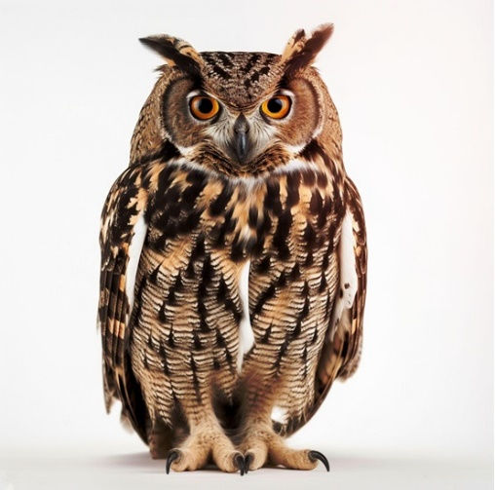
Figure 2. Realistic Owl Portrait on White Background [Stock photo], by R. Javed, 2024, Shutterstock (https://www.shutterstock.com/image-photo/realistic-owl-portrait-on-white-background-2564093319). Copyright 2024 by R. Javed. Used under license.
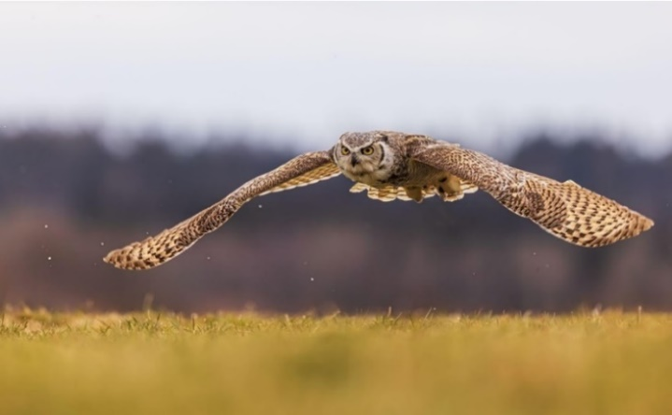
Figure 3. Male great horned owl (Bubo virginianus), also known as the tiger owl has a low overflight [Stock photo], by M. Ninger, 2023, Shutterstock (https://www.shutterstock.com/image-photo/male-great-horned-owl-bubo-virginianus-2287394585). Copyright 2023 by M. Ninger. Used under license.
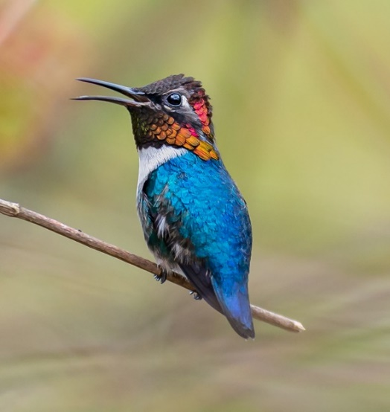
Figure 4. Bee hummingbird (Mellisuga helenae) male perched with green background at Playa Larga Cuba [Stock photo], by P. Poznan, 2022, Shutterstock (https://www.shutterstock.com/image-photo/bee-hummingbird-mellisuga-helenae-male-perched-2143984955). Copyright 2022 by P. Poznan. Used under license.
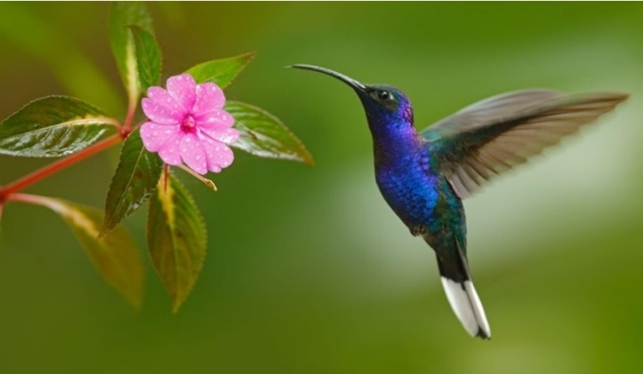
Figure 5. Hummingbird violet sabrewing flying next to flower [Stock photo], by O. Prosicky, 2014, Shutterstock (https://www.shutterstock.com/image-photo/hummingbird-violet-sabrewing-flying-next-beautiful-235104346). Copyright 2014 by O. Prosicky. Used under license.

Day Three

Explore: Create a Flying Machine With a Sketch and an AI Image Generator

Part A
Each student is provided with an 8½x11” sheet of paper and a pencil and asked to sketch an imaginary flying machine inspired by their knowledge of owl and hummingbird flight, or biomimicry. Selected guiding questions for students include:
- What might your imaginary flying machine look like? How will it fly?
- What will your imaginary flying machine be able to do? (How many passengers will it hold? How far will it be able to travel? Where will it be able to go? Will it have special powers?)
- How will you use what you already know about the flight of the owl and the hummingbird to design your flying machine (biomimicry)?

Part B
The teacher conducts a brief review of the flying machine sketches and engages students in a discussion about the design process and how it works. The teacher also asks students if they think an AI image generator might help them design their flying machine? How?
Selected guiding questions for students include:
- Is anyone familiar with AI image generators?
- If yes, how can an image generator help with the designing of our flying machines? What would we prompt it to do?
At this stage, the teacher introduces students to the AI image generator DALL-E as a way for them to learn to use AI as an “assistant” to create a unique flying machine. Since DALL-E is a text-to-image model for generating digital images based on prompts entered by the user, the teacher points out that it is important to make the prompts specific and descriptive. Students can tweak their prompts and re-generate their images, as needed. The teacher then prompts DALL-E to create a flying machine and explains to the students what words to use. The teacher first demonstrates how to enter prompts and then provides a list of prompts students can explore. Some keywords may be flying machine, plane, three-dimensional, art, realistic, shapes, lines, or words taken from the elements of art and the principles of design (Trust, 2011). Teachers should stress that the prompt is a “dialogue” with the AI and that the results may be surprising because the images from AI can be different from our common thoughts or expectations (see Resources for Teachers section).
The teacher now asks questions such as:
- What happens when you use these prompts in DALL-E: flying machine, plane, three-dimensional, art, realistic, shapes, lines?
- Is the image DALL-E created what you expected?
- What is the same as what you imagined? What is different?
After the students experiment for a while, the teacher refocuses their attention on how to enhance their prompts with new explanations and instructions to help students understand how subtle changes in the words they use can greatly affect the DALL-E output.
- What happens when you take a vocabulary word and make it into a verb; for example, thrust to thrusting, lift to lifting, flying, gliding, soaring, cruising, etc.? (Teachers may provide students with a pre-made word list or encourage them to create a list of their own.)
- What are some nouns and adjectives that relate to our topic?
- What happens when you add nouns and adjectives to the prompts (e.g., red lifting flying machine or soaring blue flying machine cruising at a high altitude)? (Teachers may provide students with a pre-made word list or encourage them to create a list of their own either individually or as a group.)
The teacher provides the following prompts and encourages students to use the same prompts several times since DALL-E generates different images even with the same prompts.
- “Create planes inspired by owls” (Figure 6)
- “Create images of planes that mimic flying owls” (Figure 7)
- “Create planes inspired by hummingbirds” (Figure 8)
- “Create images of planes that mimic flying hummingbirds” (Figure 9)
Students have to come up with prompts that will tell DALL-E what to do. To that end, they will need nouns, verbs, and adjectives to express their ideas in a language that the DALL-E can understand. After attempting the above suggestions, students are encouraged to invent their own prompts. Students and teachers might create a word list together (or students can make up their own) suitable for creating interesting flying machines that look like specific birds, or the teacher may provide a few of the introductory prompt words or prompts that can be shared by the entire class as cooperative learning. When coming up with prompts, flexible thinking and thinking outside the box is important.
After viewing the images generated by DALL-E, students can compare them to the sketches they created on Day Two and refine and finalize them.

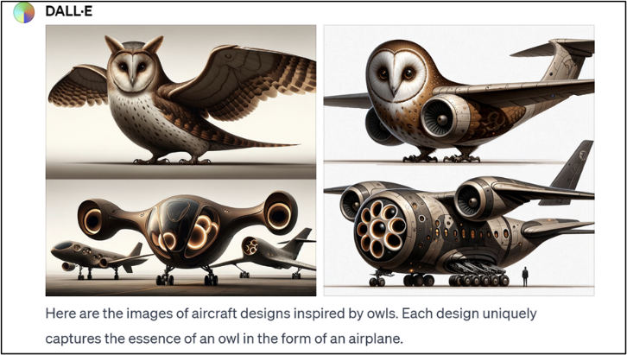
Figure 6. AI generated image from prompt, “Create planes inspired by owls.” Note. Images generated using the prompt "Create planes inspired by owls," by OpenAI, DALL-E, 2024 (https://openai.com/dall-e-2).
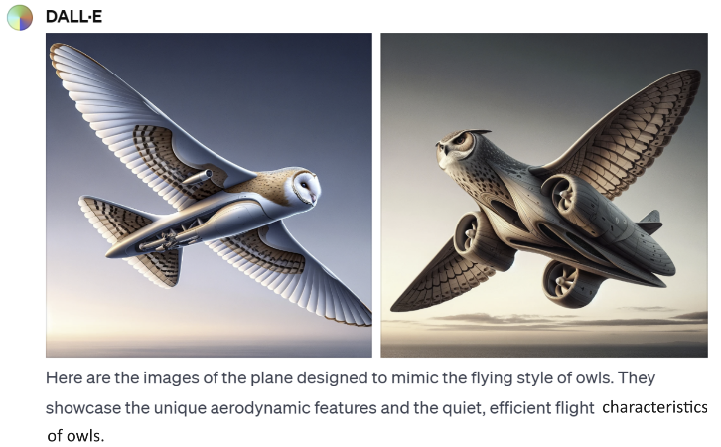
Figure 7. AI generated image from prompt, “Create images of planes that mimic flying owls.” Note. Images generated using the prompt "Create images of planes that mimic flying owls," by OpenAI, DALL-E, 2024 (https://openai.com/dall-e-2).
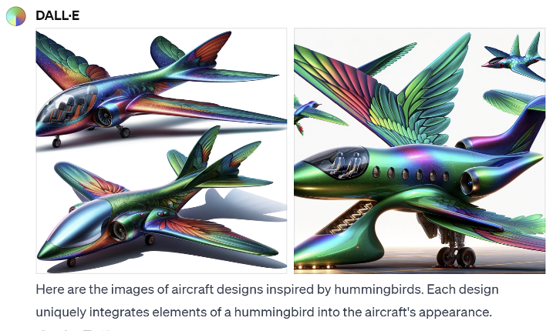
Figure 8. AI generated images from prompt, “Create planes inspired by hummingbirds.” Note. Images generated using the prompt "Create planes inspired by hummingbirds," by OpenAI, DALL-E, 2024 (https://openai.com/dall-e-2).
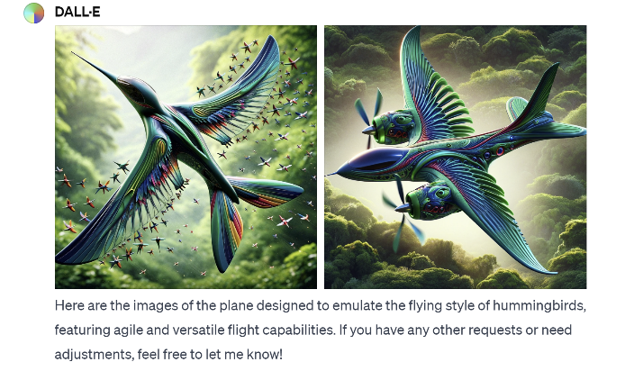
Figure 9. AI generated images from prompt, “Create images of planes that mimic flying Hummingbirds.” Note. Images generated using the prompt "Create images of planes that mimic flying hummingbirds," by OpenAI, DALL-E, 2024 (https://openai.com/dall-e-2).

Day Four

Explain
Students post their 2D sketches and 3D flying machines and their reflections on online sticky notes such as those in Padlet (https://padlet.com/), which provides online boards for posting and presenting any types of work, including texts, links, images, and videos. As such, sites like Padlet can be used to store students’ product development and reflection. In addition, the teacher can post reflection questions using organizing tools (see the example in Figure 10). Prompts that the teachers could ask to elicit reflective thinking include:
- What made you sketch your flying machine the way you did?
- In what ways did observing bird pictures and watching videos of flying birds inspire you to sketch your flying machine?
- In what way did sketching the birds inspire you to create your 3D flying machine with the art materials?
- If any, how did using the AI image generator (DALL-E) help you create an image of your flying machine?
- What do you think works best to create the flying machine?
Based on what students have added to Padlet, the teacher can encourage a class wide discussion by asking students to share the features of birds they observed in photos and videos that influenced the design of their flying machines. The goal of such discussions is to help students recognize that birds can inspire human aircraft design and to introduce students to the concept of biomimicry.
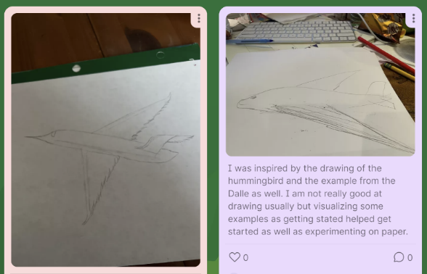
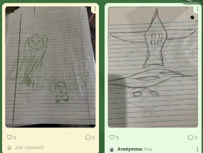
Figure 10. Example of students’ works and their reflections on the Padlet.
In this stage, students can also watch some videos on biomimicry and discuss the themes. For example, in “From Birds to Brothers – The Evolution of Flight,” students can gain a better understanding of how birds fly and how humans obtain a scientific understanding of this phenomenon through keen observations, experiments, and created inventions. Similarly, in “Tunneling with a Mechanical Worm on Steroids,” students learn another example of biomimicry, in which engineers in Mexico City developed a boring machine that follows the same tunneling processes as a worm.
- From Birds to Brothers – The Evolution of Flight (Smithsonian National Air and Space Museum, 2021)
- Tunneling with a Mechanical Worm on Steroids (Science Channel, 2015)

Day Five

Elaborate
In this stage, the teacher encourages students to review the ideas behind their 2D drawings done on Day Two and to imagine a 3D model. The teacher poses some of the following questions:
- Could a hummingbird or an owl inspire the design of an imaginary flying machine?
- Can you imagine making a flying machine out of art materials after seeing these birds?
- Could you make it fly? Why or why not?
- How would you do that?
- Which traits of a hummingbird or an owl might be incorporated into the design of such a contraption?
- Can you think of any real things that fly (airplanes, etc.)?
- What part of the bird do you think was copied? Why?
The teacher points out that Leonardo da Vinci’s flying machines only stayed as ideas in a sketchbook due to the limitations of his time and emphasizes the role of creative brainstorming with art materials as a valid basis for scientific inventions that might come later.
Students use the final version of the sketch they have drawn to create a 3D flying machine. For this activity, teachers can set up centers in the classroom to cultivate collaboration verbally and visually, with peer learning among students (see Figure 11). Students can choose materials that the teacher brings in, including construction paper, markers, scissors, rubber bands, softer types of white paper (e.g., sheets of paper towels), straws, string, hole punchers, glue sticks (or Elmer’s glue), and popsicle sticks.
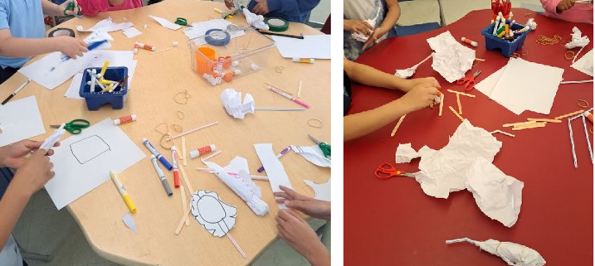
Figure 11. Centers with sample materials.
The teacher inspires students to work with these materials by demonstrating a few uses of the materials joined together. This is an open-ended activity, with students using the materials to try out various things. The teacher provides a brief explanation of the theory of flight, specifically covering the four forces of flight – lift, weight, thrust, and drag – and points out the relationship among them. Furthermore, the teacher elaborates on how humans are not built to fly. More information on this topic may be found at the National Air and Space Museum (n.d.).
Towards the end of this session, the teacher asks several students to show their 3D flying machines and explain the processes used to design them. Students also name their creations (e.g., “Ornithopter). This process is recorded as a formative assessment used at the Evaluate stage to see how students’ thoughts have developed.

Evaluate
In this final stage, students are evaluated on the quality of the flying machine they designed and the explanations they posted on the Padlet during the Explain phase (see Biomimicry Rubric). A rubric for this purpose may consist of the categories “Flying Machine” and “Reflections on the Padlet.” AI-produced images are analyzed by teachers using the rubric “AI-Produced Images,” which analyzes the level of impact AI image generators had on creating and explaining the flying machine.
The categories, performance levels, and descriptions may be adjusted to fit students’ needs and circumstances. For example, the “Flying Machine” category could assess creative ideas and structural details of the flying machine, and the “Reflections on the Padlet” category could assess constructive thoughts on design thinking and the impacts of an AI image generator on design thinking.

Critical Reflection
This lesson sequence has been implemented twice in the same urban school district in New Jersey, where many students have limited English proficiency. It effectively helps students visualize both the flight of owls and hummingbirds and the process of creating a flying machine. The lesson is best suited for students from Grade 4 through middle school, as learners at these levels are able to understand how a two-dimensional sketch can inspire a three-dimensional artwork. Younger students tend to engage more spontaneously with art materials and may struggle with this conceptual leap.
Using sketching to study owls and hummingbirds has proven highly effective, as it allows students to directly engage with the birds’ anatomy and flight patterns, even if they cannot depict them with complete accuracy.
The technology component, utilizing DALL-E, requires careful guidance from the teacher for several reasons. First, generating and refining AI prompts necessitates a level of English proficiency that may be challenging for English language learners. Second, keeping students focused on the flying machine project is essential, as some students—especially those familiar with AI image generators—may be tempted to explore unrelated topics.
In addition, teachers should prepare in advance for the managerial and technical aspect of using DALL-E. Some school networks may block certain websites. Therefore, teachers should check access to OpenAI’s (n.d.) site in advance or seek school or district approval for using generative AI tools and request IT support if needed. Further, using DALL-E involves setup time for opening accounts and helping students as needed. That is, while some students might navigate the tool independently, others may face a learning curve.
For schools in low-resource settings where students don’t have access to internet-connected devices, teachers can demonstrate DALL-E on a large interactive board or projector. Students can suggest prompts, and the teacher can enter them in real time, making it an interactive, whole-class activity. This approach allows all students to engage with DALL-E even if individual devices are not available.
For the hands-on construction of flying machines, teachers may need to assist students with threading and tying materials through holes made with hole punchers. Given the time required for this process, it may be beneficial to extend the project over two class sessions, allowing students to fully engage with both the materials and the construction process.
Students' prior knowledge of some owl and hummingbird flight facts, as well as an introduction to the concept of inventing flying machines, is preferred but not required. While the lesson sequence offers a rich and engaging learning experience, the pacing may be challenging for some students. Adjustments should be made as needed to support diverse learners

Classroom Management Tips
To make sure the activities in this lesson are successful, it is important to build rapport with the students. As many of the activities involve questioning and answering, students should feel comfortable sharing their thoughts, opinions, and reflections. Additionally, the teacher should set clear rules and expectations for the activities that students are asked to do. Minor disturbances should be ignored, as students might get excited and sidetracked by the images that DALL-E might generate. For DALL-E activities, provide clear expectations for the work to be generated. Specific classroom management tips for groupings include teaching students to both talk and listen to each other, as they will have many opportunities to share their thoughts.

Conclusion
The term scaffolding (Bruner, 1983) is generally used to describe an instructional process in which the instructor provides carefully programmed support, reducing the amount of support as the learner gradually progresses through and masters learning. The approach used in the lesson described here goes beyond what can be achieved through lectures alone by showing how AI tools, coupled with teacher guidance, can be used to scaffold students’ design thinking and divergent thinking to generate their own sketches for flying machines. Additionally, by creating their flying machines based on the sketches they draw while observing bird photos, videos, and AI-generated images, students achieve a greater understanding of the concept of biomimicry, which can expand their concrete artmaking experience into more developed and scaffolded products.

References
Arizona State University (ASU) Online. (2022, August 16). What is biomimetic architecture? https://asuonline.asu.edu/newsroom/online-learning-tips/biomimetic-architecture-biomimicry
Brown, T. (2008). Design thinking. Harvard Business Review, 866(6), 84–92.
Bruner, J. (1983). Child’s talk: Learning to use language. W. W. Norton.
Bybee, R. W. (2015). The BSCS 5E instructional model: Creating teachable moments. NSTA Press.
da Vinci, L. (1970). The notebooks of Leonardo da Vinci (J. P. Richter, Trans. & Ed., Vol. 2). Dover Publications. (Original work published 1883)
Eklund, A. R., Aguiar, U. N., & Amacker, A. (2022). Design thinking as sensemaking: Developing a pragmatist theory of practice to (re)introduce sensibility. Journal of Product Innovation Management, 39(1), 24–43. https://doi.org/10.1111/jpim.12604
Feather Light Photography. (2021, Sept. 7). Barn Owl in Flight [Video]. YouTube. https://youtu.be/ ZGUvUsmJpg8?si=NoZFuTr5_moUynlk
Goss, J. (2009). Biomimicry: Looking to nature for design solutions [Unpublished master’s thesis]. Corcoran College of Art + Design. http://www.proquest.com/dissertations-theses/biomimicry-looking-nature-design-solutions/docview/503430610/se-2
Howard, T. (2014). Journey mapping: A brief overview. Communication Design Quarterly Review, 2(3), 10–13. https://doi.org/10.1145/2644448.2644451
International Society for Technology in Education. (2016). ISTE standards for students. ISTE. https://www.iste.org/standards/iste-standards-for-students
Kennedy, E. B. (2017). Biomimicry: Design by analogy to biology. Research-Technology Management, 60(6), 51–56. https://doi.org/10.1080/08956308. 2017.1373052
Micheli, P., Wilner, S. J., Bhatti, S. H., Mura, M., & Beverland, M. B. (2019). Doing design thinking: Conceptual review, synthesis, and research agenda. Journal of Product Innovation Management, 36(2), 124–148. https://doi.org/10.1111/jpim.12466
National Air and Space Museum. (n.d.). We aren’t built to fly. Retrieved September 25, 2025, from https://howthingsfly.si.edu/forces-flight/we-aren%E2%80%99t-built-fly
National Coalition for Core Arts Standards. (2014). National core arts standards: Visual arts. State Education Agency Directors of Arts Education. https://www.nationalartsstandards.org
Nature Notes. (2021, Sept. 13). Only bird that can fly forward, backward, upside-down and hover [Video]. YouTube,. https://youtu.be/ 3oQ6IpHrNfo?si=ndag4BWdq6XLV7B9
New Jersey Student Learning Standards (2020). Computer Science & Design Thinking. https://www.nj.gov/education/standards/compsci/index.shtml
OpenAI. (n.d.). DALL-E (Version 2) [Artificial intelligence system]. https://openai.com/dall-e-2
Science Channel. (2015, August 10). Tunneling with a Mechanical Worm on Steroids [Video]. YouTube. https://youtu.be/7ABa4GHW_ws?si=EvqUw96LR0KMXG3J
Smithsonian National Air and Space Museum. (2021, Dec 10). From Birds to Brothers – The Evolution of Flight [Video]. YouTube. https://youtu.be/ AWUnvYwPODs?si=eQrwtR-y6WAy70S9
Stobierski, T. (2022, January 11). Design thinking skills for business professionals. Business Insights, Harvard Business School Online. https://online.hbs.edu/blog/post/design-thinking-skills
Trust, P. G. (2011). Elements of arts. https://www.getty.edu/education/teachers/building_lessons/elements_art.pdf

Resources for Teachers
- Biomimicry in Action: https://bit.ly/3XShdiL
- How to Write the Most Effective AI Image Prompt for DALL-E: https://bit.ly/3YrDp3m
- OpenAI's DALL·E Platform: Teachers can create an account and start generating images directly through OpenAI's platform:
https://openai.com/dall-e​

About The Authors
Heejung An, EdD, is a professor and chair of the department of Educational Leadership and Professional Studies in the College of Education at William Paterson University of New Jersey. She can be contacted at anh2@wpunj.edu
Triada Samaras, MA, MFA, is an adjunct professor of art and art education at Kean University and William Paterson University of New Jersey. She is also a practicing visual artist and can be contacted at triadasamaras@gmail.com
Woonhee Sung, EdD, is an assistant professor of instructional technology in the School of Education at the University of Texas at Tyler and can be contacted at wsung@uttyler.edu

Sharing & Modification Permissions
Unless otherwise noted, this article and its resources are published under a Creative Commons Attribution-NonCommercial-ShareAlike 4.0 International license:

You can freely share the article and its resources if you indicate the original authors, identify the Creative Commons license, and use them non-commercially.
You may also make and share modifications by:
- Identifying the original authors.
- Using the resources non-commercially.
- Licensing modifications under the CC BY-NC-SA 4.0 license (and including a link to the license).
- Indicating what modifications were made.

