The Plot Thickens:
Literacy Through Computational Thinking
  - Bataul Alkhateeb¹ and Eiman Abushihab²
¹University of Delaware, ²Qatar University

Overview
In this lesson, students analyzed word frequency, character interactions, and recurring themes in Frankenstein to predict how the novel unfolds before reading the next chapter. Students mapped a decision tree for Victor Frankenstein’s choices and predict alternative endings. This lesson utilized Plotting Plots (n.d.-a), created Dr. Tom Liam Lynch as a classroom resource that blends literature with data analysis. This tool leverages computational and quantitative approaches to understanding books by creating visual representations of literary data. The Much Ado About K-12 Computer Science: A Crash Course for ELA and English Teachers YouTube video playlist videos (Plotting Points, n.d.-c) are designed for secondary English Language Arts teachers to strategically map keywords and to support students’ exploration and inferences of what they could mean for the plot of the text.
Topics: Computational Thinking, Mixed Literary Analyses, Multimodal Literacy
Time: 45 minutes

Materials
- Plotting Points (n.d.-b) Plots Page
- Computer device with internet access
- 51 book selections from secondary English Language Arts classrooms
- A Guide to Plotting Plots (Lynch, n.d.-a)
- How to Plot a Plot Tutorial (Lynch, n.d.-b)

Context-at-a-Glance
Setting
9th-12th grade English Language Arts classroom at a private faith-based Islamic high school in the U.S.
Modality
Synchronous in-person learning
Class Structure
This lesson is 45 minutes with desks in groups. Students meet three times a week for class sessions.
Organizational Norms
The school emphasizes unique pedagogies, epistemologies, and ways of knowing, being, and doing, but also follow state standards for teaching English Language Arts.
Learner Characteristics
Students were in 9th-12th grade with knowledge on interpretating texts but were not familiar with the Plotting Plots website or using literary data to make textual inferences. All students identified as Muslim.
Instructor Characteristics
The instructor is a learning scientist and English Language Arts teacher. Instructors may need familiarity with collaborative and multimodal learning and pedagogical knowledge of literary texts. A basic understanding of using data to analyze texts is needed, alongside pre-reading skills.
Development Rationale
The purpose, technology, and computational thinking behind Plotting Plots (n.d.-a) has allowed us to imagine an opportunity where Muslim students can analyze texts that reflect their religious and cultural knowledges in creative texts.
Design Framework
Structured experimentation and unstructured play

Setup
To teach this lesson, teachers and students will need a device with access to the Internet. Teachers may find that a projector or large screen can be helpful to display curriculum materials to the class. First, teachers can create a line graph to model to students. Secondly, students can create their own line graphs based on their selected text, character names, and keywords.
Teachers can select a text, ideally one they are teaching, from the Plotting Points (n.d.-b) Plots Page, a searchable database of every word in a selected book and the number of times it was used. Next, teachers can ask students to identify a character’s name or keywords that may be of importance to the plot of the text based on the front cover, title, or other indicating points. Then, a line graph with the frequence of the name of keyword used in the text should appear.
Teachers can approach this lesson using distant reading, a method of analyzing literature that focuses on patterns and looking at the larger structure and scope of a text, rather than a single word or concept.
Teachers can set up a digital collaborative space, like Google Slides, for students to post line graphs and share with the larger class. They may also arrange the classroom for small and large group work so students can work together to create line graphs.
After students create their line graphs, teachers can project them on the screen so other students can see each other’s line graphs and visualize the selected keywords.
This lesson is adaptable to different classroom setups and can be implemented in an unplugged classroom by manually creating line graphs with paper and pencil, but access to the Plotting Plots website will still be needed for Dr. Lynch’s text mining database for literary analysis.

Standards
This lesson supports the International Society for Technology in Education (2016) student standards:
- 1.4 Innovative Designer, 1.4.a – Design Process: Students know and use a deliberate design process for generating ideas, testing theories, creating innovative artifacts or solving authentic problems.
- 1.5 Computational Thinker, 1.5.a – Problem Definitions: Students formulate problem definitions suited for technology-assisted methods such as data analysis, abstract models and algorithmic thinking in exploring and finding solutions.
- 1.5 Computational Thinker, 1.5.b – Data Sets: Students collect data or identify relevant data sets, use digital tools to analyze them and represent data in various ways to facilitate problem-solving and decision-making.
- 1.5 Computational Thinker, 1.5.d – Algorithmic Thinking: Students understand how automation works and use algorithmic thinking to develop a sequence of steps to create and test automated solutions.
This lesson also supports the Computer Science Teachers Association (2017) standards:
- 3B-DA-05 – Developing and Using Abstractions: Use data analysis tools and techniques to identify patterns in data representing complex systems.
- 3B-DA-06 – Communicating About Computing: Select data collection tools and techniques to generate data sets that support a claim or communicate information.

Context and Setting
This 45-minute lesson is the first of a reading unit on Mary Shelley’s Frankenstein The lesson focuses on students’ pre-reading skills to engage in mixed literary analysis. Learning includes combining multiple methods to understand the text, including data-driven inferences and interpretations of patterns and how they impact understanding the plot.
Students create their own line graphs before reading Frankenstein and think computationally about this literary work, how numerical data affects their interpretation of the text, and share their interpretations. Their graphical data engages in mixed literary analysis by analyzing word frequencies (quantitative) on the line graph and citing textual evidence (qualitative).

Plotting Points
Plotting Plots (n.d.a) is an opportunity for students to engage in question-asking about a text, where they can see and identify patterns in a text by looking holistically at its words. The tool’s creator explains this as the process of “zooming out” of a close reading and considering characterization, structure, genre, writing style, symbolism, and evidence-based interpretations of a text’s plot (Lynch, 2019).
This lesson was taught at a faith-based Islamic school in Northern Virginia. While the school has its unique pedagogies, epistemologies, and ways of knowing, being, and doing, they also follow state standards for teaching English Language Arts. The standards identify literacy goals and instructional and formative and summative assessment expectations, which are similar and different by grade level.
For example, the Virginia Department of Education (2024) highlights that 11th grade students are expected to create and deliver multimodal presentations and expressions while considering how digital literacy is positioned for specific audiences.

Muslim Students’ Funds of Knowledge
At this school, students bring with them their lived experiences and positionalities as Muslims to their reading experience and interpretation of characters and texts. While this did not directly inform how they plotted line graphs for our in-class reading of Frankenstein, it may have impacted their qualitative analysis and how they chose to engage in meaning-making about the text.
As we consider the location of a faith-based school, students’ cultural literacies, and religious funds of knowledge, we reimagined Plotting Plots through culturally responsive practices like pedagogies of witnessing (Baxley & Sealey-Ruiz, 2009; Ladson-Billings, 2009). In Islam, we believe God is a Witness of the self (Quran 41:53).
In critical English studies, witnessing is a process of self-restoration, where literature is a place for “worthy and responsive witnessing” and a location for healing (Baxley & Sealey-Ruiz, 2021; hooks, 1994). Reading, discussing, and engaging with texts that bear witness to students’ personal and poetic selves fosters community, wellness, and a radical love for oneself and its knowledges (Silvas, 2020).
As Bishop (1990) writes, books and discussions about books should be “mirrors, windows, and sliding glass doors,” or current representations of students’ cultural repertoires and the possibilities for cultural representations that are becoming. Plotting Plots includes examples of mainstream literature taught in secondary schooling, and while we teach those books in our faith-based school, we also teach other texts situated within our socialized schooling environment.
For example, we taught Adania Shilbi’s Minor Detail, which uncovers themes of colonialism, violence, memory, and identity. Students engaged in close reading, by analyzing specific passages from the first and second parts of the split novel to witness narrative voice and the mirroring of a felt dehumanization.
Unlike the characters in the book, the students at this faith-based school have not experienced the very specific and nuanced military occupation that the character in this text has. However, like the character, Muslim students often feel in-betweenness as a liminal and hybrid space of existence, belonging, and negotiation of self as they navigate between two or more cultural, linguistic, and/or social contexts (Sarroub, 2002; Turner, 2021).
Muslim students may not have the space in school to become their whole self as the negotiate who they are, even in a faith-based school that reflects their religious and cultural repertoires. However, in-betweenness also affords students the creativity and agency to uncover a new sense of self that is authentic to who they are.

Computational thinking
The purpose, technology, and computational thinking behind Plotting Plots has allowed us to imagine an opportunity where Muslim students can analyze texts that reflect their religious and cultural knowledges in creative texts, like Shibli and Jaquette (2020), but also in religious texts, like the Quran. For example, the Arabic word for Knowledge or عِلْمَ (in its many forms as a verb and noun) is mentioned 854 times in the Quran, emphasizing to learners that knowledge, in its many forms, is a responsibility.
By quantifying the importance and understanding the intentional choice and added context of where a word appears, the learner develops critical consciousness about their role in spreading knowledge.
This is also true for other faiths and religious texts, like the Holy Bible. While some students may struggle to relate to prophetic knowledge, trials, tests, and tribulations, they may be able to empathize and connect to characters in multicultural literature and their experiences turning to faith as a spiritual support (Rackley, 2024).

Learning Representation
This lesson is for an introductory lesson on textual analysis in the secondary English classroom. Dr. Lynch positions this lesson over a 15-day unit to be taught as a larger lesson (see Lynch, 2017), but this lesson may be considered an adaptable single class snapshot to engage student interest and set a foundational understanding of the tool and its function. This lesson can be a standalone activity or a component of a broader sequence depending on instructional time and instructor purpose.
This lesson blends students’ need for structured experimentation and unstructured play. For the former, students are given specific textual elements to engage with and receive modeled guided analysis techniques. For the latter, students experience space for experimentation, interpretation, and question-asking through creative re-interpretation of the text and its keywords and interpretive flexibility through open-ended possibilities of what a graph may look like in this activity.
Students’ prior knowledge about textual analysis and their selected text may vary. They do not necessarily need to know how to use the website prior to this lesson and one instrumental component of the lesson is navigating different tools prior to selecting a book and its keywords. Students should have some familiarity with making textual inferences about a book, including major themes, characters, and stylistic elements, which will become essential data points in the plot.

Do It For the Plot (45 minutes)
During this lesson, italic text identifies questions or prompts for the learners.

Warm-Up (10 minutes)
To start this lesson, the instructor engaged students in a discussion about their knowledge of qualitative and quantitative data and how they may define the two methods.
Students were asked to share examples of each method and explain that quantitative focuses on quantity (things that can be counted) and qualitative considers quality (stories or feelings behind the data). Then, the instructor shared an example plot (see Figure 1) by providing enough context so the students could make an inference. At this point, the title of the text, Romeo and Juliet, had not yet been provided to the students.
This is an example of a play by William Shakespeare. If we look at the x axis (act/scene), the y axis (frequency of words), and the graph, what might we learn?
The teacher asked guiding quantitative and qualitative questions to the students:
- What does it mean for the plot if we see the word, ‘love’ being used 25 times in scene 2.2?
- What does it mean that the word ‘death’ was used 18 times in scene 5.2?
From just those two words, students made the inference that this is Romeo and Juliet and they made the inference that scene 2.2 is the ball where the couple meets and scene 5.2 is a tragedy (no spoilers!).
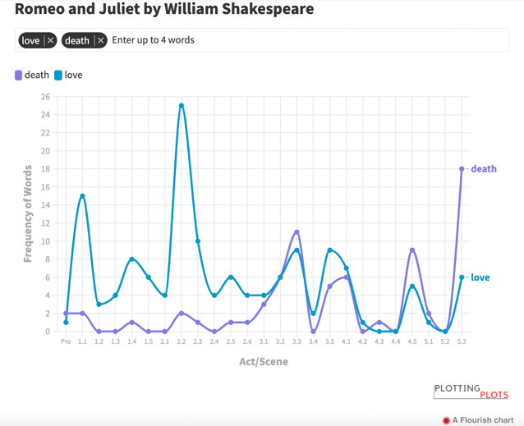
Figure 1. Plot of Romeo and Juliet.

Lesson & Demonstration (8 minutes)
After the opening discussion, the instructor facilitated discussions about students’ pre-reading and prior knowledge. Students were asked to consider what they know about the text:
- What do you already know about the text?
- What do you know about the author?
- How might this text connect to what we have read before in this class?
Students were asked to select Frankenstein from the Plotting Plots website. Scaffolding questions about the text and the database were provided:
- Are there any specific terms of ideas you’re familiar with?
- How about similar topics or themes?
Then, students were asked to identify three keywords or character names from the text (see Figure 2). If they were unsure of which words to select, based on the title, book cover, or other contextual clues, they were encouraged to play around with the database and see what words were available to them.
Plotting Plots allows for an exploratory process of learning by providing all the possible words (in alphabetical order) that were written in the book, including articles. Students can choose from an array of words, even if they are unsure about what they mean in the context of the text just yet.
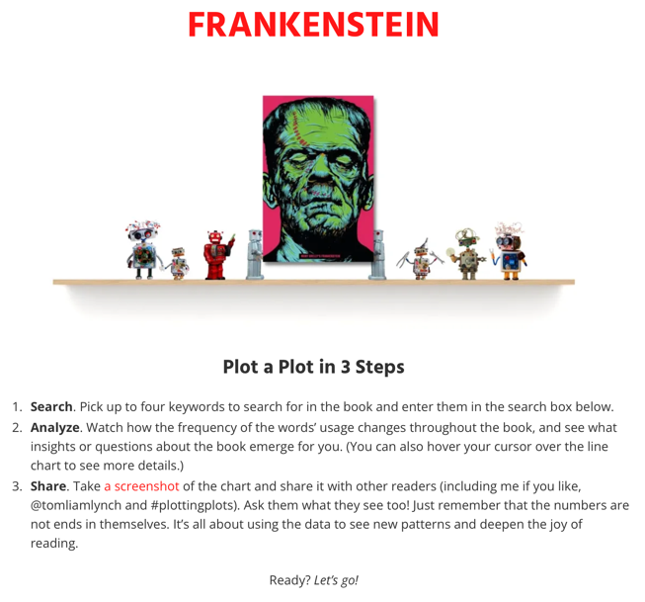
Figure 2. Steps to creating a plot.

Guided practice (15 minutes)
The instructor modeled to students how to use Plotting Plots. The instructor selected four keywords and explained to students how and why, based on their pre-reading and prior knowledge skills, the word “blessed” appears twice in chapter 8 (see Figure 3).
Throughout the text, Frankenstein mentions how knowledge (a theme) has blessed him, but it ultimately results in his downfall, which is why we see it again in the last chapter. Again, no spoilers!
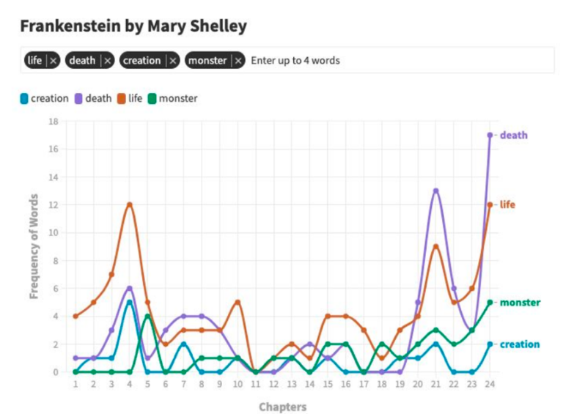
Figure 3. Teacher example of a plot.

Share-out (6 minutes)
Students explored different possibilities and were encouraged to connect their inferences back to the text (see student artifacts in Figures 4 and 5).
Students were asked to explain why they chose the keywords they chose and what they think this reflects about the narrative, the tone of the piece, and the author’s intent:
What does the word ‘betrayal’ suggest about the relationships between characters?
After students shared their keywords, they were asked to compare with their peers. This sharing activity opened a dialogue about different interpretations and allowed them to see how others viewed the same text through a different lens. This analysis can be a discussion tool to identify patterns or surprising outliers that might spark further analysis.
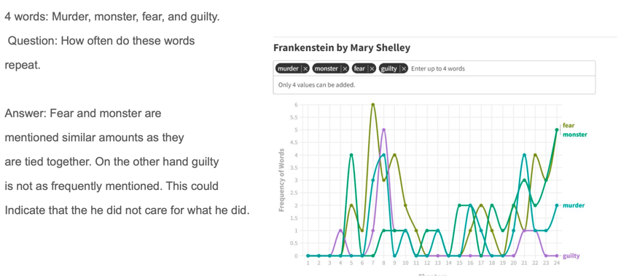
Figure 4. Example of student artifact with the keywords, “murder,” “monster,” “fear,” and “guilty.” Based on the data, the student drew an inference regarding Frankenstein’s emotional state.
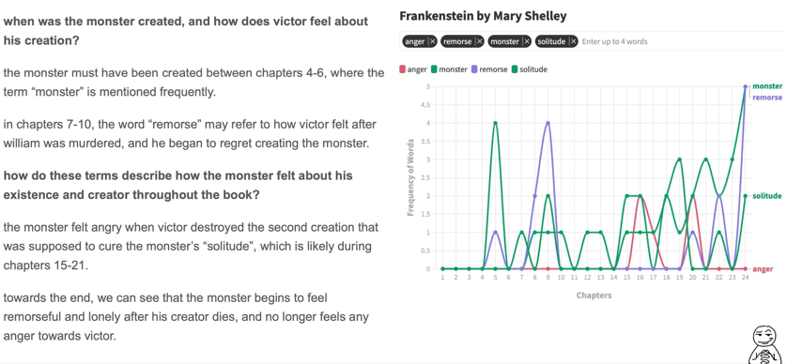
Figure 5. Example of student artifact with the keywords, “anger,” “solitude,” “remorse,” and “monster.” Based on the data and textual evidence, this student hypothesized a different interpretation to Frankenstein’s emotional state.

After selecting their keywords, students were asked to find specific quotes or scenes that align with each word. This part of the activity reinforced the connection between their inferences and the actual text.

Reflections & Exit Ticket (6 minutes)
At the end of the lesson, the instructor encouraged guided reflection by asking students to select one of two prompts designed to check for understanding:
- How did your keyword choice help you better understand the narrative? Did hearing others’ keywords change or deepen your perspective?
- If you had to convince someone else that your keyword is central to the text, what argument and evidence would you use?

Critical Reflection
The purpose of this tool is to demonstrate how computational methods can expand meaning and deepen the humanistic work of reading literature (Lynch, 2019). With line graphs, teachers can engage students in discussions about how and why certain characters interrelate and when to use quantitative data to identify patterns and then turn to the text to understand its qualitative meanings.
This lesson offers the opportunity to blend structured literary analysis with open-ended exploration and caught the interest of students intending to major in STEM disciplines. During our reading of Frankenstein, students began to generate their own questions about the text based on the data visualization and relied little on my guiding questions. While the website does not offer every book listed that a secondary English teacher may teach during an academic year, one can still leverage the tool’s resources for teaching data analysis, making meaningful connections between the text and data for interpretation between form and theme, while also modeling and scaffolding pre-reading skills.
This lesson is situated as an introduction to the teaching of Frankenstein, but in future iterations, I would like to include more opportunities for students to consider genre and how structure impacts the way a narrative is told, which then impacts the distribution of keywords and overall plot. There is no right answer in this lesson, allowing students to engage in an authentic inquiry process that emphasizes interpretation, discovery, and critical thinking, all of which can be supported with textual evidence and thematic investigations.

Thinking Ahead
Digital tools help us to ask new questions about a text and to engage deeply with its words and where they may be distributed within a text. This can provide students with the opportunity to be deeply interpretive as a pattern of meaning, not just a technical feature within a larger digital tool. It is important, then, to model to students how to pair a data point with close-reading and making “if-then” statements about potential plot points in a text.
By focusing on one book in a lesson, like we did, we can encourage students to identify multiple interpretations from the same data, where different students may draw different conclusions from the same visualization with text-based evidence. This allows for negotiated meaning with data and students can share competing analyses of the same graph and wonder how each got to different points while given the same prompt.
Also, if focusing on one book, students can experience forward-thinking and comparative analysis by comparing different word frequencies and patterns by looking across different works by the same author. This encourages them to evaluate authorial choices. For example, after reading Frankenstein, students might apply similar analytical approaches to Mary Shelley’s The Last Man!
With any tool like Plotting Plots, the aim is to empower students to see that data can support interpretation, not replace it. The numbers prompt richer qualitative questions and the interpretations give the numbers meaning. This approach not only demystifies data but also deepens students’ analytical thinking and meaning-making.
For Muslim students at this faith-based school, there are opportunities to analyze texts that are religiously situated and may inform students’ understanding of religious concepts. Like creative texts, there is significance in word recognition as it relates to religious concepts and texts.

References
Baxley, G. & Sealey-Ruiz, Y. (2021). In the Black radical tradition: Poetry as a praxis for healing and resistance in education. Research in the Teaching of English, 55(3), 311-321.
Bishop, R. S. (1990). Mirrors, windows, and sliding glass doors. Perspectives, 6 (3), ix-x.
Computer Science Teachers Association (2017). CSTA K-12 computer science standards, revised 2017. https://csteachers.org/k12standards/
Hooks, B. (1994). Teaching to transgress: Education as the practice of freedom. Routledge.
International Society for Technology in Education (2016). ISTE standards: Students. https://iste.org/standards/students
Ladson-Billings, G. (2009). The dreamkeepers: Successful teachers of African American children (2nd ed.). Jossey-Bass.
Lynch, T. L. (n.d.-a). A reader’s guide for book lovers who like data. Plotting Points. https:// plottingplots.com/wp-content/uploads/2021/ 09/plotting-plots-classroom-DRAFT-2.pdf
Lynch, T. L. (n.d.-b). How to plot a plot tutorial. Plotting Points. https://plottingplots.com/how-to-plot-a-plot/
Lynch, T. L. (2017, May 21). ELA (6-8). Plotting plots [Google doc]. https://docs.google.com/ document/d/1zbYvpdW8R_dssw5hOZe0RwBxG2I6zhzsvbpIx4WW6Sc/edit?tab=t.0
Lynch, T.L. (2019). Electrical evocations: Computer science, the teaching of literature, and the future of English education, English Education, 52(1), 15-37. https://www.jstor.org/stable/26826196
Plotting Plots. (n.d.) Frankenstein. Retrieved May 31, 2025 from https://plottingplots.com/ frankenstein/
Plotting Points. (n.d.-a). Home. Retrieved May 31, 2025 from https://plottingplots.com/
Plotting Points. (n.d.-b). Plots. Retrieved May 31, 2025 from https://plottingplots.com/plots/
Plotting Points. (n.d.-c) Much ado about K-12 Computer Science: A crash course for ELA and English teachers [Video playlist]. YouTube. https://www.youtube.com/playlist?list=PL_YqVfTEvsGJ8j-5pJiKVPN7bGjMfDvnL
Rackley, E. (2024). ‘Not reading just seems crazy to me’: Religious youths’ textual ideologies of sacred texts, Language and Literacy, 26(1), 104-122. https://doi.org/10.20360/langandlit29676
Sarroub, L.K. (2002). In-betweenness: Religion and conflicting visions of literacy. Reading Research Quarterly, 37(2), 130-148. https://www.jstor.org/ stable/748154
Shibli, A., & Jaquette, E. (2020). Minor detail. New Directions.
Silvas, T. (2020). Writing for liberation. Language Arts, 98(2), 80-82. https://www.jstor.org/stable/27140994
Turner, J. D. (2021). Mapping the intersections of religion, literacy, and public schooling for displaced, immigrant, and refugee children: A conversation with Loukia K. Sarroub. Language Arts, 98(3), 149-155. https://www.jstor.org/stable/27058935
Virginia Department of Education. (2024, March 28). 2024 standards of learning for English. https://www.doe.virginia.gov/teaching-learning-assessment/k-12-standards-instruction/english-reading-literacy/standards-of-learning

About the Authors
Bataul Alkhateeb is a Ph.D. in Education student specializing in Learning Sciences in the School of Education at the University of Delaware.
Eiman Abushihab is a Lecturer in Arabic for non-native speakers at Qatar University.

Sharing & Modification Permissions
Unless otherwise noted, this article and its resources are published under a Creative Commons Attribution-NonCommercial-ShareAlike 4.0 International license:

You can freely share the article and its resources if you indicate the original authors, identify the Creative Commons license, and use them non-commercially.
You may also make and share modifications by:
- Identifying the original authors.
- Using the resources non-commercially.
- Licensing modifications under the CC BY-NC-SA 4.0 license (and including a link to it).
- Indicating what modifications were made.

