Integrating CT/CS into a Teacher
Education Program: A Year-Long PD
  - Irene A. Bal, Karen Terrell, Hoang Bui, and Stacy Williams, Loyola University Maryland

Overview
This grant-funded, year-long professional development (PD) for higher education faculty focused on integrating computational thinking (CT) and computer science (CS) in preservice teacher education courses. A full-day PD was followed-up by four 15-minute PD sessions held during the Teacher Education Department (TED) meetings, supporting all TED faculty. A PD spinoff initiative, “Focused Faculty,” supported five TED faculty in planning and implementing a CT/CS lesson in one of their courses in Spring 2024. Multiple materials and activities were utilized in this PD including Scratch Jr., Scratch, Code.org, micro:bits, unplugged activities, machine learning, makerspaces, and literacy integration.
Topics: Computational Thinking, Computer Science, Faculty, Preservice Teachers, Professional Development
Time: Faculty PD: Five sessions totaling 7 hours over the year (one six-hour session and four 15-minute follow-up sessions). Focused Faculty: Approximately 13 hours over a semester

Setup
The PD sessions were a mix of face-to-face and online which facilitated different learning environments and materials. For the face-to-face sessions, ensure there is a room large enough for all faculty/attendees. Most of the rooms utilized in this PD included shared tables that were either circle or rectangle to allow faculty communication and collaboration. A specific setup is provided for each PD session. Although specific tools/materials are showcased, this PD can be facilitated with any CT/CS tools and activities available.

Context-at-a-Glance
Setting
Professional development (PD) for a teacher education department in an urban, private institute of higher education in Maryland, U.S.
Modality
Face-to-face with two online sessions
PD Structure
This was a grant-funded, year-long PD focused on computational thinking (CT) and computer science (CS) integration into preservice education courses. A total of five sessions occurred with one full-day session followed by four, 15-minute sessions.
Organizational Norms
Faculty were paid a stipend for the full-day session. The follow-up PDs occurred during the Teacher Education Department (TED) meetings which faculty were expected to attend.
Learner Characteristics
This PD supported TED faculty with a range of prior CT/CS experiences and knowledge.
Instructor Characteristics
Three education faculty and one CS faculty with various prior CT/CS experience and knowledge.
Development Rationale
This PD was developed to support faculty in integrating CT/CS in their courses, supporting future PK-12 teachers in the integration of CT/CS. This work supports the Maryland General Assembly (2020) bill Securing the Future: Computer Science Education for All.
Design Framework
Social Constructivist Design Theory; Adult Learning Theory

Materials
- Session 1:
  - Session 1 PD slides
  - iPads/personal mobile devices
  - Computers
  - Scratch Jr.
  - Unplugged activities
  - Scratch accounts for participants
  - Code.org accounts for participants
  - micro:bits
  - Read aloud book (e.g., Brown Bear)
  - Exit Ticket
- Session 2:
  - Session 2 PD slides
  - Cats, Dogs & Machine Learning Lesson (MIT Media Lab, n.d.)
- Session 3:
  - Physical makerspace materials (e.g., Legos, popsicle sticks, cups/containers, straws, string, tape, playdoh)
- Session 4:
  - Poem Art lesson by CODE (n.d.-d)

Standards
The Computer Science Teachers Association ([CSTA], 2020) standards for computer science teachers and the International Society for Technology in Education ([ISTE], 2019) computational thinking competences were utilized in the design and implementation of this PD.

CSTA Standards for Computer Science Teachers
- Standard 1: CS Knowledge and Skills
- Standard 2: Equity and Inclusion
- Standard 3: Professional Growth and Identity
- Standard 4: Instructional Design
- Standard 5: Classroom Practice

ISTE Computational Thinking Competencies
- Standard 1: Computational Thinking (Learner)
- Standard 2: Equity Leader (Leader)
- Standard 3: Collaborating Around Computing (Collaborator)
- Standard 4: Creativity & Design (Designer)
- Standard 5: Integrating Computational Thinking (Facilitator)

Context and Setting
In 2018, the Maryland General Assembly (2020) passed a bill entitled, Securing the Future: Computer Science Education for All. This legislation established the Maryland Center for Computing Education (MCCE), with the mission “to identify ways to expand access to high-quality computer science education, strengthen the skills of educators, and increase the number of computer science teachers” (para. 5). Concurrently, the Maryland State Department of Education (2018) approved new computer science standards for grades K-12, requiring the creation of more opportunities for students to acquire CS-related skills in all grades.
MCCE holds professional development throughout the year for both PK-12 local school systems (LSS) and institutes of higher education (IHE) including workshops, courses, micro-credentials, the Maryland Computing Education Summit, and an annual Preservice CS Education Intensive Workshop. These professional learning sessions are a mix of online (i.e., Zoom) and face-to-face and include state-wide representatives from PK-12 LSS and IHEs. The Maryland Higher Education Summer CS Intensive Workshop is a three-day annual event with various state IHEs designed to equip attendees with CT/CS concepts and skills to implement in their teacher-preparation courses and programs. In Summer 2023, the authors, representing three departments from one IHE (Teacher Education, Education Specialties, and Computer Science), attended the workshop with the support of a small grant. During the conference, the group decided to move beyond individual course integration and, instead, created a plan, which included writing a second grant, to support TED faculty in the learning and planning of CT/CS and its full integration throughout the Teacher Education Program.
The Teacher Education Program is situated in a School of Education in the Teacher Education Department (TED) which encompasses programs for PK-12 teacher licensure at the undergraduate and graduate levels. In 2023-2024, the TED department included 12 faculty who had a range of prior CT and CS knowledge. Most faculty were new to CT/CS and thought CT/CS primarily aligned with math concepts.
In the 2023-2024 academic year, it was the authors’ goal to engage the TED faculty in approximately 8 hours of CT/CS PD and integrate CT/CS in some of the Teacher Education Program courses for a 2024-2025 implementation.

Instructor Backgrounds
Four faculty collaborated on this year-long PD representing three different departments in the same IHE: (a) the Teacher Education Department, (b) the Education Specialties Department, and (c) the Computer Science Department. Each of their CT/CS background knowledge and learning during the 2023 Maryland Higher Education Summer CS Intensive Conference are presented to demonstrate their diverse knowledge, skills, and perspectives when designing and implementing this PD.
Teacher Education Department: I am currently the Teacher Education Department Chair and have been a full-time clinical faculty member in an educator preparation program for over 16 years. I hold a teaching license in biology, grades 7 - 12. I taught general methods, elementary and secondary science methods, and supervised teacher candidates in all subjects and all levels. I also serve as the coordinator of partnerships and clinical experiences, so I work closely with local schools/school systems to ensure our programs are aligned to state and local initiatives.
The 2023 Maryland Higher Education Summer CS Intensive Conference provided excellent information related to state initiatives and gave me practical ideas to prepare preservice teachers with the CT/CS skills they will need. I took away conceptual ideas for our overall curriculum and practical activities to implement into coursework. The variety of plugged and unplugged strategies that were modeled allowed me to see the ways CT/CS can be integrated at all grade levels, all ability levels, and in all school settings. I was able to relate CT concepts to concepts we are already teaching throughout our programs, and the conference sessions helped me to consider ways faculty can make explicit connections among different content areas and CT concepts. Finally, the conference provided time for our team to work together to develop a plan of action for our programs, including developing a full-day workshop with key follow-up points over the year.
Teacher Education Department: I am in my second year in the School of Education as an Assistant Professor of Mathematics Education. I have been in education for twenty-five years, beginning as a high school teacher and moving into middle school, later coaching and consulting. I attended the 2023 Maryland Higher Education Summer CS Intensive Conference as I was starting my tenure, and I was pleasantly surprised that CT/CS initiatives were so prevalent. I was already intending to incorporate technology such as the Desmos’ Activity Builder portal in my courses; however, the MCCE workshop provided a theoretical foundation for integration, as well as additional technologies to consider. Through the workshop I encountered micro:bits and block coding – technology that I had previously heard about but had never experienced. I have added both to my courses through activities such as coding the micro:bits as environmental sensors and as dice via Microsoft MakeCode. I have also been able to incorporate various activities wherein I have students create operations games through Code.org’s game lab.
Another technology that I have been able to incorporate in my courses has been Texas Instruments’ NSpire. I was familiar with their 83s and 84s from my days as a K-12 teacher, but the workshop introduced me to the expanded capabilities of the NSpire which includes Python coding. This exposure had long-term effects, establishing an ongoing partnership between my department and Texas Instruments (TI) that has expanded into our school serving as a pilot site for the company’s Rising Teachers induction-years mentoring program for our graduating seniors, as well as multiple grant collaborations. Because of the MCCE workshop, students are gaining exposure to technology that goes far beyond computations on calculators and offers authentic uses that enhance pupil engagement in mathematics and other content areas.
Education Specialties Department: I am a certified PK-12 music teacher who currently teaches learning design, educational technology, research, and music at an IHE. Since 2018, I participated in MCCE’s regular state-wide meetings for higher education and PK-12 institutions, attended their annual Preservice CS Education Intensive Workshop from 2022-2024, and was the principal investigator on four grants from MCCE.
In the 2023 Preservice CS Education Intensive Workshop, I was excited to have a team from my institution attend as I had been the only person from my institution engaged in MCCE for many years. During this workshop, I led the team on integrating CT/CS in their courses and the Teacher Education Program. After the workshop, I continued leading the team through the second grant and leading the plan to integrate CS into the Teacher Education Program at our institution.
Computer Science Department: Before attending the 2023 Preservice CS Education Intensive Workshop, I taught computer science for nearly nine years but could hardly recall encountering the concept of computational thinking. During the conference, I was introduced to CT and realized that I had been practicing it not only in my teaching but also outside the classroom. I came to understand that CT is not merely about using computers to solve problems; it represents a broader problem-solving approach rooted in computer science concepts such as divide and conquer, pattern recognition, abstraction, and algorithms. Additionally, I learned about the benefits of exposing young children to CT through unplugged activities, which can enhance critical thinking and analytical skills. This early exposure can also help children apply CT to solve everyday problems systematically and creatively. Since this workshop, I am continuing to collaborate with these authors in multiple grants, CT course design, and PD sessions.

CT/CS Four-Year Plan
During the summer of 2023, the faculty who attended the 2023 Maryland Higher Education Summer CS Intensive Conference developed a four-year plan to incorporate CT/CS as a permanent aspect in the Teacher Education Program. Figure 1 outlines the gradual rollout of this plan, beginning with department-level PD and small-scale course pilots, building into whole-scale CT/CS incorporation across the program, and formal assessment of preservice teachers’ CT/CS planning and instruction.
To aid with CT/CS instruction, TED used grant funding from MCCE to purchase a class set (N = 20) of micro:bits (n.d.-c), as well as a Cubetto (PRIMO, n.d.), six Code & Go Mice (Learning Resources, n.d.), and some unplugged resources (e.g., Legos). The department invested in a set (N = 10) of TI Nspire calculators (Texas Instruments, n.d.). The activities that were developed and implemented are described further in the Learning Representation section.
As the team developed this multi-year outline, their planning and thinking were guided by constructivist and democratic lenses of instruction. In describing his views about democratic education, Dewey (1930) describes the lack of variety and choice in educative experiences as a kind of slavery, wherein “men are engaged in activity, which is socially serviceable, but whose service they do not understand and have no personal interest in” (p.98). As such, the authors were adamant in the implementation design that if faculty were going to be asked to engage in CT/CS instruction in their courses, not only should they be exposed to a variety of CT/CS exercises, but they should also be given choice as to when the pilot of these activities should occur in their classes, and which task(s) to incorporate. Further, Piaget’s (1952) notion of learning (i.e., constructivism) dictated the fundamental interconnectedness of the mental life (i.e., assimilation) with the experiential (i.e., accommodation), “experience, accordingly, is not reception but progressive action and construction…” (p.365) and that “presupposes an organizing or structuring activity” (p.369). As such, the team was intentional in its selection of tasks to present to the faculty – ones that built upon each professor’s content knowledge and used CT/CS activities to expand their conceptions and instruction of various topics.

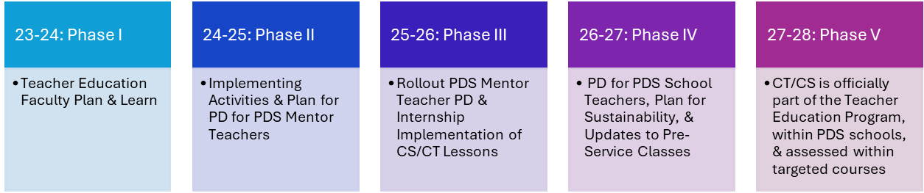
Figure 1. Original TED CT/CS training plan from 2023.
This article details the 2023-2024 Phase 1 plan to support TED faculty in the Learning Representation (Phase 1) section. The plan supported TED faculty in the learning, planning, and implementation of CT/CS lessons in their preservice courses. This was completed through a full-day PD, four 15-minute follow-up PDs, and a spinoff initiative called “Focused Faculty” where five faculty were paid to plan and implement CT/CS lessons in a Spring 2024 course.

Learning Representation (Phase 1)
The year-long plan to support TED faculty in the planning and learning of CT/CS began with a full-day PD session for all TED faculty. During this full-day PD session, faculty identified if they were interested and able to integrate CT/CS in one of their courses with planning and a pilot/attempt at activities in Spring 2024. This was a pilot with the goal of faculty trying things out to see what worked with a full implementation occurring in the 2024-2025 academic year. Five faculty signed up to integrate CT/CS in their courses and were called “Focused Faculty.”
After the full-day PD, faculty learning continued throughout the year by presenting different CT/CS integration ideas and activities in the 2023-2024 monthly TED meetings. Three activities and discussions were implemented in department meetings. The showcase of the five Focused Faculty lesson(s), reflections, and purchased materials were presented in the last department meeting of the year (see Focused Faculty section; Table 1).
During this lesson, italic text identifies questions or prompts for the learners.

TED Faculty PD

Session 1: 11/3/23 Full-Day PD
The first PD session was for all TED faculty in a one-day, six-hour session. Within the session, nine faculty members were introduced to digital and unplugged CT/CS activities, CT/CS standards for K-12 teachers and students, and given time to collaboratively brainstorm how CT/CS can be integrated into classes (Figure 2; Slide 2 in Session 1 PPT). Time provided for each activity is included; these can be adjusted based on prior knowledge, skills, and availability.
Table 1
Department Meeting Dates and Activities
TED Meeting Date | Format | CT/CS Integration Follow-Up Topic/Activity
Session 1: November 3, 2023  (6 hours) | Face-to-Face | An overview of CT/CS with unplugged and digital hands-on activities and discussions on integrating ideas in classes.
Session 2: November 17, 2023 (15 minutes) | Face-to-Face | Follow-up from the 11/3/23 full-day PD including Unplugged Machine Learning Activity, MD CS K-12 Student Standards, Discussion on how CT/CS currently fits in the School of Education & Teacher Education Vision statements.
Session 3: January 25, 2024  (15 minutes) | Face-to-Face | Integration of computational thinking to support the Whole-Part-Whole Instructional Framework
Session 4: February 22, 2024  (15 minutes) | Online | Integration of CT/CS to support social-emotional learning.
Session 5: April 26, 2024  (1 hour) | Online | Showcase of what the “Focused Faculty” completed for the year.
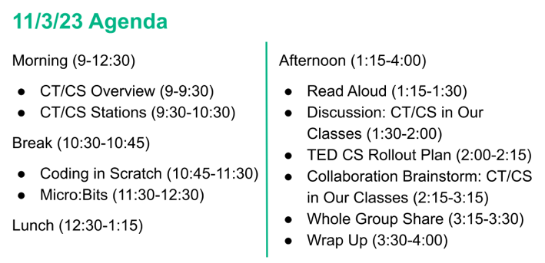
Figure 2. Agenda of full day PD for TED faculty.

Set-Up and Materials
This full-day session introduced faculty to multiple types of digital and unplugged coding and CT/CS activities. This session was facilitated in a large room with rectangle tables that sat four to six people. For the morning CT/CS stations, a second room was secured for the unplugged activities. This room was checked out for three hours to ensure the authors could set up and break down the unplugged activities. Lunch was provided to faculty (department funded) which was held in the main PD room. The authors hung posters in the main PD room before the session started showcasing the CT core practices, the Standards for CS teachers, and other printables provided by the CSTA.
The materials needed for this PD included:
- Session 1 PD Slides (PPT)
- iPads/Personal Mobile Devices
- Computers
- Scratch Jr.
- Unplugged Activities
- Scratch accounts for participants
- Code.org accounts for participants
- micro:bits
- Read aloud book (e.g., Brown Bear)
- Exit Ticket (DOC)
The iPads/Personal Mobile Devices were used for the Scratch Jr. activity, which is app based. The computers were used for the Scratch, Code.org, and micro:bit activities. The unplugged activities included (a) a maze that was laid out on the floor, (b) the Game with No Rules, a Code.org activity, and a (c) Pixels & Instagram activity. These unplugged activities are further described below.
The read aloud book for this PD was Brown Bear, Brown Bear (Martin, 1967). Any book that has repetition and similar phrases can be used for this activity. A read aloud was selected to model how CT/CS connects to literacy as there are multiple literacy faculty in the department.

Professional Development
CT/CS Overview (30 minutes): The full-day session began with an overview of CT/CS which started with a 30-minute explanation of Computing Education, encompassing Computational Thinking and Computer Science, the differences between CT and CS, and definitions (Digital Promise, n.d.; K–12 Computer Science Framework, 2016; Wing, 2006; Slides 3-5 in Session 1 PD PPT). The CT core practices from the K–12 Computer Science Framework (2016) were then presented (Figure 3; Slide 6 in Session 1 PD PPT).
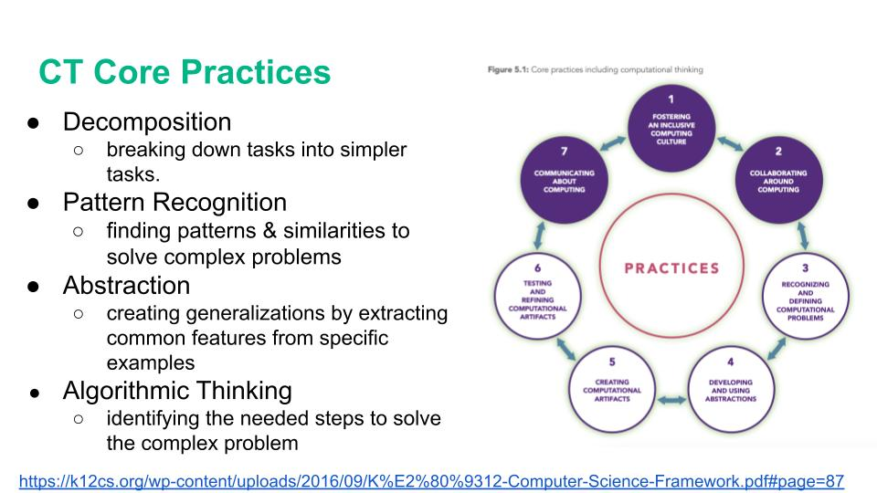
Figure 3. CT core practices from K-12 Computer Science Framework (2016), licensed under a Creative Commons Attribution-NonCommercial-ShareAlike 4.0 International License (CC BY-NC-SA 4.0).
Following this information, data and statements on CT/CS teacher preparation were presented (Slides 7-9 in Session 1 PD PPT). This information was important to present as the TED faculty are teaching future teachers and the CS teacher preparation data showcases that 24% of PK-12 CS teachers surveyed did not have college-level CS classes (Koshy et al., 2022). After this data, the Standards for CS teachers were presented with a focus on “effective K-12 CS instruction” (CSTA, 2020, para. 1; Figure 4; Slide 10 in Session 1 PD PPT).
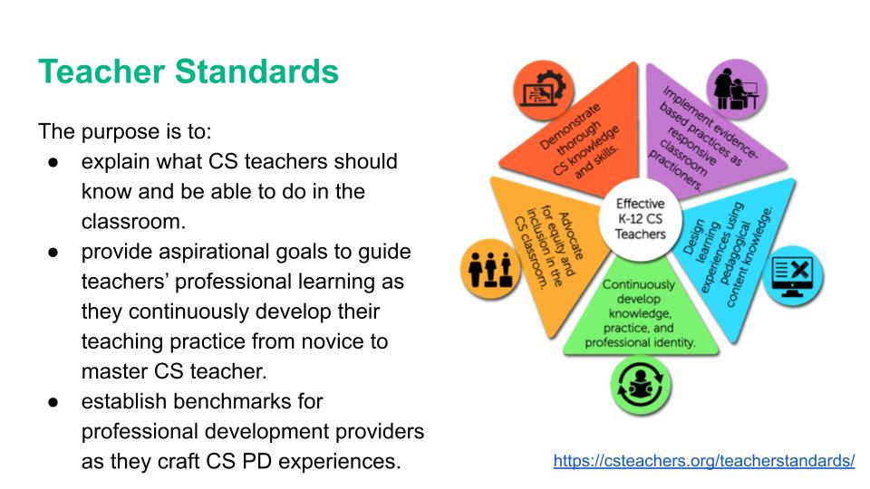
Figure 4. Slide presentation of standards for CS teachers, licensed under a Creative Commons Attribution-NonCommercial-ShareAlike 4.0 International License (CC BY-NC-SA 4.0).
CT/CS Stations (1 hour): After the overview of CT/CS, three CT/CS stations were implemented (Figure 5; Slide 11 in Session 1 PD PPT). The stations were developed to be an overview of different CT/CS options and tools available to faculty with the end goal of getting faculty interested in joining the Focused Faculty initiative and help those faculty determine the CT/CS activities/tools they could integrate in their classes. Two of these stations were digital CT/CS stations using iPads/personal devices and computers and one of the stations was unplugged with a few activities for faculty to choose from. These CT/CS stations were set up before the full-day session began. The two digital stations were in the main room with the full-day session and the unplugged station was in a separate room to allow for multiple floor and table-top activities.
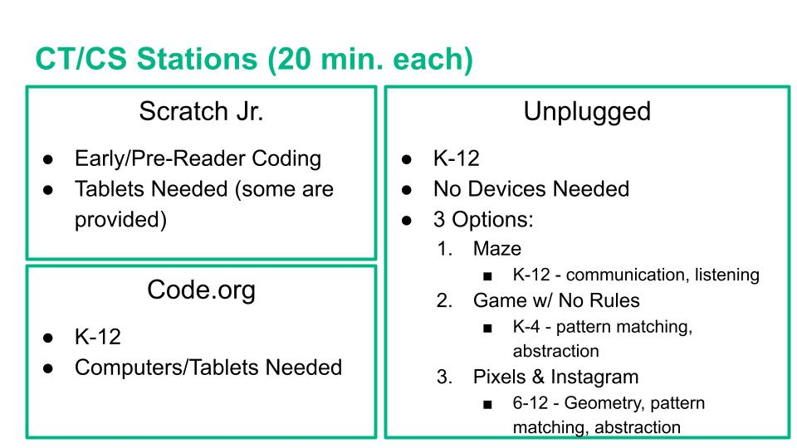
Figure 5. CT/CS stations during the full-day PD.
Participants broke into three different groups and cycled through stations for 20 minutes each. These stations were led by the authors. The stations included:
- Scratch Jr. on iPads (or personal devices)
- Code.org on computers
- Unplugged activities
Scratch Jr. (n.d.) is a tool that can be used to interactively introduce young learners (PK-2) to coding concepts. The Scratch Jr. activity was geared towards early/pre-reader coding and was an exploratory activity where faculty did basic block coding to make a character move through a background and interact with other characters. iPads were available for faculty to use but faculty were also able to download the application on their personal devices if they preferred.
Code.org is a platform that provides self-guided lessons across PK-12 grade levels (CODE, n.d.-a). The activity used was Code with Anna and Elsa lesson (CODE, n.d.-b) focusing on the integration of math and coding for upper elementary/early secondary learners. Faculty used their own computers and joined a Code.org classroom section, created by one of the authors, to engage with the activity while also demonstrating the student and teacher side of Code.org for future implementation.
Unplugged activities are non-digital CT and CS activities that can be used in classrooms with and without devices. These types of activities can include games, puzzles, and other problem-solving activities that use physical tools such as crayons/markers, dice, and mazes to support CT/CS concepts like pattern recognition, abstraction, and algorithms (CS Unplugged, n.d.). Unplugged activities are typically utilized to first introduce CT/CS concepts without coding and many educators scaffold CT/CS lessons with unplugged activities first, followed by digital CT/CS work (Sawyer, 2022). Three options were provided for the faculty to choose from:
- A maze that was laid out on the floor with directional placards for faculty to code their way through a maze. The directional placards were available in arrows for pre/early readers and in text directions (Figure 6).
- The Game with No Rules is a Code.org activity where learners have to determine how to play a game by deconstructing provided phrases with pattern matching and abstraction, determine what the algorithm is, and create their own phrases based on their analysis (CODE, n.d.-e). Dice, markers, pens/pencils, and the printed worksheets were available for the faculty to use.
- The Pixels & Instagram activity focuses on how images are displayed on digital devices. This activity begins with a Code.org (2015) video, Images, Pixels and RGB which features how images work on digital devices with the example of Instagram. Then, using the Colour by Numbers worksheet (CS Unplugged, 2021) faculty first create images based on the provided codes on the “Worksheet Activity: Kid Fax” page of the CS Unplugged (2021) Colour by Numbers worksheet (Figure 7). Then faculty create their own images and write the codes. At the end of the activity, faculty are provided a blank gridded page to rewrite the codes to their own images and swap with one another. They then attempt to create each other’s images, based on provided codes.
After the stations, a short break was given to faculty and then a whole group lesson using Scratch and micro:bits was completed.
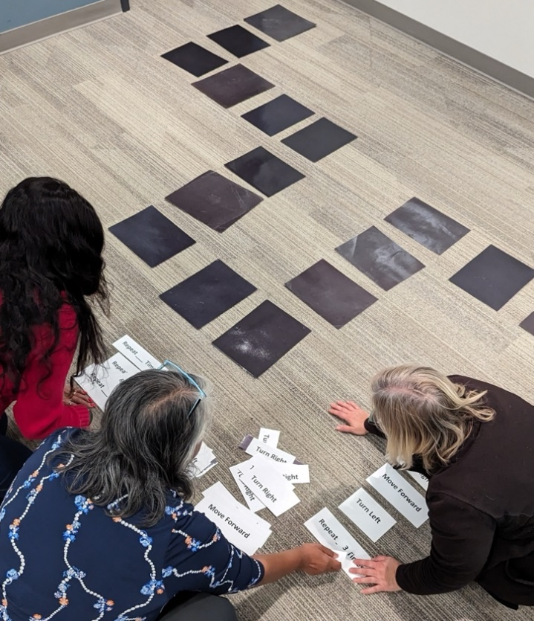
Figure 6. Faculty organize the maze directional placards.
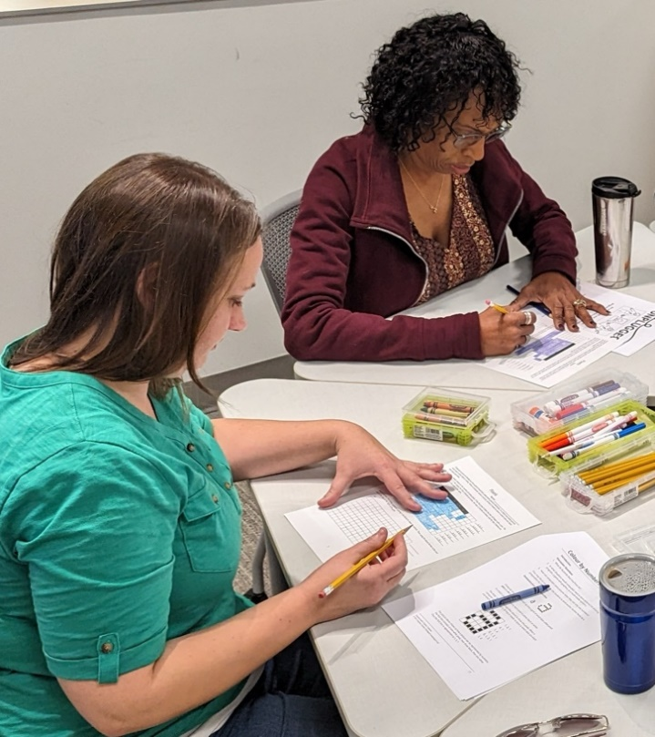
Figure 7. Faculty creating images based on the provided codes in the Colour by Numbers activity.
Coding in Scratch (45 minutes): An introduction to Scratch was the next activity the faculty engaged in as a whole group (Slide 12 in Session 1 PD PPT). Scratch is “the world’s largest coding community for children and a coding language with a simple visual interface that allows young people to create digital stories, games, and animations” (Scratch, n.d., para. 1). The faculty engaged with the Create a Story activity in Scratch where they had to create a short story with a beginning, middle, and end which they then created in Scratch (Scratch in Practice, n.d.). Although there is a tutorial available, one of the authors guided the faculty through the brainstorming and development of the story while the other authors supported faculty individually as needed. Forty-five minutes was provided for this activity and most faculty were able to brainstorm and create a short story in Scratch in that time. Here are a few of the faculty-created Scratch story projects:
- Kristina’s Dream: https://scratch.mit.edu/projects/918668441
- Obi at the beach: https://scratch.mit.edu/projects/918667925
- Play Fetch with Beau: https://scratch.mit.edu/projects/918667967
micro:bits (1 hour): The Scratch Jr., Code.org, and Scratch activities allowed faculty to engage in coding in a scaffolded manner, slowly easing them into more advanced coding and more choices in what they code/create. The final digital coding activity for the day was coding in micro:bits (Slides 13-15 in Session 1 PD PPT). micro:bits are physical programming devices that allow learners to digitally code a machine that they can then interact with in a hands-on manner (micro:bit, n.d.-c; Figure 8). In a one-hour time slot, faculty engaged in two micro:bit activities. The first activity was a warm-up of creating dice. The dice micro:bit activity is a beginner-level activity that allows you to create your micro:bit into a die using the micro:bit block coding (this activity can also be completed in Python). Although there is a Dice Lesson Tutorial on how to teach/code the micro:bit (micro:bit, n.d.-a), one of the authors led the activity while the other authors supported faculty individually as needed. This dice activity allowed faculty to block code on the micro:bit site (i.e., learning another interface) and interact with the micro:bit before being introduced to more complex coding and options.
The second activity was directly aligned to a science lesson where faculty coded their micro:bits to measure the temperature, sound, and light for different locations around campus. The Environmental Exploration activity (micro:bit, n.d.-b) includes a tutorial on how to complete the activity, including a data recording sheet, which allows easy implementation for teachers/faculty. This activity was led by the same author who led the micro:bit dice activity with the other authors supporting faculty as needed. Once faculty had their micro:bits programmed for the Environmental Exploration, they used the data recording sheet and worked in small groups to measure the temperature, sound, and light in various places on campus. The faculty were given 15 minutes to measure with their micro:bits and upon returning to the room, a brief discussion occurred on what they found and how the micro:bits could be used in their courses. Lunch followed this discussion.
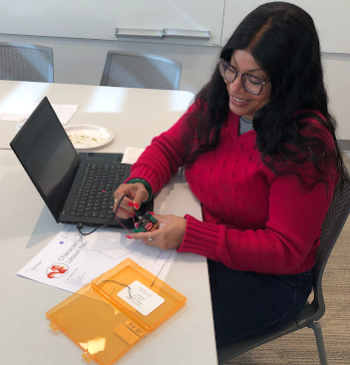
Figure 8. Faculty using micro:bits during the full-day PD.
Read Aloud (15 minutes): The afternoon started with a read aloud activity with the book Brown Bear, Brown Bear (Martin, 1967), modeling how CT/CS can be integrated in all subjects, including early literacy read aloud activities (Slide 16 in Session 1 PD PPT). This activity was completed as a whole group as people were still finishing lunch. In this activity, the book Brown Bear, Brown Bear was read to the faculty by one of the authors. Then, as a whole group, the faculty analyzed the story through the CT core practices. The CT terms were presented in English and Spanish to showcase how multilingual learners can be supported in CT/CS activities. First, the faculty decomposed the story (in Spanish, la decomposición), answering the question: How many animals/people were in the story? They then identified the patterns (los patrones) by answer the following prompts:
- What repeated in the story?
- Let’s make a prediction.
  - What if the brown bear saw a Teal Goat?
  - What would the story say?
  - What would the teal goat see?
Then, the faculty abstracted (las abstracciones) the story, by answering the questions:
- What are the important parts of the story?
- What lines/details are not needed?
Finally, ending with the algorithm (el algoritmo), the recreation of the sequence of events, by answering the prompt, what is the order of the things that occur in this story?
Finally, in an unplugged coding activity, the faculty block coded a picture of a bear to each of the animals in order as presented in the book. This was completed with a big piece of chart paper with images of the different animals (e.g., yellow duck, blue horse) and block codes with arrows, best for early/pre-readers. This activity could be made for early/novice readers by choosing a more advanced/aged appropriate book and using text block codes instead of arrows.
CT/CS Discussion (1.5 hours): Following the Brown Bear activity, the faculty discussed how to integrate CT/CS in the preservice courses (Slide 17 in Session 1 PD PPT). Faculty were divided into small groups and used poster paper to showcase their ideas. These ideas were then reviewed and the potential need for funding to implement the integration ideas was indicated (Figure 9). This integration idea and identification of funding activity helped the authors in identifying how teacher education faculty were thinking of integrating CT/CS, where more PD support was needed, and where funding supports may be needed (e.g., time for planning, materials/technical tools, more professional learning, etc.). This activity helped the authors in writing the next set of grants to fund their multi-year plan.
Whole Group Share (15 minutes): After this activity, the day was concluded with a whole group share of what faculty learned and were excited about (Slide 18 in Session 1 PD PPT). This whole group share lasted about 15 minutes which was followed by some next steps from the authors. These next steps included information on the Focused Faculty initiative, where five faculty could sign up to integrate CT/CS in their courses in the spring semester. Following that information a 3-2-1 exit ticket was given to faculty so they could reflect on three things they learned, two things they were excited to try, and one question they still had (Slide 19 in Session 1 PD PPT). In the 3-2-1 exit ticket, faculty were also asked if they were interested in participating in the Focused Faculty pilot. These 3-2-1 exit tickets were used by the authors to determine future PD topics in the upcoming TED meetings and who was interested in the Focused Faculty pilot.
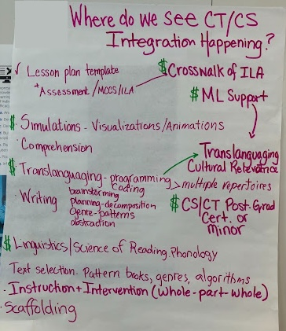
Figure 9. Faculty integration ideas from full-day PD analyzed for funding needs.

Session 2: 11/17/23 Follow-Up PD
On November 17, 2023, a follow-up meeting was held during the TED meeting. The authors were given 15-20 minutes to facilitate one activity, answer some questions from the Session 1 Exit Tickets, and announce the Focused Faculty.

Set-Up and Materials
This session was facilitated face-to-face in a room with round tables that seated six to eight people for communication and collaboration. The materials needed for this PD were:
- Session 2 PD Slides (PPT)
- MIT Media Lab (n.d.) Cats, Dogs & Machine Learning Lesson (adapted to be unplugged)

Professional Development
The 15-minute activity was an unplugged activity on machine learning led by one of the authors. Machine learning was selected as a follow-up topic because multiple faculty asked how artificial intelligence (AI) worked on the Session 1 Exit Ticket. The MIT Media Lab (n.d.) Cats, Dogs & Machine Learning lesson was adapted for this activity. This lesson is geared to fourth through eighth grade levels. Due to the limited amount of time provided for this second session, the activity was adapted to be unplugged and completed in around eight minutes.
To start this activity, a description of machine learning and AI was provided. This description was connected to the Brown Bear, Brown Bear book, read during Session 1, to feature recognizable labels for each animal (e.g., blue horse) and discuss how labels are used in technology. To introduce the information on machine learning and AI, speaking prompts were created along with a slide that included the aligning middle school standards (Slide 2 in Session 2 PD PPT).
Prompt: We are going to learn how supervised machine learning can be trained to classify complex datasets based on labeled data and make predictions about new pictures and live video feeds! AI is trying to predict something in the future or something that the data says. In a supervised machine learning system, a computer learns by example. From our Brown Bear Book last time, we see that each object has a label. We classify and label things in technology all the time such as: junk mail, face detection for snapchat filters, library databases, hashtags, etc. These labels and classifications help us make predictions on data and information that is not labeled.
After the basic information was presented, a slide of three cats and three dogs was shown and faculty provided three characters that were similar for the three cats and for the three dogs (Slide 3 in Session 2 PD PPT). Faculty were then given multiple color printed images of cats and dogs and a big sheet of paper with Cats and Dogs written at the top. They were asked to use the three characteristics for cats and three characteristics for dogs to classify the images of the dogs and cats (Figure 10). After a few minutes of sorting, faculty discussed what occurred specifically asking the questions:
- Did all the cats & dogs get classified correctly?
- What group had the higher percentage of correct identifications (cats or dogs)?
- What could we have done in our training data (the images on previous slide) to make it more accurate?
Prompt: We are going to build a very simple cat/dog classifier like a CS person would for a computer. Based on these 3 pictures of cats, give me 3 similarities between them. Based on these 3 pictures of dogs, give me 3 similarities between them. Now at your tables, use these similarities as classifiers and classify the pictures into the cat and dog categories. Be sure to use the similarities on the board to classify the pictures. So, what happened?
Finally, the activity concluded with a short discussion on algorithm bias and how the images used to identify similar characteristics were biased for and against types of dogs and cats (Slide 4 in Session 2 PD PPT).
Prompt: When algorithms, specifically artificial intelligence systems, have outcomes that are unfair in a systematic way, we call that algorithmic bias. We would say that our cat-dog classifier shows algorithmic bias and that it is biased towards ______ since it works really well for them and biased against _____ since it doesn’t work as well for them. For computer systems, when we code and classify data, the data, labels, and categories we create impact what the computer learns.
Following this activity, one of the faculty lead team members showcased the MD CS K-12 Student Standards and led a discussion on how CT/CS currently fits in the School of Education and TED vision statements. This first follow-up meeting concluded with an announcement of the five Focused Faculty and celebration for their willingness to participate.

Session 3: 1/25/24 PD
On January 25, 2024, the third CT/CS PD session occurred during the TED faculty meeting. In this meeting, the authors were given 15-minutes to conduct an activity.
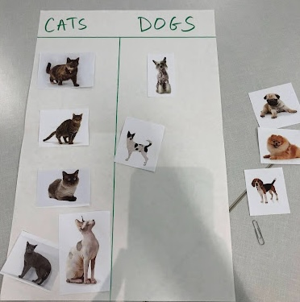
Figure 10. Image of faculty sort of cats & dogs based on identified similar characteristics.

Set-Up and Materials
This session was facilitated face-to-face in a room with round tables that seated six to eight people for communication and collaboration. This PD focused on a STEM/makerspace activity called “Build the Tallest Structure” to support the Whole-Part-Whole learning model (Swanson & Law, 1993). The materials needed for this PD were:
- Maker materials (e.g., Legos, popsicle sticks, cups/containers, straws, string, tape, playdoh)

Professional Development
One of the Focused Faculty requested support in connecting CT/CS concepts to the Whole-Part-Whole learning model around the time of this PD session. Instead of providing a direct answer to this Focused Faculty member, it was determined to have all the TED faculty connect CT/CS to the Whole-Part-Whole learning model and provide some starter ideas. This activity was created by one of the authors with the help of OpenAI (2024). Open AI was used to brainstorm some STEM/makerspace activities that connected to CT/CS. The author who led the activity had a physical makerspace with multiple items and regularly integrated STEAM into their classes.
Before the PD, the author who led the activity gathered the materials and sorted materials for four groups. The materials provided to faculty for the activity were Legos, popsicle sticks, cups/containers, straws, string, tape, and playdoh, but any kind of physical materials would suffice as long as there is a mix of adhesive/bonding and building/stacking items.
During the PD, faculty were placed in teams and challenged to make the tallest structure using the provided materials. Faculty were given 8 minutes to build a structure (Figure 11). After the activity, a discussion occurred on how this activity connected back to the CT Core Concepts and how it connected to the Whole-Part-Whole learning model with the following prompts:
- What was the task?
- How did you decompose the task?
- What types of patterns did you realize?
- How did you use abstraction in the task?
- What steps did you take to complete the task?
- Did you create the tallest structure? What could you have done differently if not?
- How does this connect to Whole-Part-Whole learning model?

Session 4: 2/22/24 PD
The fourth PD session occurred on February 22, 2024, during the TED meeting. Another 15-minute time slot was provided, and the focus was on the connection of CT/CS to social emotional learning (SEL).

Set-Up and Materials
This session was facilitated online via Zoom. Breakout rooms were used for the paired reflection. Needed materials included participants using their mics to speak (or chat functions) and access to the Poem Art lesson by CODE (n.d.-d). A slide deck was used but no slide deck is provided as it only included the prompts which are provided below.
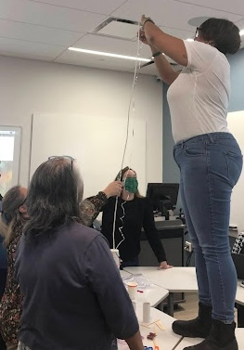
Figure 11. Faculty creating the tallest structure in the January 25, 2024, department meeting.

Professional Development
This session topic was request by another Focused Faculty member who was trying to create a CT/CS integrated lesson on SEL. This follow-up was online and began with the Poem Art lesson (CODE, n.d.-d). Faculty were given about eight minutes to try to get to the second or third progression (i.e., level) of the lesson. Faculty did not have to login to Code.org to complete this progression. After faculty were given time for the poem art, they reflected (individually and in pairs) about what was easy and difficult in the activity, how they reacted to difficult items, and how they demonstrated resilience. Four minutes was given for this reflection. The prompts included:
- What was easy for you?
- What was difficult for you?
- When you hit a difficult part of the game, what did you do? (give up - low resilience, or keep trying until you solved it - high resilience)
- Why do you think you demonstrated low or high resilience when faced with a difficult part?
Following the reflection, a brief discussion was held on how the code.org activity, both the activity of Poem Art & reflections, supported Social Emotional Learning. The CASEL framework was provided as a foundation for this discussion (CASEL, n.d.).

Session 5: 4/26/24 Wrap Up Showcase
Finally, on the last follow-up PD, the Focused Faculty showcased their created lessons, and the authors showcased the grant-purchased materials.

Set-Up and Materials
This session was facilitated online via Zoom. No breakout rooms were needed. Needed materials included a slide deck, created collaboratively by the Focused Faculty and authors, that showcased their CT/CS lessons and reflections, and the grant-purchased materials. No slide deck is provided as this is specific to implementation.

Professional Development
Each of the five Focused Faculty members showcased what they integrated in their classrooms and reflected on how it went and what they would change for the following academic year. Part of the funding from the grants that supported this work was used for reusable materials. Each of the Focused Faculty were able to purchase something for their lessons which can be used throughout the TED program. These items were highlighted for all of the TED faculty to consider integrating in the 2024-2025 academic year.

Focused Faculty
From the Session 1 full-day PD, five faculty volunteered to become the Focused Faculty that continued working with the authors in integrating CT/CS into their courses. To select the Focused Faculty, the authors decided to first see who was interested and able, as opposed to asking/requiring faculty to participate. From the initial request in the first PD session, five faculty volunteered representing these courses:
- Elementary and Secondary Math Methods
- Early and Elementary Literacy/Reading
- Elementary Education Capstone (a course taken in conjunction with internship)
The five Focused Faculty were teamed with one of the authors as a mentor and worked on creating and implementing at least one CT/CS activity, lesson, and/or assessment into one of their courses for the spring semester. The minimum requirement for this work was 10 hours. This time included approximately 3 hours of whole group meetings (the five Focused Faculty and the authors), 5 hours of co-planning (where each Focused Faculty member met with their mentor), and 5 hours of individual planning/preparation of the activities. The co-planning hours allowed the mentors to coach their assigned Focused Faculty member and support them in co-planning their integration and activities. It was encouraged for the Focused Faculty to have their faculty lead team member observe the CT/CS integration and be available for the lesson to support as needed. This informal observation also served as a component of the Focused Faculty annual evaluation in TED, allowing the Focused Faculty member to check that requirement off while also getting formative feedback on and/or support with their CT/CS lesson.
In the initial Focused Faculty meeting, the stipulations and payment information was presented, and guiding questions were provided to help the Focused Faculty choose the course to integrate CT/CS into and how to work with their mentor. Prior to this meeting, the authors met to select their Focused Faculty mentees. These were selected based on content area and course time (e.g., one of the authors teamed with a faculty member in a course they were already team teaching). The guiding questions used in this initial meeting were:
- What class are you thinking of integrating CT/CS?
- What day/time/location does the class meet?
- When are you planning your syllabus/class?
- Set up 1st co-planning time for Spring 2024.
- Set up other co-planning times (2-3)
- Set up informal peer observation & debrief time (1)
During the co-planning sessions between the Focused Faculty and their mentor, the Focused Faculty could ask questions, brainstorm ideas for CT/CS integration, and get more support on CT/CS skills. These co-planning sessions were scheduled between the Focused Faculty member and the mentor that best fit their schedules and the timing for the CT/CS lesson. Within these co-planning sessions, questions arose such as how to teach the Whole-Part-Whole instructional framework with CT/CS (see Session 3: 1/25/24 PD section) and Social Emotional Learning with CT/CS activities (see Session 4: 2/22/24 PD section). Since the Focused Faculty were teaching preservice teachers, the integration had to be a mix of content instruction and modeling, so the preservice students can learn the content and also see and/or demonstrate the application of that content in a classroom setting (K-12 spaces and in the course classroom). This meant that these CT/CS lessons needed to support the intended lesson content (e.g., Whole-Part-Whole Framework, SEL) while also demonstrating how the content is applied in a classroom setting. Some of these integration questions from the Focused Faculty became the focus of the CT/CS PD sessions in the TED meetings.
An example of how the Focused Faculty integration questions became a whole TED faculty PD is when one of the Focused Faculty members wanted to teach the Whole-Part-Whole instructional framework with CT/CS integration (see Session 3: 1/25/24 PD). First, they aligned the Whole-Part-Whole instructional framework to CT terminology by introducing the concept and the vocabulary. Students then had to answer a few questions in a discussion forum to show their understanding of the Whole-Part-Whole framework and how CT skills are applicable within the framework (Figure 12). The Focused Faculty member reflected on student answers stating the students could connect CT vocabulary to the Whole-Part-Whole framework, and when listing materials to teach Word Study Skills (question 3 in forum), students listed some of the CT/CS unplugged materials they used in the activities from the lessons.

Focused Faculty Integrated Lessons
Finally, near the end of the year, the Focused Faculty were asked to present their integrated lesson to the other TED faculty in a department meeting. The following integration activities, by course, were created and implemented by the Focused Faculty.
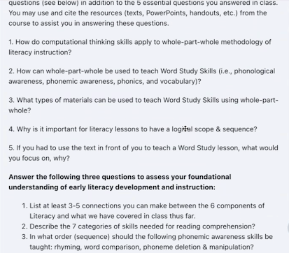
Figure 12. Discussion forum on how CT supports the Whole-Part-Whole Instructional Framework.
Course: Materials for Teaching Reading
- Introducing Whole-Part-Whole Framework Using CT Skills
- Intro to Genre-Based Writing
  - Three Stations:
    - Narrative Writing–Plugged activity using Scratch Jr.
    - Persuasive Writing–Unplugged activity using research
    - Procedural Writing–Unplugged activity using human robot in a maze
- Review: Integrating CT & Literacy
  - Three Stations using the Cubetto and two Code & Go Mice
Course: Early Literacy Assessment and Instruction
- Introduced CT concepts and vocabulary: logic, decomposition, patterns, algorithms, abstraction, and evaluation
  - Unplugged Activities
- Comprehension Retelling using We’re Going on a Bear Hunt with unplugged activity map and code and go mouse with story map
- Students used Scratch Jr for narrative writing and reflected on how the plugged activity would be useful to get early elementary students motivated to write
Course: Assessments & Instruction in Reading I
- Introduced the six concepts of computational thinking: Logic, Evaluation, Algorithms, Patterns, Decomposition and Abstraction
- Introduced five computational practices: tinkering, creating, debugging, persevering and collaborating
- Students charted the results on the connections between literacy, reading comprehension/meaning-making and computational thinking
- Three Unplugged Stations:
  - Maze Activity
  - Three Word Story
  - Oral Reflection Sentence Frame
Course: Elementary Education Capstone
- Step 1:
  - Provided overview of computational thinking concepts and approaches
  - Used Scratch Jr.
- Step 2:
  - Read Monster at the End of the Book
  - Students used Scratch to create their own monster
- Step 3:
  - Read If You Give a Mouse a Cookie
  - Students used Code and Go Mice to sequence events in the book
Course: Elementary Math Methods
- Tech Day: TI NSpire used to program micro:bits and hubs
- Introduced CT & Code.org: Code with Anna and Elsa lesson (CODE, n.d.-b)
Course: The Teaching of Mathematics
- Desmos: teacher- & student created
- Tech Day: TI NSpire programming
- TI NSpire programing with micro:bits
- Code.org: Coding a Geometric Star Quilt (CODE, n.d.-c)
Course: Math for Elementary Teachers-Geometric
- Tech Day: TI NSpire with micro:bits
- Extra Credit → Code.org: Coding a Geometric Star Quilt (CODE, n.d.-c)

Materials
In addition to the planning and co-planning support, Focused Faculty were given $100 each to spend for supplies for their CT/CS integration. This funding was part of the grants and allowed the Focused Faculty to purchase materials needed to implement the CT/CS lessons. They were encouraged to purchase materials that were not one-time use and could be utilized in other courses and by other faculty. The items purchased by the faculty included one Cubetto (PRIMO, n.d.), two additional adventure maps for the Cubetto, six Code & Go Mice (Learning Resources, n.d.), and some materials for unplugged activities. In addition to these materials, TED had access to 20 micro:bits (n.d.-c), purchased with the first grant, and 10 TI Nspire calculators (Texas Instruments, n.d.). These tools were utilized in the Focused Faculty courses in Spring 2024.

micro:bits
The micro:bits were utilized during the first PD session and heavily utilized in the math courses. The math Focused Faculty member stated,
I used [the micro:bits] in my mathematics methods courses (both elementary and secondary) to introduce block chain coding with Microsoft MakeCode’s (n.d.) Flashing Heart Activity. Then we used them as dice for probability exercises. My secondary mathematics methods course also did some activities interfacing the micro:bits with the Texas Instruments Nspire calculators. Also, I used the micro:bits with my secondary methods course this past spring to do the Environment Exploration activity. I will use them again for this activity in the early summer course.
This faculty member integrated CT/CS in multiple of their courses going beyond the one lesson in one course minimum.

Cubetto
The Cubetto was a purchase for one of the Focused Faculty to use in their literacy course (see Figure 13). The faculty provided a statement on how they used the materials for their course. This is what the faculty member stated about the Cubetto:
After scaffolding the integration of CT/CS principles using both plugged and unplugged activities into two lessons, I was able to use the Cubetto programming robot and coding mice to help solidify students’ understanding and application of CT/CS integration into literacy content instruction. Students were able to apply and synthesize CT/CS principles with their understanding of how the brain processes and performs literacy practices and determine the implication of such in relation to literacy instruction in the elementary and secondary classroom. They had to read the texts provided with the Cubetto and follow the instructions to move either the Cubetto robot or the coding mice to the locations on the map as directed. Through this activity students were using CT/CS skills in real-time in collaboration with their peers and discussed how this and similar activities would be done in their future classrooms.
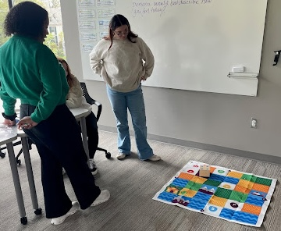
Figure 13. Undergraduate students using the Cubetto in a literacy class.

Code & Go Mice
The Code & Go Mice were purchased for two classes. First, in Early Literacy Assessment, the faculty member had students complete a comprehension retelling using We’re Going on a Bear Hunt with an unplugged activity map and the Code & Go Mice with a story map (Figure 14). The students were placed in three groups to work with the Code & Go Mice, and sequenced retelling of We’re Going on a Bear Hunt with story map using large grid paper.
Another faculty member completed a similar activity with the Code & Go Mice in the Elementary Education Capstone course with the book If you Give a Mouse a Cookie. Since two faculty completed similar activities in two different classes, this prompted a discussion amongst the authors on when activities should appear and how to scaffold the activities to ensure they become more complex in computing and integration for students. This led to a larger mapping of the current integration of CT/CS and the course sequence for preservice students.
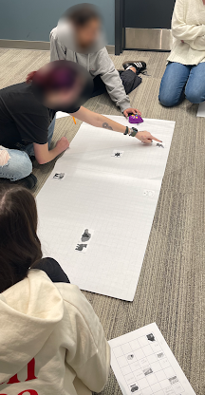
Figure 14. Literacy students using a story map with Code & Go Mice for We’re Going on a Bear Hunt.

Unplugged
One of the literacy faculty created unplugged activities in their Assessments & Instruction in Reading course stating,
I utilized chart paper, 4x6 multicolored index cards, paper copy instructions and reflections (both on paper and oral) to complete the CT/CS unplugged activities. Students struggled at first but started to make connections between the 6 principles and 5 pedagogical practices and the practice of teaching literacy and the relationships to literacy concepts. The students all enjoyed the activities and after completing the activities could see the connections more readily (Figure 15).
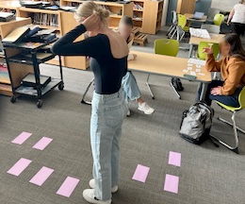
Figure 15. Image of literacy students completing unplugged activities.
Students in this class also connected five computational practices to literacy, reading comprehension/meaning-making (Figure 16). The authors observed that many of the Focused Faculty were integrating CT/CS at multiple moments in their courses which they reflected on for future considerations.

Critical Reflection
These sessions were implemented during the TED meetings which were already established meetings set in the calendar and communicated to faculty. It was expected for all TED faculty to attend these meetings. When planning whole-group PD, it is recommended to find time during an already-established meeting instead of creating more meetings.
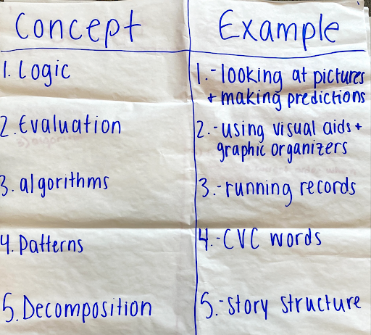
Figure 16. Images of computational practices to literacy, reading comprehension/meaning-making.
This was grant-funded which allowed for the payment of faculty for their time during the full-day, Session 1 PD, the payment of the Focused Faculty for 10 hours to plan and implement their CT/CS lessons, the purchasing of materials, and the payment of the authors for implementing this PD. This external financial motivation may have increased the number of faculty who joined in the full-day, Session 1 PD (although it was required) and the willingness of the faculty to join the Focused Faculty. Although internal motivating factors are the goal for any adult learning, it is recommended to support faculty time to learn, design, and implement activities with internal or external funding. There were limitations, however, as the funding only allowed five faculty to join the Focused Faculty in this first year.
The grant supported 10 hours of work for five Focused Faculty, but we asked the faculty to document the number of hours they spent on meeting, learning, and designing their CT/CS lessons. They each spent an average of 13 hours on CT/CS integration for their courses in the Spring 2024 semester with one faculty member spending 19 hours (Table 2). The requirement for the Focused Faculty was to integrate one lesson into one course. A few focused faculty members integrated CT/CS in their course’s multiple times, and one focused faculty member integrated CT/CS in all of their mathematics courses.
As the Focused Faculty created their CT/CS implementation activities, it was noticed that many of the activities completed in the Session 1 full-day PD and subsequent PD sessions were used in their courses (e.g., the unplugged maze activity). This speaks to the need for modeling for faculty so they can implement it in their courses. We focused on a hands-on, constructivist approach with all of the PD sessions, allowing faculty to experience and play with CT/CS activities and lessons instead of just talking about them.

Table 2
Faculty Focused Hours
Descriptive Statistic | Number of Hours
Minimum | 10.5 Hours
Maximum | 19 Hours
Mean | 13 Hours
Median | 11.5 Hours
Mode | 11 Hours
This use of modeling and hands-on approaches is best captured in the Exit Tickets for the Session 1full-day PD. Faculty listed the Brown Bear, Brown Bear activity as one of their favorites stating, “you can use CT/CS in all content areas. Love Brown Bear,” and “I can use CT/CS & coding with literacy (Brown Bear),” and “seeing there is room for CS/CT in ESOL courses.” When implementing CT/CS with faculty, it is recommended to take a constructivist, hands-on approach to model to faculty how they should be implementing in their classrooms (similar to what we expect from preservice and inservice teachers).
There were a few challenges in our year-long PD. First, there was a limitation of the number of times the authors could join the TED faculty meetings and how much time they were given during those meetings. The authors were only able to join in four TED faculty meetings over the year. There were other faculty meetings in which the authors were given time to implement an activity, but none of the authors were available due to travel and conference schedules. In each meeting, the authors were given about 15 minutes to complete an activity, discussion, and follow-up from previous sessions. This time was limited, so many of the activities were introductory to spark ideas and conversation about integrating CT/CS in classes. The limited amount of time in each session was especially impactful in Session 2 about AI and machine learning. More time for faculty to sort the cats and dogs based on their initial descriptions and discuss was needed. Session 4 was also virtual, so the activities had to be adjusted from a face-to-face facilitation to an online facilitation. The use of code.org activities supported this online facilitation but did not allow the authors to view how many levels the faculty were able to accomplish nor if faculty were actually participating in the activity. More time in meetings would allow for deeper learning of CT/CS but may also disrupt the business and other items completed during the meetings.
During the Focused Faculty lessons, implementation issues did occur with the tools and faculty ability to fully describe the CT/CS components. These specific issues were not documented in this article as they are part of the Focused Faculty lessons and should be further discussed by those faculty.
We were able to secure another grant to send four faculty to the 2024 Maryland Higher Education Summer CS Intensive Conference. Two of the authors and two of literacy Focused Faculty attended this conference. The two Focused Faculty presented some of the CT/CS activities they created in their literacy courses at this conference with the help of one of the authors (their mentor).
The activities presented were the Three Word Story to introduce computational literacy vocabulary, and connecting CT/CS to the skill of reading through genre-based writing and the Cubetto and adventure maps. For the Three Word Story game, students are trying to get their partner or someone in their group to say a hidden word without actually using it themselves. First, students are put into pairs or small groups. One student picks up a word card and keeps it hidden from the rest of the group. That student then says three words to begin the story. The next person in the group says another three words to continue the story. This process is repeated until the hidden word is said, or time limit is reached. Check out Three-Word Stories with Benedict Cumberbatch for an example (The Tonight Show Starring Jimmy Fallon, 2014). For the Cubetto activity, students first start by brainstorming and listing the connections between the skill of reading and CT/CS concepts. Then each groups reads their Cubetto adventure story listing the character(s), setting, goal of the character(s), problem, and resolution. Then groups coded their Cubetto robots (or Code & Go Mice as they were used with the Cubetto adventure maps) to follow the story. Groups then reflected and discussed the CT/CL concepts they used when reading and analyzing the story and coding the robots. This literacy focused CT/CS session was widely attended and provided an opportunity for the literacy Focused Faculty to showcase their CT/CS integration activities beyond their classroom and TED.

Department Chair Reflection
As department chair, I lead continuous improvement efforts that include curricular revisions to keep our programs current. As we implemented the plan over the year, it was rewarding to see teacher education faculty embrace CT/CS. Their enthusiasm for the PD activities we planned was evident. Many faculty members went beyond the expectations of the plan and implemented multiple activities with their teacher candidates. They were excited by the teacher candidates’ engagement in the lessons and invited other faculty to their classes to observe and/or participate. Faculty enjoyed collaborating with each other during department meetings and continue to volunteer their own time to support each other with the integration of CT/CS.

Next Steps
During the 2024 Maryland Higher Education Summer CS Intensive Conference, the attending faculty reflected upon the 2023-2024 work and further developed the department’s expansion plan (see Table 3). The plan continues into the elementary courses, resulting in more options for assignments in the final Capstone Seminar. In addition, consideration was given to exposing students to various technology or activities in at least two classes prior to the Seminar. For example, preservice teachers who work with micro:bits in Mathematics for Elementary Teachers-Geometric will also encounter micro:bits in Science Methods before being required to incorporate this technology in their lesson planning during the final semester of the program. This structure of revisiting the tools and concepts in multiple courses will ensure that the TED teacher candidates are prepared to implement CT/CS activities in their Capstone/Internship classrooms and future classrooms as practicing teachers.
We also continue to seek external grants to help fund this initiative and have acquired department and institutional funding to continue the work, including designing a cross-listed course for students in the teacher education and computer science departments that introduces the basics of CT and CS concepts for PK-8 classrooms.
Table 3
TED Revised Expansion Plan
Year | Course & CT/CS Tools/Activities (if known)
2024-2025 | - Elementary Social Studies Methods: Code & Go mice (timelines)​  - Elementary Science Methods: micro:bits/makecode (environment)​  - Secondary Science Methods: Code.org: Outbreak Simulator​  - TI Rising Teachers Program ​  - Mathematics for Elementary Teachers (Algebra): unplugged, Scratch Jr.​  - Capstone Seminar: Scratch​
2025-2026 | - Introduction to Special Education  - Classroom Management  - Elementary Mathematics Methods & Management  - Elementary Social Studies Methods & Management  - PD for PDS/Partner School Mentors  - Assessment and Evaluation for Special Education  - Collaboration and Consultation for Students with Special Needs  - Principles of Behavior Management for Special Education  - Foundations of Education
2026-2027 | - Curriculum and Instruction for Special Education  - Algebraic Concepts  - Integration Science I  - Improving Access to the General Curriculum for all Learners  - PD for PDS/partner schools  - Integration Science II  - Methods of Teaching English  - Methods of Teaching Social Studies  - Methods of Teaching Art

References
CASEL. (n.d.). What is the CASEL framework? Retrieved June 4, 2025, from https://casel.org/fundamentals-of-sel/what-is-the-casel-framework/
CODE. (n.d.-a). Anyone can learn Computer Science. Retrieved June 4, 2025, from https://code.org/students
CODE. (n.d.-b). Code with Anna and Elsa. Retrieved June 4, 2025, from https://studio.code.org/s/frozen#
CODE. (n.d.-c). Coding a geometric star quit. Retrieved June 4, 2025, from https://studio.code.org/s/csc-starquilts-2023?viewAs=Instructor
CODE. (n.d.-d). Poem art. Retrieved June 4, 2025, from https://studio.code.org/s/poem-art-2021
CODE. (n.d.-e). Unplugged: Computational Thinking. Retrieved June 4, 2025, from https://code.org/curriculum/course3/1/Activity1-ComputationalThinking.pdf
Code.org. (2015, March 11). Images, pixels and RGB. YouTube. https://youtu.be/15aqFQQVBWU?si= Ws4sOC_qo1JuOtJh
Computer Science Teachers Association (2020). Standards for CS teachers. https://csteachers.org/teacherstandards
CS Unplugged. (n.d.). About. Retrieved June 4, 2025, from https://www.csunplugged.org/en/about/
CS Unplugged. (2021, September 26). Image representation. Classic Computer Science Unplugged. https://classic.csunplugged.org/ activities/image-representation/
Dewey, J. (1930). Democracy and education: An introduction to the philosophy of education. The Macmillan Company.
Digital Promise. (n.d.). What is computational thinking? Retrieved June 4, 2025, from https://digitalpromise.org/initiative/computational-thinking/about/
International Society for Technology in Education. (2019). Computational thinking competencies. https://iste.org/standards/computational-thinking-competencies
K–12 Computer Science Framework. (2016). http://www.k12cs.org
Koshy, S., Twarek, B., Bashir, D., Glass, S., Goins, R., Novohatski, L. C., & Scott, A. (2022, December). Moving towards a vision of equitable computer science: Results of a landscape survey of PreK-12 CS teachers in the United States. https://landscape.csteachers.org.
Learning Resources. (n.d.). Code & Go robot mouse. Retrieved June 4, 2025, from https://www. learningresources.com/item-stem-robot-mouse
Martin, Jr., B. (1967). Brown bear, brown bear, what do you see? Henry Holt and Company.
Maryland General Assembly. (2020). Legislation, session: 2018 regular session. https://mgaleg.maryland.gov/mgawebsite/Legislation/Details/hb0281?ys=2018RS&search=True
micro:bit. (n.d.-a). Dice. Retrieved June 4, 2025, from https://microbit.org/projects/make-it-code-it/dice/?editor=python
micro:bit. (n.d.-b). Environmental exploration. https://microbit.org/projects/make-it-code-it/environment-exploration/
micro:bit. (n.d.-c). What is the micro:bit? https://microbit.org/get-started/what-is-the-microbit/#computing-made-physical
Microsoft Makecode. (n.d.). Flashing heart activity. Retrieved June 4, 2025, from https://makecode. microbit.org/projects/flashing-heart
MIT Media Lab. (n.d.). Cats, dogs & machine learning. Canada Learning Code. Retrieved June 4, 2025, from https://www.canadalearningcode.ca/ lessons/cats-dogs-machine-learning/
OpenAI. (2024). ChatGPT 3.5 (January 10 version) [Large language model]. https://chat.openai.com/chat
Piaget, J. (1952). The origins of intelligence in children. International Universities Press, Inc.
PRIMO. (n.d.). Meet Cubetto. Retrieved June 4, 2025, from https://www.primotoys.com/
Sawyer, H. (2022, November 20). Lesson sequence- Unplugged to plugged. Learning Beside My Learners. https://hsawyeresl.edublogs.org/2022/ 11/20/lesson-sequence-unplugged-to-plugged/
Scratch. (n.d.) About Scratch. Retrieved June 4, 2025, from https://scratch.mit.edu/about
Scratch in Practice. (n.d.). Create a story activity guide. Retrieved June 4, 2025, from https://sip.scratch.mit.edu/guides/story/
Scratch Jr. (n.d.). Home. Retrieved June 4, 2025, from https://www.scratchjr.org/
Swanson, R. A., & Law, B. D. (1993). Whole-part-whole learning model. Performance Improvement Quarterly, 6(1), 45-43. https://doi.org/10.1111/ j.1937-8327.1993.tb00572.x
Texas Instruments. (n.d.). TI-Nspire™ CX CAS graphing calculator. Retrieved June 4, 2025, from https://education.ti.com/en/products/calculators/graphing-calculators/ti-nspire-cx-cas?category=overview
The Tonight Show Starring Jimmy Fallon. (November 18, 2014). Three-word stories with Benedict Cumberbatch [YouTube]. https://www.youtube. com/watch?v=DCataNWjw-Q
Wing, J. M. (2006). Computational thinking. Communications of the ACM, 49(3). https://doi.org/10.1145/1118178.1118215

Support Materials
- Code with Anna and Elsa lesson (CODE, n.d.-b)
- The Game with No Rules (CODE, n.d.-e)
- Images, Pixels and RGB (Code.org, 2015)
- Colour by Numbers (CS Unplugged, 2021)
- Scratch Create a Story Activity (Scratch in Practice, n.d.)
- micro:bit Dice Activity (micro:bit, n.d.-a)
- micro:bit Environmental Exploration Activity (n.d.-b)
- Cats, Dogs & Machine Learning Lesson (MIT Media Lab, n.d.)
- Poem Art Lesson (CODE, n.d.-d)
- Coding a Geometric Star Quilt (CODE, n.d.-c)
- Microsoft MakeCode’s (n.d.) Flashing Heart Activity
- Scratch Jr. (n.d.)

About the Authors
Irene A. Bal is an Assistant Teaching Professor of Learning Design & Technology at Loyola University Maryland with research interests in microlearning, micro-credentials, teacher professional development, computational thinking and computer science for preservice and inservice teachers, and innovative PK-12 classroom practices and technology.
Karen L. Terrell is the Assistant Professor of Mathematics Education at Loyola University Maryland, as well as a Faculty Associate for the Center for Equity, Leadership, and Social Justice in Education. Her specialties include content and language integration, mathematics education, technology, and assessment for diverse learners. Dr. Terrell is currently the Editor of MCTM’s journal, The Banneker Banner; Junior Co-Chair of the Research of Mathematics Education SIG of AERA; and a member-at-large for the Association of Maryland Mathematics Teacher Educators. She also serves on the Newsletter Working Group of the Bilingual Education Research SIG of AERA and a member of the TLC4ME Consortium, a nationwide research group for multilingual learners.
Hoang Bui is an Associate Professor in the Computer Science Department at Loyola University Maryland. He received a B.S. and M.S. in Computer Science in 2004 and 2007 from Midwestern State University. He received his Ph.D. in Computer Science in 2012 from the University of Notre Dame. From 2012 to 2015, he worked as a post-doctoral researcher at Rutgers University. After that, he spent seven years at Western Illinois University, often teaching programming and system courses. In addition to teaching, his research interests are computing education, big data storage, high-performance computing, and parallel and distributed systems.
Stacy Williams is a Clinical Professor and the Teacher Education Department Chair at Loyola University Maryland. She began her career teaching high school biology and mentoring early career teachers and is now dedicated to preparing teachers who will advocate for equitable and anti-racist education for all.

Acknowledgements
This professional development was produced with the assistance of two grants from the Maryland Center for Computing Education within the University System of Maryland under the auspices of the Maryland Preservice Computer Science Teacher Education Grant Program.

Sharing & Modification Permissions
Unless otherwise noted, this article and its resources are published under a Creative Commons Attribution-NonCommercial-ShareAlike 4.0 International license:

You can freely share the article and its resources if you indicate the original authors, identify the Creative Commons license, and use them non-commercially.
You may also make and share modifications by:
- Identifying the original authors.
- Using the resources non-commercially.
- Licensing modifications under the CC BY-NC-SA 4.0 license (and including a link to it).
- Indicating what modifications were made.

