Group Lesson Design Template
  - Ugur Kale¹ and Yuahnua Wang²
¹Indiana University, ²West Virginia University
- Introduction (1pt)

Your Names: | List all the names of your group members here
Title of your lesson plan: | What’s the title of your lesson activity?
Grade level: | What grade level is the lesson activity designed for?
Learning objective (s): | What will the students be able to do with the completion of this lesson activity?
Contextual Issue (s): | What WV contextual issue(s) is the lesson may be addressing? Briefly describe here.

- Coding Project (Snapshot and URL) (1pt)
Here, paste a snapshot of your group coding project along with the project URL. For Minecraft, please submit a URL for coding, and a downloaded document for the Minecraft world. Click here for instructions on specific instructions.
- Your group coding project can build on any of the existing projects that the group members have just completed individually.
- Or, it can totally be based on a new project idea different that the existing projects

- Timeline of Learning Activity (4pt)
Think about learning activities that will help students achieve the learning objective(s) by engaging in computational thinking via the coding project. In a chronological order, describe what you will do as the teacher, as well as what you expect students to do (e.g., especially with the coding project), and how they might respond to what you are doing in order to further scaffold their learning.
- …
- …
- …
- ..
- …
- …
- …

- CT Practices and CT Processes

  - Please examine the list of CT practices and CT processes below:
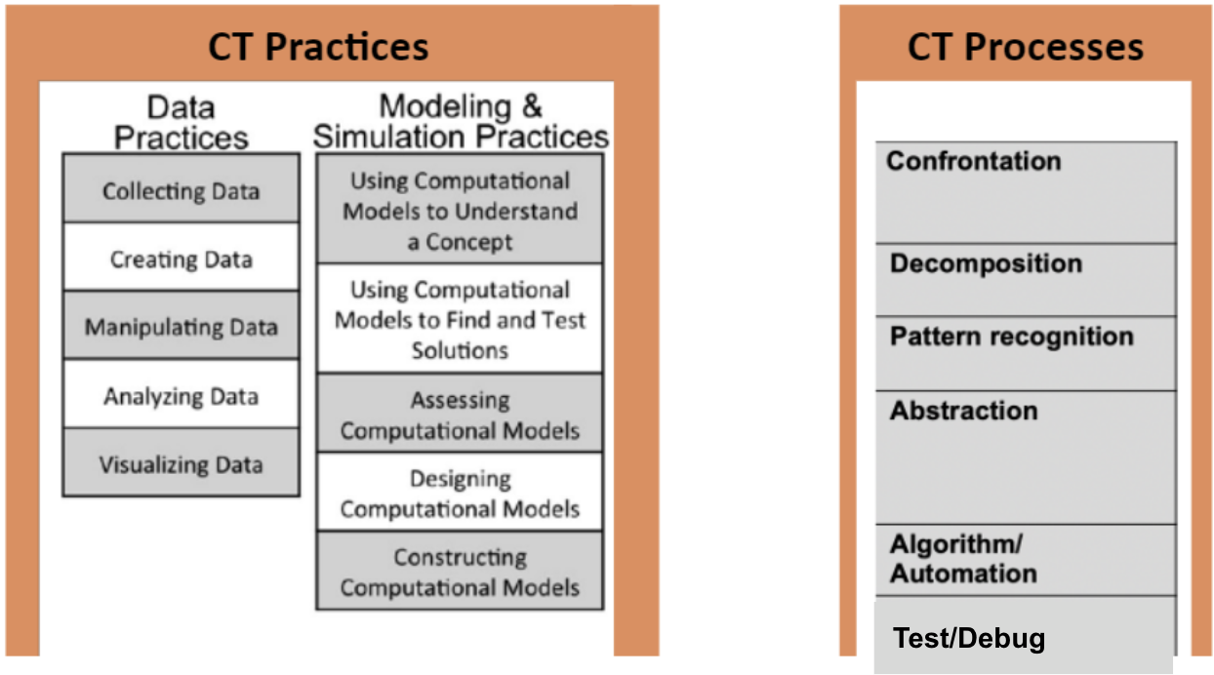

  - Please review the brief descriptions of the CT processes and CT practices below. Based on your understanding of these descriptions, answer the questions in section 5.
CT PROCESSES—--------------------------------------------------------------

- Confrontation: Being confronted with a given problem. Defining the problem

- Decomposition: Breaking the problem into smaller chunks

- Pattern recognition: Identifying patterns among smaller chunks

- Abstraction: Identifying underlying characteristics to filter out details

- Algorithm/Automation: Generating and automating steps for solving the problem

- Test/Debug: Analyzing solutions by debugging or troubleshooting.

CT PRACTICES
Data Practices

- Collecting data: Data are collected through observation and measurement. Students who have mastered this practice will be able to propose systematic data collection protocols and articulate how those protocols can be automated with computational tools when appropriate.

- Creating data: This is about using computational tools to generate data. It’s different than collecting actual data. This is the case when investigating phenomena that cannot be easily observed or measured or that are more theoretical in nature. Students who have mastered this will be able to define computational procedures and run simulations that create data they can use to advance their understanding of the topic under investigation.

- Manipulating data: This includes sorting, filtering, cleaning, normalizing, and joining disparate datasets. These manipulations serve for both analysis and communication. Students who have mastered this practice will be able to manipulate datasets with computational tools, reshaping the dataset to be in a desired or useful configuration so that it can support further investigation.

- Analyzing data: This practice entails looking for patterns or anomalies, defining rules to categorize data, and identifying trends and correlations. Students who have mastered this practice will be able to analyze a given set of data and make claims and draw conclusions based on the finding from their analysis.

- Visualizing data: This is about using conventional visualizations such as graphs and charts, as well as dynamic, interactive displays that allow the observer to interact with the data being displayed. Students who have mastered this practice will be able to use computational tools to produce visualizations that convey information gathered during analysis. Not everything visual can be considered visualizing data! Visualizing data involves taking the data (e.g. numbers, size, frequency, etc) and turning them into bars charts, etc.

Modeling and Simulation Practices

- Using computational models to understand a concept: Computational models (non-static representations of phenomena that can be simulated by a computer) that demonstrate specific ideas or phenomena can serve as powerful learning tools. Students who have mastered this practice will be able to advance their own understanding of a concept by interacting with a computational model that demonstrates the concept (e.g., interdependence within ecosystems, how objects move in a frictionless environment, and probabilistic distributions of random events)

- Using computational models to find and test solutions: Computational models (non-static representations of phenomena that can be simulated by a computer) can also be used to test hypotheses and discover solutions to problems. Students who have mastered this practice will be able to find, test, and justify the use of a particular solution through the use of a computational model as well as be able to apply the information gained through using the model when appropriate.

- Assessing computational models: A key practice in using a computational model (non-static representations of phenomena that can be simulated by a computer) effectively is to understand how the model relates to the phenomenon being represented. Students who have mastered this practice will be able to articulate the similarities and differences between a computational model and the phenomenon that it is modeling, this includes raising issues of threats to validity as well as identifying assumptions built into the model.

- Designing computational models: There are many reasons that might motivate designing a computational model, including wanting to better understand a phenomenon under investigation, to test out a hypothesis, or to communicate an idea or principle to others in a dynamic, interactive way. Students who have mastered this practice will be able to define the components of the model, describe how they interact, decide what data will be produced by the model, articulate assumptions being made by the proposed model, and understand what conclusions can be drawn from the model.

- Constructing computational models: An important practice in scientific and mathematical pursuits is the ability to create new or extend existing computational models. This requires being able to encode the model features in a way that a computer can interpret. Students who have mastered this practice will be able to implement new model behaviors, either through extending an existing model or by creating a new model either within a given modeling framework or from scratch. An example of this practice will be the generation of simulations that mimic a previously conducted experiment (data) or understanding of how various elements in a system may impact each other.

- Reflect on CT Processes and Practices (3pt)

  - Based on your understanding on the CT practices and CT processes described above and discussed in class, please answer the following questions reflecting on students’ engagement with CT in the lesson:

- What are some CT processes that the students would be engaged in in this lesson? Also, when in the lesson would the students be engaged in these processes (refer to your timeline of planned events)?

- What are some CT practices that the students would have in your lesson? Also, when in the lesson would these practices occur (refer to your timeline of planned events)?

- Describe how your proposed learning activities are suitable for the students at this grade level?

- Describe how your proposed learning activities may transfer to classrooms of students beyond WV context. Think about how to do these activities if you start teaching in a different state after graduation.

- What issues do you see may arise with the use of CT approach in your lesson? Think about the cons of the CT approach in the context of this lesson.

- CT Concepts

  - Consider the list of CT concepts below (Make sure to read the page 3, 4, and 5 from this article regarding the examples for each CT concept)
- Sequences: “A key concept in programming is that a particular activity or task is expressed as a series of individual steps or instructions that can be executed by the computer. Like a recipe, a sequence of programming instructions specifies the behavior or action that should be produced.”
- Loops: “Loops are a mechanism for running the same sequence multiple times”
- Events: “One thing causing another thing to happen – are an essential component of interactive media. For example, a start button triggering the beginning of a music video, or the collision of two objects causing a game’s score to increase”
- Parallelism: “Most modern computer languages support parallelism – sequences of instructions happening at the same time. Scratch supports parallelism across objects. For example, a dance party scene might involve several characters dancing simultaneously, each with a unique sequence of dance instructions”
- Conditions: “Another key concept in interactive media is conditionals – the ability to make decisions based on certain conditions, which supports the expression of multiple outcomes (e.g., IF this happens, THEN do that).”
- Operators: “Operators provide support for mathematical, logical, and string expressions, enabling the programmer to perform numeric and string manipulations (e.g., +, -, *, /, <, >, , =, and, or, not, etc…).”
- Data: “Data involves storing, retrieving, and updating values (e.g., score points collected each time a task is accompanied in a game)”

- Reflect on CT Concepts (1pt)

  - Based on your understanding of the CT concepts described above and in the article, what CT concepts will be addressed in your activity? Also, when in the lesson would the students be engaged in these concepts (refer to your timeline of planned events)?

