Scratch Post Test
  - Jessica Kerr and Theodore J. Kopcha, University of Georgia
1. What kind of block do I use to make my sprite move around?
○ Motion
○ Sensing
○ Sound
○ Control

2. What is the function of the “when green flag clicked” command block?
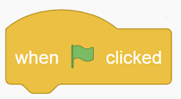
○ Points the sprite in a specific direction
○ If the condition is true, run the blocks inside
○ Runs the code
○ Stops the code

3. What is the function of the “If__, Then__” command block?
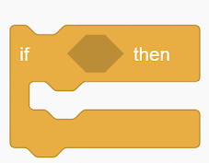
○ Run the program over and over
○ Move the sprite
○ If the condition is true, run the blocks inside
○ Increase the speed of the sprite

4. What is the function of the “forever” command block?
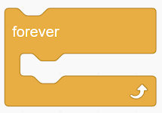
○ If the condition is true, run the blocks inside
○ Point sprite in a specific direction
○ Change the background
○ Run the code inside over and over

5. Scratch Cat is trying to jump over the rock. What code needs to be added next to put Scratch Cat back on the ground?
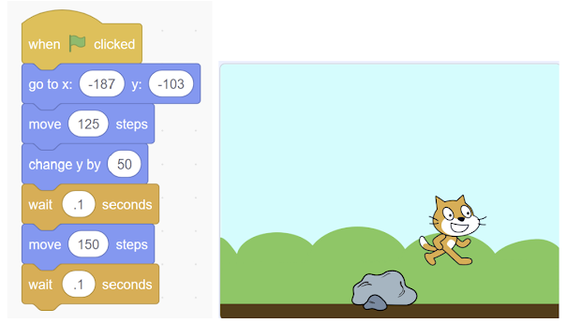

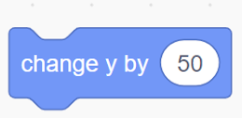
○ Change y by 50
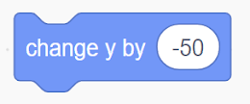
○ Change y by -50

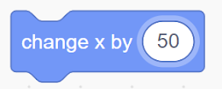
○ Change x by 50

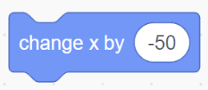
○ Change x by -50

6. What is the variable in this code?
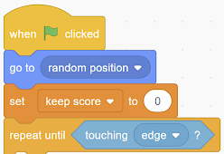
○ Touching edge
○ Random position
○ When green flag clicked
○ Keep score

7. Scratch is trying to draw a square. How do I need to change the code so that Scratch can make a square? (2 points)
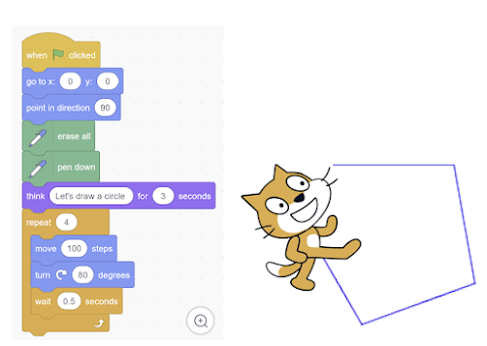

Your Answer: ____________________________________________________________________________________________

8. Scratch is trying to draw a square. How do I need to How could you make this code shorter? (2 points)
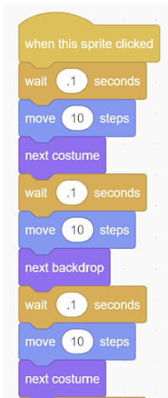

Your Answer: ____________________________________________________________________________________________

