
Join the Sons of Liberty! Exploring
1773 Bloxels Boston
  - Elisa L. Shaffer, Old Dominion University
This lesson won the 2024 AECT Teacher Education Division PK-12 Lesson Design Competition. It was not peer-reviewed

Overview
Learners will create a colonial character to explore 1773 Boston and gain insight into the underpinnings of the events that led up to and occurred during the Boston Tea Party on December 16, 1773. Using Bloxels, learners will travel the streets of Boston, interacting with different characters and learning about their concerns and events. They will also interact with British soldiers and tax collectors. Additionally, they will be given an opportunity to join the Sons of Liberty and participate in the Boston Tea Party.
Topics: Boston Tea Party, Social Studies, US Revolutionary War
Time: Student Preparation-90 minute class; Bloxels Exploration-60 minute class
Materials
- Markers, colored pencils, crayons
- Create Your Colonialist
- Short readings of different individuals and stories involving the Boston Tea Party, the Tea Act, and its impact on the American Revolution
- Bloxels (n.d.-a) Edu sets for every 2-3 students
- iPad/tablet for every 2-3 students or access to the school computer labs
- Bloxels (n.d.-b) app installed on each tablet if using iPads/tablets

Context-at-a-glance
Competition Parameters
The Teacher Education Division of the Association for Educational Communications and Technology provided live explorations of Bloxels Edu during the 2024 annual convention. Attendees accessed Bloxels plastic grids and cubes, iPads, the Bloxels: Build Your Own Games app, sample character and game layout cards, resource workbooks, and blank grids to draw and scan ideas. During a three-day time period, attendees were invited to design original, hands-on, curricular materials based on the tools. Their instructions were to amplify or transform student learning in a PK-12 (or equivalent) educational setting and describe their idea in approximately 750 words.
Setting
Fifth-grade social studies in the United States.
Modality
In-person instruction
Lesson Rationale
Exploring the Boston Tea Party and its events helps learners understand the causes of the American Revolution, develop critical thinking and historical analysis skills, learn about civic engagement and democracy, and explore the significance of symbolic actions.
Technology Rationale
Utilizing Bloxels sets, students will have a unique opportunity to engage in hands-on learning about the events leading up to the Boston Tea Party and decide whether to join the Sons of Liberty and participate in the Boston Tea Party. This allows the students to invest in their character as they experience the same issues that affected the colonists of 1773, therefore creating greater engagement with the topic.

Setup
Prior to implementation, the teacher should ensure Bloxels (n.d.-a) Edu sets have all of the components and/or the Bloxels (n.d.-b) app is installed on all of the iPads/tablets. It is helpful if the teacher creates a Bloxels classroom and student accounts prior to the start of this lesson. It is suggested that learners create their characters off-line with a printed version of the Create Your Colonialist document. Finally, a 1773 Bloxels Boston, including key dates, figures, and events, should be created by the teacher (see 1773 Bloxels Boston section).

Learning Objectives
By the end of the lesson, the learner will be able to:
- Recognize critical historical figures from Boston Tea Party events.
- Identify the date of the Boston Tea Party.
- Summarize events of the Boston Tea Party.
- Summarize reasons behind the Boston Tea Party, (e.g., taxation without representation, the Tea Act).

Learning Representation

Creation of Colonial Characters
Students will use one hour to create their colonial character (e.g., “Jonathan” in Figures 1 and 2) using planning worksheets that include the character's backstory and a gridded template to draw the character (see Create Your Colonialist document. Students should use markers, colored pencils, or crayons to sketch their characters. During this time, as students complete their Create Your Colonialist document worksheets, they should gain access to either Bloxels (n.d.-a) Edu sets or iPads/computers to create their colonialists in the Bloxels (n.d.-b) app or on the Play Bloxels website (Play Bloxels, n.d.). If using the Bloxel (n.d.-a) EDU sets, the teacher should assist students with scanning their characters into the student Bloxel profiles.
The students will use iPads/tablets or desktops for 30 minutes to input their created characters, including their various “states,” into the Bloxels software (e.g., idle, walking, jumping, falling). After the characters are completed, learners should read short passages about the Sons of Liberty, the Tea Act, the Boston Tea Party, and their impact on the American Revolution. After readings, students will have one hour to explore a teacher-created 1773 Bloxels Boston. After the lesson, students can be allowed to revisit 1773 Bloxels Boston in any downtime or as an incentive.
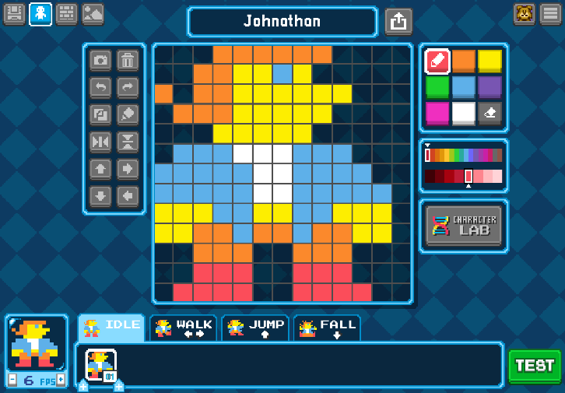
Figure 1. Jonathan character in idle position.
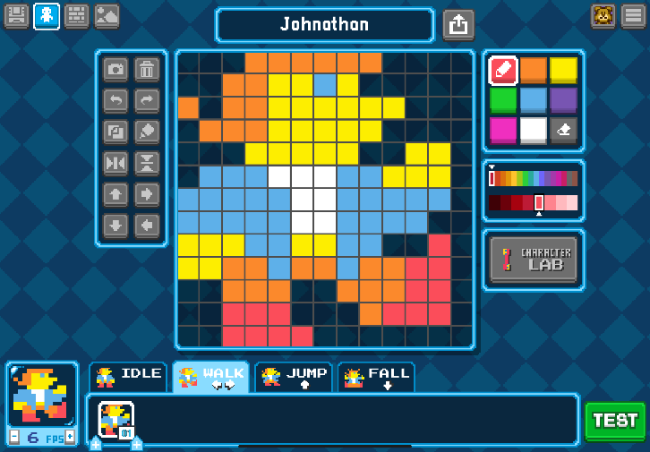
Figure 2. Johnathan character in walking position.

1773 Bloxels Boston
The 1773 Bloxels Boston is teacher-created and should include key dates, figures, and events such as:
- The Tea Act of 1773 & Townshend Acts
- Samuel Adams, John Hancock, Paul Revere
- The Sons of Liberty
- Boston Harbor
  - Dartmouth, Elanor, and Beaver-the three ships involved
- The Boston Tea Party - Evening of December 16, 1773
  - 90,000 pounds of tea
  - 90,000 pounds of tea
  - Equal to £10,000 or $1.7 million in today’s economy
This 1773 Bloxels Boston should be created with various scenes where students interact with different colonists and see how the Tea Act and the Townshend Acts affected the characters. Students should encounter British soldiers and members of the Sons of Liberty. Following these initial scenes, students will be given an opportunity to join the Sons of Liberty and participate in the Boston Tea Party or abstain from the activities. It is recommended that scenes be created based on both decisions so the student can see the consequences of joining or abstaining. The final scene should show the effects of their decision (see example video - Boston 1773; Shaffer, 2024).

Assessments
By exploring these topics, students should be able to describe how this event led to increased colonial unity and resistance which in turn led to the American Revolution. Following this activity, students should submit a written assignment, discussing the specific individuals they met throughout the game, if they chose to join the Sons of Liberty in the Boston Tea Party events, and what influenced that decision.

References
Bloxels. (n.d.-a) Bloxels build your own video games: Official kit. Retrieved on November 23, 2024, from https://store.bloxelsbuilder.com/collections/get-started-with-bloxels-edu/products/bloxels-personal-edition
Bloxels. (n.d.-b). Retrieved on November 23, 2024, from https://edu.bloxelsbuilder.com/
Play Bloxels. (n.d.). Retrieved on November 23, 2024, from https://play.bloxels.com/
Shaffer, E. (2024, October 22). Boston 1773 [YouTube]. https://youtu.be/uXGxiQ1Dam8?si=fVDP8WXpvxVn7bxT

About the Author
Elisa L. Shaffer, Instructional Designer, in conjunction with subject matter experts, develops short (3.5-week) professional development courses for academic advisors for NACADA: The Global Community for Academic Advising since 2016. She is currently a PhD Candidate at Old Dominion University in Instructional Design and Technology. Her research agenda is to enhance learning for neurodivergent learners in online learning environments.

Sharing & Modification Permissions
Unless otherwise noted, this article and its resources are published under a Creative Commons Attribution-NonCommercial-ShareAlike 4.0 International license:

You can freely share the article and its resources if you indicate the original authors, identify the Creative Commons license, and use them non-commercially.
You may also make and share modifications by:
- Identifying the original authors.
- Using the resources non-commercially.
- Licensing modifications under the CC BY-NC-SA 4.0 license (and including a link to it).
- Indicating what modifications were made.

