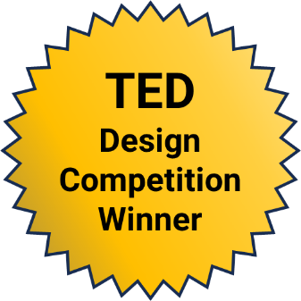
Unraveling Author’s Purpose:
5th Graders Step into the Role of Creator!
  - Brittany Musgrave Rivera, Learning Resource Specialist, Pasadena Independent
School District, Pasadena Texas
This lesson won the 2024 AECT Teacher Education Division PK-12 Lesson Design Competition. It was not peer-reviewed.

Overview
In this lesson, students demonstrate an understanding of author’s purpose by developing their own narrative and bringing it to life with Bloxels, a platform/app and physical kit for people to build their own video games (Bloxels, n.d.b). This lesson is a progressive activity where students apply what they learned about the authors' purpose, according to TEKs Guide (n.d.) ELA.5.10, and create a narrative. Students are divided into groups and given a base “setting.” They can expand and evolve this setting to fit their narrative using the included Bloxels Planning Materials to help them plan it. The student groups plan their narrative, design key scenes using Bloxels, and narrate them using a consistent viewpoint. In groups, students work collaboratively and practice their communication skills. A rubric is used to create clarity for students’ expectations. Students are expected to include: text (script, setting description, character descriptions), graphics/images, point of view, anecdote or hyperbole, figurative language.
Topics: Author’s Purpose & Craft; Collaboration; Narrative Development
Time: 5-6 days, meeting for 45-minute class periods each day

Materials
- Bloxels Edu Set (one per group; Bloxels, n.d.a)
- Bloxels Lesson & Rubric
- Bloxels Planning Materials
- Bloxels Example Planning Materials
- Laptops (one per group)

Context-at-a-Glance
This lesson was developed conceptually for a PK-12 lesson design competition.
Competition Parameters
The Teacher Education Division of the Association for Educational Communications and Technology provided live explorations of Bloxels Edu during the 2024 annual convention. Attendees accessed Bloxels plastic grids and cubes, iPads, the Bloxels: Build Your Own Games app, sample character and game layout cards, resource workbooks, and blank grids to draw and scan ideas. During a three-day time period, attendees were invited to design original, hands-on, curricular materials based on the tools. Their instructions were to amplify or transform student learning in a PK-12 (or equivalent) educational setting and describe their idea in approximately 750 words.
Setting
A 5th-grade classroom in the United States. Students in this classroom include emerging bilingual, special education, and general education students.
Modality
In-person instruction
Instructor Characteristics
A collaboration between the English Language Arts, Reading (ELAR) teacher, and the campus librarian.
Technology Rationale
Using Bloxels, students will think critically about how different mediums impact graphic design and story development. Bloxels allows for frame-by-frame development to bring students’ stories to life, encouraging team communication, critical thinking, and problem-solving skills.

Standards
The following Texas English Language Arts standard aligns with this lesson (TEKS Guide, n.d.):
- TEKS ELA.5.10. Author’s Purpose and Craft
This lesson also aligns with the following Common Core State Standards for English (Council or Chief State School Officers & National Governors Association, 2010):
- CCSS.ELA-Literacy.RL.5.5 Craft and Structure
- CCSS.ELA-Literacy.RL.5.7 Integration of Knowledge and Ideas
- CCSS.ELA-Literacy.W.5.3 Narrative Writing
Additionally, this lesson aligns with the following International Society for Technology in Education (ISTE; 2016) Student Standards:
- ISTE 1.1 Empowered Learner
- ISTE 1.6 Creative Communicator
- ISTE 1.7 Global Collaborator

Learning Objectives
By the end of this lesson, the students will be able to:
- Clearly articulate the author’s purpose.
- State the purpose of the narrative.
- Organize and draft a narrative.
- Organize well-reasoned ideas.
- Apply narrative elements (plot, setting, characters, dialogue).
- Purposefully use narrative elements to create an engaging story.

Learning Representation
In the weeks leading up to the Bloxels activity, students should receive instruction over Author’s Purpose and Craft (TEKS Guide, n.d., ELA.5.10). Instruction should cover figurative language, the use of images within a text, point of view, and hyperbole. After completing classroom instruction, students come to the library for the Bloxels assessment activity, co-taught by the campus librarian and the English Language Arts, Reading (ELAR) teacher. This lesson is separated into six days.

Day 1: Introduction
Students are introduced to the assignment and put into groups of 2-3 students to work collaboratively.
During this time, students are introduced to the Bloxels Edu Set (Bloxels, n.d.a). Students are provided with the rubric and planning materials to help them think through ideas (see Bloxels Planning Materials and Bloxels Lesson & Rubric). They begin brainstorming the author’s purpose for their narrative. The narrative development includes plot, character, setting (including time period, landscape, reality or alternate reality) and a short script.

Day 2: Planning and Early Creation
Students will continue planning in Day 2. By the end of the class, they should have their planning materials completed (see Bloxels Planning Materials). This will include character descriptions, a short script, a completed plot diagram, and a description of their author’s purpose (see Bloxels Example Planning Materials for an example).

Day 3: Creating with Bloxels
On Day 3, students begin creating their key scenes with Bloxels Art Creator and their characters with Character Builder on the Play Bloxels website (see Figures 1 and 2; Play Bloxels, n.d.). The campus librarian and the ELAR teacher will support use of the Bloxel Edu Set as needed.
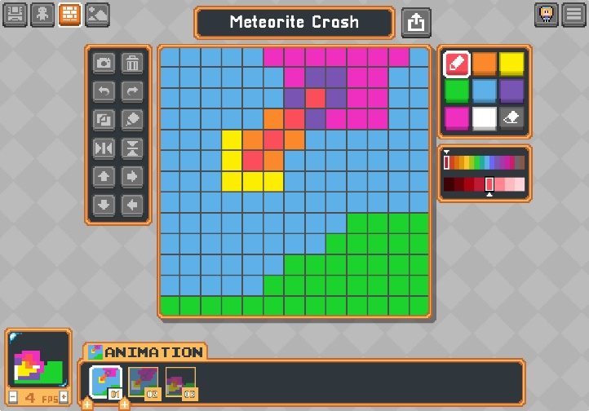
Figure 1. Scene creation example of meteorite crash in Bloxels Art Creator.
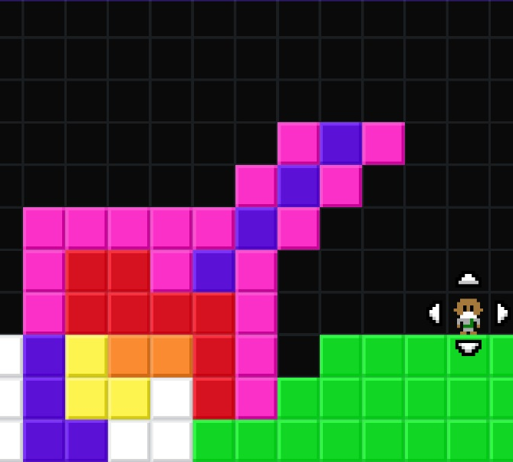
Figure 2. Sample scene with character.

Day 4: Continuing Bloxels Scenes
Students complete their Bloxels scene creation on Day 4. Their final product should include at least three scenes and a minimum of three characters. The completed Bloxels Planning Materials should be used as guide to complete the scenes and characters.

Day 5: Complete and Begin Presenting
At the start of Day 5, students should fine-tune their Bloxels scenes and save them to the Bloxels Edu Class Library.
Students begin presenting their presentations to the class. During the presentations, the campus librarian and the ELAR teacher will use the rubric to provide feedback to each group.

Day 6: Bloxel Presentations
Students continue presentations. At the conclusion of the presentations, rubrics will be returned to groups. Students will have an opportunity to review their rubrics and ask questions to the librarian and ELAR teacher.

Assessment
Students have access to the rubric throughout the assignment as it was presented on Day 1. The rubric was created using Magic School AI (n.d.) and inputting the TEK Guide (n.d.) ELA 5.10 standards, the lesson, and the key components of the narrative (plot, character, setting, and script).
The use of a rubric articulates clear grading expectations for students to self-asses their work, using the rubric as a guide to the project creation (Edutopia, 2008). For teachers, the rubric provides a scale to provide feedback and examine more specifically areas where students need additional instruction (Ferlazzo, 2021).
Formative assessment can be included informally during each class session, and more formally at the end of Day 2 when the students complete the Bloxels Planning Materials. This formative feedback can be provided by the campus librarian and/or ELAR teacher.

References
Bloxels. (n.d.a) Bloxels build your own video games: Official kit. Retrieved on November 23, 2024, from https://store.bloxelsbuilder.com/collections/get-started-with-bloxels-edu/products/bloxels-personal-edition
Council or Chief State School Officers, & National Governors Association. (2010, June 2). Common Core state standards for English language arts and literacy in history/social studies, science, and technical subjects. Washington, DC: Authors.
Edutopia. (2008, July 15). How do rubrics help? https://www.edutopia.org/assessment-guide-rubrics
Ferlazzo, L. (2021, April 18). Assessment strategies for English-language learners. EducationWeek. https://www.edweek.org/teaching-learning/opinion-assessment-strategies-for-english-language-learners/2021/04
International Society for Technology in Education. (2016). ISTE standards: For students. https://iste.org/ standards/students
TEKS Guide. (n.d.). English language arts and reading 5.10. Texas Education Agency. Retrieved on November 11, 2024, from https://teksguide.org/teks/ ela510/overview

Support Materials
Bloxels. (n.d.b). Retrieved on November 23, 2024, from https://edu.bloxelsbuilder.com/
Magic School AI (n.d.). Home. Retrieved on November 23, 2024, from https://www.magicschool.ai/
Play Bloxels. (n.d.). Retrieved on November 23, 2024, from https://play.bloxels.com/

About the Author
Brittany Musgrave Rivera received her master’s in library science from the University of North Texas in 2016. Brittany worked as a special education teacher until 2021 when she moved into the role of school librarian. In this role, she seeks out partnerships with classroom teachers and instructional coaches to align library lessons with classroom instruction. Brittany is a doctoral candidate in the Department of Learning Technologies at the University of North Texas. While pursuing her doctoral degree, she is studying technology integration in K-12 learning environments, creating accessibility, and facilitating extended learning opportunities using educational technology.

Sharing & Modification Permissions
Unless otherwise noted, this article and its resources are published under a Creative Commons Attribution-NonCommercial-ShareAlike 4.0 International license:

You can freely share the article and its resources if you indicate the original authors, identify the Creative Commons license, and use them non-commercially.
You may also make and share modifications by:
- Identifying the original authors.
- Using the resources non-commercially.
- Licensing modifications under the CC BY-NC-SA 4.0 license (and including a link to it).
- Indicating what modifications were made.

