Transformations Throw Down: Extending Mathematics Knowledge with Assemblr
  - Brian T. Johnson, Rebecca Bramwell, Josef Stamps, Katie Patterson, and Kyle Jones, Lakeside Junior High
School, Springdale Arkansas

Overview
The purpose of these 8th grade math lessons was to extend students’ knowledge of sequences of mathematical transformations by providing students with a digital experience of transformations in a three- dimensional environment. Assemblr, an augmented reality app was used to create these experiences for students after they learned these concepts in 2D. Past studies noted that augmented reality activities and gamification promote active learning and increase academic performance (Lampropoulus, et al., 2022; Sukriadi et al,. 2023; Kurniawan, et al., 2024). Students used Assemblr to extend their knowledge in a 3D environment. Their learning was expressed in a game where correct answers to Assemblr challenge questions related to transformations initiated a turn for a team to connect dots and create a square.
Topics: Transformations, Rotations, Symmetry, Dilations, Augmented Reality
Time: 2, 40-minute class periods

Materials
- Assemblr Website
- Teacher Presentation Slides
- Student Presentation Slides
- Student Reflection Survey
- Transformations Videos (Johnson, 2024a, 2024c, 2024d)
- Whiteboards for student answers (1 per team)
- Whiteboard markers (1 per team in various colors)
- A large white board for the Dots game
- Chromebooks, tablets, or smartphones
- A computer connected to a projector to display answers
Context-at-a-glance :
Setting
8th grade students in an 8-9th grade, public, suburban junior high school in the United States
Modality
Face to face instruction with student groups of 2-4
Class Structure
Two 40-minute 8th grade math extension classes were held for groups of 15-20 students during intervention class periods
Organizational Norms
Three 8th grade math teachers used assessment data to assign students to two sequential extension days in the library for this lesson.
Learner Characteristics
Students who were evaluated at or above proficiency for the unit on transformations. Students were new to using Assemblr.
Instructor Characteristics
One mathematics teacher and one librarian co-taught
Development Rationale
Students extended their learning with transformations while engaging with augmented reality. Teams observed how a polygon moved on a coordinate grid and identified the type of transformation that occurred. They earned units that could be used in playing “the dot game” (The Game Gal, 2018). Adding this additional strategic component helped to engage the students in the competition.
Design Framework
5 E’s Framework (Bybee & Landes, 1990)

Setup
Students completed the activity in the library. There was a table with a whiteboard, marker, and eraser for each team as well as a table for the game board. All of these were spaced out enough that teams could have private conversations about their answers (see Figure 1). The library also had displays around the room so that each team could easily view the challenges displayed on the screen as well as the timer.
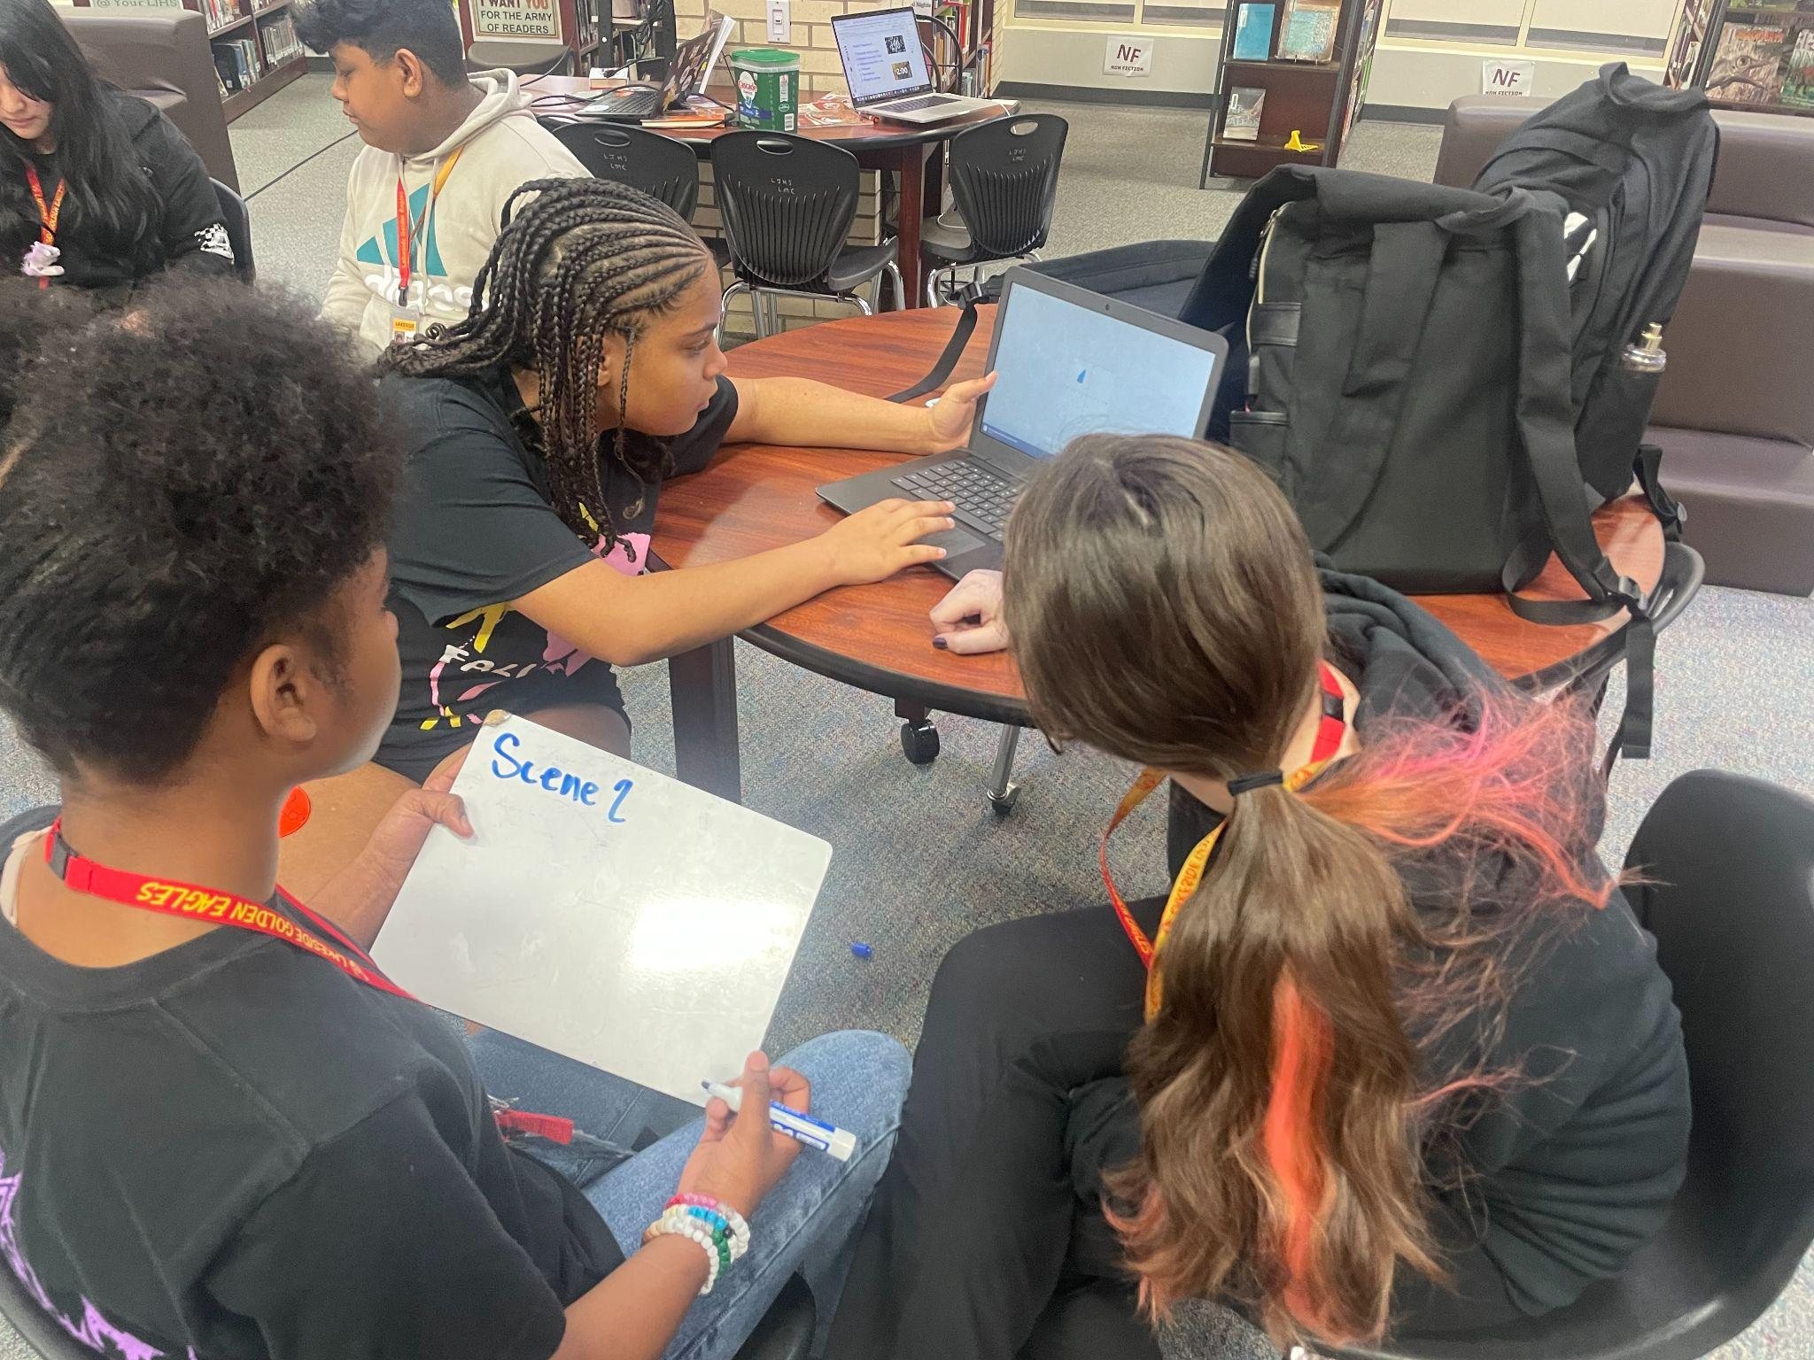
Figure 1. Students collaborating to determine a solution for a scene in Assemblr

Standards
The following Arkansas Math 8 standards aligned with this lesson (Arkansas Department of Education, 2016):
8.GM.7: Identify a single transformation used to transform one figure onto another on a coordinate plane
8.GM.8: Given two congruent figures, describe a sequence of transformations that maps one figure to another.
8.GM.11: Given two similar two-dimensional figures, describe a sequence of transformations that exhibits similarity, including rotations, reflections, translations, and dilations
The following International Society for Technology in Education standards for educators (2017) were used:
2.5.b Design authentic learning activities that align with content area standards and use digital tools and resources to maximize active, deep learning.
2.6.b Manage the use of technology and student learning strategies in digital platforms, virtual environments, hands-on makerspaces or in the field.
2.6.c Create learning opportunities that challenge students to use a design process and computational thinking to innovate and solve problems.
This lesson also aligned with four of eight Mathematical Practice Standards from the Common Core State Standards for Mathematics (National Governors Association Center for Best Practices & Council of Chief State School Officers, 2010):
CCSS.MATH.PRACTICE.MP1 Make sense of problems and persevere in solving them.
CCSS.MATH.PRACTICE.MP2 Reason abstractly and quantitatively.
CCSS.MATH.PRACTICE.MP6 Attend to precision.
CCSS.MATH.PRACTICE.MP7 Look for and make use of structure.

Context and Setting
This instructional unit was implemented at an 8-9th grade junior high school in a suburban region of the mid-south United States. In this school setting, students have 1:1 access to Chromebooks. Teachers in the school frequently collaborate with the librarian to plan instructional extensions. Students participate in content area instruction and extension activities in the library.
This instructional unit emphasized describing sequences of transformations, aligned with Arkansas Math 8 Standards (8.GM.7, 8.GM.8, 8.GM.11). It pushed students to look for patterns to recognize the type of transformation performed, as well as opportunities to describe sequences performed in 3D.
The lessons were developed for extension sessions held during enrichment class periods as a part of an 18-day instructional unit on rigid and non-rigid transformations. The lessons were designed to help students who had already demonstrated proficiency in working with transformations to continue to extend their learning (Arkansas Math 8 Standards 8.GM.7, 8GM.8, 8.GM.11).
The lessons also added elements of autonomy for learners to think critically about sequences of transformations. Students had learned about transformations in a two- dimensional environment on paper during classroom instruction. Extension lessons pushed students to think critically about transformations in the three-dimensional space of the Assemblr app. In practice, students’ critical thinking included their small group discussions during the game and their correct responses written on the white boards for each challenge.

Learning Representation

Engage
The goal of these lessons was to extend students’ knowledge of sequences of mathematical transformations by providing students with a digital experience of transformations in a three-dimensional environment. As students entered the library, they were sorted into teams of three and directed to a table. Each table had a whiteboard, dry-erase marker, and three chairs. Each team was directed to open one Chromebook and navigate to a shared Google Slides presentation as part of the “Transformation Throwdown!” Each team was challenged to read the description of a transformation on the slide and select all “scenes” that depicted the transformation(s). To ensure each team was ready to access the challenge, they were directed to the next slide which linked to the augmented reality site, Assemblr (free version). While familiar with the idea of transformations, this was the first time students used an augmented reality site or worked with polygons they could see moving in real-time on the coordinate grid. In teams, students were given about five minutes to play with the program and familiarize themselves with the actions that might happen as they clicked, zoomed, and rotated the figures on the screen, or changed the scene (see Figure 2).
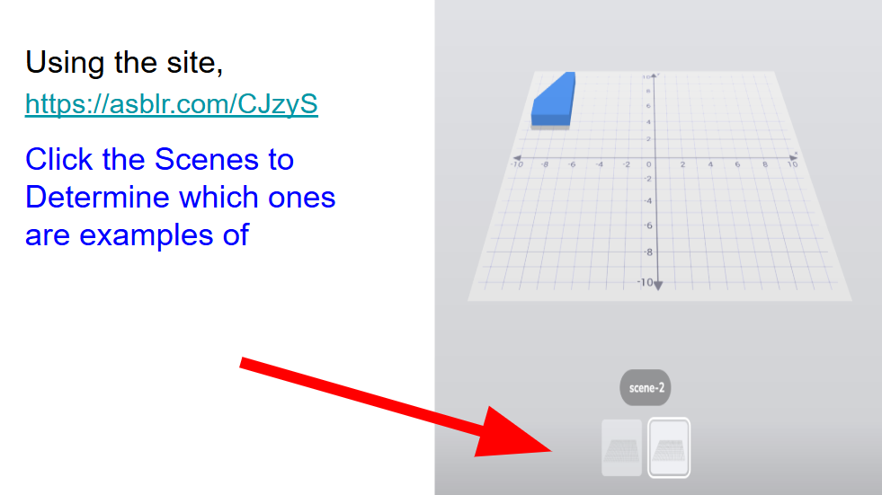
Figure 2. Slide highlighting Assemblr scenes.

Explore & Explain
After students familiarized themselves with the program, they were directed to an Assemblr scene where they observed a transformation and answered the displayed questions like, “On scene 1, describe the reflection.” An online timer posted on the screen informed students how long they could respond to each question. Teams had to agree on their answers and record them on a whiteboard at their table.
When the timer concluded, teams with correct answers sent a representative to the game board to play “dots” (see Figure 3; The Game Gal, 2018). On a small grid consisting only of dots, the team representative created a line segment by connecting two dots either vertically or horizontally. Teams created squares by connecting line segments around four dots. The team with the most squares at the end of class won the game. Placing segments was strategic because teams could use any existing segment on the board to help them create a square. This game was new to some students, but they picked up the rules quickly.
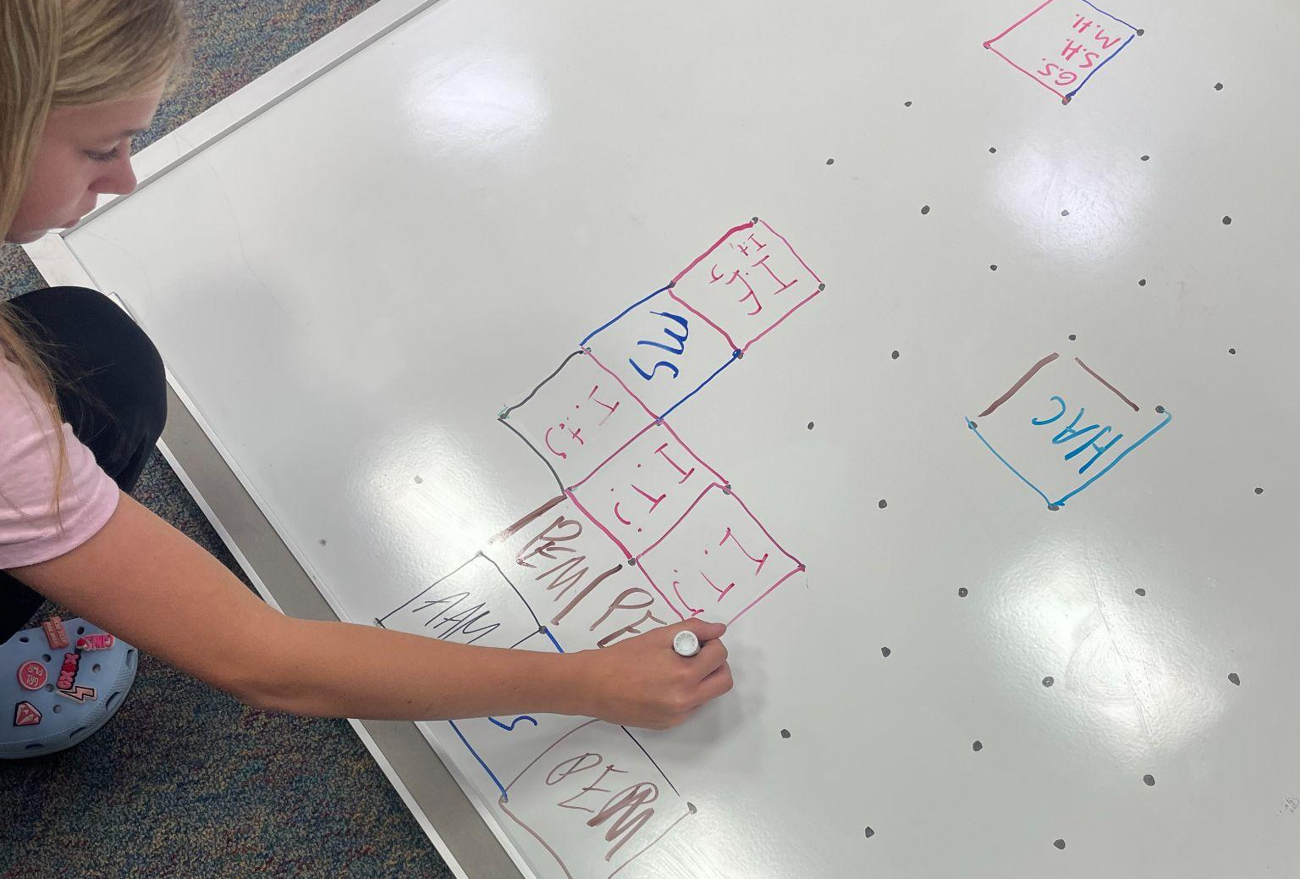
Figure 3. Students add lines to the connect the dots board.
We spent the first day continuing this process for a few rounds, letting team members work together to answer questions on specific screens, reviewing key terms related to transformations, and getting familiar with the dots game. This process set up teams for the competition on day two!

Elaborate
On day two of the transformation throwdown, students went back to their teams, opened their Google Slides, and opened a tab for Assemblr.
The competition began and the questions got a little more difficult. Instead of being directed to a specific scene and asked about the details of a given transformation, teams were given a series of transformations and asked to list all scenes that demonstrated the transformation (see Figure 4). Within the round, teams were directed to specifically find all scenes that matched criteria 1, “Translated into a new quadrant”. They were given either one or two minutes to complete the task and write the numbers of each scene meeting the criteria on their team whiteboard. When the timer expired, teachers checked for correct answers. Teams with correct answers placed a segment on the dot game board. For example, Round 1 had six opportunities for teams to demonstrate their understanding and make a segment on the dot game board.
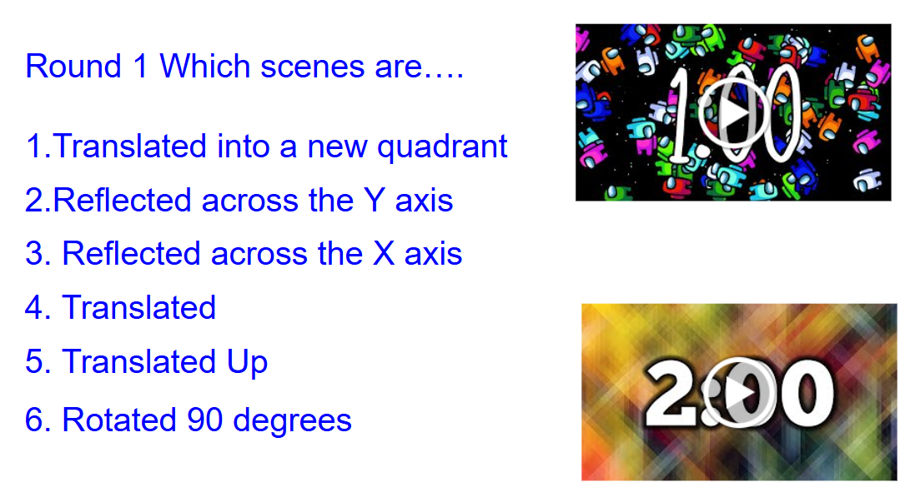
Figure 4. Instructions for Round 1 where students compiled a list of all scenes showing the identified transformations.
In the next round, teams were asked to complete the same task, but each scene showed a sequence of transformations rather than a single transformation. Teams used the features in Assemblr to drag and rotate the coordinate plane to view the transformation from different angles. They were able to get very specific about how they described the transformation. The conversations between the teammates were rich with academic math language as they debated which scenes included the specific criteria.
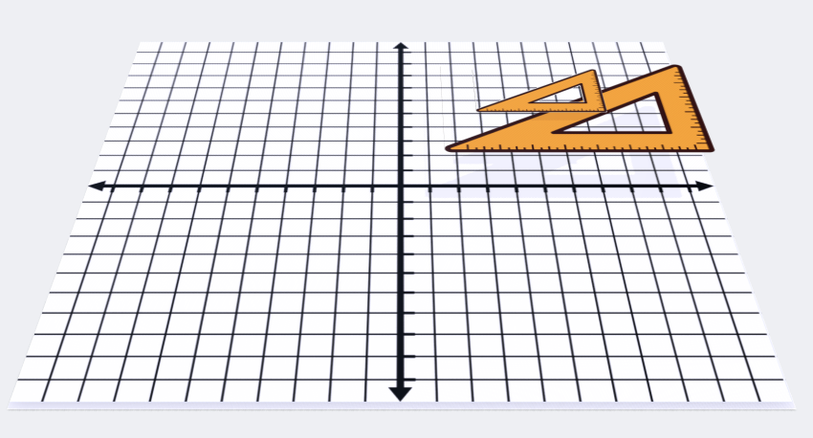
Figure 5. Initial view of polygons in Assemblr
For example, Figures 5 and 6 show the initial view of the polygons and the transformed view of the polygon scene, respectively. Paper assignments often show something like Figure 6, but from a more straight-on angle. Students are told which image is the pre-image and lean into procedural knowledge to arrive at their solution. In this activity with Assemblr, teams moved the plane around. Because the polygons almost seem to hover above the coordinate plane, there is somewhat less precision about the exact location of the vertices of the polygon. Lacking this precision led to conversations that pushed students to demonstrate a conceptual understanding of the whole process of the transformation. Students debated which image was the pre-image and why, explained why a translation might be a certain direction or distance, and proved a specific dilation scale factor to their other teammates by zooming in or out and pointing to the points they were using.
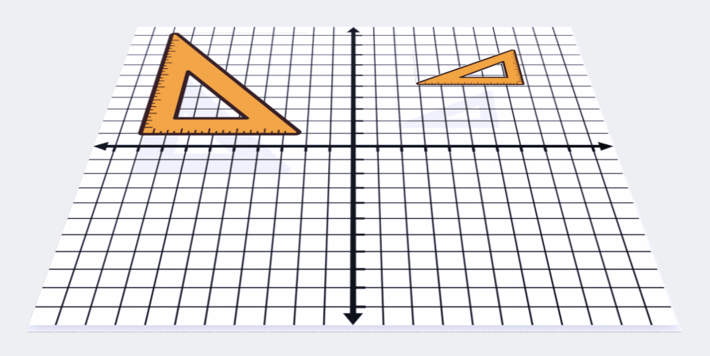
Figure 6. View of polygons in Assemblr after initiating transformation sequence.
In the following round, teams were asked to look for lines of symmetry as part of their criteria with three dimensional shapes (see Figure 7). Although this topic was briefly touched in class, this was a newer concept for these students, especially on a site where they were able to consider more lines of symmetry than the two-dimensional activities seen beforehand.
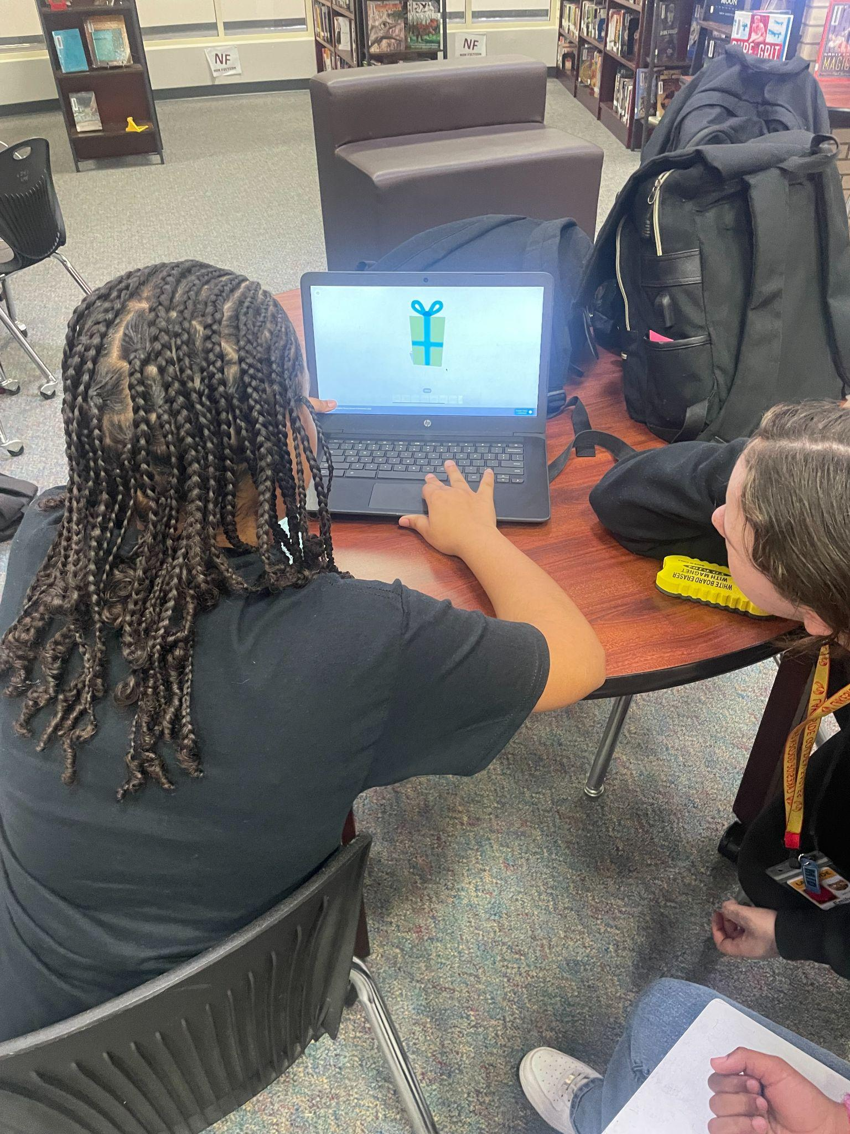
Figure 7. Identifying Lines of Symmetry
In the last round, teams were asked to compare three-dimensional figures existing on the same scene and on the same coordinate plane to determine which figures were congruent. This helped tie academic vocabulary and concepts to the rigid transformations they had seen in round one.

Evaluate
Teachers were able to evaluate students’ understanding by questioning their answers, listening to rich discussions of each team during challenges, and asking representatives who came to the dot board to elaborate on how they arrived at their conclusions.
In addition to evaluating their mathematical knowledge, after each intervention/enrichment period, students were encouraged to complete a brief survey about their experience via a Google Form. Students were asked to rate the activity on a scale of 1-5 and answer four reflection questions about the activity.
One third of students who completed the survey said that the Transformations Throw Down helped them to better visualize transformations.

Critical Reflection
While the teachers heard academically rich conversations throughout the activity, in the future they will create a reference sheet of “listen-for” statements or vocabulary to help assess and give feedback to groups in the activity.
In addition to evaluating their mathematical knowledge following the activity, after each intervention/enrichment period, students were encouraged to complete a brief survey about their experience via a Google Form. Students were asked to rate the activity on a scale of 1-5 and answer four reflection questions about the activity.
One third of students who completed the survey said that the Transformations Throw Down helped them better visualize transformations. Many students who rated the activity favorably noted that their favorite part of the Transformation Throw Down was the competitive nature of the activity.
This led the teachers to discuss how other more commonly known games might be utilized in the same or other similar mathematical lessons. In future iterations of this activity, we might use a game that is more familiar for the competition component, such as Connect 4.
Other ideas for improving the session included an additional class period so that there is enough time to have teams complete all challenge questions. While some groups were able to complete all rounds, it was rushed for just two 40-minute class periods and not all groups were able to accomplish every round. If an additional class period were added, it might allow students to create their own sequences and challenge questions using Assemblr to present to other teams. For either option, it would be important to have the initial experience so that students understand how the platform worked.
Another critical reflection was the realization that this activity might benefit all learners, not just those who had demonstrated proficiency in the standard. The visual of watching a reflection physically flip over an axis could help other students beyond the use of traditional physical manipulatives. It would be interesting to see how the teachers could adapt this lesson to a full 85-minute class period for all students rather than just the enrichment periods. Other keys to successful implementation of the lesson might include:
1. Making sure the game board isn’t too big for the dot game. The strategic thinking that comes with this game will be more apparent if the board is small enough that the teams end up playing off each other’s segments to build squares.
2. Strategically creating the teams. Some kids are more familiar with technology. Some are super competitive while others feel stressed by competition. By creating heterogeneous groupings, each team was able to use their strengths and learn from each other rather than feeling stuck or stressed.
3. If students are struggling with analysis paralysis, adding a speed bonus. For some classes, the starting rounds left students feeling stuck or too worried to write an answer on the board. When we added a speed component - a bonus line segment for the dot game for whichever team had the correct answer on their board first - students were willing to give it a try and write an answer down, even if they weren’t 100% confident.
4. Rotating team roles. The teams typically consisted of 3-4 students. If there was not a specific role given and rotated, there’s a good chance that one student is “in charge” of the computer or one student takes over all the dot game work. Student roles could include: image mover to rotate scenes in the Assemblr app, scribe (for the whiteboard), and marker of the lines on the gameboard. By rotating roles, students were motivated to work together and share their knowledge, especially when it came to the new concepts of the augmented reality platform or the dot game strategies.

References
Arkansas Department of Education. (2016). Arkansas Mathematics Standards Grades 6-8. https:// dese.ade.arkansas.gov/Files/20201211113747_Arkansas_Mathematics_Standards_6_8.pdf
Assemblr Studio. (2025). [Computer software]. https://studio.assemblrworld.com/projects
Bybee, R., & Landes, N. M. (1990). Science for life and living: An elementary school science program from Biological Sciences Curriculum Study. The American Biology Teacher, 52(2), 92-98. https://doi.org/10.2307/4449042
International Society for Technology in Education. (2017). ISTE standards: For educators. Retrieved May 19, 2025 from https://iste.org/standards/ educators
Johnson, B.T. (2024a, October 16) Transformations throw down congruent examples [Video]. YouTube. https://youtube.com/shorts/ bcdyZc7nOaM?feature=share
Johnson, B.T. (2024b, October 16). Transformations throw down lines of symmetry explanation [Video]. YouTube. https://youtu.be/XRrMgulytCg
Johnson, B.T. (2024c, October 16). Transformations throw down reflection explanation [Video]. YouTube. https://youtube.com/shorts/ZKoQTn-BapY
Kurniawan, P. Y., Nisa, E. K., Sari, F. K., & Ramdhan, N. A. (2024). Revolutionizing language learning: Exploring the efficacy of augmented reality technology through Assemblr Studio. E3S Web of Conferences, 500, 1–9. https://doi.org/ 10.1051/e3sconf/202450001020
Lampropoulos, G., Keramopoulos, E., Diamantaras, K., & Evangelidis, G. (2022). Augmented reality and gamification in education: A systematic literature review of research, applications, and empirical studies. Applied Sciences, 12(13), https://doi.org/10.3390/app12136809
The Game Gal. (2018) The dot game. Retrieved October 17, 2024 from https://www.thegamegal. com/2010/07/25/the-dot-game/
National Governors Association Center for Best Practices and Council of Chief State School Officers. (2010). Mathematics standards. Retrieved May 20, 2025 from https://www.thecorestandards.org/Math/
Sukriadi, S., Kusdar, K., Djangka, L., Muhlis, M., Febiola, D., & Salim, N. A. (2023). Feasibility of developing creative mathematics learning media augmented reality building materials. Technium Social Sciences Journal, 40, 139–147. https://doi.org/10.47577/tssj.v40i1.8480

About the Authors
Brian T. Johnson is the School Library Media Specialist at Lakeside Junior High School in Northwest Arkansas. He also serves as an adjunct professor for the University of Memphis in the Instruction and Curriculum Leadership department. His research interests include information literacy, coding in K-12 education, makerspaces, successful technology integration and flipped learning. He can be contacted at b.t.johnson16@gmail.com.
Rebecca Bramwell is an Instructional Facilitator at Lakeside Junior High School in Springdale, Arkansas. She has served as a math teacher for ten years. She holds a Math degree from Eastern Illinois University and a Master’s degree in Administration and Leadership from William Woods University. She is a Google Certified Educator and Trainer. Her favorite thing about education is the opportunity to collaborate with others to create meaningful learning opportunities for students.
Josef Stamps is an 8th grade math teacher at Lakeside Junior High School in Arkansas. He is a graduate of John Brown University and earned his Master’s degree in teaching through Arkansas State University. In his free time, he enjoys being outdoors, reading, and playing board games.
Katie Patterson is an 8th grade math teacher at Lakeside Junior High in Springdale, AR. She is a graduate of Kansas State University and received her M.Ed from Clemson University. In her free time, she enjoys hiking, reading and playing with her kids.
Kyle Jones is an 8th grade math teacher and football coach at Lakeside Junior High in Springdale, Arkansas. He graduated from Harding University with a bachelor's degree in Middle Level Math & Social Studies Education. In his free time, he enjoys fishing, hiking, and spending time with his wife.

Sharing & Modification Permissions
Unless otherwise noted, this article and its resources are published under a Creative Commons Attribution-NonCommercial-ShareAlike 4.0 International license:

You can freely share the article and its resources if you indicate the original authors, identify the Creative Commons license, and use them non-commercially.
You may also make and share modifications by:
- Identifying the original authors.
- Using the resources non-commercially.
- Licensing modifications under the CC BY-NC-SA 4.0 license (and including a link to it).
- Indicating what modifications were made.

