
Moving Beyond 2D Covalent Bonding:
Interactive 3D Experiences with
Water and Carbon Dioxide Molecules
  - Katheryn Ure¹ and Irene A. Bal²
¹St. Paul’s Schools, Maryland; ²Loyola University, Maryland
This article won the 2024 JTILT Technology-Rich Lesson Plan Competition. It was not peer-reviewed.

Overview
This three-lesson sequence is from a Bonding unit in a sophomore High School Chemistry class that focuses on the formation of covalent bonds in simple molecules. The purpose of these lessons is for students to apply their theoretical knowledge of atomic structure and electron arrangements, and understand, at an atomic level, why non-metal atoms share pairs of electrons to achieve electronic stability. Learning objectives are formatively assessed throughout the lessons, focused on addressing student misconceptions. This is done through drawing diagrams and making simple 2D models, through teacher-led question/answer and discussion, and an in-class worksheet. For this three-lesson sequence, eight three-dimensional (3D) experiences were created to support the visualization of the covalent bond formation and minimize students’ misconceptions. This paper focuses on two 3D experiences, water and carbon dioxide.
Topics: 3D Experiences, Bonding, Chemistry, Covalent Bonding, Hands on Learning, High School
Time: Three 50-60-minute classes

Materials
- Worksheet showing 11 single bond and multiple bond compounds (see Table 1)
- Counters
- Clear Plastic Sheets or mini (8” x 11”) white boards, dry erase markers & erasers
- Paper diagram of the Bohr atomic model
- Student Phones or other QR reading devices

Context-at-a-Glance
Setting
Suburban, all girls, independent high school in the northeastern United States.
Modality
In-person classroom
Organizational Norms
The school has a bring-your-own device policy and has access to a learning management system (LMS) and Microsoft Office 365.
Learner Characteristics
Learners were in 10th grade, all owned iOS devices, and most preferred physical papers and handwriting to complete work. Most students completed physics in 9th grade.
Instructor Characteristics
The lesson was designed by a Chemistry teacher and a Learning Design & Technology faculty member at a local university.
Curriculum Fit
The Chemistry class is divided into seven units over an academic year. This set of lessons falls within Unit 3 which focuses on Bonding.

Setup
For all three lessons, students work in small groups with each group receiving the following materials:
- Eight or more 4” x 4” squares of clear plastic (or mini white board), dry erase markers & erasers
- A large sheet of paper showing a simple Bohr atomic model diagram
- Multiple colored counters
In Lesson 2, students receive a worksheet that includes a partially completed table and information about the bonding and presentation conventions of 11 simple covalent molecules (see Table 1). This worksheet is completed over Lessons 2 and 3. The teacher should check the QR codes and ensure they are working, and students should be prepared to use phones for Lessons 2 and 3.

Context and Setting
This lesson took place at a suburban, all girls, independent high school in the northeastern United States during the 2023-2024 academic year. The school is a bring-your-own-device (BYOD) institution. Cell phones are allowed in class. Students have access to an LMS and Microsoft Office 365. Digital citizenship and technology use are taught at the beginning and throughout the year. Students complete both lab work and classwork. The teacher has access to a lab setting with counters, stools, and various equipment, and a traditional classroom setting with desks and chairs.

Learner Characteristics
Institutional Review Board (IRB) approval was obtained to report the following percentages:
- Sophomore (10th grade) high school students.
- 100% of the students had iOS devices (iPhones).
- 64.1% of students preferred to handwrite their answers while 25.64% preferred to type their answers (10.26% indicated handwriting and typing preference).
- 79.49% of students stated they knew which app to use for a QR code and 92.31% of students indicated they know how to access a link after scanning a QR code.
- 87.17% of students agreed they preferred a physical piece of paper for their work with 94.87% of students stating they like having access to a digital version of the printed worksheet.
- Students are still learning the challenges of Chemistry models and how to use and critique them effectively.
- In 9th grade, students take a mix of math courses (e.g., Geometry, Algebra 1/2). Most students (95%) took Physics in 9th grade.

Instructor Characteristics
The Chemistry teacher had a master’s degree in education and 16 years of experience teaching science. The Learning Design & Technology faculty member had a PhD in Instructional Design and Technology and 18 years of experience teaching PK-12 and higher education.

Fit within Larger Curriculum
The Chemistry class is divided into seven units. This set of lessons falls within Unit 3 on Bonding, typically presented in the middle of the school year. Prior to this unit, students learned states of matter, physical changes, separations, atomic structure, and trends in the periodic table. Students should understand the Bohr atomic model and be confident with the vocabulary of valence electron shells. Familiarity with the groups on the periodic table and how these relate to the number of valence electrons is useful. Covalent and ionic bonding are taught within this unit. It is immaterial whether ionic or covalent bonding is taught first and, often, the order of teaching responds to student questions about atom stability. This set of lessons focuses on covalent bonds in simple molecules.
The bonding unit falls after the atomic structure and electron configuration unit and spans approximately 12 lessons. The unit begins with information such as atoms rarely existing alone and that atoms must join in specific patterns (following specific rules) to make molecules and structures called compounds. The primary drivers of the bonding process are the structure of atoms and arrangement of valence of electrons achieving stability. Covalent bonding was focused on second, after ionic bonding, so these three lessons were taught near the middle of Unit 3 (Lessons 5-8 of 12).
The work increases in complexity and subtlety as the lessons progress, so the students collaborate and actively explore each other’s perspectives. Assessment of student learning is largely formative in these lessons with small group discussions during the lesson and question/answer sessions to assess knowledge and its application. The collaborative learning environment allows students to build confidence in their groups, so any questions are dissociated from any particular individual and corrections are a shared responsibility.

Learning Representation

Objectives
By the end of this three-lesson sequence, three learning objectives are met. Students can:
- Apply the octet rule to complete the valence shells of atoms by sharing pairs of electrons.
- Demonstrate how nonbonding and bonding pairs of electrons impact the shape of molecules.
- Decipher and encode molecular structures in three different conventions.

Lesson 1-Single Covalent Bonds

Review
Begin the first lesson with a review of atomic structure and electron configurations of the first 36 elements. Using the squares of clear plastic (or mini white boards), the Bohr model diagram, and counters, ask student groups to create diagrams and electron configurations (see Figure 1). Students should make and draw 2D electron arrangements in shells and give numerical electron arrangements as the teacher draws parallels between the atom’s position on the periodic table and the atomic structures. Most of the lesson is focused on this review.
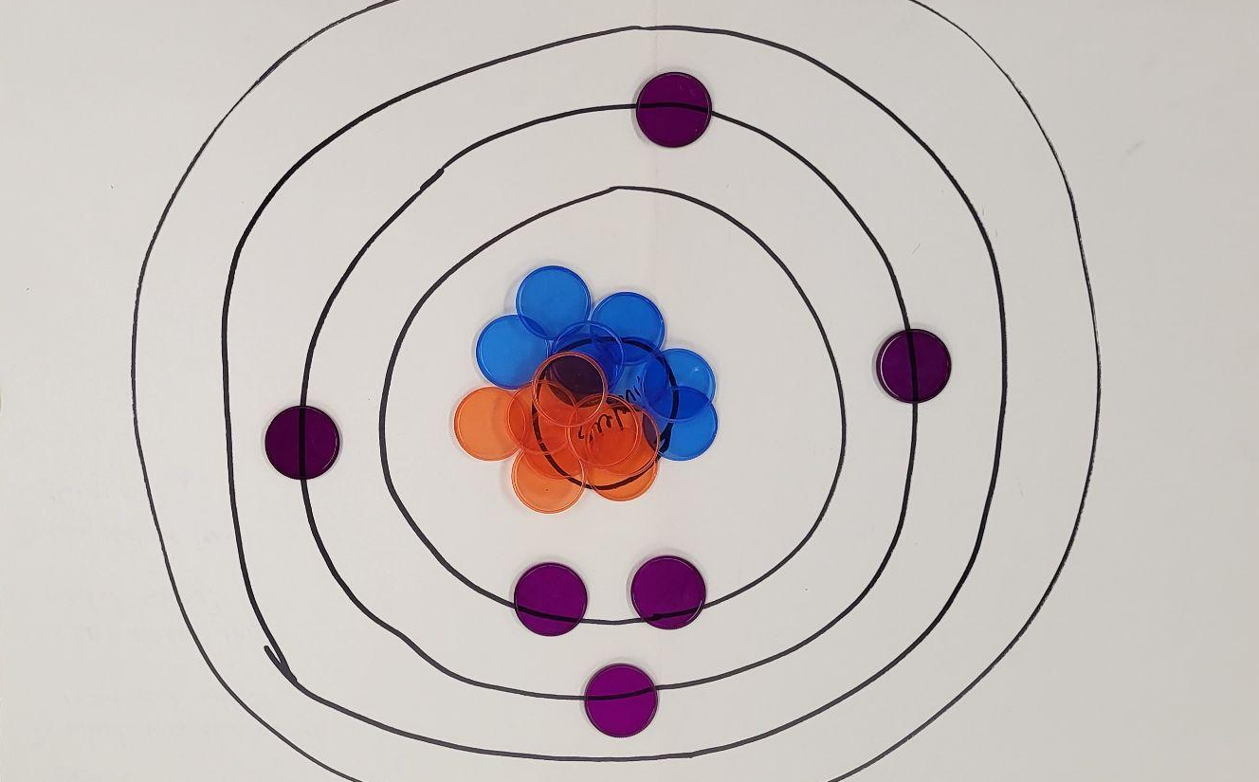
Figure 1. Bohr Model and counters to indicate protons, neutrons, and electrons.

Main Lesson
The main lesson includes a short lecture about atoms coming together to complete their valence shells and the Octet Rule to achieve stability. After the lecture, students engage with an interactive activity from PBS (Bruce, n.d.).
After engaging with the interactive PBS activity, students draw valence shells and their valence electrons for some Period 1 and 2 elements (from the periodic table) on clear plastic sheets and overlap the shells (sheets) to share pairs of electrons and complete the outer valence shells (see Figure 2). The worksheet for Lessons 2 and 3 is introduced, and students begin converting these models into diagrams on their worksheet (see Table 1).
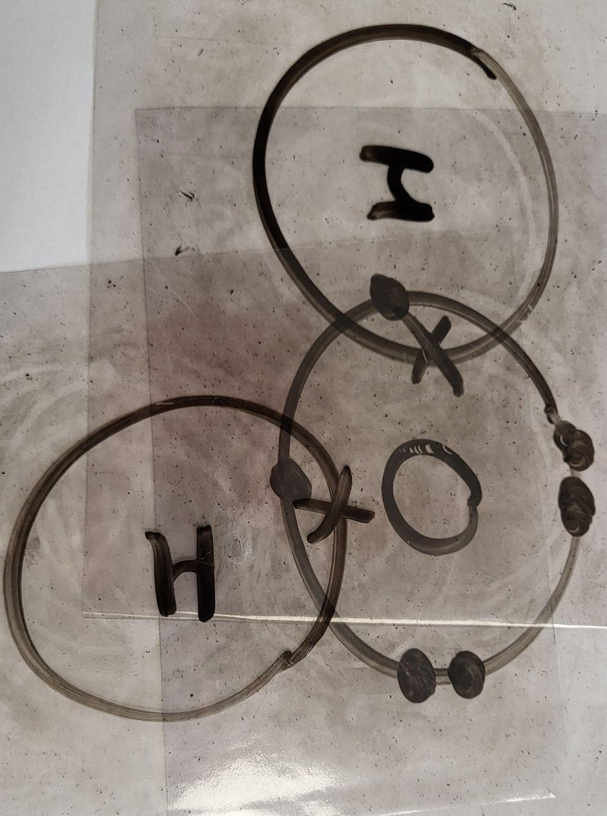
Figure 2. Water showing overlapped valence shells and their valence electrons.
Name | Formula | Atoms | Dot Cross & Lewis diagram | Structure
Water |  | 2 x H  1 x O |  | 
 | CO₂ |  |  | 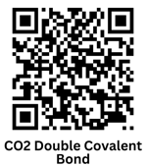
Table 1. Example of worksheet given to students with water and Carbon Dioxide (CO₂).
Students have access to the 3D experiences for the single bonded compounds in this lesson but tend to run out of time to view these experiences. They are focused on in Lesson 2.

Formative Assessment
During the main lesson portion of Lesson 1, the teacher circulates the room engaging each group in where they are in the activities (i.e., PBS, drawing valence shells, worksheet), and what questions they have. It is helpful for the teacher to redirect students who are off-task and ensure students are progressing at a pace that allows the whole class to be ready for Lesson 2.

Lesson 2-Single Covalent Bonds
Continued

Review
Start the lesson with a review of prior lesson content. Using clear plastic squares and dry erase markers, ask students to work collaboratively and make simple covalent bonds and molecules to reengage the content from lesson 1 (see Figure 2).

Main Lesson
The main work of the lesson starts with a short teacher-led explanation introducing the rules governing bonding pairs of electrons and nonbonding pairs of electrons and how these influence the shape of molecules while simultaneously satisfying the octet rule for each atom.
Students work in cooperative groups to complete the formulas and dot cross models on the worksheet (Table 1), focusing on creating simple molecules with single covalent bonds. Table 2 is a completed version of the worksheet focusing on water (H₂O). The worksheet contains information for a total of 11 simple molecules, seven of which use single covalent bonds. The simple molecules presented on the worksheet get progressively more complex. This article is only showcasing one single bonded molecule, water (H₂O; Bal & Ure, n.d.-b).
Students used the 3D experiences to interact with and visualize the bond formation and the geometric arrangement of bonding and nonbonding electron pairs around the atoms (see Figure 3 for the water 3D experience). The 3D experiences animate the traditional 2D models and support further discussion on the rules governing molecular shapes and number of covalent bonds formed.
Name | Formula | Atoms | Dot Cross & Lewis diagram | Structure
Water | H₂O | 2 x H  1 x O | 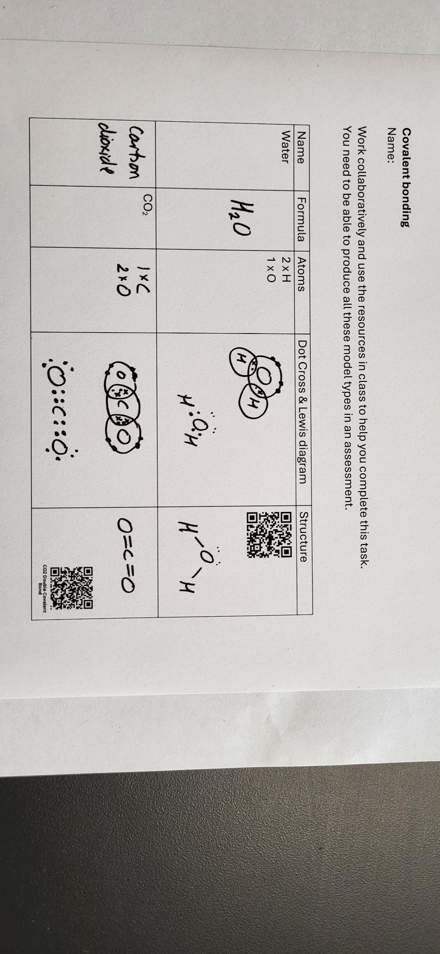
Table 2. Completed worksheet questions for water (Single Bond).
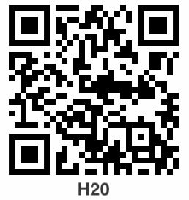
Figure 3. Water (H₂O) 3D experience.

Formative Assessment
During the main lesson, the teacher formatively assessed learning progress and challenged the students to consider the geometry of molecules such as water, ammonia, and methane using the position of nonbonding and bonding pairs of electrons to justify the molecular shapes. It is helpful for the teacher to intermittently check group worksheet responses to ensure accuracy, redirect students who are off-task, and ensure students are progressing at a pace that allows the whole class to be ready for multiple covalent bonds (Lesson 3).

Lesson 3-Multiple Covalent Bonds

Review/Formative Assessment
Start the lesson with a formative assessment using the mini whiteboards. Ask students to give the formulas and draw the dot cross models of molecules studied in Lesson 2 (e.g., water, methane).
Elicit, though a collaborative snowball discussion, the reasons for geometric molecular shape and how the covalent bonds satisfy the octet rule for each atom. This is both a review for students and a formative assessment for the teacher.

Main Lesson
If further time is needed to master the single bonded molecules, dot cross model, and the octet rule content, then it can be given here before moving on. It is imperative that students understand single bonds before moving to multiple bonds.
Using the squares of clear plastic (or mini white board) and dry erase markers, students explore the formation of multiple bonds to complete octet electron arrangements whilst simultaneously creating stable electron arrangements. Students work out the valence electron arrangements in oxygen gas, nitrogen gas, and carbon dioxide (see Figure 4). The 2D models are limited because the electrons cannot move. The 3D experiences provide animated, interactive visualization of electron rearrangement in the shells as they are shared between the pairs of nuclei (see Table 3 and Figure 5). Students can use the 3D experiences to create models of all types for multiple bonded molecules.
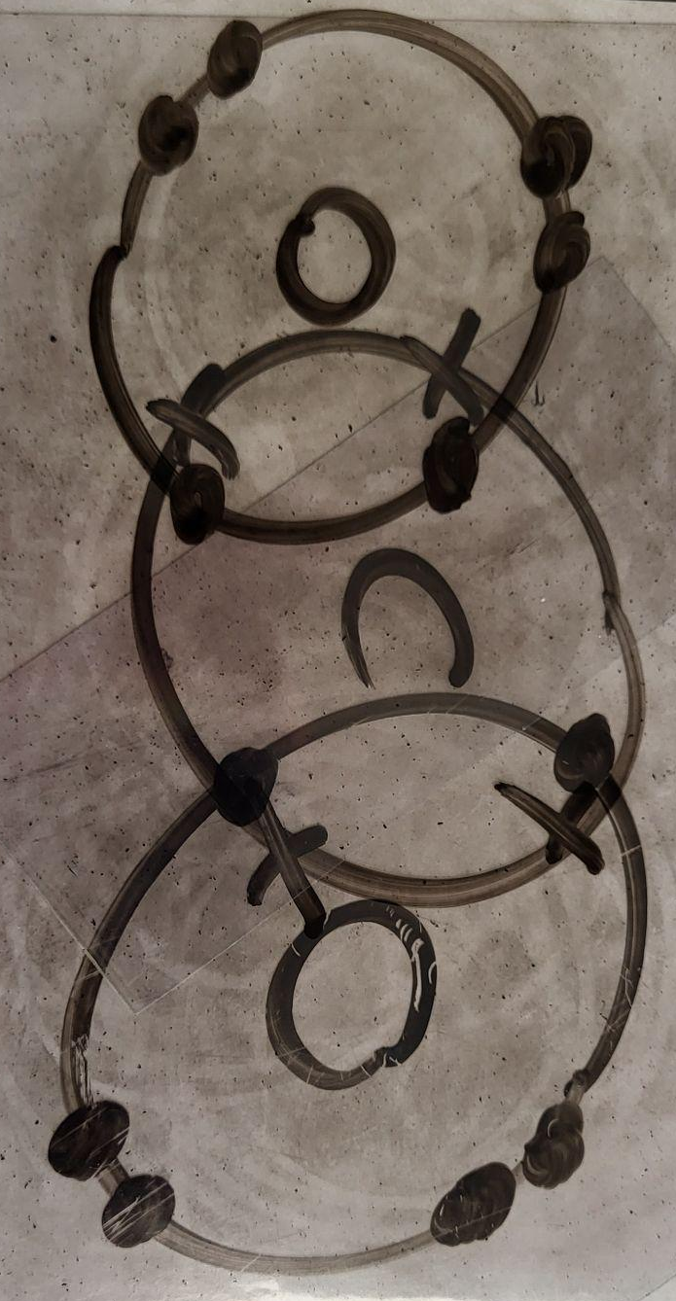
Figure 4. Carbon Dioxide showing overlapped valence shells and their valence electrons.
Students then return to the worksheet to complete the multiple covalent bonds. Four of the 11 items on the worksheet are multiple covalent bonds. This article is only showcasing one multiple bonded molecule, Carbon Dioxide (CO₂; Bal & Ure, n.d.-a).

Name | Formula | Atoms | Dot Cross & Lewis diagram | Structure
Carbon Dioxide | CO₂ | 1 x C  2 x O
Table 3. Completed worksheet questions for Carbon Dioxide (double bond).
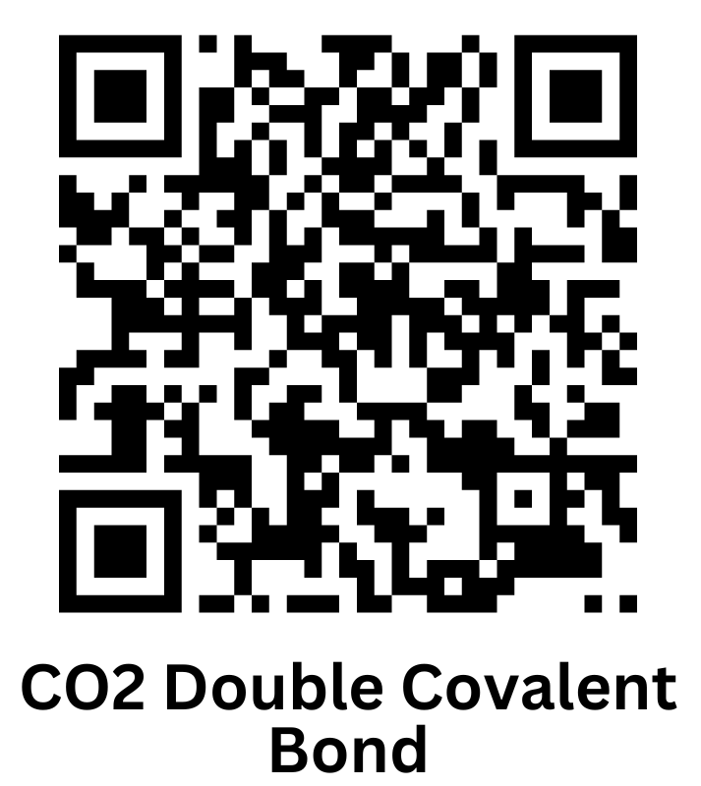
Figure 5. Carbon Dioxide (CO₂) 3D experience.

Formative Assessment
The teacher should circulate the classroom, assessing student understanding of molecular structure and the multiple bonds being formed. Close questioning can elicit whether the students are using the octet rule and an understanding of why each atom forms the number of bonds with different types of atoms. The teacher should also check worksheet responses to ensure accuracy.
The resulting completed worksheet is a comprehensive study guide for simple molecules that the students frequently refer to in their HS Chemistry lessons. It also provides the teacher with formative assessment feedback on the ability of students to apply prior learning on atomic structure to the formation of simple compounds.

Critical Reflection
This lesson sequence has been implemented annually from 2022-2024. These three covalent bonding lessons fit within a larger bonding unit, and the two featured 3D experiences, along with several others that were developed, provide an effective way for students to visualize the process of bond formation when incorporated into a sequence of other activities throughout the unit. Implementing the lessons requires clear instructions to students on the appropriate use of phones in the learning environment to avoid distractions or misuse. The experiences are web based which avoids the need for downloading apps, but instructors need to test the QR codes prior to each lesson to ensure the experiences are working. Further consideration is needed in the design of these experiences to ensure they continue to be available regardless of software updates, acquisitions, and discontinuations.
The students were more engaged when using the 3D experiences in this complex topic than in prior years without the experiences. The students were challenged to work collaboratively and construct their understanding of the concepts after group and class discussions. This collaboration extended their abilities and vocabulary as they had to articulate their understanding of the observed bond formation and relate this to prior learning on atomic structure.
In the 2023-2024 academic year, students’ (n = 34) perceptions were collected at the end of the unit with most students reporting a positive learning experience. When asked if they liked using the apps and 3D experiences on their phones, 85.29% of students agreed. Students also agreed (91.18%) that the apps and 3D experiences helped them understand the materials. Students value the opportunity to interact with electrons, see bond formation, and manipulate the final molecules to visualize the 3D structures. There are limitations to the created 3D experiences because inner electrons are not shown and the electrons remain static in the valence shells, but these are similar considerations when using the 2D Bohr models or ball and stick plastic molecular models.

References
Bal, I. A., & Ure, K. (n.d.-a). Carbon Dioxide 3D experience. Retrieved November 24, 2024, from https://app.vectary.com/p/223r7oSZ2VFJ2DWmTGfEfg
Bal, I. A., & Ure, K. (n.d.-b). Water (H₂O) 3D experience. Retrieved November 24, 2024, from https://app.vectary.com/p/3gl7GOWdq3FjGE6Bg5IV3j/
Bruce, C. (n.d.). Covalent bonding. PBS LearningMedia. Retrieved November 24, 2024, from https://mpt.pbslearningmedia.org/resource/lsps07.sci.phys.matter.covalentbond/covalent-bonding/

About the Authors
Katheryn Ure is a Teacher of Chemistry and Science Department Chair at St Paul's School for Girls, a member of The Saint Paul's Schools, in Maryland. She has an interest in the integration of augmented reality and three-dimensional learning opportunities into the teaching of theoretical Chemistry.
Irene A. Bal is an Assistant Teaching Professor of Educational Technology at Loyola University Maryland with research interests in microlearning, micro-credentials, teacher professional development, computational thinking, and computer science for preservice and inservice teachers, and innovative PK-12 classroom practices and technology.

Sharing & Modification Permissions
Unless otherwise noted, this article and its resources are published under a Creative Commons Attribution-NonCommercial-ShareAlike 4.0 International license:

You can freely share the article and its resources if you indicate the original authors, identify the Creative Commons license, and use them non-commercially.
You may also make and share modifications by:
- Identifying the original authors.
- Using the resources non-commercially.
- Licensing modifications under the CC BY-NC-SA 4.0 license (and including a link to it).
- Indicating what modifications were made.

