Podcasts and Practice:
An Approach for Teaching Vocabulary
  - David J. Mulder, Dordt University

Overview
This article explains an approach to support students’ mastery of vocabulary utilizing brief, instructor-created instructional podcasts and low-stakes formative assessment. Students learned the vocabulary outside of class time by listening to podcasts and had repeated opportunities to take and retake quizzes to work towards mastery of the essential vocabulary for the course. The students described in this article were undergraduate students taking a foundations of education course, but the practice is flexible and could be adapted for use in many different content areas and grade levels.
Topics: Educational Podcasting, Formative Assessment, Vocabulary Development
Time: Variable. In this article, students spent approximately 60 minutes each week learning and practicing vocabulary, spread out across 10 weeks of the semester.

Materials
- Vocabulary words and definitions
- Podcast recording software (e.g., GarageBand)
- Microphone
- Learning Managements System (LMS; e.g., Canvas or Google Classroom)
- Internet-capable devices for students
- Podcast for Standard 3-Learning Environments (MP3 file)
- Script for Standard 3-Learning Environments (MS Word document)

Context-at-a-glance
Setting
A foundations of education course for first-year undergraduate students in a teacher preparation program at a private, faith-based university located in the northern Midwest United States.
Modality
Face-to-face with a learning management system (LMS)
Class Structure
The course is a 15-week face-to-face course that meets one 75-minute period each week. Students taking the course also participate in a 10-hour field experience (one hour per week for 10 weeks of the semester) and have substantial outside-of-class work to learn new content and synthesize their learning through reflective writing.
Learner Characteristics
First-year undergraduate students (N = 68) exploring education as their major.
Instructor Characteristics
A university professor with over 25 years of experience teaching in PreK-12 and higher education who has taught more than 20 instances of the course.
Development Rationale
This approach was developed to support future teachers’ mastery of educational jargon. The focus was to move beyond rote memorization of vocabulary words to a working facility of terminology used by professionals in the field.

Context and Setting
This project was developed in the context of an educational foundations course for first-year undergraduate education majors at a private, faith-based university located in the northern Midwest United States. The course, entitled Introduction to Education, is the prerequisite course for all other coursework in the program, and is designed to help future teachers understand the whole field of education, and begin to develop a “teacher imagination.”
There were 68 students taking the course during the 2022-2023 academic year. These students were divided into three class sections: two sections in the fall semester with 28 students in each section, and one section in the spring semester with 12 students. All participants were exploring the field of education, but a wide variety of grade levels and many different content areas were represented among these students such as early childhood, elementary classroom, middle school subject areas, high school subject areas, PreK-12 subject areas, and special education.
The course is laid out over a 15-week semester, with one 75-minute class meeting each week. Along with class meetings, students taking Introduction to Education also participate in a 10-hour practicum (one hour each week for ten weeks of the course) as an early field experience. This field work gives these future teachers the opportunity to observe the things being discussed in class first-hand, and to have opportunities to work with real students in real classrooms at the grade level and content area they imagine themselves teaching.
With only one class meeting each week, students need to do a fair bit of out-of-class work to ensure they are prepared for the time spent in the classroom. This out-of-class work includes reading, reflective writing, and developing a working facility with key vocabulary used in the profession.
The learning representation described in this article focuses on the mastery of vocabulary. Because the course is intended to give a 30,000-foot view of the whole landscape of the teaching profession, future teachers taking Introduction to Education are expected to learn professional language utilized by contemporary educators. The goal is that they will have a working facility with the jargon regularly used in the field. Students are expected to learn the vocabulary prior to coming to class for the week and then be able to effectively recognize it and utilize it as part of their in-class learning. To support students’ learning and practicing of this vocabulary, the instructor created short instructional podcasts, to introduce the professional language, and low-stakes quizzes to practice and demonstrate their learning of the vocabulary.

Learning Representation

Introduction
Like most professions, the field of education has its own jargon, and preservice teachers need to become familiar with the professional language used by colleagues in the field. School reform advocate, Diane Ravitch (2010) described this teacher jargon in a slightly tongue-in-cheek manner as “the exotic and mysterious language spoken by educators” (p. 2). The question that arose when designing this course was, how can teacher educators best support future teachers’ mastery of this professional language?
I taught over 20 instances of Introduction to Education to first-year undergraduate students over the past twelve years. Over that time, I developed an approach utilizing podcasts, low stakes quizzing as part of the learning process, and practice assessments to foster mastery of a collection of approximately 120 vocabulary terms and acronyms.
The Introduction to Education course is a sweeping survey of the entire field of education. It is intended to give first-year students a foundation in all aspects of the profession such as professionalism and ethics, an exploration of learners and learning environments, an investigation of content knowledge and curriculum, and an introduction to pedagogical practices involved in planning, assessment, and instructional methods.
The learning sequence in this course is structured around an introduction to the InTASC Standards (Council of Chief State School Officers, 2011), which serve as a framework for our teacher preparation program. Along the way, students are expected to learn vocabulary related to these standards to ensure their understanding of key facets of the teaching profession.
There are three components included in the approach to teaching and practicing the professional language introduced in this course. First, students can learn the professional language by considering it in the context where it is used, rather than simply memorizing a list of definitions. Next, students can rehearse and demonstrate initial proficiency with the vocabulary by taking low stakes online quizzes. Finally, students can take practice assessments multiple times to approach mastery of the professional language.

The Approach for Teaching and
Practicing Vocabulary
The approach utilized in this course for teaching vocabulary is rooted in the Formative Assessment Framework developed by Black and Wiliam (2009). In particular, this learning sequence leverages the first three aspects of the framework:
- Clarifying and sharing learning intentions and criteria for success.
- Engineering effective learning tasks that elicit evidence of student understanding.
- Providing feedback that moves learners forward.
The approach for teaching and practicing professional language follows these aspects in sequence.

Clarifying and Sharing Learning Intentions
Early in the semester, I introduce the professional language component of the course, explaining it as an opportunity for preservice teachers to develop a working facility with the jargon used by professional teachers. I break down the full list of 120 vocabulary terms into subgroupings of 10-15 terms that correspond to the ten InTASC standards. For 10 weeks of the semester, we focus on one standard a week. Students listen to a podcast created by the instructor. They are expected to learn the jargon associated with that standard and use it fluently in class as we discuss the meaning and importance of the standard. I clearly lay out reasons for learning this professional language and the methodology for learning and practicing the professional language.
Each professional language list is shared with students through the LMS. I created an assignment page for each week to guide students with professional language (see Figure 1).
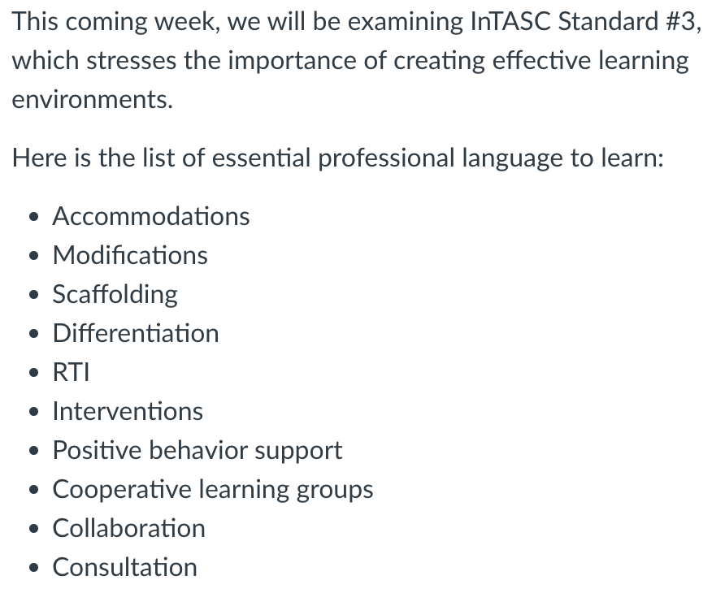
Figure 1: Screenshot of an assignment in the LMS, introducing the professional language to be learned and practiced as students prepared for the class meeting.

Engineering Effective Learning Tasks
To help students become familiar with the way teachers use the vocabulary, rather than just memorizing a list of terms and definitions, the instructor decided to create short podcasts that illustrate the professional language being used in context. Researchers recently explored educational podcasts as a useful strategy to support vocabulary acquisition, particularly in the field of language acquisition (see Elekaei et al., 2020; Hasan & Hoon, 2013; Indahsari, 2020). However, other researchers have specifically explored podcasts as a way of developing vocabulary within content-oriented courses, and advocate for this approach (see Kennedy et al., 2014; Putman & Kingsley, 2009). A total of 10 podcasts were created for the course.
A brief script was written for each podcast a that included the vocabulary to be learned that week in context. Each script was approximately two pages long, which was just long enough to give examples of how the 10-15 vocabulary words for that week are used by actual educators These scripts were read and recorded verbatim.
The podcasts are short, being only about five minutes long. Drew (2017) advised for the “quick burst” genre of educational podcast (p. 205) which was followed in the creation of the 10 podcasts. GarageBand, on a MacBook, was used to record the podcast episodes. A short song using loops was also created in GarageBand as introduction and closing music for each podcast. This music was used to give a consistent feel to each “episode.” I used a Blue Yeti microphone (Logitech, n.d.) to record my spoken audio and did a little light editing in GarageBand to correct the audio (see Figure 2).
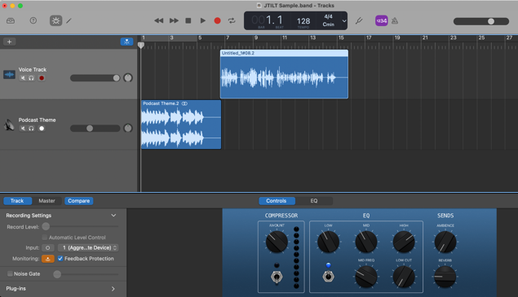
Figure 2: Editing a podcast episode in GarageBand.
I should note that I use GarageBand because it’s a tool I have used for several years for audio projects. It is an easy-to-learn tool, and free to use if you have access to Apple products. There are, however, a wide variety of tools, including many useful apps that are free for users, that can be used to create audio podcasts. For example, a smartphone with a free voice recorder app could be used very effectively to create such podcasts. A professional podcasting studio is certainly not required! There are a variety of free apps that can be used—both device-specific downloadable apps (like GarageBand, which I used in this instance, or Voice Recorder on a Windows-based PC) or web-based podcasting apps. If you are interested in exploring different tools, a quick web search for “free podcasting apps” will result in many different possibilities for tools you might utilize.
I saved the podcast episodes as MP3 files, and I embedded the audio files in pages in our LMS for easy access by students. I also saved my scripts for each podcast as PDFs and posted these on the assignment page alongside of the audio files, seeking to utilize Universal Design for Learning principles for supporting all learners (Tobin, 2014).
A sample podcast introducing the professional language for InTASC Standard 3: Learning Environments is included (see Podcast for Standard 3-Learning Environments MP3). The script used for that podcast episode is also included (see Script for Standard 3-Learning Environments PDF).

Providing Feedback that Moves Learners Forward
The author believes that feedback helps you grow, and feedback must be timely, specific, and actionable (Wormeli, 2023). Receiving immediate feedback while practicing is a research-based promising practice for closing the gap between students’ current performance and where they need to be (Hattie & Timperley, 2007).
To provide students with the opportunity to rehearse the vocabulary and get immediate feedback on their performance, low-stakes online quizzes were created in Canvas, the utilized LMS. Students can retake these quizzes as many times as they like, with the intent that multiple attempts will allow them to practice the terms they do not (yet) know in a low-stress approach to work towards mastery (Hinze & Rapp, 2014). Low-stakes quizzing for practice is considered a promising instructional practice for vocabulary development and retrieval practice (Kenney & Bailey, 2021; Rausch & McKenna, 2020).
The quiz feature in Canvas has several features that facilitate low stakes quizzes with repeated attempts. A question bank was created for each quiz with objective questions (i.e., multiple choice) for the vocabulary of the week (see Figure 3). Using multiple choice questions allowed the quizzes to be self-scoring for immediate feedback to students.
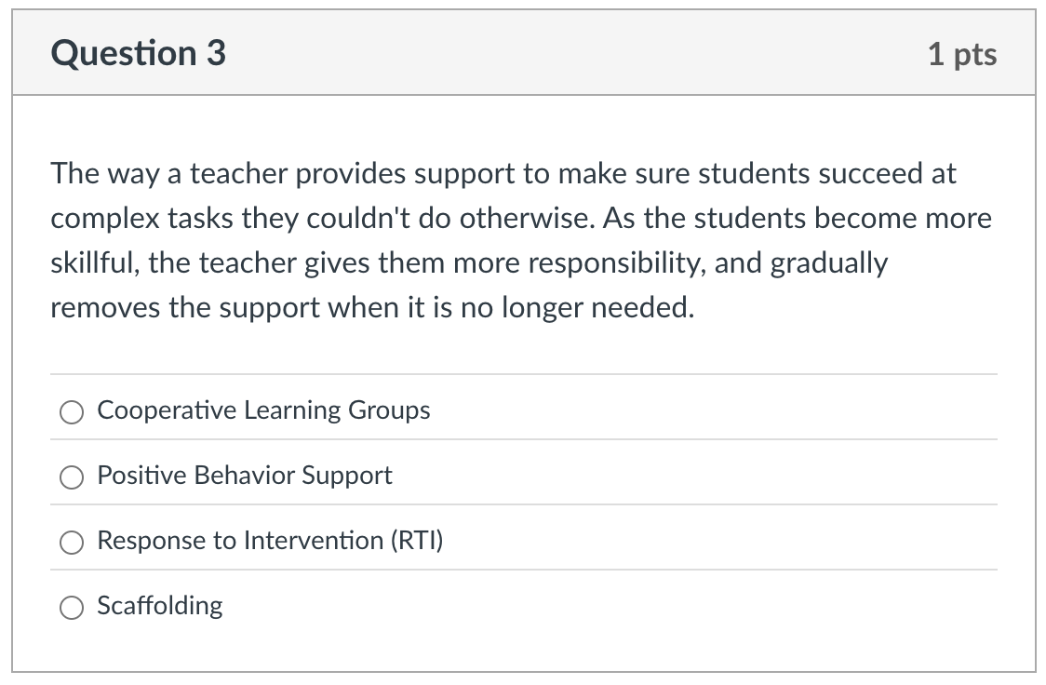
Figure 3: Screenshot of a sample quiz question. If students saw this question in a subsequent quiz, answer choice ordering differed, pushing them to understand the term being described, rather than rote memorization.
In each student attempt of the quiz, Canvas would pull in ten questions from the question bank and place them in a random order on the quiz page. This resulted in a unique quiz each time the student would take it. Also, Canvas allows the randomization of the answer choices, so even if a student saw the same question on a repeated attempt, they would not be able to just memorize, “Oh, the answer for that question is ‘C’” as the multiple choice answers would be mixed up. These features made the quizzes more of an opportunity for real practice, rather than just an exercise in rote memorization.
It was explained it to the students, “If you take the quiz and get six out of ten correct, that’s great—you knew six of the terms after listening to podcast! But you should get ten out of ten on each quiz. So, if you missed some, go back and listen again, or read the transcript. Then come and retake the quiz as many times as you need to score 10/10.”
Students took advantage of this retake approach. Being able to reimagine the quiz as an opportunity for practice resonated with them, and most students wound up scoring 10/10 after practicing.

Summative Assessment: Closing the
Loop
At the end of the semester, a summative assessment of all the professional language students learned throughout the semester was given as a part of their final exam. A Canvas quiz was used for this final professional language assessment, but there were a
few differences from the quizzes. First, for the final assessment, a random sample of 30 of the 120 learned vocabulary terms were pulled (similar to the question bank in the quizzes). The students did not have to demonstrate their knowledge on all 120 terms. Instead, they received 30 terms in the final assessment. Second, the final assessment is higher stakes, so students were allowed two attempts instead of the unlimited number of attempts in the quizzes. Since the question bank included all 120 learned vocabulary terms from the semester, most students would not receive the same words on their second attempt as they did on their first. The higher of the two scores was used in the gradebook as the final assessment evidence for learning this professional language.
To help students prepare for this higher-stakes final assessment, a practice exam was provided that students could take as many times as they wanted. This practice exam allowed students to get a feel for how the final (higher stakes) assessment would unfold. Being able to practice an exam in a lower stakes setting first can help students adapt to the high stakes setting (Hinze & Rapp, 2014). A majority of students took the practice quiz at least once.
The students responded well to this whole approach of listening to podcasts, taking weekly quizzes to demonstrate their learning, and having practice exams for the higher-stake testing. They clearly learned the professional jargon throughout the semester, and the evidence is clear in both the way they use the vocabulary throughout the class meetings, as well as in their scores on the final assessment.

Critical Reflection
I used this podcasting and practice approach for teaching educational jargon in Introduction to Education for several years, and I found it to be generally successful as a means of helping students develop working facility with the professional language. The results of the summative assessment are very encouraging. During the 2022-2023 academic year, 34 of my 68 students (50%) scored 30/30 on their final assessment. Another 20 of the 68 (29%) scored 29/30, and 4 of 68 (6%) scored 28/30.This means only 10 of the students (15%) scored lower than an “A” on this final assessment.
Interestingly, the analytics in Canvas also reveal how many times students took the quizzes as they practice. Most students (approximately 70%) attempted the quizzes two or three times. About 15% of the students attempted just one time, and about 15% attempted more than three times. One interesting outlier was one student who took fourteen attempts to score 10/10 on one quiz, demonstrating real tenacity in practicing.
After considering this data, I wanted to learn more about my students’ perceptions of how the podcasts and practice method worked. I created a brief survey with three open-ended questions and had students complete it via Google Forms at the end of the semester. The questions were:
- What were the pros of our approach for learning professional language?
- What were the cons?
- What else should I know?
The results were interesting, but not entirely surprising. The majority of the responses were very positive and affirming and gave a variety of reasons for their appreciation for this approach. Here are a few of the students’ responses to the first question, what were the pros of our approach for learning professional language:
- “I liked that I got to practice a lot and got 10/10 on every quiz.”
- “multiple retakes >>>>>>>>”
- “podcasts were good. short enough but still told me what I needed to know”
- “I was glad you always included the transcript because I preferred to read instead of listen.”
In response to the question about the cons of this approach, the most common response was “nothing!” which was gratifying for me. In fact, very few students named any critique of this approach at all. However, some students shared thoughtful comments, including:
- “Sometimes I wasn’t sure what the quiz questions meant because it wasn’t phrased the same way as what you said in the paper. But it worked out because I just retook the quiz until I got everything.”
- “The final quiz was harder than I thought it would be.”
Only a few students responded to the third, very open-ended prompt of “What else should I know?” Their comments were important, however:
- “I never listened to the podcasts, I just took the quizzes until I got them all right.”
- “Thanks for the way you structured this part of the class, I feel like I learned a lot!”
- “It seemed as if the professional language quizzes each week were just ‘tacked’ onto the content. They weren't connected to much in class or outside of class, other than the quizzes.”
The comment about never listening to the podcasts caught my attention. I also assume that this student did not read the transcripts, though this was not explicitly stated. This comment has me wondering about this student’s approach. It was apparently successful (enough?) that they did not feel that the instructional aspect was needed.
Likewise, this final comment about the tacked-on nature of the professional language assignments prompted some introspection on my part. While I was intentionally using the professional language as part of my lessons, they perhaps did not notice or realize this. Moving forward, I plan to be more intentional at naming the ways I am using the vocabulary as part of our lessons. I am also considering ways to have the students explicitly practice using the vocabulary as part of our in-class work, such as collaborative whiteboarding to define a few vocabulary words as part of the lesson. As another playful approach, I’m considering putting the list of the week’s professional language up on the board and challenging the whole class to speak aloud each word on the list throughout our class discussions, with the person who correctly uses the term in context running up to erase the word from the list.
This approach to developing a working facility with vocabulary has proven valuable and effective for my students. I believe this approach could be adapted to any content area and to almost any grade level.

References
Black, P., & Wiliam, D. (2009). Developing the theory of formative assessment. Educational Assessment, Evaluation and Accountability, 21(1), 5-31. https://doi.org/10.1007/s11092-008-9068-5
Council of Chief State School Officers. (2011, April). Interstate Teacher Assessment and Support Consortium (InTASC) Model Core Teaching Standards: A Resource for State Dialogue. CCSSO.
Drew, C. (2017). Educational podcasts: A genre analysis. E-Learning and Digital Media, 14(4), 201-211. http://dx.doi.org/10.1177/204275301 7736177
Elekaei, A., Tabrizi, H. H., & Chalak, A. (2020). Evaluating learners’ vocabulary gain and retention in an e-learning context using vocabulary podcasting tasks: A case study. Turkish Online Journal of Distance Education, 21(2), 190-203. https://doi.org/ 10.17718/tojde.728162
Hasan, M., & Hoon, T. B. (2013). Podcast applications in language learning: A review of recent studies. English Language Teaching, 6(2), 128-135. http://dx.doi.org/10.5539/elt.v6n2p128
Hattie, J., & Timperley, H. (2007). The power of feedback. Review of Educational Research, 77(1), 81-112. https://doi.org/10.3102/0034654302 98487
Hinze, S. R., & Rapp, D. N. (2014). Retrieval (sometimes) enhances learning: Performance pressure reduces the benefits of retrieval practice. Applied Cognitive Psychology, 28(4), 597-606. https://doi.org/10.1002/acp.3032
Indahsari, D. (2020). Using podcast for EFL students in language learning. Journal of English Educators Society, 5(2), 103-108. https://doi.org/10.21070/jees.v5i2.767
Kennedy, M. J., Thomas, C. N., Aronin, S., Newton, J. R., & Lloyd, J. W. (2014). Improving teacher candidate knowledge using content acquisition podcasts. Computers & Education, 70, 116-127. https://doi.org/10.1016/j.compedu.2013.08.010
Kenney, K. L., & Bailey, H. (2021). Low-stakes quizzes improve learning and reduce overconfidence in college students. Journal of the Scholarship of Teaching and Learning, 21(2), 79-92. https://doi.org/10.14434/josotl.v21i2.28650
Logitech. (n.d.). Yeti - Premium multi-pattern USB microphone with Blue VO!CE. https://www. logitechg.com/en-us/products/streaming-gear/yeti-premium-usb-microphone.988-000100.html?srsltid=AfmBOopQmH1gxy7WdCh8gCkJLrzjn17MJdcXPTPU0ivFfS3i4y7ImNZw
Putman, S. M., & Kingsley, T. (2009). The atoms family: Using podcasts to enhance the development of science vocabulary. The Reading Teacher, 63(2), 100-108. https://doi.org/10.1598/ RT.63.2.1
Rausch, T., & McKenna, K. (2020, October 27-30). Low stakes quizzing: A tool for practice not assessment [Paper presentation]. American Association for Adult and Continuing Education, 2020. https://files.eric.ed.gov/fulltext/ ED611620.pdf
Ravitch, D. (2010). Edspeak: A glossary of education terms, phrases, buzzwords, and jargon. ASCD.
Tobin, T. J. (2014). Increase your online student retention with Universal Design for Learning. Quarterly Review of Distance Education, 15(3), 13-24.
Wormeli, R. (2023). Fair isn't always equal: Assessment & grading in the differentiated classroom (2nd ed.) [eBook]. Routledge. (Original work published 2017) https://doi.org/10.4324/ 9781032681122

About the Author
David J. Mulder serves as Professor of Education at Dordt University, where he teaches courses in educational foundations, STEM education, and educational technology in both the undergraduate Teacher Preparation Program and the Master of Education program. His research interests include technology integration, social presence in online learning, and digital citizenship. He can be contacted about this lesson at david.mulder@dordt.edu.

Sharing & Modification Permissions
Unless otherwise noted, this article and its resources are published under a Creative Commons Attribution-NonCommercial-ShareAlike 4.0 International license:

You can freely share the article and its resources if you indicate the original authors, identify the Creative Commons license, and use them non-commercially.
You may also make and share modifications by:
- Identifying the original authors.
- Using the resources non-commercially.
- Licensing modifications under the CC BY-NC-SA 4.0 license (and including a link to it).
- Indicating what modifications were made.

