Differentiating Instruction with AI Tools
  - Tonia Bauer, University of South Carolina - Upstate

Overview
In their junior year, preservice teachers engaged in a lesson to facilitate the effective development of an integrated inquiry unit. Preservice teachers had to design at least three lesson plans they implemented during their clinical week. To assist preservice teachers in differentiating instruction, they experimented with using ChatGPT and the Poe feature Ludia to learn ways to differentiate instruction by unpacking the Science, ELA, Social Studies, or Math Standards.
The goal of this lesson was to ensure that preservice teachers understood what the standards meant and to provide ideas for differentiating their units and incorporating Universal Design for Learning (UDL) to meet student needs. Preservice teachers experimented with both AI tools to achieve these goals and reflected on the one they preferred with a rationale.
Topics: Artificial Intelligence, Differentiation, Integrated Unit Plan, Universal Design for Learning, Unpacking Standards
Time: one 75-minute class session

Materials
List materials needed for your learning representation:
- Differentiation and UDL Nearpod Presentation
- Comparing AI Tools Checklist
- Rubric for Integrated Inquiry Unit-Assessment Focus on Reflection
- AI websites (ChatGPT, Poe: Ludia)
- State K-12 standards (ELA, Science, Social Studies, Math)
- Laptops

Context-at-a-Glance
Setting
The lesson occurred in a public, four-year, accredited university in the southeastern United States.
Modality
In-person instruction
Class Structure
This session comprised a group of eight preservice teachers in a junior-level undergraduate course, six females and one male ranging from ages 21- 29, including seven Caucasians and one Latino. They created an integrated unit plan to implement during a clinical week in a K-3 grade setting in a local elementary school. The course involved a mix of lecture-based, discussion-based, hands-on, and project-based learning. This session was 75 minutes in length.
Organizational Norms
Preservice teachers worked collaboratively and respectfully with each other, sharing different perspectives as they explored using ChatGPT and Ludia to clarify the meanings of the standards and obtain ideas for differentiation instruction incorporating UDL.
Development Rationale
The goal of this lesson was to assist preservice teachers with using AI to help simplify state standards as they worked on developing an integrated unit plan.
Design Framework
Gagné's Nine Instruction Events (Gagné & Medsker, 1996; Ullah et al., 2015)

Setup
This lesson occurred in a classroom where preservice teachers sat in groups of two around a rectangular table. Organizing the preservice teachers in groups took approximately two minutes. Each group had copies of the standards for the subject area for their integrated inquiry unit.

Standards
Revised SC Literacy Competencies Indicator 4.7: “The teacher will be able to Differentiate instruction to meet the needs of all preservice teachers” (South Carolina Department of Education, 2024, p. 15).
INTASC Standard 4:
The teacher understands the central concepts, tools of inquiry, and structures of the discipline(s) he or she teaches and creates learning experiences that make these aspects of the discipline accessible and meaningful for preservice teachers to ensure mastery of the content (CCSSO, 2013, p. 24).

Context and Setting
This lesson occurred in a face-to-face classroom with eight undergraduate preservice teachers in a 400-level literacy course. It was a 75-minute session where preservice teachers worked with peers in a small group setting. The preservice teachers created an integrated unit plan, implemented during their clinical week in an elementary school in grades 1-3. The instructor grouped the preservice teachers with similar topics. For instance, three preservice teachers decided to work on habitats and chose to complete the group work for this lesson together. Groups consisted of 2-3 preservice teachers. The instructor guided group formation, but preservice teachers had some autonomy if their topics aligned.
Preservice teachers did not have assigned specific roles but collaboratively determined how to divide the task, drawing on norms established at the beginning of the semester such as respecting each other's opinions, refraining from using cell phones during class time, and engaging in class discussions.
Prior to the lesson, most of the preservice teachers had some experience with ChatGPT and had little to no experience with Ludia. This was determined with a quick Nearpod Poll which showed that 67 % agreed to having used ChatGPT and 87% stated they had no knowledge of Ludia (Differentiation and UDL Nearpod Presentation [PDF], slides 28-31). This led to providing a pre-written prompt to students to scaffold their use of the AI tools. The prompt was to help ease cognitive load and to model effective prompt engineering which is a critical skill when integrating AI into instructional planning. In terms of tool selection, the instructor chose ChatGPT because of its broad accessibility and preservice teachers’ familiarity with it. The instructor selected Ludia specifically for its alignment with the Universal Design Principles. These AI tools simplified the standards, provided learning goals, and generated differentiation ideas using the Universal Design for Learning.

Learning Representation
During this lesson, italic text identifies questions or prompts for the learners.

Introduction
First, preservice teachers had to join the lesson via Nearpod by going to https://nearpod.com/ and entering the instructor provided code. The instructor used Gagné's first instruction event to gain the preservice teacher's attention by asking, Differentiating, what is it? Moreover, what is it not? to activate thinking about the lesson's central concept. The preservice teachers wrote their responses using the collaborate feature within the Nearpod lesson and applying the second event of instruction-informing preservice teachers of the objectives (Gagné & Medsker, 1996; Differentiation and UDL Nearpod Presentation [PDF], slides 1-2). The instructor presented four goals for the lesson. One objective was Preservice teachers will be able to use generative AI Tools: ChatGPT and Ludia to simplify teaching standards and obtain ideas for differentiating instruction (Differentiation and UDL Nearpod Presentation [PDF], slide 3).
The instructor stimulated recall of prior knowledge (Gagné & Medsker, 1996) by engaging preservice teachers in a Think, Ink, Pair, share activity to answer the discussion prompt: List all of the differences between preservice teachers, which may account for ways we should match learning to them
(Differentiation and UDL Nearpod Presentation [PDF], slide 4). Preservice teachers responded, "Some may be visual preservice teachers, while some are more hands-on,” and "attention span."

Content Presentation
The instructor employed Gagné's fourth instruction event- presenting the content (Gagné & Medsker, 1996) by utilizing Nearpod slides to explain and elaborate on the meaning of differentiation regarding the planning of content, process, and product (Differentiation and UDL Nearpod Presentation [PDF], slides 5-15). Content refers to the knowledge and skills preservice teachers need to master; the method relates to the activities preservice teachers use to master the content, and the product deals with the instruction output (Tomlinson, n.d.). The instructor asked preservice teachers to share reasons for why we differentiate. The instructor provided a simplified definition of differentiation, which included instructing in various ways to meet preservice teachers' needs and maximize their opportunities for success (Tomlinson, n.d.).
The instructor explained some factors to consider when planning (Figure 1). These factors started with making decisions after giving a pre-assessment. These decisions included the curriculum, student readiness, interest, prior knowledge, content, process, and product (Oaksford & Jones, 2001, as cited in Hall, 2002).
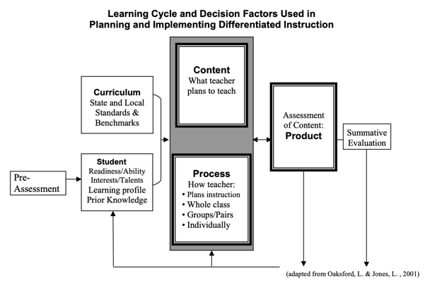
Figure 1. Learning cycle and decision factors.
The instructor explained the principles of a differentiated classroom. For example, the instructor explained that assessment and instruction are inseparable. Also, content, process, and product are tailored in response to student readiness, interests, and learning profile. The instructor elaborated on what differentiation is not (chaotic, individualized instruction, just modifying an assignment) and what it is (proactive, rooted in assessment, student-centered, and multiple approaches to content, process, and product). A short discussion ensued on the advantages of differentiation. Then, preservice teachers had the following discussion question: What do you think are some of the key challenges associated with implementing differentiation in the classroom? (Differentiation and UDL Nearpod Presentation [PDF], slide 16). See Figure 2 for some of the preservice teachers' responses where lack of time seemed to be the biggest challenge.
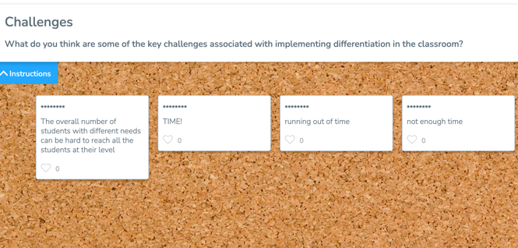
Figure 2. Challenges of differentiation.
The instructor presented essential tips to be mindful of, such as the need for learning activities to be engaging and exciting and the importance of balancing student-selected and teacher-selected assigned tasks. After the lecture and discussion, the instructor asked preservice teachers to share their prior experiences with the Universal Design for Learning (UDL) by completing an activity in Nearpod (Differentiation and UDL Nearpod Presentation [PDF], slide 20), which indicated that six preservice teachers had no prior knowledge of Universal Design for Learning knowledge.
The instructor explained that UDL is a scientifically valid framework for guiding educational practice (Differentiation and UDL Nearpod Presentation [PDF], slide 21). It provides flexibility in how educators present content and how preservice teachers respond or demonstrate knowledge and skills (CAST, n.d.). It also removes barriers to learning (U.S. Department of Education, 2024). Preservice teachers looked at images depicting equity and accessibility regarding UDL (Differentiation and UDL Nearpod Presentation [PDF], slide 22). Preservice teachers had to differentiate between differentiation and UDL by engaging in small groups (Differentiation and UDL Nearpod Presentation [PDF], slides 23). Two photos of road signs were on a slide. One stated, "Beware of
Moose" in four different languages; the other was a picture of a moose and a car. Preservice teachers engaged in a short discussion by answering the following questions:
- Which sign is differentiated?
- Which is UDL?
- Which would you put in a public road?
Preservice teachers shared their responses with supporting rationale. The instructor guided preservice teachers in understanding the connections between differentiation and UDL (Differentiation and UDL Nearpod Presentation [PDF], slides 24-27). For instance, UDL focuses on multiple means of representation that connect with content from differentiation. The differentiation process is closely related to the various means of action and expression in UDL, and the product from differentiation aligns with multiple means of engagement and different means of action and expression in UDL.

Practice
After explaining UDL, the instructor provided another poll in Nearpod with two questions and four responses to prepare preservice teachers to use ChatGPT and Ludia to simplify standards and ask for ideas to differentiate instruction for their integrated unit plan (Differentiation and UDL Nearpod Presentation [PDF], slides 28-31). One question asked, How often do you use ChatGPT?, and the other asked, How often do you use Ludia?. The answer choices were daily, weekly, occasionally, or never. The poll showed that 67% of students admitted to using ChatGPT occasionally, and 83% of students never used Ludia.
The instructor placed preservice teachers in small groups based on the similarities between the subjects/topics they were integrating into their unit plan. The instructor then provided learning guidance (Gagné & Medsker, 1996) to support preservice teachers as they applied their knowledge of differentiation and UDL using ChatGPT and Ludia (Differentiation and UDL Nearpod Presentation [PDF], slide 32). Preservice teachers used the written directions supported by the instructor's explanation of each step to complete the following tasks:
- Select a standard from your integrated unit plan and copy it.
- Google the AI tools "Poe-Ludia" and "ChatGPT"
- Use the following prompt to interact with both AI tools:
  - Prompt: "Simplify the following standard, provide learning goals and differentiated instruction ideas using the Universal Design for Learning (UDL), followed by a colon (:)
- After the colon, paste the standard you copied from your unit plan.
- Generate responses from both ChatGPT and Ludia.
The preservice teachers engaged in the activity, eliciting their performance (Gagné & Medsker, 1996). An example of a preservice teacher's prompt for a first-grade unit on plants was: "Simplify the following standard, provide differentiated instruction ideas using the Universal Design for Learning (UDL), followed by a colon: 1-LS1-1. Use materials to design a solution to a human problem by mimicking how plants and/or animals use their external parts to help them survive, grow, and meet their needs” (Next Generation Science Standards, n.d.).
The preservice teachers evaluated both AI tools based on the provided criteria. Comparing AI Tools [DOC] highlights criteria, including ease of use, alignment with standards, differentiation, and UDL strategies. The preservice teachers shared their thoughts about each tool. For instance, one learner stated that he preferred ChatGPT because it was more detailed and even explained the characteristics of UDL, although he did not ask it to. Another noted that she preferred Ludia because it provided specific examples to help differentiate preservice teachers with different needs.

Assessment
The instructor provided feedback (Gagné & Medsker, 1996) and conducted informal assessments as preservice teachers discussed and shared responses regarding differentiation with UDL using the AI tools. For enhancement and transfer (Gagné & Medsker, 1996), the instructor asked: After using Ludia and ChatGPT, which tool do you prefer to simplify standards and provide differentiation ideas using UDL? (Differentiation and UDL Nearpod Presentation [PDF], slides 34-35). Figure 3 reveals that 50% of students stated both, 33% of students stated ChatGPT, and 17 % did not respond.
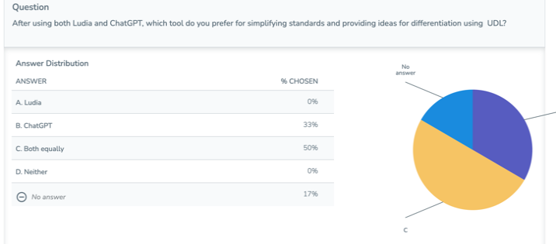
Figure 3. Preservice teachers preferred AI tool.
As an additional means of assessing preservice teachers' understanding of differentiating instruction using UDL, the instructor reviewed the preservice teachers' lesson plans for evidence of differentiation when they submitted it for approval before implementing it during the clinical week. Preservice teachers participated in a structured clinical experience carefully designed to support the application of skills learned in class and preparation for student teaching. The College of Education Field Placement Coordinator did the clinical placement, ensuring each preservice teacher was assigned to a public elementary school in grades K-3. Even when some preservice teachers were placed at the same school, they worked in different grade levels, ensuring each preservice teacher had an individualized experience. Preservice teachers were expected to implement all three lessons at their placement.
At the end of the preservice teachers' clinical week, they compiled their units, including a reflection on the implementation process, which they submitted via Blackboard LMS. The instructor assessed the preservice teachers' performance (Gagné & Medsker, 1996) using a rubric to evaluate their units, focusing specifically on the reflections submitted (see Rubric for Integrated Inquiry Unit-Assessment Focus on Reflection [DOC]). Additionally, the instructor evaluated the effectiveness of using ChatGPT and Ludia to simplify standards and generate ideas for differentiation instruction using UDL. All eight preservice teachers performed well. Presented are some sample excerpts from their reflections:
- “The biggest celebration for me was seeing the students go from such little knowledge of goods and services to building an understanding of them. I think seeing how much knowledge they could grasp in such a short amount of time was impressive. They surprised me with how they built their understanding in a few lessons."
- "Overall, I think this inquiry unit was informative and engaging for the students, but helpful in developing my ability to design engaging, student-centered lessons based on state standards. My lessons effectively captured student interest, promoted active engagement, and supported extended learning through Bloom's taxonomy."

Closing
To enhance retention and transfer (Gagné & Medsker, 1996), the instructor summarized the lesson and reminded preservice teachers to use AI as a tool for ideas rather than relying on it to write their papers. Preservice teachers shared how they plan on using these tools in the future for designing instruction and reflected on key insights gained from the lesson.

Critical Reflection
Overall, the lesson met its objectives. Preservice teachers were able to distinguish between differentiation and UDL and noted the connection between the two. They also effectively used ChatGPT and Ludia to simplify standards and obtain ideas for differentiating content, process, and product using UDL. At the end of the clinical week, preservice teachers turned in the entire unit with a reflection, which I evaluated using a rubric. The reflection from them demonstrated growth in understanding the state standards and using engaging activities during the implementation process. They also reflected on the student's development and how well it piqued their interests.
The instructor learned a few lessons throughout this process. The instructor spent more time on differentiation and less time on UDL. Since the preservice teachers had no prior knowledge of UDL, the instructor will plan another lesson in future iterations to solidify the concept for preservice teachers. Also, the instructor engaged more in lecturing with a few discussions within the lecture. In future lessons, the plan will be for preservice teachers to actively learn and construct knowledge with the instructor as a guide or facilitator.
Additionally, a preservice teacher asked the instructor if they could use their own prompt. In the future, the instructor will provide more time for preservice teachers to explore different prompt engineering opportunities and create their own prompts.
Another limitation is the ethical aspect of using AI as a tool. This became evident when a short discussion occurred regarding academic dishonesty. This observation demonstrated curiosity about the appropriate use of AI in academic and instructional settings. In future lessons, the instructor will build discussions on ethical uses of AI within lesson planning and create/implement scenarios where these tools are used unethically in higher education classrooms such as submitting AI generated work without citations or relying on AI to complete assignments. Additionally, using information gathered from the scenario discussions, the instructor would work with preservice teachers to create guidelines for utilizing generative AI ethically in the classroom. Finally, in future lessons or studies, preservice teachers will be given time to measure the effectiveness of AI tools by using provided criteria to determine the accuracy, quality, and developmental appropriateness of AI in designing instruction.

References
CAST. (n.d.). Evidence and benefits of UDL. Retrieved April 27, 2025, from https://www.cast.org/what-we-do/evidence/
CCSSO. (2013, April). InTASC: Model core teaching standards and learning progressions for teachers 1.0. https://753a0706.flowpaper.com/INTASC LearningProgressionsforTeachers/#page=1
Gagné, R. M., & Medsker, K. (1996). The conditions of learning: Training applications. Harcourt Brace College Publishers
Hall, T. (2002). Differentiated instruction: Effective classroom practices report. National Center on Accessing the General Curriculum. https://eclass.upatras.gr/modules/document/file.php/PDE1342/differentiated%20instruction.pdf
Next Generation Science Standards. (n.d.). 1-LS1-1 from molecules to organisms: Structures and processes. Retrieved April 27, 2025, from https://www.nextgenscience.org/pe/1-ls1-1-molecules-organisms-structures-and-processes
OpenAI. (2023). ChatGPT (Oct 31 version) [Large language model]. OpenAI. https://chat.openai.com/chat
Poe. (2023). Ludia (Version x.x) [Large language model]. https://poe.com/profile/Ludiachatbot
South Carolina Department of Education. (2024, May). South Carolina literacy competencies for PreK – 5th grade teachers. https://ed.sc.gov/ instruction/early-learning-and-literacy/literacy-specialists-and-coaches/south-carolina-literacy-competencies/sc-literacy-competencies-for-prek-5th/
Tomlinson, C. A. (n.d.). Differentiated instruction: Maximizing the learning of all students. IRIS Center. https://iris.peabody.vanderbilt.edu/ module/di/cresource/q2/p04/
Ullah, H., Rehman, A. U., & Bibi, S. (2015) Gagné's 9 events of instruction: A time-tested way to improve teaching. Pakistan Armed Forces Medical Journal, 65(4), 535-539. https://pafmj.org/PAFMJ/article/view/1009
U.S. Department of Education. (2024, October 21). Higher Education Opportunity Act of 2008. Retrieved April 27, 2025, https://www.ed.gov/ laws-and-policy/higher-education-laws-and-policy/higher-education-opportunity-act-of-2008

About the Author
Tonia Bauer, Ed.D., is an Assistant Professor of Early Childhood and Elementary Education with over 16 years of experience teaching in K–5 public schools. As an educator and researcher, she specializes in literacy instruction grounded in the Science of Reading, focusing on designing innovative, developmentally appropriate strategies for the classroom. Her work bridges theory and practice, particularly through integrating technology to support instructional planning and enhance student learning.

Sharing & Modification Permissions
Unless otherwise noted, this article and its resources are published under a Creative Commons Attribution-NonCommercial-ShareAlike 4.0 International license:

You can freely share the article and its resources if you indicate the original authors, identify the Creative Commons license, and use them non-commercially.
You may also make and share modifications by:
- Identifying the original authors.
- Using the resources non-commercially.
- Licensing modifications under the CC BY-NC-SA 4.0 license (including a link).
- Indicating what modifications were made.

