Robotic Badges for Girl Scouts:
Coding Exploration Integrated with
Multimodal Literacy
  - Meize Guo¹ and Jue Wang²
¹University of Florida, ²University of Idaho

Overview
This three-day computer science (CS) robotics coding exploration targets three Girl Scouts (n.d.) Brownie (2nd/3rd grades) badges. For each badge, a 60-minute session follows the 5E instructional model, which incorporates various robots to provide learners with diverse coding experiences. Throughout the coding exploration, learners engaged with real-life robot applications and used different robots to complete coding challenges. This learning exploration concluded by having learners complete at least one robot coding challenge per session, tailored to their capability, and utilize their expressive language skills to describe and explain their designed artifacts, algorithms, and block-based codes. This coding exploration can be extended to support broader elementary-level CS instruction.
Topics: Coding, Girl Scouts, K12 CS, Multimodal Literacy, Robots
Time: One hour per session, three sessions total

Materials
- LCD projector
- Masking tape in multiple colors
- Plastic cups
- Educational robots: Cubelets, BeeBots, Dash Robots (or other robots with similar functionality)
- Ipads with Internet access
- Paper and pencils
- Girl Scouts robotic badges slides: Day 1, Day 2, and Day 3 (Guo, n.d.-b, n.d.-c, n.d.-d)
- Learning Website: Think Like a Programmer (Guo, n.d.-f)

Context-at-a-glance
Setting
An informal learning experience for Girl Scouts Brownies in a rural area of the northwestern U.S., supporting three robotics badges.
Modality
In person
Class Structure
10-12 girls were divided into small groups (3-4 girls)
Organizational Norms
Providing more computer science (CS) access, raising awareness of CS significance, and developing knowledge of CS and computational thinking through diverse coding experiences for girls.
Learner Characteristics
Girl Scouts Brownies (2nd/3rd graders)
Instructor Characteristics
The instructors were the CS education and literacy faculty; the teaching assistants were Ph.D. students and preservice teachers.
Development Rationale
This coding exploration aimed to develop students' language literacy, technology literacy, CS knowledge, and coding skills through hands-on robotic activities. The collaboration with local Girl Scouts broadened CS access in a larger community, particularly by increasing girls’ participation. The goal is to attract more students' interest in CS and open a discussion about involving local communities in CS education.
Design Framework
5E Model of Instruction

Setup
The instructors need to pre-charge the robots and iPads, install and test the robot-related apps on the iPads, and set the pre-designed maps on the floor with masking tape before each session. The learning environment should include a projector for information presentation, tables and chairs for Cubelets activity, an indoor flat field/space for students' unplugged activities, and a flat field/space for educational robot (e.g., BeeBots and Dash Robots) movements. The Learning Website (Guo, n.d.-f) should be reviewed prior to each session. The instructors should estimate 30 minutes for this preparation, other than charging the robots and devices.

Standards
Idaho K12 Content Standards for Computer Science (n.d.):
- 3-5.D.02 Identify, using accurate terminology, simple hardware and software problems, and apply strategies for solving these problems (Grades K-5).
- 3-5.AP.02 Construct and test problem solutions using a block-based visual programming language, both independently and collaboratively (Grades K-5).
- 3-5.AP.05 Understand, explain, and debug the sequencing in an algorithm (Grades 3-5).
Idaho K12 Content Standards for English Language Arts/Literacy (Idaho State Department of Education, 2022):
- 2. ODC-2. Recount or describe key ideas or details from a text read aloud or information presented orally or through other media.
- 3. ODC-4. Report orally on a topic, tell a story, or recount an experience with appropriate facts and relevant, descriptive details, speaking clearly at an understandable pace.

Context and Setting
This three-day coding exploration aimed to provide young girls in a rural area in the northwestern U.S. with early exposure to Computer Science (CS). These

sessions supported young girls in exploring their interests in the CS field, developing their technology literacy, and experiencing various robots via hands-on coding activities. Primary CS knowledge was optional for participation in the lesson.
This lesson was developed for Girl Scouts Brownies (2nd/3rd graders) as a three-day informal learning experience. This lesson included three sessions that matched with three Girl Scouts (n.d.) Robotics badges:
- Designing Robots
- Showcasing Robots
- Programming Robots
Each session was 60 minutes long and hosted a maximum of 10-12 girls in one troop. This three-day coding exploration was delivered to two Girl Scouts Troops face-to-face at the university technology integration center, which housed various robots and plenty of CS teaching materials. This lesson employed three types of robots: Cubelets, BeeBots, and Dash Robots.
Since this three-day coding exploration was designed for these specific Girl Scouts Robotics badges, emphasizing robots and programming, the lesson designer purposely chose three standards from the state K12 content standards for CS (Algorithms and Programming). In addition to the CS standards, we adopted the English Language Arts/Literacy standards because New Literacy Studies (Gee, 2023; Sang, 2017) describe literacies as a multiplicity of practices that include engagement with multimodal texts. Taking this perspective allowed us to consider multimodal literacies in the CS coding context that invoked girls' awareness of literacy practices while coding robots. Girls were provided with opportunities to be consumers and inventors of these digital textual interactions during CS coding. Hence, in this lesson design, designers included three standards from the state K12 content standards for English Language Arts/Literacy (Oral and Digital Communications Strand) to encourage students’ exploration of multimodal literacies and open up spaces for digital text reading and interpretation, self-expression, and oral presentation.
The three-day coding exploration was designed to follow the 5E Model of Instruction (Bybee, 2014), and each session included five phases: Engage, Explore, Explain, Elaborate, and Evaluate, with each session emphasizing one of the five phases. For example, the Day 1 - Designing Robots session emphasized the Explain phase, encouraging the girls to describe their robots' design. The Day 2 - Showcasing Robots session emphasized the Explore phase, which provided the girls with opportunities to program the robots. The Day 3 - Think Like a Programmer session emphasized the Explore and Elaborate phases, which connected robot coding to real-life examples.
This three-day coding exploration involved lead instructors and teaching assistants to support content delivery. Before the sessions, all teaching assistants received a 30-minute workshop to familiarize themselves with the device usage, instructional activities, debugging strategies, and the possible errors students could make. The role of the lead instructors was to introduce the CS concepts and demonstrate the usage of robots, as well as to facilitate class discussion, hands-on practice, and learning debriefing. During each session, teaching assistants actively interacted with students to help with device usage, clear up concerns, debug the algorithm and programs, create inquiry plans, and answer the "in the moment” questions. After each session, all instructors and teaching assistants gathered to share critical reflections regarding the teaching processes. The instructors adjusted the instructional strategies based on the reflections for the following session and future teaching practices.
We employed various robots, such as modular robots (Cubelets), pre-built robots (BeeBots), and programmable robots (Dashes), that were available in our lab, to enrich and expand the students' coding experience. Since this lesson was specially designed for the Girl Scouts, we included female computer scientists and females in CS development on the learning website (Guo, n.d.-e, n.d.-f). The goal was to introduce CS to girls and encourage them to explore the CS field. Instructors had the flexibility to modify the content, session length, and room setup based on the size of the class, the space of the room, and the number of technical devices. The robots could be replaced by similar robots available to instructors.

Day 1 - Designing Robots
The Day 1 - Designing Robots session was a 60-minute lesson featuring Cubelets. Each of the 5E phases is provided with estimated timing for each phase. The Girl Scouts Robotic Badges - Day 1 slides (Guo, n.d.-b) will be needed for this lesson.

Engage (15 minutes)
First, lead a discussion on what computers, computer science, and computer scientists are using the prompts from the Learning Website, Intro to CS/CT page (Guo, n.d.-e). Then, let the girls imagine what a computer scientist looks like and have them draw a computer scientist avatar using the Avatar Maker (n.d.), sharing their art with each other once completed. Discuss the similarities and differences in their avatars. Next, the instructor introduces the famous female computer scientists in history (e.g., Ada Lovelace and Grace Hopper; see details in Girl Scouts Robotic Badges - Day 1 slides).
Ask the girls about their robots' experiences and allow them to describe their experiences with various robots and multiple contexts. Brainstorm with the girls about what they want the robots to do. Use the following questions as a guide to this discussion:
- Have you experienced any robots?
- What can these robots do?
- How do the robots function?
- What do robots mean to you?
- If you can design/create a robot, what do you want it to do?
Introduce the Cubelets (Modular Robotics, n.d.-a) to the girls and clarify that each functional robot needs to include at least one input module, one processing module, and one output module (review the Introduction to Cubelets guide; Modular Robotics, n.d.-c). Separate the girls into smaller groups, let them explore the different Cubelets modules, and challenge them to build robots.

Explore (25 minutes)
After playing around with and testing out the function of each Cubelets module, the girls should be able to combine Cubelets modules to build their functional robots with a free design. At this point, the teaching assistants challenge the girls to build three items: (a) a lighthouse, (b) a vehicle, and (c) an ambulance car, according to the girls' working pace (see Figure 1). These three challenge examples are selected because the design difficulty of these three prototypes gradually increases.
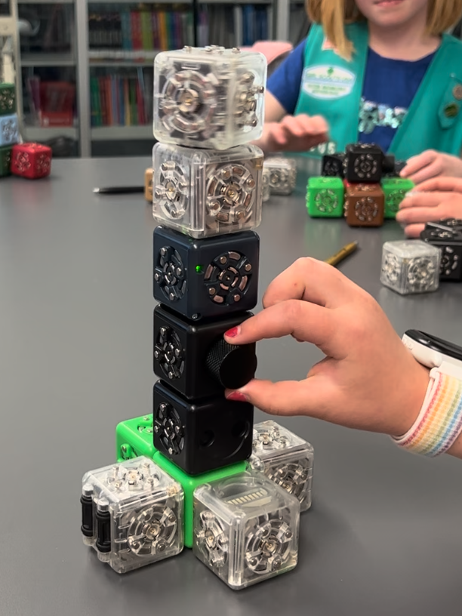
Figure 1. Girls are creating a Cubelets lighthouse.
During the process, the teaching assistants provide continuous guidance and feedback to support the girls in completing the challenges asking questions such as:
- What makes a lighthouse a lighthouse?
- What are the distinctive features of an ambulance?
In addition, the teaching assistants could ask constructive questions to encourage the girls to explain their robot design such as:
- Which cubes are necessary for the design?
- Which cube can be removed from the design but not impact the functions?
- What can this cube do?
- Why do you put this cube in here?
Beyond that, the teaching assistants should support the girls' debugging. For example, the Cubelets vehicle may not be going forward because the wheels are turning in different directions.

Explain (10 minutes)
Once the girls finalize their robots, the instructor invites each team to introduce their robots to the whole class, showcase their design and function, and explain how the robots work, how they were designed, and how they were debugged during the robot-building process (Idaho K-12 Content Standards for Computer Science, n.d.).
In this informal oral presentation, the girls demonstrate their understanding of the robots’ design based on the knowledge from previous engagement and exploration and their creative interpretation of the robot building. Through this practice, the overall oral expression skills, including applying technology vocabularies, conversational skills, contextual clues, rationale clarification, and academic presentation language, are addressed using the context of robot building presentation (Idaho State Department of Education, 2022).

Elaborate (5 minutes)
While the girls showcase and introduce their robots, the instructor reinforces the terms they use, such as input, processing, output, sensor, etc. Additionally, these CS terms can be used in various contexts, such as input and output for a computer. Due to the girls' backgrounds, the context in which the CS terms are used can be generative. For example, the processing cube could be the CPU in a computer.
The instructor can also link the girls' artifacts to real-life products around them and reinforce the language in a real-world context. For example, self-driving cars use distance sensors to sense objects around them.

Evaluate (5 Minutes)
Since this is an informal learning context, the instructors and teaching assistants evaluate the girls' learning by facilitating class discussions, asking open-ended questions, and getting direct responses from the girls.

Day 2 Showcasing Robots
The Day 2 - Showcasing Robots session was a 60-minute lesson featuring BeeBots. Each of the 5E phases is provided with estimated timing for each phase. The Girl Scouts Robotic Badges - Day 2 slides (Guo, n.d.-c) will be needed for this lesson. A BeeBots map taped on the floor needs to be completed prior to the lesson (see Figure 2). According to the number of students, the size of the map could be flexible. In this curriculum, the map was a 16 by 16 squared grid with a center hive (four-by-four grid), and the length of each squared grid’s side was 15 centimeters.

Engage (10 minutes)
Building upon what the girls learned on Day 1, this session goes beyond fundamental Cubelets design and focuses on programming and coding BeeBots. To begin the Day 2 lesson, several questions were prepared that used child-friendly terms to activate the girls’ prior knowledge of programming and coding:
- When I say programming/coding, what are the top three words in your mind? Why?
- What does a typical programmer/coder look like to you?
- What do you think programmers/coders can do?
After the girls’ responses to the questions, start with an unplugged activity, “Code Friends to get the BeeBots,” to engage them in preparing for the demonstration. In this game, pair the students up with one girl playing the robot and another playing the coder. Have the coder give step-by-step instructions to the robot to pick up an object off the floor. Remind the girls to give one step of instructions at a time. If there is time, have the girls switch roles.

Explore (25 minutes)
Introduce to the girls that an “algorithm” is a set of step-by-step instructions, and an algorithm describes how to perform a task (see Guo, n.d.-a). These steps are used to solve a problem or reach a result. Directly introducing the “algorithm” concept will facilitate the girls’ holistic understanding of basic programming logic and prepare them for the exploration activities. After a brief safety demonstration for the BeeBots including not putting hands close to the wheels of the BeeBots, treating the BeeBots as friends, and watching the BeeBots move but not moving with
them (see Girl Scouts Robotic Badges – Day 2 slides), the instructor codes the BeeBots with the girls step-by-step using the BeeBots code cards. Have the whole group observe and participate in the BeeBots operation collaboratively before they try it independently. For this lesson, there were enough BeeBots for each girl to use one. If you do not have a one-to-one match of BeeBots to learners, you can match students in pairs or small groups. The instructor should pass out or place the BeeBots in different places of the room for the independent use and introduce the guidelines for independent exploration:
- Think about the goal: What do you need to do?
- Step-by-step instructions: Write down all the steps.
- Test the codes: Run the BeeBots.
Using the guidelines, the girls practice identifying the moving distance, programming with cards, writing codes on paper, and testing the codes. The practice is conducted on a big BeeBots map on the floor (Figure 2), previously set up by the instructor(s). After a few minutes of free exploration, as the girls feel comfortable using the BeeBots, the instructor starts to challenge the groups by putting barriers on the map and encouraging the girls to code the robots to reach the center area by moving around the barriers. For this session, plastic cups were used as barriers (Figure 2). The girls are encouraged to write down their codes for the challenges and test them individually.
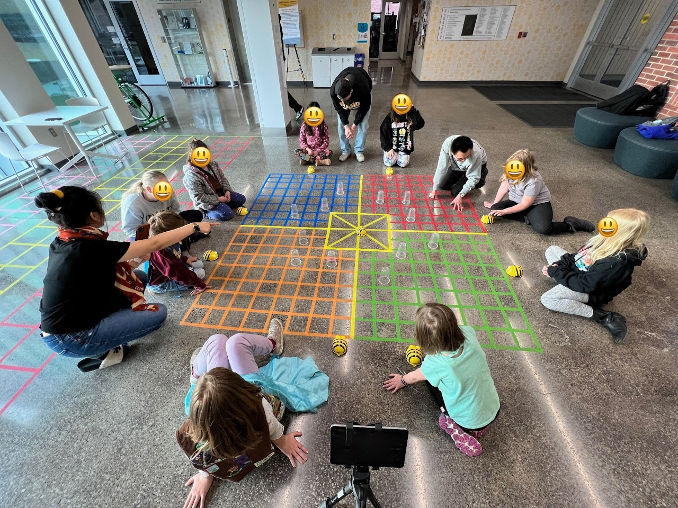
Figure 2. Girls are coding BeeBots and playing the “Hive Challenge” on the map.
Instructors and assistants give ongoing guidance and advice to the girls who struggle with coding. As soon as the individual exploration is completed, the instructor expands the challenge and endeavors a “Hive Challenge.” Every girl selects their starting point on the map and codes their BeeBots to reach the Hive Mark at the center of the map with the shortest algorithm. They can play the “Hive Challenge” multiple times if time allows.

Explain (15 minutes)
During the BeeBots challenge, the girls frequently use coding language to articulate their BeeBots exploration. The coding terms include algorithm, debugging, and turning right and left. When the girls explain, instructors and assistants employ questioning strategies to encourage their detailed expression. For instance, invite learners to describe the design processes of their routes with differentiated selections of starting points and levels of challenges. Girls' descriptive reasoning of the approaches and sequences of operating BeeBots demonstrate their ability to explicitly indicate selections, solutions, and rationales of BeeBots programming, which are aligned with the state content standards.

Elaborate (5 minutes)
The elaboration of BeeBots exploration manifests itself in three significant aspects. First, ask the girls to repeatedly elaborate on the BeeBots’ operations using coding terms during the process (see Guo, n.d.-f). Second, encourage them to demonstrate their flexibility in problem-solving. As observed in the BeeBots challenge, the girls used multiple approaches to problem-solving and did not necessarily follow the pre-planned paths throughout. For example, one girl separated the whole moving path into several segments and coded these segments one by one. Third, train the girls’ higher-order thinking skills by asking them to elaborate on the advantages and disadvantages of using BeeBots compared to Cubelets.

Evaluate (5 Minutes)
We recommend using a variety of informal ways, including norm-referenced and criterion-referenced evaluations, to assess the girls’ BeeBot learning outcomes. The informal assessments help instructors pinpoint the girls’ progress and locate areas where they may need more support for upcoming sessions. The following are examples of assessments we propose using in this Day 2 session.
- Observations of the girls’ engagements
- Oral presentations and explanations of coding processes
- Results of completed BeeBots challenges
- Interaction and discussion during activities
- Girls’ self-evaluation of BeeBots route designs and challenge completion

Day 3 Programming Robots
The Day 3 - Programming Robots session was a 60-minute lesson featuring Dash Robots. Each of the 5E phases is provided with estimated timing for each phase. The Girl Scouts Robotic Badges – Day 3 slides (Guo, n.d.-d) will be needed for this lesson. A coding map taped on the floor needs to be completed prior to the lesson (see Figure 4). Depending on the teaching space, the size of the coding map could be flexible. In this curriculum, each Dash robot ran on a two-by-ten squared grid map, and the length of each squared grid’s side was 30 centimeters.

Engage (10 minutes)
In order to build the connection between robots and real-life examples, we use a local food delivery robot system (Starship, n.d.) to show the girls how robots are used in their daily lives. The instructor orders bottles of water on the app with the girls together as the first thing in this session and uses the delivery waiting time to introduce the Dash Robots.
While waiting for the delivery in the classroom, the instructor introduces the Dash Robots, explains how to drive them for movement in the Go App (Wonder Workshop, n.d.), and provides safety guidance (see the Girl Scouts Robotic Badges – Day 3 slides). The Go App is an application that requires no coding and supports the movement of a Dash Robot through a joystick and buttons. At this moment, the girls experience driving the Dash Robots using the Go App.
When the delivery is getting close, the instructor and teaching assistants pause the Dash Robot introduction and take all the girls outside to watch how the robot is arriving at the delivery spot. The instructors and teaching assistants ask the girls constructive questions and discuss with the girls, such as:
- Why does the robot stop when a person is in front of it?
- How does the robot cross the intersection?
- How does the robot read the traffic lights?
- How do we ensure that only the buyer can open the robots to get the order?
Once the delivery robot arrives, allow the girls to explore the robot and observe how it delivers the water (Figure 3).
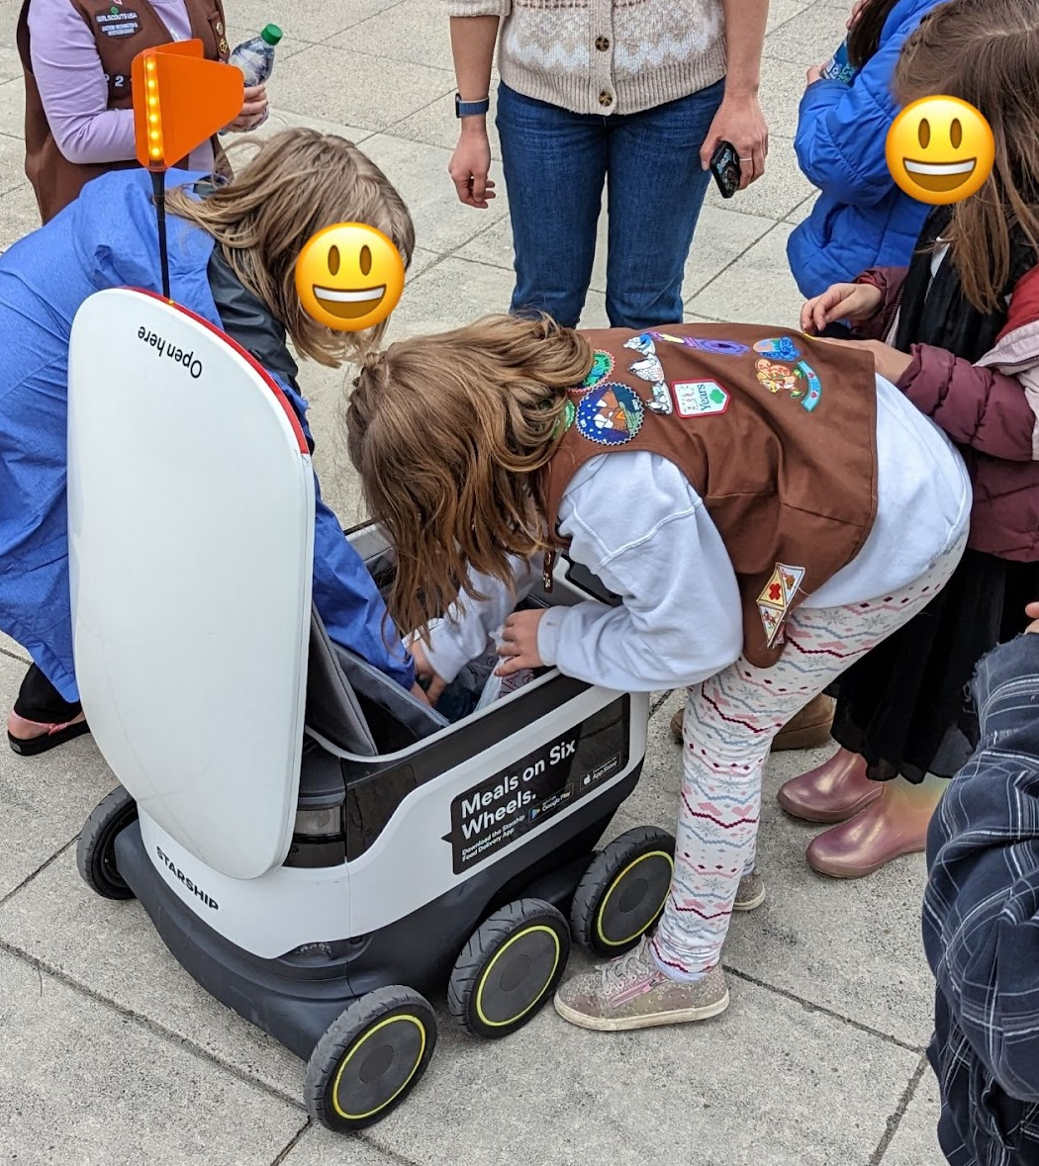
Figure 3. Girls are experiencing the Starship food delivery robots.
After getting the delivery from the Starship (n.d.) Robots, the instructor brings the girls back to the classroom and discusses using robots to deliver food based on what they observed earlier:
- We can use iPads to drive the Dash Robots, but who drives the Starship delivery robots?
- Who controls the Starship delivery robots?
- How to control multiple Starship delivery robots at the same time?
- Who else is involved in this progress, from ordering to receiving the products?
- What is the programmers' role in this progress?

Explore (30 minutes)
Let the girls compare the driving experiences of Robots with the Starship (n.d.) delivery experiences and emphasize that moving the robots is not good enough; moving the robots accurately and safely is more important in the real-life world. Then, introduce the Blocky App (Wonder Workshop, n.d.) and use block-based coding to move the robots controllably and accurately.
The instructor allows the girls to explore and become familiar with the robots and also control the robots via the Blocky App (Wonder Workshop, n.d.). Then, the instructor clarifies the numbers and distance settings in the Blocky App and explains the inch-to-centimeter conversion to the girls if necessary. The instructor and teaching assistants take the girls to the coding map, which was pre-designed and taped to the floor, and challenge the girls to deliver Lego pieces with Dash Robots in multiple ways: (a) deliver Legos to the endpoint, (b) deliver Legos to a selected location, and (c) deliver the Legos to a selected location and back to the start point. Teaching assistants can put obstacles, such as cups or cones, on the map to challenge the girls based on their capabilities (Figure 4).
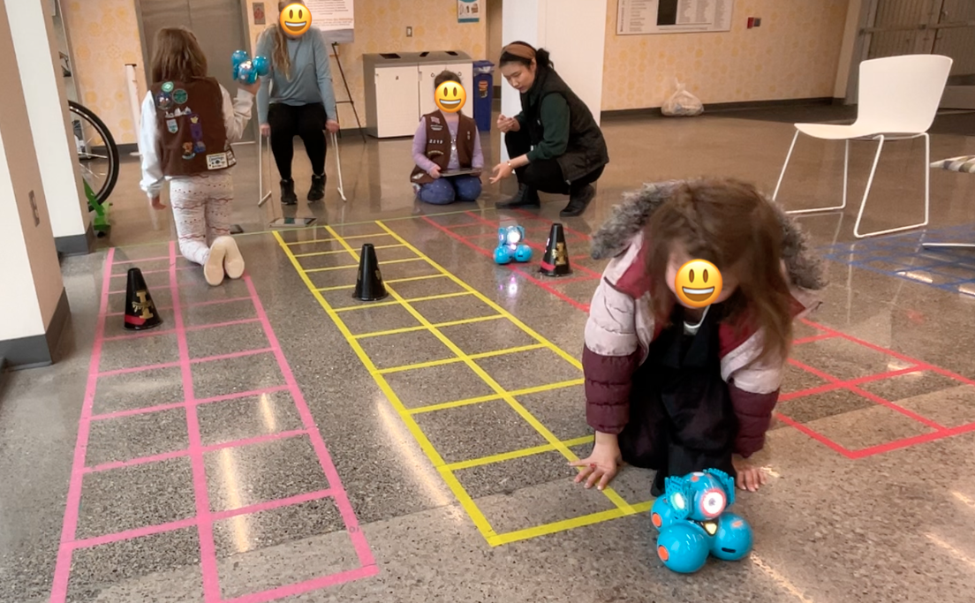
Figure 4. Girls are coding Dash Robots to avoid obstacles.
The teaching assistants should continuously guide and support the girls in completing the challenges during the process. For example, the teaching assistants could conduct a shared reading with the girls to read aloud the textual blocks on the app to consolidate the terms to code a Dash Robot. This quick reading activity also examines girls’ responses, interactions, and creations of digital texts before they use the digital texts as a tool to code their Dash Robots. Also, the teaching assistants should help the girls debug during their coding exploration. Meanwhile, we encourage the teaching assistants to have constructive conversations with the girls about how to make the codes more efficient and effective. For example, if multiple "move-forward" blocks are used, consider using a "repeat" block with numbers and one "move-forward" block together.
It is also valuable to inspire the girls to try out the other coding options in Dash Robots, such as the lights, the colors of the light, and the sounds. In addition, Dash Robots have a function that allows users to record their voices to customize the robots. Considering the possibilities of exploring the multiple coding options using the abundant vocabulary on the app, it is essential to discuss the girls’ multimodal literacy engagement and creation. In that context, the girls verbally, textually, and auditorily author their multimodal literacy interactions in Dash Robots play and see themselves as influential programmers. Implementing multimodal literacies would also provide girls opportunities to use multiple sources, such as the information on the Blocky App, guidelines, and other supportive materials to navigate solutions or find answers to the challenges and inquiries they encounter.

Explain (5 minutes)
During the exploration, the girls are encouraged to showcase how the Dash Robots completed the challenges, describe what blocks they used in the codes, and explain the function of their codes to the teaching assistants and instructors while completing the challenges. In the showcase, the girls expand their robot sponsorship to incorporate detailed illustrations of code planning and path designs that are used, expressed, and embodied in the Dash Robots coding exploration. Besides, encouraging the girls to articulate their coding experiences also increases opportunities for them to be owners and creators of technological material.

Elaborate (10 minutes)
The instructor brings all the girls back for a discussion, focusing on real-life robots, such as sweeping and food delivery robots in restaurants. What can robots do, and what can they not do? What are the advantages and disadvantages of using robots in our lives? When designing a robot, what do you want it to do?
If the girls have new questions, the instructors can contextually explain them. For instance, during the discussion, the girls asked about differentiating robots, artificial intelligence (AI), search engines (SE), and virtual assistants (VA), and the instructor also explained how programming matters in these implementations.

Evaluate (5 Minutes)
In this informal learning context, the instructors and teaching assistants evaluate the girls' learning by facilitating class discussions, asking open-ended questions, getting direct responses from the girls, and assisting them in completing the coding challenges.

Critical Reflection
This CS robotic coding exploration was implemented with 20 students from two Girl Scouts Brownies in the aforementioned classroom setting. Both implementations incorporated minor changes due to the girls' various knowledge backgrounds. We aligned the activities of each session with the state's content standards (Idaho K-12 Content Standards for Computer Science, n.d.; Idaho State Department of Education, 2022). For instance, the Cubelets Building activity on Day 1 (Designing Robots) focused on the CS standards 3-5.CS.02 and 3-5.AP.05, as well as the Language standards 2. ODC-2 and 3. ODC-4. The BeeBots Moving activity on Day 2 (Showcasing Robots) focused on CS standard 3-5.AP.05 and Language standards 2. ODC-2 and 3. ODC-4. The Dash Robots Driving activity on Day 3 (Programming Robots) focused on the CS standards 3-5.AP.02 and 3-5.AP.05 and the Language standards 2. ODC-2 and 3. ODC-4.
To expand CS access, we utilized a variety of robots (modular, pre-built, and programmable robots) in this exploration. We also provided multiple teaching assistants for timely feedback and sufficient support. The girls in both troops enjoyed exploring the different robots over the three days. We received exceptionally positive feedback from the Girl Scouts troop leaders, who noted that the level of engagement exceeded their expectations. This dynamic exploration, coupled with the design of creative artifacts, directly bridged real-life robot examples with CS concepts and coding. When parents and guardians picked up their children each day, we received many comments and inquiries about the different robots, coding language, and CS learning resources. The girls and the families in our community were more aware of the significance of learning CS, robotics, and coding since they observed the girls talking about their experiences and showcasing their artifacts.
In terms of developing students' CS knowledge and language skills, we observed that the girls demonstrated increased interest in applying CS concepts. For example, on Day 3, the girls challenged each other by moving the obstacles and coding Dash Robots for their designed paths instead of simply completing the given challenges. Regarding enhancing their language skills, the girls viewed multimodal literacies as tools to author their CS coding practice. For instance, they read and interpreted guidelines/questions on the daily slides, sought digital information on the Dash app to solve challenging coding problems, and adopted writing strategies to plan paths for the BeeBots movements. In addition, the girls began using more expressive language and coding terms while responding to the instructors’ questions and describing their coding designs. Particularly on the final day, the instructors and teaching assistants noted that the girls used more coding terms as expressive information and eloquent knowledge for articulations.
The activities of each session required the girls to continuously participate over the three-day exploration, following a specific sequence that gradually increased in difficulty. Although the girls had fun with the robots and grasped the basic CS concepts during the exploration, we had one emotional breakdown on Day 2. A girl cried because the challenge was too hard for her to complete. It was an unforeseen circumstance for one of the teaching assistants, who was a junior undergraduate student in a teacher education program. The Girl Scouts troop leaders and instructors intervened immediately, and that girl showed persistence in finishing the rest of the coding challenges. For future practice, we would ensure the teaching assistants receive training about emotional support in coding persistence. Also, to ensure full participation in all activities and to improve classroom management, we would use timers to secure equitable robot access for each student during group collaborations in the Cubelet activity. We also recommend that instructors include teaching assistants or practicum interns to help with robotic debugging, coding, and problem-solving.
The overall design of this exploration manifested an interplay of students’ CS coding and multimodal literacy practices. For further adoptions and implementations, however, based on the content/topic of coding projects, instructors could integrate extended multimodal literacy practices (e.g., reading, interpreting, responding to, interacting with, and creating technological and digital texts) before, during, and after the coding activities (Walsh, 2010, as cited in Hines, 2014). As such, this exploration created a cross-disciplinary engagement between computer science learning and multimodal literacy practices, highlighting the role of expression, innovation, and analytical skills in both content areas.
This three-day dynamic robotic exploration, including artifact creation and coding development, was purposely designed for the Girl Scouts Brownies (2nd/3rd graders). However, we selected the state CS standards that can be integrated into K-5 grade bands. In terms of integrating multimodal literacies into CS, instructors could customize the English language arts/literacy standards related to the oral and digital communication (ODC) strand to match the students' grade level. Regarding the unisex content, although the exploration was initially created for young girls, the instructor could modify the gender-related content and introduce the content more inclusively, such as "CS is for everyone" in regular classrooms.
The limitation of this exploration is the heavy reliance on specific robots (e.g., Cubelets) and services (e.g., Starship Delivery), which may not be accessible to all instructors. We suggest the instructors utilize their available modular, pre-built, and programmable robots and play robotic delivery videos as examples if there is no access to robot delivery. Each day's activities and challenges could be used separately in any informal CS learning scenarios (e.g., STEM night, Robots Day) or supplements for CS events (e.g., summer camp activities) at the elementary level based on students' prior CS knowledge and skills.

References
Avatar Maker. (n.d.). Free Avatar Maker. Retrieved May 23, 2024, from https://avatarmaker.com/
Bybee, R. W. (2014). The BSCS 5E instructional model: Personal reflections and contemporary implications. Science and Children, 51(8), 10-13.
Gee, J. P. (2023). Discourse and ‘the New Literacy Studies’. In The Routledge handbook of discourse analysis (pp. 469-480). Routledge.
Girl Scouts. (n.d.). Badges, journeys, and awards. Retrieved May 23, 2024, from https://www.girlscouts.org/en/members/for-girl-scouts/badges-journeys-awards.html
Guo, M. (n.d.-a). Algorithms. Retrieved November 3, 2024, from https://sites.google.com/view/girlscout2023/course-content/5-algorithms
Guo, M. (n.d.-b). Girl Scouts Robotic Badges - Day 1 [Slides]. Retrieved May 23, 2024, from https://bit.ly/girlscoutsbadge1
Guo, M. (n.d.-c). Girl Scouts Robotic Badges - Day 2 [Slides]. Retrieved May 23, 2024, from https://bit.ly/girlscoutsbadge2
Guo, M. (n.d.-d). Girl Scouts Robotic Badges - Day 3 [Slides]. Retrieved May 23, 2024, from https://bit.ly/girlscoutsbadge3
Guo, M. (n.d.-e). Intro to CS/CT. Retrieved November 3, 2024, from https://sites.google.com/view/girlscout2023/course-content/1-intro-to-cs-and-ct
Guo, M. (n.d.-f). Think like a programmer. Retrieved May 23, 2024, from https://sites.google.com/view/girlscout2023/home
Hines, S. (2014). Multimodal literacy and why it matters: A brief overview. Against the Grain, 26(4), 14-16, Article 55. https://doi.org/10.7771/2380-176X.6902
Idaho K-12 Content Standards for Computer Science. (n.d.). https://stem.idaho.gov/wp-content/uploads/2018/01/IdahoK-12ContentComputerScienceStandards-TableFormat-OfficialVersion.pdf
Idaho State Department of Education. (2022, January 3). Idaho Content Standards English Language Arts/Literacy. https://www.sde.idaho.gov/academic/ela-literacy/
Modular Robotics. (n.d.-a). Home. Retrieved November 3, 2024, from https://modrobotics.com/
Modular Robotics. (n.d.-b). Introduction to Cubelets. Retrieved November 3, 2024, from https://cubelet-files.s3.us-west-1.amazonaws.com/Introduction+to+Cubelets.pdf
Sang, Y. (2017). Expanded territories of "literacy": New literacies and multiliteracies. Journal of Education and Practice, 8(8), 16-19. https://files.eric.ed.gov/fulltext/EJ1139059.pdf
Starship. (n.d.). Home. Retrieved May 23, 2024, from https://www.starship.xyz/
Wonder Workshop. (n.d.). Products & Solutions. https://home.makewonder.com/apps

About the Authors
Dr. Meize Guo is a Research Assistant Scientist at the CSEveryone Center for Computer Science Education at the University of Florida. She centers her professional endeavors on supporting learners and educators in instructional design, technology integration, STEM education, and computer science education.
Dr. Jue Wang is an Assistant Professor of Literacy Studies in Curriculum and Instruction at the University of Idaho, the United States. She obtained her doctoral degree in Curriculum and Instruction from the Pennsylvania State University in 2021. Her research specializes in curriculum planning and literacy instruction, in particular for students in underserved communities. Jue has been training graduate students in ethnographic research methods and preservice teachers in early childhood and elementary literacies.

Sharing & Modification Permissions
Unless otherwise noted, this article and its resources are published under a Creative Commons Attribution-NonCommercial-ShareAlike 4.0 International license:

You can freely share the article and its resources if you indicate the original authors, identify the Creative Commons license, and use them non-commercially.
You may also make and share modifications by:
- Identifying the original authors.
- Using the resources non-commercially.
- Licensing modifications under the CC BY-NC-SA 4.0 license (and including a link to it).
- Indicating what modifications were made.

