Immersing Students in Classics: Turning Scenes from a Short Story into Interactive Posters Using Makey Makey Kits
  - Matthew Panozzo¹ and Jennifer Hockless²
¹University of Memphis, ²Annuciation Orthodox School

Overview
This lesson engages 7th grade students in a creative reading/writing project where they extend their knowledge of a text by utilizing block coding, sound recording, and Makey Makey kits which are "a digital toolkit that creates a closed-loop circuit by connecting alligator clips to conductive materials” (Turcotte, 2024, p. 1)—to create an interactive poster. This lesson requires students to move beyond comprehension to analysis and interpretation. This lesson could be adapted for any subject and grade level with the proper scaffolding and supports.
Topics: Block Coding, Close Reading, Design-Thinking, Problem-solving, Project-Based Learning
Time: Two to four 50-minute class periods.

Materials
- Makey Makey Classic Kits
- Makey Makey Educator's Guide (Deck & Moyer, 2018)
- Bag of Wonder Activity
- Interactive Poster Story Board
- Makey Makey Project Checklist
- Teacher Modeling Outline
- Projector and display screen/flat panel
- Internet-enabled computers with a USB port
- Recording device
- Snap! (n.d.-b)
- Construction paper and markers
- Conductive materials (e.g., brass tacks, paperclips)
- Insulating materials (e.g., plastic straws, tape)
- 5mm LED bulbs in multiple colors
- Short stories

Context-at-a-glance
Setting
Private middle school in a major metropolitan city in the United States.
Modality
Face-to-Face
Class Structure
Class of 15-20 middle school students which met 3-4 times a week.
Organizational Norms
The school prioritizes engaging students in critical thinking and problem solving through project-based learning. Professional learning communities facilitate cross-curricular, multi-grade level collaboration.
Learner Characteristics
Students had prior experience with conductive material, block coding, and collaboration through previous curriculum. They were new to Makey Makey kits.
Instructor Characteristics
Two instructors collaborated for this lesson. The English teacher was a digital literacy specialist. The Middle School Innovation Coordinator brought STEM and technology expertise to the lesson.
Development Rationale
This lesson was created to engage students in a fun, creative manner while promoting creative writing merged with skill building and logical coding processes.
Design Framework Design Thinking, Project-Based Learning (PBL)

Standards
This lesson supports the following Common Core State Standards Initiative (CCSS, n.d.), International Society of Technology in Education (2016), and International Technology and Engineering Educators Association (ITEEA, 2020) standards:
ELA-LITERACY.RL.7.1 - Cite several pieces of textual evidence to support analysis of what the text says explicitly as well as inferences drawn from the text (CCSS, n.d.)
ELA-LITERACY.RL.7.3 - Analyze how particular elements of a story or drama interact (e.g., how setting shapes the characters or plot; CCSS, n.d.)
1.4a - Students know and use a deliberate design process for generating ideas and creating innovative artifacts (International Society of Technology in Education, 2016)
1M - Apply creative problem-solving strategies to the improvement of existing devices or processes or the development of new approaches (ITEEA, 2020)
2M - Differentiate between inputs, processes, outputs, and feedback in technological systems (ITEEA, 2020)

Prerequisite
To support students through this project, teachers should take time to familiarize themselves with Makey Makey boards and block-coding. The Makey Makey Educator’s Guide supports educators at any entry point in using Makey Makey kits in the classroom. There are also several YouTube videos with clear instructions such as the Makey Makey First Time Plug-In and Troubleshooting Guide video (Makey Makey, 2021).

Setup
We spent one-to-two hours organizing materials into kits that would be checked out by the student partners. This involved unboxing the Makey Makey board, USB cable, alligator clips, and wires and adding them to a larger bag which included a variety of conductive and insulator materials that could be used on their posters.
Before the main lesson, the instructors spent one 50-minute class period reviewing conductive and insulator materials. They also used this time to pre-teach block coding and the Makey Makey boards since most students were unfamiliar with these resources. Please see the “Optional Step A” and “Optional Step B” sections for more details. If students are familiar with Makey Makey boards and Snap!, the “Optional Step A” and “Optional Step B” can be skipped.
For the main lesson, students were paired up and the desks were arranged in pairs so the student partners had plenty of workspace and the instructors could easily monitor. For some groups, students opted to work on the floor or recruit additional desks to comfortably spread out their laptop, Makey Makey kit materials, books, and poster.
Students were well versed in the practice of close reading, having worked on this skill throughout the school year. With the practice of close reading, two different annotation practices were utilized. The second practice was more effective, so it is the one discussed in this lesson plan.

Context and Setting
The lesson described takes place in a middle school English Language Arts classroom. The school has a history of cross-curricular collaboration, utilizing Professional Learning Communities (PLC) and academic coordinators to promote innovative instructional practices in the classroom. This approach is rooted in the belief that students take responsibility for learning when they are actively engaged. For this, teachers are asked to embrace new approaches and technologies to give students the knowledge and skills to be successful in their adult lives. Bill Ferriter states, “Empowering students means giving kids the knowledge and skills to pursue their passions, interests, and future” (Spencer & Juliani, 2017, p. 21).
The lesson occurred in the spring semester during a unit on Edgar Allan Poe’s short stories and poetry. Students engaged in a variety of adaptations of Poe’s works, including a reading of Gareth Hinds’ (2017) Poe and viewing several film adaptations. For this project, students were tasked with bringing the short story to life by creating an interactive poster of a scene from “The Raven.”
Harvey and Goudvis (2017) propose that close reading in the 21st century is tied to close listening and viewing. This entails focusing on an excerpt of a text and asking students to read between and beyond the lines to determine what is said and not said. When describing close reading, Harvey and Goudvis’s approach that “close reading is strategic reading” geared towards helping students “learn about interesting content, immerse themselves in great literature, engage in rich talk about text, and read extensively” (p. 31) was used.
At this school, students are assigned their own Chromebook laptop. However, the limited number of Makey Makey kits made partner work a more feasible option. Students were introduced to the Makey Makey board and its possibilities through the Bag of Wonder activity.

Learning Representation
This lesson was founded on the following premises:
- Coding teaches us to identify, break down, and solve problems, supporting the development of analytical thinking (Bers, 2022).
- Coding is a means of communication with sentence structure (Hack Upstate, 2015).
- Reading instruction needs to be authentic, creative, and aesthetic (Young et al. 2022).
- Educators need to empower students by giving them “the knowledge and skills to pursue their passions, interests, and futures” (Spencer & Juliani, 2017, p. 21).

With these premises in mind, we sought to help students see parallels between reading, writing, and coding. Each is a valuable literacy skill our learners need. The newer generation of learners are heavily influenced by technology and its uses, seeing it as fun. Unfortunately, these entertaining and educational applications of technology too often occur outside of their core classes. Meeting learners at their interest is key to ensure they obtain important instruction and enjoy learning. Coding can be a bridge to literacy, allowing students to enhance their literary skills while integrating a creative S.T.E.M. element into their learning.

Snap! is a block programming site that is similar to the Scratch project and allows more customization and advanced coding for young adult learners (Snap!, n.d.-a). In Snap!, the command and response is similar to the subject and predicate of a sentence. When the command and response are correct and compatible, the students hear their sound. This is similar to having proper grammatical structures in the subject and predicate of the sentence, only the block coding provides a reward, or helps the students realize there is a problem if it does not run (Koeser, 2019).

Learning through play is an effective way for students to gain the knowledge and skills they need. Maria Montessori was once quoted saying, “play is the work of the child,” emphasizing children naturally learn through play (Mansio Montessori of Geneva, 2023, para. 5). Inevitably, students will grow their traditional literacy skills and gain a worthy 21st century skill of computational thinking. As close reading requires a student to focus on words, ideas, flow, structure, and purpose, so does coding. Cognitively, both advance problem-solving, structural understanding, analytical thinking, and communication skills for students.

Activity Overview

Step 1: Read the Text
For this lesson, students need a strong foundation of the original text. In addition to reading the original text of Edgar Allan Poe’s “The Raven,” before, during, and after reading, students independently answered questions to help focus their attention on key details that might bring their scene to life. This was especially important in helping them understand the allusions of the piece.
In addition to reading the text, the English teacher wanted students to think of the different ways the text could be interpreted. Thus, students read Hinds’ (2017) adaptation of “The Raven” and watched a popular cartoon adaptation. Seeing familiar characters embody the narrator, Lenore, and the raven helped students dive deeper into the characterization and dynamic relationships of the original text.

Teacher Checkpoints
Any time the class compared the original text to the graphic novel or animated adaptation, text evidence was used to support observations and hypothesize what the artist intended with the changes. This was a great way for students to feel like they had
permission to interpret a classic work when creating their interactive poster.

Step 2: Close Reading Activity
Students were then assigned partners to complete a close reading of one stanza (see Figure 1). In close reading activities, students are asked to summarize the text they read into their own words to show their understanding. Students do this through steps of reading, analyzing the text for tone, and observing patterns in the writing. By this point in the year, students were already familiar with the process of annotating a text, so instruction was limited on how and what to do. Students were specifically asked to identify sense details to help make the posters immersive, thus considering sounds and textures to add to their drawing. Students utilized Hinds’ (2017) illustrations to both guide and compare their interpretations. Students then articulated how these details would be reflected in their scene.
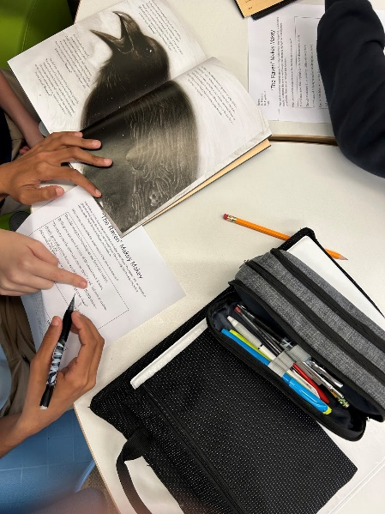
Figure 1. Students analyzing a stanza and pulling support from Hinds’ (2017) illustrations.

Teacher Checkpoints
For students unfamiliar with annotations, Harvey and Goudvis (2017) provided several great prompts for close reading, listening, and viewing that could direct students to dive more fully into the text.

Optional Step A: Introducing Makey Makey Kits
To introduce students to the technology component of the project, each partner group was assigned a Makey Makey kit consisting of the Makey Makey board, USB cable, and alligator clips. As a class, the group reviewed the Becoming Familiar with Makey Makey (Deck & Moyer, 2018, p. 11-13), identifying all parts of the kit and how to connect the pieces.
The Middle School Innovation Coordinator modeled for the students how to utilize the Makey Makey kits. The step by step actions are outlined in the Teacher Modeling Outline. Modeling made the process clear for students to use the Makey Makey board while also reinforcing the knowledge that they themselves are conductive material and are essential to complete a circuit.
The students were assigned to repeat the steps modeled for them. After practicing, the students furthered their understanding of conductivity with the Makey Makey board through the Bag of Wonder activity. Students were given a bag of conductive and insulator materials along with a worksheet (see Bag of Wonder). On this worksheet, students had to label material as conductor or insulator and provide a brief explanation of why that item fell into the category. This was also a great way for them to practice closing circuits with the Makey Makey boards as often students forget to ground the board, completing the circuit.
The worksheet was reviewed with students as a class to reinforce the difference between conductors and insulators and what type of materials are necessary for their project to be a success.

Optional Step B: Teaching SNAP! with Makey Makey Kits
To integrate sounds with the Makey Makey board, SNAP! was used to produce commands. The students had background knowledge of block coding from their 3rd and 4th grade maker space enrichments, which made this section of the unit
easy to teach. Many of them were still tinkerers at heart and continued block coding exploration on their own when they moved into middle school. However, some students needed a refresher.
With the Makey Makey board connected to the instructor’s flat panel board, the Middle School Innovation Coordinator reviewed how to use SNAP! They browsed a royalty free website for a sound effect (e.g., BBC Sound Effects), downloaded it, and loaded it into the SNAP! library for their demo project. The teacher block coded, “When space key is pressed”, “Play sound howl” (see Figure 2).
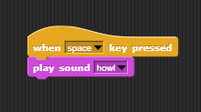
Figure 2. Example of block code from Snap! platform.
In block coding, the connecting words are missing (Figure 2 illustrates the block code structure). A normal sentence written out would read as:
When the space key is pressed, play the howl sound.
In block coding, you need to pseudo insert words and typically connection words (i.e., the, and) are removed. The above normal sentence written for code would read as:
When space key pressed, play sound howl.
Students were asked to write their needed code out in standard sentence form first, then remove connection words to develop their block code.
Students were then asked to repeat the exact steps as the Middle School Innovation Coordinator in the Snap! platform. The Middle School Innovation Coordinator and English teacher walked to each group asking students to demonstrate their understanding and read their code as a sentence.

Teacher Checkpoints
It was necessary to point out to students the connection between sentence structure and writing code. While writing code may look incomplete at times, it reinforces the nature of writing sentences and how individual words and their order are necessary to convey a point, or in the SNAP! example complete a command.

Step 3: Plan the Scene
Once students are familiar with conductive materials, Makey Makey boards, and block coding, students plan their scene. To do this, they must brainstorm what their interactive poster will actually look like, which parts of the poster will be interactive, and what effects the commands on the Makey Makey board will trigger when activated. This encouraged collaboration and set the stage for design thinking to emerge. Using the Interactive Poster Story Board, students visually outlined their thoughts. Some students utilized clip art and others used online images, found through search engines, to inspire their project vision. Usually, while one student was drawing the scene the other student began constructing the scene (Step 5).

Teacher Checkpoints
We found it appropriate for Steps 4 and 5 to happen in tandem with one another as the partners inevitably divided-and-conquered the work. Through this, they were communicating their visions. As one student drew the vision in a storyboard, the other student would find clipart, sound effects, and other audio/visual elements that would work well with their project. Sometimes the student storyboarding would hear a sound that would inspire the drawing to take a new form. This also provided an authentic moment for students to discuss their interpretations of the original text.

Step 4: Construct the Scene
Once the plan was complete, students used their drawings or printed clip art to stage the scene on construction paper. Conductive elements such as copper tape, brass fasteners, paper clips, pencil lead shaded areas, and modeling clay were used to provide conductive touch points for the project. These conductive touch points created the interactive and immersive experience once coupled with audio and visual items.

Teacher Checkpoints
Since this project is partner focused, while one partner is constructing the scene, the other partner is locating sounds online or recording sounds to incorporate into the coding aspect of the project. This happened organically. Allowing students the freedom to lean into one another’s strengths produced more buy-in for the project. If one student knew they were not as visually creative as their partner, they happily supported their partner’s vision and produced sounds that would complement. Steps 5 and 6 could happen in tandem as well if the partnership benefitted from dividing the work.

Step 5: Record the Immersive Elements
Students explored online libraries of free sounds to use royalty free sound effects, or they recorded their own. When recording their own sounds, students utilized the school-issued Chromebook laptops with a built-in microphone, or they used their smart phones—with or without microphoned earbuds. Creating their own sounds proved to be more rewarding for students that found it difficult to locate the exact sound they needed.

Teacher Checkpoints
It was great seeing students look around the classroom to determine what materials would make the intended sounds. Student’s creativity was boundless as things like metal water bottles were used for crashing sounds. It might speed up the process if the students were asked to practice recording a sound in “Optional Step B” and adding it to the code prior to reaching that step in the project. This would also be a good warm-up activity if students have been away from the project for a couple of days, such as a long weekend.

Step 6: Assign Elements to Codes and Controls
After recording sounds, students decided what areas of the Makey Makey board were assigned to each sound. Students could use the up, down, left, right, space, and click controls on the front of the board.

Teacher Checkpoints
Students were reminded to ground themselves during testing. Advanced students were encouraged to find a way to continuously ground the Makey Makey board without using themselves in the closed circuit.

Step 7: Assemble the Circuits
During the assembly stage, students layered conductive material over their constructed scenes from Step 5. Since the idea was for the project to be interactive or immersive, the material should be layered in a way that allows the wires to be hidden through the back of the construction paper. As seen in Figures 3 and 4, students labeled the conductive material on the back of their posters so they knew which alligator clips to connect with each Makey Makey control.

Teacher Checkpoints
It was suggested to students to use different colored alligator clips to help when troubleshooting. For example, if a sound did not happen or the wrong sound was made when tested having a specific color alligator clip for sound makes the physical connection issues easier to see. Students were also encouraged to layer conductive material on the front and back for easier connections between the conductive material and the alligator clips. Students could use the “cleaner” looking items on the front, like brass fasteners, and modeling clay pushed into the end of those fasteners behind the project. The modeling clay provided more stability for wires.

Step 8: Gallery Walk
When all projects were completed, student groups took turns doing a gallery walk. As seen in Figure 5, students grounded the Makey Makey board and triggered the features of the interactive posters. In doing so, we were able to retell the story one stanza at a time. Additionally, we asked students to provide constructive feedback, such as glows-and-grows (i.e., good components and things to continue updating), for their peers. To encourage meaningful feedback, we provided them with sentence stems.
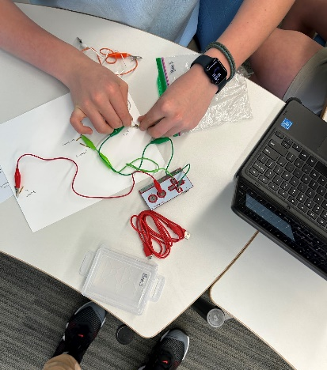
Figure 3. Students connecting alligator clips to the back of their project.
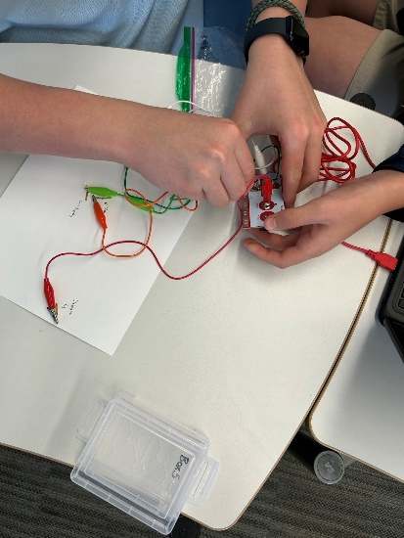
Figure 4. Students connecting opposite side of alligator clips to Makey Makey board.
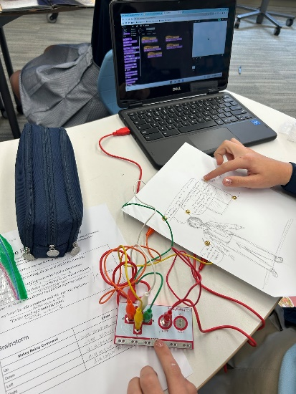
Figure 5. Students showcasing their completely assembled project.

Critical Reflection
We implemented this lesson in two different years. The first year, it was a single implementation of this lesson across four days. Given this was the first time utilizing this technology in an English Language Arts class, we allowed ample time for the students to explore the conductive materials, insulators, and LED bulbs. For the English teacher, this felt out of place as it seemed we were teaching more science and technology standards than English Language Arts standards. To address this concern in the second year, we limited the pre-teaching to conductive materials only. We believed that in limiting the exploration of materials and the LED bulbs in the second year made students less adventurous in making their interactive posters. In the first year, students utilized far more materials—such as brads, foil, paper clips, and copper tape--to make their interactive posters, whereas in the second year, students mainly utilized brads.
During the second year, we did this project across multiple texts. Not only did the student’s rate of creating the posters quicken, but they also integrated more complex sounds and circuitry. Part of this is attributed to a change in how passage annotations were done from the first year. Sadly, no group attempted the integration of a lightbulb in the two years of this project. We attribute this to the way the Makey Makey boards are formatted: LED bulbs must be connected to the back of the board using thin wires, while alligator clips are connected more securely through the front of the board. The LED bulb wires would disconnect when the board was moved or adjusted, even when activating the poster controls. One option would be to use two Makey Makey boards for one poster—one dedicated to bulbs and one dedicated to sounds and effects. However, we did not have the resources to allow for this.
In the second year, having the iterative cycles of creating interactive posters back-to-back was less than ideal. For some, this assignment provided an entry point for engaging in a story and making the classic text more contemporary. For others, this assignment was a frustrating mix of steps, especially if their partner was absent or the class ended before a clear stopping point was reached while constructing the poster.
Overall, the requirement to work with a partner was a valuable opportunity for students to dive deeper into the texts and/or coding. There were several instances of students teaching each other. For example, one student was familiar with coding and even practiced in his own time. When paired with someone less familiar with coding, he was eager to share his passion and knowledge with them.
If this assignment were to be done another time, we feel students would benefit from a checklist of reminders, such as:
- Grounding the Makey Makey board to activate the buttons.
- The steps for block-coding.
- Tips for sequencing the sounds and/or effects.
Lastly, we would consider using this project as a whole class formative assessment and then include interactive posters as an option for students to show master on future literary units.
This assignment could be modified for other grade levels and subject areas. For example, a history class might create an interactive poster highlighting the details of a historic event, such as the signing of the Declaration of Independence. The interactive elements could be scaled up to not only include sound, but video, animations, and other graphics through the Snap! platform.

References
Bers, M. U. (2022). Beyond coding: How children learn through human values through programming. The MIT Press.
Common Core State Standards Initiative. (n.d.). English Language Arts standards >>Reading: Literature>>Grade 7. Retrieved November 17, 2024, from https://www.thecorestandards.org/ELA-Literacy/RL/7/
Deck, A. S., & Moyer, L. A. (2018, January). Makey Makey educator's guide (Volume 1.0). ITEEA. https://cdn.shopify.com/s/files/1/0162/8612/files/Makey_Makey_Educators_Guide.pdf?16481577170705338427
Hack Upstate. (2015, Nov. 13). 5 ways coding & writing are the same. Medium. https://medium.com/@hackupstate/5-ways-coding-writing-are-the-same-b9937ee685ff
Harvey, S., & Goudvis, A. (2017). Strategies that work: Teaching comprehension for understanding, engagement, and building knowledge, grades K-8. (3rd ed.). Routledge.
Hinds, G. (2017). Poe: Stories and poems. Candlewick.
International Society for Technology in Education. (2016). ISTE standards: For students. https://iste.org/standards/students
International Technology and Engineering Educators Association. (2020). Standards for technological and engineering literacy: The role of technology and engineering in STEM education. https://assets-002.noviams.com/novi-file-uploads/iteea/standards/18193-00018_iteea_stel_2020_final_security-d1e2c729.pdf
Koeser, R. S. (2019, December 2). Coding is writing. PrincetonWrites. https://pwrites.princeton.edu/news/coding-is-writing/
Makey Makey. (2021, September 30). Makey Makey first time plug-in and troubleshooting guide [Video]. YouTube. https://www.youtube.com/watch?v=aW8h9JqXg0w
Mansio Montessori of Geneva. (2023, January 4). What is the Montessori approach to play? https://www.genevamontessori.org/what-is-the-montessori-approach-to-play#:~:text=Simply%20put%2C%20the%20Montessori%20approach,allowing%20them%20to%20have%20fun
Snap! (n.d.-a). About Snap! Retrieved November 17, 2024, from https://snap.berkeley.edu/about
Snap! (n.d.-b). Welcome to Snap! Retrieved December 2024 from https://snap.berkeley.edu/
Spencer, J. & Juliani, A. J. (2017). Empower: What happens when students own their learning. IMPress.
Turcotte, N. (2024). Designing collaborative tech-rich learning: Building a multi-player game controller with Makey Makeys. Journal of Technology-Integrated Lessons and Teaching 2(2), 68–74. https://doi.org/10.13001/jtilt.v2i2.8281
Young, C., Paige, D., & Rasinski, T. V. (2022) Artfully teaching the science of reading. Routledge.

About the Authors
Matthew Panozzo, Ed.D., has over 15 years of experience working with children and young adults in schools, camps, and youth centers. He focuses on exploring all types of stories, the connections they foster, and the communities that are built around them.
Jennifer Hockless, M.S., has 20 years of information technology and S.T.E.M. curriculum experience. As an immersive classroom advocate, Jennifer focuses on using technology and engineering curriculum to bridge core subjects and make learning more engaging.

Sharing & Modification Permissions
Unless otherwise noted, this article and its resources are published under a Creative Commons Attribution-NonCommercial-ShareAlike 4.0 International license:

You can freely share the article and its resources if you indicate the original authors, identify the Creative Commons license, and use them non-commercially.
You may also make and share modifications by:
- Identifying the original authors.
- Using the resources non-commercially.
- Licensing modifications under the CC BY-NC-SA 4.0 license (and including a link to it).
Indicating what modifications were made

