Makey Makey Project Checklist
  - Matthew Pannozzo¹ and Jennifer Hockless²
¹University of Memphis, ²Annuciation Orthodox School
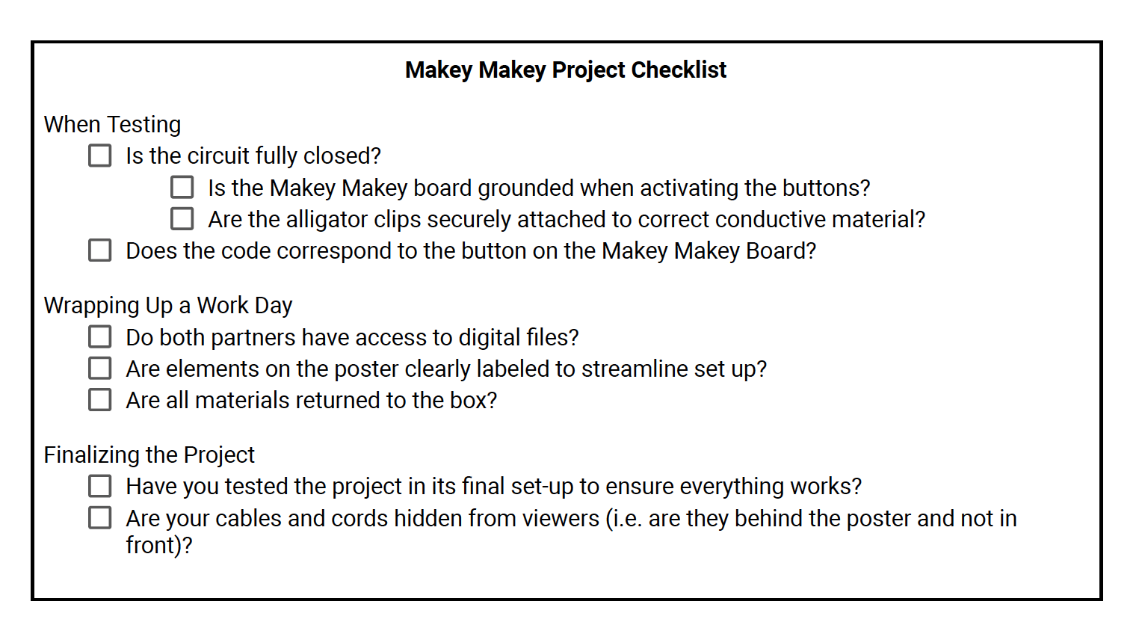
Notes

