Makey Makey Storyboard Template
  - Matthew Pannozzo¹ and Jennifer Hockless²
¹University of Memphis, ²Annuciation Orthodox School
Story:
Context:

In preparation for your Makey Makey interactive poster, choose a moment from the story, break it down into six elements. Consider how each element contributes to the larger scene as a whole. You also might consider how your viewer needs to activate the elements.
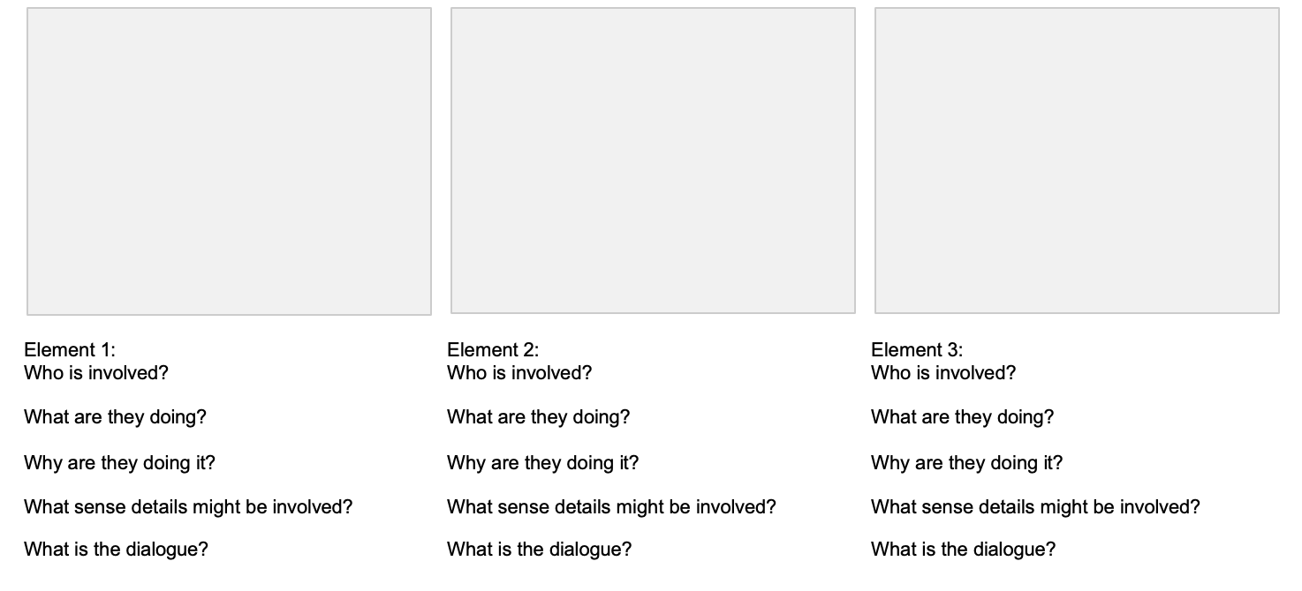
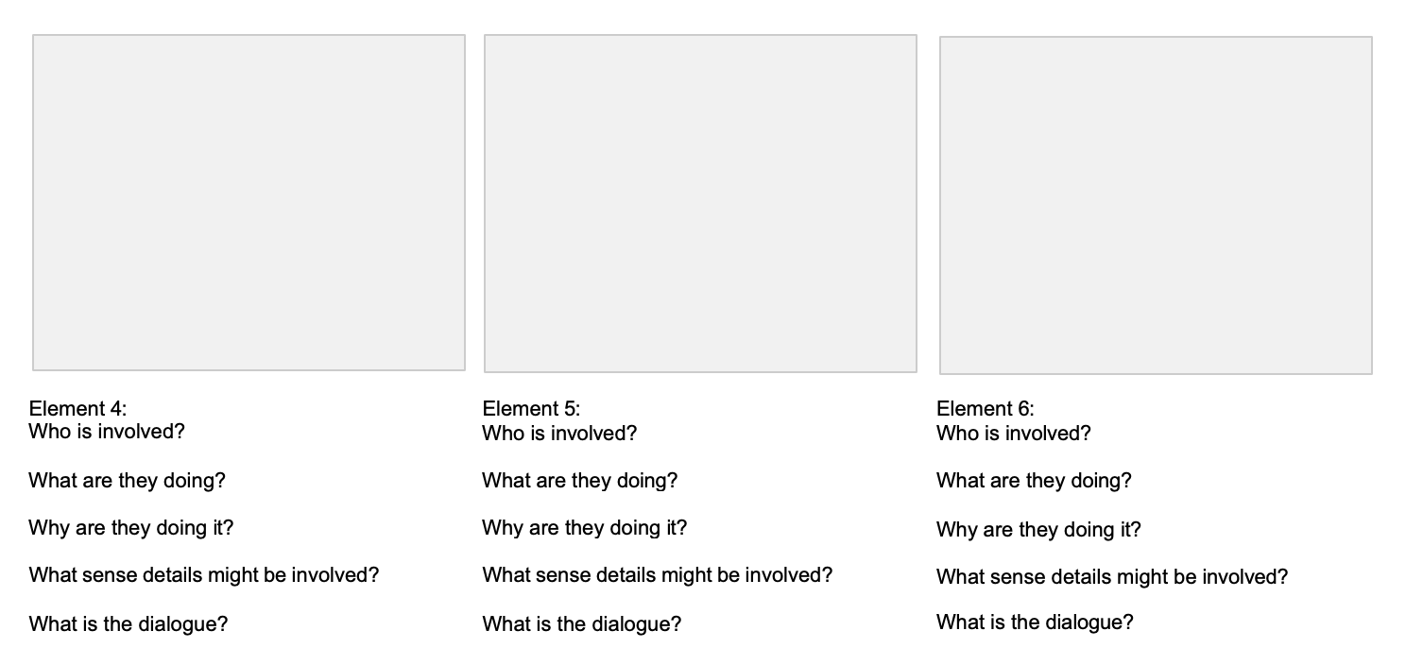

Notes:
________________________________________________________________________________________________________________________________________________________________________________________________________________________________________________________________________________________________________________________________________________________________________________________________________________________________________________

