Digital Escape Room: Agency, Personalized Instruction, and Flow Theory
  - Cecil R. Short, Emporia State University

Overview
Scheduled during the final two weeks of a practicum internship, this asynchronous online lesson for preservice teachers focuses on Flow Theory and provides first-hand experience with agentic instruction to deepen students’ pedagogical understandings and promote future implementation of such practices. Applying principles of inquiry-based learning and digital escape room design, students are tasked with completing the digital escape room to rescue their instructor who has been trapped in a digital world by his jealous colleagues. Delivered through the Canvas learning management system, students seemingly enjoy the activity, despite occasionally struggling, and some students plan their own digital escape rooms as a result of this activity.
Topics: Engagement, Flow Theory, Learner Agency, Personalized Learning
Time: Students stated completion took anywhere from 30 minutes to 3 hours

Materials

- Device with internet access
- Learning Management System (LMS)
- Assignment Puzzles
- Escape Room Image
- Puzzle Answer Key
- Google Form Escape Room Quiz Link
- Google Folder of all Puzzle Items

Context-at-a-glance
Setting
A Midwest, public university in the United States of America.
Modality
Online, asynchronous activity in a hybrid course
Class Structure
Instruction rotates between in-person synchronous and online asynchronous modalities due to two 4-week practicum internships. This assignment is scheduled during the last two asynchronous weeks of the second internship.
Organizational Norms
Educator preparation program with a historical reputation for preparing high quality educators. Students’ failure to meet institutional standards can result in program removal.
Learner Characteristics
Senior secondary education majors, most of whom have completed the prerequisite course, “Technology for Educators.”
Instructor Characteristics
Assistant professor with expertise in online and blended learning, previous experience creating digital escape room puzzles, and who attended a digital escape room workshop at the AECT 2022 international conference.
Development Rationale
First-hand experience with personalized instruction promotes understanding of the pedagogy and its future implementation (Arnesen et al., 2019).
Design Framework
Inquiry-Based Learning; Digital Escape Room Design (Neumann et al., 2020; Neumann et al., 2022)

Setup
Setup of this lesson had three parts: (a) design of the digital escape room for instruction, (b) integration of the digital escape room with the learning management system (LMS), and (c) introduction of the escape room and its expectations to students.

Part 1: Design of the Digital Escape Room
Designing the digital escape room followed the steps for creating an educational digital escape room from Neumann et al. (2020). Specifics concerning the design are described in the Learning Representation section below. This part of the setup was the most time consuming by far, taking around seven hours to complete. In this case, setting up the digital escape room included:
- Understanding the previous experiences of the students who would participate in the activity regarding escape rooms and digital literacy to provide adequate introduction, scaffolding, and support for the activity.
- Establishing instructional goals related to learner engagement and learner agency for the activity.
- Writing the questions that students should be able to answer if the instructional goals are met.
- Finding resources that students could use to answer these questions.
- Designing a narrative theme for the digital escape room.
- Developing the videos, images, puzzles, hints, and clues to be used for the escape room.
- Hiding links to the puzzles, hints, clues, and resources within the digital escape room.
- Creating a Google Form that students could use to read and answer questions related to the learning outcomes.
- Providing a single location within our Canvas learning management system (LMS) where these elements could all come together in one location.

Part 2: Integration With the LMS
The second part of the setup was more straightforward and only took about one hour. Following the example provided by Neumann et al. (2022), the instructor created a Canvas assignment to host the first clue and instructions to get the escape room started (see Puzzle 1, Assignment Puzzles). The assignment instructions included a link to a Canvas page with Agency Escape Room Image (PDF), and the escape room Google Form, which was embedded within the page. The only submission for the Canvas portion of the assignment was a text entry box for the answer to a reflection question that students were unable to see until they progressed to the last page of the Google Form (see Google Form Escape Room Quiz Link). This means, students had to complete the Google Form Escape Room Quiz to access the reflection question prompt to submit the Canvas assignment.

Part 3: Introducing the Escape Room to Students
The digital escape room was assigned during weeks 13 and 14 of the course. These weeks consisted of students’ last week in their second four-week practicum internship (week 13) and a week (week 14) in which they met at the local high school for “daily sessions” with various groups within the school that support teachers – special educators, librarians, school counselors, instructional coaches, and administrators. The last time that the instructor saw students prior to their internship was during Week 9. During this week, the instructor took about 5 minutes at the beginning of one class period to explain that the assignment for weeks 13 and 14 (this activity) would be little different than the assignments they were used to. He explained that the digital escape room would likely cause students to experience a wide range of different emotions. He explained that this experience is by design. His best tips to students included persevering in the face of struggle, clicking on as many links as they could find, and reaching out to him only if they get really stuck.

Standards
This activity fulfills the following Kansas Educator Preparation Program Standards (Kansas State Department of Education, 2023):
3.1.3PS The teacher manages the learning environment to actively engage all learners appropriately by organizing, allocating, and coordinating the resources of time, space, and learner’s attention.
3.3.1CK The teacher understands the relationship between motivation and engagement and knows how to design learning experiences using
strategies that build learner self-governance, self-direction, and ownership of learning.

5.2.3PS The teacher facilitates innovative learning experiences that require creative and critical analysis.

Context and Setting
To understand how this digital escape room might have been impacted by the context of the course that it is part of and the university that offers it, details are provided to better explain university and program norms. Additionally, this section details why a digital escape room was chosen as the medium to deliver this instruction as opposed to a different approach.

Course & Program Context
This activity took place at the end of a 16-week course for classroom management. “Classroom Management” is one of the courses that students must take in the semester directly preceding student teaching. The course follows a hybrid schedule with weeks 1-3 occurring on campus, weeks 4-7 occurring online while students are placed in a pre-student teaching practicum, weeks 8-9 occurring on campus to cover new information and debrief concerning the first practicum experience, weeks 10-13 occurring online while students are placed in their second pre-student teaching practicum, week 14 occurring online while students meet at the local high school for “daily sessions” with school support staff, and then week 15 occurring on campus for one final practicum debrief and preparation for finals during Week 16.
While this activity could easily be accomplished in one week, students are given two weeks to complete it due to the heavy assignment-load that accompanies the end of their practicum experiences. Additionally, the extended timeline provides students with additional opportunities to experience personalized learning by having control over the goals, time, place, pace, and path of the learning activity (Graham et al., 2019). Research from Arnesen et al. (2019) suggested that such experience with personalized instruction helps preservice teachers to understand the pedagogical strategy and increases their interest in implementing it in their future instruction. Because personalized learning is one focus of this activity, such experience is an important benefit to offer to students.
Additionally, the extended timeline provides opportunities for students to struggle with the activity, put it aside for a while, and then come back to it. This pattern of working through the activity was important to creating inquiry-based learning. Such learning is often characterized by an activity that has (a) a driving question, (b) authentic, situated inquiry, (c) learner ownership of the problem, (d) teacher-support as opposed to teacher-direction, and (e) artifact creation (Buchanan et al., 2016).
The driving question for this escape room was centered around the lived experience of learning through personalized learning and how such learning would impact learner’s motivation and emotions. The narrative context of the escape room provided situated learning. The introduction of the escape room as an activity that is designed to promote struggle allowed learners to take ownership of their progress and to understand that they should only reach out to the instructor if they felt support was necessary. While artifact creation was not a direct part of the activity, a final reflection question asked students to consider how creating a similar activity might be effective in their respective content area.
The educator preparation program at this university is known for preparing high quality educators, and has a long history of doing so, being the oldest educator preparation program in the state. As such, students are held to rigorous standards concerning their professionalism, grades, and general dispositions. There are two sets of programs at the university that can remove students from their programs – the nursing program within the School of Applied Health Sciences and educator preparation programs within The Teachers College. Students are made very aware of this policy throughout their professional education courses and are careful to live up to the programs’ expectations. One dispositional expectation, which likely has bearing on students’ willingness to persevere through the challenges of a digital escape room activity, states that “The teacher education candidate demonstrates a positive outlook and perseverance (sees setbacks as an opportunity to learn).” The instructor carefully reminded students of this expectation when introducing them to the expectations of the activity.

Escape Room Rationale
By the end of this course, when students are tasked with completing this activity, most students are exhausted from their back-to-back internships. These internships require students to spend 90-120 minutes at one of the local-area schools, Monday through Friday, to gain their first course-related experiences in teaching a K-12 class fully on their own. Students whose licensure is a 6-12 license spend four weeks at a middle school and four weeks at a high school. Students seeking a K-12 license (the areas of music, physical education and health, art, and world languages) spend four weeks at either a high school or middle school, and then four weeks at a local elementary school. In all cases, students are expected to take over the full responsibilities of teaching – administrative tasks, attendance, lesson planning, grading, etc. within the four weeks that they are in each placement. In addition to these responsibilities, most students still take at least 12-credit hours of courses, work part time jobs, and heavily participate in extra-curricular activities.
One of the reasons that a digital escape room was the chose medium for delivering instruction to students was as a (hopefully) fun and engaging refresher from the stress of experiencing classroom teaching assignments for the first time. Additionally, students in the “Classroom Management” course come from four consecutive weeks of online discussion boards and constructed response assessments that require extended responses. The escape room seemed like a fun and engaging way to deliver instruction at the end of a semester, while attempting to prevent preservice teacher burnout.
Another reason for delivering this instruction using a digital escape room is that the instructor wanted to model for students (a) what engaging asynchronous online instruction could look like, and (b) how gamification of learning can lead learners to experience emotions related to Flow Theory (Csikszentmihalyi, 1998). Many of the preservice teachers in this course experienced online instruction for the first time during the pandemic, and that emergency remote teaching version of online instruction left many of them jaded towards the modality. Such feelings did not drastically change when they entered college and experienced additional mundane online instruction. The use of the digital escape room was a chance to help change students’ minds about online learning possibilities as they approach completion of their teacher preparation program.
Additionally, the instructor prides himself on being able to model for students the use of educational technology outside of the “Technology for Educators” course. While some solitary educational technology courses may be able to help prepare preservice educators for effective technology-integration (Wilson et al., 2020), such approaches are often not enough to demonstrate ongoing applications and best practices (Moursund & Bielefeldt, 1999). To this end, some scholars feel as though all teacher educators need to be able to demonstrate proficient technology integration (Foulger et al., 2017). The instructor of this course and activity agrees with such assertions, and, as the Director of Secondary Education for his institution, works to ensure that best practices for technology-rich instruction permeate students’ professional education courses and content area methods courses. Using an application of technology that students had not previously encountered allowed him to do his part in extending technology integration beyond a single course.
Lastly, because one of the purposes of this instructional unit was to teach students about Flow Theory, which is often associated with games, it seemed like game-based instruction would be a good choice. Many students reported on the final question of the escape room that they experienced flow during completion of the escape room. Smaller groups of students reported that they felt relaxation, control, arousal, or anxiety. After three semesters of repeating this activity with students, none of them have reported feeling worried, apathetic, or bored, which is reason enough to continue using an activity that seems to promote achievement of the learning outcomes.

Learning Representation
The following sections detail the implementation of the digital escape room. The description follows the steps listed in the Setup section above. The first step, understanding students’ abilities and prior experiences, is omitted as it has already been covered in the Context and Setting section. There was no kind of formal data gathering process to complete this step. The instructor relied on his conversations with students, knowledge of their previous coursework, and reports on their dispositions from previous instructors.
The following details of the activity start with the creation of questions to use within the escape room and establishing resources that can help students answer those questions. It then transitions to detailing the creation of the escape room’s narrative and then the media created to support that narrative, including the design of the digital escape room and its puzzles. Lastly, the learning representation details how to create a Google Form for the escape room and how to put all the pieces together within the LMS.

The Escape Room Questions
In addition to the Standards provided above, the course outcomes that this activity measured were the following:
Students can:
- Demonstrate understanding of how to prevent and manage problem behaviors.
- Demonstrate understanding of how to motivate students.
The two modules preceding this activity focused on prevention and management of student misbehavior, and how one approach to doing so is through using motivation to reduce misbehavior. This module sought to build on these ideas through providing an example of what motivation can look like and how instruction can illicit different levels of motivation for different learners.
One way to provide learners with motivation is to personalize their learning, which can provide learners with a sense of “flow” during their learning. Flow Theory, as introduced by Csikszentmihalyi (1990), is a feeling of engagement with an activity wherein someone seems to experience timelessness (i.e., someone’s self-consciousness is overridden by focus on the task and their perception of time becomes distorted; Csikszentmihalyi, 1998). Feelings of flow are encouraged by matching learners’ ability levels to the tasks they are asked to complete.
Personalized learning, as students learn throughout this activity, can take on different forms but is primarily concerned with tailoring learning to students’ knowledge, skills, and attitudes. Personalized learning can occur through the tailoring of learning outcomes, activities, or assessments along the dimensions of goals, time, place, pace, or path. It can also be based on different kinds of data – performance, activity, and/or learner profile data, and can be tailored by the instructor, the learner themselves, or via adaptive learning software (Short, 2022). Tailoring instructional activities to learners’ specific abilities should, in theory, promote feelings of flow.
To lead students to these understandings, the questions in the escape room’s puzzles were created. While these puzzles can be found in the Assignment Puzzles (DOC), the questions have undergone some fine tuning for the purposes of gamification. The questions in their original forms are listed below with simplified answers in italicized parentheses.
- What is it that we can include in our lessons to help keep students on task, therefore preventing misbehavior? (Engagement)
- What did Mihaly Robert Csikszentmihalyi create in 1975 that can provide a framework for creating engaging instruction? (Flow Theory)
- What are the three areas on the simplified version of Csikszentmihalyi’s Flow Theory chart? (Boredom, Flow, and Anxiety)
- What does the more complex range of Flow Theory emotions consist of? How do these theoretically manifest in students? (Depending on learners’ abilities related to the task at hand, they can feel anxiety, arousal, flow, control, relaxation, boredom, apathy, worry, or anxiety.)
- In what hobby is Flow Theory often utilized? (Gaming)
- How can we promote feelings of flow for students? (Personalized Instruction)
- What does designing personalized instruction look like? What are the design considerations? (These are presented in the Personalized Learning Design Framework.)
- What kind of data can teachers use to create personalized instruction? (PAL Data – Performance, Activity, or Learner Profile data)
- Why might Flow Theory or personalized learning be something that students should use in their future classrooms? (Answers will vary but should connect the two approaches to the preservice teacher’s content area, experiences, thoughts, or interests.)
Some additional questions were added to the end of the Google Form that built on the previous questions and provided some application, reflection data, and feedback to the instructor:
- What was your experience with this digital escape room like? Where would you place yourself on the complete Flow Learning chart throughout the activity?
- If you knew how to create a digital escape room like this, do you think you would for your own students? Explain how such an activity could lead to and/or prevent classroom management problems.

Escape Room Readings
Two readings from open educational resources and a couple of images were used to provide students with information to answer the previous questions. The full citations with links for the readings are in the Support Materials section at the end of this article.
The first reading is about “Flow Theory and Learning Experience Design in Gamified Learning Environments” from Vann & Tawfik (2020). This can be a pretty dense reading for some of the students, so the instructor specifically led learners to read Sections 1 through 2.2 of the chapter. This allowed learners to be able to answer the first three questions listed above, as well as question number five. To answer the fourth question, the instructor provided a link to a more complex chart describing Flow Theory (Figure 1). This image was located via Wikimedia Commons and released into the public domain by its creator, Oliverbeatson (2010).
The second reading is the description of the Personalized Learning Design Framework (PLDF). This framework was developed through an analysis of different definitions of personalized learning as well as thematical analysis of blended and personalized learning strategies from over 60 K-12 teachers across content areas and grade levels (Short, 2022). This reading would provide learners with answers to questions six through eight.
Once students completed both readings and looked at the chart provided in Figure 1, they were able to answer question nine and the additional reflection questions.
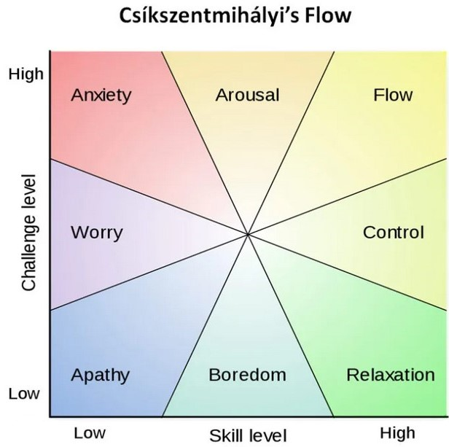
Figure 1. The full range of Flow Theory emotions. From “Challenge vs skill.svg,” by Oliverbeatson, 2010 (https://en.wikipedia.org/wiki/File:Challenge_vs_skill.svg). In the public domain.

Creating the Narrative
Neumann et al., (2020), as well as Clarke et al. (2017), suggest that some kind of escape mode, mystery mode, or narrative design is important to help establish a motivation for completing the escape room. In this case, the instructor came up with a story that allowed him to live out a childhood dream a la shows like Digimon, Reboot, or Nick Arcade – getting stuck in a digital world. In this case, the instructor would be trapped in the digital world with only a note left behind for his students to explain what happened. This note, in alignment with Neumann et al. (2022), would serve as the first clue of the escape room.
The instructor decided that as his students progressed through the escape room, they would encounter puzzles that hinted at who was behind his digitalization. To help sell the idea that he had been digitized, he used the Bitmoji application to create a two-dimensional avatar. This avatar would appear in an introductory video posted to YouTube (Figure 2).
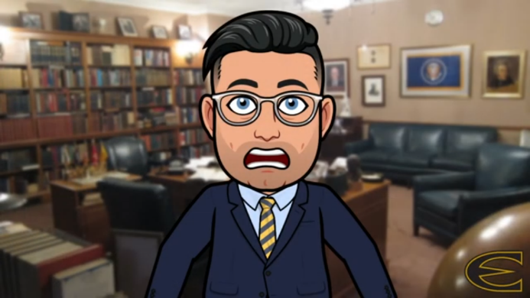
Figure 2. The instructor’s Bitmoji avatar when he first discovers that he has been digitized!
The introductory video starts off as an explanation about the assignment and the learning goals for the week (The Personalized Learning Professor, 2022-a). The instructor included such a video in an overview for every module during the weeks in which instruction was online, so students would not suspect that the video was really introducing the escape room’s narrative. Additionally, the video’s title did not say anything about an escape room, this allowed for a little bit of a fun surprise. The video also served as a reminder for students because it had been about four weeks since he first told them about the digital escape room activity.
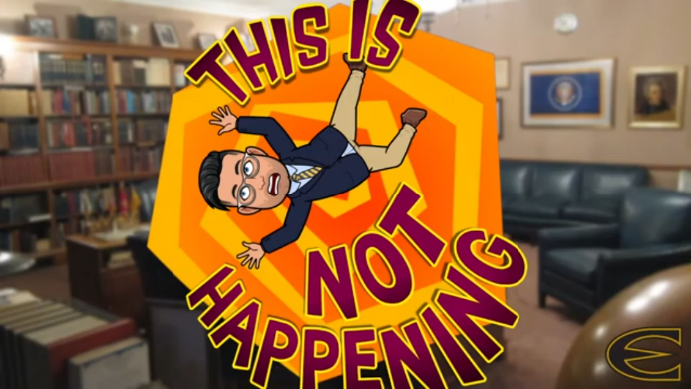
Figure 3. The instructor’s Bitmoji avatar falls into the digital world.
Towards the end of the video, it transitioned into the narrative as the instructor fades from view and is replaced with his Bitmoji avatar. The Bitmoji avatar first appeared frightened to find himself having been made digital and flat, before falling into, and getting subsequently trapped in the digital world (Figure 3).
The final video was posted to YouTube as an unlisted video and embedded in the module’s overview page, which listed the learning outcomes for the week, where to find the module’s readings, and the assignment for the week – which was entitled “Week 14-15: HELP ME! – Learner Agency.” The video citation is provided in the Support Materials section below.

Designing the Puzzles
The puzzles used for the digital escape room were created using free online puzzle creation tools provided by Neumann et al. (2020) and exemplified in the workshop by Neuman et al. (2022; all puzzle tools are listed under Support Materials). There wasn’t much of a rationale as to which puzzles to use outside of finding puzzles that would be (a) engaging, (b) easy to make, and (c) might fit either the narrative or relate to the topic of the learning. The only puzzle that did not rely on one of the puzzle-making tools was the first puzzle, which appeared in Canvas as part of the assignment (see Puzzle 1 in Assignment Puzzles DOC). This puzzle was a kidnapper’s note with random letters capitalized to provide the answer to the first question.
All the puzzles are available in the Assignment Puzzles (DOC) and include the hints and connections associated with them from the Google Form. From working with other teachers in creating digital escape rooms on their own (Cowley & Short, 2024 in this issue) or via participation in the digital escape room workshop, most of the puzzle creation tools are straightforward in how to use them and provide instructions or tutorials for using them on their respective webpages. The following passages describe puzzles that were either especially fitting to the theme or were a little more complex to make than the others.
For example, the instructor chose to use a sales receipt as one of the puzzles because he could make the receipt appear to be from a gaming or hobby store (Figure 4). The items on the receipt, as well as clues such as “The hobby starts/ends with G” could provide extra clues in answering the revised form of question number five above. Additionally, the cashier and customer names on the receipt were the titles and initials of the instructor’s co-workers who were responsible for kidnapping him. Other puzzles that were able to provide additional contexts for the narrative included the text message exchange, the newspaper clipping, and the prescription note (see Assignment Puzzles DOC for all puzzles).
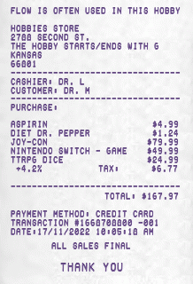
Figure 4. Receipt puzzle with the question for the Google Form at the top and hints sprinkled throughout.
The text message exchange provided another use for the initials of the instructor’s captors and was an easy way to present the clue related to one of the aspects of question number seven – the Taxonomy of Learner Agency, which is one part of the Personalized Learning Design Framework (see Text Message Exchange puzzle in Assignment Puzzles DOC). The prescription note also used the initials of the instructor’s captors/colleagues (see Prescription Note Puzzle in Assignment Puzzles DOC). The newspaper clipping was useful because it could present a clue related to question number six as students’ answers would transition from being about Flow Theory to focusing on personalized learning (see Newspaper Puzzle in Assignment Puzzles DOC; Figure 5). The clue included referencing in capital letters the title of the book that had the next reading and it provided some motive for the capture. Additionally, the description in the paper might have also created some emotional motivation to save the instructor through invoking his family’s heartbreak over his disappearance (Figure 5).
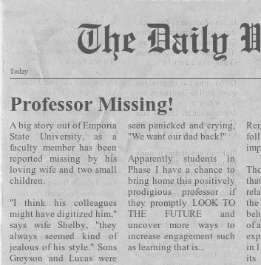
Figure 5. Newspaper clipping that provides motive and emotional motivation for completing the escape room.
An example of a more complex puzzle to create was the jigsaw puzzle. This tool was chosen because putting together a puzzle should be something that most students can easily accomplish, which could invoke flow. Once the puzzle was completed (Figures 6 and 7), it provided a revised form of question three above, focused on the three areas of the simplified Flow Theory chart (Figure 8).
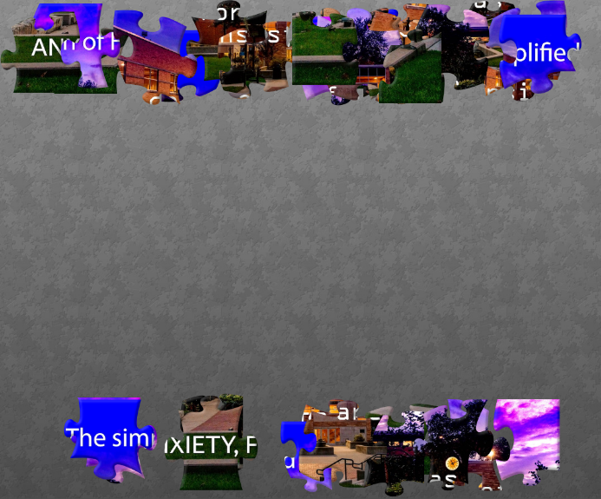
Figure 6. The jigsaw puzzle in pieces.
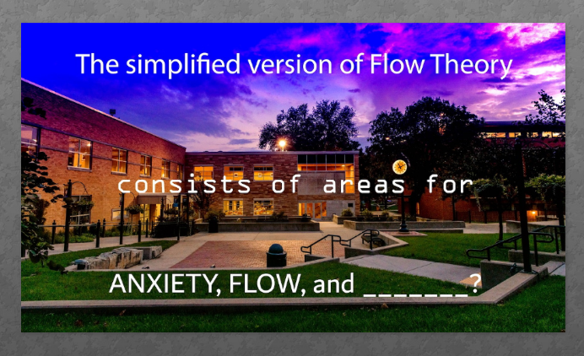
Figure 7. Completed jigsaw puzzle with the revised form of question three.
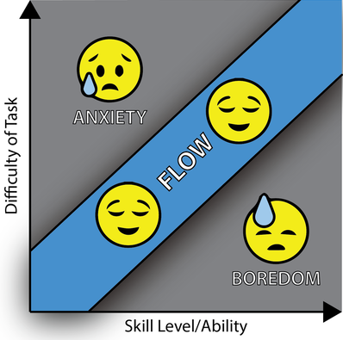
Figure 8. Simplified Flow Theory with three areas (anxiety, flow, and boredom). From “Flow Theory,” by C. Short, 2018, (https://www.cecilrshort.com/blog/my-passion-for-education). CC BY SA 4.0.
To get this question onto the puzzle, the instructor downloaded a virtual background image provided by his institution, and then placed text over the top of it in Adobe Illustrator (this could also be accomplished in a tool like Canva). The website used to create the puzzle was called Jigsaw Planet, which turned the image into a puzzle. While the instructor could have chosen to break the image into more pieces, he didn’t want to create a challenge or cause his students to be bored, so he opted for the 32-piece option. The tool had features that allowed students to view the image without solving the puzzle. Savvy students might realize they can do this by clicking on the right tools. This does not affect students’ ability to know the answer to the question, so the instructor was not worried about these features.

Sharing the Puzzles
Once each puzzle was created, it was downloaded as an image file and saved to a folder in Google Drive. This provided the instructor with a static link that he could use to share each puzzle with his students. The only puzzle that did not allow for this kind of link was the jigsaw puzzle. The instructor must check this link each semester to make sure the link still works. Once all puzzles were created and properly stored, the next step was to create the image for the escape room and hide links to the puzzles throughout it.

Designing the Digital Escape Room
Setting up an image that can be used to contextualize the digital escape room experience is perhaps the most essential step in this entire process because this is the landing page for students and where they will spend a lot of their time. The Escape Room Image (Figure 9) was created using a combination of the Bitmoji application, CoPilot (i.e. Microsoft’s Bing Artificial Intelligence (AI) powered by Dalle-3), Google Drawings, and the instructor’s own image files.
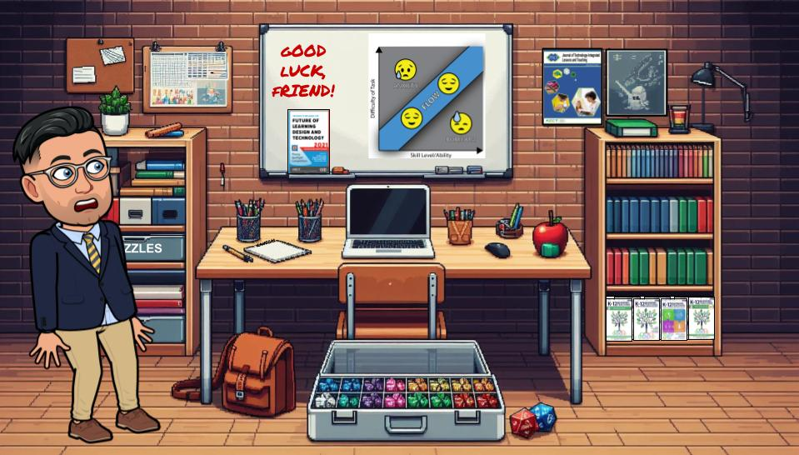
Figure 9. The digital escape room created for this activity.
The Bitmoji application was used to create the instructor’s avatar, which appears on the left side of Figure 9.
CoPilot was used to create the background image of the instructor’s classroom or office. In the original implementation of this activity, the instructor used the classroom image provided by Neumann et al. (2022), replacing Dr. Neumann’s Bitmoji avatar in the image with his own. However, the instructor became interested in creating his own image through the assistance of AI, and subsequently created the image as it appears in Figure 9. The AI image still bears
some resemblance to the original image from Neumann et al. (2022) such as the white board in the center of the wall, the message on the white board addressing students as “friend,” the use of a desk and bookshelves, and the emotion displayed by the Bitmoji avatar (Figure 10).
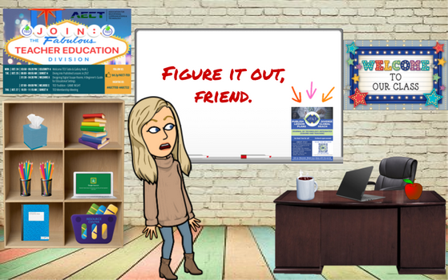
Figure 10. Dr. Neumann’s escape room with her Bitmoji avatar.
Google Drawings was used to create hyperlinks throughout the image. Figure 11 provides an illustration of the areas that are hyperlinked (in yellow). Shapes were created overtop the image and hyperlinked so when students clicked on the part of the image, they would select the hyperlinked shape and navigate to a webpage. In Figure 9, these shapes were made “invisible” through adding clear fills and borders. Images that were added from the instructor’s own files, or taken from online sources, were hyperlinked themselves instead of adding shapes over the top of them, except in the case of the book cover images on the bottom shelf of the right bookcase. Instead of hyperlinking each individual cover of the K-12 Blended Teaching book series, an invisible box was placed over them so clicking anywhere on the shelf would take students to these professionally useful resources that mostly served as a distraction during the completion of the escape room.
The images that were directly hyperlinked included:
- The cover of Theories to Influence the Future of Learning Design and Technology: Theory Spotlight Competition 2021 (Leary et al., 2022), which linked to Short’s (2022) Personalized Learning Design Framework.
- The image of flow theory (Short, 2018), which linked to the reading on Flow Theory from Vann and Tawfik (2020).
- The cover image of the Journal of Technology-Integrated Lessons and Teaching (JTILT), which linked to the journal about page.
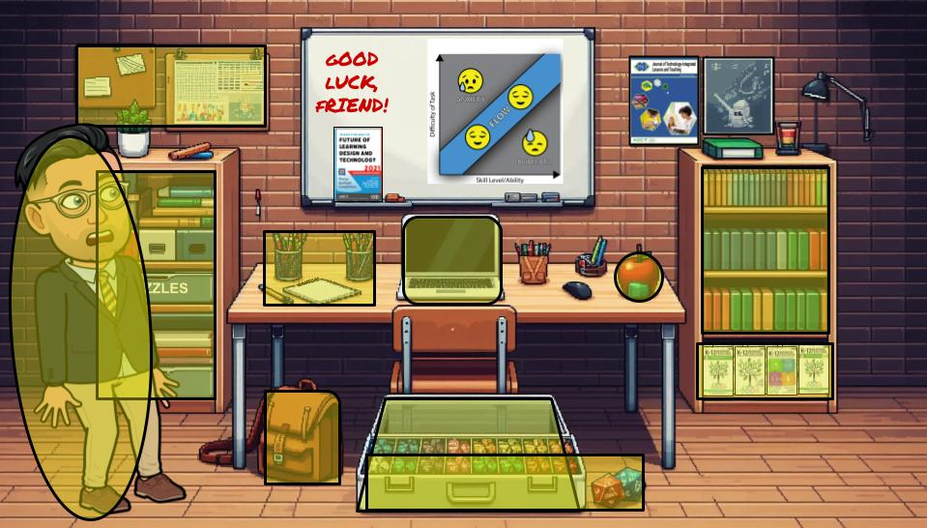
Figure 11. Highlighted areas represent invisible shapes that are hyperlinked to escape room clues or resources.
There were three links in the escape room that were not needed to complete the activity. These links instead led students to other useful websites that were meant to be distracting. These links included the previously mentioned links to JTILT and the K-12 Blended Teaching book series, as well as a link to the instructor’s personal website, which could be accessed by clicking on his Bitmoji avatar.
Including these distractor links helped to meet the Kansas Educator Preparation Program standard 3.3.1CK, focusing on “self-governance, self-direction, and ownership of learning.” It proved difficult for some students to avoid the distraction of exploring the JTILT website, the K-12 Blended Teaching book series, or the instructor’s personal website. This temptation became even harder for some students because these sites each included their instructor’s name.
The instructor tried to hide links to puzzles around objects in the image that might make sense (see Assignment Puzzles DOC for the full list of puzzles). For example:
- The jigsaw puzzle is linked from the storage bins in the left bookshelf. The instructor added a label to one of these bins that is partially visible, reading “ZZLES.”
- The newspaper puzzle is linked from the backpack, this location is hinted at in the Google Form.
- The ransom note is linked from the piece of paper and nearby pencils on the desk.
- The marquee puzzle is linked from the bulletin boards in the top left corner. The Google Form hints at there maybe being a show on the instructor’s calendar. It also references a local theater with a marquee in case students are unfamiliar with the term.
- The text message exchange is linked from the laptop.
- The gaming receipt is linked from the case full of tabletop role playing game dice, as well as the two large dice next to the case.
- The full version of the Flow Theory chart is linked from the books of similar colors on the bookshelf to the right.
And then as appropriate, the book covers seen in the image link to the corresponding book and the JTILT cover links to JTILT.
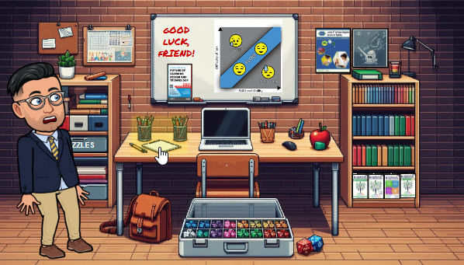
Figure 12. Screenshot of the escape room from Canvas, the cursor is highlighting the location of the ransom note puzzle/clue.
It is important to note that the instructor chose to upload the escape room image to the LMS as a PDF (see Escape Room Image PDF). When saved as a PDF and uploaded to a page in Canvas, with a setting to display a preview of the file in-line, it is easier for students to uncover all the hidden links because hovering over them with their cursor will reveal the linked shape or image (Figure 12).

Creating the Google Form
With the puzzles created and ready for the students, the next step became creating the Google Form. The questions and answers for the form can be found in the Puzzle Answer Key (DOC) and the Google Form Quiz can be supplemental materials. You can also access the Google Form Escape Room Quiz Link. A copy of all the materials used for the escape room are available in the Support Materials section.
There were three important considerations to follow when making the Google Form for the digital escape room. First, each entry on the form needed its own separate section. Second, each item had to be set up so that students could only continue to the next section if they provided the exact answer that was keyed in. Third, students needed hints, so they knew how to spell out the answer.
For example, the second section requires students to type the answer “FLOW THEORY” into the space provided (see Section 2 of 10 in Puzzle Answer Key DOC). To make sure they type it correctly, the following hint is provided:
“The next password is 2 words, ALL CAPS, 11 Letters counting the space, e.g. “Big Blue” would be 8 letters.”
Additionally, the Google Form provides them with information concerning where they might look for the hint or resource they need for the password. In the case of the same password, the hint is:
“Ch. 4 Sections 1-2.2, 1975 Mihaly Robert Csikszentmihalyi creation.”
The rest of the text provided for each clue consists of narrative flavor and voice (see Puzzle Answer Key DOC for all answers and hints).
The last page of the Google Form instructs students to finish the assignment in Canvas and reminds them to hit the submit button on the embedded Google Form. It also provides a link to a final video, unlisted on YouTube, which wraps up the narrative and demonstrates that the instructor is back to being his normal three-dimensional self (The Personalized Learning Professor, 2022-b).
For hints about setting up the Google Form, please reference the following Google Workspace Learning Center article (Google Workspace Learning Center, n.d.).

LMS Integration
With all the pieces of the escape room in place: the puzzles saved in a Google Folder for students to access, a Google Form ready to share, and a PDF of the escape room with invisible links, the final step was combining all the pieces and integrating them into the LMS.
As previously stated, the module for this unit only had two links in it. The first was the overview that hosted the learning outcomes, the location of the readings, the assignment title, points, due date, and the introductory video that introduced the narrative. The second was the assignment page itself.
The assignment page starts off with a narrative introduction (Puzzle 1: Kidnapper’s Note in Assignment Puzzles DOC) that includes the first clue:
“TERRIBLE NEWS CLASS!
I havE beeN digitized and trapped in a virtual classroom. It's cold...and flat...and I want out!
There is a letter here I want to share with you. It reads:
Dear Dr. Short
We have had it up to here with you (insert Gesture thAt's not very high because you're short and all).
If you ever want to escape from this digital prison your students are going to have to find the hidden clues and passwords.
They'll never find them all...and then you'll be trapped forever and they will be all ours!
Good Luck, but not rEally,
ED/JM
What on earth do you think that all MEaNs? Please...look for The clues and the passwords.
Get me out of here!”
Following this text is a line break and then instructions for how to navigate the escape room.
“Use the image Google Survey below to input your passwords and save Dr. Short. Use the Escape Room Image to look for passwords and password clues.
Some of the links in the Escape Room Image are not useful, just distractors. Other links will provide content and/or clues to help you identify passwords. In most cases, the password you are looking for mentions the clue you need. Click on lots of things to find the right clues and content.
This is meant to be fun and exploratory. If you get stuck...keep trying...If you get REALLY stuck, reach out to Dr. Short for help - his phone was also digitized, so he can access his email.”
The Google Form follows these instructions, embedded in in the LMS. From the student’s view, there is then also a text entry box to use for completing the assignment.

Escape Room Image in Canvas
To make the Escape Room Image display correctly in Canvas, a page (not a module) is created in Canvas. That page is linked within the text in the first clue. The page only has the escape room PDF on it. To make the escape room display correctly in Canvas, edit the page, and go to Insert > Document > Upload Document and select the PDF from your computer. Once the file is inserted it will appear as a hyperlink. Placing the cursor within the link pulls up “Link Options.” From the options menu, select “Preview inline” and “Expand preview by Default.” This should guarantee that students see the escape room image upon opening this page.

Embedding the Google Form in Canvas
To embed the Google Form into the Canvas assignment, hit the send button on the Form’s page in Google Drive, and then select “<>” in the “Send via” row. You can copy the embed code provided, and then enter the HTML editor on the Canvas assignment to paste in the embed code into the end of the assignment’s code.
The HTML script for the narrative introduction on the assignment page is provided in the Assignment Puzzles DOC (see Assignment HTML Code) to assist with any LMS integration that utilizes HTML.

Summary Task Analysis
As stated in the “Setup” section, creating the escape room puzzles and integrating them into the escape room was very time consuming, taking around seven hours total. To facilitate replication of this process, the following task list outlines each step of the process that was followed in setting up the activity. The list also includes an estimation of how much time each step took to complete.
The following steps were followed as part of creating the learning representation:
- Establishing instructional goals related to learner engagement, personalized learning, Flow Theory, and learner agency for the activity (less than half an hour).
- Writing the questions that students should be able to answer if the instructional goals are met (less than half an hour).
- Finding resources that students could use to answer these questions (approximately half an hour).
- Designing a narrative theme for the digital escape room (less than half an hour).
- Developing the videos, images, puzzles, hints, and clues to be used for the escape room (approximately 2-3 hours).
- Hiding links to the puzzles, hints, clues, and resources within the digital escape room (approximately half an hour).
- Creating a Google Form that students could use to read and answer questions related to the learning outcomes (approximately one hour).
- Providing a single location within our Canvas (LMS) where these elements could all come together in one location (less than half an hour).
It should be noted that time estimates will vary drastically based on an instructor’s familiarity with image and video creation tools, setting up a Google Form as a quiz, and creating pages with hyperlinks in an LMS. While the resources included with this article provide a quick entry to creating a digital escape room, this is not an activity that can be quickly created for implementation.

Critical Reflection
This activity was implemented for the first time during the Fall 2022 semester following the instructor’s attendance of the digital escape room workshop at the AECT 2022 International Conference. At the time of this article’s submission, it was implemented across three different semesters. There have been no major changes in any of the puzzles or hints throughout that time.
The largest change to puzzles and hints was to account for a change in colleagues. The initials used in some of the puzzles had to be altered to align with new colleague’s initials. This is a bit of a pain to update each time the instructor obtains new co-workers, but it is essential for keeping up the narrative.
The change to the hints was also cosmetic more than it was related to student support. When the background image used for the escape room switched from the default image provided by Neumann et al. (2022), some of the hints also had to be updated. For example, the newspaper puzzle used to be hyperlinked to the open laptop in the cube organizer in Dr. Neumann’s escape room (Figure 10). Thus, the hint to find the newspaper puzzle was “do they even still print those things,” alluding to the digitization of the press. In the new image (Figure 9), the link was moved to the backpack. The password now has a much more direct hint stating “Okay…where is the newspaper? Did I put it in my bag? Do they even still print those things?”
The other editing that had to be done was to the introductory video. The instructor did not have the foresight to think about using the video from semester to semester. As such, the beginning of the video, and some slight details throughout, referred to the students’ current semester and the upcoming holiday break. This did not work as well for the Spring semester.
Instead of re-recording the video, the instructor used YouTube’s video editor to remove parts of the video that were irrelevant. For this reason, the current video appears to skip and stutter in some places. The instructor chose to embrace the change and chalk it up to himself glitching as he begins to become digitized. He liked this idea enough that he added unnecessary skips and stutters to the video to make it appear more glitchy.

Instructional Goals & Reactions
Based on students’ responses to the Google Form, assignment reflection questions, and the short debrief conversation that follows students’ return to campus for the last week of instruction, the activity appears to successfully meet the learning objectives. Students voice deeper understandings of learner agency and the emotions that learners might encounter when facing new learning experiences. Students also frequently mention the benefits of considering Flow Theory and personalized instruction when creating instructional lesson plans and activities.
Regarding providing students with an engaging use of educational technology, after the first semester, many students found the activity so engaging that they began to email the instructor about how they could create and implement their own digital escape rooms. After the first semester that the escape room was implemented one student reached out with the following request:
“I am currently in student teaching! I really want to create a fun activity for my older students, and I was thinking about past assignments that I have done that were really fun! So that is why I am sending you this email. I want to create an online escape room much like the one we did in Classroom Management!”
Likewise, the next semester, a student asked:
“I was wondering what you used to create the Digital Escape Room assignment we did in Classroom Management. I have found myself with a lot of excess time while students are doing MAP testing and would like to make one as a review activity for ‘The Cask of Amontillado’.” (see Cowley & Short, 2024 in this issue)
This request became frequent enough that the instructor added a day of instruction to the end of the course to discuss creating escape rooms. However, some students simply could not wait until the last week of class to learn!
One student requested to meet with the instructor so she could create her own digital escape room as a final project in another class, explaining:
“I know that you plan on showing us how to do the digital escape room in class. However, I have a multimodal final project that I have to work on this weekend for [my methods] class. [The instructor] wants to be entertained. I think this would be a great option for my project. Would you have time to show me how to do it after daily sessions either today or tomorrow?”
The student reported back that her other instructor loved the creativity and enjoyed getting to explore her history themed escape room. The instructor of the “Classroom Management” course had not previously thought about using the digital escape room activity as a kind of performance assessment but was happy to hear that it worked out well for this student.

Implementation Tips
For those who are interested in creating a digital escape room, the instructor offers the following tips.
First, take the time to make something that will be high quality and work for multiple semesters or years to come. Given the intense amount of time needed to create the puzzles, the images, and LMS integrations, you will want to make sure that this activity is something that can be easily reused in the future. This was not something the instructor had in mind when he created the escape room for the first time. This led to the activity requiring even more time to setup than was necessary for future classes.
You might also consider a narrative that can withstand changing social climates, trends, or in the case of this escape room, personnel. While making changes such as swapping one set of initials for another might seem like a small edit, most of the Puzzle creation tools required the puzzle to be completely remade. This meant trying to remember what tool was used and how it was used. This protection against change is the reason that the new receipt puzzle lists titles for the cashier and customer as opposed to names or initials.
The instructor would also encourage you to iterate on the amount of support students need to complete the activity. Fewer students have emailed the instructor for help as he has added additional support or clarity to the password hints on the Google Form.
From working with other workshop attendees and prior students who have created digital escape rooms, the instructor is confident that students completing a digital escape room asynchronously at a distance need a little more support than students who are able to work through the activity in person and in groups (Cowley & Short, 2024 in this issue). Providing learners with adequate support is not only essential to learning new information and developing new skills, but also to helping learners navigate new experiences. The kind of problem solving, and exploration needed to navigate a digital escape room might not come naturally to some learners, so instructors should be prepared to offer them additional support (Cain, 2019; Kinio et al., 2019).
Lastly, if you choose to pursue the use of a digital escape room, have fun with it. The students who completed this activity were excited to do so because they could tell it was something that took a long time to create. Many students remarked that they would likely not use an escape room in their future contexts because creating one seemed to take too much time and effort. This is an astute observation, and the instructor feels as though it translated into students having more appreciation for his efforts in providing the escape room experience.

References
Arnesen, K. T., Graham, Charles R., Short, C. R., & Archibald, D. (2019). Experiences with personalized learning in a blended teaching course for preservice teachers. Journal of Online Learning Research, 5(3), 251-274. https://www.learntechlib.org/p/210637/
Buchanan, S., Harlan, M., Bruce, C., & Edwards, S. (2016). Inquiry based learning models, information literacy, and student engagement: A literature review. School Libraries Worldwide, 22(2), 23-39. https://doi.org/10.29173/slw6914
Cain, J. (2019). Exploratory implementation of a blended format escape room in a large enrollment pharmacy management class. Currents in Pharmacy Teaching and Learning, 11(1), 44-50. https://doi.org/10.1016/j.cptl.2018.09.010
Clarke, S. J., Peel, D. J., Arnab, S., Morini, L., Keegan, H., & Wood, O. (2017). EscapED: A framework for creating educational escape rooms and interactive games for higher/further education. International Journal of Serious Games, 4(3), 73-86. https://doi.org/10.17083/ijsg.v4i3.180
Cowley, T., & Short, C. R. (2024). Cask of Amontillado digital escape room. Journal of Technology-Integrated Lessons and Teaching, 3(1), 46-52. https://doi.org/10.13001/jtilt.v3i1.8473
Csikszentmihalyi, M. (1990). Flow: the psychology of optimal experience. Harper & Row.
Csikszentmihalyi, M. (1998). Finding flow: The psychology of engagement with everyday life (1st ed.). Basic Books.
Foulger, T. S., Graziano, K. J., Schmidt-Crawford, D., & Slykhuis, D. A. (2017). Teacher educator technology competencies. Journal of technology and teacher education, 25(4), 413-448. https://www.learntechlib.org/p/181966/
Graham, C. R., Borup, J., Short, C. R., & Archambault, L. (2019). K-12 blended teaching: A guide to personalized learning and online integration. EdTech Books. https://edtechbooks.org/k12blended
Kansas State Department of Education. (2023). Kansas educator preparation provider accreditation and program standards: 2023-2024. https://www.ksde.org/Portals/0/TLA/Program%20Standards/Educator%20Preparation%20standards%2006-23-2023.pdf?ver=2023-07-07-153818-817
Kinio, A. E., Dufresne, L., Brandys, T., & Jetty, P. (2019). Break out of the classroom: The use of escape rooms as an alternative teaching strategy in surgical education. Journal of Surgical Education, 76(1), 134-139. https://doi.org/10.1016/j.jsurg.2018.06.030
Leary, H., Greenhalgh, S. P., Staudt Willet, K. B., & Cho, M. H. (2022). Theories to Influence the Future of Learning Design and Technology (1st ed.). EdTech Books. https://dx.doi.org/10.59668/308
Moursund, D., & Bielefeldt, T. (1999). Will new teachers be prepared to teach in a digital age? A national survey on information technology in teacher education. Milken Exchange on Education Technology. https://files.eric.ed.gov/fulltext/ED428072.pdf
Neumann, K. L., Alvarado-Albertorio, F., & Ramírez-Salgado, A. (2020). Online approaches for implementing a digital escape room with preservice teachers. Journal of Technology and Teacher Education, 28(2), 415-424. https://www.learntechlib.org/primary/p/216209/
Neumann, K., Hall, J., Short, C. R., Kopcha, T. J., Lu, Y., Liao, Y., Alvarado-Albertorio, F., Bal, I. A., & Jung, J. (2022, October 24-28). Designing digital escape rooms: A beginner's guide for educational settings [Workshop]. 2022 Association for Educational Communication and Technology Convention, Las Vegas, NV, United States.
Short, C. R. (2022). Personalized learning design framework: A theoretical framework for defining, implementing, and evaluating personalized learning. In H. Leary, S. P. Greenhalgh, K. B. Staudt Willet, & M. H. Cho (Eds.), Theories to Influence the Future of Learning Design and Technology. EdTech Books. https://edtechbooks.org/theory_comp_2021/personalized_learning_short
Short, C. R., & Arnesen, K. T. (2022). Using a personalized learning choice board for blended teacher preparation. Journal of Technology-Integrated Lessons and Teaching, 1(2), 36-46. https://doi.org/10.13001/jtilt.v1i2.7389
Wilson, M. L., Ritzhaupt, A. D., & Cheng, L. (2020). The impact of teacher education courses for technology integration on pre-service teacher knowledge: A meta-analysis study. Computers & Education, 156, Article 103941. https://doi.org/10.1016/j.compedu.2020.103941

Support Materials

Readings
Short, C. R. (2022). Personalized learning design framework: A theoretical framework for defining, implementing, and evaluating personalized learning. In H. Leary, S. P. Greenhalgh, K. B. Staudt Willet, & M. H. Cho (Eds.), Theories to Influence the Future of Learning Design and Technology. EdTech Books. https://edtechbooks.org/theory_comp_2021/personalized_learning_short
Vann, S. W. & Tawfik, A. A. (2020). Flow theory and learning experience design in gamified learning environments. In M. Schmidt, A. A. Tawfik, I. Jahnke, & Y. Earnshaw (Eds.), Learner and user experience research: An introduction for the field of learning design & technology. EdTech Books. https://edtechbooks.org/ux/flow_theory_and_lxd

Image Resources
Bitmoji. (2021). Brand guidelines. https://www.bitmoji.com/bitmoji_brand_guidelines.pdf
Oliverbeatson. (2010, January 28). Challenge vs skill.svg [Public domain image]. https://en.wikipedia.org/wiki/File:Challenge_vs_skill.svg
Short, C. R. (2018). Flow Theory [Creative Commons graphic]. https://www.cecilrshort.com/blog/my-passion-for-education

Puzzle Resources
Custom Prescription Maker. www.prescriptionmaker.com/.
Fake Receipt. (Tool Unavailable).
iFake Text Message. https://ifaketextmessage.com/
Jigsaw Planet. https://www.jigsawplanet.com/
Movie Marquee Generator 2. http://www.redkid.net/generator/marquee2/
Newspaper Generator. https://www.fodey.com/generators/newspaper/snippet.asp
The Ransomizer (Ransom Note Generator). https://www.ransomizer.com/

Google Form Setup Resources
Google Workspace Learning Center. (n.d.). Create a quiz with Google Forms. https://support.google.com/a/users/answer/13344425?hl=en#create_quiz

Videos
The Personalized Learning Professor. (2022a, November 18). ED 334 – Dr. Short’s Intro to Learner Agency. YouTube. https://youtu.be/v9qZj1b8AM4?si=jKObXs1r_RzX-5zN
The Personalized Learning Professor. (2022b, November 18). He’s Back! Live in 3D!. YouTube. https://youtu.be/ndj-lPGPNrc?si=lmqwMrESBcGu5fsZ

Design Files
- Google Folder of all Puzzle Items
- Google Form Escape Room Quiz Link
- Escape Room Image Link

About the Author
Cecil R. Short is Assistant Professor/Director of Secondary Education at Emporia State University. His research focuses on Personalized Learning, Blended Teaching, Open Educational Resources (OER), and OER-Enabled Practices. More about Dr. Short and his work can be found online at https://www.cecilrshort.com/.

Sharing & Modification Permissions
Unless otherwise noted, this article and its resources are published under a Creative Commons Attribution-NonCommercial-ShareAlike 4.0 International license:
You can freely share the article and its resources if you indicate the original authors, identify the Creative Commons license, and use them non-commercially.
You may also make and share modifications by:
- Identifying the original authors.
- Using the resources non-commercially.
- Licensing modifications under the CC BY-NC-SA 4.0 license (and including a link to it).
- Indicating what modifications were made.

