# LMS Assignment and Puzzle Pages

Cecil R. Short, Emporia State University

## ****Assignment and First Puzzle****

**TERRIBLE NEWS CLASS!**

I havE beeN digitized and trapped in a virtual classroom. It's cold...and flat...and I want out!

There is a letter here I want to share with you. It reads:

Dear Dr. Short

We have had it up to here with you (insert Gesture thAt's not very high because you're short and all).

If you ever want to escape from this digital prison your students are going to have to find the hidden clues and passwords.

They'll never find them all...and then you'll be trapped forever and they will be all ours!

Good Luck, but not rEally,

ED/JM

What on earth do you think that all MEaNs? Please...look for The clues and the passwords.

Get me out of here!

Use the Google Survey to input your passwords and save Dr. Short. [Use this digital escape room image](https://journals.uwyo.edu/index.php/jtilt/article/view/8631/6635) to look for passwords and password clues.

Some of the links in the image are not useful, just things that exist. Other links will provide content and/or clues to help you identify passwords. In most cases, the password you are looking for mentions the clue you need. Click on lots of things to find the right clues and content.

This is meant to be fun and exploratory. If you get stuck...keep trying...If you get REALLY stuck, reach out to Dr. Short for help - his phone was also digitized, so he can access his email.

## ****Assignment HTML Code****

<h2><strong>TERRIBLE NEWS CLASS!</strong></h2>

<p><span style="font-size: 14pt;">I hav<span style="text-decoration: underline;">E</span> bee<span style="text-decoration: underline;">N</span> digitized and trapped in a virtual classroom. It's cold...and flat...and I want out!</span></p>

<p><span style="font-size: 14pt;">There is a letter here I want to share with you. It reads:</span></p>

<p><span style="font-size: 14pt; color: #ba372a;"><em>Dear Dr. Short</em></span></p>

<p><span style="font-size: 14pt; color: #ba372a;"><em>We have had it up to here with you (insert <span style="text-decoration: underline;">G</span>esture th<span style="text-decoration: underline;">A</span>t's not very high because you're short and all).</em></span></p>

<p><span style="font-size: 14pt; color: #ba372a;"><em>If you ever want to escape from this digital prison your students are going to have to find the hidden clues and passwords. </em></span></p>

<p><span style="font-size: 14pt; color: #ba372a;"><em>They'll never find them all...and then you'll be trapped forever and they will be all ours!</em></span></p>

<p><span style="font-size: 14pt; color: #ba372a;"><em><span style="text-decoration: underline;">G</span>ood Luck, but not r<span style="text-decoration: underline;">E</span>ally,</em></span></p>

<p><span style="font-size: 14pt; color: #ba372a;"><em>ED/JM</em></span></p>

<p><span style="font-size: 14pt;">What on earth do you think that all <span style="text-decoration: underline;">ME</span>a<span style="text-decoration: underline;">N</span>s? Please...look for <span style="text-decoration: underline;">T</span>he clues and the passwords.</span></p>

<p><span style="font-size: 14pt;">Get me out of here!</span></p>

<hr />

<p><span style="font-size: 14pt;">Use the Google Survey below to input your passwords and save Dr. Short. Use this image (<a title="Digital Escape Room" href="https://journals.uwyo.edu/index.php/jtilt/article/view/8631/6635" target="_blank">Digital Escape Room</a>) to look for passwords and password clues.</span></p>

<p><span style="font-size: 14pt;">Some of the links in the image are not useful, just things that exist. Other links will provide content and/or clues to help you identify passwords. In most cases, the password you are looking for mentions the clue you need. Click on lots of things to find the right clues and content.<br /></span></p>

<p><span style="font-size: 14pt;">This is meant to be fun and exploratory. <span style="text-decoration: underline;">If you get stuck...keep trying</span>...If you get REALLY stuck, reach out to Dr. Short for help - his phone was also digitized, so he can access his email.</span></p>

<p><iframe src="GOOGLE LINK HERE" width="640" height="837"></iframe></p>

## ****Puzzles****

All files can be found in this Google Folder: <https://drive.google.com/drive/folders/1YlwRAhaUpVwmriR87czSYjnrxUaR4J_M?usp=sharing>

### Prescription Note Puzzle

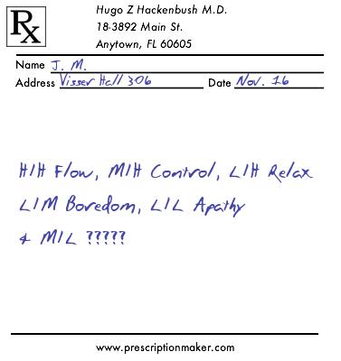

### Receipt Puzzle

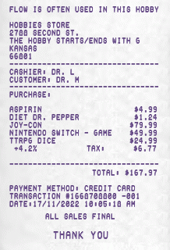

### Ransom Note

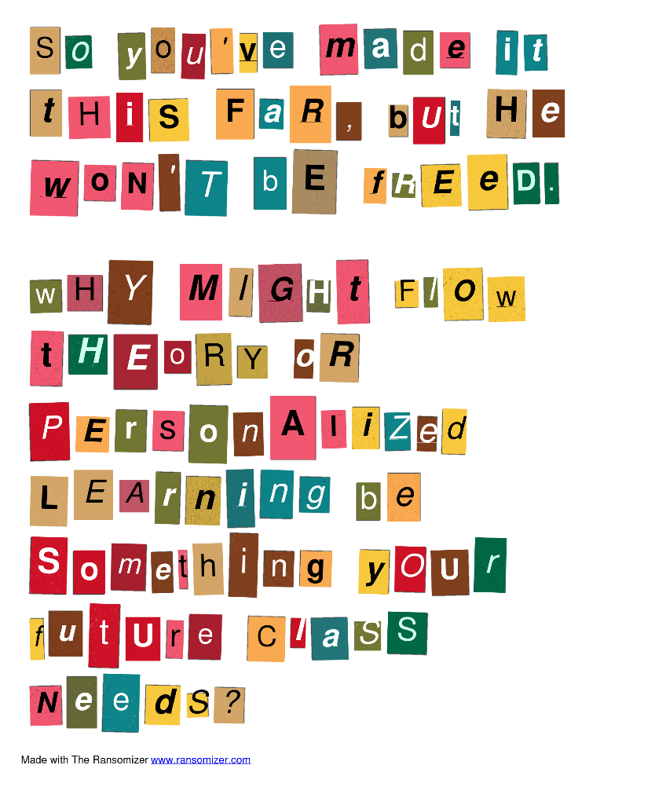

### Newspaper Puzzle

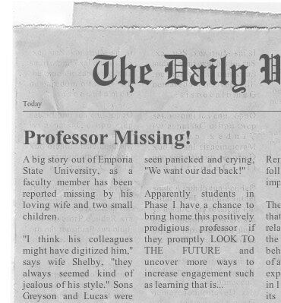

### Marquee Puzzle

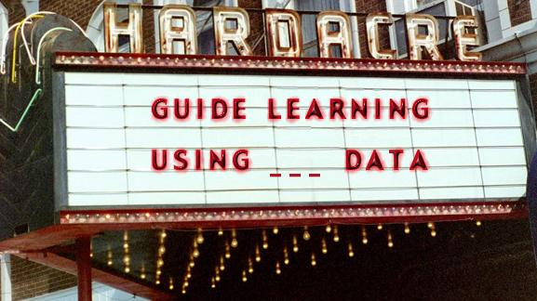

### Text Message Exchange

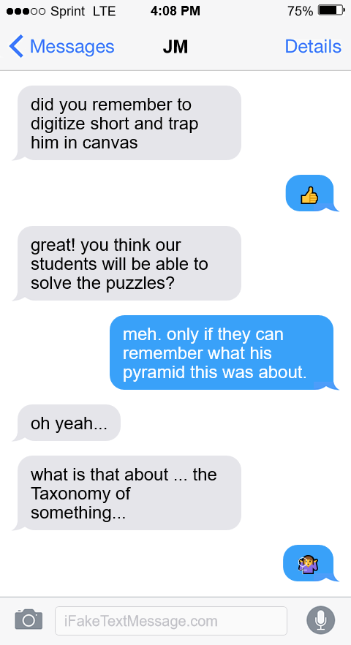

### Hobby Store Receipt

