Experiential Learning in Higher Education
  - Charlotte Jones-Roberts and Crystle Bechtold, University of Central Florida

Overview
Kolb’s (1984) experiential learning theory explains how to turn a four-stage cycle that relies on concrete experience, reflective observation, abstract conceptualization, and active experimentation into effective learning. This unit, intended for university students, is designed to teach this theory through implementation. The learners progress through the four stages in Kolb’s theory while learning to fold an origami paper crane. Each stage requires the learner to reflect and share their discoveries in an online video discussion forum. The lesson concludes with a reflection on the process of learning to fold a paper crane and on learner’s understanding of experiential learning in practice.
Topics: Experiential Learning, Learning by Doing, Online Learning
Time: Approximately 4 hours

Materials
- Computer and internet connection
- Canvas Web course (see Support Materials)
- Padlet (n.d.) discussion board (or similar tool)
- Web camera
- Microphone
- Scrap paper
- Scissors

Setup
This is a fully online, asynchronous unit within a larger course. To prepare the online course and assessments, instructors will need to ensure that all instructional materials are accessible through Canvas learning management system (LMS; see Support Materials). Additionally, Padlet (n.d.) video discussions must be published and enabled for each of the five discussions.
Context-at-a-Glance
The design of this unit is self-referential, in that the students learn Kolb’s (1984) Experiential Learning Theory by doing Experiential Learning Theory.
Setting
An online graduate education course required before enrolling in internships at a university in the United States.
Modality
Fully online, asynchronous
Class Structure
A group-paced, asynchronous online course divided into modules.
Organizational Norms
All students have access to Canvas Learning Management System. The university prioritizes experiential learning to create inclusive opportunities that promote collaboration between students, faculty, and community partners.
Learner Characteristics
Graduate students (N=19) with limited experience in experiential learning or Padlet video discussions.
Instructor Characteristics
The educator holds an M.A. in Instructional Design and Technologies.
Development Rationale
The course emphasizes the importance of experiential learning as a pedagogical approach that bridges theory and practice, preparing students for real-world challenges in their internships and future professional endeavors. By engaging in hands-on activities and interactive learning experiences, participants gain a deeper understanding of concepts and develop practical skills that are transferable to their respective fields.
Design Framework
ADDIE Framework; Kolb’s (1984) Experiential Learning Theory

Context and Setting
This project introduces graduate level students to the principles and practices of experiential learning before they embark on their requisite internships.
The course was offered at a public, metropolitan, research university with a quality graduate-level professional education program. The Instructional Design and Technologies program that the course is a part of includes a practicum that is completed towards the end of the program. The university prioritizes experiential learning and internships as a leading “partnership university” and strives to develop and sustain quality experiential learning opportunities that promote collaboration between students, faculty community, and employer partners. The students are guided by faculty as they apply theory to practice in ways that enhance their academic learning and development of skills and abilities to contribute to their field of choice.

Learner Characteristics
The students who participated in this activity were diverse in backgrounds and understanding. Some of the students were professional educators in PK-12 classrooms, others were practicing instructional designers, and some were pursuing career-changes either into or out of education. Their experience and understanding of the learning theories were equally diverse.
From a technical standpoint, all students completed at least some professional education graduate-level coursework, had a working knowledge of Canvas, were comfortable operating a webcam or phone for the purpose of recording a video and submitting it, and successfully engaged in a group-paced, asynchronous online course prior to this course. This experiential learning activity, however, has the potential to be used across class standings and disciplines as a precursor for experiential learning. It could be easily modified to meet the needs of other learners or varying settings.

Experiential Learning Activity
This activity was introduced following assigned readings and videos related to experiential learning theory. The course is completed prior to the learner beginning a practicum as a part of their program requirements. By engaging in this activity, and the course, the students may better understand the theory behind practical internships as well as develop an understanding of Kolb’s (1984) experiential learning theory and its implementation. The unit also provides additional resources and applications for experiential learning in higher education.
Incorporating asynchronous video discussions with Padlet (originally Flip before it was discontinued) in an online course on experiential learning for busy university students serves a dual purpose:
- Video discussions facilitate the integration of hands-on, experiential activities into the curriculum while accommodating the diverse schedules and commitments of students. By utilizing Padlet, or alternative video discussion tools, students can engage in reflective activities and share their experiential learning experiences through video recordings at their convenience, allowing for flexible participation without the constraints of fixed class times. This approach not only promotes active engagement with course content but also encourages students to apply theoretical concepts to real-world situations, fostering deeper understanding and integration of experiential learning principles.
- The visual and auditory nature of video discussions on Padlet also enhances social presence and collaboration among students, creating a sense of community despite physical distance and time constraints.
The instructional unit is grounded in experiential learning theory. It instructs the learner about Kolb's (1984) experiential learning theory by having students actively complete the steps of the theory and reflect on each of them.
The activity, creating a paper crane, was chosen to contextualize this theory because it requires very few materials (a piece of paper and scissors), does not take as much time as other forms of genuine experiential learning (such as service learning, internships, or study abroad), and is something that requires the learner to be hands-on.
Reflective observation is a pivotal part of the experiential learning process (Kolb, 1984). Kolb’s (1984) emphasis on a "here-and-now concrete experience" echoes the importance of hands-on learning in testing and validating abstract concepts. For instance, the creation of a paper crane with the learner's own hands provides a genuine opportunity to learn by doing. Through each step of creating the paper crane, students are actively engaging in Kolb’s experiential learning process:
- Concrete Experience: Making a paper crane involves physically folding and manipulating paper, providing a hands-on, tangible experience for the learner that is representative of the concrete experience phase in Kolb's model.
- Reflective Observation: As students fold the paper crane, they can observe their actions, notice patterns, and reflect on their progress. They may consider what techniques are working well and what adjustments need to be made. This reflective observation encourages introspection and insight, characteristics of this phase.
- Abstract Conceptualization: Through the process of reflection, students can begin to abstract general principles or concepts from their concrete experience. They might identify underlying principles of origami, such as symmetry, precision, and technique. This abstraction allows them to conceptualize broader ideas beyond the specific task at hand.
- Active Experimentation: After reflecting on their experience and conceptualizing key principles, students can apply this newfound understanding by actively experimenting with different folding techniques or variations of the paper crane. They might try different approaches to improve their technique or personalize their creation. This experimentation fosters continued learning and skill development.
By engaging in the process of creating a paper crane, students can actively participate in all stages of Kolb's experiential learning model, making it a powerful and effective way to illustrate the principles of learning by doing.

Learning Representation Overview
This learning experience is a self-led, online lesson. Students will engage with the material presented on the Canvas Web course in sequential order (as described below; see Figure 1). This organization follows the best practices highlighted in Malone and Minor (2014) for experiential learning in online settings.
After students review the objective of the lesson, they read the introduction and watch the embedded YouTube video introducing Experiential Learning (Sprouts, 2015). The text following the video focuses on Experiential Learning Principles and includes an example of baking bread and a supporting diagram image.
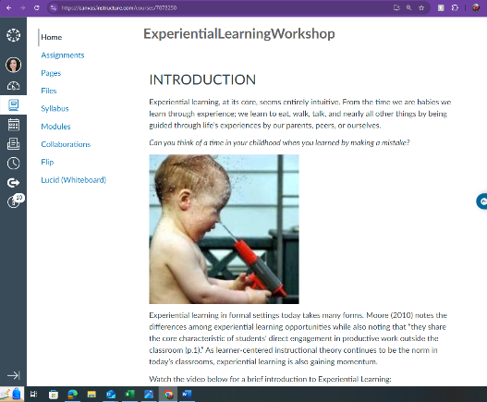
Figure 1: Screenshot of introduction page in canvas.
Following the reading portion of the lesson, students are asked to share their preconceptions of the assignment through the Padlet discussion tool. Three questions related to their currently held perceptions of paper cranes are provided for them to answer (see #1 Abstract Conceptualization section)
In the active experimentation portion of the lesson, students must use a scrap piece of paper to fold a paper crane without using additional supports or reference materials. They then post a picture of the attempt on Padlet.
The students then record a reflective observation of the activity using Padlet and share these insights with their peers. They are provided with three guiding questions to help facilitate their responses (see #3 Reflective Observation section).
After viewing the reflections of their peers, the students develop improved strategies to fold a paper crane. They may now consult outside resources such as friends, family, or online tutorials. In another Padlet video, students discuss how their strategy changed based on new knowledge and display their latest paper crane.
In a final Padlet video, students reflect on the active experimental portion of the assignment (try, learn, try again). They are provided with five leading questions that tie the active experimental portion to the steps in Kolb's (1984) experiential learning theory. As with the reflective observation videos done during step 3, students will review the Padlet of their peers to develop a deeper understanding.

Detailed Learning Representation
The following sections outline the content in the Canvas Web course. Italic text identifies directions, questions, or prompts provided to the learners.

Objectives
The objectives course page presents a comprehensive overview of the terminal and enabling objectives. The terminal objective is the goal students aim to achieve. In this unit, the terminal objective is:
- Learners will actively practice and reflect upon the basic principles of Experiential Learning Theory.
Enabling objectives serve as intermediate milestones facilitating the attainment of the terminal objective. In this unit, the enabling objectives are:
- Learners will understand an introduction to Kolb's Experiential Learning Theory.
- Learners will abstractly conceptualize the process of making a paper crane.
- Learners will actively experiment to create a paper crane.
- Learners will reflectively observe their crane creation process.
- Learners will produce concrete experience on how to effectively create a paper crane.
- Learners will reflect upon the Experiential Learning Model and its potential classroom applications.

Introduction
The introduction course page serves as an instructional guide for Kolb's (1984) experiential learning theory, providing insight into the concept of experiential learning and highlighting its increasing popularity. It serves as a foundational understanding for students, setting the stage for a more in-depth exploration of the content. The page incorporates a video component titled "Experiential Learning: How We All Learn Naturally" (Sprouts, 2015), offering an alternative mode of information delivery.
This video, shown in figure 2, serves as an additional resource to familiarize students with the key concepts and principles of Kolb’s (1984) experiential learning theory. By combining textual information with visual content, the instructional approach aims to enhance the learning experience and cater to different learning styles. Together, these elements contribute to a holistic learning environment, supporting participants in their engagement with the content.
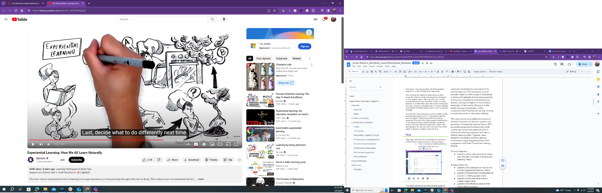
Figure 2: Screenshot of Video on “Experiential Learning: How We All Learn Naturally” (Sprouts, 2015).
Beyond the video, there are introductory text and visuals. The following is the content found on the introduction course page:

INTRODUCTION
Experiential learning, at its core, seems entirely intuitive. From the time we are babies we learn through experience; we learn to eat, walk, talk, and nearly all other things by being guided through life’s experiences by our parents, peers, or ourselves.
Can you think of a time in your childhood when you learned by making a mistake?
Experiential learning in formal settings today takes many forms. Moore (2010) notes the differences among experiential learning opportunities while also noting that “they share the core characteristic of students’ direct engagement in productive work outside the classroom” (p. 1). As learner-centered instructional theory continues to be the norm in today’s classrooms, experiential learning is also gaining momentum.
Watch the video below for a brief introduction to Experiential Learning:
- Experiential Learning: How We All Learn Naturally (Sprouts, 2015)
EXPERIENTIAL LEARNING PRINCIPLES
In the 1980s, MIT professor Michael Kolb was seeking a better way to challenge and instruct students, and experiential learning was his answer. Inspired heavily by Lewin’s model, Kolb (1984) published the Experiential Learning Model (ELM), shown in the figure below, and the Elements of Experiential Learning. Kolb is now the most recognizable name associated with Experiential Learning. There are four stages of learning within Kolb’s ELM and each one provides grounding for the next. These stages are more cyclical than concrete, ordinal steps.

Through Kolb’s theory, a person learns through experience. Take for example, a person who wants to learn to bake bread, but they do not have a recipe. So, they create an abstract conceptualization of what amounts of wheat, water, and yeast they will need. They use active experimentation to bake the bread. Unfortunately, it does not rise properly, so they reflectively observe what went wrong. They try again, and this time observe their grandma baking bread to abstractly conceptualize and realize that the bread needed to sit for at least overnight before baking. Then, there is success, creating concrete experience they can use for baking bread in the future.

Assignments
After the introduction, students begin the assignments which include the creation of the origami paper crane and the five Padlet video discussions. The assignments were designed based on the experiential learning principles. All assignments and prompts can be found on the assignments course page (Figure 3).

Experiential Learning Principles
The focus of this unit is to elaborate on Kolb's (1984) experiential learning theory by offering a detailed exploration of its key components and principles. This instructional approach involves using a practical example to enhance understanding. Specifically, the lesson incorporates a hands-on activity, centered around the process of folding a paper crane.
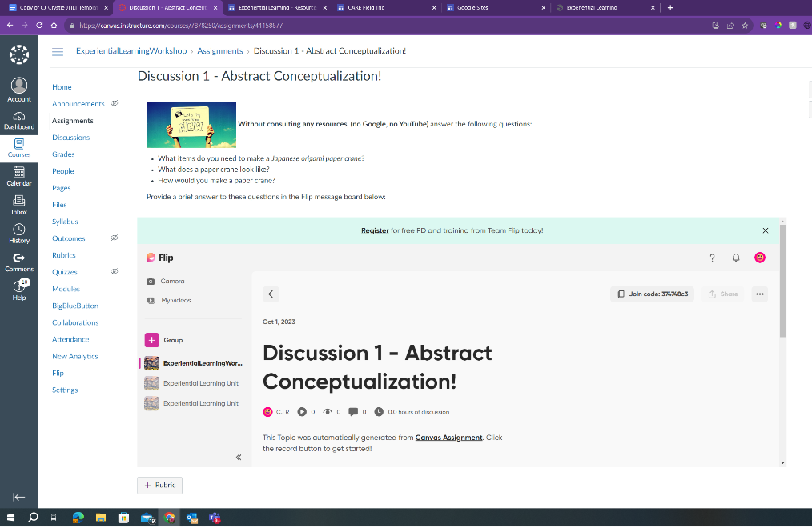
Figure 3: Screenshot of Padlet discussion page.
By engaging in the act of folding a paper crane, learners can directly experience and apply the concepts as illustrated by Kolb’s Experiential Learning Cycle in Figure 4. This experiential learning activity not only serves as a practical illustration of the theoretical framework but also provides a tangible and memorable context for grasping the underlying principles. Through the combination of theory and real-world application, this lesson aims to foster a deeper comprehension of Kolb's (1984) experiential learning theory while promoting an interactive and engaging educational experience.
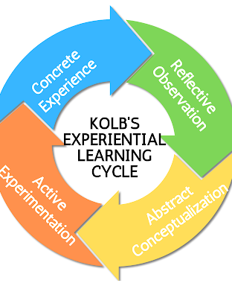
Figure 4: Image of Kolb’s Experiential Learning Cycle, created by Charlotte Jones-Roberts.

#1 Abstract Conceptualization
Abstract conceptualization represents the stage where individuals reflect on their concrete experiences and create generalized principles or theories. It involves thinking critically about their experiences, drawing connections, and extracting broader concepts.
The first Padlet video discussion involves only the cognitive understanding of origami techniques and is completed prior to creating an origami paper crane. The following is the #1 Abstract Conceptualization content found on the assignments course page:
Now, let's deepen your engagement with the origami process through a self-reflection video. Without resorting to external resources such as Google or YouTube, share your insights on the following questions within a concise 30-60 second video. If you need additional help using Padlet, please visit Record and Post a Video on Padlet (Wilds, 2024).
- What items do you need to make a Japanese origami paper crane?
- Discuss the materials you utilized in your origami endeavor. Highlight the essential items required to craft a Japanese origami paper crane. This could include the type and size of paper, any additional tools, or any improvised alternatives you might have explored.

- What does a paper crane look like?
- Offer your personal description of a paper crane. Share your perceptions of its characteristic features, such as wings, beak, and body. This is an opportunity to articulate your understanding of the quintessential appearance of a traditional Japanese origami crane.

- How would you make a paper crane?
- Provide a brief overview of your approach to creating a paper crane. Describe the sequence of folds and maneuvers you employed, emphasizing any unique techniques or interpretations you incorporated. This part of the video allows you to showcase your individual style in approaching the origami process.
Remember, the objective is to rely solely on your intuition and prior knowledge. This exercise encourages a genuine exploration of your understanding of origami, setting the stage for future comparisons and insights as you delve deeper into the art. After recording your video, consider revisiting it later to observe your progression and newfound understanding as you continue your origami journey.

#2 Active Experimentation
Active experimentation involves the process of applying new knowledge and skills in real-life situations to test their practicality and effectiveness. It emphasizes hands-on experiences, allowing individuals to actively engage with the material, reflect on their actions, and refine their understanding through direct application.
The second activity and Padlet video discussion involves the physical execution of folding paper to bring the concept to life. As students navigate the folds and creases, they are actively experimenting with their knowledge, refining their skills through trial and error, and gaining a deeper understanding of the principles behind origami. This tactile experience not only reinforces their learning but also fosters creativity and problem-solving skills as they adapt and refine their approach during the process. The following is the #2 Active Experimentation content found on the assignments course page:
Now, let's embark on the hands-on portion of our origami journey. Your task is to create a paper crane without consulting any external resources. This is an opportunity to tap into your creativity and intuition. Remember, perfection is not the goal at this stage—simply aim for your first and best attempt.
Craft Your Paper Crane:
- Set aside a quiet space, gather your materials, and start folding. Follow your instinct and recall any prior knowledge you have about origami. Allow yourself to experiment with the folds and creases, embracing the unique character that may emerge from your unguided approach.
Capture the Moment:
- Once your paper crane is complete, capture the moment by recording a video showcasing your creation. Share insights into your thought process, the challenges you encountered, and any surprising discoveries along the way. This video serves as a snapshot of your initial exploration into origami without external guidance.
Post Your Video:
- Share your video within the designated platform or forum. This not only allows you to contribute to the collective learning experience but also provides an opportunity for mutual support and encouragement within the learning community.
Reflect on the Process:
- After posting your video, take a moment to reflect on your experience. What aspects of the folding process felt intuitive, and where did you encounter challenges? Consider the overall aesthetic of your crane and any unique elements that emerged from your unassisted endeavor.
By creating and sharing your first paper crane without external guidance, you are embracing the essence of experiential learning. This unscripted exploration allows for personal discovery and sets the stage for future improvement and refinement. Embrace the imperfections and celebrate the uniqueness of your origami creation!

#3 Reflective Observation
Reflective observation focuses on the thoughtful examination and analysis of one's own experiences. Students can engage in a reflective session after completing the task of folding a paper crane. This reflective phase prompts students to consider the intricacies of their folding process, the challenges they faced, and the strategies they employed to overcome obstacles. By encouraging students to share their observations with peers, they can gain insights into different approaches and learn from each other's experiences.
This third activity and Padlet video discussion not only enhances self-awareness but also promotes a deeper understanding of the learning process. It encourages students to recognize patterns, assess the effectiveness of their actions, and identify areas for improvement. Through reflective observation, learners develop a heightened sense of metacognition, allowing them to transfer these insights to future experiences and learning endeavors. The following is the #3 Reflective Observation content found on the assignments course page:
Now, it's time to delve deeper into your learning experience and provide thoughtful responses to the following questions in a concise 30-60 second video:
- Did your experiment look like a crane?
- Reflect on the outcome of your experiment. Did your origami creation resemble a crane, or did it take on a different form? Be specific in your observations and consider the key features that make a crane distinct in the realm of origami.

- What do you think went wrong?
- Analyze the factors that may have contributed to any deviations from the intended crane design. Was it a particular step in the folding process, a misunderstanding of instructions, or perhaps a material-related issue? Offer a brief but insightful assessment of what you believe may have gone awry.

- What is your improvement strategy?
- Outline your plan for improvement. Share the steps you intend to take to enhance your origami skills and achieve a crane-like outcome. Possible strategies could include seeking guidance from your instructor, consulting friends or family members experienced in origami, exploring relevant websites, or watching instructional YouTube videos. Clearly articulate how you aim to address the identified challenges.
Now, to put your strategy into action by creating a second crane:
- Execute your improvement strategy by folding a second origami crane. Apply the insights gained from your reflections and take deliberate steps to enhance your technique. Pay close attention to the details and nuances that will contribute to a more accurate representation of a crane. Capture the process in a time-lapse or showcase key moments in your video response.
By engaging with these questions and actively pursuing improvement, you'll not only refine your origami skills but also cultivate a mindset of continuous learning and adaptation. Your video response serves as a tangible demonstration of your commitment to growth and mastery in the art of origami.

#4 Concrete Experience
Concrete experience emphasizes direct engagement with a particular task or activity. In a lesson designed to facilitate concrete experience, students can focus on gaining mastery in folding a paper crane.
This hands-on, fourth activity and Padlet video discussion provides learners with a tangible and practical encounter with the art of origami. Through the physical act of folding, students develop a tactile understanding of the step-by-step process. The following is the #4 Concrete Experience content found on the assignments course page:
Now that you've reflected on the Experiential Learning Unit and identified areas for improvement, let's take proactive steps to enhance your paper crane-folding skills. The process of improvement is an integral aspect of experiential learning, and there are various strategies you can employ to refine your technique. Consider the following steps:
Consulting Resources:
- Reach out to your instructor: Seek guidance from your instructor by asking for specific tips or additional resources related to paper crane folding. They may provide insights, correct common mistakes, or recommend alternative approaches.
- Engage with friends or family: Collaborate with peers or family members who may have experience in origami. Their practical tips and shared experiences can offer valuable insights into refining your technique.
- Explore online resources: Utilize reputable websites that provide detailed instructions, images, or videos on paper crane folding. Websites dedicated to origami often offer step-by-step guides and troubleshooting tips for common challenges.
- Watch video tutorials: YouTube and other video platforms host a plethora of origami tutorials. Observing experienced folders in action can provide a visual understanding of the folding process and help clarify any ambiguities.
- Changing Your Folding Process:
- Experiment with alternative techniques: Take the opportunity to explore different folding approaches. Adjust your grip, try folding from a different starting point, or experiment with varying levels of precision. Embrace a trial-and-error mindset to discover what works best for you.
- Break down the steps: If you found certain steps challenging, break them down into smaller, more manageable components. Focus on mastering each sub-step before attempting the entire process, allowing for a more gradual and controlled learning experience.
Stating Your Strategy for Improvement:
- Clearly articulate your plan: Outline your specific strategy for improvement. Whether it involves seeking advice from your instructor, watching online tutorials, or experimenting with alternative folding techniques, having a defined plan will guide your learning process.
- Set measurable goals: Establish specific, measurable goals to track your progress. For example, aim to complete a paper crane with fewer errors or achieve a smoother folding process. Regularly assess your performance against these goals to gauge improvement.
- Creating a Third Crane:
- Apply your improvement strategy: Implement the lessons learned from your reflection and improvement strategy to create a second paper crane. Pay attention to the details and adjustments recommended through your chosen approach.
- Compare the results: Compare your second crane to the initial one, noting any visible enhancements or changes in your folding technique. Reflect on the effectiveness of your chosen improvement strategy and identify areas for further refinement.
By actively engaging in the improvement process and incorporating various learning resources, you'll not only enhance your paper crane-folding skills but also deepen your understanding of experiential learning in action. Remember, the journey of improvement is a continuous and iterative process.
Post a Padlet Video sharing what strategies you used to improve your crane and include your new crane. The video must be a minimum of 30 seconds.

Final Reflection
Completing the final (fifth) activity and Padlet video discussion, using Kolb's experiential learning theory, provides students with a structured framework to deeply engage with their learning experiences. By following the provided guidelines, students share moments from the unit based on their Concrete Experiences, reflect on their thoughts and feelings through Reflective Observation, connect their experiences with relevant theories by Abstract Conceptualization, and propose applications or changes during Active Experimentation.
This approach fosters self-awareness, critical thinking, and synthesis of knowledge, aligning with the grading criteria and enhancing the learning process. In addition, incorporating visuals of a paper crane to represent each stage of Kolb's theory adds a creative element to the reflection, aiding comprehension and retention.
Engaging with peers' reflections further enriches the learning experience, fostering collaboration and diverse perspectives. By integrating Kolb's framework into their final video reflection, students demonstrate their understanding of the unit and their commitment to lifelong learning and personal development. The following is the #5 Final Reflection content found on the assignments course page:
Now, let's dive into the guidelines for your final reflection. Your reflection should not only recap your journey through the unit but also explicitly connect your experiences with Kolb's (1984) Experiential Learning Theory. Remember, Kolb's theory consists of four stages: concrete experience, reflective observation, abstract conceptualization, and active experimentation.
In your reflection post, consider addressing the following:
- Concrete Experience: Describe a specific moment or activity from the unit that stands out to you. What did you do, see, or feel during this experience?
- Reflective Observation: Explore your thoughts and feelings about the chosen experience. How did it impact your understanding of the topic? Did you encounter any challenges or surprises?
- Abstract Conceptualization: Connect your experience with relevant theories, concepts, or previous knowledge. How does what you've learned align with or challenge existing ideas?
- Active Experimentation: Propose potential applications or changes based on your reflections. How might you incorporate your newfound knowledge into real-life situations or future learning experiences?
Now, let's tie this back to the grading criteria, emphasizing the connection to Kolb's theory:
- Video post substantially addresses the corresponding step of Experiential Learning (3 points): Ensure your video post covers each of the four stages of Kolb's theory. Clearly articulate your concrete experience, reflective observation, abstract conceptualization, and plans for active experimentation. The video should be no longer than 5 minutes.
- Visual of paper crane is available, created by the student (1 point): As an additional creative element, consider representing each stage of Kolb's theory through visuals on your paper crane. This could include symbols or images that capture the essence of each stage.
- Student responds to another post (1 point): Engage with a peer's reflection post. Share your insights, ask questions, or provide constructive feedback. This interaction fosters a collaborative learning environment, enhancing the overall experiential learning process.
By integrating Kolb's Experiential Learning Theory into your final reflection, you'll not only showcase your understanding of the unit but also demonstrate the application of a powerful framework for lifelong learning. Happy reflecting!

Critical Reflection
After implementing the experiential learning unit, students made significant strides in their understanding and application of the fundamental principles of experiential learning theory. Engaging in hands-on activities and reflective exercises, students actively immersed themselves in practical learning experiences designed to deepen their knowledge and skills.

Despite these commendable achievements, a notable challenge emerged regarding the students' ability to articulate detailed reflections in their assigned posts. Some video posts did not fully substantiate how the learner’s thought process related to experiential learning. This highlighted the importance of providing clearer examples and a more comprehensive grading rubric to support and guide students’ reflective process effectively. Additionally, the instructor believes that additional time for video responses, up to 5 minutes as opposed to the 30-60 seconds provided, may be more necessary for a full reflection.
The Padlet platform, chosen for its interactive features, generally garnered positive feedback from students. However, a subset of learners encountered initial connectivity issues and had difficulties navigating permissions for Learning Tools Interoperability (LTI). Some of these connection issues were related to cookies settings in students' browsers. Addressing these technical challenges through detailed, step-by-step instructions on adjusting camera permissions during Padlet video discussions on computers is essential to ensure a seamless learning experience for all students.

The instructor found this unit to garner exciting insights into students’ thoughts and understanding of experiential learning. For an asynchronous unit, the instructor was very impressed with the connection between learners and the student's engagement in the process. Likewise, the students mentioned they enjoyed the unit significantly, especially the video reflection.
Overall, as students completed the unit, they successfully achieved the terminal learning objective of actively practicing and reflecting upon the core principles of experiential learning theory. Through well-structured activities and thought-provoking exercises, students not only deepened their understanding but also gained practical insights into applying these principles in real-world contexts.

References
Kolb, D. A. (1984). Experiential learning: Experience as the source of learning and development. Prentice-Hall.
Malone, M., & Minor, K. (2014). Guided experiential learning; Focused interactivity in online and hybrid learning environments. In A. Hirumi (Ed.), Grounded designs for facilitating online and hybrid learning: Online and hybrid learning designs in action (pp. 131-157). International Society for Technology in Education.
Moore, D. T. (2010). Forms and issues in experiential learning. New Directions for Teaching and Learning, 2010(124), 3-13. https://doi.org/10.1002/tl.415
Padlet. (n.d.). Retrieved November 27, 2024, from https://padlet.com/
Sprouts. (2015, October 12). Experiential learning: How we all learn naturally [Video]. YouTube. https://youtu.be/aF63HHVbpQ8?si=-0IfkUytIAZBGbUX
Wilds, R. (2024). Post videos on a Padlet. Padlet Help. Retrieved November 27, 2024, from https://padlet.help/l/en/article/drmkz03rmn-post-videos-on-a-padlet

Support Materials
- Instructure Canvas Shell: Open access, you must create an account to view. Long link: https://canvas.instructure.com/courses/7878250

About the Authors
Charlotte Jones-Roberts is an instructional designer at the University of Central Florida with a doctorate in Curriculum and Instruction. Her research centers on enhancing quality in online learning, student facing generative AI, open educational resources, and supporting mental health for student success in virtual environments.
Crystle Bechtold is a graduate of the University of Central Florida, where she earned her master’s degree in Instructional Design and Technologies. She also works in the College of Sciences at UCF, promoting inclusive and welcoming learning environments in higher education.

Sharing & Modification Permissions
Unless otherwise noted, this article and its resources are published under a Creative Commons Attribution-NonCommercial-ShareAlike 4.0 International license:

You can freely share the article and its resources if you indicate the original authors, identify the Creative Commons license, and use them non-commercially.
You may also make and share modifications by:
- Identifying the original authors.
- Using the resources non-commercially.
- Licensing modifications under the CC BY-NC-SA 4.0 license (and including a link to it).
- Indicating what modifications were made.

