Computational Thinking in Undergraduate
Preservice Special Education Programs
  - Rachel H. Billman¹, Kandace M. Hoppin¹, and Julia Murphy²
¹Towson University, ²Baltimore County Public Schools

Overview
In the 21st century, an increased emphasis on integrating computational literacy within classrooms occurred (Bouck & Yadav, 2020). This learning representation aims to equip preservice special education teachers (PSSETs) with tools to deliver inclusive computational thinking (CT) and computer science (CS) instruction, fostering an understanding of CT/CS concepts and promotes integration across content areas. This technology-rich learning representation employs robots, interactive whiteboards, and a blend of unplugged and plugged CT activities to demonstrate how CT can be integrated into a PK-12 classroom. This learning representation concludes with an assessment tasking PSSETs to create an activity integrating CT. This approach prepares PSSETs to provide equitable and accessible CT/CS education, aligning with current educational priorities.
Topics: Computational Thinking, Special Education, Teacher Education
Time: 1.5-2 hours

Materials
- CT in SPED Slides
- Design a CT Activity Rubric
- Interactive whiteboard or projector that connects to a computer (i.e. screen projection capability)
- Speakers
- Robots (preferably Sphero-mini, mTiny, or Dash & Dot, but these types are not required)
- Chart paper and markers OR whiteboard and whiteboard markers
- Virtual whiteboard (e.g., Padlet or FigJam)
- Sticky notes

Context-at-a-Glance
Setting
A university undergraduate special educator preparation program.
Modality
Face-to-Face
Class Structure
Session lasting 1.5 to 2 hours, arranged with tables or desks grouped to encourage group work.
Organizational Norms
The teacher preparation program utilizes the Universal Design for Learning (UDL) framework to prepare preservice special education teachers (PSSETs) and integrate technology effectively.
Learner Characteristics
Learners are third-year undergraduate PSSETs with limited prior exposure to special education and computational thinking (CT).
Instructor Characteristics
The instructor was a special education expert with a novice understanding of CT and computer science (CS). No CS background is necessary for implementation.
Development Rationale
The learning representation addresses the lack of CT exposure for students with disabilities by tasking PSSETs with integrating CT into the curriculum, aligning with current educational priorities, and ensuring equitable and accessible instruction.
Design Framework
Backward Design Approach

Setup
The setup for this lesson takes about 15-20 minutes. Instructors should preview and work through the CT in SPED Slides (PDF) before implementation, review the Design a CT Activity Rubric (PDF), and practice using all technology before expecting preservice special education teachers (PSSETs) to use it effectively. This includes setting up robots and other technology items with the appropriate applications, ensuring they are charged, and placing them in a safe place within the classroom.
The learning environment should promote collaboration and discussion amongst the PSSETs in the classroom. Grouped seating is encouraged. Screen projection or an interactive whiteboard is required to display the technology-embedded slides with speakers and play sound.

Standards
This lesson supports an International Society for Technology in Education (ISTE, 2017) standards for educators and a Council for Exceptional Children’s High Leverage Practice (McLeskey et al., 2017). The ISTE (2017) standard this lesson meets is, “Educators continually improve their practice by learning from and with others, and exploring proven and promising practices that leverage technology to boost student learning” (2.1 Learner).
The Council for Exceptional Children’s High Leverage Practice this lesson meets is #19:
Teachers select and implement assistive and instructional technologies to support the needs of students with disabilities. They select and use augmentative and alternative communication devices and assistive and instructional technology products to promote student learning and independence. They evaluate new technology options given student needs; make informed instructional decisions grounded in evidence, professional wisdom, and students’ IEP goals; and advocate for administrative support in technology implementation. Teachers use the universal design for learning (UDL) framework to select, design, implement, and evaluate important student outcomes. (McLeskey et al., 2017, p. 24)

Context and Setting
Computational Thinking (CT) is considered a vital “21st-century skill” (Tabesh, 2017) that involves breaking down complex issues into manageable parts and using logical reasoning to devise solutions. CT is an essential skill for understanding computer science (CS) but extends beyond coding, including crucial cognitive skills that can transfer to many fields and academic content areas. As such, it is necessary that PSSETs be made aware of these critical thinking and life skills that pre-Kindergarten through twelfth grade (PK-12) students will be tasked with understanding in our ever-evolving digital landscape. However, students with disabilities in PK-12 settings are often not included in opportunities to learn about CT/CS. With an increasing number of states incorporating CT/CS standards as mandatory graduation requirements (Ofgang, 2022), it is imperative to ensure that students with disabilities have access to CT content in their academic curriculum. PSSETs, therefore, must be prepared to include CT into the curriculum for their learners, not only to increase accessibility and equity in CT content but also to emphasize the importance that CT knowledge can have in a student’s future.
To prepare PSSETs for integrating CT into the curriculum, the integration of CT concepts into two key courses was the focus. The courses were a course on Universal Design for Learning (UDL) and a course on curriculum and methods for instruction for students with disabilities. Students take these courses concurrently. Together, these courses support PSSETs’ learning of methods for teaching students with disabilities across the content areas in PK-12 settings and the support required to provide students with access to academic content. In the UDL course, PSSETs are provided with opportunities to create lesson plans for different content areas for learners with disabilities. As UDL is a central concept taught in this course, PSSETs must incorporate and align to UDL in their lesson plans and activities. Technology use is heavily emphasized in the UDL course, and a substantial portion of the course also focuses on instructional and assistive technology.
This learning representation was presented to PSSETs in the UDL course during weeks 11 and 12 of the 15-week semester. At this point in the semester, PSSETs were exposed to methods for teaching special education in mathematics, reading, social studies, and science; the UDL framework; instructional planning; and assistive and instructional technology. Given the aims of the UDL course, the learning representation discussed in this lesson aligns with the following concepts:
- Understanding of content and methods for teaching various content areas to learners with disabilities.
- Supports for teaching learners with disabilities.
- Instructional planning for learners with disabilities.
Our university’s UDL course is most frequently taught in a classroom with multiple technology access points, including a computer with screen projection, an interactive whiteboard, multiple brands of robots (Sphero, mTiny, mBot, Dash & Dot), and various crafting supplies. Approximately 12-20 students are in each section of this course, and all are either Special Education majors, dual Early Childhood and Special Education majors, or dual Elementary Education and Special Education majors. The room is arranged with large tables, and students sit in groups of four. The course is taught by faculty in the Department of Special Education. This learning representation is customizable to the unique needs of each of the majors offered within the Department of Special Education, as PSSETs can choose the grade level and content area of interest.

Learning Representation
The following description outlines the details of our learning representation for increasing awareness and understanding of CT for PSSETs. At the end of this learning representation, PSSETs are tasked with creating an accessible activity for learners with disabilities, integrating CT into a content area of the PSSETs’ choice. With this result in mind, a backward design was applied to create the following activities to assist PSSETs with identifying the importance of CT in the classroom, exploring CT concepts, learning CT concepts, and exploring ways of integrating CT concepts into their future curricula.
The learning representation begins with an introduction to CT concepts through a group activity, followed by a description and discussion of what CT is. Then, in the content presentation, concepts are elaborated on and PSSETs explore technology and CT/CS concepts in an applied format. The instructor discusses concepts of equity and access for students with disabilities and CT, and statistics for students with disabilities and their inclusion in CS courses are presented. Then, PSSETs are asked to practice making suggestions, based on the UDL framework, for scenarios in which general educators are including CT in their classrooms for learners with disabilities. After PSSETs practice this, they are presented with the limited research that exists around incorporating CT into the curriculum for students with disabilities. Finally, PSSETs are asked to independently create a CT activity integrated into the content area of their choice, including accommodations, modifications, and specific references to CT concepts. During this lesson, italic text identifies questions or prompts for the learners.

Introduction (20 minutes)
The learning representation opens with the presentation, or the CT module, visible on the screen projection or interactive whiteboard. PSSETs also have access to the presentation on their personal laptops that they bring to class. The module opens with critical questions that the student will answer (see Slide 2 of CT in SPED Slides PDF):
- What is computational thinking?
- Why is computational thinking important?
- How do I teach computational thinking to learners with disabilities?
After these questions are presented to the class, an engaging activity that serves as a hook for PSSETs is introduced. PSSETs can answer one of three questions with a small group of peers (see Slide 3 of CT in SPED Slides PDF). They are asked to create a set of directions or a diagram to describe the process of one of the following questions, ensuring that no directions are left out:
How would you:
- Describe the process for alphabetizing graded papers?
- Build a structure out of Legos?
- Cook a meal (rice, meat, and vegetables) to ensure everything is ready at the same time and nothing gets cold?
The instructor then provides students approximately 5-10 minutes for PSSETs to work in small groups to discuss and map out their answers. Whiteboards and dry-erase markers are provided to students, as well as sticky notes. Instructors should encourage PSSETs to write each step on a sticky note to rearrange the order of events easily. After the time is up, the groups share their answers with the class. The instructor should highlight their process, make subtle corrections to their directions (debugging), work together to seek out patterns that they can loop (pattern recognition), or describe a formula to follow (algorithmic thinking). The instructor can use CT/CS terminology to describe this process, or can wait to make that connection, as students will be asked to make explicit connections later in the module.
Next, the instructor formally describes CT using a definition provided by Cuny et al. (2010): “Computational thinking refers to the thought processes involved in expressing solutions as computational steps or algorithms that can be carried out by a computer” (see Slide 4 of CT in SPED Slides PDF). The instructor should ask the class, “why is it important that we are able to articulate information to be carried out by a computer?” PSSETs should describe reasons why and a conversation should ensue.
The instructor should also state that CT is a “way of thinking,” “a critical and logical thinking process,” and “can be applied to computer sciences or any content area” (see Slide 5 of CT in SPED Slides PDF). These aspects of CT are important to highlight, as they emphasize that CT is not necessarily computer science, but a way of thinking that helps us understand how computers think, given the human inputs that create them.
The instructor then provides an introductory video to students that explains the concept of computational thinking by solving a complex mathematics problem (College & Career Ready Labs, 2018; see Slide 6 of CT in SPED Slides PDF)). Closed captioning should be enabled to increase accessibility for this fast-paced video.
This video introduces the PSSETs to CT vocabulary and the problem-solving process using a familiar method that they have worked with in the past in a mathematics course during their high school careers.

Content Presentation and
Exploration (25-35 minutes)
The PSSETs are then provided with definitions of key CT vocabulary, including decomposition, pattern recognition, abstraction, and algorithms. Slide 8 of CT in SPED Slides (PDF) lead PSSETs through the actions required to engage in that part of the CT process.
After introducing the vocabulary, PSSETs are asked to connect it back to their introductory activity (see Figure 1). The instructor will ask the students to reflect on their chosen challenge, and identify when they engaged in decomposition, pattern recognition, abstraction, and algorithmic thinking. PSSETs will be directed/asked to talk about this in their groups and will share after five minutes. The instructor should encourage as many groups to share their ideas as possible.
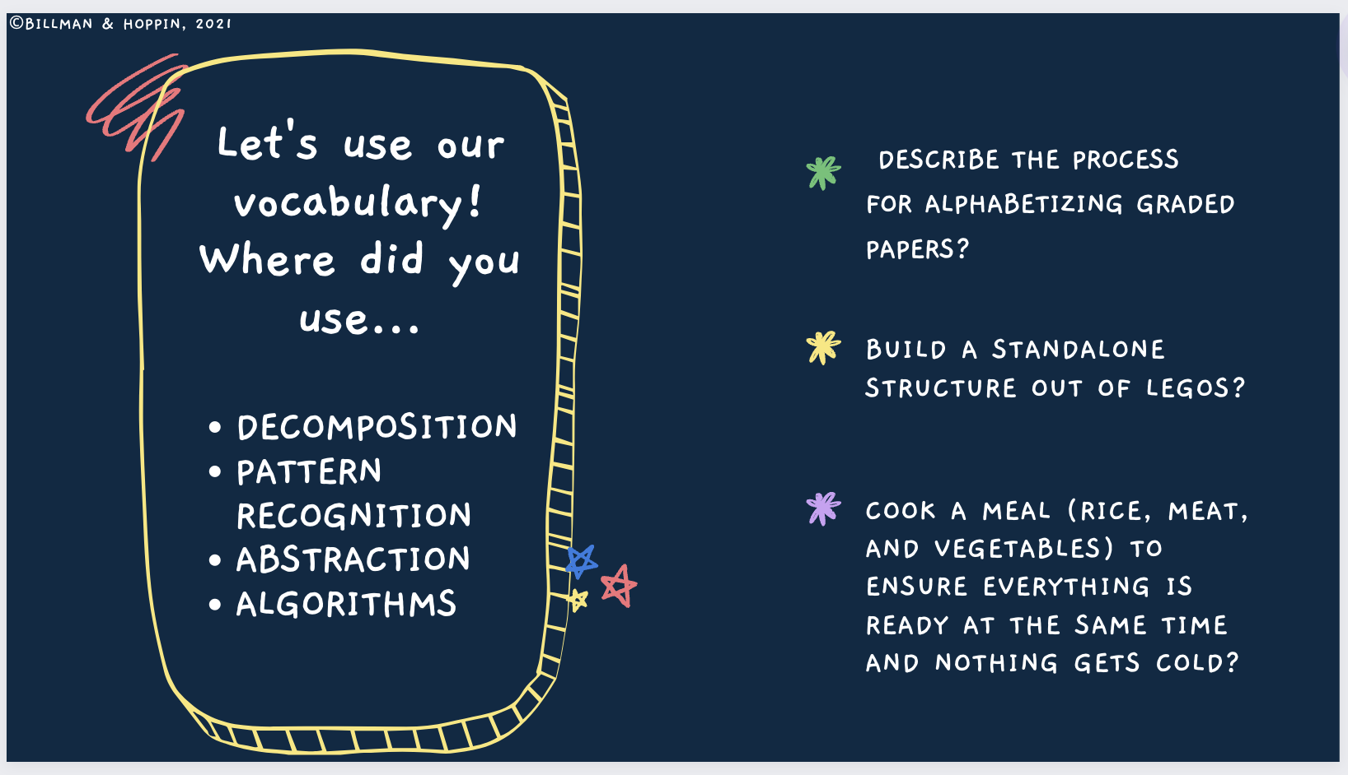
Figure 1. Connect the vocabulary back to the hook (see Slide 9 of CT in SPED Slides PDF).
The instructor will then share a slide that discusses CT concepts (logic, evaluation, abstraction, patterns, decomposition) and the approaches for engaging with those concepts (tinkering, creating, debugging, persevering, collaborating). These approaches are presented in a way that emphasizes the importance of providing these opportunities for engaging in CT concepts to promote inclusivity and equity in the classroom. The instructor should underscore the idea that “we’re all computational thinkers here” (Barefoot Computing, n.d.)
The instructor should then transition into a discussion about why CT is important for all learners (see Slide 10 of CT in SPED Slides PDF). The slides include that future career paths may increasingly rely on CT/CS and an understanding of how computers work, along with the importance of STEM concepts and coding in PK-12 curricula (see Figure 2). The information included in the presentation slides are hyperlinked to current data and articles around these concepts.
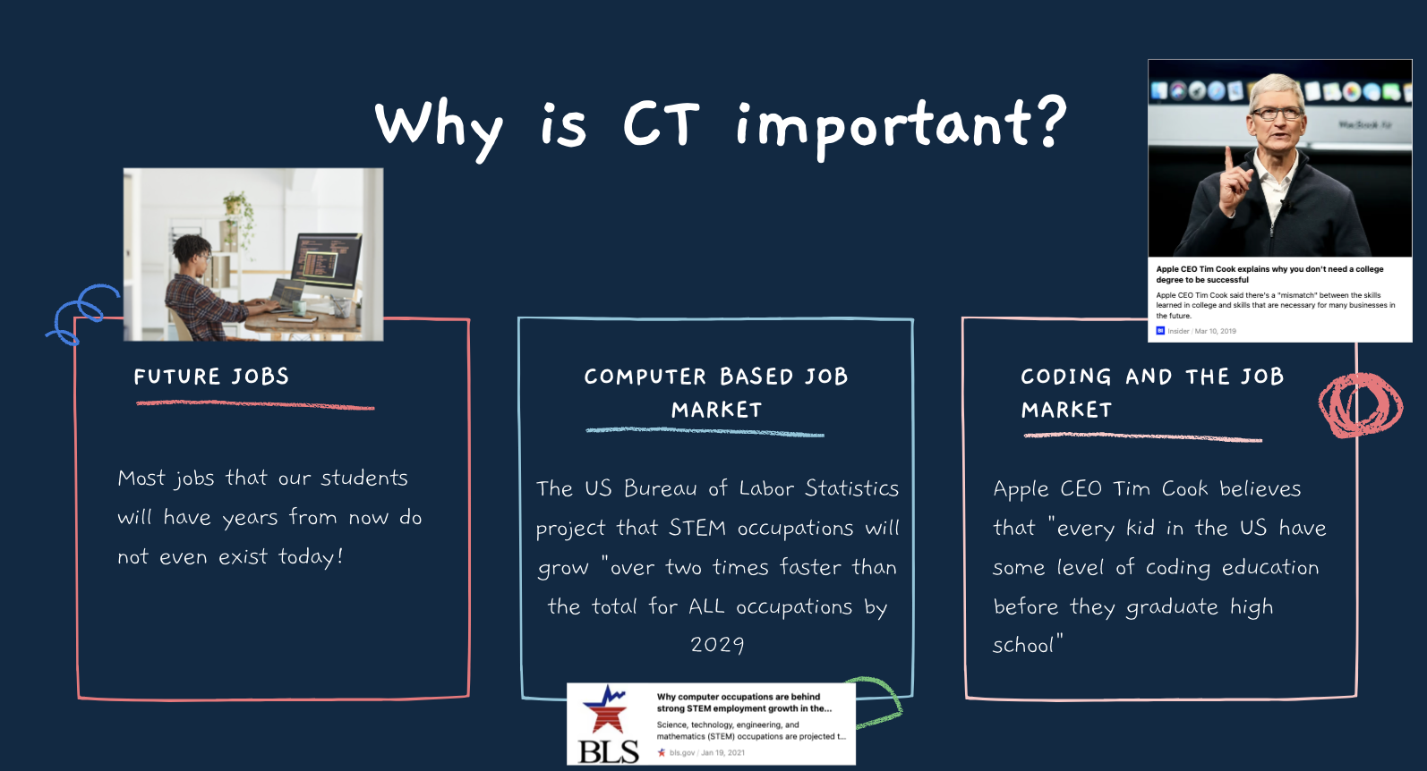
Figure 2. Why is CT Important?
An exploration activity is provided to engage the PSSETs further. They are instructed to do a series of tasks with a partner/small group using the Sphero robots, or other robots that instructors may own. Please note that the following activities should be adjusted if working with another brand of robot. We chose Sphero-mini robots due to their low cost, easy-to-use format, and smaller size than most robots. However, the following activity can be adjusted using any robot that instructors can access. The following activity emphasizes open-ended exploration for PSSETs, limited instruction in using the robots, and reflection on engagement and the steps needed to adequately program or use the robots.
First, PSSETs will be asked to take the Sphero-mini bowling. No instructions will be given to the PSSETs, other than how to connect them to a device to navigate them. Second, PSSETs will be asked to build and navigate a Sphero through an obstacle course Once PSSETs have attempted these tasks for about 10 minutes, they will be asked the following questions to reflect on with a partner/small group (see Figure 3 and Slide 12 of CT in SPED Slides PDF):
- Were these tasks challenging for you/your partners? Why or why not?
- What CT skills/steps did you use? Reference your resources!
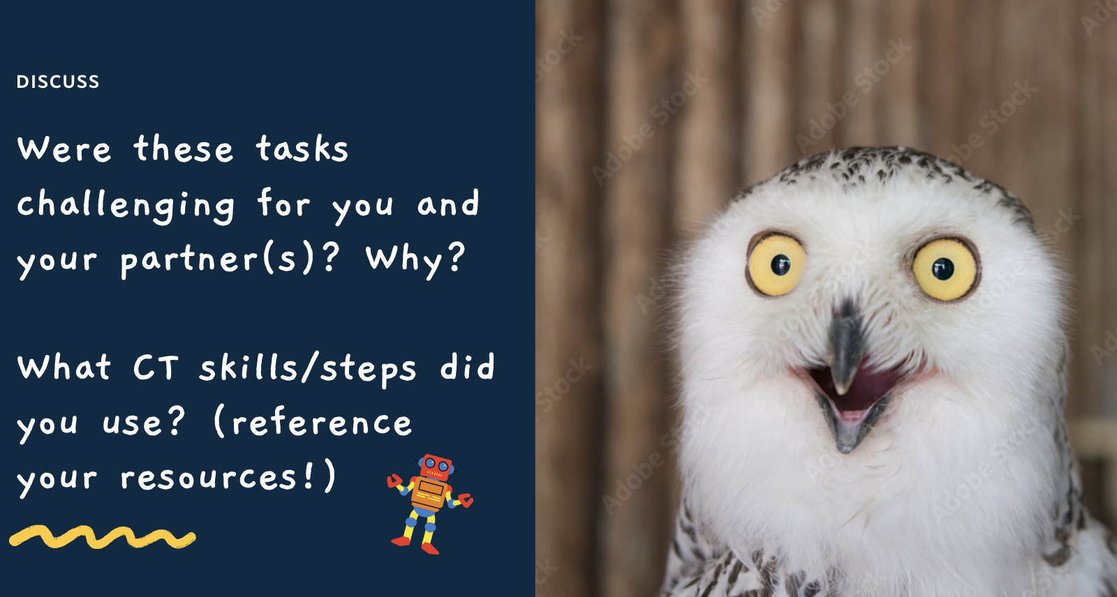
Figure 3. Sphero reflection activities
PSSETs will share their answers with the class after discussing with their partner/small group for about five minutes.
The instructor will then discuss current state initiatives around incorporating CT/CS into the curriculum for all learners, and for learners with disabilities. This discussion should take about five minutes and involves the instructor clicking through relevant links to show PSSETs where to find this information independently (see Slides 13-15 of CT in SPED Slides PDF). The state CS standards will briefly be examined. The instructor will go into depth on the current ISTE standards, so that PSSETs can see what is expected of different age groups regarding their knowledge of CT/CS information.
Additional internet resources are provided to PSSETs, including Scratch (https://scratch.mit.edu/), resources from the ISTE website (https://iste.org/), and resources from https://code.org/ (see Slide 19 of CT in SPED Slides PDF).The instructor clicks through these websites to show vetted lesson plans, and activities to incorporate into the classroom for learners in PK-12 grades. PSSETs are given about five to 10 minutes to explore these websites and acclimate to their features.
A discussion about equity and access in CT/CS content is the most critical component of this lesson. After all the resources above are explained and the importance of CT/CS is highlighted, the instructor will discuss applications of CT/CS specifically for students with disabilities (see Slide 20 of CT in SPED Slides PDF). The instructor begins this conversation with the quote:
The purpose of equity in computer science is not to prepare all students to major in computer science and go on to careers in software engineering or technology. Instead, it is about ensuring that all students have the foundational knowledge that will allow them to productively participate in today's world and make informed decisions about their lives. Equity is not just about whether classes are available, but also about how those classes are taught, how students are recruited, and how the classroom culture supports diverse learners and promotes retention. The result of equity is a diverse classroom of students, based on factors such as race, gender, disability, socioeconomic status, and English language proficiency, all of whom have high expectations and feel empowered to learn. (K–12 Computer Science Framework, 2016, p. 23)
After the quotation is displayed on the screen and PSSETs are given sufficient time to read and reflect, the instructor will ask the students what parts of this quote resonate most with them. Given that we have framed the importance of CT as an equity and accessibility issue that must be resolved to equip students with disabilities with the needed skills to participate in our society, it is assumed that PSSETs will most likely drive the conversation toward equity and access. If not, then the instructor can ask PSSETs about what their role is or should be regarding CT in their future teaching practice.
A graph that depicts the trends in education regarding specific disability categories is shown next (see Slide 21 of CT in SPED Slides PDF). These slides show that students with various disabilities experience CT/CS content in their classrooms at very low rates, and these rates decline over time in school (Fancsali & Israel, 2021).

Practice (25-30 minutes)
A slide that describes multiple elements of CT in special education is presented next (see Slide 22 of CT in SPED Slides PDF). This slide highlights multiple articles on CT/CS for learners with disabilities. First, a teaching brief on using UDL to increase accessibility for all learners in computer science is presented to students (Project TACTIC, n.d.) The instructor reads the scenarios and makes connections to the UDL content currently being discussed in their coursework. The instructor asks the PSSETs to think/pair/share on the question, “What UDL elements should the teacher consider for each student in this scenario?” The PSSETs should take five to ten minutes to discuss their ideas with a partner, and the instructor should have the PSSETs verbally share this information or write their ideas on a whiteboard or virtual whiteboard application (e.g., Padlet or FigJam) in the classroom. It is suggested that the physical/virtual whiteboard be laid out in a similar format to that of the UDL framework, with “Multiple Means of Representation,” “Multiple Means of Engagement,” and “Multiple Means of Action and Expression” written across the top of a table. After all ideas are presented, the instructor should review the ending of the teaching brief where multiple ideas are presented, and these answers should be compared to those the PSSETs generated.
Now that PSSETs have begun to generate ideas around increasing accessibility for students with disabilities in CT/CS content, the instructor should also describe additional research that accompanies this concept. An article by Bouck and Yadav (2020) provides additional ideas for supporting students with disabilities in CT/CS content. They suggest that teachers should:
- Use explicit instruction and immediate feedback.
- Include CT vocabulary in instruction.
- Explore ways that CT can be integrating into the mathematics curriculum, answering the question, how can it support instruction of the content?
- Use the resources in their classroom such as mobile devices, computers, robots, etc.
- Use vetted lesson plans from code.org, ISTE, etc.

Assessment (30 minutes; in the classroom or as homework)
PSSETs have now learned what CT is, why it is important for students, how to integrate it into the curriculum, and how to specifically design CT content for students in a way that is accessible to increase equity in education. The final component of this lesson is to have PSSETs design an activity for students in a hypothetical classroom of their choosing (see Figure 4 and Slide 23 of CT in SPED Slides PDF). PSSETs are asked to do the following:
Brainstorm HOW you would incorporate computational thinking skills into a lesson you have taught or planned for. Consider some of the following:
- Could you use some of the suggested resources to enhance an assessment in your lesson?
- Do you require computers or devices to incorporate CT into your lesson plan, or can it be an "unplugged" activity?
- Can you teach/reteach a concept using CT skills?
After brainstorming the above, describe your activity. Include the grade level, classroom setting, and academic standard you are addressing and explain the activity. Describe the activity or activities and your plan for how students will engage in this activity. Be sure to include CT terminology!
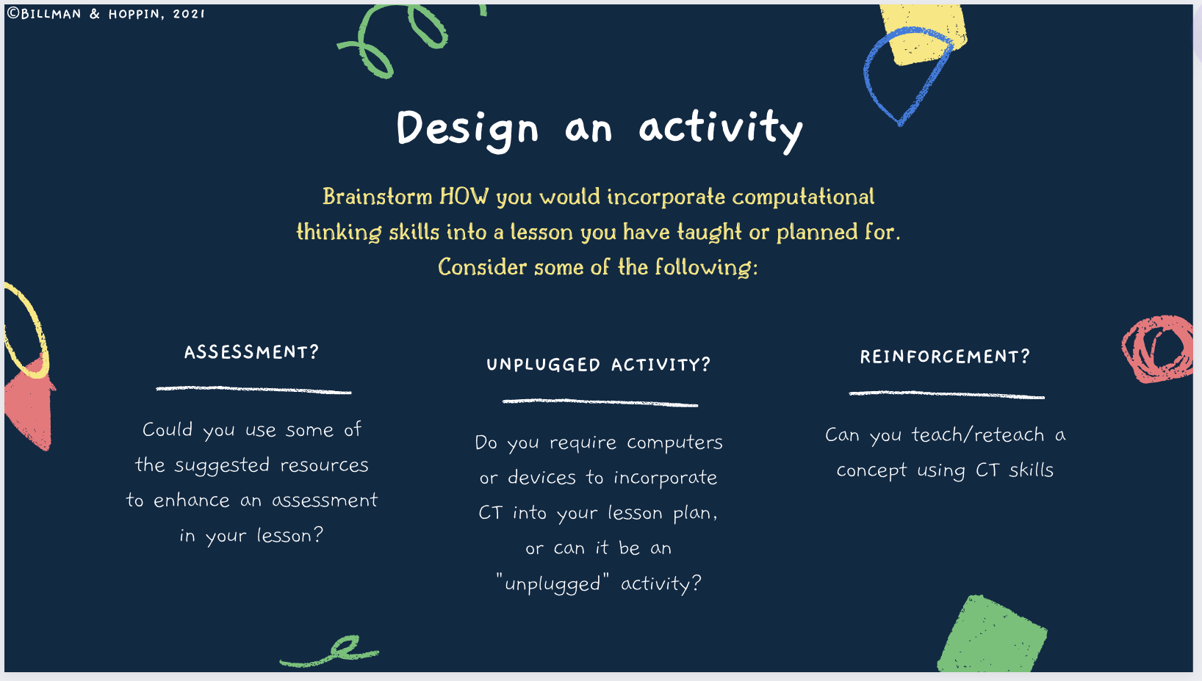
Figure 4. Design an activity.
PSSETs will require 30 minutes to one hour to complete this activity. The instructor should consider providing time outside of class to have students work on this independently. Students could generate ideas in class, discuss with an instructor or a peer, and then work independently outside of class. In the next class session, the instructor should review the previous class meeting and should ask PSSETs to describe some of their activities and ways they include both CT terminology/concepts and accessibility into their plan. A suggested rubric for this activity is included (see Design a CT Activity Rubric PDF).

Critical Reflection
This learning representation was implemented in five consecutive semesters (Fall 2021-Fall 2023) with at least 225 undergraduate students. The goals for this learning representation are to increase awareness and understanding of CT amongst PSSETs and to increase understanding of ways to incorporate CT into existing curricula for students with disabilities. PSSETs were asked to participate in pre/post surveys in all semesters of this project. The surveys were not required, and participation in the surveys did not impact PSSETs’ grades in the courses. When asked to respond to the statement, Please specify your level of agreement to the following statement: I am confident in my ability to teach computational thinking to students with disabilities, through a Likert scale (1=strongly disagree, 2=disagree, 3=neither disagree or agree, 4=agree, 5=strongly agree), PSSETs showed a significant difference from pre- to post-survey (t(191)=5.30, p <0.0001), with post-survey scores higher than pre-survey scores on this item.
Reflections on the lesson revealed both strengths and weaknesses. For many PSSETs, this lesson likely marks their first exposure to CT terminology and concepts in their higher education careers. Ideally, there should be many other “touchpoints” across their academic careers where they are exposed to CT content, but we must consider that they have little to no exposure to CT up until this point. We believe that this lesson, while limited, provides PSSETs with the rationale, purpose, and impetus for including and integrating CT in their future curricula.
PSSETs indicated that they have increased their understanding of CT and appear to place importance on teaching CT concepts to all learners through our pre-/post-surveys. However, per the grades and anecdotal reports from instructors on the “Design a CT Activity”, PSSETs seemed to struggle with creating meaningful opportunities for future learners to learn CT concepts, indicating a limited understanding of how they could integrate CT concepts, or limited understanding of lesson planning for future students. Due to time constraints, one to two class meetings (totaling one and a half to two hours) dedicated to discussing CT is all that is currently available in the UDL course. In the future, we are hopeful other special education faculty will begin to discuss CT and integration of CT teaching methods in their coursework, where applicable, to provide more opportunities for exposure and practice with this content.
Many PSSETs struggled to create meaningful and challenging CT activities for their future learners. More specifically, many PSSETs created activities that asked students with disabilities to engage in lower-order thinking skills such as defining terms, knowledge retrieval, or literal comprehension, as per Bloom’s Taxonomy (Adams, 2015). As this is their first time being asked to do such an assignment, we consider this a learning opportunity for PSSETs. We believe that this should not be the only time that PSSETs consider integrating CT skills in their lesson plans or activities they design throughout their preservice teacher programs and that with reinforcement in other coursework, PSSETs can refine these skills over time. We encourage instructors implementing this lesson to conference with PSSETs, using the Design a CT Activity Rubric (PDF) as a guide, to see where improvements can be made to the activities that PSSETs developed. Specifically, we encourage instructors to give examples of possible activities that encourage students to engage in higher-order thinking skills. We also encourage other special education faculty to discuss CT in any special education coursework that they teach, as this content is as important as mathematics, reading, and writing.
PSSETs expressed to instructors the challenges they experienced with the limited instructions provided to them in the Sphero-mini robot activity. The instructor should continually reinforce the concept that limiting instructions is an intentional practice to engage our PSSETs in productive struggle and utilize their social-emotional skills. Experiencing this challenge simulates what their PK-12 students with disabilities may experience their first time working through the CT problem-solving process. More explicitly linking CT to social-emotional learning (SEL) skills (e.g. collaboration, emotional regulation, perseverance, etc.) in future lessons could also broaden the application and integration of CT concepts in future PSSET classrooms. Connecting CT to SEL equips PSSETs to analyze situations, communicate effectively, and gain insight into future student interactions in their classrooms. In the future, we may consider connecting and highlighting SEL skills to CT in a more purposeful and intentional way, recognizing that SEL is a critical component of effectively supporting and instructing learners with and without disabilities.
It is critical that instructors spend time reading about CT and exploring the resources before implementing this learning representation with PSSETs. While this is always true for educators, for this lesson it was essential due to the instructor’s role as a novice/learner of CT/CS. Additionally, instructors should model expectations for working with high-tech items such as robots (e.g., ways to share the robots and ways to keep the robots from breaking) before allowing PSSETs to explore these resources. This, in turn, will encourage PSSETs to do the same with their future students.

References
Adams, N.E. (2015). Bloom’s taxonomy of cognitive learning objectives. Journal of the Medical Library Association, 103(3), 152-152 https://doi.org/10.3163/1536-5050.103.3.010
Barefoot Computing. (n.d.). Computational Thinking Poster. Retrieved November, 11, 2024 from https://www.barefootcomputing.org/resources/computational-thinking-poster
Bouck, E. C., & Yadav, A. (2020). Providing access and opportunity for computational thinking and computer science to support mathematics for students with disabilities. Journal of Special Education Technology, 37(1). https://doi.org/10.1177/0162643420978564
College & Career Ready Labs. Paxton Patterson (Director). (2018, May 8). Computational thinking: What is it? How is it used? [Video]. https://www.youtube.com/watch?v=qbnTZCj0ugI
Cuny, J., Snyder, L., & Wing, J. M. (2010). Demystifying computational thinking for non-computer scientists. Unpublished manuscript in progress, referenced in http://www.cs.cmu.edu/~CompThink/resources/TheLinkWing.pdf
Fancsali, C., Israel, M. (2021). To what extent are students with disabilities included in K-12 computer science education? Spotlight on NYC Schools. Research Alliance for New York City Schools. https://steinhardt.nyu.edu/research-alliance/research/spotlight-nyc-schools/what-extent-are-students-disabilities-included-k
International Society for Technology in Education. (2017). ISTE standards: Educators. https://www.iste.org/standards/iste-standards-for-teachers
K–12 Computer Science Framework. (2016). https://k12cs.org/wp-content/uploads/2016/09/K%E2%80%9312-Computer-Science-Framework.pdf
McLeskey, J., Barringer, M-D., Billingsley, B., Brownell, M., Jackson, D., Kennedy, M., Lewis, T., Maheady, L., Rodriguez, J., Scheeler, M. C., Winn, J., & Ziegler, D. (2017, January). High-leverage practices in special education. Council for Exceptional Children & CEEDAR Center. https://ceedar.education.ufl.edu/wp-content/uploads/2017/07/CEC-HLP-Web.pdf
Ofgang, E. (2022, September 26). Why more states are requiring computer science classes. Tech & Learning Magazine. https://www.techlearning.com/news/why-more-states-are-requiring-computer-science-classes
Project TACTIC: Teaching All Computational & Thinking through Inclusion and Collaboration. (n.d.). Helpful strategies for utilizing the Universal Design for learning framework in computer science education. University of Florida College of Education. https://ctrl.education.ufl.edu/wp-content/uploads/sites/5/2020/06/CTRL-TACTIC-UniversalDesign.pdf
Tabesh, Y. (2017). Computational thinking: A 21st century skill. Olympiads in Informatics, 11(2), 65–70. https://doi.org/10.15388/ioi.2017.special.10

About the Authors
Dr. Rachel Billman is an Assistant Professor in Special Education at Towson University. Before coming to Towson University, she taught secondary math subjects to students with disabilities. She researches math interventions, learning disabilities, special education teacher preparation, technology for the classroom, and computational thinking for students with disabilities. She can be reached at rbillman@towson.edu
Dr. Kandace Hoppin is an Associate Professor in Special Education at Towson University. Before coming to Towson University, she taught in public elementary schools as a special education teacher for students with EBD, & as a general education classroom teacher. She researches supports for students with emotional, behavioral, & neuropsychiatric needs; preparing teachers to effectively apply collaborative and inclusive practices; & computational thinking for students with disabilities.
Julia Murphy is a former undergraduate student and researcher in the Special Education department at Towson University and a current elementary special educator in Baltimore County Public Schools.

Sharing & Modification Permissions
Unless otherwise noted, this article and its resources are published under a Creative Commons Attribution-NonCommercial-ShareAlike 4.0 International license:

You can freely share the article and its resources if you indicate the original authors, identify the Creative Commons license, and use them non-commercially.
You may also make and share modifications by:
- Identifying the original authors.
- Using the resources non-commercially.
- Licensing modifications under the CC BY-NC-SA 4.0 license (and including a link to it).
- Indicating what modifications were made.’

