Preparing Educators to Navigate the Social-Emotional Terrain: A Game-Based Approach
  - Erin C. Wachter and WeiHsuan Lo, University of Northern Colorado

Overview
The FIXIT Social-Emotional Learning (SEL) game was created by the authors as an analog card game to help educators prepare for social-emotional challenges in the classroom. In the game, players work together as a team to overcome obstacles and practice addressing challenging scenarios while thinking through support beyond academic needs. This game-based approach provides a low-risk environment for educators to practice and prepare for real-life situations. Learning assessment is completed through gameplay discussions, end-of-game debriefs, and personal learning reflections. This version of FIXIT is for educators, but the game can be adapted to fit any content that includes problem-solving for all ages and grades ECE-12+.
Topics: Teacher preparation, professional development, game-based learning, social-emotional learning
Time: 20-30 minutes per round

Materials
- One facilitator for every 4-6 players
- FIXIT! SEL game cards – separated into three stacks:
  - Paths
  - Emotional tiles
  - FIXIT solutions
- Video: How to Play FIXIT!
- Assessment: Debrief questions and/or FIXIT rubric

Context-at-a-glance
Setting
Western United States of America, teacher preparation and professional development

Modality
In-person setting
Class Structure
Instruction is delivered by discussing the game rules and dividing learners into groups of 4-6.
Organizational Norms
A focus is on preparing educators to implement effective and inclusive pedagogies addressing each learner's academic and social-emotional needs.
Learner Characteristics
Both pre- and in-service educators engage in problem-solving scenarios to prepare for diverse student needs.
Instructor Characteristics
The authors are interested in game-based and technology-infused pedagogies. One author has experience as an instructional coach and special educator. The other is a Chinese language instructor.
Development Rationale
FIXIT aims to authentically stimulate the use of critical thinking, collaboration, communication, creativity, and problem-solving skills in a game-based educational setting. The game is digitally customizable, allowing adaptation to suit various instructional needs.
Design Framework
Backward design within the TPACK framework and game-based learning pedagogies.

Setup
The game should be downloaded, printed two-sided on card stock, and cut out. Players should be prepared by discussing their shared understanding of the behavioral issues (barrier cards) and potential interventions (FIXIT solution cards) they will encounter during gameplay. The game should be set up by placing the Start Card in the center of a table or gameplay space, and one Goal Card face down in four directions (Figure 1). Space should be left for three Path Cards to be placed before reaching a goal card. One facilitator should moderate play among 4-6 players by dealing cards, asking guiding questions, giving prompts as needed, and facilitating a debrief discussion after gameplay.
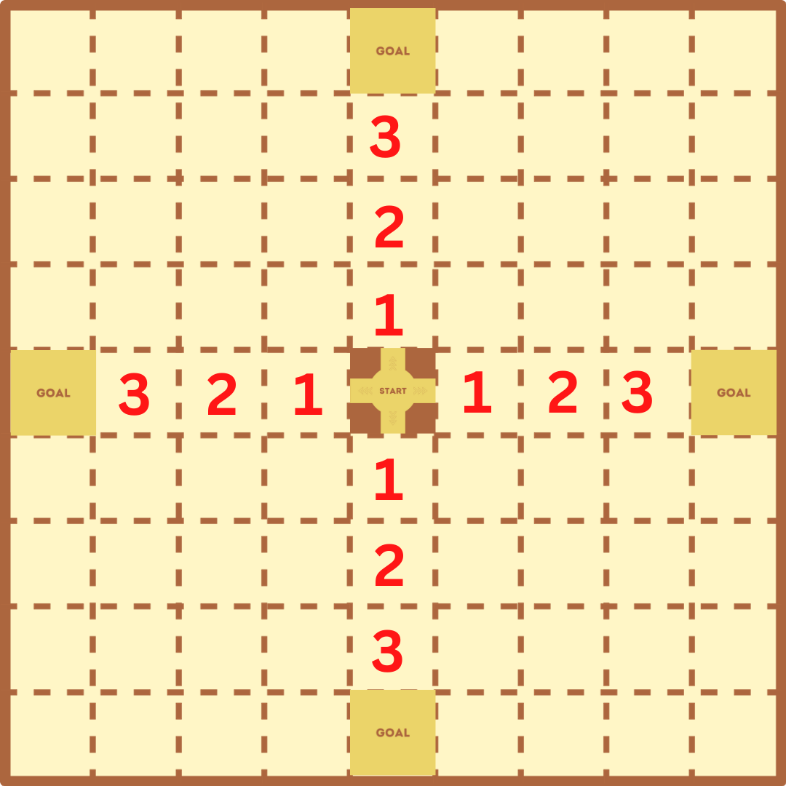

Figure 1: Placement of the Start Card and Goal Cards with a closer view of both card types.

Path Cards
Path cards should be shuffled and placed face down. The facilitator deals one path card during each player's turn. Players engage by building a pathway, placing a barrier, or using a chance card to peek at one goal (Figure 2).

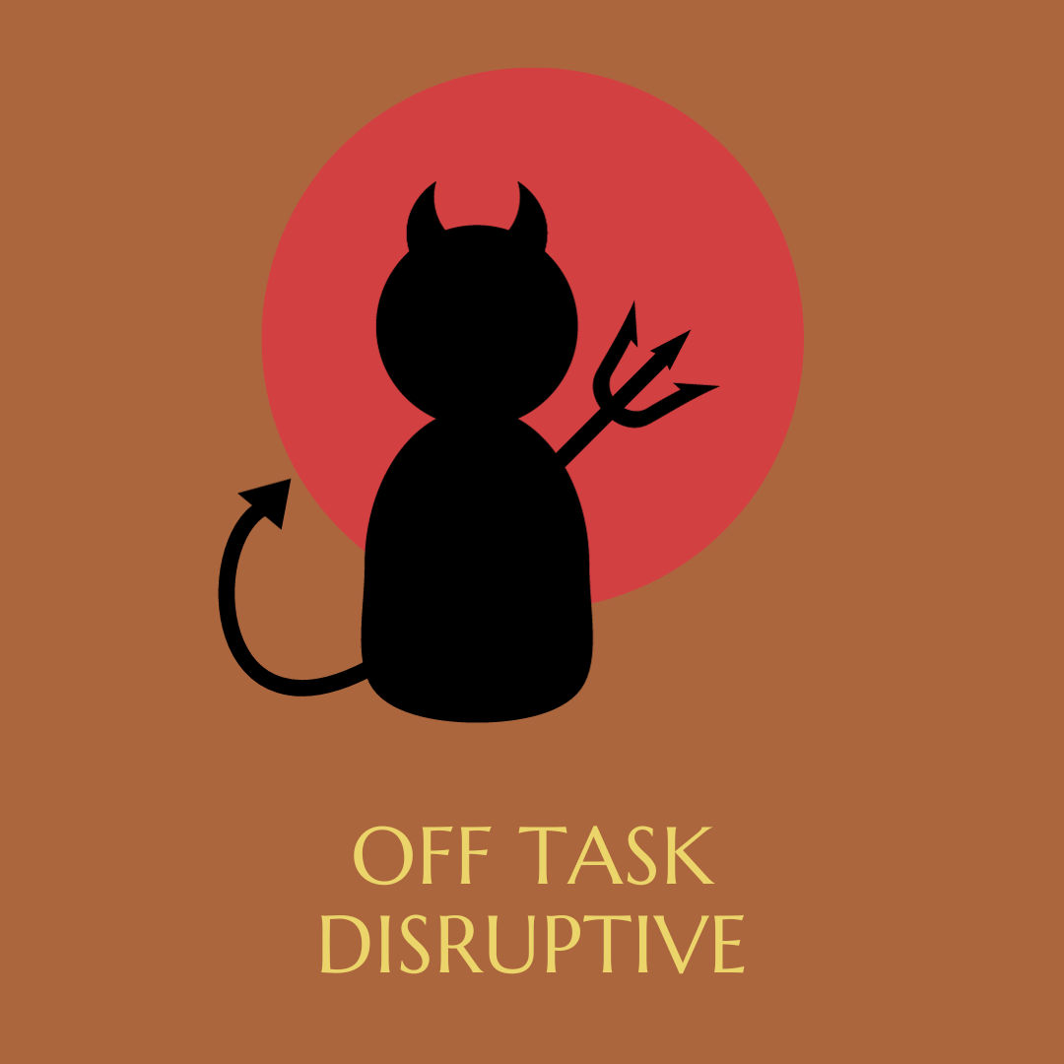
Figure 2: Examples of Path Cards with examples of a Chance Card (top left), a Barrier Card (bottom left), and Pathway Cards (right).

Emotion Tiles (Placed on Path Cards)
Emotion tiles should be placed face down and include a variety of positive emotions. As players are dealt pathway cards, they draw and place an emotion tile on the pathway card and state the game narrative, “I am feeling ____ today.” Figure 3 provides examples of Emotion Tiles, and some of the emotions players may encounter.

Figure 3: Examples of Emotion Tiles that include tiles for being Optimistic, Grateful, Joyful, and Proud.

FIXIT Cards
The FIXIT solution cards should be shuffled and placed face-down near the facilitator. If a barrier card has been placed, the next player must draw a solution card and discuss how the solution would apply. If the team does not agree on the justification for the solution, they may draw another solution until a consensus is reached to resolve the barrier. Figure 4 provides an example of the solution card for “redirecting student behavior.”

Figure 4: The Redirect Solution, one of the FIXIT cards.

Standards
The following standards from the Association for Educational Communications and Technology (2012), International Society for Technology in Education (2024), and Collaborative for Academic, Social, and Emotional Learning (2022) align with this instruction:
AECT Standard 2 (Content Pedagogy): Candidates develop as reflective practitioners able to demonstrate effective implementation of educational technologies and processes based on contemporary content and pedagogy.
AECT Standard 3 (Learning Environments): Candidates facilitate learning by creating, using, evaluating, and managing effective learning environments.
AECT Standard 5 (Research): Candidates explore, evaluate, synthesize, and apply methods of inquiry to enhance learning and improve performance.
ITSE Standards for Educators 2.5.c (Designer): Create innovative learning environments. Explore and apply instructional design principles to create innovative digital learning environments that engage and support learning.
CASEL (SEL-Focused Classrooms): A supportive classroom climate and integration of SEL into academic instruction.

Context and Setting
The development of the FIXIT games is a response to a need for learners to engage in deep and meaningful learning experiences through problem-solving discussions. This section discusses the design and use of the FIXIT card game, its various iterations, and previous research. With a focus on game-based learning, the authors have also used FIXIT as a research tool for investigating learning experiences related to educational technology, teacher preparation, media literacy, ocean pollution, and language learning. An overview of its use as a research tool is available in the Critical Reflection section.

Design and Original Use
Integrating social-emotional learning (SEL) practices into academic instructions is crucial, as research shows that students who develop strong SEL skills are more likely to succeed in high school, post-secondary education, and employment (CASEL, 2022). York et al. (2021) noted the lack of research on students engaging in diverse gameplay, including digital and analog formats. The FIXIT card game was inspired as a response to an educational game development course the authors completed. The game was further developed and iterated to be used as an educational tool to engage learners in cultivating both social and academic skills.
Initially, the game was a reskin of the card game Saboteur, with changes to the roles, content, game rules, and pathways to the goals. However, after multiple iterations and playtesting feedback, the game was significantly modified and included a guided narrative and speaking component for each turn. These changes resulted in a more collaborative problem-solving approach. Additionally, the game was changed to allow for gameplay in all four directions, making it easier to play in larger groups.

Iterations
From 2021 to the time of this publication, four significant iterations of the game were created, adjusting the game mechanics and play features in response to playtesting feedback. The use of sentence stems and game tiles were added to include a guided narrative and speaking component to each turn in the game. The game was also adjusted, removing player competition and strategies to sabotage others to include a more collaborative problem-solving approach. This alteration allowed players to work together to develop solutions for a common goal. In this way, the game does not end with one player out strategizing other players to become a winner. Rather, a team works together to discuss and determine the best solutions for each scenario.
Through these iterations, the game became a tool for collaborative problem-solving discussions. The next round of iterations came when the authors discussed changing the content and theme of the game and allowing the game itself to become a template that could be adapted to any content or focus. The authors have created many versions of the game to teach various content, including ocean pollution, media literacy, educational technology applications, and Chinese language learning.
FIXIT is now an engaging game-based learning tool that facilitates critical thinking, collaboration, communication, and creativity in problem-solving scenarios.

Learning Representation
Starting with a discussion on pedagogy is crucial to effectively introduce game-based learning to educators. This discussion should highlight the advantages of creating a low-risk and motivating learning environment that nurtures creative thinking, collaboration, problem-solving, and discussions. The introduction should also touch on the significance of social-emotional learning and assess the group's understanding of effective classroom management and behavior intervention strategies. Defining some of the terms in the game for preservice teachers early in their training program may be helpful.
Some key terms include students’ challenging behaviors such as bullying, poor coping skills, using AI to plagiarize, no work completion, losing materials, disrupting learning, being withdrawn, and being unprepared. Other key terms for intervention strategies include social contracts, rewarding positive behavior, avoiding power struggles, giving choices, restorative justice, parent conferences, one-on-one conversations, redirects, and student breaks. For further information and exploration of these terms and concepts, visit https://www.pbisworld.com/ (PBIS World, 2024), which provides behavior descriptors and examples of tier 1, 2, and 3 intervention strategies.

Presentation
Verbal and visual demonstrations are advised to effectively present the game mechanics, rules, and parameters to the entire group. An engaging approach to the first round of gameplay is the fishbowl technique, which involves seating 4-6 players in an inner circle at a table while the remaining players gather around in a larger circle to observe.
Gameplay begins at the start card. The facilitator then gives each player the cards one at a time during their turn in a counterclockwise direction, beginning with the youngest player. Only one of the four goals (placed in all four directions from the center start card) is gold; the other three are silver. Players will work together to construct a path to reach the gold goal. If a group reaches a silver goal, gameplay will continue.
The facilitator will hand the first player a path card. If a pathway card is dealt, the player will strategically choose a location to connect the pathways and then draw a positive emotion tile to place on the path card. They will then state out loud the sentence stem, "I am feeling ____ emotion today." This gameplay narrative represents an optimistic classroom that is effective and functions well. Players may receive barrier cards from the facilitator, which represent challenging student behaviors. Once a barrier is received, it must be placed to block the pathway. After a barrier is placed, the next player will draw from the FIXIT solution pile and work with the team to describe how the solution will repair the barrier.
Once the team reaches a consensus on the solution, the FIXIT card can be placed over the barrier, and a new pathway can then be rebuilt over the FIXIT card. If consensus is not reached, the player who drew the FIXIT card will need to draw a new FIXIT card. Players then discuss and justify whether the new solution resolves the barrier. This play repeats until a FIXIT card can be placed over the barrier card.
Players may also be dealt a chance card, meaning they can choose one goal to peek at but cannot show or tell anyone else what they saw. They can, however, communicate nonverbally by influencing the direction of the pathway cards by placing pathways that lead to the gold goal card.

Practice
After the demonstration round, small groups of 4-6 players can practice gameplay. Although more players can be added, it will increase the time of each round and potentially affect player dynamics. It is important to assign a facilitator to each group who has played the game before and can prompt more in-depth discussions and explanations when needed. Multiple rounds are preferable as this allows players to experience a greater variety of barriers and potential solutions. Each round of gameplay is unique.
The facilitator plays a crucial role in dealing cards one at a time, controlling the game's pace, and ensuring everyone gets an equal chance to speak. The facilitator should encourage the group to keep generating ideas until a consensus is found and prompt players to explain and justify their thinking. Depending on the group's expertise, the facilitator may provide examples of challenging behaviors or FIXIT solutions.

Assessment
After the game ends, the facilitator initiates a debrief conversation with the group, including the observers, if any. Some potential questions for debriefing are:

- What was the most challenging aspect of this experience?
- What surprised you?
- What was the most enjoyable part?
- What does your experience imply?
- What will be your next steps?
The facilitator may also ask more detailed questions about the topics that arose during the gameplay, correct any misunderstandings, and offer suggestions and solutions.
A formal assessment can be administered through a pre and post-test to evaluate player knowledge of interventions and ability to address challenging behaviors. Alternatively, instructors can provide a written learning reflection or debrief prompt for players to complete individually after the gameplay.
The facilitator or an additional observer could also use or adapt the educator skill development section of the FIXIT rubric to assess the potential of educators to apply effective strategies that address social-emotional challenges in the classroom.

Critical Reflection
Since the fall of 2022, the authors have completed the learning representation in the described formats two times each semester, using various versions of the FIXIT game to facilitate learning experiences within various contexts and content applications. The game has also been used for various research projects, which provide a critical reflection on its use and effectiveness for promoting specific learning outcomes.

Research
Using FIXIT as a research tool, the authors examined to what extent playing the SEL version promoted creative self-efficacy among preservice teachers. The authors conducted a study using a randomized cluster block to measure the impact of gameplay on the self-reported measures of creative self-efficacy before and after gameplay compared to a control group (Lo et al., 2023). The results demonstrated playing the game decreased the self-reported measures of creative self-efficacy, indicating that preservice teachers may realize through a safe and low-risk environment that there is a lot to prepare for and learn to address the comprehensive needs of their future students academically, socially, and emotionally. This research concluded that a game-based approach can prepare future teachers for the challenges they will face in the classroom. By simulating real-life scenarios, preservice teachers can gain practical experience and develop the skills they need to succeed in their careers. This study further highlighted the importance of exposing preservice teachers to various training methods that promote self-awareness and enable them to apply their learning in diverse and practical settings. By doing so, preservice teachers can be better equipped to meet their students' needs and positively impact their communities.
In a different study, the authors utilized a technology-integration version of FIXIT to promote the effective application of technology-infused teaching and learning strategies to address potential learning barriers in the classroom (Lo et al., 2023). The study analyzed 9 rounds of FIXIT gameplay among 6 groups with a total of 59 players to determine the quantity of 4C skills (communication, collaboration, critical thinking, and creative thinking) that occurred during each phase and component of gameplay. Most 4C skills were observed when players discussed the FIXIT solutions during gameplay, with the highest frequency in communication and collaboration, followed by critical and creative thinking.
The game was also used as a game-based lesson planning tool for preservice teachers enrolled in the educational technology courses taught by the authors. Employing a strategic backward design approach, preservice teachers played the game in class, were provided with a digital game template, and guided in developing game-based lesson plans that catered to specific disciplinary content areas. With an intensive analysis of content and the development of problem scenarios and solutions aligned to the learning objective of the lessons, preservice teachers were able to construct learning experiences and anticipate ways to foster student collaboration and discourse. Over six semesters, preservice teachers produced many FIXIT versions for grades ECE-12 in all disciplinary areas (Wachter et al., 2023).
Lo (2024) addressed the need for updated language education curricula that align learning goals with 21st-century demands. Examining how teacher-centered approaches in Chinese language education further complicate the adoption of student-centered pedagogies, Lo (2024) proposed using game-based learning to foster language proficiency and 21st-century skills. The results of this study show sustained growth in vocabulary knowledge and improved language skills through problem-solving games to stimulate students to apply 4C skills in Chinese-speaking scenarios, improving speaking, listening, and reading skills.
Wachter (2024) used FIXIT to explore preservice teachers' experiences, constructing game-based learning experiences and integrating technology into lesson plans using the TPACK framework. Preservice teachers developed their versions of FIXIT. The findings highlighted unique and intersecting themes, focusing on creative utilization of game-based learning, deepening understanding of pedagogical methods, addressing developmentally appropriate tools, fostering social-emotional growth, and preparing learners for the real world through an engaging, collaborative, standards-based, technology-infused, and reflective approach.
In addition to the research mentioned, the authors utilized FIXIT with a group of experienced international educators. The authors adapted the FIXIT game to incorporate media literacy principles. It was then played with international educators who had completed 6-week media literacy and educational technology courses instructed by the authors. These individuals were experienced educators who were part of an international teacher exchange program. The gameplay served as both a means of assessing the knowledge acquired throughout the courses and an opportunity for the global teams of educators to collaborate and devise solutions to the challenges in implementing media literacy instruction in their respective home countries.

Future Implementation
A player’s reception to the learning process can vary, with some embracing it and others finding it uncomfortable depending on their knowledge of the content, language proficiency, or group dynamics. This is particularly true for preservice teachers who may feel unprepared for the real-time applications of knowledge simulated in the FIXIT game. However, the game also provides a valuable opportunity for educators to practice and reflect on their teaching methods and strategies. Therefore, the authors offered pragmatic solutions, emphasizing the role of facilitator guidance and scaffolding using the effective Gradual Release of Responsibility (GRR) Instructional Framework (Fisher & Frey, 2021).
The GRR Framework follows a four-step learning structure: (1) focused instruction, where extensive teaching on the content knowledge, specifically addressing social-emotional barriers and strategies; (2) guided instruction, where students play the game with teacher facilitation; (3) collaborative learning, where students engage in small group gameplay without teacher interference, followed by debrief conversations to consolidate learning; and (4) independent learning, where students engage in post-game debrief reflections. Depending on the game's content, this framework can foster collaborative discussions and the application of existing knowledge.
The effectiveness of this educational experience hinges on the players' mindset, the value of the introductory stages, and sufficient time for the game to be played with a follow-up discussion. In our experience as educators and researchers, educators who embrace adaptable, expansive, and analytical teaching methods often discover the worth and significance of this activity and explore ways to incorporate these tactics into their teaching.
In the future, this learning experience can be further enhanced through a fully digitalized platform for both playing and creating games. Moreover, this game is versatile, as it can be employed as a valuable teaching tool at different phases of the learning journey if the facilitator offers clear prompts, detailed explanations, and obstacle-solving guidance. It can also be used to teach or assess specific instructional requirements, including language acquisition, higher-level thinking skills, social-emotional strategy use, and collaborative problem-solving capabilities.

References
Association for Educational Communications and Technology. (2012). Competencies and indicators – AECT standards, 2012 version. Retrieved June 24, 2024 from https://cehs.usu.edu/itls/competencies
Collaborative for Academic, Social, and Emotional Learning. (2022). What does the research say? Hundreds of independent studies confirm: SEL benefits students. Retrieved June 24, 2024 from https://casel.org/fundamentals-of-sel/what-does-the-research-say/
Fisher, D., & Frey, N. (2021). Better learning through structured teaching: A framework for the gradual release of responsibility. ASCD.
Fullerton, T. (2018) Game design workshop: A playcentric approach to creating innovative games (4th ed.). Taylor & Francis. https://doi.org/10.1201/b22309
Garcia, A., & Gomez, M. (2017). Player professional development: A case study of teacher resiliency within a community of practice. Teaching and Teacher Education, 66, 349-359. https://doi.org/10.1016/j.tate.2017.05.003
Hammond, Z. (2020). Looking at SoLD through an equity lens: Will the science of learning and development be used to advance critical pedagogy or will it be used to maintain inequity by design? Applied Developmental Science, 24(2), 151-158. https://doi.org/10.1080/ 10888691.2019.1609733
International Society for Technology in Education. (2024). ISTE standards: For educators. Retrieved June 24, 2024 from https://iste.org/standards/educators
Lo, W. (2024). Enhancing Chinese language learning through problem-solving gameplay (Publication No. 3054429490) [Doctoral dissertation, University of Northern Colorado]. ProQuest One Academic.
Lo, W., Wachter, E. C., & Miller, C. R. (2023). The effect of gameplay on the creative self-efficacy of educators in hypothetical classroom management situations. Journal of Educational Research and Innovation, 11, (5). https://digscholarship.unco.edu/jeri/vol11/iss1/5
Lo, W., Wachter, E. C., & Ku, H. Y. (2023, October 15-19). Using educational gameplay to promote preservice teachers’ critical thinking, creativity, communication, and collaboration skills [Conference session]. Association for Educational Communications and Technology Annual Convention, Orlando, FL, United States.
Muhammad, G. (2020). Cultivating genius an equity framework for culturally and historically responsive literacy. Scholastic.
PBIS World. (2024). https://www.pbisworld.com/
Resnick, M., & Robinson, K. (2017). Lifelong Kindergarten: Cultivating creativity through projects, passion, peers, and play. MIT Press.
Wachter, E. C. (2024). Preservice teachers and game development: Constructing learning experiences (Publication No. 3054336213) [Doctoral dissertation, University of Northern Colorado]. ProQuest One Academic.
Wachter, E. C., Lo., W., & Ku, H. Y. (2023, October 15-19). Stimulating learning through gameplay: A showcase of adaptable game-based lesson planning [Conference session]. Association for Educational Communications and Technology Annual Convention, Orlando, FL, United States.
York, J., Poole, F. J., & Dehaan, J. W. (2021). Playing a new game — an argument for a teacher-focused field around games and play in language education. Foreign Language Annals, 54(4), 1164-1188. https://doi.org/10.1111/flan.12585

Support Materials
If you use the FIXIT game resources for this lesson, please identify your use in the following form:
https://forms.gle/qCCXFoByjvkYKPTEA

About the Authors
Erin C. Wachter, earned her Ph.D. in Educational Technology from the University of Northern Colorado. Erin is an experienced Special Education teacher, instructional coach, university instructor for preservice teachers, and co-founder of Inspire Playful Minds. Erin is interested in creating transformative and inclusive learning experiences using critical and game-based pedagogies. She can be contacted at erincwachter@gmail.com.
WeiHsuan Lo, earned her Ph.D. in Educational Technology from the University of Northern Colorado. WeiHsuan is an experienced Educational Technology and Chinese language Instructor with a background in business administration and Teaching Chinese as a Second Language. She is also a co-founder of Inspire Playful Minds. She is interested in integrating educational technology to transform foreign language teaching. She can be contacted at weihsuan.lo@unco.edu.

Sharing & Modification Permissions
Unless otherwise noted, this article and its resources are published under a Creative Commons Attribution-NonCommercial-ShareAlike 4.0 International license:

You can freely share the article and its resources if you indicate the original authors, identify the Creative Commons license, and use them non-commercially.
You may also make and share modifications by:
- Identifying the original authors.
- Using the resources non-commercially.
- Licensing modifications under the CC BY-NC-SA 4.0 license.
- Indicating what modifications were made.

