Escape Room Answer Set
  - Tabitha Cowley and Cecil R. Short, Emporia State University

Can You Escape The Catacomb?

Question One

Who even is he really?
Hint - In the directions, capital letters
Answer – MONTRESOR
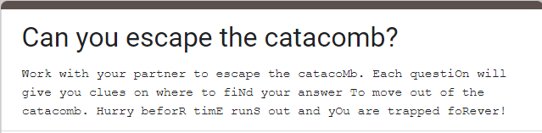

Question Two

What is the family motto?
Hint - In the tweet, the family motto
Answer - NEMO ME IMPUNE LACESSIT
Photo on page 2.

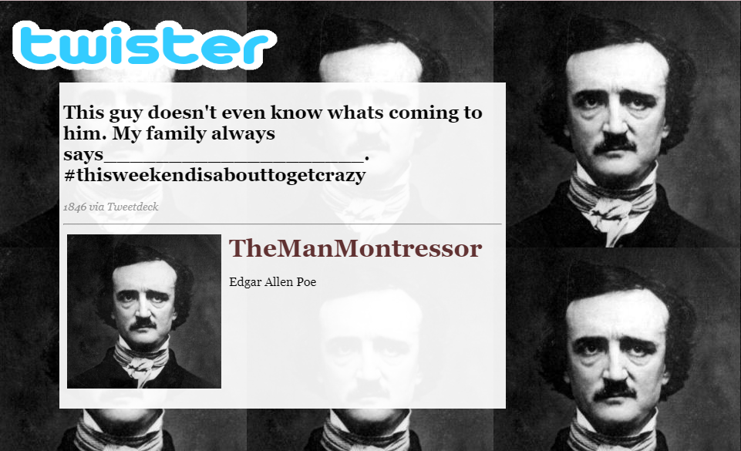

Question Three

I wonder what his motive is?
Hint - Rx prescription
Answer - REVENGE
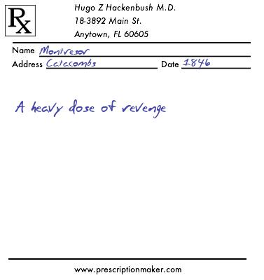

Question Four

Why would I even wear this costume?
Hint - Fortunado’s Clown suit, meme
Answer - SYMBOLISM
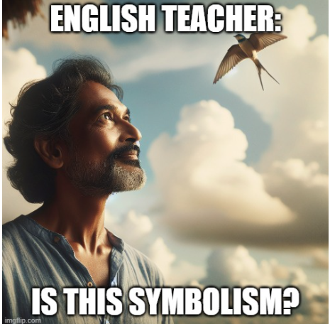

Question Five

What happens when you only see 1st person POV?
Hint - Seeing eye chart, 1st person POV
Answer – UNRELIABLE
Photo on page 4.

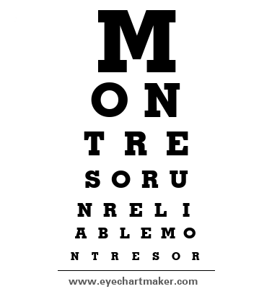

Question six

I don’t know if ill ever get out!
Hint - Wordle
Answer - SUSPENSE
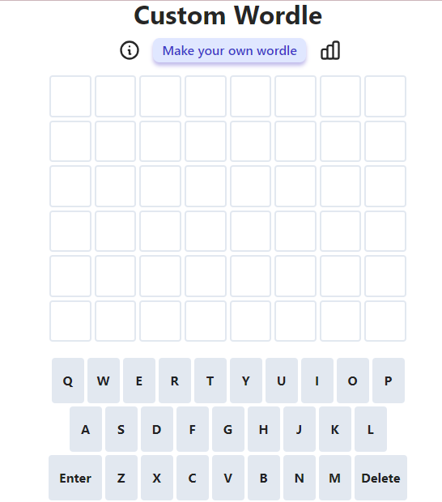

Question seven

Do you know anyone who can help?
Hint - Crossword and riddle
Answer - CATACOMBS
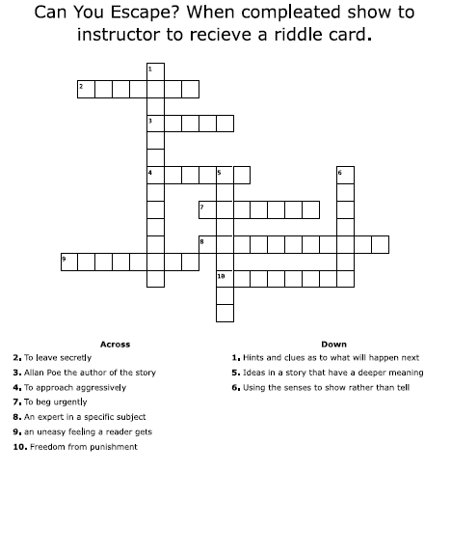

Question eight

Order the plot events.
Hint: answer will be in all caps (ex. ABCDE…)
A. Setting: The story takes place during the carnival season in an unnamed Italian city.
B. Montresor completes the wall, entombing Fortunato.
C. Montresor lures Fortunato into the catacombs with the promise of sampling Amontillado, a rare wine.
D. Fortunato is already inebriated, making him an easier target.
E. Montresor concludes the story by noting that no one has ever discovered Fortunato's remains or suspected foul play.
F. Montresor reveals his motive for revenge, which is not explicitly stated but involves a thousand injuries and Fortunato's insult.
G. Montresor uses reverse psychology and flattery to keep Fortunato moving deeper into the catacombs.
H. He emphasizes that he has remained unpunished for his crime, citing his family motto, "Nemo me impune lacessit."
I. Montresor chains Fortunato to a wall within the catacombs.
J. Characters: Montresor, the narrator, seeks revenge against Fortunato, who is portrayed as a wine connoisseur.
K. He finishes his task and retreats, leaving Fortunato to his grim fate.
L. Montresor begins to build a wall to encase Fortunato, sealing him alive in the catacombs
__AJFCDGHILBKE___

Link to make copy of google form:
https://docs.google.com/forms/d/1Df7z02aJlXxj4EF1v8kRBLgCH-d8cXqgUKCQ7m9m2wE/copy

