# Escape Room Puzzles Resource

Tabitha Cowley and Cecil R. Short, Emporia State University

## The Cask of Amontillado – Digital Escape Room

### Contents

Page 1: Table of Contents

Page 2: [Digital Escape Room Drawing](#_6u9gr5x68ng)

Page 3: [Puzzle 1 - Hidden Letters](#_t86b47bxjo4b)

Page 4: [Puzzle 2 - Montresor Tweet](#_9xculwm3y1cr)

Page 5: [Puzzle 3 - Prescription](#_i2q8jyfe5qvy)

Page 6: [Puzzle 4 - Jester Symbolism](#_v4d2jp644la6)

Page 7: [Puzzle 5 - Eye Chart](#_yzfaru3vb1bf)

Page 8: [Puzzle 6 - Wordle](#_srnz6frs0n2)

Page 9: [Puzzle 7 - Crossword and Riddle](#_sruaq5d5vr00)

Page 10: [Puzzle 8 - Chronological Plot Events](#_gts9qlr9qbl3)

### Digital Escape Room Drawing

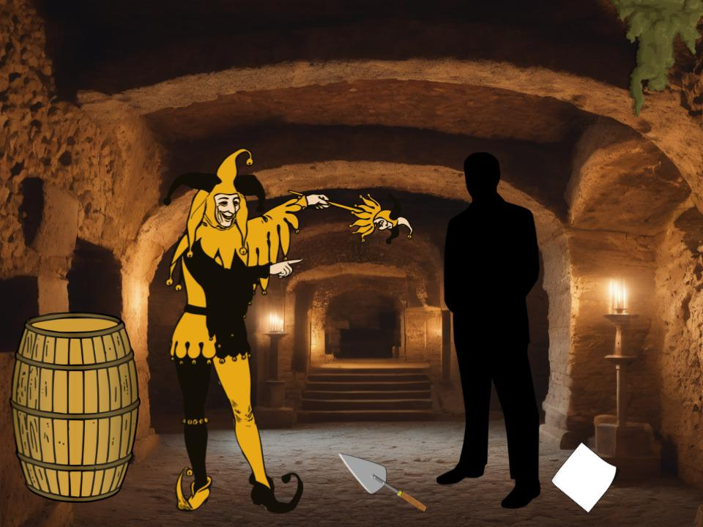

Made using Google Drawings

Links to puzzles on are each of the images:

* Barrel
* Trowel
* Paper
* Moss
* Jester
* Mysterious Man

### Puzzle 1 – Hidden Letters

This is the first puzzle of the digital escape room. Students have to identify the capital letters in the directions and see what word they create.

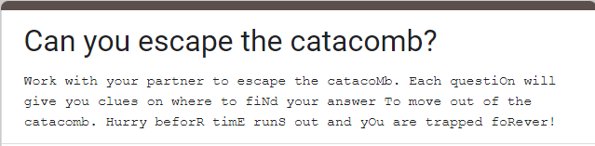

The form was originally created using Google Forms. A worksheet version is also available.

### Puzzle 2 – Montresor Tweet

The second puzzle has students connect to the story to figure out what Montresor’s family motto is.

Twister image with the words: This goes doesn't even know whats coming to him. My family always says _________. #thisweekendisabouttogetcrazy

An image of Edgar Alan Poe is under these words with the words TheManMontressor next to the image.

Made using <https://www.classtools.net/twister/>

### Puzzle 3 – Prescription

This puzzle shows what Montresor’s motive was for his actions against Fortunato,

An Rx Pad with the words:
Hugo Z. Hockenbush, M.D.
18-3892 Main St.
Anytown, FL 60605

Name: Montresor
Address: Catacombs
Date: 1846
A heavy dose of revenge

Made using [www.prescriptionmaker.com](http://www.prescriptionmaker.com)

### Puzzle 4 – Jester symbolism

For this puzzle the instructor created a meme about symbolism to have students connect Fortunato’s actions with the costume he was wearing.

A meme with the words: English Teacher: Is this symbolism? 

An image of a man looking towards a cloudy sky with a bird flying.

Made using <https://imgflip.com/memegenerator>

### Puzzle 5 – Eye Chart

For this puzzle, the students had to find the hidden word in the eye chart related to 1st person narratives.

An eye chart with the letters: 
M
ON
TRE
SORU
NRELI
ABLEMO
NTRESOR

Made using [www.eyechartmaker.com](http://www.eyechartmaker.com)

### Puzzle 6 – Wordle

For this puzzle students have six guesses to try to solve the hidden word. The site will show students when they get a letter correct and if they have it in the right spot.

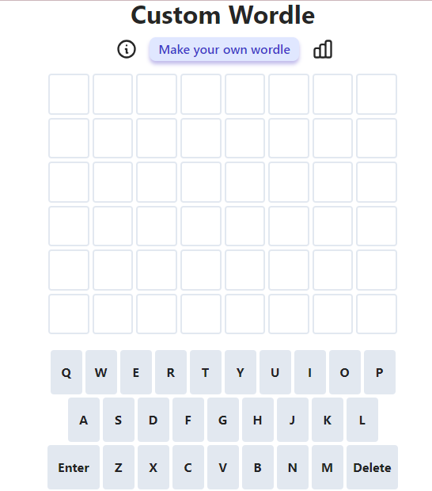

Made using <https://mywordle.strivemath.com>

Link to the one used in learning representation: <https://mywordle.strivemath.com/?word=oijspros>

### Puzzle 7 – Crossword and riddle

This puzzle connects to the vocabulary used within the story as well as literary elements used in the story. The riddle is used to have students identify the setting of the story.

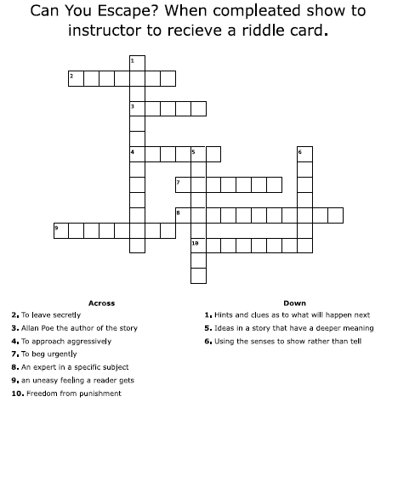

Crossword made using <https://crosswordlabs.com/>

|  |
| --- |
| "I'm the fate that Fortunato could not foresee,  Hidden in a labyrinth where he could not flee.  In the tomb, his destiny,  What am I, in Poe's dark story?" |

### Puzzle 8 – Chronological Plot Events

For your last task, the students placed the plot events in chronological order.

A. Setting: The story takes place during the carnival season in an unnamed Italian city.

B. Montresor completes the wall, entombing Fortunato.

C. Montresor lures Fortunato into the catacombs with the promise of sampling Amontillado, a rare wine.

D. Fortunato is already inebriated, making him an easier target.

E. Montresor concludes the story by noting that no one has ever discovered Fortunato's remains or suspected foul play.

F. Montresor reveals his motive for revenge, which is not explicitly stated but involves a thousand injuries and Fortunato's insult.

G. Montresor uses reverse psychology and flattery to keep Fortunato moving deeper into the catacombs.

H. He emphasizes that he has remained unpunished for his crime, citing his family motto, "Nemo me impune lacessit."

I. Montresor chains Fortunato to a wall within the catacombs.

J. Characters: Montresor, the narrator, seeks revenge against Fortunato, who is portrayed as a wine connoisseur.

K. He finishes his task and retreats, leaving Fortunato to his grim fate.

L. Montresor begins to build a wall to encase Fortunato, sealing him alive in the catacombs

\_\_\_\_\_\_\_\_\_\_\_\_\_\_\_\_\_\_\_\_\_\_\_\_\_\_\_\_\_