# Visual Mnemonics and Gamification: A New Approach to Teaching Muscle Physiology

Tyler Bland1 and Meize Guo2  
1University of Idaho, 2University of Florida

## Overview

This learning representation is an innovative approach to teaching muscle physiology in a first-year medical school curriculum, utilizing assets from the [Medimon game-based website](https://medimon.games/). *Medimon* is a game designed to enhance students' preference and retention of medical concepts through interactive and visually engaging game contexts. The *Medimon* game experience allows students to (a) engage with characters representing various physiological components, (b) explorebuildings designed to align with visual mnemonics, and (c) reinforce knowledge via game activities of muscle physiology, including muscle, cardiac, and smooth muscle structure and function. By leveraging the detailed visual mnemonics of the game, we implemented *Medimon* game assets into a presentation on muscle physiology to supplement existing presentation materials and promote long-term retention of muscle physiology.

**Topics:** Anatomy and Physiology, Cardiac Anatomy, Game-Based Learning, Interactive Learning Experiences, Medical Mnemonics, Muscle Physiology, Student Engagement

**Time:** 60-90 minutes

### Materials

* [Medimon Website](https://medimon.games/)
* A health/medical science project that students are developing (or have recently finished) for the purpose of enhancement
* [Muscle Physiology Lecture presentation](https://journals.uwyo.edu/index.php/jtilt/article/view/8469/6631) and [PDF](https://journals.uwyo.edu/index.php/jtilt/article/view/8469/6633)

Context-at-a-Glance

**Setting**  
A preclinical medical school level physiology course at a large public university in the northwestern United States.

**Modality**  
Face-to-face

**Class Structure**  
A one-hour lecture during a four-hour class on fundamentals of medical science. The lecture is structured as a didactic lecture with interspersed active recall questions.

**Organizational Norms**  
The organizational goal is to train the next generation of medical professionals, including a strong support for both students and faculty.

**Learner Characteristics**  
Learners are first-year medical students from various disciplines with varied prior accessibility knowledge and beginning familiarity with muscle physiology .

**Instructor Characteristics**  
The instructors include a content expert in muscle physiology and a designer of the *Medimon* website.

**Development Rationale**  
The goals of this lesson are to enhance learning and retention of important physiological processes, and to create a more enjoyable form of learning to prevent burnout (common in medical professionals).

**Design Framework**  
Digital Health Education for Healthcare Professionals Conceptual Framework (CFDHEHP), Cognitive Theory of Multimedia Learning (CTML), Gamification, Dual Coding Theory (DCT)

### Setup

When preparing for this lesson using the [Medimon website](https://medimon.games/), it's crucial to create an environment conducive to interactive and visual learning. The setup should be effectively designed to facilitate engagement with the game-based learning elements.

#### Environment Setup

* **Technology Integration:** Ensure that each student has access to a computer or tablet with internet connectivity. The devices should be capable of accessing the *Medimon* website and displaying its visual content clearly.
* **Classroom Arrangement:** Arrange the classroom to encourage interaction and collaboration. Desks should be positioned to allow easy viewing of shared screens or projections, if used. A central focus area where the instructor can guide the session is recommended.
* **Visual Aids:** If possible, use a projector or large screen to display game elements and mnemonics from *Medimon*. This will aid in group discussions and collaborative learning.
* **Supplementary Materials:** Prepare handouts or guides that summarize key concepts from *Medimon*, including the mnemonics and their medical significance.

#### Instructor’s Role

The instructor should be familiar with the *Medimon* website and be ready to guide students through its features. A brief walkthrough of the game mechanics and how they relate to the learning objectives at the start of the session will help students engage more effectively with the material.

## Context and Setting

The implementation of the *Medimon* website was driven by a need to address the inherent complexities in teaching muscle physiology—a topic that poses significant challenges for first-year medical students due to the high cognitive load of the material. Muscle physiology, encompassing striated, cardiac, and smooth muscle types, is traditionally presented through information-dense images and text-heavy slides. These conventional methods, while informative, often result in a high cognitive load for students, making it difficult to understand and retain the details of the subject matter (Sweller, 1994).

Recognizing these challenges, the course designers sought an innovative approach to simplify and enhance the learning experience. The complexity of muscle physiology lies not only in its conceptual depth but also in the need for students to visualize and understand the dynamic processes and structures involved. Traditional teaching methods, though comprehensive, could be overwhelming, leading to student disengagement or difficulty in grasping key concepts (Stuart & Rutherford, 1978).

We adopted the Conceptual Framework of Digital Health Education for Healthcare Professionals (CFDHEHP) as a guiding structure to reformulate and enhance the instructional content pertaining to muscle physiology (Figure 1; Car et al., 2022). The CFDHEHP framework delineates six critical domains: context, infrastructure, education, learners, research, and quality assurance. All six domains collectively underpin the effective design and delivery of digital health education. Within the context of this framework, this lesson focused on four domains:

1. **Context:** The educational intervention was situated within a classroom environment, thereby situating the learning within a familiar academic setting conducive to the educational needs of medical students.
2. **Infrastructure**: The *Medimon* website was employed to facilitate the delivery of the instructional content, capitalizing on the benefits of technology-enhanced learning environments to support a dynamic and interactive educational experience.
3. **Education**: The pedagogical strategy incorporated a gamified approach complemented by mnemonic-based multimedia resources. This innovative educational design was aimed at enhancing engagement, facilitating memory retention, and promoting an enjoyable learning experience through the application of *Medimon* game elements and mnemonic devices.
4. **Learners:** The target demographic for this educational intervention comprised of first-year medical students (*N* = 40). This focus on early-career healthcare professionals underscores the significance of establishing a strong foundation in muscle physiology as part of their broader medical education.

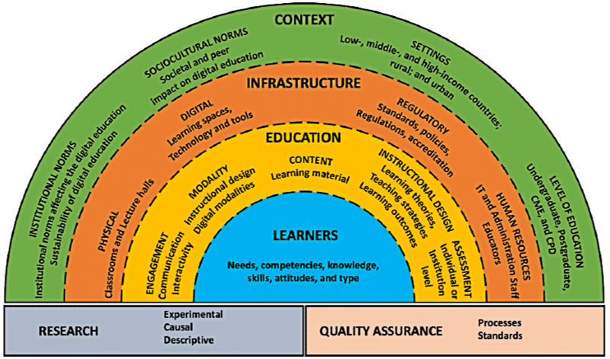

*Figure 1: Conceptual Framework of Digital Health Education for Healthcare Professionals (CFDHEHP). Reprinted from (Car et al., 2022). CC BY 4.0 DEED.*

We plan to extend our investigation to encompass the remaining domains outlined in the CFDHEHP framework in future research endeavors. Specifically, a more structured observational study is proposed to examine the effectiveness of the *Medimon* website. In this future observational study, quantitative and qualitative methodologies will be employed to assess student engagement, preferences, and educational outcomes. Such an analysis will contribute to the current research by generating empirical evidence on the impact of *Medimon*. Additionally, the evaluation of learning outcomes will inform quality assurance practices by providing insights into the efficacy of the pedagogical design and the potential for its broader application in digital health education for healthcare professionals.

The decision to gamify a lecture on muscle physiology by integrating *Medimon* game assets into the curriculum was influenced by the unique approach to presenting complex scientific information. *Medimon* utilizes visual mnemonics through its game art assets, transforming the way muscle physiology is taught. This approach is grounded in contemporary educational frameworks and theories that emphasize active, learner-centered approaches to instruction. Drawing inspiration from the Dual-Coding Theory, which specifies that we have two channels for receiving and processing information, words, and pictures (Clark & Paivio, 1991), and gamification, which incorporates game attributes in a non-gaming context (van Gaalen et al., 2021), our approach incorporates visual *Medimon* game assets to promote learning. This is consistent with Mayer's (2005/2012) Cognitive Theory of Multimedia Learning, which posits that the facilitation of learning is achieved via the multimodal presentation of textual information, either in printed or spoken form, in conjunction with visual representations, encompassing both static and dynamic imagery, ranging from slide presentations to videos and animations. By representing various muscle types as '*Medimon*'—each with its distinct visual characteristics that encapsulate key physiological features—the website makes learning more intuitive and memorable.

Mnemonic-based instruction is a powerful teaching technique that has a long history of empirical success in helping students learn and retain information (Levin, 1993; Patten, 1990). There are several different types of mnemonic strategies,

Figure 2: Medimon families incorporated into the learning representation. The Skeletal Muscle and Heart families also included the other family members (see supplemental material) while Artery and Bronchial Tree were the only representatives of their family, Vasculature and Lung respectively.

*Figure 2: Medimon families incorporated into the learning representation. The Skeletal Muscle and Heart families also included the other family members (see supplemental material) while Artery and Bronchial Tree were the only representatives of their family, Vasculature and Lung respectively.*

including linguistic, spatial, visual, physical, and verbal (Amiryousefi & Ketabi, 2011; Lubin & Polloway, 2016). These strategies can be used individually or in combination, depending on the needs and preferences of the learner. *Medimon* incorporates visual design as not just artistic representations but carefully designed mnemonics to reflect the core attributes of the muscle types they represent.

One example in the learning representation is the Cardiomyocyte *Medimon* (Figure 2, far left Skeletal Muscle image). This character has a cow slinky. In *Medimon* cows/milk represent cowcium (i.e. calcium). This connection is meant to represent the calcium-induced-calcium release that occurs during cardiomyocyte activation. The linkage of the head of the cow slinky (voltage-gated calcium entry) to the tail of the cow (intracellular sarcoplasmic reticulum calcium release) acts as a visual mnemonic strategy for easy recall of calcium-induced-calcium release in cardiomyocytes. This alignment of visual art with scientific accuracy ensures that the learning is not only engaging but also academically rigorous. The game's design, therefore, serves a dual purpose: reducing the cognitive load of learning complex material and providing a more interactive and engaging way to grasp difficult concepts (Levin, 1993).

In summary, the integration of *Medimon* into the muscle physiology lecture was a strategic decision to address the cognitive challenges associated with learning this subject. By replacing traditional text and image-heavy content with interactive, mnemonic-based game assets, the course aimed to enhance student engagement, understanding, and retention of muscle physiology concepts. This innovative approach highlights a shift in educational strategies, moving towards more interactive and visually stimulating teaching methods, particularly in fields that require a deep understanding of complex systems.

Learning Representation

Learning Objectives

The integration of *Medimon* into the muscle physiology lecture aimed to achieve specific student learning objectives, focusing on the complex domain of muscle physiology:

1. Understand muscle contraction, especially the role of actin filament sliding and ATP-dependent myosin motor proteins.
2. Explain excitation-contraction coupling and relaxation in skeletal muscle, including the roles of t-tubules, calcium channels, and ATP-dependent calcium pumps.
3. Differentiate between slow/type 1 and fast/type 2 skeletal muscle fibers, including twitch contractions and molecular bases for their behavior.
4. Describe how skeletal muscle produces smooth, graded contractions through stimulus intensity changes and motor unit recruitment.
5. Understand the differences in excitation-contraction coupling across skeletal, cardiac, and smooth muscles, including the phospho-regulatory cascade in smooth muscle contraction.
6. Compare nervous system control across skeletal, cardiac, and smooth muscles, defining single-unit and multi-unit smooth muscle types.

### Educational Context and Rationale

Medical education continually evolves to align with healthcare advancements and student needs. Traditional teaching methods, though foundational, sometimes fall short in engaging students and facilitating long-term retention. Game-based learning and gamification, specifically educational video games, offer an interactive and engaging approach, enhancing cognitive skills and fostering critical thinking (Connolly et al., 2012; Gee, 2013; Gentry et al., 2019). In medical education, video games have improved various competencies, including diagnostics and clinical decision-making (van Gaalen et al., 2021).

*Medimon* addresses a notable gap in medical instruction literature and in practice by combining medical knowledge with gamification, visual mnemonics, and associative learning methods (Xu et al., 2023). This game-based website targets two critical aspects of medical education: learning enhancement and burnout reduction. In terms of learning enhancement, utilizing visual mnemonics, *Medimon* seeks to enhance memory performance and comprehension. The game's design, featuring medically-themed monsters and battle moves, acts as an effective mnemonic tool (Amiryousefi & Ketabi, 2011; Bellezza, 1981; Levin, 1993). For burnout reduction, given the high stress and emotional exhaustion in medical education (Dyrbye et al., 2006, 2014), *Medimon* offers an engaging, enjoyable learning approach, potentially mitigating burnout and improving student well-being.

Following the CFDHEHP framework (Car et al., 2022), we employed the *Medimon*-infused muscle physiology lecture in the context of the students’ daily classroom experiences. The students were familiar with this learning space and this decision was made to minimize the distraction of a new learning environment. Furthermore, students were informed about the *Medimon* website in a separate lecture in advance of the discussed learning representation.

Learning Representation

In our innovative approach to the first-year medical school lecture on muscle physiology, we gamified a lecture on muscle physiology by strategically integrating specific game assets of the *Medimon* game to enhance the learning experience. The game assets included labeled representations of each of the related *Medimon*, skeletal, cardiac, and smooth muscle (Figures 2 and 3), as well as the building location of the skeletal muscle *Medimon* (Figure 4).

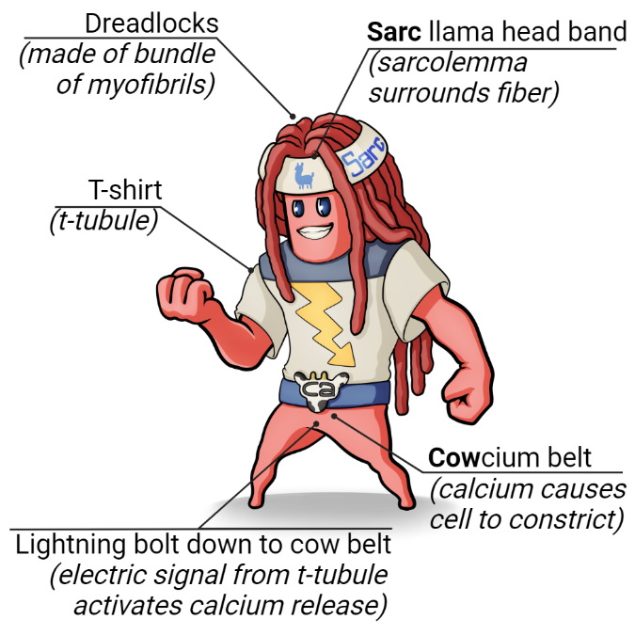 Figure 3: Muscle Fiber Medimon. The game art asset for the Muscle Fiber Medimon who is part of the Skeletal Muscle family. Design mnemonics are labeled.

This integration aimed to provide a more interactive and visually engaging understanding of complex physiological concepts. This was in line with the Dual-Coding and CTML theories of enhanced learning with the use of both text and images (Clark & Paivio, 1991; Mayer, 2005/2012), which has been shown to increase interest and exam scores when utilized to design medical school multimedia presentations (Bland et al., 2024).

For skeletal muscle physiology, we introduced key *Medimon* characters like Myofibril, Muscle Fiber, and Muscle (see page 7, Muscle Physiology Lecture PDF). Each character was designed to visually encapsulate critical aspects of muscle structure and function, aiding in the visualization and comprehension of their roles in muscle physiology. In the realm of cardiac physiology, Heart *Medimon* characters such as Cardiomyocyte, SA Node, and Heart were used (see page 25, Muscle Physiology Lecture PDF). These characters provided a unique, mnemonic-based method to understand heart function, representing different components of cardiac anatomy and their interactions. For smooth muscle concepts, the *Medimon* Artery and Bronchial Tree illustrated the structure and function of smooth muscles in various body parts, making the learning process more relatable (see page 30, Muscle Physiology Lecture PDF).

Each *Medimon* was crafted with visual mnemonics, translating complex physiological concepts into memorable and easily understandable visual representations (Figure 3). These mnemonics were not just artistic interpretations, but visual cues aligned closely with the real-world characteristics they represented. For example, the Muscle Fiber *Medimon* has a "Sarc Llama" hair band to represent the sarcolemma surrounding the fiber (Figure 3). These details of the Muscle Fiber *Medimon* help learners memorize the components, terminology, and functions of a muscle fiber. Additionally, the building related to the Muscle *Medimon* resembled a workout machine, serving as a visual mnemonic for the layout of a sarcomere (Figure 4). This creative representation provided a tangible and familiar reference for students, making the concept of sarcomere structure more accessible. During the gamified learning representation, these characters were presented and then discussed, with a particular focus on their visual mnemonics as well as the relationship between individual *Medimon* (see Muscle Physiology Lecture PDF).

It's important to emphasize that all game assets were used to supplement the existing curriculum, enhancing traditional teaching methods by gamifying the curriculum through the addition of an interactive and visual learning dimension. These game-based elements complemented the material presented in class, offering a comprehensive and engaging learning experience (see Muscle Physiology Lecture PDF). By integrating *Medimon* into the muscle physiology lecture, we created a dynamic and student-friendly learning environment, making the subject matter more interesting and hopefully facilitating deeper understanding and retention of complex medical concepts. 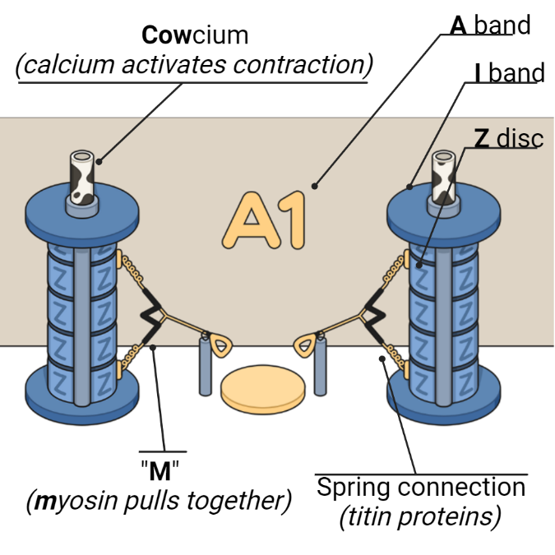

*Figure 4: Sarcomere workout machine. The game art asset for the sarcomere workout machine, which can be located inside the building that is related to the Skeletal Muscle Medimon family. Design mnemonics are labeled.*

Implementation Strategy

All session materials for teaching muscle physiology are provided as supplementary materials (see Support Materials). To expand outside of muscle physiology and into other body system presentations, the *Medimon* game art assets are freely accessible and shared with a Creative Commons CC-BY-NC-SA 4.0 International License, and can be seamlessly integrated into lectures, presentations, and handouts. This flexibility allows instructors to adapt *Medimon* to various curricular needs and settings, covering most body systems. The website's design and resources provide educators with a versatile tool to enhance traditional medical education methods, tailoring use to the specific needs of their students and the curriculum.

Critical Reflection

The *Medimon* gamified learning representation was trialed once in the context of teaching muscle physiology. However, similar versions focusing on other body systems were previously implemented, indicating a broader application of the website across the breadth of medical curriculum.

### Evaluation of Implementation

#### Achievement of Goals

The implementation successfully met its intended educational objectives. The effectiveness of this approach was empirically validated by the performance outcomes observed by the instructor in the classroom setting. Specifically, the aggregated data revealed that students attained an average score of 88% in terms of correct responses on examination questions that directly corresponded to the content disseminated through the *Medimon-*infused learning representation. This notable level of achievement not only reflects the successful attainment of the educational objectives set forth by the implementation but also highlights the substantial impact of employing gamified learning methodologies in the facilitation of comprehension and the retention of intricate medical concepts.

This measurement of achievement also corroborates existing literature that supports the efficacy of game-based learning in educational settings which has demonstrated that the integration of gamification and game-based elements into the learning process can significantly enhance student engagement, motivation, and, ultimately, learning outcomes (Hamari et al., 2016; Nadeem et al., 2023; Xu et al., 2023). These studies posit that the interactive and immersive nature of game-based learning can foster a deeper understanding and retention of subject matter, which is particularly pertinent in the context of medical education, where the mastery of complex concepts is paramount.

Lastly, this outcome further validates our application of the Conceptual Framework of Digital Health Education for Healthcare Professionals (CFDHEHP), particularly emphasizing the reinforcement of the Education domain, which encompasses aspects of assessment (Car et al., 2022).

#### Student Engagement and Feedback

Students expressed enjoyment and a desire for further incorporation of game art assets into their curriculum. One student responded, “Have you seen [Dr. Bland’s] Medimon? 100% better than anyone else’s [presentations]” in their end-of-course student evaluations. This feedback highlights the website's appeal and potential to enrich the learning experience. Moreover, considering the prevalent conditions of heightened stress and emotional exhaustion within the realm of medical education, it is imperative to acknowledge and address students’ positive response to *Medimon* as helping to ease these significant challenges. The rigorous demands and intense curriculum associated with medical training often contribute to elevated levels of stress among students, which, if not properly managed, can lead to emotional exhaustion (Dyrbye et al., 2006, 2014). This state of emotional overextension and depletion can adversely affect students' well-being, academic performance, and eventual burnout (Abreu Alves et al., 2022; Bhugra et al., 2021). The positive reception of the *Medimon*-infused curriculum has the potential to aid in the positive emotional state of students to prevent this ever-looming burnout. This outcome further validates our application of the Learners domain of the CFDHEHP framework, particularly emphasizing the needs and attitudes of the students (Car et al., 2022).

#### Integration Within the Curriculum

The *Medimon* website aligned seamlessly with the larger instructional context. Its ease of implementation and consistency with other topics where game art assets were used, demonstrated its versatility and compatibility with existing teaching methods. As a supplemental resource, the assets provided by *Medimon* could be easily integrated into a variety of instructional materials, including lectures, handouts, and digital content. This ease of integration serves to support the infrastructure domain of the CFDHEHP (Car et al., 2022). Moreover, the comprehensive incorporation of *Medimon* throughout a curriculum fosters a sense of consistency and familiarity among learners with the content being delivered. Such an approach facilitates the revisitation and reinforcement of previously covered concepts, effectively employing the principle of spaced repetition. Spaced repetition, a cognitive science strategy, is recognized for its capacity to significantly bolster knowledge retention among learners (Smith & Scarf, 2017).

Lessons Learned

A key takeaway from this implementation was the importance of thoroughly explaining the mnemonic designs used in *Medimon*. Detailed descriptions of these mnemonics would likely enhance the learning impact, aiding students in making more meaningful connections between the game elements and medical concepts. Additionally, the positive reception and effectiveness of the website suggest that expanding *Medimon* across the entire curriculum could be beneficial.

### Future Modifications

Based on the experience and feedback, a notable area for future development is the integration of interactive elements. Providing links to a playable version of *Medimon* within the curriculum would offer students an even more engaging and immersive learning experience. This enhancement would not only consolidate learning but also provide an innovative way to explore and understand medical concepts through interactive gameplay.

### Reflection

The successful integration of the *Medimon* game elements into the muscle physiology lecture and the favorable student responses highlight the effectiveness of innovative, gamified learning tools in medical education. However, this experience also sheds light on the need for continuous improvement, particularly in enhancing the depth of interaction within the game elements and expanding its application throughout the curriculum. The incorporation of interactive game elements and broader curriculum integration represent exciting future directions for this innovative educational approach.

## References

Abreu Alves, S., Sinval, J., Lucas Neto, L., Marôco, J., Gonçalves Ferreira, A., & Oliveira, P. (2022). Burnout and dropout intention in medical students: The protective role of academic engagement. *BMC Medical Education*, *22*, Article 83. <https://doi.org/10.1186/s12909-021-03094-9>

Amiryousefi, M., & Ketabi, S. (2011). Mnemonic instruction: A way to boost vocabulary learning and recall. *Journal of Language Teaching and Research*, *2*(1), 178–182. <https://doi.org/10.4304/jltr.2.1.178-182>

Bellezza, F. S. (1981). Mnemonic devices: Classification, characteristics, and criteria. *Review of Educational Research*, *51*(2), 247–275. <https://doi.org/10.3102/00346543051002247>

Bhugra, D., Molodynski, A., & Ventriglio, A. (2021). Well-being and burnout in medical students. *Industrial Psychiatry Journal*, *30*(2), 193-197. <https://doi.org/10.4103/IPJ.IPJ_224_21>

Bland, T., Guo, M., & Dousay, T. A. (2024). Multimedia design for learner interest and achievement: A visual guide to pharmacology. *BMC Medical Education,* *24*, Article 113. <https://doi.org/10.1186/S12909-024-05077-Y>

Car, L. T., Poon, S., Kyaw, B. M., Cook, D. A., Ward, V., Atun, R., Majeed, A., Johnston, J., Van der Kleij, R. M. J. J., Molokhia, M., Wangenheim, F. V., Lupton, M., Chavannes, N., Ajuebor, O., Prober, C. G., & Car, J. (2022). Digital education for health professionals: An evidence map, conceptual framework, and research agenda. *Journal of Medical Internet Research*, *24*(3). <https://doi.org/10.2196/31977>

Clark, J. M., & Paivio, A. (1991). Dual coding theory and education. *Educational Psychology Review*, *3*(3), 149–210. <https://doi.org/10.1007/BF01320076>

Connolly, T. M., Boyle, E. A., MacArthur, E., Hainey, T., & Boyle, J. M. (2012). A systematic literature review of empirical evidence on computer games and serious games. *Computers & Education*, *59*(2), 661–686. <https://doi.org/10.1016/J.COMPEDU.2012.03.004>

Dyrbye, L. N., Thomas, M. R., & Shanafelt, T. D. (2006). Systematic review of depression, anxiety, and other indicators of psychological distress among U.S. and Canadian medical students. *Academic Medicine*, *81*(4), 354–373. <https://doi.org/10.1097/00001888-200604000-00009>

Dyrbye, L. N., West, C. P., Satele, D., Boone, S., Tan, L., Sloan, J., & Shanafelt, T. D. (2014). Burnout among U.S. medical students, residents, and early career physicians relative to the general U.S. population. *Academic Medicine*, *89*(3), 443–451. <https://doi.org/10.1097/ACM.0000000000000134>

Gee, J. P. (2013). *Good video games and good learning* (2nd ed.). Peter Lang Inc., International Academic Publishers.

Gentry, S. V., Gauthier, A., Ehrstrom, B. L. E., Wortley, D., Lilienthal, A., Car, L. T., Dauwels-Okutsu, S., Nikolaou, C. K., Zary, N., Campbell, J., & Car, J. (2019). Serious gaming and gamification education in health professions: Systematic review. *Journal of Medical Internet Research*, *21*(3). <https://doi.org/10.2196/12994>

Hamari, J., Shernoff, D. J., Rowe, E., Coller, B., Asbell-Clarke, J., & Edwards, T. (2016). Challenging games help students learn: An empirical study on engagement, flow and immersion in game-based learning. *Computers in Human Behavior*, *54*, 170-179. <https://doi.org/10.1016/j.chb.2015.07.045>

Levin, J. R. (1993). Mnemonic strategies and classroom learning: A twenty-year report card. *The Elementary School Journal*, *94*(2), 235–244. <https://doi.org/10.1086/461763>

Lubin, J., & Polloway, E. A. (2016). Mnemonic instruction in science and social studies for students with learning problems: A review. *Learning Disabilities: A Contemporary Journal*, *14*(2), 207–224. <https://files.eric.ed.gov/fulltext/EJ1118431.pdf>

Mayer, R. E. (2012). Cognitive theory of multimedia learning. In R. Mayer (Ed.), *The Cambridge handbook of multimedia learning* (pp. 31–48). Cambridge University Press. <https://doi.org/10.1017/CBO9780511816819.004> (Print work published 2005)

Nadeem, M., Oroszlanyova, M., & Farag, W. (2023). Effect of digital game-based learning on student engagement and motivation. *Computers, 12*(9), Article 177. <https://doi.org/10.3390/COMPUTERS12090177>

Patten, B. M. (1990). The history of memory arts. *Neurology*, *40*(2), 346–352. <https://doi.org/10.1212/WNL.40.2.346>

Smith, C. D., & Scarf, D. (2017). Spacing repetitions over long timescales: A review and a reconsolidation explanation. *Frontiers in Psychology*, *8*, Article 962. <https://doi.org/10.3389/FPSYG.2017.00962>

Stuart, J., & Rutherford, R. J. D. (1978). Medical student concentration during lectures. *Medical Education,* *312*(8088), 514–516. <https://doi.org/10.1016/S0140-6736(78)92233-X>

Sweller, J. (1994). Cognitive load theory, learning difficulty, and instructional design. *Learning and Instruction*, *4*(4), 295–312. <https://doi.org/10.1016/0959-4752(94)90003-5>

van Gaalen, A. E. J., Brouwer, J., Schönrock-Adema, J., Bouwkamp-Timmer, T., Jaarsma, A. D. C., & Georgiadis, J. R. (2021). Gamification of health professions education: A systematic review. *Advances in Health Sciences Education: Theory and Practice*, *26*(2), 683–711. <https://doi.org/10.1007/S10459-020-10000-3>

Xu, M., Luo, Y., Zhang, Y., Xia, R., Qian, H., & Zou, X. (2023). Game-based learning in medical education. *Frontiers in Public Health*, *11*. <https://doi.org/10.3389/FPUBH.2023.1113682>

Support Materials

*Medimon* website: <https://medimon.games/>

The [Muscle Physiology Lecture (PDF)](https://journals.uwyo.edu/index.php/jtilt/article/view/8469/6645) utilizing *Medimon* game assets is supplied as a supplemental file.

About the Authors

**Dr. Tyler Bland** has been deeply involved in pioneering innovative approaches to medical education as a dedicated Clinical Assistant Professor in the WWAMI Medical Education Department at the University of Idaho. His primary responsibility includes leading the pharmacology material, where they are committed to providing comprehensive and engaging educational experiences to future medical professionals. Additionally, he has been instrumental in developing the *Medimon* project. This project reflects his passion for utilizing technology-rich educational tools to enhance learning and retention, particularly in complex subjects like pharmacology, physiology, and pathology. Dr. Bland’s work in this area is driven by a belief in the transformative power of interactive learning experiences in shaping the next generation of medical practitioners.

**Dr. Meize Guo** is currently a postdoctoral research associate with the CSEveryone Center for Computer Science Education at the University of Florida. Dr. Guo centers her professional endeavors on supporting learners and educators in the realms of instructional design, technology integration, STEM education, and computer science education.

## Sharing & Modification Permissions

Unless otherwise noted, this article and its resources are published under a [Creative Commons Attribution-NonCommercial-ShareAlike 4.0 International license](https://creativecommons.org/licenses/by-nc-sa/4.0/):

[](https://creativecommons.org/licenses/by-nc-sa/4.0/)

You can freely share the article and its resources if you indicate the original authors, identify the Creative Commons license, and use them non-commercially.

You may also make and share modifications by:

* [Identifying the original authors](https://wiki.creativecommons.org/wiki/best_practices_for_attribution).
* Using the resources non-commercially.
* Licensing modifications under the CC BY-NC-SA 4.0 license (and including a link to it).
* Indicating what modifications were made.

*Medimon* is a product of Panacea Interactive. Medimon Game Assets, which include images and descriptions of *Medimon* as found on medimon.games/medifamilies and on specific medifamily web pages are licensed under a [Creative Commons Attribution-NonCommercial-ShareAlike 4.0 International license](https://creativecommons.org/licenses/by-nc-sa/4.0/):

[](https://creativecommons.org/licenses/by-nc-sa/4.0/)