Exploring the Volume of a Cylinder
  - April Day, Brigham Young University
This lesson received an Honorable Mention in the 2023 AECT Teacher Education Division PK-12 Lesson Design Competition. It was not peer-reviewed.

Overview
During this lesson, students create cylinders of different radii and heights using the Cricut Maker 3. They then test the volume of their own cylinder and compare it to the volume they calculate from the formula. They observe the differences in volume for cylinders with various radii or heights.
This lesson is intended for 8th grade math, but it could be modified for different grades by changing the shape students work with. For example, 5th graders could use rectangular prisms. Other shapes could include square and triangular pyramids, triangular or hexagonal prisms, and dodecahedrons.
Topics: Formulas, Geometry, Mathematics, Volume
Time: 2 hours

Materials
The following materials are needed for this activity:
- Paper for the Cricut Maker 3 machine
- Tape
- Items that can be used to measure volume (e.g., sugar, salt, sand, kinetic sand, Floam)
- A graduated cylinder or a clear measuring cup with markings
- Calculator
- Pencil and paper
- Cricut Maker 3
- Computers with Cricut Design Space

Learning Objective
By the end of this lesson, students will be able to visualize the change in volume of a cylinder depending on the diameter of its base and height.

Context-at-a-Glance
This lesson was developed conceptually for a PK-12 lesson design competition.
Competition Parameters
The Teacher Education Division of the Association for Educational Communications and Technology provided live explorations of two Cricut Maker 3 machines during the 2023 annual convention. Attendees were given three days to design original, hands-on, curricular materials based on the tool. Their instructions were to amplify or transform student learning in a PK-12 (or equivalent) setting and describe their idea in approximately 750 words.
Setting
A public middle school in the United States
Modality
Face-to-face instruction
Class Structure
Cylinder volume is typically taught in 8th-grade math.
Technology Rationale
Students use the Cricut Maker 3 to measure and create their cylinders. The Cricut helps them visualize that the base of a cylinder is a circle, and the side of a cylinder is a rectangle. They also visualize the relationship between the circumference of a circle and the length of the side of the rectangle. It can be difficult to measure the diameter of a circle by estimating its center. The Cricut provides the exact shapes and dimensions, so students do not have to measure them with a ruler. This reduces measurement errors. Finally, the Cricut allows students to adjust the size of their cylinders and observe how adjustments to the radius or height impact volume.

Learning Representation
Give students the following instructions:
- Create a new project in Cricut Design Space (https://design.cricut.com/#/) and draw two circles with a rectangle in between to create the net for your cylinder.
- Adjust the diameter of the circle to the size of your choice. Use the diameter to calculate the circumference of the circle (π D or 2 π r).
- Create the rectangle that will be the sides of the cylinder. Pick the height and use the circumference calculated in step 2 for the length.
- Repeat the previous steps to make a second cylinder, but this time change the circle's size or the rectangle's height.
- Add tabs on the circles and one end of the rectangle (using the Combine > Unite function in the Layers section) so you can tape them together.
- Cut out your cylinders using the Cricut Maker 3. Tape the bottom circle to the sides of the cylinder. Do not tape the top yet (see Figure 1).
- Fill the open cylinder with material whose volume can be measured. Some options include sugar, salt, sand, kinetic sand, or Floam that can fill the cylinder and easily be measured.
- Pour the cylinder's contents into a measuring container.
- Calculate the volume (π r² h).
- Compare the calculations and measurements for both cylinders and the differences in volume.
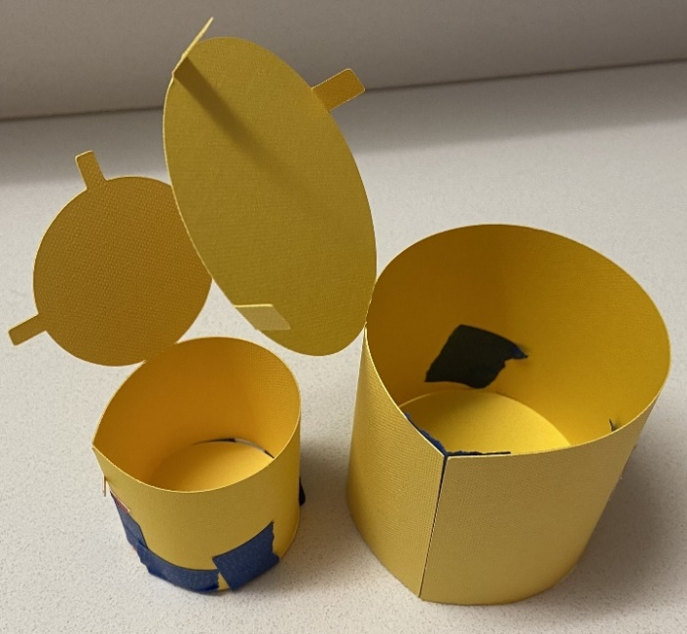
Figure 1. Prototype cylinders.

Discussion Questions
Here is an example project for this lesson in Cricut Design Space. During Step 10, have students explore volume by asking questions like:
- What is the difference in volume of the two cylinders with different radii?
- How does the change in height affect the volume?
- Which makes more of a difference to the volume, changing the radius, changing the height, or do they have the same impact?
- What are some real-world applications for this? (Example: Suppose you own a soup company. How would slightly changing the height or radius of your cans impact the consumer? Do you see examples of this practice today?)

About the Author
April Day is an Associate Instructional Designer for Brigham Young University Continuing Education. She specializes in creating high-quality, interactive math courses for online high school and middle school programs. She is passionate about making math clear and relatable through improved instruction and technology integration. She can be contacted at aprildwork@gmail.com.

Sharing & Modification Permissions
Unless otherwise noted, this article and its resources are published under a Creative Commons Attribution-NonCommercial-ShareAlike 4.0 International license:
You can freely share the article and its resources if you indicate the original authors, identify the Creative Commons license, and use them non-commercially.
You may also make and share modifications by:
- Identifying the original authors.
- Using the resources non-commercially.
- Licensing modifications under the CC BY-NC-SA 4.0 license (and including a link to it).
- Indicating what modifications were made.

