Frog Olympics
  - Abby Harris, Brigham Young University
This lesson won the 2023 AECT Teacher Education Division PK-12 Lesson Design Competition. It was not peer-reviewed.

Overview
Using different sized paper frogs cut from the Cricut Maker 3, students complete different events and collect data over two classes. This data will be compiled and analyzed to determine winners. Learners form groups of three students and make a small, medium, and large frog, using Cricut Design Space to size correctly and personalize their frogs. Once the frogs are folded, they are entered into five Olympic events: long jump, same-side flipper, backwards flipper, high jump, and fastest faller. Each student uses the three frogs from their team to complete each event and keeps track of their measurements. After each team member has completed all the events, students calculate the mean, median, and mode for the three frogs in their team for each event. As a class, students put all the data on the board and decide if the mean, median, or mode best represents the data fairly to decide which team receives first place. An awards ceremony follows for the top three teams of each event.
Topics: Mathematics, Measures of Central Tendency, Population, Sample Population, Statistics and Probability
Time: 120 minutes over 2 class periods

Materials
- Cricut Maker 3
- Computers with Cricut Design Space for students
- Cricut Score tool
- Cricut Marker
- Rulers or measuring tape for each team
- Notepad and Pencil for each team
- Scientific calculator for each team
- Frog template (for use with Cricut Design Space; Harris, n.d.)
- Computer with LCD projector

Context-at-a-Glance
This lesson was developed conceptually for a design competition.
Competition Parameters
The Teacher Education Division of the Association for Educational Communications and Technology provided live explorations of two Cricut Maker 3 machines during their annual convention in October 2023. Attendees were given three days to design original, hands-on, curricular materials based on the tool. Their instructions were to amplify or transform student learning in a PK-12 (or equivalent) setting and describe their idea in approximately 750 words.
Setting
A public middle school setting in the Western United States.
Modality
Face-to-face instruction
Class Structure
Designed for a 7th grade mathematics classroom.
Technology Rationale
The Cricut Maker 3 allows students to have fun being creative, and in this case, facilitates learning about variations in size and scale, and evaluating different patterns in test data. The Cricut Maker 3 allows the students to easily fold straight, crisp lines by scoring the paper and color coding/numbering the folds.

Standards
This project supports two of the four critical areas for 7th grade mathematics:
In Grade 7, instructional time should focus on four critical areas: (1) developing understanding of and applying proportional relationships; (2) developing understanding of operations with rational numbers and working with expressions and linear equations; (3) solving problems involving scale drawings and informal geometric constructions, and working with two- and three-dimensional shapes to solve problems involving area, surface area, and volume; and (4) drawing inferences about populations based on samples (Utah Education Network, n.d., Course Introduction section).

Learning Representation

Class 1
Start this lesson reviewing mean, median, and mode with quick examples. Students are then put into teams of three and decide on roles (i.e., leader, timekeeper, and problem-solver). The Frog Olympics are then explained with a flow of the lesson.
Demonstrate of how to size the frog template (Figure 1) on Cricut Design Space to be small (6x6 inches), medium (9x9 inches), or large (12x12 inches), and how to personalize it with the team’s name and frog eyes. Students have 10 minutes to design and submit their personalized frog templates to the teacher.
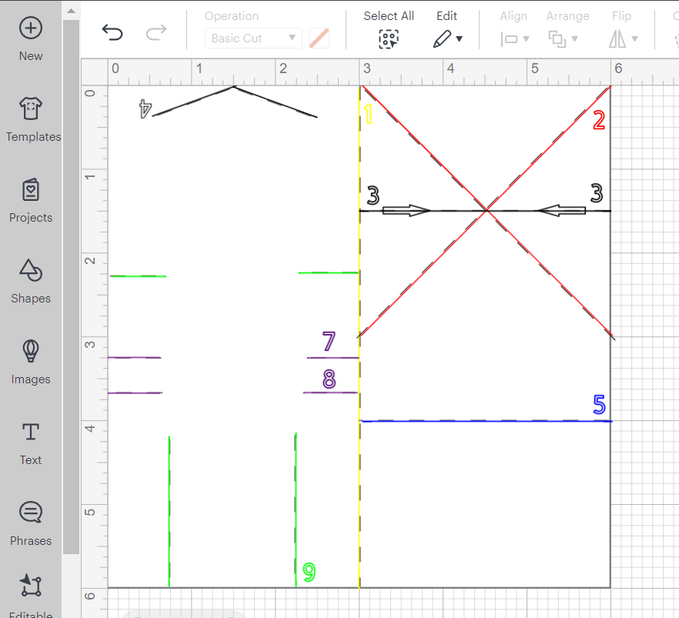
Figure 1. Frog template in Cricut Design Space sized to six inches.

Class 2
Before the next class period, the teacher should score, print, and cut all the frogs using the Cricut Maker 3. The teacher should also prepare a digital table to present the class-wide data.
The students will start the next class period by folding their frogs with advice from the teacher on how to make clean, crisp folds. Each student should make a table (digital or non-digital) to document their data for the five events and for three attempts per frog (Figure 2). The five events are:
- Long jump,
- Same-side flipper,
- Backwards flipper,
- High jump, and
- Fastest faller.
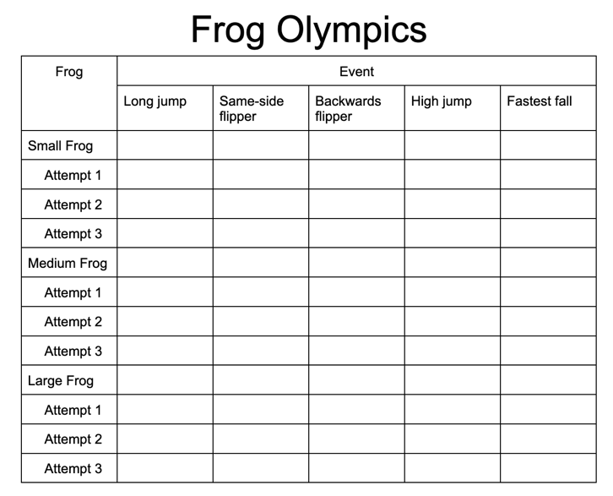
Figure 2. Example table students should create to collect data for Frog Olympics.
After the frogs and tables are prepared, hold an ‘opening ceremony’ so every student can see the different team’s personalized frogs.
After the ‘opening ceremony,’ each student will attempt the five events with each of their team’s frogs. During each event, the students can make three attempts and keep the best measurement. Only one measurement per frog per event is needed per student.
While one student is completing the events, the other two teammates will act as judges for another team to ensure accurate readings are taken. The students will then rotate through the events with the other teams, switching responsibility of judging and competing until all students have completed all five events with their team’s three frogs, and documented the measurements.
Students should circle their best score for each event for each frog. Then teams will get back together at desks and make a table of data of the best score received for each event for each frog. They will also calculate the mean, median, and mode for each event and each frog using each student's data.
Once they calculate their team data, each team leader will share the data points with the teacher who will put them on the projected class-wide data table. The teacher will facilitate a discussion about who should win each event, the difference between mean, median, and mode, and why each is valuable with the events.
The students will then get to have the ‘closing ceremonies’ where the top three teams of each event are recognized. The teacher should lead a discussion on the variations of the winning frogs and if they notice any tendencies that made the winning frogs win.

References
Harris, A. (n.d.). Frog Olympics. Cricut Design Space. Retrieved January 8, 2023, from https://design.cricut.com/#/landing/project-detail/652deb655928b0dc92db38b2
Utah Education Network. (n.d.). Mathematics grade 7. Retrieved December 2, 2023, from https://www.uen.org/core/core.do?courseNum=5170

About the Author
Abby Harris loves teaching with technology and bringing creativity to the classroom. Abby has taught in the middle school and high school math classrooms over the last 12 years in Utah, Indiana, and Ohio. She is currently a PhD student in Instructional Psychology and Technology at BYU, teaches at BYU Online High School and is an assistant math professor at Nightingale College.

Sharing & Modification Permissions
Unless otherwise noted, this article and its resources are published under a Creative Commons Attribution-NonCommercial-ShareAlike 4.0 International license:
You can freely share the article and its resources if you indicate the original authors, identify the Creative Commons license, and use them non-commercially.
You may also make and share modifications by:
- Identifying the original authors.
- Using the resources non-commercially.
- Licensing modifications under the CC BY-NC-SA 4.0 license (and including a link to it).
- Indicating what modifications were made.

