Synthesis Instructions for Lab
  - Katheryn Ure, St Paul’s School for Girls and Irene A. Bal, Loyola University Maryland

Synthesis of magnesium oxide reaction

Equipment
Check you have all the equipment listed below:
- Crucible & lid
- Strip of Magnesium
- Tongs and/or heat proof glove
- Bunsen burner
- Clay triangle
- Ring stand or tripod
- Safety goggles for each person

Instructions
Set up the equipment as shown in Figure 1.
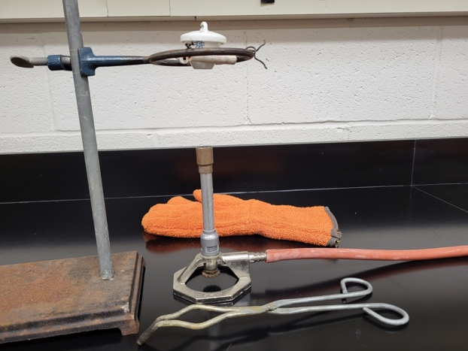
Figure 1. How equipment should be placed. Safety goggles should be included.
- Place about 2-3cm of magnesium ribbon into the crucible and heat it with the Bunsen burner.
- Occasionally lift the lid using the tongs to allow air into the crucible. SAFETY – this is very hot!
- Make observations in your lab notebook.
- Once the reaction is complete, shut off the Bunsen burner and leave the items to cool.
- Start work, as a group, on the worksheet U4WS14AR. Use your phones to access the QR code and follow the instructions.

