Welcoming Newcomers to Makerspaces
  - Shannon M. Smith¹, Craig E. Shepherd², and Maxine Evans²
¹University of Wyoming, ²University of Memphis

Overview
This article provides several self-guided, simple, creative activities to help learners gain familiarity and create with maker tools. Activities center around four categories: low technology, paper circuitry, Sphero robotics, and Cricut cutting machines. Learners use maker resources to build animals, construct LED bracelets or lanterns, code sirens, design stickers, and more. Although the intended audience for this article was undergraduate preservice teachers, most activities have also been completed by students in grades 3-8. Because materials differ by activity, they are presented in each activity.
Topics: makerspace, prototyping, robotics, circuits, block coding, arts and crafts.
Time: Activities are completed either in the makerspace or with packets provided from the makerspace. Lengths vary from 10-30 minutes each.

Standards
These activities instigate space and tool awareness and loosely align with the following ISTE Standards for Students (ISTE, 2017).
1.4.a Students know and use a deliberate design process for generating ideas, testing theories, creating innovative artifacts or solving authentic problems.
1.4.c Students develop, test and refine prototypes as part of a cyclical design process.
1.4.d Students exhibit a tolerance for ambiguity, perseverance and the capacity to work with open-ended problems.

Context-at-a-glance
Setting
These activities were intended for a physical makerspace in a College of Education at a public, United States university.
Modality
Although some tools are in circulation, physical presence within the makerspace was desired.
Class Structure
Resources primarily served preservice teachers in a hybrid technology integration course with a makerspace module.
Organizational Norms
The College of Education in Memphis, Tennessee, focuses on urban education with a mission to promote diversity, equity, and inclusion. Technology awareness, access, and use are components of this mission.
Learner Characteristics
Most students were White-Caucasian femme presenting in their late teens to mid-twenties. Most students were enrolled in a technology integration course to fulfill major requirements. Few students had previously used makerspaces.
Instructor Characteristics
Instructors have familiarity using and managing makerspaces. They are technology savvy, and one is a practicing librarian. They enjoy hands-on and project-based learning.
Development Rationale
These activities were developed from various afterschool programs, clubs, presentations, and maker movements. After obtaining a formal makerspace in 2022, activities were updated to familiarize users with the space and its tools.

Learning Objectives
By the end of each activity, the learner will:
- Gain awareness of tools and resources available in the makerspace.
- Use selected tools to create an artifact.

Setup

Several of the activities described in this document require advanced preparation to create inexpensive, consumable resource packets (e.g., instructions, activity components, feedback opportunities). Specific materials, setup needs, and instructions are provided in setup sections for each activity.

Context and Setting
The activities provided in this document originated from myriad sources developed by the authors. Some activities began as lessons to introduce STEM topics to grade 3-8 students in elective courses taken at a multi-use makerspace in a public university school. Others were developed to introduce technology tools a) during an after-school club, b) as part of a technology integration course for preservice teachers, c) as part of a makerspace for preservice teachers, or d) during professional conferences. Regardless of origin, these activities were used in a technology-integration course to introduce preservice teachers to makerspaces.

Use Problems
Between 2011 and 2018, the authors organized space in a public library housed within a College of Education to double as a multipurpose, flexible-use, makerspace (Kvenild et al. 2017; Shepherd et al., 2015, 2017). Additionally, the authors leveraged makerspaces on and around campus to gain greater access to STEM resources. These spaces were housed within highly visible areas and contained amazing collections. The spaces provided maker services at no or low-cost to students and faculty (Shepherd et al., 2021). However, these spaces saw less-than-desired use, despite their locations. Although much time and effort were put into tool selection and space design, seemingly less consideration was made regarding space implementation and user engagement. This mentality was familiar to us; we initially experienced similar problems in our library space—ordering circulation materials and equipment without considering use (Kvenild et al., 2017). Stryker (2021) reported similar concerns in another makerspace setting. In these scenarios, it appeared that designers spent greater resources planning the space than considering implementations of the space (Smith & Ragan, 2005).
Although considerable research and scholarship regarding makerspaces exists, the concept of makerspaces remains unfamiliar to many PK-16 students and teachers, including teacher education programs. Inquiry, constructionism, and problem-based learning are common topics in many teacher education programs but familiarity with cutting machines, 3D printers, robotics, and other equipment is less common. Lack of familiarity presents a barrier to entry for makerspaces. Their apparent complexity with limited opportunities for observation and trial may exacerbate lack of use (Rogers, 2003). Students need opportunities to examine, explore, and use these tools in non-threatening environments.

Current Context and Space
Prior to one author’s arrival at the University of Memphis, the instructional design and technology program housed various maker and STEM resources in a multi-use studio space. Resources included low-technology tools like crafting materials (e.g., paper, glue, craft sticks), building bricks, and mathematics manipulatives to high-technology tools like smart speakers, and robotics. In subsequent years, this collection grew to include Cricut machines, Micro:bits, paper circuits, portable green screens, 3D printers, and so forth.
These materials are predominantly used by preservice teachers enrolled in technology- integration courses for degree completion. As part of one course, preservice teachers complete a unit where they select various maker projects to familiarize themselves with tools and processes. This unit is preceded by information and a hands-on activity regarding project-based learning, and the use of inquiry and prototyping to solve authentic problems. The maker unit is designed to help students experience various forms of making so they can conceptualize their own project-based learning lesson plan in a later unit.
Maker resources are stored in an instructional design studio within the education building. Because the studio serves multiple stakeholders (where making was not central to each group), the tools were historically kept out-of-view in storage. Current and former students who knew about these resources could request them during the academic year, but they were essentially hidden to the broader college community. In 2022, a permanent space within the studio was provided for the makerspace. This allowed greater access and visibility of available resources. It also allowed these resources to enter larger circulation within the College of Education. However, given prior experience with makerspaces, we speculated that we needed to consider awareness and exploration of the space to help users feel welcome and comfortable using available resources.

Attitude Formation
Use considerations often align with individual attitudes regarding the tools and space in question (Smith & Ragan, 2005). Those unfamiliar with 3D printers, cutting machines, and other tools may express interest when the tools are demonstrated but question how they are relevant to their interests and skills or believe they are unqualified or lack needed permissions to use them (Stryker, 2021). When developing instruction to impact attitudes, Smith and Ragan (2005) considered three components: cognitive, behavioral, and affective.
Cognitive components focus on how to do the task at hand. Without this knowledge, attitudes cannot be shaped because users lack ability. Similarly, designers must focus on the behavioral components of performing the task. Knowledge about how to complete something is insufficient for attitude formation; users must be able to physically apply their knowledge to a task. Thus, they must be able to access, interact with, and use the resources in question. We sought to help users explore the tools by providing safe and encouraging environments where they can observe and try the resources in question with support.
Yet, convincing people to interact with unfamiliar tools can be challenging, particularly when those tools differ markedly from what they regularly use (Rogers, 2003). Knowledge of use must transfer into desire for use. An affective component towards attitude formation also exists. Users should consider why they might use a tool and how it may influence an educational setting or experience (Smith & Ragan, 2005). When users have access to makerspaces, know how to use them, and understand how they add value to educational settings, positive attitudes are more likely to form.

Our Approach
Although the makerspace within the College of Education has a physical space and tools for individuals to use, the authors worried that more attention was needed to attract users.
The following activities were designed to provide self-guided awareness opportunities (targeting physical access and use to generate knowledge formation) to those curious about the makerspace. All activities provided entry points into the space and used available tools. Realizing that some tools may intimidate users, we also provided options for low technology projects (e.g., paper, scissors, glue, craft sticks). Low-technology activities were designed to help users gain comfort in the space and pique their interest in other tools (and tutorials) that they saw in the space. Activities were designed to take minimal time and promote successful completion. Some activities end with additional challenges to increase tool and space use.
Although many tools are available in the space, this paper highlights low-tech projects, paper circuits, Sphero robotics, and Cricut cutting machines. The pages that follow describe only a few activities for these tools. These activities are not meant to promote self-sustaining interests in the makerspace or describe the purpose of making. Additional activities were (and continue to be) developed to sustain interests and describe maker purposes. The activities discussed here invite individuals into the space to gain tool awareness and comfort.

Low-Technology Activities

Overview
Self-directed activities in this section are meant to welcome users into the makerspace and provide familiar resources and tasks to help them interact with the space. Through interaction, we hope users will gain comfort in the space and realize that it is a place they can come to explore familiar and new tools, which should be visibly placed around them. Low-technology activities include building a diorama, animal, monster, vehicle, stand, or origami object.
Topics: makerspace, arts and crafts, design
Time: 10-30 minutes

Materials
Material needs will vary based on the task and user familiarity. The following list of ideas may help:
- Flier of instructions
- Markers, crayons, colored pencils, paint
- Glue, hot glue gun, and glue sticks
- Craft supplies (e.g., colored paper, card stock, craft sticks, pipe cleaners, rubber bands, paperclips, popsicle sticks, straws, magazines, various tape, string, yarn, boxes, felt, fabric)
- Stapler, scissors (for fabric and paper)
- Building blocks (e.g., Megablock, Lego)
- Wood, screws, nails, sandpaper
- Screwdriver, hammer, wrench, clamps

Setup
The flier with instructions will need to be printed and cut out prior to this activity. Although it may not be feasible to display all materials mentioned above, a list of available materials and costs should be prominently displayed in the space (e.g., webpage, poster). Additional activities should also be displayed to encourage continued exploration.
Determination of who can access the supply room with materials should be established and communicated to users prior to the activity. We freely provided resources to encourage participation.

Instructions
Each flier provides an indication of how difficult the project is, how much time it may take, and what the learner is challenged to do. Because these activities are meant to be exploratory, minimal instruction was provided (see Figure 1).
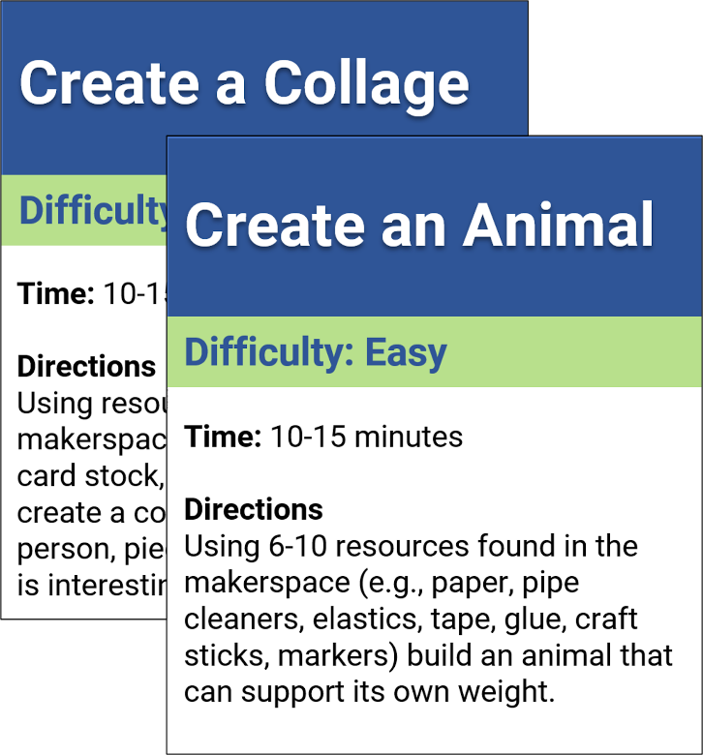
Figure 1. Two low-technology instructional fliers.
Learners locate and use resources to complete the activity (see Figure 2).
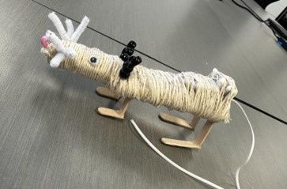
Figure 2. Learner-created rat using maker resources. Copyright 2023 by Aubrey Bakalekos. All rights reserved. Used with permission.

Circuit Bracelet Activity

Overview
This self-directed activity guides learners in or outside of a makerspace to create a paper bracelet with one or more working LED lights. It introduces students to basic circuit principles that require little prior knowledge. Because the activity emphasizes awareness of making, circuitry vocabulary (e.g., open, closed, series, parallel, and short circuits) is not introduced.
Topics: makerspace, basic circuits, elementary science, art
Time: 10-15 minutes

Materials

Makerspace or Home Materials
- Internet access via computer, tablet, or phone
- Scissors to cut the bracelet
- Markers or crayons to decorate bracelets
- QR code generator (or URL shortener)
- Printer to print QR code

Consumable Packet Materials
- One envelope to hold materials
- Five short strips of transparent or masking tape
- One blank sheet of 8.5 X 11-inch paper
- Three ~5-inch strips of copper tape
- Two or three LED lights (ensure they light together by testing them with a battery before packing).
- One 3V coin battery (e.g., CR 2032, CR 2025)
- QR code to Power Bracelet directions, printed on the envelope and labeled as instructions

Setup

Construct packets prior to the activity; this takes a few minutes per packet (with increased time savings through bulk construction). Make sure the battery poles are covered so they do not form short circuits with included components. Markers, crayons, scissors, and internet access should also be available.

Instructions

Instructions are located on the Power Bracelet webpage. Learners cut a bracelet out of the sheet of paper, fit it to their wrist (adding an extra inch of space), and decorate one side. The bracelet is then flipped over, and a circuit drawing is made by marking two parallel lines along the long side of the paper. These lines represent wires. X marks represent LED placements (see Figure 3).

Figure 3. Drawing the circuit.

Learners cover the parallel lines with copper tape to create wires, mark which wire is positive and negative, secure LED lights with tape, and add a battery (see Figure 4).

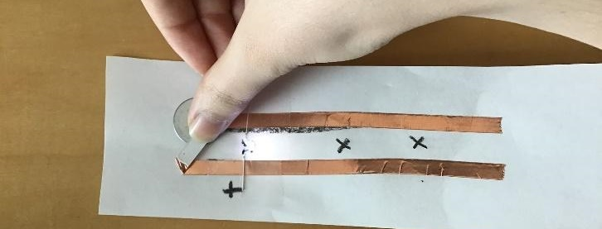
Figure 4. Connecting the battery with one LED added.

Fasten the bracelet with tape (see Figure 5).

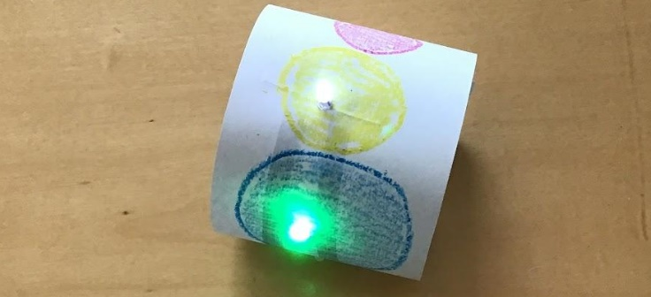
Figure 5. Finished bracelet.

Origami Lantern Activity

Overview
This self-directed activity helps learners create an origami lantern with an LED light. It introduces students to origami principles that require little prior knowledge. Circuit construction is nonexistent. However, an explanation about how electricity lights the LEDs is provided along with additional challenges.
Topics: makerspace, basic circuits, elementary science, origami
Time: 15-30 minutes

Materials

Makerspace or Home Materials
- Internet access via computer, tablet, or phone
- Scissors
- Markers or crayons to decorate lantern (optional)
- QR code generator (or URL shortener)
- Printer to print QR code

Consumable Packet Materials
- One envelope to hold materials
- One 1.5-inch strip of transparent tape
- One blank sheet of 8.5 X 11-inch paper
- One or two LED lights (ensure they light together by testing them with a battery before packing).
- One 3V coin battery (e.g., CR 2032, CR 2025)
- QR code to Cube Light directions, printed on the envelope and labeled as instructions

Setup
Construct packets prior to the activity; this takes a few minutes per packet (with increased time savings through bulk construction). Make sure the battery poles are covered so they do not form short circuits with included components. Markers, crayons, scissors, and internet access should also be available.

Instructions
Lantern instructions are provided on the Cube Light website. Learners scan the QR code and begin with a video to fold an origami cube or stellated octahedron.
After all folds are completed, but before inflation, they deconstruct the shape to secure the LED lights and battery with transparent tape (see Figure 6).

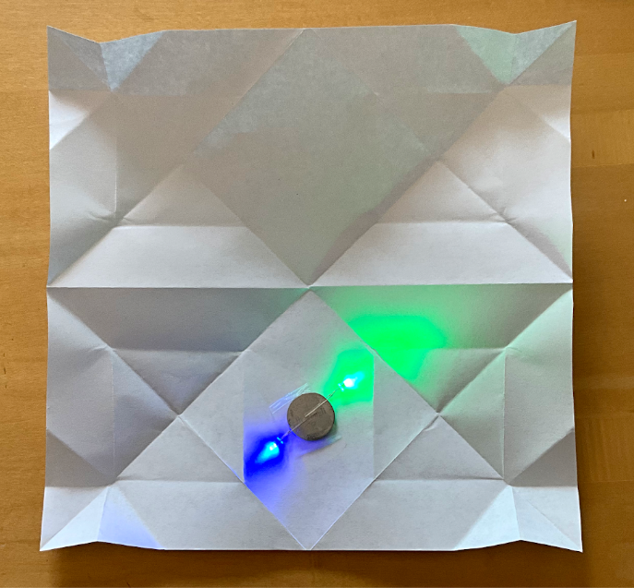
Figure 6. Lights and battery on the unfolded origami cube.
Afterwards, the shape is refolded (see Figure 7).
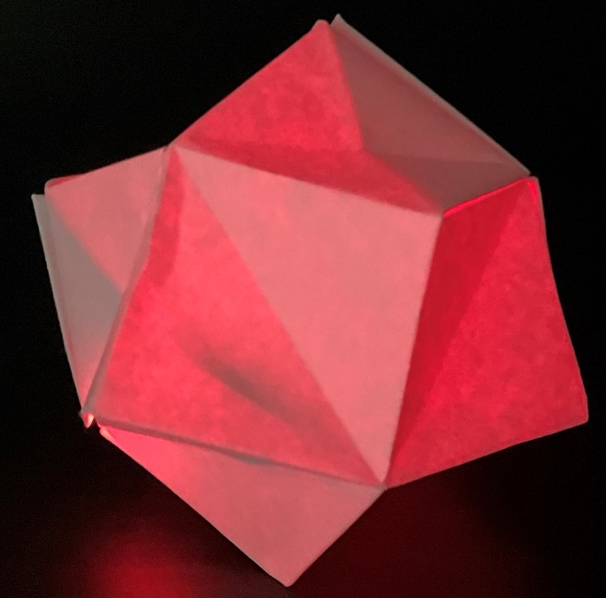
Figure 7. Completed stellated octahedron shape.

Sphero Robotics: Siren Activity

Overview
This self-directed activity is completed with the aid of a printed flier. Learners check-out a Sphero robot and use the flier to download Sphero Edu (an app to interact with the robot). Students navigate the app to the coding canvas and use block codes to create a siren. The flier identifies needed blocks, their description, and their location in the app. Hints and a partial solution are also provided. When learners complete the task, they are asked to personalize their program by adding additional features.
Topics: computer science, robotics, coding, block coding, computational thinking
Time: 10-15 minutes

Materials
- Sphero Bolt robot (other Sphero robots will also work with limited changes to the activity)
- Sphero Robotics: Siren flier
- Bluetooth enabled computer, tablet or phone
- Sphero Edu (all major operating systems)
- Printer (to print the flier)
- Transparent tape (for the flier)

Setup
Sphero Bolt robots need to be charged prior to this activity. The flier needs to be printed and folded into a tri-fold brochure with an additional fold covering the partial solution (and taped shut). The flier should be placed in an easily accessible location.

Beyond flier and robot distribution, there is no need for additional setup, though having a knowledgeable guide available can help troubleshoot and answer questions.

Instructions
Instructions are located on the Sphero Robotics: Siren flier (see additional materials). Learners take a minute or two to consider what an emergency siren does and what they might do to mimic a siren. They then download the app, navigate to the programs section, and create a new program.
Images in the flier show how to add block commands, what blocks they will use, and where to find them. Additional sections provide ideas to consider as students create their programs (see Figure 8).

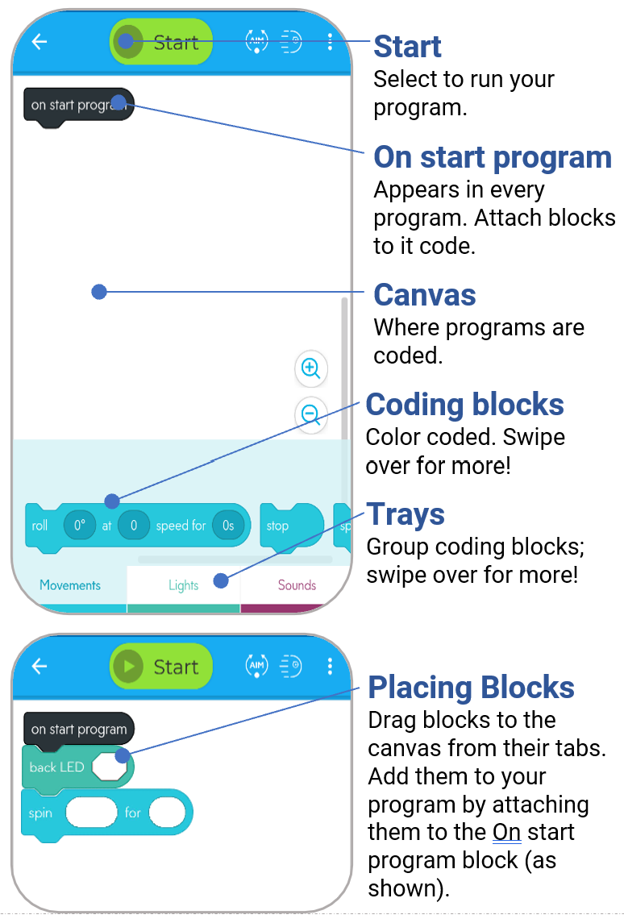

Figure 8. Basic instructions within the flier.
Finally, instructions are provided about how to connect their device to their robot. If additional help is needed, a partial solution is provided in the flier. It shows the placement of 4 blocks and asks what else is needed.
When learners complete the program, they are asked to personalize it by adding additional sounds, lights, and animations.

Sphero Robotics: Square Activity

Overview
This is a self-directed activity with the aid of a printed flier. Learners check-out a Sphero robot and use the flier to download Sphero Edu, create a new program, and use block codes to instruct their robot to move in a square shape. Necessary blocks are indicated in the flier along with a few hints. A partial solution is provided, though taped shut. When learners complete the task, they are asked to personalize their program by adding lights, sounds, and lengthening the shape.
Topics: computer science, coding, robotics, computational thinking
Time: 10-15 minutes

Materials
- Sphero Bolt robot (or other Sphero robots)
- Sphero Robotics: Square flier
- Bluetooth enabled computer, phone, or tablet
- Sphero Edu application
- Transparent tape (for the flier)

Setup
Sphero Bolt robots need to be charged prior to this activity. The flier needs to be printed and folded into a tri-fold brochure, with an additional fold covering the partial solution (and taped shut). The flier should be placed in an easily accessible location.

Beyond flier and robot distribution, there is no need for additional setup, though having a knowledgeable guide to troubleshoot problems and answer questions is helpful.

Instructions
The flier begins with three questions asking learners how they would describe a square to someone, what directions are needed to draw a square, and how those directions might convert to block coding.

After learners ponder these questions, they are provided with instructions to download the Sphero Edu app, navigate the interface, and create a new program.
To keep time commitments minimal for this project (approximately 10 minutes), the flier includes a list of required blocks, where to find them in the app, and their general description. Learners are instructed to use the “roll,” “delay for,” and “exit” blocks.
Afterwards, they are given a few hints regarding the specifications of a square (e.g., 90º interior angles) and how to manipulate the roll block.
Following these hints, the flier instructs learners how to connect their robot via Bluetooth to the Sphero Edu app on their device. It also instructs them how to aim their robot using the app.
Finally, a partial solution is provided (though initially taped shut) to help them troubleshoot their program (see Figure 9).

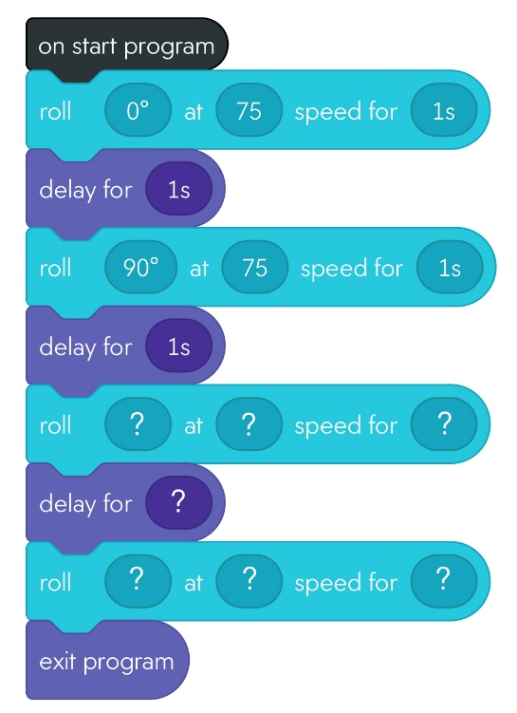
Figure 9. Partial solution for the square program.

Cricut: Sign Cutout Activity

Overview
Learners gain awareness of Cricut Design Space and the Cricut Maker machine as they print a sign on cardstock and cut it into a shape with the Cricut Maker during a self-directed activity.
Topics: makerspace, sticker, Cricut, craft
Time: 20-30 minutes

Materials
- Computer/tablet with the Cricut Design Space app
- Cricut Maker with fine-point blade
- 12” by 12” Light Grip Mat for Cricut device
- One piece of colored cardstock paper (8.5” X 11”)
- Printer (inkjet or laser)
- Instructions (provided below)

Setup
Learners need a computer or device with Cricut Design Space, access to a printer, and the Cricut Maker Machine with fine-point blade installed. Learners also need a piece of colored cardstock and access to the following instructions.

Instructions
- Login to Cricut Design Space or create a free account.
- Select the “New Project” button.
- Select the “Images” option on the left navigation.
- Select the “Free” option under Highlighted Categories (left of the screen).
- Locate an image, select it, and press the “Add to Canvas” button at the bottom of the window.
- Resize the image as desired (no larger than 6.55” X 9.05”)
- Select the “Offset” button (top-middle of window) and adjust the border distance to .1 inches. Then select “Apply.”
- Select a border color.

Add Text
- Add text to your image using the Text tool on the left-navigation menu.
- If you want to curve text to fit your image, use the Curve toolwhich appears in the top-middle of the window when the text tool is selected.

Print Your Image
- Select the “Select All” button(top-middle of window). Then select “Flatten” in the Layers section (lower-right side of window) to merge your image, border, and text into one object.
- Make sure “Maker” (Cricut Maker) is selected to the left of the “Make It” button in the top-right of the window.
- Select the “Make It” button.
- Preview your cutout and select “Continue.”
- Select “Send to Printer.”
- In the computer window, deselect “Add Bleed”
- Select “Use Printer Dialogue” (this window may appear behind the main window).
- Select the manual tray and indicate you will be printing on cardstock. Then print the cutout!

Cut Your Cutout
- After printing, set your base material to cardstock with the “browse for” button in the app.
- Load the fine-point blade into clamp B on the Cricut Maker (as needed).
- Remove the plastic protective sheet from a standard mat and place the cardstock sheet face-up on the mat (beginning at the top-left corner, coordinates 0,0).
- Place the mat in the Cricut Maker and press the “load” button on the machine.
- Press the “Go” button on the machine.
- After cutting, press the “load” button on the machine and remove the mat.
- Remove your cutout from the mat.
- Replace the plastic protector over the mat.

Cricut: Sticker Activity

Overview
Learners gain awareness of Cricut Design Space and the Cricut Maker as they create a sticker in this self-directed activity.
Topics: makerspace, sticker, Cricut, craft, design
Time: 25-30 minutes

Materials
- Computer/tablet with the Cricut Design Space app
- Open access image repository
- Cricut Maker with cutting tool
- One piece of white sticker paper (2 3/4” x 2 1/8”)
- One piece of printer paper
- 12” X 12” Standard Grip Mat for Cricut device
- Pen or pencil
- Masking tape
- Color printer (inkjet or laser)
- Instructions (provided below)

Setup
A computer or device with Cricut Design Space, access to a printer, and the Cricut Maker Machine with cutting tool installed is needed. Learners also need a piece of printer paper, masking tape, a pen, and a 2 3/4” X 1/8” piece of sticker paper. They also need access to the instructions below. We recommend test printing the stickers on local printers to avoid paper jams.

Instructions

Locate and Upload Images to the Cricut App
- Open an open access image repository that does not require attribution (e.g., Pixabay, Pxhere).
- Locate and download an image.
- Login to Cricut Design Space or create a free account.
- Select the “New Project” button.
- Select the “Upload” and “Upload image” buttons.
- Locate your image.
- Select the “Complex” image type and “Continue.”
- Remove the background with the provided tools (if desired) and select “Apply and Continue.”
- Select “Print Then Cut Image” and “Upload.” Your image will appear in the Upload window.

Print Your Sticker
- Select your image in the Upload window and select “Add to Canvas.”
- Resize the Image to fit a 2.5” X 1.8” rectangular space.
- Select the “Offset” button in the top-middle of the window and adjust the border distance to 0.1 inches. Select “Apply.”
- Select a border color.
- Select the “Select All” button (top-middle of window). Then select “Flatten” in the Layers section (lower-right side of window) to merge your image, border, and text into one object.
- Make sure “Maker” (Cricut Maker) is selected to the left of the “Make It” button in the top-right of the window.
- Select the “Make It” button.
- Preview your sticker and select “Continue.”
- Select “Send to Printer.”
- Draw an arrow on the top corner of a piece of printer paper and load it in the printer’s manual tray (remember the arrow location to see how the printer feeds paper).
- In the computer window, deselect “Add Bleed,” then select “Print.”
- After printing, use narrow pieces of masking tape to adhere your sticker paper over the printed image. Do not place tape over the image or black rectangle.
- Reload your paper in the manual tray.
- In the computer window, deselect “Add Bleed.” Then select “Print.”

Cut Your Sticker
- Remove the plastic protective sheet from a standard mat. Place the printed sticker with paper on the mat (at the coordinates 0,0).
- Set your base material to “Printable Vinyl” with the “browse for” button in the app.
- Load the fine-point blade into clamp B on the Cricut Maker (as needed)
- Place the mat in the Cricut Maker and press “load” on the machine.
- Press “Go” on the machine.
- After cutting, press “load” on the machine, remove your sticker, and replace the mat cover.

Assessment
These activities were designed for quick, informal exploration and not intended for formal or individual assessment. Rather, formative assessment took the form of ascertaining whether engagement with the space and tools occurred. We also monitored whether users were able to successfully complete activities individually, in groups, or with assistance.
Questions asked after iterations of these activities included: Do users ask questions? Are they interested in the space and/or the tools? Is the use of space or tools growing?

Critical Reflection
Overall, these activities seem successful. As predicted, some students first gravitated to the low-technology and familiar options. They built dioramas, constructed furniture with various objects, made animals out of crafting supplies, or located tools they have previously used. However, the course requires students to complete additional activities and they therefore branch out into less familiar options. Some students do begin with less familiar activities. In these situations, included directions help guide these students. Often, they can complete the activities on their own (or with help from others in the space), but a few activities seem more likely to require assistance. Because the sticker creation activity is printer dependent, what worked on one printer often required small adjustments with another. This frequently meant students asked for assistance to orient their sticker and avoid paper jams when printing. An easier approach to this activity would be to provide students with a full vinyl sticker sheet. However, to lower costs and avoid waste, we opted for using a smaller sticker.
Although most students were able to self-navigate included directions, some needed additional support. In larger groups (20-30 individuals) there were usually 2-5 people who struggled with directions or other aspects of the space. For example, one individual focused too literally on a Sphero robotics flier, adding the identified blocks in the order introduced rather than considering the purpose of each block and how they work together to complete the task. Regardless, our experience suggests that these activities can pique interest in makerspaces and associated tools.
We are, however, still considering how to effectively balance new learners with makerspace regulars. Regulars add a spirit of sustained exploration to the space and can mentor new learners. Yet, we acknowledge their skills and tool use may intimidate new members. Regulars may also fail to adequately explain complex processes because they seem routine. Comparatively, new members require additional support and compete for time with equipment. These dynamics may discourage regulars from frequenting the space if it interferes with their goals. While not a direct correlation, since the focus is on conversation-centric interaction, we liken this experience of new members and regulars to third place theory which welcomes regulars and novices alike (Oldenburg, 1989).

Tool Use
Initially, we were not intentional regarding entry to makerspaces. When we developed some of these activities we focused on use of available tools. Yet, over time we realized that activities like these promoted success with minimal time investment. These successes often sparked curiosity and further exploration of the space and its tools.
These activities intentionally sought to remove failure, encourage unfamiliar tool use, and welcome learners to the space. Similarly, the use of low-tech, common items was meant to remind learners that they were already familiar with the concept of making and did not have to attribute making to tools or professions (e.g., visual and performing arts, computer science, engineering). This aligns with third place principles where spending time with familiar processes may help learners feel comfortable in the space (Lin et al., 2015; Oldenburg, 1989). Once familiarity with a tool or space is achieved, further exploration can be encouraged (along with the possibility of failure).
Implementing these principles during the maker unit in a technology integration course for preservice teachers verified these ideas. The provided directions helped some learners immediately explore unfamiliar tools (e.g., Cricut machines, 3D modeling, paper circuits). However, most began the unit using familiar resources and tasks (e.g., build a diorama of a historical event, make a collage, create an animal using household items). As students worked with these familiar processes, they often verbalized how they enjoyed completing similar projects in earlier grades. However, seeing others create stickers, create vinyl iron-ons for tee shirts, construct circuit-based greeting cards, and other activities, seemed to pique their interests in other activities. Granted, learners in the course had to complete a specific number of activities and this required them to move beyond familiar, low-tech tools. However, they were free to choose activity categories, including robotics and video production which had been previously introduced to them. Most students completed the assignment by choosing unfamiliar tools.

Space Attraction and Entry
Designers should always consider points of entry for implementation (Rogers, 2003; Smith & Ragan, 2005). Makerspaces, and the tools used within those spaces are no different. However, while the activities provided in this article give suggestions for how learners can interact with makerspaces and tools, they do not provide guidance for how to attract users to the space. Makerspaces may sit dormant because learners do not realize they can and should enter them (Stryker, 2021). Once entrance occurs, these activities may encourage use. However, until someone enters, these activities may do little to attract audiences. Additional emphasis for makerspace use is needed. Emphasis should also be placed on different foci of the space (e.g., art production, STEM, historical representation, problem-based learning, and prototyping) to attract different audiences and identify tie-ins to education and learning.
Some strategies to attract audiences may include:
- Digital signage
- Friendly competitions with tangible rewards
- Posters and display boards
- Messages and announcements within classes
- Informal learning sessions during class breaks
- Show and tell sessions for younger audiences
- Social media posts tied to the institution
- Open houses

Attitude Formation
Although knowing how to use something and physically being able to do so are necessary components of attitude formation, so too is knowing why something should be used (Smith & Ragan, 2005). These activities provide little information regarding why makerspaces should be used in education. Instructors and other support personnel may add this missing information. Such conversations for our students came in later explorations or other venues (e.g., informal conversation, course discussions and lectures, scholarly literature). Instructors should consider questions such as: Why should teachers be interested in making a sticker (or having their students do so)? and How do these skills translate to curricular goals?

Material Costs
Most of the activities provided above include consumable resources. These resources include circuitry components (e.g., batteries, copper tape, LEDs), printed materials, and paper. The cost of these materials is minimal. However, costs accrue over time, particularly as use of the space increases. Currently, the department that houses the makerspace is paying for these and other maker materials. However, this does not represent a long-term, sustainable solution. Additionally, machines wear out, accidents happen, and replacing equipment is also necessary.
In the past, library budgets associated with the makerspaces where we worked included options for these replacements. Those budget items do not apply to our current makerspace, which is not directly tied to a library. Another approach may be to tie the makerspace to student technology fees at the university. Each college at the University of Memphis receives funds from student fees that must support student technology endeavors. Makerspace equipment and consumables could be incorporated into these annual fees. Additionally, consumables could be sold to students at an increased cost to account for equipment replacements and expansions. In public school settings, families could be asked for resource donations to help offset costs. Of course, charging material fees in any setting may discourage use and exploration for some learners by adding a different barrier to entry.
We realize that there are additional approaches to hosting a permanent makerspace. We would love to hear what others are doing to promote and support learning in their space.

Additional Resources
If you appreciated these activities, you might be interested in these as well:

Circuits
- Glowing paper airplane
- Origami box with light switch
- Circuit pictures

Sphero Robotics
- Hot potato
- Magic 8 ball

Cricut Cutting Machines
Once learners gain familiarity with the machines and how to swap blades and materials, great project ideas and tutorials are searchable on YouTube and related websites. Examples include vinyl iron-ons for t-shirts, personal logo creation, and game piece construction with stickers and matboard.

References

International Society for Technology in Education. (2017). ISTE Standards: Educators. Retrieved June 21, 2022, from https://www.iste.org/ standards/iste-standards-for-teachers
Kvenild, C., Shepherd, C. E., Smith, S. M., and Thielk, E. (2017). Making friends and buying robots: How to leverage collaborations and collections to support STEM learning. Knowledge Quest, 45(3), 62-69.
Lin, H., Pang, N., & Luyt, B. (2015). Is the library a third place for young people? Journal of Librarianship and Information Science, 47(2), 145-155. https://doi.org/10.1177/0961000614532303
Oldenburg, R. (1989). The great good place: Cafes, coffee shops, community centers, beauty parlors, general stores, bars, hangouts and how they get you through the day. Marlowe.
Rogers, E. M. (2003). Diffusion of innovations (5th ed.). Free Press.
Shepherd, C. E., Dousay, T., Kvenild, C., & Meredith, T. (2015). Fostering technology-rich service-learning experiences between school librarians and teacher education programs. Knowledge Quest, 44(2), 44-52.
Shepherd, C. E., Kvenild, C., Smith, S. M., and Buss, A. (2017). The unspace case: Developing a maker movement in a multipurpose, flexible space, library setting. International Journal of Designs for Learning, 8(1). https://doi.org/10.14434/ijdl.v8i1.22658
Shepherd, C. E., & Smith, S. M. (2021). Introduction to series and parallel circuits. Journal of Technology-Integrated Lessons and Teaching. https://doi.org/10.13001/jtilt.vi.6803
Smith, P. L., & Ragan, T. J. (2005). Instructional Design (3rd ed.). Wiley.
Stryker, J. (2021). When the experimental lab is itself the experiment: Making someone else’s design work. International Journal of Designs for Learning, 12(2), 59-78. https://doi.org/10.14434/ijdl.v12i2.29132

About the Authors
Shannon M. Smith is an Assistant Librarian at the University of Wyoming. Her research interests include best practices and ethics for emerging library services, collaborative learning, and multimedia information behavior. She can be contacted at shannon.smith@uwyo.edu.
Craig E. Shepherd is an Associate Professor of Instructional Design and Technology at the University of Memphis with research interests regarding technology use in formal and informal settings to foster knowledge acquisition and community. He can be contacted at craig.shepherd@gmail.com.
Maxine D. Evans is currently enrolled in the doctoral program at the University of Memphis pursuing studies in Instructional Design and Technology. Her research interests include technology integration in public schools. She has engaged with the school system as a parent, as an advocate for children with special needs, and as a substitute teacher. She can be contacted at maxyevans@gmail.com.

Sharing & Modification Permissions
Unless otherwise noted, this article and its resources are published under a Creative Commons Attribution-NonCommercial-ShareAlike 4.0 International license:
You can freely share the article and its resources if you indicate the original authors, identify the Creative Commons license, and use them non-commercially.
You may also make and distribute modifications by:
- Identifying the original authors.
- Using the resources non-commercially.
- Licensing modifications under the CC BY-NC-SA 4.0 license (and including a link to it).
- Indicating what modifications were made.

