**Solved It?**

**Hints**

**Getting Started (New Users)**

What can you add to make it your own?

* Spin motors to begin or end a round.
* Add sounds (through your device running Sphero Edu).
* Add animation.
* Begin the program displaying one color and change it to let players know they are out.
* A set time to change colors is predictable and makes a boring game.
* When a player gets out, be sure to allow a few seconds time before starting a new round.
* This program loops forever so it doesn’t need an exit program command.
* Download and open Sphero Edu.
* Agree to the Terms of Use and Privacy Policy.
* Select the Home User option.
* Scroll past login information and select Quick Start

Let’s Code.

* Select the Programs Tab 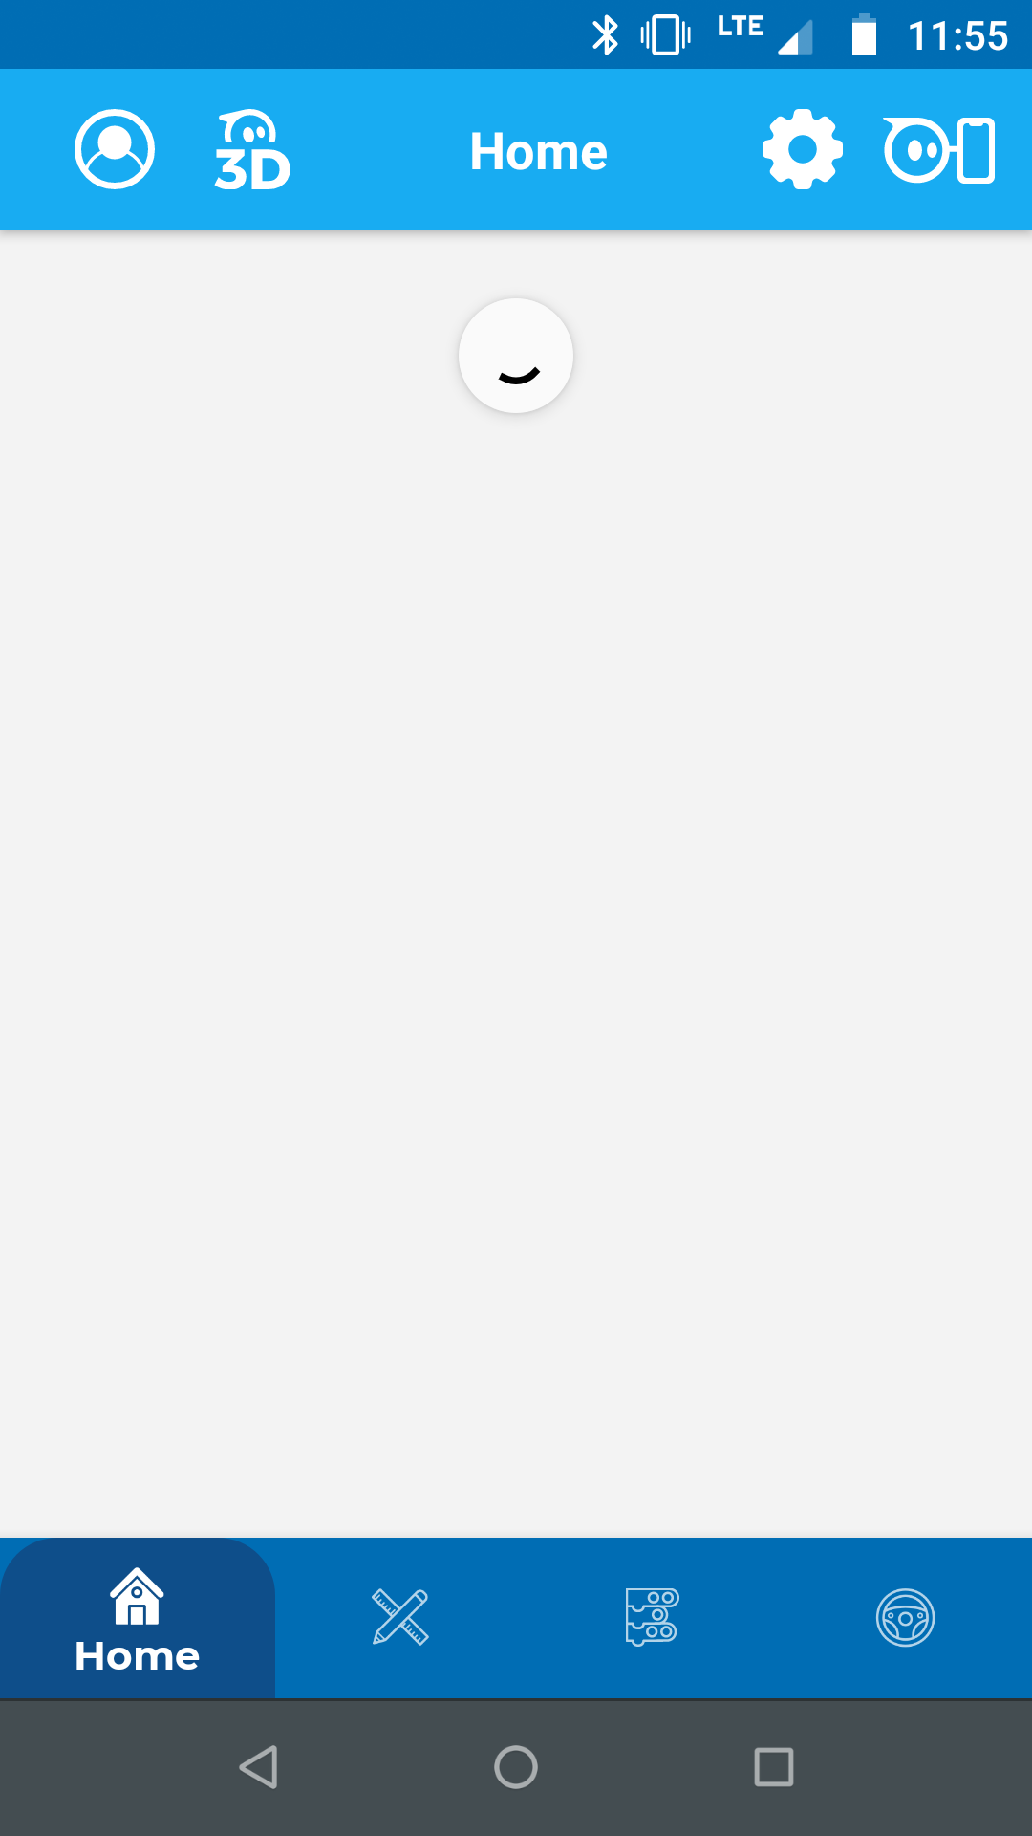 on the home screen.
* Select the + button, and title your program.

**Coding Layout**

**Connect Your Robot**

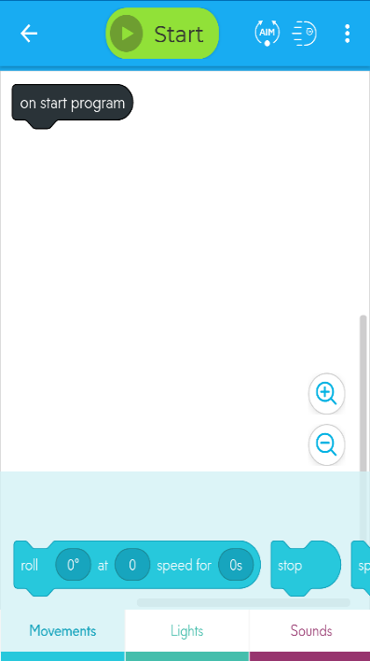

**Start**  
Select to run your program.

**Coding blocks**  
Color coded. Swipe over for more!

**Canvas**  
Where programs are coded.

**On start program**  
Appears in every program. Attach blocks to it to code.

**Trays**Group coding blocks; swipe over for more!

* Make sure Bluetooth is enabled on your device.
* Press the Start button at the top of the coding window.
* Select Sphero BOLT from the list of options.
* Connect your robot by its identifying number (the number is printed on the internal components of your robot under the Sphero logo). It also appears on the LED screen when you first turn on your robot.

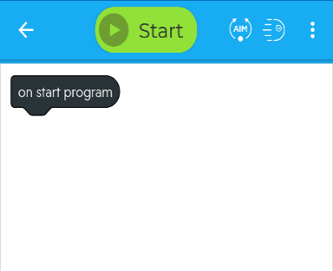

**Placing Blocks**

Drag blocks to the canvas from their tabs. Add them to your program by attaching them to the “On start program” block (as shown).

**What’s Next?**

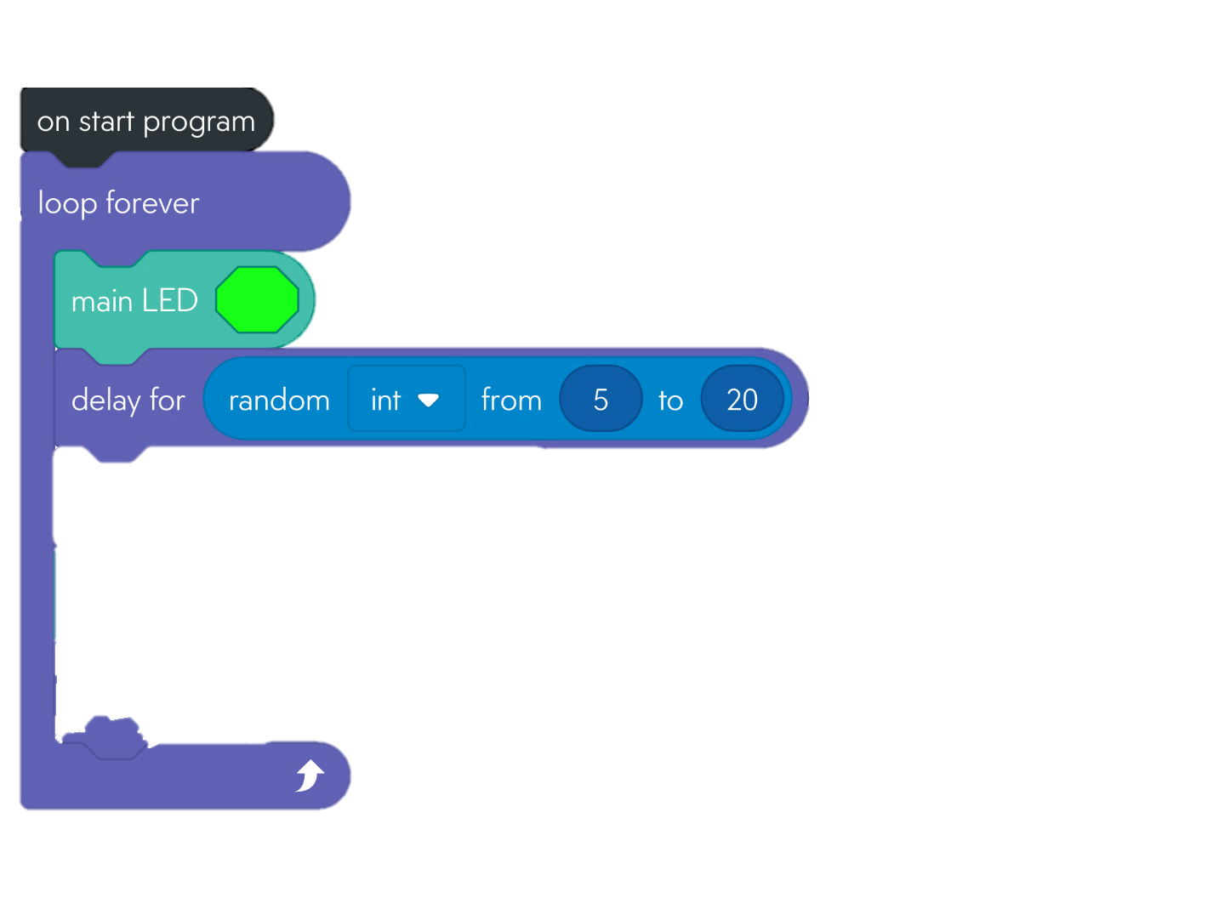

**Use These Blocks**

**Sphero Robotics: Hot Potato**

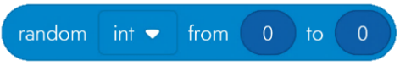

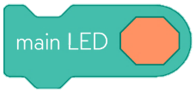

In Lights Tab

In Operators Tab

This block is added inside other blocks with a circular option (e.g., the delay command) to create a random integer between the numbers specified.

Changes the color of the LED display.

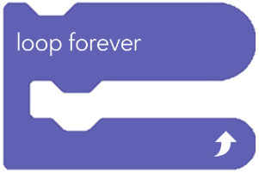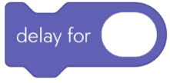

In Controls Tab

Blocks placed inside this block repeat forever based on their placement order.

This block causes a delay for the number of seconds entered.

To play **Hot Potato**, players stand in a circle. When music begins, the player with the ball gently passes it to a person on their left. Passing continues until the music randomly stops. The person holding the ball when the music stops is out. Play continues when the music resumes. The last person out wins.

**Consider for a minute!**

* Sphero robots do not play sounds. What are some other ways players may know they are out?
* How might you create a timer of variable duration?
* Write down a few ideas!

**Pre-Planning**

**Explore**: Simple coding to create a hot potato game for two or more players.

**Time:** 10-15 minutes

**Download:** Sphero Edu (free for iOS/Android)

**Difficulty: Beginner**

See Partial Solution