**Hints**

**Use These Blocks**

**Introduction to Variables**

* Magic 8 Balls have two basic answers: Yes and No. Begin with those. Then expand with variations (or uncertain answers).
* Most commands will occur when you shake your robot.
* How might you use a variable to randomly select a response?
* Keep your text and sound messages short.

In Controls Tab

**What is a variable?**  
A variable is a container that holds specified items. For example, one variable might hold letters; another might hold numbers. You use variables every day! A plate (container) holds food (a type of item). Foods on a plate vary based on who has the plate. Yet, plates don’t hold laundry (another type of item)! Think of other everyday variables? What items do they store?

You can create and use variables to add choice or variety in your programs.

**Create a Variable in Sphero.edu**

Follow these steps to create a variable in Sphero Edu:

* Navigate to the “Variables Tab.”
* Select the “Create a Variable” button.
* Provide a descriptive name for the variable.
* Indicate what items it will hold (e.g., string [text], numbers, true or false, colors).
* Select the “check mark” (Okay) button.
* You will now see a circular variable and a “Set variable” block in the Variables Tab.

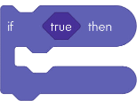

If a specified condition is met (placed in the diamond-like shape), code inside the If block will run. Otherwise, it will not. run.

Random integer code block

This is added inside blocks with a circular option (e.g., set variable) to create a random integer between the numbers specified.

In Operators Tab

Variable code insertVariable code blockEvent code blockComparison code block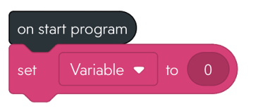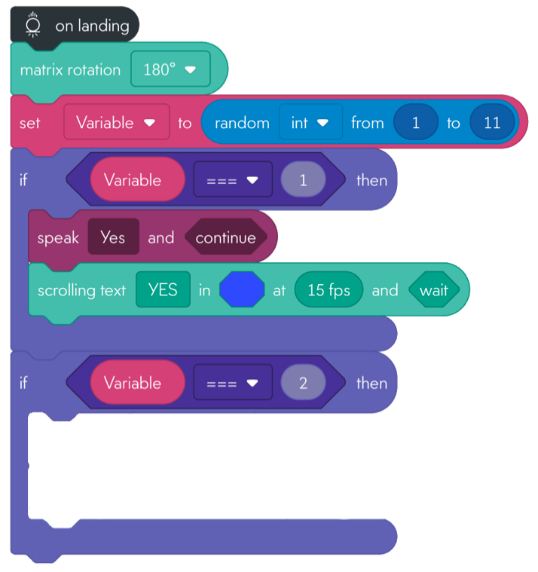

This inserts the value of your variable into a block with a circular option.

This specifies the value of your variable.

In Variables Tab

This is placed by the “on start program” block. Blocks attached to it will run when the robot lands after a gentle toss.

In Events Tab

This is added inside blocks with a diamond-shape option (e.g., if blocks) to determine if a condition is met (e.g., a variable equals a number).

In Comparators Tab

What next?

**Sphero Robotics: Magic 8 Ball**

**Use These Blocks**

Sound code blockScrolling text code block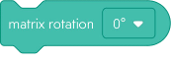

**Explore**: Variables and if statements to create a magic 8 ball.

**Time:** 20-30 minutes

**Download:** Sphero Edu (free for iOS/Android)

**Note:** This guide assumes you are familiar with coding in Sphero Edu.

**Consider for a minute!**

* What does a Magic 8 Ball Do?
* What types of answers are provided?
* What does the user do to receive an answer?
* How might you randomly select one answer from a list of answers?
* How might a program select one answer from a list of answers?
* How might your directions convert into block codes?

**Pre-Planning**

In Lights Tab

Scrolls text (you enter in first box) across the LED matrix. Continues the program (or waits) while text scrolls.

Rotates animations on the LED matrix by a specified angle.

In Sounds Tab

Your device (e.g., phone or tablet) speaks the message written in the first box. You indicate whether the program continues to the next block (or waits until spoken text ends) before continuing the program.

**Difficulty: Intermediate**

See Partial Solution

Solved it? Make it your own!

Try other languages!

Add more sayings!

Add lights!