**Hints**

**Getting Started (New Users)**

**Aiming Your Robot**

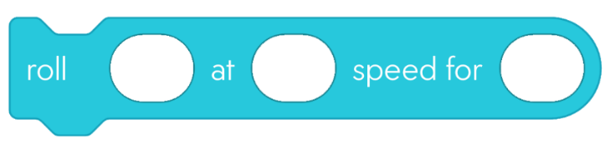

Duration   
(in seconds)

-255 to 255

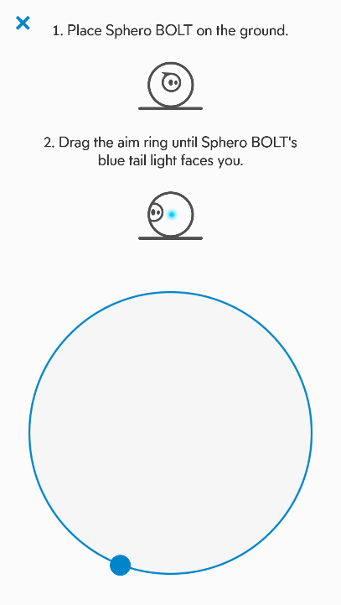

* Download and open Sphero Edu.
* Agree to the Terms of Use and Privacy Policy.
* Select the Home User option.
* Scroll past login information and select Quick Start

Let’s Code.

* Select the Programs Tab 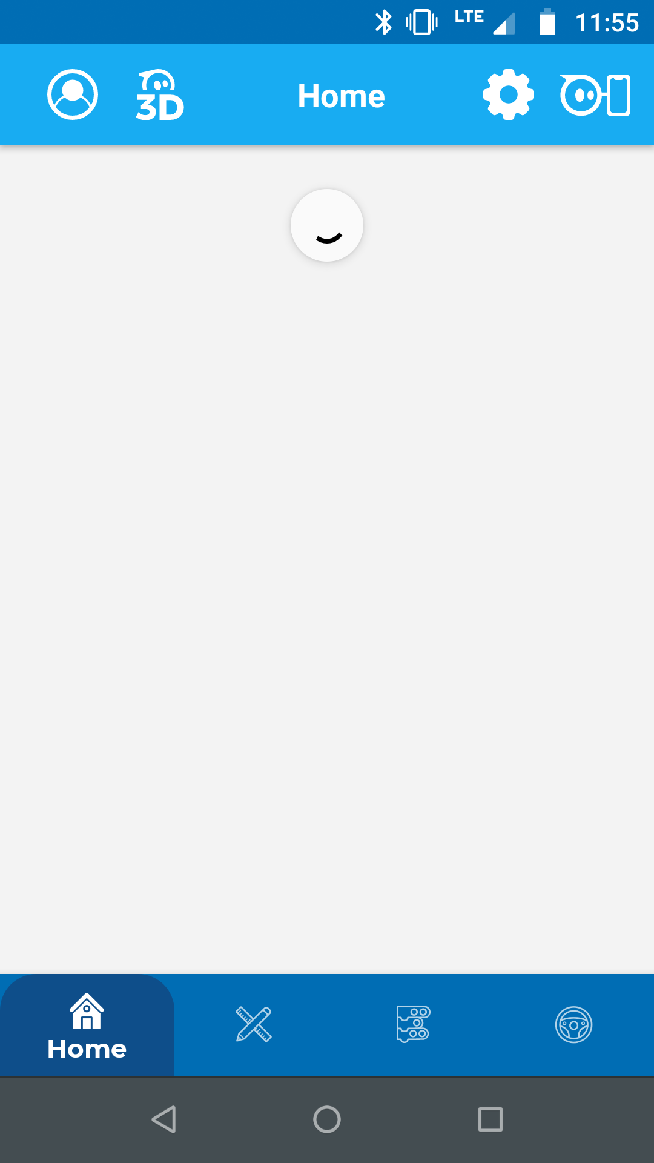 on the home screen.
* Select the + button, and title your program.

Forward  
0o

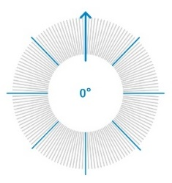

90o  
Right

270o  
Left

AIM your robot before you Run your program!

**Coding Layout**

180o Backward

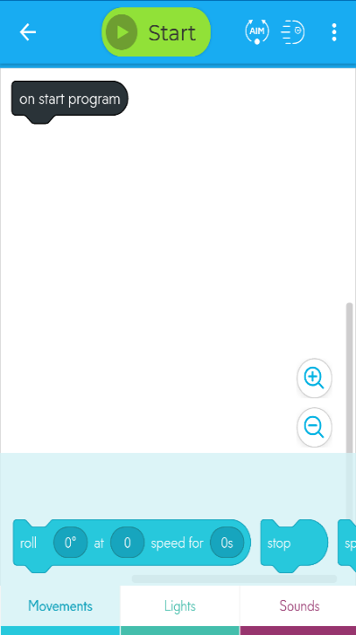

**Coding blocks**  
Color coded. Swipe over for more!

**Canvas**  
Where programs are coded.

**Start**  
Select to run your program.

**On start program**  
Appears in every program. Attach blocks to it to code.

**Trays**Group coding blocks; swipe over for more!

* Squares have 90o interior angles.
* Set your speed to a mid-range (above 60).
* Set the same speed and duration in all roll blocks.
* Include short durations (below 2 seconds).
* Add delay commands between roll commands so movements don’t bleed into each other.
* Don’t move your device when running a program.

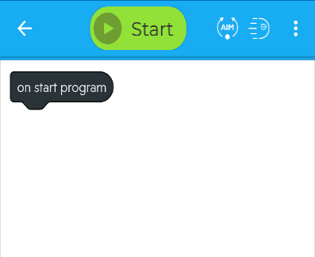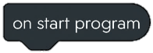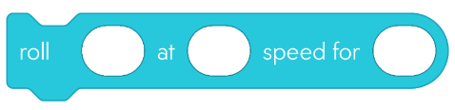

**Placing Blocks**

Drag blocks to the canvas from their tabs. Add them to your program by attaching them to the “On start program” block (as shown).

* Make sure Bluetooth is enabled on your device.
* Press the Start button on top of the coding window.
* Select Sphero BOLT from the list of options.
* Connect your robot with its identifying number (printed on the internal components under the Sphero logo as well as on the LED screen on start-up).
* If needed, press the AIM button to orient your robot.

**Connect Your Robot**

**90o**

**75**

**75**

**?**

**?**

**0o**

**?o**

**?o**

**Use These Blocks**

**Sphero Robotics: Square**

Image of exit program code block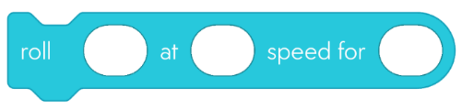

Solved it? Make it your own!

Lengthen the shape.

Add sounds.

Add lights.

This block exits the program.

In Movement Tab

This block moves the robot in a specified direction, speed, and time.

In Controls Tab

This block causes a delay for the number of seconds entered.

* How would you describe a square to someone?
* What directions do they need to draw a square?
* How do your directions convert into block codes?

**Pre-Planning**

**Explore**: Simple coding to move a robot in a square

**Time:** 10-15 minutes

**Required Materials**

* This flier
* A Sphero BOLT robot
* Bluetooth enabled computer, phone, or tablet
* Sphero Edu: Free for Win/Mac/iOS/Android users at https://edu.sphero.com/d

**Difficulty: Beginner**

See Partial Solution