**Getting Started (New Users)**

**Hints**

**Solved It?**

* Download and open Sphero Edu.
* Agree to the Terms of Use and Privacy Policy.
* Select the Home User option.
* Scroll past login information and select Quick Start

Let’s Code.

* Select the Programs Tab 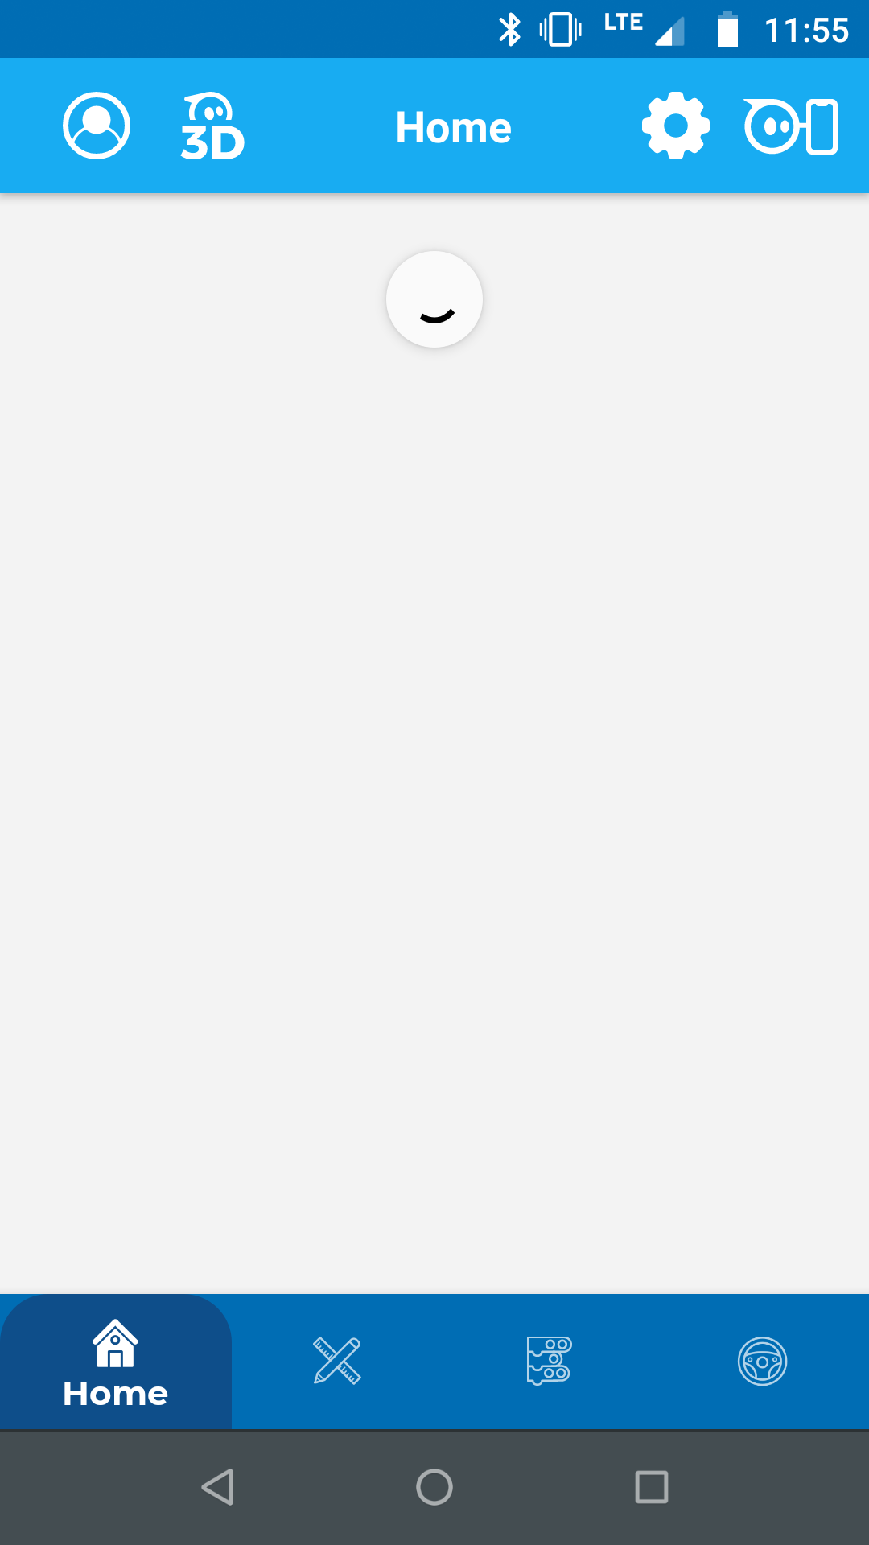 on the home screen.
* Select the + button, and title your program.

What can you add to make the program your own?

* Add additional lights.
* Add additional sounds.
* Add animations to the main display.
* Identify colors for your siren.
* Identify a siren sound to play (on your device).
* If you want commands to repeat, place them in the loop forever block.

**Connect Your Robot**

**Coding Layout**

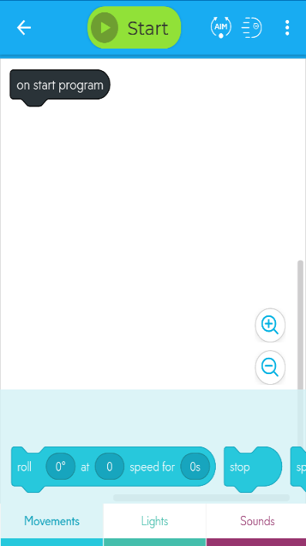

**Start**  
Select to run your program.

* Make sure Bluetooth is enabled on your device.
* Press the Start button at the top of the coding window.
* Select Sphero BOLT from the list of options.
* Connect your robot by its identifying number (the number is printed on the internal components of your robot under the Sphero logo). It also appears on the LED screen when you first turn on your robot.

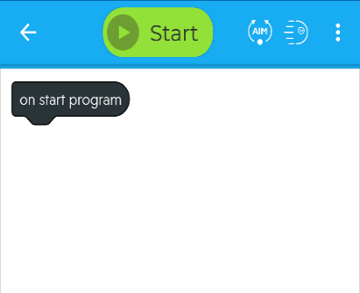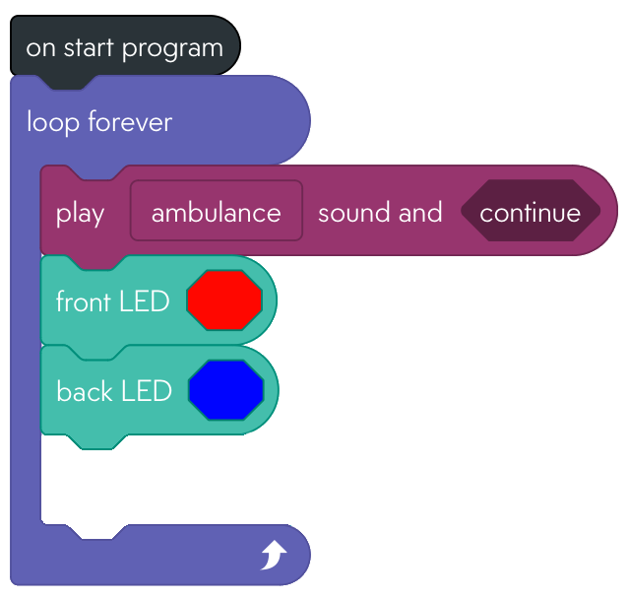

**On start program**  
Appears in every program. Attach blocks to it to code.

**Canvas**  
Where programs are coded.

**Coding blocks**  
Color coded. Swipe over for more!

**Trays**Group coding blocks; swipe over for more!

**Placing Blocks**

Drag blocks to the canvas from their tabs. Add them to your program by attaching them to the “On start program” block (as shown).

**What’s Next?**

**Use These Blocks**

**Sphero Robotics: Siren**

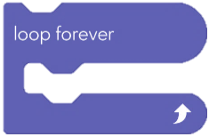Image of play a sound code blockImage of a movement code blockImage of a front LED color code blockImage of a back LED color code block

* What does an emergency siren look and sound like?
* Is there motion involved? If so, how?
* What will your siren do?
* Take a minute or two to write a few ideas!
* What do you need to instruct your robot to do?

**Pre-Planning**

**Explore**: Simple coding to create flashing lights, motion, and sounds

**Time:** 10-15 minutes

**Required Materials**

* This flier
* A Sphero BOLT robot
* Bluetooth enabled computer, phone, or tablet
* Sphero Edu: Free for Win/Mac/iOS/Android users at https://edu.sphero.com/d

Plays a sound of your choosing and waits for the sound to finish or continues to the next command.

Blocks placed inside this block repeat forever in the order they are placed.

In Controls Tab

In Sounds Tab

In Movement Tab

In Lights Tab

Changes the color of the front back LEDs (not the display grid).

Spins the robot for a specified time.

Blocks placed inside this block repeat forever based on their placement order.

**Difficulty: Beginner**

See Partial Solution