Fortune Telling Finches:
Linear Functions as Predictors
  - Brian T. Johnson and Rebecca Bramwell, Lakeside Junior High School
This lesson won the 2023 JTILT Lesson Plan Competition and was peer- reviewed.

Overview
This lesson gives students experience with block coding Finch robots to move across plexiglass surfaces. It builds student computational thinking skills, mathematical self-efficacy, and interest in technology careers (McLurkin, et al., 2013; Martin, 2019; Kazi, 2023). Finch robots are small, physical robots that can be coded to move in a space. In this 8th grade math unit, conducted in the library, students identify relationships between variables while using block coding to make predictions and test hypotheses. This lesson extends students' knowledge of linear functions through observing patterns and using the guess and check strategy to complete a variety of challenges.
Topics: Rate of change, initial value, linear functions, slope-intercept form, dependent/independent variable
Time: Three 85-minute classes and two 40-minute optional enrichment class periods

Materials
- White board or other markers or pens
- Tape measures or measuring sticks
- Large plexiglass board or flat tabletop surface (one per group)
- Lesson presentation file
- Enrichment presentation file
- Challenge cards
- Video of Factory Robots in Northwest Arkansas
- Optional challenge completion incentive tickets
- Computers or tablets (1 per group)
- Finch Connection app
- Finch robots-either 1.0 or 2.0 model (1 per group)
- Newline board (or other projection technology) to explore the dependent/independent variables.

Context-at-a-glance
Setting
8th grade students in an 8-9th grade, public, suburban, junior high school in the United States.
Modality
Face to face instruction with student groups of 2-3
Class Structure
Three, 85-minute 8th grade math classes, with two, 40-minute optional, extension classes held during intervention periods.
Organizational Norms
The librarian collaborates frequently with classroom teachers to deliver instruction. Extension/intervention classes are offered three days per week for student assignment or selection.
Learner Characteristics
Classes ranged in size from 12-28 students. Students participated during part of a linear functions unit. Few students had previous experience with Finch robots.
Instructor Characteristics
One mathematics teacher and one librarian co-taught
Development Rationale
Kazi (2023) suggested that coding Finch robots has the potential to improve middle students’ mathematics achievement and self-efficacy. Students collected data related to distance, time, and wheel power. Tables, equations, descriptions, and graphs were used to demonstrate student predictions with block coding. Students coded Finch robots to move a desired time or distance (based on their created functions) to check their predictions.
Design Framework
5 E’s Framework (Bybee & Landes, 1990)

Standards
The following ISTE Standards for Educators aligned with this lesson (ISTE, 2017):
2.5.b Design authentic learning activities that align with content area standards and use digital tools and resources to maximize active, deep learning.
2.6.b Manage the use of technology and student learning strategies in digital platforms, virtual environments, hands-on makerspaces or in the field.
2.6.c Create learning opportunities that challenge students to use a design process and computational thinking to innovate and solve problems.
The lesson also aligned with five of eight Mathematical Practice Standards from the Common Core State Standards for Mathematics (National Governors Association Center for Best Practices & Council of Chief State School Officers, 2010):
CCSS.MATH.PRACTICE.MP1 Make sense of problems and persevere in solving them.
CCSS.MATH.PRACTICE.MP2 Reason abstractly and quantitatively.
CCSS.MATH.PRACTICE.MP5 Use appropriate tools strategically.
CCSS.MATH.PRACTICE.MP6 Attend to precision.
CCSS.MATH.PRACTICE.MP8 Look for and express regularity in repeated reasoning.

Setup
These lessons were conducted in an open space in the school library media center. The floor was cleared of tables and chairs so plexiglass boards could be placed on the floor. Seven to ten plexiglass boards were placed in the open space. Creating the workspace for the lessons took about 15 minutes.
Students placed the robots on the plexiglass. They used the space to code the robots and test out their linear function predictions (see Figure 1).
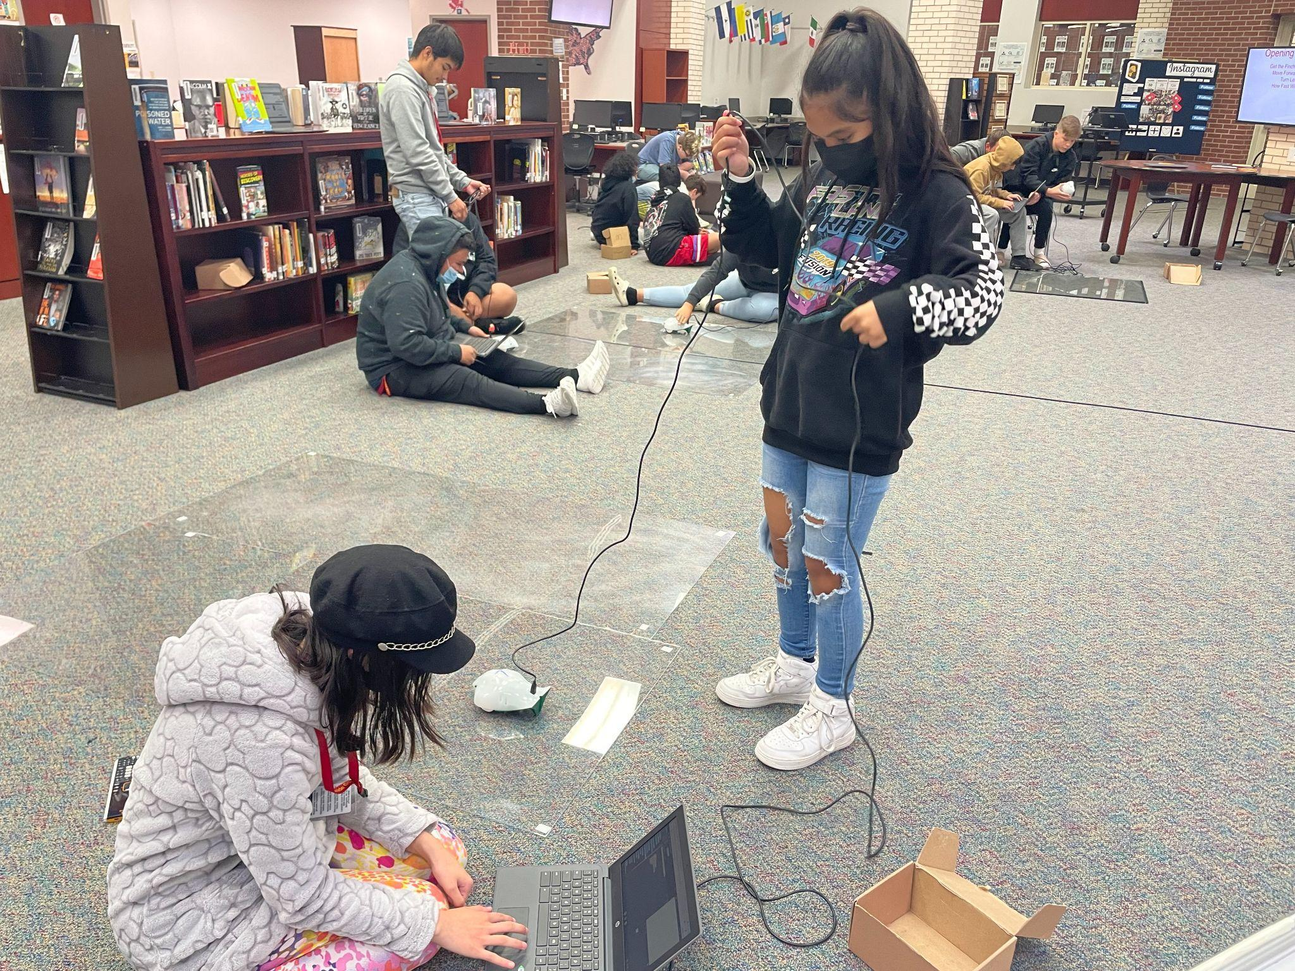
Figure 1. Students coding Finch robots and testing their predictions on plexiglass boards.

Context and Setting
This lesson was implemented at an 8-9th grade junior high school in a suburban region of the mid-south United States. This lesson is an extension of the How Far Will the Finch Turn lesson plan (Johnson, 2019). In the original lesson, students coded Finch robots, measured how far they would turn at various time increments (e.g., half a second, one second), and created line graphs of the results.
The larger, linear functions instructional unit that this lesson was a part of emphasized applying the eight mathematical practices, though only five were focused on in this lesson. This lesson pushed students to look for patterns and gave them opportunities to design and test their own linear equation-based challenges using Finch robots.
The 5E’s Framework (Bybee & Landes, 1990) was selected to design this lesson due to its ease of use to develop technology based instructional activities using a variety of technology tools.
The 5E Framework was employed in this lesson in the following way. First, students Engaged with the robot technology challenge of coding Finch robots to move. The students Explored how to get the Finch robot to move and measured the movements with precision. Following that, students Explained relationships between speed, time and Finch robot wheel power using their prior knowledge of linear functions to code Finch robots to move. Students completed the Elaborate step of the 5E model by applying their knowledge to additional Finch robot challenges. They then Evaluated their learning through whole class reflection and developing their own Finch robot challenges for classmates to try.
The lessons were designed and developed for classroom instruction with additional sessions held during extension/enrichment class periods as a part of an instructional unit on linear equations. Three, 85-minute lessons were held during class periods, as well as two, 40-minute extension lessons. These extension lessons were designed to help students who had already demonstrated proficiency in working with linear equations to continue to extend their learning. The sessions also added learner autonomy by asking students to develop and test their own linear equation prediction-based challenges.

Learning Representation

Engage
The lesson presentation file features the media files to support the following instructional activities (Fortune Telling Finches Presentation; Enrichment Sessions Presentations; Challenge Cards).
Students started in their math classrooms by watching a video filmed at a local machine shop where plastic buckets are manufactured (Johnson, 2016). Students were asked to think about what was being made, how it was being made, and what careers may be involved in making this process happen. Students were able to reason that computer coding was involved to get the robot to complete its task and that the code would need to be precise to be effective. The teacher led a discussion about the value and flexibility of an education in coding and the need for the ability to recognize patterns and make predictions. The teacher asked students to dissect the learning goal, “I can use coding to make predictions about how a Finch robot will move and explain the process in relation to the 8 Mathematical Practices” and talk with their peers about what they anticipated doing.
After reviewing the goal, students were directed to open their Chromebooks, download the Finch Connection app, and set up a Finch robot account. Note: For some versions of the app, the Java Script extension and Extension blocks options must be checked under the setting cog menu. Then students must save their program and name it. Students were given 15 minutes to interact with the coding options by using the whiteboard space in the program.
Students worked in groups of two or three and were given a Finch robot. They were given a code to duplicate (see figure two) and five minutes to:
- Get the Finch robot to move.
- Move the Finch robot forward/backward.
- Move the Finch robot left/right.
- See how fast the Finch robot can move and identify the minimum and top speeds it can travel.
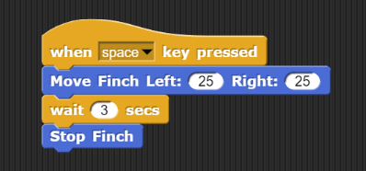
Figure 2. Code Given to Students to Duplicate
Students were given sentence frames to reflect on their observations about the Finch robots. They then reviewed the 8 Mathematical Practices and each group summarized one of them for the class. They were then asked to reflect on what they had done so far and write about which of the 8 Mathematical Practices they had used. Finally, they were asked to come up with a definition (in their own words) for independent variable, dependent variable, and constant. After sharing a few definitions, the teacher helped to solidify a common definition for the class and asked students to classify each of the components of their code if they were asked to perform the operations in figure 3.
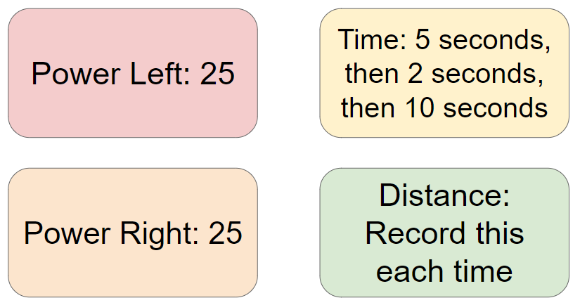
Figure 3. Operations for students to code
Students were asked to hand in their worksheet as an exit slip so the teacher could assess whether students grasped the 8 Mathematical Standards and understood the different terms used in classifying the operations they would use to code.

Explore
During day two, students met in the library where their worksheets were returned. The teacher reviewed the terms and 8 Mathematical Practices. Students got into their groups, attached their Finch robot, and opened their saved programs. Additionally, students were given a plexiglass or dry erase board workspace on the ground, a tape measure, and a dry erase marker. After reviewing the basics of using the robot, students were given the first challenge to use their code and run the robot for two seconds. Students recorded their findings on the back of the Challenge Card (see Figure 4).
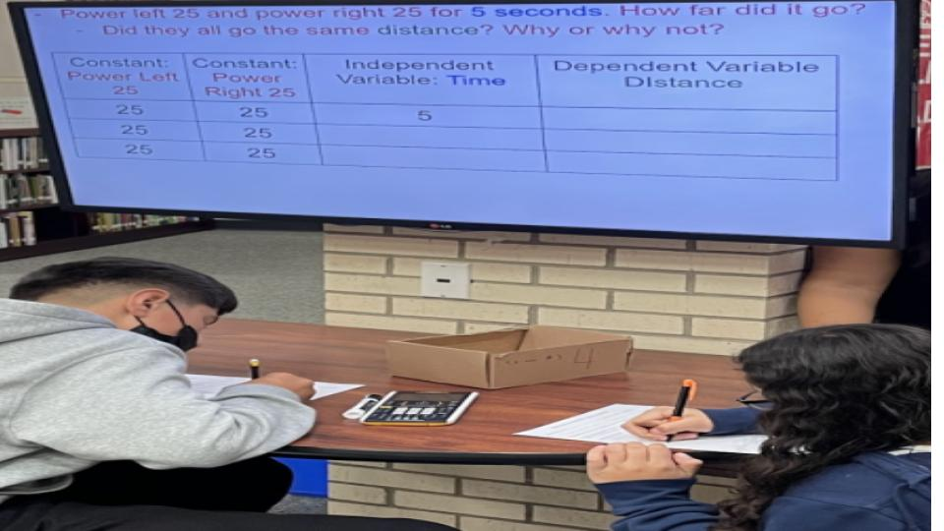
Figure 4. Students Recording Data on Challenge Card
Then students were asked to measure and record the distance the Finch robot traveled. The teachers then paused the class and led a discussion about measurement. They helped students understand that precise measurement would need to record the distance traveled. The teachers emphasized the necessity of measuring the robot’s movement either nose to nose or tail to tail (but not a mix of both). They also discussed strategies for getting the most precise measurement (e.g., using the expo marker to mark the robot’s start and stop position and then measuring a straight distance, repeating the same trial a few times to ensure accuracy).
A discussion regarding reasons for measurement variations between groups using the same code occurred. Possibilities included groups using different surfaces (plexiglass versus a whiteboard), different Finch robots, or different methods to hold the robot’s power cord.
After the groups identified a strategy for precise measurement, they were given a challenge: Run the Finch robot for five seconds at the same power and record the distance moved. Students used the recorded measurements to predict how far the robot would travel for ten seconds (see Figure 5).
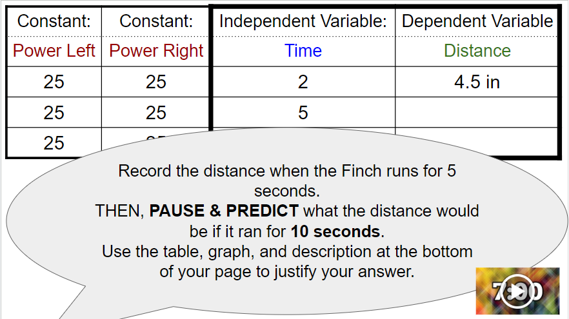
Figure 5. First Prediction Challenge
Students were given time to graph their results and predictions, write a description of what happened, and create an equation that represented the pattern. After sharing their predictions and their models with one of the teachers, the students ran the Finch for 10 seconds and measured the distance traveled. They reflected on how close their prediction was to their actual measurement and indicated which of the 8 Mathematical Practices were used.

Explain & Elaborate
As a whole class, students shared strategies and results, eventually making connections between making predictions and the patterns that they established as a rate of change.
During day three, students applied their procedural knowledge and completed additional Finch robotics Challenge Cards at their own pace for the rest of the class period and during the first extension session.
During the second extension session, students were given a new Challenge Card with three criteria given and one missing criterion to predict. The Challenge Cards increased in difficulty so that student thinking was continually stretched. Before groups could begin a new Challenge Card, they were required to present their findings to one of the teachers for assessment purposes.

Evaluate
The final Challenge Card invited students to create their own Challenge Card for another group to try. Additionally, students were asked to reflect during the final part of the class period on what mathematical practices they had used.

Critical Reflection
This series of lessons was conducted over three, 85-minute class periods and two 40-minute extension/enrichment class sessions over two weeks.
The setup phase of the lesson, where students added the Finch Connection app to their Chromebooks and connected their robots, took considerably longer than anticipated. For future iterations, we recommend that teachers model how to add the app to student computers prior to attending instructional sessions. Making this change will allow students to engage in coding and begin making predictions about linear functions quicker.
The first time these lessons were implemented, students listened to instructions provided by the math teacher and the Librarian and engaged in coding activities. The second and third times this unit was conducted, intentional pauses for whole class reflection were added to the lessons. This addition allowed students to reflect on their learning and identify the mathematical practices they were employing as they coded and tested their predictions.
Adding whole class reflective pauses helped students to identify patterns they saw emerging in the data. For example, one student commented: “one second rolls for 5 inches…..7 seconds would get us close to 35 (the goal was 36’). So to roll 36 it must be a bit more than 7 seconds!” This comment reflected evidence of patterns student’s observed. It demonstrates how participation in this lesson helped students to grow in the mathematical practice of attending to precision (CCSS.MATH.PRACTICE.MP6).
One negative outcome of including the whole class reflective discussions throughout the instruction was that the time for more holistic, class reflection after the conclusion of a day’s activities was limited and not implemented due to a lack of time. Perhaps in the future, students could independently complete an exit ticket or other reflection activity (such as a Flip video) to share their thoughts on the impact of the overall lesson or the unit’s impact on their understanding of linear functions.
During the second and third iterations of this instructional unit, whole class discussions reviewing the dependent and independent variables were conducted when time allowed. This helped to provide closure at the end of each session. Adding in this reflective element also allowed the instructors to provide sneak previews of the following days activities. This inclusion helped to maintain student motivation throughout the lesson.
The first Challenge required slight edits to clarify students’ understanding. Students appeared to be confused by the addition of 5 seconds in the chart for this challenge. The instructors had to adjust their explanations to make them clearer (so that students knew not to use 5 seconds as one of the values they were testing). Instead, we reminded students to “use other numbers for seconds, but not five seconds” as they created and tested their predictions.
Slight changes to the instruction on Challenge 3 were also made to account for students’ struggles to correctly identify the dependent and independent variables. Because of this issue, the teachers had to spend time with multiple student groups to clarify this misunderstanding, as correctly identifying the dependent and independent variables was essential to completing the third challenge (see Figure 6).
Despite student struggles with identifying the dependent and independent variables, they identified the pattern(s) they saw in their data. Students also identified the variability of individual Finch robot’s power as a reason for differing results (one team got
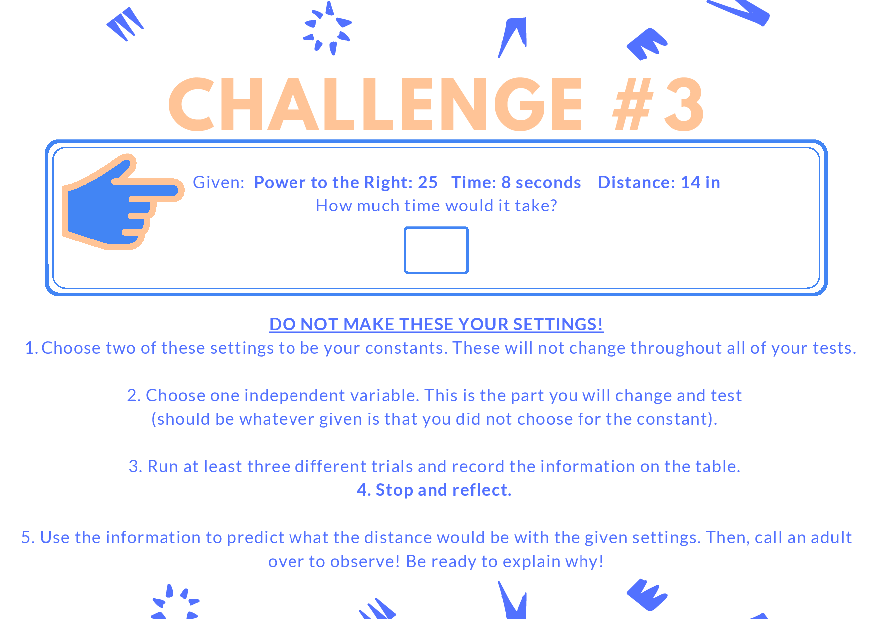
Figure 6. Challenge Three Card
slightly more than 7 as the answer whereas the other team found results for 7 and 8 second tests produced results “close to 36” but did not have time to get the exact answer. Comments such as these also were evidence of students’ developing computational thinking skills.
Additionally, student success in meeting the learning goals of this lesson was assessed through whole group discussions at the end of each session and informal conversations with student groups when they presented their data gathered from completing each Challenge Card. Another measure of the student's success was the number of challenges each group successfully completed. Multiple groups engaged in the most difficult Challenge Card where they were asked to develop their own Finch robot challenges for their peers to complete.
Students in the enrichment sessions initially struggled to develop and implement the “guess and check” mindset. However, students who attended a previous enrichment session showed more signs of embracing the guess and check mindset. This was evidenced by their high engagement during the “pick a challenge” option and their increased confidence in completing challenges and designing their own challenges.
A key factor driving motivation was the empowerment students felt when they had to employ creativity to design their own challenge(s). One example of this was a group of two boys that adjusted the first challenge they made since their design did not work (they changed the power to left 50, right 60). They had to think about the problem/challenge in a different way. Instead of engaging with the challenge they created as students, they had to view the challenge through a teacher lens - i.e. how will “my students” answer/respond to the challenge?
Future iterations of this unit could include additional challenges. One example could be a challenge where the distance the robot moves is constant and students have to find a range of values for either the left or the right wheel (when the opposite wheel’s power remains constant) to move a given distance. Another extension for this lesson could be for students to present the challenges to their peers and have them try them out in a competition to determine which challenge features the best design, or presented the highest level of difficulty.

References
Bybee, R., & Landes, N. M. (1990). Science for life and living: An elementary school science program from Biological Sciences Improvement Study (BSCS). The American Biology Teacher, 52(2), 92-98.
International Society for Technology in Education. (2017). ISTE standards: For educators. Retrieved January 8, 2024, from https://iste.org/standards/educators
Johnson, B. T. (2016. February 10). Factory robots in Northwest Arkansas [Video]. YouTube. https://youtu.be/54bgHri7hDI
Johnson, B. T. (2019). How far will the Finch turn? Retrieved January 8, 2024 from https://learn.birdbraintechnologies.com/finch1/activities/how-far-will-the-finch-turn/
Kazi, M. J. (2022). The effects of using Finch robots to teach math on middle school students’ math self-efficacy and achievement. Remake Learning. Retrieved January 8, 2024 from https://remakelearning.org/wp-content/uploads/2023/09/Research-Report-Learning-Math-wih-Finch-Robot.docx.pdf
Lakeside Junior High School Library Services Center. (2023, August 28). JTILT Finch Linear Equations Challenge Video. [Video]. YouTube. https://youtube.com/shorts/H0W-8067wQ4
Lakeside Junior High School Library Services Center (2023, August 28). JTILT Finch Linear Equations Challenge Video with Precision Marking the Start. [Video]. YouTube. https://youtube.com/shorts/ZK5e9C6V09w
Martin, C. (2019). Designing for STEM in libraries serving underserved communities. In V.R. Lee and A.L. Phillips (Eds), Reconceptualizing libraries: Perspectives from the information and learning sciences (pp. 123–139). Taylor & Francis.
McLurkin, J., Rykowski, J., John, M., Kaseman, Q., & Lynch, A. J. (2013). Using multi-robot systems for engineering education: Teaching and outreach with large numbers of an advanced, low-cost robot. IEEE Transactions on Education, 56(1), 24–33. https://doi-org.ezproxy.memphis.edu/ 10.1109/TE.2012.2222646
National Governors Association Center for Best Practices & Council of Chief State School Officers. (2010). Common core state standards for mathematics. Retrieved January 8, 2024 from https://corestandards.org/mathematics-standards/

About the Authors
Brian T. Johnson is a School Library Media Specialist at Lakeside Junior High School in Northwest Arkansas. He also serves as an adjunct professor for the University of Memphis in the Instruction and Curriculum Leadership department and in the Online Teaching Academy program at the University of Central Arkansas. His research interests include information literacy, coding in K-12 education, makerspaces, successful technology integration, adult professional development, and flipped learning. He can be contacted at b.t.johnson16@gmail.com.
Rebecca Bramwell is an Instructional Facilitator at Lakeside Junior High School in Springdale, Arkansas. She has served as a math teacher for ten years. She holds a Math degree from Eastern Illinois University and a master’s degree in Administration and Leadership from William Woods University. She is a Google Certified Educator and Trainer. Her favorite thing about education is the opportunity to collaborate with others to create meaningful learning opportunities for students.

Sharing & Modification Permissions
Unless otherwise noted, this article and its resources are published under a Creative Commons Attribution-NonCommercial-ShareAlike 4.0 International license:
You can freely share the article and its resources if you indicate the original authors, identify the Creative Commons license, and use them non-commercially.
You may also make and distribute modifications by:
- Identifying the original authors.
- Using the resources non-commercially.
- Licensing modifications under the CC BY-NC-SA 4.0 license (and including a link to it).
- Indicating what modifications were made.

