Digital Florilegium: A High-Tech Twist on
an Ancient Reading Practice
  - David J. Mulder, Dordt University

Overview
This lesson explains an approach to engaging students in close reading of challenging texts. It introduces florilegium, an ancient reading practice utilized by copyists in medieval European monasteries. This lesson’s approach to florilegium took on a digital twist: rather than hand-writing snippets of text into a copybook as medieval monks might, we used a Google form to capture the whole class’s snippets from a shared reading. These text snippets became a shared digital repository that students could use to engage the text in a variety of interactive, creative ways. In the instance described in this article, the students were graduate students taking an online Educational Technology course, but the practice is flexible and could be adapted for use in many different content areas and grade levels.
Topics: Content-Area Literacy, Close Reading, Student Engagement
Time: Variable

Materials
- Internet-capable devices for students
- A demanding reading (e.g., article, chapter)
- Survey or Form (e.g., Google or Microsoft; see Sample Survey)
- Spreadsheet (e.g., Google or Microsoft; see Sample Spreadsheet)
- Video for introducing Florilegium strategy (Mulder, 2023a)
- Video to explain strategies for exploring the collection of text snippets (Mulder, 2018)
- LMS discussion board
- Optional: A video tutorial for how to use a word cloud generator may be useful as well (Mulder, 2023b)

Context-at-a-glance
Setting
An online, masters-level educational technology course ambitiously entitled, “Teaching and Learning with Technology.”
Modality
Online asynchronous
Class Structure
The course was a group-paced, asynchronous course divided into eight modules that were each two weeks in length.
Learner Characteristics
22 graduate students who were all practicing PK-12 teachers.
Instructor Characteristics
A university professor with over 25 years’ experience in PK-12 and higher education who has taught the course multiple times on an annual basis, along with other courses in the EdTech track of the M.Ed. program.
Development Rationale
This lesson was developed to support students in reading and discussing a challenging article as part of their work late in the course.
Design Framework
Community of Inquiry Framework (Garrison et al., 2010)

Setup
The instructor will need to prepare a survey to collect responses (this author used Google Forms; thus, this survey will be referred to as Google Forms for the duration of the article) and create a spreadsheet of student responses to share (this author used Google Sheets; thus, this spreadsheet will be referred to as Google Sheets for the duration of the article). Students will need internet-capable devices to access the survey and shared spreadsheet for collecting responses and working with the text.

Context and Setting
This project was developed in the context of an asynchronous, online course for graduate students that is part of a Master of Education program at a private, faith-based university located in the upper Midwestern United States. The program is fully online, with students from around the world participating.
There were twenty-two students taking the course, which was ambitiously titled, “Teaching and Learning with Technology.” All participants were practicing PK-12 teachers representing a wide variety of grade levels and content areas, from PK to high school Mathematics, from Special Education to middle school Science, from a 3rd grade classroom in a traditional face-to-face school to high school History and Government in an online academy. Participants in the course came from four different countries: Canada, Indonesia, South Korea, and the United States.
The course was designed as an asynchronous, group-paced course arranged into eight separate two-week modules. Optional synchronous sessions were held several times throughout the term, but almost all the interaction among the learners took place through asynchronous discussion forums in each module of the course. While a variety of different kinds of prompts were used for initiating these discussions, by module 6, it was clear that it was time to mix things up for the students, and bring in some novelty, and capitalize upon the cognitive and social presence of the learners in the community of inquiry we had developed as a class (Garrison et al., 2010).
Specifically, the approach for the discussion shared in this lesson involved a process for closely reading the text, deconstructing it, and capturing snippets of the text via Google form. Then, using a variety of creative approaches, reconstruct the text to enrich students’ understanding of the big ideas being shared. The resulting discussion of the text was rich and robust, and the digital approach on an ancient reading practice was cited as one of students’ favorite activities from this course in their end-of-semester evaluations.

Learning Representation

Introduction
Course readings are a foundational aspect of almost every educational endeavor. Many instructors, however, may struggle with getting their students to complete the readings (Hoeft, 2012). This is not a new problem in education; several authors have documented struggles with getting middle school, high school, undergraduate, and graduate students to complete assigned reading going back to the 1980s and 1990s (Burchfield & Sappington, 2000; Hoeft, 2012; Murden & Gillespie, 1997; Ryan 2006). Hoeft (2012) suggests that many university instructors believe students will be more engaged and class discourse will be richer if they comply with instructors’ expectations to complete assigned readings. And this logic is sound; without the background knowledge built through engaging with the ideas of others—through reading, and through classroom discourse—an individual’s understanding is limited to their own ideas and experiences.
Instructors therefore often attempt to find ways to motivate students to complete the reading. Some instructors use reading quizzes (Hoeft, 2012; Ryan, 2006) or assigned reading guides to be submitted as homework (Hatteberg & Steffy, 2013; Ryan 2006) as ways of cajoling students into complying with assigned reading. Others use calling on students in class at random with questions drawn from the reading as a means for accountability (Hatteberg & Steffy, 2013). Still others use a form of small group discussion to build interdependence and a sense of social responsibility to motivate students to complete the reading (West, 2018). All of these approaches, however, tend towards external motivation aimed at compliance. Perhaps a more effective strategy to draw students into doing the reading is providing an interesting twist such as something novel that might draw them in to completing the reading because the task itself is made more intriguing.
To try and capture the students’ imagination and interest, an ancient reading practice utilized by medieval scribes and copyists called florilegium (Horster & Reitz, 2018) was implemented. The term “florilegium” comes from two Latin words: “flos” [flowers] + “legere” [to gather]. The idea is that copyists would “gather flowers” while copying manuscripts by capturing passages that had caught their attention or interest into small copy books that they would keep by their side while working. These florilegia were compilations of shorter works, or passages from longer works, often collected on a theme. Taking this basic idea of florilegia as a creative impetus, a florilegium-inspired reading assignment was created to see if a sense of intrigue and self-motivation that would drive close reading and active engagement in the ensuing discussion could be fostered.

The Florilegium Strategy
Module 6 of the course is entitled “Technology and Discipleship.” While this course is in a faith-based institution, the students come from many different backgrounds, and while most would describe themselves as Christians, there is considerable diversity among the students in terms of their theology and practice. What this means, practically, is that the topic of “discipleship” means different things to different students, and based on previous experiences teaching this course, the instructor knew that this particular module often challenged and stretched students. To introduce the idea of a faith-informed approach towards technology, a short article by Christian philosopher James K. A. Smith (2016), entitled In the Beginning Was…Technology was assigned to the students. This article has been used in the past, and students generally appreciated it, but often found it very challenging to read. The hope was that utilizing a novel approach to facilitating a close, careful reading of this piece would help the students engage deeply with the ideas being presented and foster a collegial discussion of the topic.
In the introduction for the module discussion, a video was included to introduce the basic idea of florilegium and the historical context for this approach (Mulder, 2023a). It was then explained that the students would be trying a high-tech twist to this ancient reading practice: they would use a Google Form to capture snippets of text as they read the piece, similar to the way medieval copyists would capture snippets of text in their florilegia.
The article “In the Beginning was…Technology” (Smith, 2016) was then assigned for the students to read in preparation for the discussion. The students were asked to read it very closely, and look for phrases or sentences that caught their eye or captured their imagination. A Google Form with a text box and prompt was then created (Figure 1; see attached Sample Survey PDF). The prompt in the Google Form included:
- Find a snippet (from a few words to a sentence in length) from the article that caught your attention.
- Copy and paste that snippet into the form below.
- Click “submit.”
- Repeat this process to add 3-6 snippets of text ("flowers") to the collection.
The idea was that the students would add a few “flowers” to the class’s collective florilegium, and they would use this collection as a means of reflecting on the reading and discussing the big ideas the article introduced. The students read the article during the first week of the two-week module, with the plan that they would discuss it during the second week.
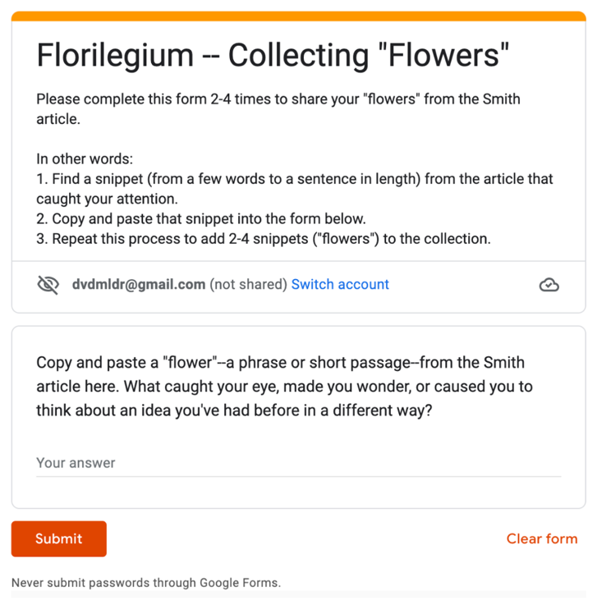
Figure 1: Google Form used for “gathering flowers.”

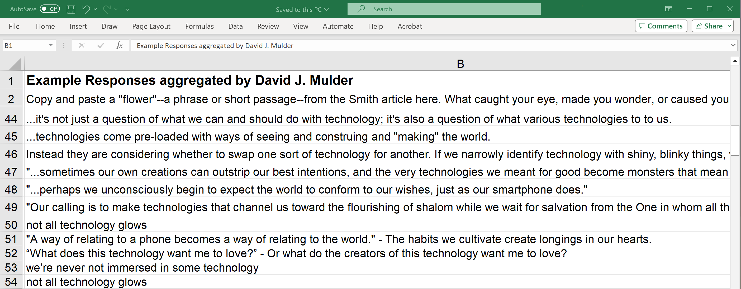
Figure 2: Screenshot of collected “flowers.”

Students captured snippets of text as they read the article throughout the first week of the module; by the end of the week students had added 96 “flowers” to our shared florilegium. The text snippets varied in length from phrases to whole sentences.

The Discussion of the Reading
During week 2 of the module, results of the students’ “flowers” were shared as a Google Sheet (see Figure 2 and Sample Spreadsheet).
The shared Google Sheet allowed students to investigate and manipulate the text snippets they had collected in some interesting ways. Another video introducing the idea of “arranging” the flowers the students collected was created (Mulder, 2018). This video included several suggestions for how the students might play with the text that was collectively captured, and some direction and encouragement to make meaning from the ideas that had been distilled through the shared reading. The instructions in the video included:
- Choose 5 “flowers” at random, put them together in a “bunch” and see what emerges.
- Skim for repeated words and then search the document how many times these words appear.
- Take note of any phrases that show up repeatedly. Also take note of any phrases that are unique in this collection.
- Consider using a word cloud generator to visualize our collection of snippets.
Students are encouraged that there really isn’t a “wrong” way for them to approach playing with the text snippets. The main idea is that they should take the time to notice the variety of different ideas that our class collectively drew out of the article. The provided strategies were just several ways for students to explore and experiment with the snippets of text and to encourage them to reengage the big ideas from the article.
After spending some time “arranging flowers,” students were prompted to share the results of their work with their small groups of 5-6 students each in a discussion board on the course page in the learning management system (LMS). For this course, the students were arranged into small groups based on affinity (e.g., early elementary educators grouped together, middle school and high school humanities teachers grouped together, etc.) and those groups were kept together for multiple weeks of the course. This helped students get to know each other more deeply, and by this point in the course, they were sharing their thinking quite freely with each other.
In the discussion forum, students shared their strategies for re-engaging with the ideas from the text, and the new insights that began to emerge. Some shared their word counts, or the way they mashed up multiple snippets from the florilegium, or the word clouds they created. See Figure 3 for an example word cloud created by a student.
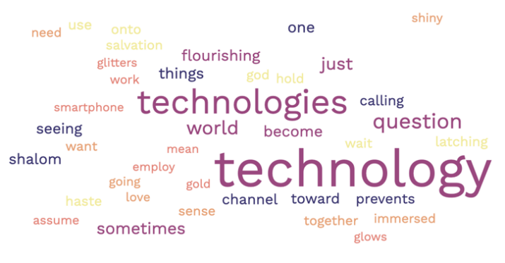
Figure 3. Example word cloud created by a student exploring the collection of text snippets curated by our class.
The prompt provided to students for this LMS discussion board was:
After exploring the "flowers," write a brief reflection (~200 words ±50) in which you elaborate on how you are now thinking about the role of technology in a Christian teacher's teaching practice (i.e., how does/can/should technology fit with your view of the role of a Christian educator?) As always, after sharing your thoughts, please respond to at least one classmate, and strive to make this a conversation.
By the end of the week, a robust, interactive discourse emerged, and students had come to a deep understanding of essential ideas for the course. Figure 4 illustrates examples of comments shared by students in their small group discussions. As the instructor, it was intriguing to me how many of the students used language that came directly from the snippets of text they had collected, yet they were pulling the ideas together in novel ways, rather than just quoting the text of the original article. This is the aspect that was most compelling about using the florilegium approach: it encouraged students to make connections within the text in ways that might not seem obvious on their first reading.
The students responded thoughtfully, exhibiting the kind of cognitive and social presence idealized in the Community of Inquiry Framework (Garrison et al., 2010). As the Community of Inquiry Framework suggests, high levels of social and cognitive presence interact to support discourse, which leads to a richer educational experience. The students who participated in this digital florilegium experienced the four stages of the practical inquiry model used to support cognitive presence (Swan et al., 2009):
- A triggering event (a “shared world” experience).
- Exploration (a “private world” experience).
- Integration (based in student reflection).
- Resolution (facilitated by discourse).
This approach works well for helping students interact and engage with challenging topics, such as those raised in the article students read as part of this learning representation.

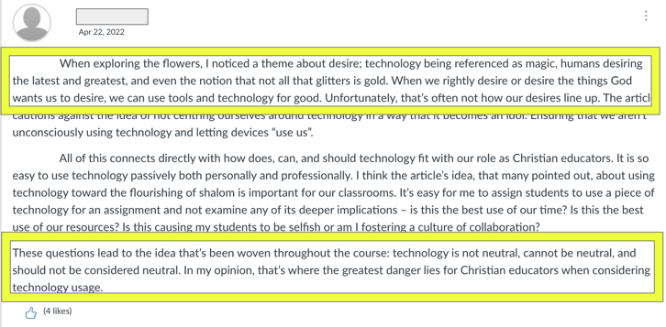
Figure 4. An example of a reflection shared by a teacher in response to the prompt. The text in the highlighted box uses language directly from the reading.

Critical Reflection
I have used the digital florilegium approach in this course in the past four offerings of this course and have only refined it slightly in those offerings. Initially, I had a text-based exploration of how to “arrange flowers” as we were moving into the discussion phase of the learning sequence.
The text-based prompt I shared with students in the initial version of this lesson was, “Here is the link to the spreadsheet behind the form we completed earlier as we were gathering flowers. You have view access, and this will allow you to make your own copy of the spreadsheet to manipulate. Explore the text! What words seem to show up often? Are there some phrases that many of us included? Are there some phrases that appear only once? What else can you discover as you play with the text? It might be interesting to choose three or four ‘flowers’ at random, put them together, and see what new ideas emerge. The main idea here is that you will spend some time exploring the different snippets of the text that we have collectively pulled together in this process. Spend about 30 minutes ‘arranging flowers’ before you begin to write your response to this activity.”
Some students took to the idea immediately, but others held back. I added the video for introducing Florilegium strategy (Mulder, 2023a) in the second iteration of this lesson which allowed me to show-and-tell some ideas of how to play around with the text in the Google Sheet. After providing this video, I was much more satisfied with the results as students’ responses were richer and exhibited more creativity and variety than they had in the first iteration. This improvement gave me a sense that they were benefitting by some more explicit show-and-tell in the video.
On the third iteration I also added the encouragement to use a word cloud generator to explore the text. While not all students used this approach, it added a richness to the resulting discussion that many students commented on. I created a video tutorial for how to use a word cloud generator to illustrate how to create a word cloud (Mulder, 2023b). While I considered requiring all students create a word cloud, I decided not to make this a mandate and instead gave students a variety of options for how they would explore the text.
The fourth time I used this approach, I did not make any further adjustments; students participated admirably, and I was very pleased with the resulting discussion.
More than that, several participants specifically mentioned this discussion and the florilegium approach as a deeply meaningful learning experience in their end-of-course ratings of instruction. I am encouraged to keep using this strategy, and I’ve since started using it in other courses—both online and face-to-face courses for both graduate and undergraduate students.
This article explored the usage of this close reading strategy as it was employed in a faith-based, higher education setting. I believe it could also be an engaging addition to courses in many other learning environments beyond Christian higher education, including secular or more pluralistic settings. The roots of this ancient reading practice might be within a religious tradition (i.e., Christian monastic communities), but many contemporary educational practices have similar religious origins (Friesen, 2017). That said, I do acknowledge that the particular students participating in this course may have gravitated to this approach because of the way I described it as being used by faith communities in the past, and this might have helped to build more interest. Overall, I suspect that it was the freshness of the approach that was truly the most engaging aspect of using this strategy with my students.
I believe the florilegium approach to facilitating close reading of challenging texts could be used in a wide variety of content areas, and at many different grade levels from middle school through graduate school. The novelty will capture their imagination, and the structure will support high levels of discourse that lead to deeper learning.

References
Burchfield, C. M. & Sappington, J. (2000). Compliance with required reading assignments. Teaching of Psychology, 27(1), (58-60).
Friesen, N. (2017). The textbook and the lecture: Education in the age of new media. John Hopkins University Press.
Garrison, D. R., Anderson, T., & Archer, W. (2010). The first decade of the community of inquiry framework: A retrospective. The Internet and Higher Education, 13(1-2), 5-9. https://doi.org/10.1016/j.iheduc.2009.10.003
Hatteberg, S. J., & Steffy, K. (2013). Increasing reading compliance of undergraduates: An evaluation of compliance methods. Teaching Sociology, 41(4), 346-352. https://doi.org/10.1177/0092055X13490752
Hoeft, M. E. (2012). Why university students don’t read: What professors can do to increase compliance. International Journal for the Scholarship of Teaching and Learning, 6(2), Article 12. https://doi.org/10.20429/ijsotl.2012.060212
Horster, M., & Reitz, C. (2018). Handbooks, epitomes, and florilegia. In S. McGill & E. J. Watts (Eds.), A Companion to Late Antique Literature (pp. 431-450). New York: Wiley. https://doi.org/10.1002/9781118830390.ch27
Mulder, D. (2018, April 24). EDUC 508 – Florilegium on Smith [Video]. YouTube. https://youtu.be/DlJA0M_MGG4?si=2s8BYZTNzqeZsEcl
Mulder, D. (2023a, May 15). EDUC 508 – Florilegium introduction [Video]. YouTube. https://youtu.be/6hak_XM1VAk?si=ppE29goKGgnJjj4n
Mulder, D. (2023b, May 15). EDUC 508 – Word cloud generator [Video]. YouTube. https://youtu.be/tgxscG8UX9Q?si=GRhbUOZCKNh-jPwH
Murden, T. & Gillespie, C. S. (1997). The role of textbooks and reading in content area classrooms: What are teachers and students saying? In W. M. Linek & E. G. Sturtevant (Eds.), Exploring Literacy (pp. 87-96). Pittsburg, KS: College Reading Association. https://files.eric.ed.gov/fulltext/ED418374.pdf#page=98
Ryan, T. E. (2006). Motivating novice students to read their textbooks. Journal of Instructional Psychology, 33(2), 135-140.
Smith, J. K. A. (2016, February 3). In the beginning was…technology. The Banner, 151(3), 18-20. https://www.thebanner.org/features/2016/02/in-the-beginning-was-technology
Swan, K., Garrison, D. R. & Richardson, J. C. (2009). A constructivist approach to online learning: the Community of Inquiry framework. In Payne, C. R. (Ed.) Information Technology and Constructivism in Higher Education: Progressive Learning Frameworks. Hershey, PA: IGI Global, 43-57. https://doi.org/10.4018/978-1-60566-654-9.ch004
West, J. (2018). Raising the Quality of Discussion by Scaffolding Students' Reading. International Journal of Teaching and Learning in Higher Education, 30(1), 146-160. https://files.eric.ed.gov/fulltext/EJ1169822.pdf

About the Author
David J. Mulder serves as Professor of Education at Dordt University, where he teaches courses in educational foundations, STEM education, and educational technology in both the undergraduate Teacher Preparation Program and the Master of Education program. His research interests include technology integration, social presence in online learning, and digital citizenship. He can be contacted about this lesson at david.mulder@dordt.edu.

Sharing & Modification Permissions
Unless otherwise noted, this article and its resources are published under a Creative Commons Attribution-NonCommercial-ShareAlike 4.0 International license:
You can freely share the article and its resources if you indicate the original authors, identify the Creative Commons license, and use them non-commercially.
You may also make and share modifications by:
- Identifying the original authors.
- Using the resources non-commercially.
- Licensing modifications under the CC BY-NC-SA 4.0 license (and including a link to it).
- Indicating what modifications were made.

