First and Last Name: ______________ Date: ______

Welcome to The Module Three Lesson One Assignment

Assignment Directions
Have you ever used a computer microscope? Let’s use one now to look inside animal and plant cells.

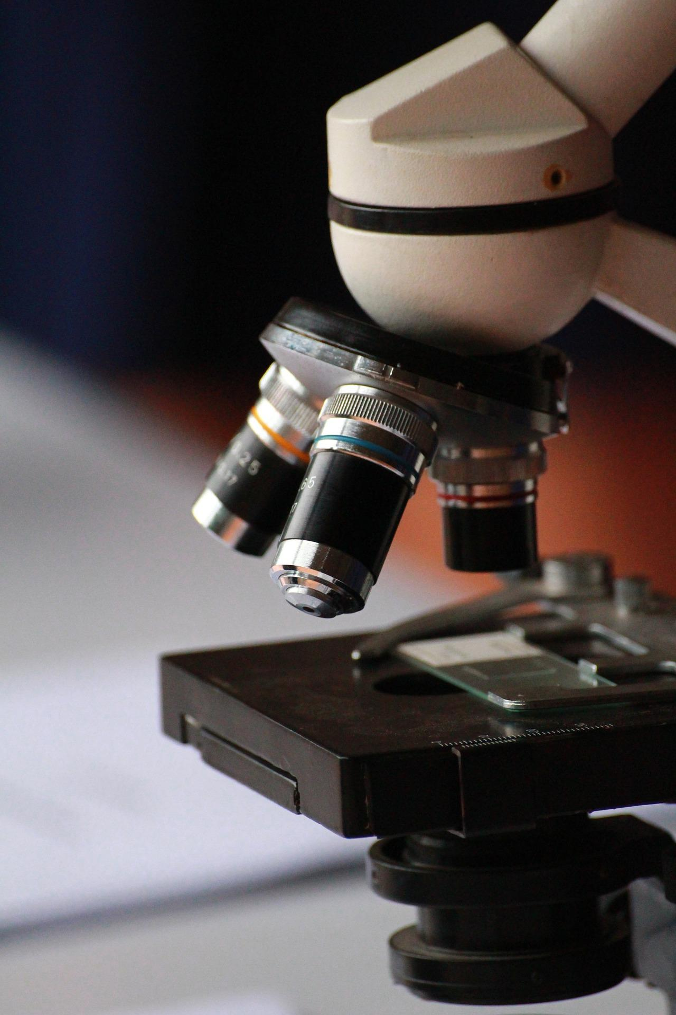
Image by Kaidevil Wiwan from Pixabay

1. DOWNLOAD the assignment here- https://docs.google.com/document/d/1_qfnrDFkagYJKGz3l9vHARC0WP7-WWMJQ2befFx9LJA/edit? usp=sharing)

2. Click Here to log into the Gizmo account using your username and password.

3. Click on the Gizmo called Cell Structure.\

4. Launch the Gizmo called Cell Structure.

5. Use the handout to guide you through the lab.

6. When you finish the activity, take the assessment quiz. Check your answers then print your paper. Give your paper to your classroom teacher. Please remember to include your

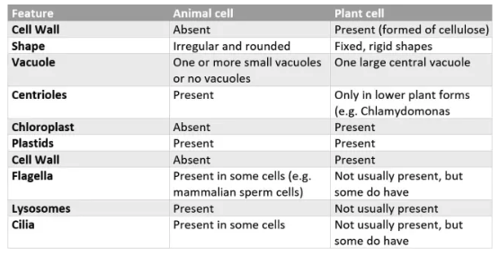

Check with your classroom teacher to determine if you need to Click “Next” to move to your Take-Two activity or Click “Next” twice to move to Module Three Lesson Two.

Submit Your Work

1. Click “Start Assignment” in the upper right corner of the screen.
2. To upload a file, click on Choose File to select the file from your computer.
3. To answer using a text box, click on the Text Entry tab and answer the questions in the text box.
4. Finally, click "Submit Assignment" for it to be graded by your teacher.

