Designing Accessible Immersive Learning Experiences
  - Pamela M. Saca, University of Michigan

Overview
Immersive learning experiences are simulated real-world environments that allow learners to practice skills in low-stakes contexts. The following activity supports instructors in improving the accessibility of their designed immersive learning experiences. Instructors first reflect on their in-progress design using guiding questions. After the completion of the immersive learning design, the instructors self-evaluate to identify areas of improvement for potential revisions. Guidelines and criteria utilized within the process are adapted from the Web Content Accessibility Guidelines (WCAG) and Universal Design for Learning (UDL) principles. This approach can be used with immersive experiences designed for any age group.
Topics: Accessibility, Extended Reality (XR), Immersive Learning, Universal Design for Learning (UDL), Web Content Accessibility Guidelines (WCAG)
Time: 60 minutes

Materials
Learners need:
- Accessibility Guide for Designing Immersive Learning Experiences.
- Design Elements and Supporting Standards Guide.
- An immersive learning/extended reality experience that they are currently designing (or have recently completed) for purposes of refinement.

Context-at-a-Glance
Setting
A graduate level learning experience design course at a large public university in the midwestern United States.
Modality
Hybrid
Class Structure
One-hour guest lecture during a three-hour seminar on accessible design. Follow up activities were posted within the learning management system.
Organizational Norms
Primary instructors draw guest speakers and topics from the team of Learning Experience Designers (LXDs) associated with the course’s residency requirement component.
Learner Characteristics
Twenty graduate students from various disciplines with little to no prior accessibility knowledge and beginning familiarity with Extended Reality (XR) applications.
Instructor Characteristics
A learning experience designer (LXD) for accessibility and former elementary teacher, who was exploring accessibility in the XR space.
Development Rationale
Designed for a team of LXDs creating accessible 360-degree XR experiences. The lecture was later expanded into a checklist to support graduate students with creating accessible XR experiences for online courses.
Design Frameworks
Web Content Accessibility Guidelines (WCAG) and Universal Design for Learning (UDL)

Setup
Minimal setup is required for this activity because it is a reflection and self-evaluation activity for instructors during the design phase of immersive learning experiences. Instructors should be designing an immersive learning/extended reality experience (or have a completed experience that can be edited). Ensure that instructors have access to the resources listed in the materials section.
Alternatively, this activity can be used as an informational introduction to basic accessible design principles and the various design elements that go into creating accessible immersive learning experiences.

Standards
- Web Content Accessibility Guidelines (WCAG) 2.1 (W3C Web Accessibility Initiative WAI, 2019)
- Universal Design for Learning (UDL) Principles (Center for Applied Special Technology [CAST], 2018)

Context and Setting

Original Use
The ideas within the Accessibility Guide for Designing Immersive Learning Experiences (see attached) were originally developed to support the organization’s task of designing multiple immersive learning experiences to include in Massive Open Online Courses (MOOCs) with the intention of increasing learner engagement. One of the early tensions in the design process was that many learners accessing the MOOCs may not have access to head mounted devices (HMDs) and would not be viewing the immersive learning experiences in HMDs. Because of this, the immersive learning experiences needed to also be designed for use on more common technology to include computer browsers and mobile phone applications, in addition to HMDs. HMDs, however, would provide the most immersive XR experience for learners who had the access and ability to utilize this special equipment.
The intended audience of the Accessibility Guide for Designing Immersive Learning Experiences was an internal team of learning experience designers (LXDs) who were all familiar with basic accessibility in course design. LXDs did not have a pre-existing process for considering accessibility in XR, specifically in 360-degree learning activities across multiple devices, although the organization’s internal accessibility guidelines still needed to be followed. This lack of a process created the question: How could LXDs use accessible design practices to create equitable and inclusive activities for learners with disabilities in the XR space?
The Accessibility Guide for Designing Immersive Learning Experiences, created to support LXDs in their design process, consists of two main parts:
- Reflection questions to consider during the design process.
- A self-evaluation checklist to apply to a fully designed immersive learning experience.
The purpose of the guide was to extend pre-existing general accessibility knowledge into the XR design space, making connections between accessibility practices in traditional online course design to the newer 360 video learning space.

Iterations
The Accessibility Guide for Designing Immersive Learning Experiences (attached) was continually revised and updated as LXDs created different immersive learning activities. The most crucial revisions were made to incorporate a method of self-evaluation through a usable checklist. This change occurred after presenting in a graduate level learning experience design class at a large public university in the midwestern United States. These graduate students were a part of a learning experience design certificate program, where the central course introduced the field of learning experience design through seminars and an in-person residency program alongside full-time LXDs. The LXDs had basic familiarity with accessible design, but most of the graduate students in this program did not have familiarity with accessibility. To bridge this knowledge gap, the author opted to include the self-evaluation portion in the form of a checklist as a tool that both experienced and novice LXDs would be able to use.
To train the graduate students to work alongside the team on XR projects, the graduate students were asked to use the Accessibility Guide for Designing Immersive Learning Experiences (attached) to evaluate an already completed 360-degree learning activity and discuss areas of improvement based on basic accessibility guidelines. The purpose of this activity was to teach and demonstrate basic digital accessibility guidelines using an example artifact and to expose the graduate students to the XR space.
After this activity, the graduate students then worked alongside the LXDs at the Center for Academic Innovation to assist in the development of immersive learning experiences for MOOC courses with topics such as autonomous vehicle technology, public speaking, and health equity and bias. These specific courses were identified as valuable opportunities to increase MOOC learner engagement through the use of XR technology due to the potential level of immersion that could be provided using 360-degree video learning activities.

Expansion of Use
The expansion of the Accessibility Guide for Designing Immersive Learning Experiences (attached) for use outside of the original context was easily completed. Because external audiences would most likely be using different technologies and authoring tools than in the original context (360 videos), the materials were revised to remove tool-specific language. In Part 1, additional reflection questions were added to specifically address inclusive design and accessible design considerations for each design element (see attached Accessibility Guide for Designing Immersive Learning Experiences, Part 1). These reflections are not specific to the creation of XR experiences and can therefore be utilized to support the creation of a variety of learner-facing experiences. In Part 2, additional adjustments were made to the wording of some guidelines within the checklist for more broad application in the creation of any immersive learning experience, and even to content outside of XR, when applicable (see attached Accessibility Guide for Designing Immersive Learning Experiences, Part 2).

Learning Representation

Learning Objectives
After utilizing the Accessibility Guide for Designing Immersive Learning Experiences, users will be able to:
- Understand and articulate how WCAG principles are present in the design process of immersive learning environments.
- Understand and articulate how UDL principles are present in the design process of immersive learning environments.
- Evaluate their own immersive learning experiences and generate a list of potential revisions to remove barriers to learning.
- Create more accessible immersive learning environments to remove barriers to learning.

Introduction of Terms (10 Minutes)

Immersive Learning
Immersive learning puts learners in a simulated environment mimicking the real world. It is often low-stakes in nature and allows learners to practice concepts such as interviewing or performing job-related tasks over and over, working toward comfortability or even mastery of the task (XR Today, 2022). One way learners are brought into immersive learning environments is through XR. The immersive learning content is virtual and can be accessed in various ways, such as through a computer or mobile phone. Because it is relatively easy to access, immersive learning content can also remove barriers to learning within a variety of contexts. Such barriers to learning include:
- Limited geographical access to real-world content and scenarios.
- Learner disengagement with content.
- Inability to reuse content and resources (Dalgarno & Lee, 2010).
Additionally, educators may also choose to create immersive learning experiences to further expand upon and enhance their courses beyond traditional methods. Benefits to learners include:
- Development of enhanced spatial knowledge.
- Increased intrinsic motivation and engagement.
- Improved transfer of knowledge and skills to real situations through contextualized learning (Dalgarno & Lee, 2010).
While immersive learning environments open learning opportunities for all learners in terms of access to new kinds of activities, there is also the very real challenge of ensuring those learners can utilize the experiences by making them accessible. In immersive learning environments, there may be images that appear, videos that automatically play, sounds to indicate wayfinding, quick movements, timers for actions, or clickable elements, all designed to enhance the learning experience, for some. For learners with disabilities, however, such interactive elements will create inferior experiences, or complete exclusion, by imposing insurmountable barriers to learning.

Accessible Design
Accessible design is a process which entails making design choices that enable a wide variety of people to participate in learning (University of Washington DO-IT, 2022). All learners exist along a spectrum with various abilities and disabilities. Common categories of disability include visual, auditory, cognitive, mobility, and seizure disorders (Web Accessibility in Mind [WebAIM], 2020). Accessible design specifically addresses designing content for learners with such disabilities. It is included as a subset of the broader concept of inclusive design, which considers the full range of human diversity. The end goal is the same: include as many learners as possible!

Accessible Immersive Learning
Educators and learning designers should strive to always create experiences that remove barriers to learning, whether in a classroom, online context, or a virtual XR environment. Immersive learning experiences highlight the importance of utilizing accessible design guidelines because they are poised to possibly exclude a large number of learners based on their disabilities. Often, such learning experiences require the use of multiple concurrent senses for comprehension while in a virtual environment. In turn, this presents many unique design challenges to consider. Immersive learning experiences, however, can also actively include those same learners if some simple adjustments are made to remove as many barriers as possible, utilizing concepts from a few well-known frameworks.
The attached Design Elements and Supporting Standards resource utilizes ideas from WCAG and the UDL Principles, two resources widely used in the digital design world to show the relationship between the proposed design guidelines and how they support learner accessibility needs. WCAG focuses primarily on creating accessible web content for people with disabilities, but many of the general ideas readily transfer to the creation of online learning materials. UDL focuses primarily on providing multiple ways to engage learners, to represent content to learners, and to allow learners to have many methods of action and expression. Similarly, the general ideas also readily apply to the creation of online learning materials.
Neither existing framework is a direct fit for ensuring immersive learning experiences are designed to be as accessible as possible. But utilized together, they provide a robust framework for creating accessible digital content for as many learners as possible. Below are the main ideas driving both existing frameworks.

Web Content Accessibility Guidelines (WCAG)
- Perceivable: Information and user interface components must be presentable to users in ways they can perceive.
- Operable: User interface components and navigation must be operable and usable.
- Understandable: Information and the operation of the user interface must be understandable.
- Robust: Content must be robust enough that it can be interpreted by a wide variety of user agents, including assistive technologies (W3C Web Accessibility Initiative WAI, 2019).

Universal Design for Learning Principles (UDL)
- Provide multiple means of Engagement: The “why” of learning.
- Provide multiple means of Representation: The “what” of learning.
- Provide multiple means of Action & Expression: The “how” of learning (CAST, 2018).

Part 1: Reflection Practice (20 Minutes)
The Accessibility Guide for Designing Immersive Learning Experiences (attached) utilizes ideas from both WCAG and UDL, adapting them to fit the unique design requirements of immersive learning experiences. To accomplish this, design elements are grouped across four main categories: text, audio, media, and overall design consistency elements.
Each element has been carefully adapted from WCAG 2.1 standards and written to help support learners across multiple categories of disability. Below are the design elements, which are also found in Part 1 of the Accessibility Guide for Designing Immersive Learning Experiences (attached). These design elements include examples of what that element may look like in an immersive experience, common design considerations for that element, and related design questions to consider. The questions are written to make the designer think about their intended audience, their particular needs, and reflect on what potential barriers to learning the designers might be creating through their design, with the end goal of understanding how to remove or redesign those particular elements.

Design Element 1: Text
Text elements in immersive experiences can include:
- Text appearing in the environment itself.
- Text over an environment (e.g., closed captioning isn’t a part of the scene, it’s just overlaid on the screen).
Common text considerations are:
- Size
- Environmental color contrast
- Alignment/justification
- Conciseness
- Line breaks
Design questions to consider:
- Learning Experience: In what ways are you using text in your immersive experience?
- Inclusive Design: How will you design your experience for learners who aren’t fluent in reading English?
- Accessible Design: How will you design your textual content for learners with visual and cognitive disabilities, whether they have some degree of vision loss, color blindness, or learning disabilities that relate to reading and processing text, such as dyslexia?

Design Element 2: Audio
Audio elements in immersive experiences can include:
- Sound effect clips
- Text-to-speech files
- Human speech
- Ambient noise in the background of a scene
Common audio considerations are:
- Volume
- Distractibility
- Chosen language
- Speaker language accents
Design questions to consider:
- Learning Experience: In what ways are you using audio in your immersive experience?
- Inclusive Design: How will you design your audio content for learners who speak a different language than the chosen language?
- Accessible Design: How will you design your audio content for learners with auditory disabilities, whether hard of hearing or deaf?

Design Element 3: Media
Media elements in immersive experiences can include:
- 2D images
- 2D videos
- 360-degree images
- 360-degree videos
Common media considerations are:
- File resolution
- Complexity of environment
- Blinking or flashing elements
- Consistent feel
Design questions to consider:
- Learning Experience: In what ways are you using various forms of media in your immersive experience?
- Inclusive Design: How are you representing learner diversity within your chosen media elements?
- Accessible Design: How will you design your media content for learners with visual or additional disabilities, such as low vision, seizures, or vertigo?

Design Element 4: Overall Consistency
Design consistency elements in immersive experiences can include:
- Actions related to learner directions
- Wayfinding
- Attention
- Comfort levels
Common design consistency considerations are:
- Allowing learners to make choices.
- Intuitive navigation.
- Naturally guiding learners’ attention using visual or auditory cues.
- Any mental health concerns the experience may bring up.
Design questions to consider:
- Learning Experience: In what ways are you creating intuitive and logical immersive experiences?
- Inclusive Design: How are you considering a wide variety of learners from various demographics and backgrounds, and not just learners from the United States?
- Accessible Design: How will you design your environment for learners with cognitive disabilities, such as memory, attention, anxiety, and depression?

Part 2: Self-Evaluation Practice (30 Minutes)
Once the reflection from Part 1 of the Accessibility Guide for Designing Immersive Learning Experiences is complete, revisions will likely need to be made to the design of the in-progress immersive learning experience. After the revisions are complete, instructors should move to Part 2.
Part 2 of the guide is used with a completed draft or final immersive learning experience product. It includes a checklist for instructors to self-evaluate their design across each design element. Instructors can check off elements of design success. Some design elements may be easy to evaluate, such as checking that all text is on a 100% solid fill background or that an easy-to-read font is used (see attached Accessibility Guide for Designing Immersive Learning Experiences, Part 2, Text Design Elements). Other elements require the instructor to make a decision based on personal judgement or on what they know about their potential intended audience when going through the evaluation. For instance, the audio element of checking that background noise is non-distracting can be subjective and contextual (see attached Accessibility Guide for Designing Immersive Learning Experiences, Part 2, Audio Design Elements). An instructor may consider that design element and decide to reduce the volume of background music in order to provide what they think is a better experience. An instructor may also consider the design element and completely remove the background music because they know the immersive learning experience is geared toward a particular population of learners prone to hearing difficulties or loss. Either design choice can be correct depending on the context.
For any design elements that are not met, the instructor should consider why they may be important to the activity or immersive environment. The Part 2: Self-Evaluation section will help instructors identify areas for improvement within their work and consider revisions to include more learners. For example, in Figure 1, a text box is shown in a 360-degree virtual environment. After completion of the self-evaluation, the designer identified multiple text elements that needed updates. These text elements included the background, line breaks, font type, font size, and text box width. Instructors may not be able to satisfy all accessibility guidelines due to a lack of functionality in the utilized XR tool or XR technology.
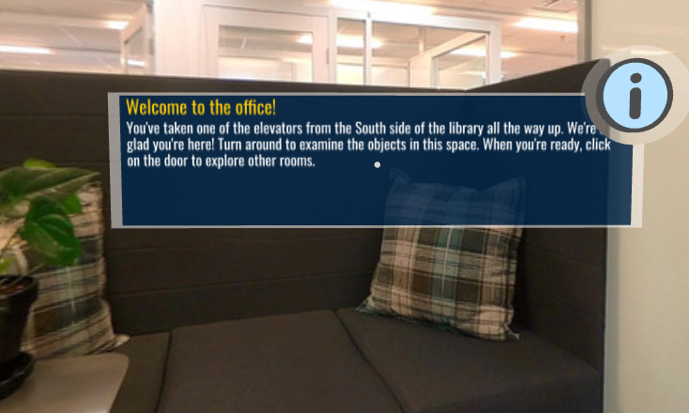
Figure 1. A text box in a 360-degree virtual environment before completion of the self-evaluation process. Multiple text elements require revision. Image courtesy of the University of Michigan.
Figure 2 shows learner navigation elements within the 360-degree virtual environment. After completion of the self-evaluation, the designer identified multiple elements that required revision. These elements included the two buttons that allowed learners to move through scenes, which were identified as being unintuitive in their wording, icons, and locations. Additionally, the buttons in the virtual environment did not naturally guide a learner’s attention in the intended direction of the scene.
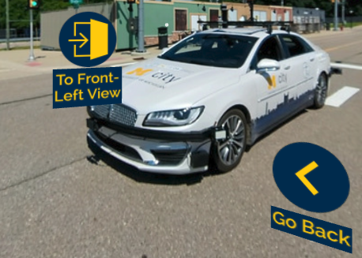
Figure 2. Navigation elements in a 360-degree virtual environment before completion of the self-evaluation process. Multiple design consistency elements require revision. Image courtesy of the University of Michigan.

Revisions
After the Part 2: Self-Evaluation, there will likely be revision work necessary to the design of the immersive experience. As comfortability is gained with the various design elements, the evaluation process of reflection and self-evaluation of the accessibility of immersive learning experiences will become shorter for future projects. Eventually, the guidelines will become internalized and part of the instructor’s everyday design style.
For example, in Figure 3, the previous text box from Figure 1 is shown in a 360-degree virtual environment redesigned with the appropriate accessibility guidelines applied. Accessibility improvements included:
- Changing the text background from translucent to opaque (100% solid fill).
- Adding appropriate line breaks to the text block.
- Utilizing an easier to read font.
- Increasing the size of the font.
- Reducing the overall width of the text box for improved reading and line tracking considerations.
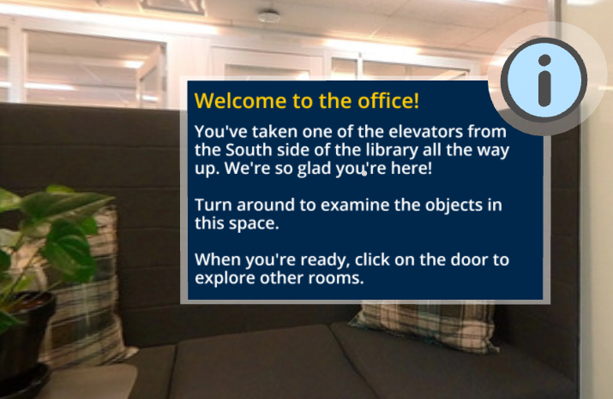
Figure 3. The text box in a 360-degree virtual environment redesigned with accessibility guidelines applied. Image courtesy of the University of Michigan.
In Figure 4, the previous navigation elements shown in Figure 2 are shown in a 360-degree virtual environment redesigned with the appropriate accessibility guidelines applied. Accessibility improvements included:
- Changing the wording of the first navigation button from “Go back” to “Previous” to avoid confusion with the term “back” indicating behind the learner (as in physical direction), rather than indicating moving to the previous scene, as intended.
- The icon on the second button, labeled “Front-Right View,” was changed from an arrow pointing into an open door to an arrow that visually indicates moving around, or rotating around an object in the intended specified direction. This was to relieve potential confusion that learners would be entering a door or portal, and allowed learners to understand that they were not leaving the scene, but rather moving to experience a different view within the same scene.
- The location of the two navigation buttons was changed, swapping their locations to put the “Previous” button on the left side of the scene and the “Front-Right View” button on the right side, relative to the textual directions within the scene. This put the buttons physically near their corresponding actions to guide learners visually in the direction in which they wanted to go.
- The two buttons were placed over top a 2D white solid fill rectangle to create a more intuitive and organized visual navigation menu element.
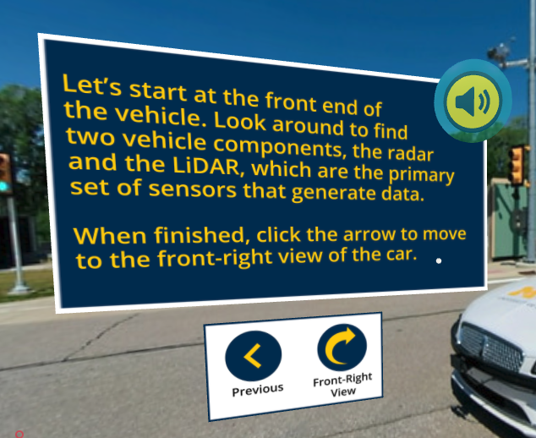
Figure 4. The navigation elements in a 360-degree virtual environment redesigned with accessibility guidelines applied. Image courtesy of the University of Michigan.

Additional Potential Uses (Non-XR)
It is recognized that not everybody will be designing XR learning experiences in their everyday work. It is also true that not all of these accessibility guidelines will be applicable to all types of immersive learning experiences, just as not every immersive learning experience will be a 360-degree activity as per the original use case. One advantage of the guideline content in Part 2 of the Accessibility Guide for Designing Immersive Learning Experiences is that it is highly adaptable to designing anything, whether making a simple poster, recording a video lecture, or designing an augmented reality application.
Adapt these guidelines for whatever type of experience is being designed and created for learners. Good design principles transcend media and contexts. For example, making text labels large enough to read in a 360-degree environment for a learner using a VR headset is a must. But also, the design guideline to make text readable also applies to any other activity that may be developed. Questions such as: can learners read the text in presentations? on worksheets? physical handwriting on a whiteboard? can help guide the design of other resources with this checklist. Once the main design principles of accessibility are understood, it is easier to see how they can be applied to many contexts outside of XR. Accessibility should be infused anywhere there are learners.

Critical Reflection
The Accessibility Guide for Designing Immersive Learning Experiences was used six times by the author in the evaluation of authentic 360-degree XR activities designed for MOOCs. After self-evaluating the six activities, the author added additional design elements that were relevant to the experience or were not satisfied through that version of the guide. The most helpful piece of the self-evaluation process was the output of having a clear list of revisions ready to return to the learning experience designer. In many cases, the author was able to screenshot problem areas in the immersive learning experience and include those images in the digital copy of the checklist for easy reference. This allowed LXDs to understand necessary areas of improvement for accessibility, make revisions, and likely not repeat those same errors moving forward in subsequent design experiences. It also served as a way to generate consistent experiences and a consistent feel across multiple projects.
The author also used feedback gathered from the graduate students during the first activity (evaluation of an already created immersive learning experience for the purpose of exposure to WCAG and basic accessible design in XR). Based on written and verbal comments from the graduate students, the author added additional columns to the Design Elements and Supporting Standards document to tie in how UDL principles support each element, making the connection between design element, disability category, and UDL principles more apparent. This update also provided robust support to justify why each design element should be included in the checklist in Part 2 of the Accessibility Guide for Designing Immersive Learning Experiences.
Overall, the Accessibility Guide for Designing Immersive Learning Experiences is helpful in a variety of contexts, depending on the user. For someone with advanced accessibility knowledge, the checklist serves as a helpful, ordered, self-evaluation tool to quickly check for consistency across multiple projects. For a designer with less accessibility knowledge, the reflection questions in Part 1, combined with the checklist in Part 2, serves as a helpful reminder to think deeply about their intended audience and which barriers to learning might exist from bias in design. For students with less or no accessibility knowledge, the Accessibility Guide for Designing Immersive Learning Experiences serves as a basic but adequate introduction to WCAG ideas and how they intersect with the general XR space. For everyone, the resource serves as a way to keep disabilities in mind during the design phase of any educational experience and attempt to mitigate as much design bias as possible from the process by removing barriers to learning through relatively simple design considerations.
The author recognizes that this resource will not make all immersive learning experiences completely accessible for all learners. Sometimes, design choices that are made are positive for one learner while simultaneously excluding another learner. For instance, removing all the text elements in favor of audio only within an immersive learning experience might better support learners with motion sickness. This same decision might in turn cause negative effects on learners who rely on printed text due to hearing loss or for whom English is not their first language. Chances are, there will never be an immersive learning experience that is completely accessible to one hundred percent of learners. The Accessibility Guide for Designing Immersive Learning Experiences, however, is a good starting point to understanding how small design choices, such as text elements, can have a big impact on learners. If it does not matter to the designer what type of font is used in an experience, for example, it should be no trouble to understand that utilizing a simple font is an easy win toward accessibility for many learners that requires little effort on the designer’s part. The goal is to begin to internalize good design habits that remove barriers to learning.
Future modifications to the Accessibility Guide for Designing Immersive Learning Experiences could include dedicated space to provide screenshots for each listed design element. For example, if there are multiple instances where line breaks are necessary within text elements, it would probably be easier for the person doing the revisions to know exactly where to look and how many instances of the revision need to happen. Otherwise, some instances might be overlooked because quantity and location are hard to glean from the current version. If the evaluator and reviser are the same person, this may not be a potential issue to modify.
Other future modifications might include design elements specific to particular types of experiences (Augmented Reality, Virtual Reality, Mixed Reality, 360 Video, etc.) or to particular types of software being used to design the experiences. The checklist could be expanded to fit the specific needs of the particular learning context and activity, whether XR-related or non-XR in nature. The format of the checklist allows for ample additional design elements to be included depending on need.

References
Center for Applied Special Technology. (2018). Universal design for learning guidelines version 2.2 [Graphic organizer]. https://udlguidelines.cast.org/
Dalgarno, B., & Lee, M.J.W. (2010). What are the learning affordances of 3-D virtual environments? British Journal of Educational Technology, 41(1), 10-32. https://doi.org/10.1111/j.1467-8535.2009.01038.x
University of Washington DO-IT. (2022, May 24). What is the difference between accessible, usable, and universal design? https://www.washington.edu/
doit/what-difference-between-accessible-usable-and-universal-design
W3C Web Accessibility Initiative WAI. (2019, October 4). How to meet WCAG (Quick reference). https://www.w3.org/WAI/WCAG21/quickref/
Web Accessibility in Mind. (2020, April 14). Introduction to web accessibility. https://www.webaim.org/intro/#people
XR Today. (2022, July 4). What is immersive learning? https://www.xrtoday.com/virtual-reality/what-is-immersive-learning/

About The Author
Pamela M. Saca is a Learning Experience Designer for Accessibility at the University of Michigan’s Center for Academic Innovation. As a former public school teacher, she has thirteen years of experience teaching at the elementary level. She holds a master’s degree in educational studies (Design and Technology for Learning) from the University of Michigan and a master’s degree in Curriculum and Instruction from Eastern Michigan University.

