Lights, Camera, Accessibility! Applications
in Video Design
  - Irene A. Bal, Loyola University Maryland

Overview
The focus of this lesson is the authentic application of accessibility for a video through an asynchronous discussion forum. Set in an online, graduate, education multimedia design course, students design an instructional video over multiple weeks, applying course content to their video, demonstrating their application, and receiving formative feedback through discussion forums. This article details one discussion forum, occurring over one asynchronous week, used as a formative assessment to support students in applying accessibility guidelines (WCAG 2.1 and Section 508) and best practices for accessible multimedia design.
Topics: Accessibility, Multimedia Design, Video Production
Time: One week, asynchronous

Materials
- Week 3 Accessibility Resource Guide
- Accessibility Resources (see Resources section)
- Discussion Forum Activity Rubric
- Did You Know? Resource
- Learning Management System with discussion forum capabilities
- Internet/Devices
- Students should be working on a multimedia creation project – this activity focuses on accessibility in video products

Context-at-a-glance
Setting
Online, graduate educational technology program at an urban, private institute of higher education (IHE) in the northeastern United States.
Modality
Online, Asynchronous
Class Structure
The course is an 8-week multimedia design course with five asynchronous discussion forums. The students create multiple multimedia products, with discussion forums focusing on a video product. This activity was the discussion forum for Week 3, focused on accessibility and copyright.
Organizational Norms
The students are online with no expectation to come to campus.
Learner Characteristics
The students are current PK-12 teachers enrolled in a master’s program. They have a range of previous multimedia and video design knowledge and experience.
Instructor Characteristics
The course was developed by one IHE faculty member with multimedia and video design experience and PK-12 teaching experience.
Development Rationale
This activity was created to support students with limited prior knowledge and experience applying accessibility and copyright to multimedia products. In this activity, the students receive formative feedback on their inclusion of accessibility and copyright from peers and the instructor.
Design Framework
ASSURE Model

Setup
This activity was conducted in an asynchronous, online environment but can be adapted for a face-to-face discussion. A discussion forum should be set up in the provided learning management system (see Discussion Forum Directions & Prompts section for prompts). Expectations for discussion forums should be provided or co-created by the class before implementation. It is highly recommended that the discussion forum be a part of a multimedia creation project for authentic application.

Standards
The ISTE (2017) Standards for Educators were used for this discussion forum activity:
2.1.c: Learner – “Stay current with research that supports improved student learning outcomes, including findings from the learning sciences.”
2.2.b: Leader – “Advocate for equitable access to educational technology, digital content and learning opportunities to meet the diverse needs of all students.”
2.4.a: Collaborator – “Dedicate planning time to collaborate with colleagues to create authentic learning experiences that leverage technology.”
2.5.a: Designer – “Use technology to create, adapt and personalize learning experiences that foster independent learning and accommodate learner differences and needs.”

Course Objectives
This course includes five learning objectives focusing on analyzing, designing, and creating multimedia products for PK-12 or professional learning. For this discussion forum activity, two course objectives were supported:
Course Objective 1 – “Analyze multimedia products through the lens of multimedia and learning research, instructional design, copyright law, accessibility guidelines, and media messages and media literacy influence.”
Course Objective 2 – “Apply copyright law and accessibility guidelines in multimedia products” (Educational Technology Program Documents, personal communication, January 5, 2023).

Context and Setting
This discussion forum is in an 8-week online, graduate, education, multimedia design course. The course introduces students to the “design, development, and evaluation of multimedia products for K-12 and professional learning environments” (Educational Technology, MED, n.d., ET620-Multimedia Design in the Classroom). In the course, the students create multiple multimedia products, in pairs or individually, such as infographics, videos, and the choice of other multimedia products. Although multiple products are created, the main product for the course is an instructional video for either PK-12 classroom learning or professional learning with adults.

ASSURE Model
In Spring 2021, the course was redesigned with the ASSURE model (Ibrahim, 2015), using a cyclical process for each week. The ASSURE model includes six steps: (A) Analyze learners, (S) State objectives, (S) Select methods, media, and materials, (U) Utilize technology, media, and materials, (R) Require learner participation, and (E) Evaluate and revise (Ibrahim, 2015). The students in the course were (A) analyzed based on their prior design knowledge and experience at the beginning of the course and after each week to (S) determine the learning objectives, (S) select the appropriate media and materials, support the students in (U) using those media and materials, (R) engage students in the content, and (E) determine if the students gained the knowledge and skills to authentically apply the content in their multimedia creations (Ibrahim, 2015). In the redesign, the course content included:
- multimedia and general learning research,
- multimedia design best practices
- multimedia instructional design models,
- bias in media, media messages, and media literacy,
- accessibility and copyright for multimedia design, and
- best practices for PK-12 student multimedia products.
The creation of the instructional video product is chunked over five to six weeks (depending on the time of year) with five discussion forums, one each week, that focus on applying content from that week to the video.
All five discussions were developed to (R) require learner participation in the authentic application of the (S) selected media and materials and (U) the authentic application of those media and materials in their videos. The authentic application occurs as students apply the learning from each module directly to their video design and display this application via textual, visual, or video examples. The discussions were also developed as an (E) evaluation to determine if the students understood the content and if any aspects of the content needed to be updated.
The activity featured in this article is a Week 3 discussion forum on accessibility and copyright for a video creation project, but it can be adapted for any multimedia project. Before this activity, students explored what multimedia is and why they need to learn how to design multimedia products, including an overview of the 4Cs, constructivism, and Universal Design for Learning guidelines (Week 1). They also learned practices for multimedia production, including Cognitive Load Theory, Cognitive Theory for Multimedia Learning principles, and Self-regulated Learning Theory (Week 2). In Week 3, prior to the discussion forum activity, the students explored accessibility and copyright in media focusing on Web Content Accessibility Guidelines (WCAG) 2.1, created by the World Wide Web Consortium (W3C) to support more accessible web content (W3C, 2018), and Section 508 accessibility guidelines, requirements that focus on the U.S. Federal government, ensuring people have access to all content in web or electronic form (U.S. Access Board, n.d., Section 508; see Resources section). Copyright, Fair Use, creative commons, public domain, and open educational resources were also included. For the purposes of this article, the Week 3 module content and description of the discussion forum activity will only include the accessibility content.

Students
Since the redesign of the course in Spring 2021, four sections of the course have occurred, with a total of 68 students enrolled. Students in the course are PK-12 teachers and have varying previous multimedia and video development knowledge, with most students identifying as Beginner (see Table 1), and varying multimedia and video design experience, with most students identifying with Some (see Table 2).
Table 1
Students’ Prior Development Knowledge
Prior Development Knowledge | Levels for Development Knowledge
 | Beginner | Competent | Expert
Multimedia Development Knowledge | 54.55% | 43.64% | 1.82%
Video Development Knowledge | 61.82% | 38.18% | 0.00%
Note. Percentages are based on consenting participants, N = 55 (80.88% of students), from a study of the four sections with IRB approval.
Table 2
Students’ Prior Design Experience
Prior Design Experience | Levels for Design Experience
 | Very Little | Some | Quite a Bit
Multimedia Design Experience | 38.18% | 47.27% | 14.55%
Video Design Experience | 45.45% | 47.27% | 7.27%
Note. Percentages are based on consenting participants, N = 55 (80.88% of students), from a study of the four sections with IRB approval.

Week 3 Module Content
The discussion forum activity is one of the activities in the Week 3 module. The Week 3 content includes both accessibility and copyright, but accessibility will be the sole focus of this article. The following section details the Week 3 module setup, objectives, resources that students engage in, and the discussion forum activity.

Module Setup
The modules in the course are set up in a weekly fashion for students to complete one module per week. Each module is set up the same way:
- Introduction to the week.
- Resources for reading/viewing that week.
- Ongoing Activities to complete that week.
- Submissions for the week.
The Introduction section includes a brief audio introduction of what the students will learn during the week, the module objectives and how they align with the course objectives, a checklist for the week that auto-checks off when items are completed, and a Resource Guide (see attached file) to support the learners in understanding the content in the Resources section.
The Resources section includes a list of resources for the students to read/view. Each resource briefly describes why the students are reading/viewing that item. The resource section is divided into Required Resources and Optional Resources (see Resources section).
The Ongoing Activities section includes work the students should be working on during the week but may not necessarily submit that week. Many of the student-created multimedia products in this course (e.g., the video) are created over multiple weeks. This section details what the students should work on within their products each week to keep them on track and chunk the work over the weeks. For this article, the Ongoing Activities section included work that is irrelevant to the discussion forum activity; thus, this section is not further detailed below.
The Submissions section is what the students should be submitting that week. This section includes the assignment links for students to use for submissions and includes any resources, such as directions and rubrics, for students to reference.
The following Week 3 Module Content will be presented in the order as seen by students in the module. In this section, regular text identifies instructor notes, and italicized text indicates content to be presented to the students, unless otherwise noted. Only content about the accessibility part of the module is included.

Introduction
The content in the introduction is presented to students in an audio format, a transcript (written), and as attachments to download. The audio introduction is read by the instructor and includes:
By the end of this module, you will be able to analyze multimedia products through accessibility guidelines (Course Objective 1) and apply accessibility guidelines in multimedia products (Course Objective 2).
A few items were created to support you through this module. A Week 3 Resource Guide was created to support you through the content in the Resources section. You will not submit this Resource Guide but instead can use it as you explore the module readings and viewings to guide you through the important points and provide prompts for notes. There are also Optional Resources to support any prior knowledge gaps or as a refresher for previously learned concepts.
A Resource Guide (see attached file) is provided each week, so by Week 3, the students are accustomed to using it. In this class, it is an optional resource for students to use, and they do not submit it. This could become a required resource and be submitted for grading or extra credit opportunities.

Resources
The following resources are required for students to engage with (view, read, watch) before completing the discussion forum activity. These resources include various web accessibility guidelines and are not limited to accessibility for videos. Within this course, students need to analyze and apply accessibility guidelines to various types of multimedia products (see Course Objectives 1 and 2); thus, the resources include guidelines for all types of multimedia and web-based resources. In the discussion forum, it is expected for the students to select the appropriate accessibility guidelines for a video. The descriptions under each resource were written to help students understand how the content specifically supports video accessibility.
This module has multiple resources, but many are around one minute long. The length of each video is included. The resources are numbered in the order students should view them. The description for each resource is also included. The students are in the third week of creating a video. Some of the prompts provided for each resource guide student considerations for their video designs.
The Week 3 Resource Guide (see attached file) is organized in the same order as these resources. Please note that the resources and descriptions are not italicized for the sake of reading but are presented to the students as listed. Any notes for instruction are indicated by Instructor’s Note.
- Introduction to Web Accessibility and W3C Standards (W3C Web Accessibility Initiative (WAI), Copyright © 2017b W3C ®).
  - Length: 4:07
  - This video includes an introduction to web accessibility and the W3C standards.
- Web Accessibility Perspectives: Video Captions (W3C Web Accessibility Initiative (WAI), 2016e).
  - Length: 0:47
  - This video includes an introduction to video captions for accessibility.
  - In your video, you should have video captions. The great thing is, most video storage platforms (YouTube, Vimeo, Google Drive, etc.) include captions! The stinky thing is they are only about 80% correct. You will need to update your captions for this video project to ensure they are correct, but if you have a script and use a video storage platform that includes captions, most of the work is done for you!
- Web Accessibility Perspectives: Colors with Good Contrast (W3C Web Accessibility Initiative (WAI), Copyright © 2016 W3C ®).
  - Length: 1:03
  - This video includes an introduction to color contrast for accessibility. I see poor color contrast a lot!
  - In your video, review your visual and text media through color contrast. If you have a student who is color blind, will they be able to see various elements of your video content?
- Web Accessibility Perspectives: Customizable Text (W3C Web Accessibility Initiative (WAI), 2016b).
  - Length: 0:46
  - This video includes an introduction to customizable text for accessibility. This is more applicable to a website or LMS (Learning Management System like Canvas, Google Classroom, Moodle, etc.).
  - In your video, you will want to ensure the text you are using is large enough to read/view without having to make the video full screen.
- Web Accessibility Perspectives: Clear Layout and Design (W3C Web Accessibility Initiative (WAI), 2016a).
  - Length: 1:05
  - This video includes an introduction to layout and design for accessibility. This is more applicable to a website or LMS (Learning Management System like Canva, Google Classroom, Moodle, etc.).
  - In your video, consider if the layout of your video is consistent from start to finish. You may notice, in my multimedia products for this course, I am using the same type of layout. This is to support your cognitive load and expectations when you view each item and plan your week.
    - Instructor’s Note: In the course, a lot of content was created into multimedia products so students would learn with multimedia as opposed to traditional readings.
- Web Accessibility Perspectives: Understandable Content (W3C Web Accessibility Initiative (WAI), 2016d).
  - Length: 0:54
  - This video includes an introduction to understandable content for accessibility. Understandable content focuses on jargon.
  - In your video, consider the words, vocabulary, and acronyms you are using. Will your audience understand the content?
- Web Accessibility Perspectives: Large Links, Buttons, and Controls (W3C Web Accessibility Initiative (WAI), 2016c).
  - Length: 0:42
  - This video includes an introduction to large links, buttons, & controls for accessibility. This is more applicable to a website, presentation, or HyperDoc (you will experience these more in a future class).
  - In your video, consider the platform you chose to distribute your video (YouTube, Google Drive, your LMS, etc.). Are the links, buttons, and controls large enough for touchscreen devices? Will your students know how to navigate these controls, or will they need some support?
- Provide Sufficient Contrast Between Foreground and Background (White et al., Copyright © 2016 W3C ® [White]).
  - This website segment includes an example and tips for utilizing contrasting colors in your design. I see a lot of lack of color contrast!
  - In your video, review your visual and text media to determine if the color contrast between the background and the text/visual is contrasting enough.
- Don’t Use Color Alone to Convey Information (White et al., Copyright © 2016 W3C ® [White]).
  - This website segment includes an example and tips for conveying information beyond color changes. This is more applicable to websites, forms, documents, presentations, etc.
  - In your video, consider if you are using color to convey information such as highlighting, words in different colors, etc. Consider if other elements, such as arrows, circles, or other objects, could be used to direct the viewers' attention.
- Use Headings and Spacing to Group Related Content (White et al., Copyright © 2016 W3C ® [White]).
  - This website segment includes an example and tips for using white space around images and headings. This is more applicable to a website or in documents, presentations, and graphic media.
  - In your video, consider how you are using whitespace in your graphic/image media. Review your visual media to determine if it is too cluttered or doesn't have enough white space.
- Include Image and Media Alternatives in Your Design (White et al., Copyright © 2016 W3C ® [White]).
  - This website segment includes an example and tips for using text alternatives for media. This is more applicable to a website or LMS (Learning Management System like Canva, Google Classroom, Moodle, etc.).
  - In your video, you will want to ensure you have a transcript and it is correct. This means you may need to update the YouTube transcript or include a transcript if you are not using YouTube to distribute your video.
- Provide Controls for Content that Starts Automatically (White et al., Copyright © 2016 W3C ® [White]).
  - This website segment includes an example and tips for allowing users to control media in your designs. I see violations of this a lot in student website design through picture carousels and music with no pause/stop button.
  - In your video, you will want to consider where or how you plan to share it with your students and what types of user controls they have. Can they pause/stop it? Will they be able to mute the sound and turn on/off the captions?
- Accessible Design Guidelines Infographic (Bal, n.d.).
  - This infographic includes some guidelines for accessible design.

Optional Resources
Each week, optional resources are provided to students to fill gaps in knowledge they should already have or expand their knowledge on the topic if they are interested. The following resources are optional resources for Week 3 that students can elect to review. These resources support students continued learning about accessibility.
These optional resources are not included in the Week 3 Resource Guide. Please note that the optional resources and descriptions are not italicized for the sake of reading but are presented to the students as listed.
- Did You Know? Resource. This file includes some information regarding web accessibility that you may or may not know.
- WCAG 2.1 – Principle 1: Perceivable Infographic (Meredith S, n.d.).
  - This infographic has an overview of the main aspects of the Perceivable principle from WCAG. These are most relevant for your video product.
- Create Accessible Digital Products (General Services Administration, n.d.)
  - This website provides some guidelines focused on creating digital products. These are focused on 508 guidelines (guidelines for federal agencies) but should be considered as you continue creating multimedia products for your learners.
- WCAG 2.1 at a Glance (Henry & Dick, Copyright © 2018 W3C ® [Henry & Dick]).
  - This website provides a quick glance at the WCAG 2.1 guidelines.

Submissions
Within this module, there are multiple submissions, such as the discussion forum activity, a multimedia product that the students have been creating for the prior three weeks, and a weekly reflection journal entry. For this article, the discussion forum activity will be the focus, as the other submissions are not relevant to this activity.
The students are on Week 3 of creating their video, working individually or in pairs (selecting their partners if they want to work in pairs). At this point in the course, students have generated an idea and content outline for their video, received peer and instructor feedback on that content (Week 1), applied researched practices for multimedia production to their video, and received peer and instructor feedback on that application (Week 2). The purpose of the Week 3 discussion forum is to apply accessibility guidelines (and copyright) to their video product. At this stage of their video product, they are beginning to storyboard and create a script and visuals based on their prior outline and applications from Weeks 1 and 2, and the feedback they received thus far. The final video is due in Week 5 or 6, depending on the time of year.

Discussion Forum Directions & Prompts
The students are expected to post one main post and respond to one student in the discussion forum. If students work in pairs, they will collaboratively post one main post and individually post one response post. For the response posts, the students are purposefully paired by the instructor at the beginning of the semester to create an equitable response system and to attempt to match the students by content area and grade level so they can provide more detailed content and design feedback to one another (see Response Posts Prompts section for more details). The assigned pairs are stated in the first forum (Week 1) and continue throughout the course. This pairing also allows students to see the progress of a video project throughout each step, from the beginning idea to the final product.
This discussion forum has general directions, main post prompts, and response post prompts.

Week 3 Discussion Forum General Directions
Each discussion forum is set up the same, with one main post and one response post. The directions within the discussion forums vary week-by-week based on the content but are similar to support consistency for students:
This Week 3 discussion forum will focus on applying accessibility guidelines to your video (final video due in Week 6). You are entering the post-production stage, where you will be finalizing the media and begin editing your video in your video editing tool.
For this forum, you will post one (1) main post. Then, you will post a response. You only need to respond to one (1) person. To create an equitable response system, I have teamed you up for responses. You only need to respond to that one (1) person, but you are encouraged to read and respond to other students. Follow the prompts in the discussion forum for your main post and response posts. It is suggested you review the Forum Activities Directions & Rubric prior to posting and responding (see Evaluation section for more details).

Week 3 Main Post Prompts
The prompts for the main post guide students in what they should post:
In this module, you explored various accessibility resources for visual media, audio/visual media, and web content. Consider these specific resources and how you plan to support accessibility in your video product. Specifically respond to:
- Discuss the plan for your video, such as:
  - Where do you plan to host the video?
    - Ex: YouTube, Google Drive, Vimeo, etc.
    - For this response, students are encouraged to consider copyright guidelines and their content, as some platforms are more open to sharing than others.
  - Who will review/update the transcript?
  - When do you plan to review/update the closed captions & transcript?
    - Note. Content is included in Week 6 on how to update closed captions & the transcript for various hosting platforms if needed.
  - Also discuss how you are supporting accessibility guidelines through your color choices, text, and other media in your video. Examples, images, screenshots of your video, etc. could be included to showcase your plan but are not necessary at this point (any examples, images, screenshots, etc. can be added to your storyboard for Week 4).
  - Within these discussions, if you have slides or media already created, feel free to include a screenshot or example of what you are planning on doing for feedback. If you don't yet, no worries! You will be building this in Week 4.
    - In Week 4, students work on and complete their storyboard, including the script and visuals.

Week 3 Response Post Prompts
For the response posts, the assigned response post pairs are listed below the forum prompts in a table format (see Table 3). Students who are working in pairs receive two responses (see Ashley A. & Carmella C. example in Table 3). The instructor reviews the students’ PK-12 teaching content, video content (e.g., fractions for 4th graders), and grade level to make the pairs. The instructor makes every effort to match students so they can support specific content and grade level/developmental needs based on the age of the intended audience for the video.
Table 3
Example of Response Post Pairs Listed in Forum
Find Your Name  (ABC Order): | Respond to:
Ashley A. | Fitz F.
Brandon B. | Ashley A. & Carmella C.
Carmella C. | Brandon B.
Don D. | Gerald G.
Eliza E. | Ashley A. & Carmella C.
Fitz F. | Eliza E.
Gerald G. | Don D.
The prompts for the response post guide students in what they should respond to:
You will individually respond to one main post by following the below prompts. One (1) response post is needed. See the list of response partners below.
- For the accessibility information, provide comments or feedback centered on:
  - The plan for updating the closed captions/transcript.
    - Do you think their plan is feasible?
    - This can take some time depending on the number of errors. Is their timing sound?
  - What suggestions do you have on their design decisions for color choices, text, and other media?
  - Are the materials included/plan accessible to you?
  - What updates do you suggest?

Facilitation
Although this is an asynchronous discussion forum, facilitation is needed by the instructor. The students have one week to complete the module, including the resources, ongoing activities, and submissions. Throughout the week, the instructor monitors the discussion forum to ensure accurate content and application of content are posted, re-directing/correcting learners through public-facing and private discussion replies as needed. The instructor also reviews the discussion forum near the end of the week (before the submission deadline) to determine if anyone has not posted a main post, thus possibly limiting their response partner from responding.
Since the COVID-19 pandemic, the submission dates for assignments across the instructor's program have become more flexible, and deductions in points due to late work have been reduced or removed to best support students. Occasionally, the need for flexibility, resulting in a later submission date of the main post, impacts other students when paired for responses. When this occurs, the instructor directs the respondent, who is waiting for a post to reply to, to either wait until a specific date or reply to another post. The response to wait or reply to another post depends on the time needed for the other student to post a main post beyond the deadline. Typically, students also contact the instructor if there is no main post to respond to. In addition to this facilitation, the instructor also grades the discussion forum posts.

Evaluation
In this course, the discussion forums are used as a formative evaluation to determine if the students understand the content and if any aspects of the content need to be updated.
The Forum Activities Directions & Rubric is utilized for all forum post activities. General directions and a rubric are provided for students at the beginning of the semester.

Course Level Discussion Forum Activity Directions
These directions apply to all discussion forum activities:
In an online environment, opportunities for learner-to-content interactions and communication between learners can be limited. The purpose of the discussion forum activities is to engage you with the content and the other learners in the class. These activities are not a place for you to regurgitate the material but rather focus on the important aspects of the resources, extend current thinking, introduce alternatives, facilitate new understandings, and add value to your graduate experience.
The length of your posts and responses should be guided by whatever you have to say, the number of resources you are referencing, and the experiences you are tying to the content. Some responses may be a few sentences in length, while others may require one or more paragraphs. It is expected of you to follow all Course Expectations and the Educational Technology Program Netiquette Policy, as stipulated in the syllabus.
I strongly encourage you to compose your posts (and other online content) in a Word document, Notepad/TextEdit application, or Google Document first and then paste it into the discussion forum. This helps avoid issues with losing content due to poor connections, creates an offline record for your personal records, and helps with grammar and spelling errors. If grammar, spelling, and writing are not a strong aspect for you as a student, it is suggested to utilize a spell/grammar check tool built within applications such as Microsoft Word, use Grammarly as a Chrome extension or outside tool, have a peer reviewer read your writing prior to submission, or utilize the Writing Center.

Discussion Forum Rubric
A general rubric for discussion forum posts is used to grade students (see attached Discussion Forum Activity Rubric file). The instructor developed this rubric, which accounts for the main and response posts. There is no minimum or maximum length for the main or response posts, as the length should be guided by whatever the student has to say, the number of resources they are referencing, and the demonstration of skills.

Exemplar Forum Posts
Although most main forum posts are excellent, two were selected to feature as exemplary models of the types of posts students should be posting. Student words are presented in italics.

Main Post Exemplars
This post by Student A demonstrates adjustments to visuals made after reviewing the accessibility content:
The area of accessibility I plan on incorporating in my project are color choice, text, and other media in my video. The background of my slides is white and mostly has black text. At first, I used light-colored blue and light-colored pink (see Figure 1). After viewing the content, I decided to change those colors - I changed the light-colored font colors to a darker shade of pink and teal (see Figure 2). Throughout my video, I will be consistent with my colors and use less than 7 different colors throughout the video. Also, I was sure to highlight important information. However, as we learned, color and only color alone, should never be used to highlight important information. To make my design more accessible, I added a box around important key terms throughout the slides (see Figure 2). In addition to the colors, I considered the text. All parts of my slide have a simple font (Arial) and a larger than 24-point font. Also, I made sure my text had spacing to be more legible and accessible to the viewer.
Before I made changes [referencing Figure 1]: I had blue and pink colors that may be hard for some viewers to view. Also, not all the text was large enough (24-point font or larger).
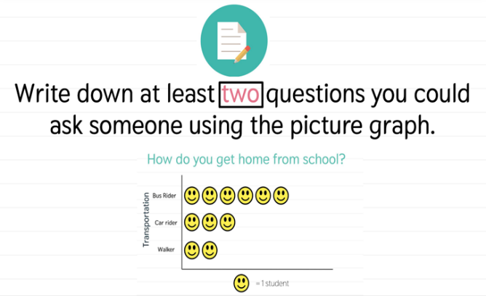
Figure 1. Before changes – pink and teal colors.
After I made changes [referencing Figure 2]: I selected a dark teal and a dark pink for the white background instead.
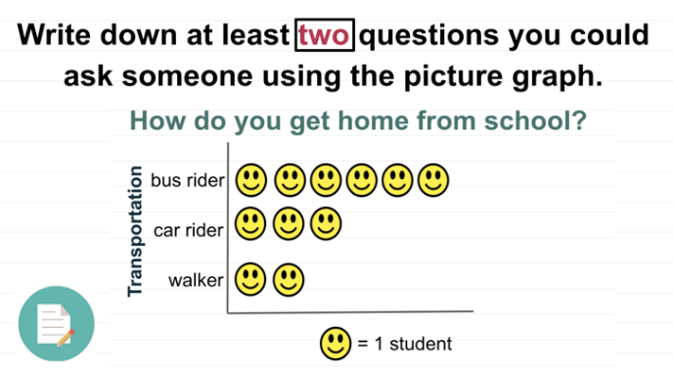
Figure 2. After changes – darker pink and teal color with a box around the important content.
The following post by students B & C demonstrates color contrast adjustments and discusses closed caption editing within Adobe Premiere Pro:
At first, we chose very colorful backgrounds (see Figure 3) and images but changed the slides to emphasize the text color and the contrast to the background color as well as the font size (18 pt.; see Figure 4).
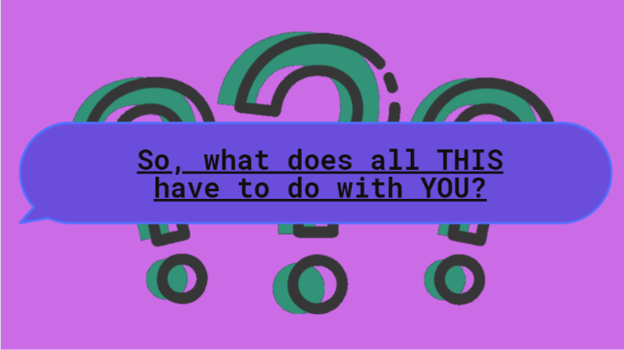
Figure 3. Before student changes – colorful backgrounds.
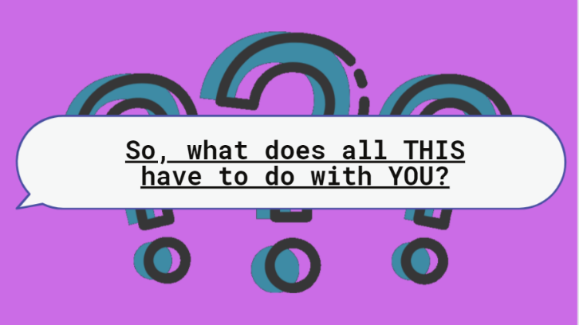
Figure 4. After student changes – text color and contrast.
One of the great features in Adobe Premiere Pro is the “closed caption display” that is available to add while editing the video. We plan to learn, then utilize this tool for our project. It has been decided to have the transcript available as a Google Doc, and the link for it will be shared at the end of the credits. The transcript will be the text form of the video’s narration to ensure equal understanding of information. Furthermore, we plan to make the transcript available in English & Spanish. We will review and edit the transcript together as a team to check for discrepancies. Our multimedia video will be stored in Google Drive.

Response Post Exemplar
The response posts do not typically include the visuals provided in the main posts. Most of the response posts are overly positive, with some suggestions or questions (see Critical Reflection section).
An exemplar response from Student A to another student includes the consideration of using a platform that automatically translates the audio into other languages:
I think your plan is feasible. I am not sure how to edit the transcript using Google Drive. I found it very easy to do so on YouTube when I was practicing. A suggestion that you may want to consider is having it accessible to other languages. Many of my families speak Spanish, so it would be beneficial to have the media accessible to their families to help encourage support from home. If there is a way to do it with Google Drive, please let me know!

Critical Reflection
This discussion forum activity has not changed much since the redesign in Spring 2021. Overall, students understand the content of this module. The accessibility content is the most cited consideration for future multimedia design and the students’ largest identified area of growth when asked at the end of the course.
Students regularly include correct accessibility information and specific examples (in visual and text format) they plan to apply within their video design supporting course objectives one and two. Students also regularly receive full points on the Discussion Forum Activity Rubric for both their main post and response. Although the students understand the content and no content has needed to be updated since the Spring 2021 redesign, a few changes are suggested to receive exemplary posts.
Currently, including examples, images, and screenshots of the students’ videos for the main post is optional as the students may not have developed these visuals yet. Although students should learn about accessibility before designing their visuals, as showcased in the Exemplar Forum Posts section, the inclusion of visuals in a before and after format or to demonstrate the application of accessibility in their video is more visually engaging and easier to see the students’ understanding of the content. Requiring students to include visual examples in their main posts may make the discussion forum more robust and assist the instructor in determining if the students understand the content.
As indicated earlier, the response posts are overly positive, and many students do not provide constructive criticism, suggestions, or questions. This may be due to students still developing their accessibility knowledge or because many main posts are highly detailed such as the examples in the Exemplar Forum Posts section. Regardless, providing a model response post for students to view prior to responding to their partner, making the response post prompts more explicit in constructive criticism, suggestions, and questions, or guiding students in how to respond to one another may make the feedback provided in the response posts more helpful for students.
Overall, the students receive this module and discussion forum activity well. When asked at the end of the educational technology program, multimedia design and accessibility are frequently listed as the students’ most crucial programmatic learning.

References
Bal, I. A. (n.d.). Accessible design guidelines [Infographic].
Educational Technology, MEd. (n.d.). Curriculum Core (15 credits). Name Redacted for Review. Retrieved January 4, 2023, from URL redacted for review.
General Services Administration. (n.d.). Create accessible digital products. Section508.gov. Retrieved January 4, 2023, from https://www.section508.gov/create/
Henry, S. L., & Dick, W. (Copyright © 2018 W3C ® [Henry & Dick]). WCAG 2.1 at a glance. W3C Web Accessibility Initiative (WAI). Retrieved January 4, 2023, from https://www.w3.org/WAI/standards-guidelines/wcag/glance/
Ibrahim, A. A. (2015). Comparative analysis between System Approach, Kemp, and ASSURE instructional design models. International Journal of Education and Research, 3(12), 261-270.
International Society for Technology in Education. (2017). ISTE standards: Educators. Retrieved January 3, 2023, from https://www.iste.org/standards/iste-standards-for-teachers
Meredith S. (n.d.). WCAG 2.1 – Principle 1: Perceivable [Infographic]. Venngage. Retrieved January 4, 2023, from, https://infograph.venngage.com/ps/L5qxGXplL38/wcag-principle-1-perceivable
U.S. Access Board. (n.d.). About the U.S. Access Board. Retrieved February 5, 2023, from https://www.access-board.gov/law/ra.html#section-508-federal-electronic-and-information-technology
W3C. (2018, June 5). Web Content Accessibility Guidelines (WCAG) 2.1. https://www.w3.org/TR/WCAG21/
W3C Web Accessibility Initiative (WAI). (2016a, May 17). Web accessibility perspectives: Clear layout and design. YouTube. https://youtu.be/tfkzj5VC9P8
W3C Web Accessibility Initiative (WAI). (2016b, May 17). Web accessibility perspectives: Customizable text. YouTube. https://youtu.be/rbiI65Jcz5s
W3C Web Accessibility Initiative (WAI). (2016c, May 17). Web accessibility perspectives: Large links, buttons, and controls. YouTube. https://youtu.be/CzfKB3PuuIY
W3C Web Accessibility Initiative (WAI). (2016d, May 17). Web accessibility perspectives: Understandable content. YouTube. https://youtu.be/BYRxF2yInfA
W3C Web Accessibility Initiative (WAI). (2016e, May 17). Web accessibility perspectives: Video captions. YouTube. https://youtu.be/iWO5N3n1DXU
W3C Web Accessibility Initiative (WAI). (Copyright © 2017b W3C ®). Introduction to web accessibility and W3C standards. YouTube. https://youtu.be/20SHvU2PKsM
W3C Web Accessibility Initiative (WAI). (Copyright © 2016 W3C ®). Web accessibility perspectives: Colors with good contrast. YouTube. https://youtu.be/Hui87z2Vx8o
White, K., Abou-Zahra, S., & Henry, S. L. (Eds.). (Copyright © 2016 W3C ® [White]). Designing for web accessibility. W3C Web Accessibility Initiative (WAI). Retrieved January 4, 2023, from https://www.w3.org/WAI/tips/designing/

About the Author
Irene A. Bal is an Assistant Teacher Professor of Educational Technology at Loyola University Maryland with research interests in microlearning, micro-credentials, teacher professional development, computational thinking and computer science for pre- and in-service teachers, and innovative PK-12 classroom practices and technology. She is a doctoral candidate in the Instructional Design & Technology Program at Old Dominion University in Virginia. She can be reached at ireneabal1@gmail.com.

