Tinkering and Modeling: A Hands-on Learning Experience in a Supplementary Mathematics Classroom
  - William Tai, University of Idaho

Overview
In high school Geometry, three dimensional solids are often overlooked and not part of the regular curriculum. The exclusion of three-dimensional (3D) geometry can affect spatial relationships and cause learner anxiety, correlating to a negative relationship with environmental navigation (Lawton, 1994). To mitigate learner anxiety in the introduction and manipulation of spatial figures, Tinkercad was utilized for creative virtual design and papier mâché was used for a hands-on, artistic approach to mathematics.
Topics: 3D Design, 3D Modeling, Geometry, Hands-on, Spatial Learning
Time: Seven, 80-minute in-class sessions and two hours outside of class (make-up work/homework)

Materials
- Tablet devices (e.g., iPads, Android tablets, Chromebooks, PC’s, etc.) to access the Tinkercad cloud application
- Polyhedra Viewer (Alison, n.d.)
- Tinkercad or Tinkercad application for Tinkercad Classroom access (Autodesk Tinkercad, n.d.)
- Papier mâché materials (e.g., chicken wire, wire cutters, pliers, scrap paper or newspaper, 17-gauge wire, flour, water, and paint)
- 3D printer (any model or generation)
- Email account to log into Tinkercad Classroom for students (one account per group)
- First aid kit

Context-at-a-glance
Setting
A seven-day enrichment mathematics class at the University of Idaho, United States, TRIO Upward Bound Program.
Modality
Face-to-face
Class Structure
In class, students worked in groups of three to five on each of the activities.
Organizational Norms
The enrichment class took place after the COVID-19 shutdown and was the first face-to-face enrichment after the nationwide lockdown.
Learner Characteristics
Learners were 40 high school students who were TRIO eligible and classified as under resourced or underrepresented populations. TRIO eligibility is defined as low-income and/or first-generation college students (U.S. Department of Education, 2023).
Instructor Characteristics
The enrichment class was designed by a Ph.D. Candidate, majoring in STEM Education, serving as the summer instructor for the program.
Development Rationale
The exclusion of three-dimensional solids in high school geometry can be a factor in the inability for some to visualize spatial aspects in the real-world space (Lawton, 1994). Additionally, these activities were designed to make higher order mathematics more practical and approachable for learners.

Standards
This learning experience occurred in the state of Idaho, United States, with several state-level content standards and International Society for Technology in Education (ISTE, 2016) student standards met.
Idaho State Department of Education (2022b) Mathematical Practice Standards:
- 4. Model with Mathematics.
- 5. Use appropriate tools strategically.
- 6. Attend to precision.
Idaho State (2022b) Mathematical Content Standards
- G.GMD.4: Identify the shapes of two-dimensional cross-sections of three-dimensional objects, and identify three-dimensional objects generated by rotations of two-dimensional objects.
- G.MG.5: Use geometric shapes, their measures, and their properties to describe objects (e.g., modeling a tree trunk or a human torso as a cylinder).
- G.MG.7: Apply geometric methods to solve design problems (e.g., designing an object or structure to satisfy physical constraints or minimize cost; working with typographic grid systems based on ratios).
Idaho State Department of Education (2015) Visual Arts Standards
- VA:Pr5.1.8a: Collaboratively prepare and present selected theme based artwork for display, and formulate exhibitive narratives for the viewer.
Idaho State Department of Education (2022a) English Language Arts/Literacy Standards:
- 9/10.ODC-4: Report orally on a topic or text or present an argument, emphasizing salient points in a focused, coherent manner with relevant evidence, sound reasoning, and well-chosen details in a style appropriate to purpose, audience, and task.
ISTE (2016) Student Standards:
- 1.4.b: Design Constraints-Students select and use digital tools to plan and manage a design process that considers design constraints and calculated risks.
- 1.6.b: Original and Remixed Works-Students create original works or responsibly repurpose or remix digital resources into new creations.

Setup
The students were separated into two classes so that there was enough classroom space for them to distribute themselves for group work. Students formed teams with no less than three and no more than five students each. Roles were encouraged for each group (i.e., Materials Manager, Virtual Designer, Constructors, and Project Lead), so that students did not idle for long. All staff and instructors gathered to help students should they have any questions or concerns. In each class, there was at least one staff member who was first aid certified in case there were any accidents with students handling sharp tools, and a first aid kit.
At the beginning of each class session, the instructors displayed the daily agenda on a projected screen. The student with the role of Materials Manager was responsible for gathering that day’s supplies or tools from the instructor or staff. Once all materials were distributed, each class participated in the day’s specific activities.
During each class session, all instructors and support staff circulated the room to make sure students were on task and address any questions or concerns they might have. At the end of each class, the Materials Manager was once again responsible for returning all equipment that was checked out at the beginning of the class. For this experience, Day 7 was shorter than the others due to programmatic scheduling.
Prior to the implementation of this learning experience, instructors should create a Tinkercad classroom account, create student accounts, and assign the basic tutorials for student groups to complete (needed on Day 2), ensure there is enough filament, and the 3D printers are available (needed on Day 3), and gather all papier mâché materials needed for Days 4 and 5.

Context and Setting

Summer Enrichment Program Context
The summer enrichment program was hosted by University of Idaho TRIO Upward Bound as a collaborative effort between four separate Upward Bound grants. This learning experience occurred in Summer 2022. The summer programming included three modules of instructions, each taking place in a different part of the state. The second instruction module took place at the main campus of the University of Idaho in the College of Education, Health, and Human Sciences building. Participants of the enrichment program (N = 40 high school students) had full schedules of classes, meals, and healthy active lifestyle events. Additionally, for participants to experience an immersive college experience, they were required to stay overnight in assigned campus housing facilities.

Participants
To qualify for services provided by any Upward Bound project, the prospective participant must meet one of three eligibility requirements:
- Low-income family,
- First generation college student, or
- Both.
Student populations came from North and North Central Idaho and were part of the immersive post-secondary experience module. Prior to the first class, instructors met with the students for an informal introduction and talk about the general expectations for the class.

Project Goal
The project was for students to develop spatial understanding in mathematics with the help of makerspace technology and modeling techniques. The foundations of the project were based on a basic understanding of regular polygons. Regular polygons form the cornerstones of geometric solids in mathematics. The project featured the use of Tinkercad Classroom for students to design their three-dimensional models based on their understanding of geometric solids and spatial manipulation (https://www.tinkercad.com/). Tinkercad is a free cloud-based application created by Autodesk for 3D design, coding, and electronics (Autodesk Tinkercad, n.d.).
Three activities were created to facilitate learning for the students:
- Basic foundations of three-dimensional geometry.
- 3D modeling in a computer-aided design (CAD) program.
- Mathematical modeling in art.

Instructor Expertise
Instructors need to have a solid understanding of two-dimensional geometry as well as a conceptual understanding of three-dimensional geometry and its relationships to regular polygons. To facilitate any student questions regarding geometric solids, instructors must have a fluency in the process and manipulation of Platonic solids to form truncated solids.
Working expertise or understanding of Tinkercad or Tinkercad Classroom is also needed to facilitate the implementation of the computer-aided design portion of the learning objective. Instructors will also need to have working knowledge of how to make student projects into 3D printable objects. The use of 3D printers is essential to students making their virtual designs into physical reality via papier mâché.
Additionally, a conceptual or procedural understanding of how papier mâché is constructed would be helpful. This understanding could stem from, but not limited to, experiences in art or engineering perspectives.

Learning Representation
The project consisted of three separate activities. The first activity is a review of regular two-dimensional polygons with a brief introduction to three-dimensional geometric solids. The second activity was the design activity that used Tinkercad Classroom. The third activity was using a miniaturized 3D printed model to serve as a guide for the papier mâché representations.

First Activity: Mathematical
Foundations
A review of regular polygons including equilateral triangles, squares, and other regular polygons with less than eight sides took place prior to exploring three-dimensional figures. Instead of an instructor driven delivery, students were asked to volunteer information, establishing prior knowledge, about what makes a polygon regular.

Day 1
After assessing prior knowledge, students explored how regular polygons, with congruent sides, became the foundations of Platonic solids and Archimedean solids. With the aid of the Polyhedra Viewer (https://polyhedra.tessera.li/), students were able to see and manipulate, using the provided functions, to explore inter-related properties for solid geometry (Alison, n.d.). Additionally, groups of students were formed with no less than three students and no more than five students per group. The students chose unique names to identify the groups for later use. Roles such as Project Manager, Lead Designer, Tech Engineer, and Builders were suggested but not required for students to take on.
An informal formative assessment was given to measure overall understanding of solid geometry in relation to two-dimensional regular polygons.

Second Activity: 3D Modeling in CAD

Day 2
On the second day, one iPad was distributed to each student group. Students entered the Tinkercad classroom via a join code generated automatically by the Tinkercad system. Once enrolled in the Tinkercad class, each group completed the basic tutorials for making their 3D designs. After the tutorial, groups began their initial designs using principles in Tinkercad in relation to Platonic and Archimedean solids.

Day 3
On the third day, students continued working on their Tinkercad design projects (Figures 1 & 2). Students were instructed to finalize their initial designs for submission to the instructor. The instructor took the submitted designs and exported them to a compatible 3D printer software for preparation of the 3D print. Student designs were scaled down and multiple were placed in the same print process to maximize 3D printing efficiency (recommended for classrooms with less than three 3D printers).
An additional informal formative assessment was taken in the form of verbal reflective practices by the students to measure their understanding of the design process of digital artifacts.
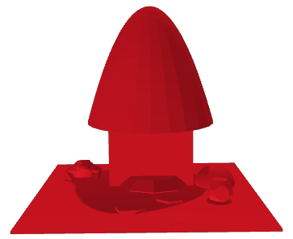
Figure 1. 3D mushroom house designed by students.
Figure 2. 3D Archimedean squid designed by students.

Third Activity: The Art in Math

Days 4 & 5
On days four and five, the printed 3D models were distributed to the students. Students then gathered the papier mâché materials and constructed their full- scale displays based on their 3D printed models. Verbal instructions guided students on how to start constructing their papier mâché sculptures.
Adult supervision was required throughout the day to ensure student safety. Wire cutters, fencing wire, and chicken wire can cause unintentional injuries. It is important to have at least one staff member who is first aid certified and a first aid kit, just in case.

Day 6
On day six, students had the opportunity to finalize their papier mâché representations of their scaled down 3D models. Finishing touches included painting and adding other decorative accessories to give students a chance for a personal flair.

Day 7
Day seven was the final day of the project. Due to the shortened schedule for the day, there was little time for final adjustments before students presented on their work. A panel of three judges were present to pick winners from the completed art displays.
Student presentations were the last formative assessment for the project (Figures 3 & 4). The judges based their decisions on student presentations on mathematical connections, initial concept, and final product.
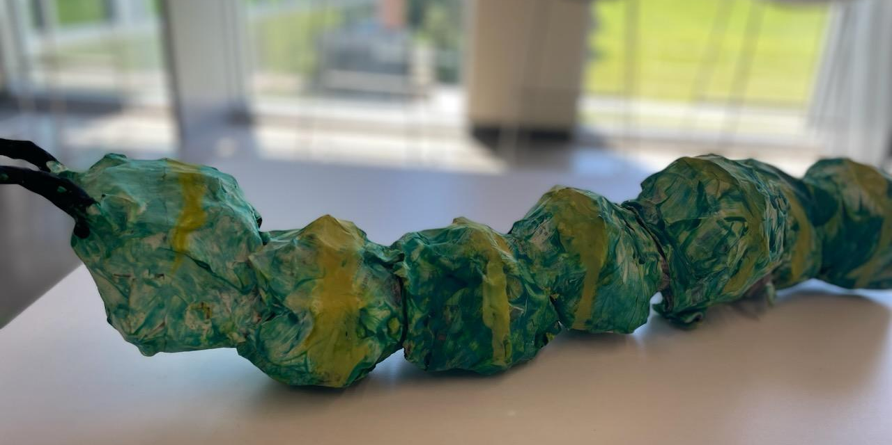
Figure 3. A papier mâché of a caterpillar. A winning student project from the last formative assessment.
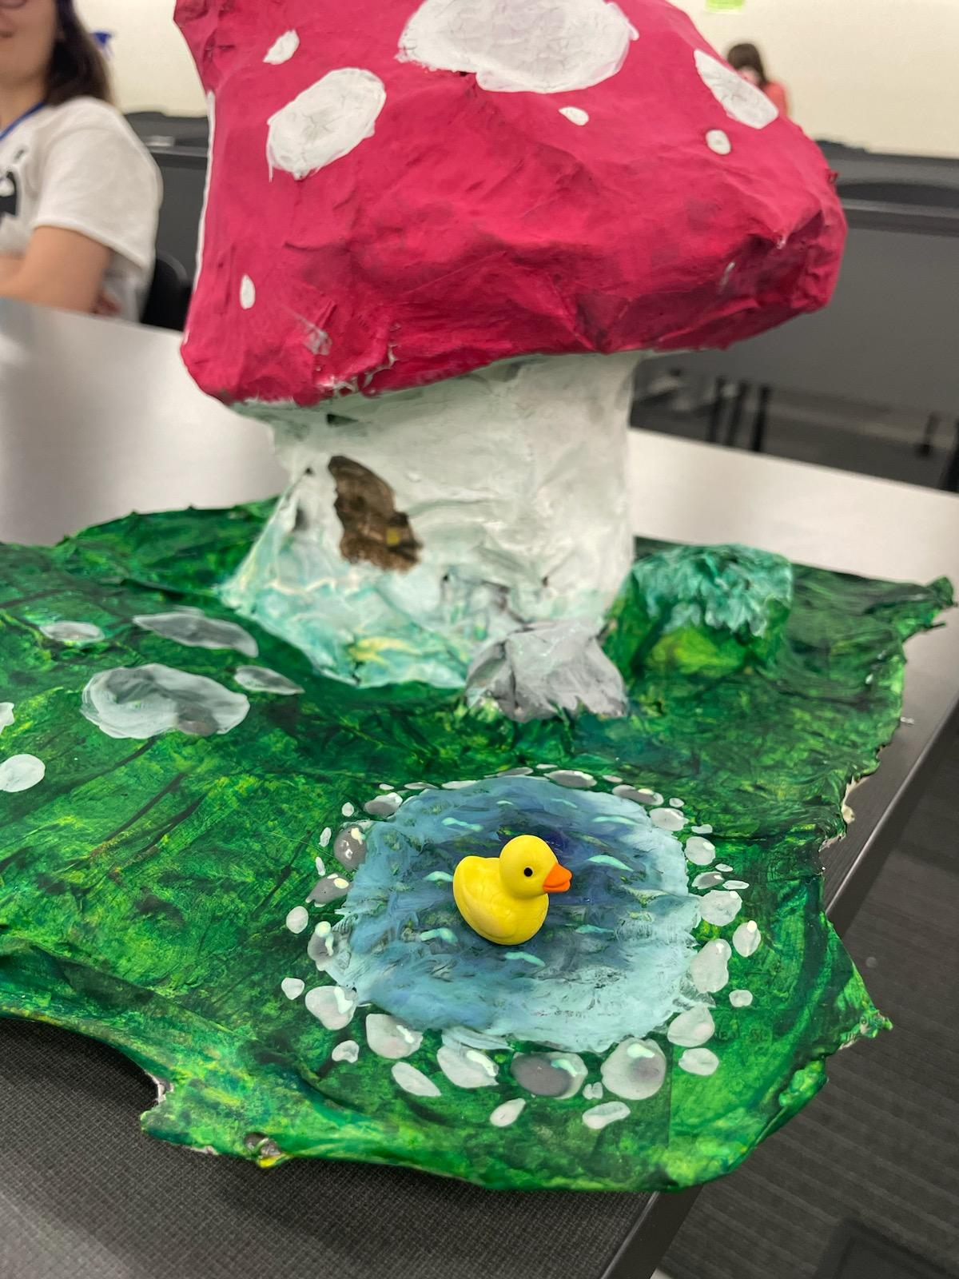
Figure 4. A papier mâché of a mushroom house. A winning student project from the last formative assessment.

Critical Reflection
Students that are eligible for TRIO programming are often from underrepresented, under resourced, and first-generation college student populations (U.S. Department of Education, 2023). Due to their backgrounds, not many are exposed to in-depth science, technology, engineering, and mathematics (STEM) topics. Additionally, those who have had a brief encounter with advanced topics have no connection to real-world applications to solidify their understanding.
Students were easily able to understand the formation of Platonic and Archimedean solids based on their two-dimensional counterparts. The visual representations of these three-dimensional figures in the Polyhedra Viewer helped the students’ understanding of spatial geometry. The awareness of understanding was observed through the development of the students’ three-dimensional renderings in Tinkercad. Students used Platonic solids as a base for forming Archimedean solids to construct their 3D designs. The use of hemispheres and other non-Platonic or non-Archimedean solids were also observed, and thus, gave an indication that the primary learning objective was achieved.
Not all the student designs were printed as some designs were incomplete, and some students did not submit a viable object file. Therefore, students who did not have a 3D printed design had to merge with other groups whose designs were printed. The 3D printed models were smaller than the students expected, however, this gave them the freedom to scale their papier mâché models to whatever size they desired. To ensure the submission of completed designs for printing, more time during the design step of the lesson is recommended. Additionally, more supervision is recommended during the design step to ensure that there are no inappropriate designs.
During the papier mâché construction, there were many students that were unfamiliar with the concepts of constructing their designs according to a smaller scale model. Additional explanations in scale proportionality are recommended to alleviate the confusion. In addition to learning the physical concepts of rigid frame construction in papier mâché models, students’ also experienced concepts in time management. The groups’ management of time to complete the papier mâché became the greatest obstacle for many students. Many of the papier mâché models were rushed at the end of the project, making it stressful for students to finish in the time provided.
Overall, the students were able to demonstrate their understanding of the topic to the instructors, support staff, and panelist judges. By the end of the experience, the student participants enjoyed the course topics and activities, in spite of the many challenges that were present.

References
Alison, N. (n.d.). Polyhedra viewer. Retrieved December 17, 2023, from https://polyhedra.tessera.li/
Autodesk Tinkercad. (n.d.). Retrieved December 17, 2023, from https://www.Tinkercad.com/
Idaho State Department of Education (2015). Idaho content standards arts and humanities visual arts. Retrieved December 17, 2023, from https://www.sde.idaho.gov/academic/shared/humanities/visual-arts/Visual-Arts-Standards.pdf
Idaho State Department of Education. (2022a, January 3). Idaho content standards English language arts/literacy. Retrieved December 17, 2023, from https://www.sde.idaho.gov/topics/admin-rules/files/negotiated-rulemaking/Idaho-K-12-State-Standards-for-ELA-Literacy.pdf
Idaho State Department of Education. (2022b, January 3). Idaho content standards mathematics. Retrieved December 17, 2023, from https://www.sde.idaho.gov/topics/admin-rules/files/negotiated-rulemaking/7-Math-Proposed-Content-Standards-Draft2.pdf
International Society for Technology in Education. (2016). ISTE standards: Students. Retrieved December 17, 2023, from https://iste.org/standards/students
Lawton, C. A. (1994). Gender differences in way-finding strategies: Relationships to spatial ability and spatial anxiety. Sex Roles, 30(11-12), 765-779. https://doi.org/10.1007/BF01544230
U.S. Department of Education. (2023, December 5). Federal TRIO programs – Home page. Retrieved December 17, 2023, from https://www2.ed.gov/about/offices/list/ope/trio/index.html

About the Author
William Tai is a Ph.D. Candidate at the University of Idaho majoring in STEM Education. He has worked with the TRIO Upward Bound program as a summer program instructor since 2017. His research interests include integrated methods for secondary mathematics and secondary science for teacher preparation, cognitive demand in secondary mathematics and secondary science classrooms, and content knowledge analyses in mathematics education teacher preparation.

Sharing & Modification Permissions
Unless otherwise noted, this article and its resources are published under a Creative Commons Attribution-NonCommercial-ShareAlike 4.0 International license:
You can freely share the article and its resources if you indicate the original authors, identify the Creative Commons license, and use them non-commercially.
You may also make and share modifications by:
- Identifying the original authors.
- Using the resources non-commercially.
- Licensing modifications under the CC BY-NC-SA 4.0 license (and including a link to it).
- Indicating what modifications were made.

