UDL Activities
  - Breanne Kirsch, Briar Cliff University
Here are several activities to help you practice with making files and content more accessible for your students. Please take the time to complete at least 2 of these activities. Though not required, it would be beneficial to complete all the activities to become more familiar with making accessible files.

Activity 1
Review this website about writing alt-text (Harvard University, n.d.) and the WebAIM alt-text recommendations (Web Accessibility in Mind [WebAIM], 2021) and then write down or type what the alt-text should be for the following images if you used them in a course. Feel free to see what the automatic alt-text is first and edit from there.

Image 1
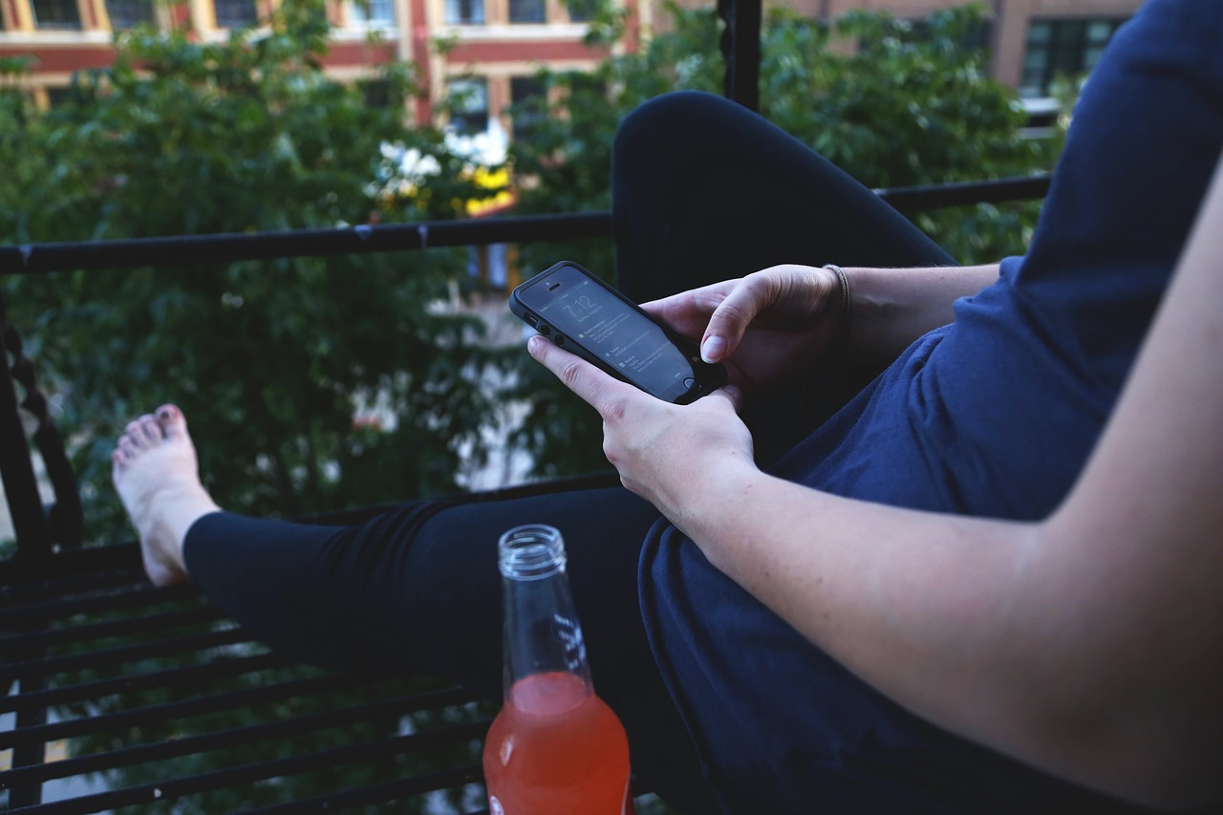
Note. From “Clusterflunk Stock Photo,” by E. Bailey, 2014 (https://commons.wikimedia.org/wiki/File:Clusterflunk_stock_photo._(23697914594).jpg). CC0 1.0.

Image 2
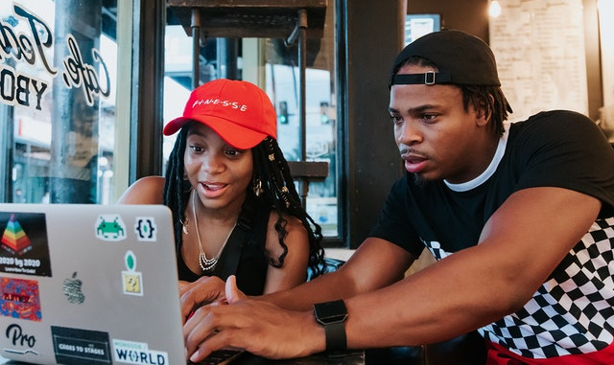Note. From “Friends Working on a Computer,” by Antoine Digital, n.d. (https://nappy.co/photo/536). CC0.

Image 3
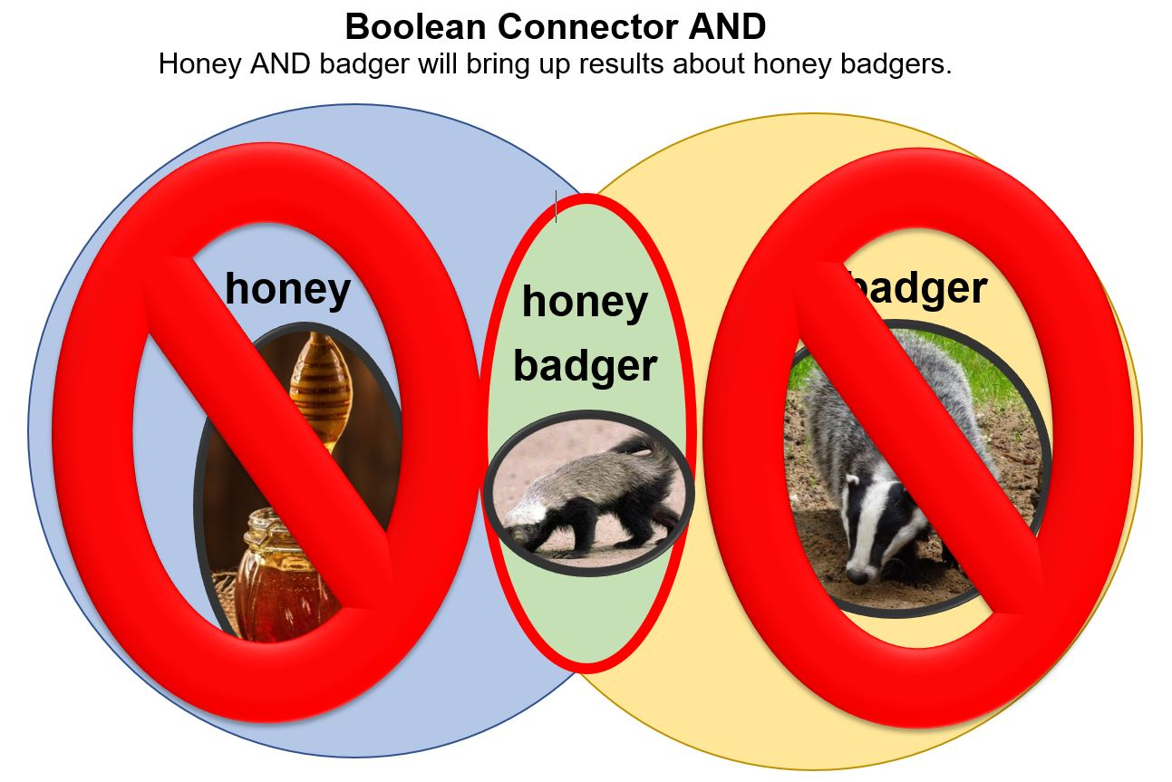
Created by Breanne Kirsch, CC BY-NC-SA.

Activity 2
View this video about an auto caption fail (Donoghue, 2022). Consider how accurate the auto captions are (or are not). Extra credit if you create a YouTube account, upload a short video (here is a short video that you can upload for practice; BooleanConnectors, n.d.), and edit the auto captions!

Activity 3
Try out the color contrast checker tool from WebAIM (WebAIM, n.d.a). This website color picker tool (ImageColorPicker.com, n.d.) might help you choose hex codes/colors to check the contrast.

Activity 4
Use the Microsoft accessibility checkers on the Bad Document Example (Microsoft Word) and Bad PowerPoint Example (Briar Cliff University, n.d., Accessibility Activities) and try to make corrections for any accessibility issues that may come up. Also keep in mind what you learned from updating your course syllabi as you complete this activity. There is more to consider than what the accessibility checker may find!

Activity 5
Use the WebAIM WAVE tool (WebAIM, n.d.b) to check a website’s accessibility.

References
BooleanConnectors. (n.d.). Retrieved May 17, 2023, from https://www.dropbox.com/s/marrdbgn9wiz969/BooleanConnectors.mp4?dl=0
Briar Cliff University. (n.d.). Universal Design for Learning: UDL Academy. Retrieved May 14, 2023, from https://briarcliff.libguides.com/c.php?g=1027132&p=8400913
Harvard University. (n.d.). Write good Alt Text to describe images. Retrieved May 17, 2023, from https://accessibility.huit.harvard.edu/describe-content-images
ImageColorPicker.com. (n.d.). Color picker. Retrieved May 17, 2023, from https://imagecolorpicker.com/color-code/474d55
Donoghue, C. [@Lovemuddoglady]. (2022, November 30). Auto caption fails!!! 😂😂😂 #lovemud #doggroomingtips #doggroomer #autocaptionfail. YouTube. https://youtube.com/shorts/lItAeeLrAwQ?feature=share
Web Accessibility in Mind. (n.d.a). Contrast checker. Retrieved May 17, 2023, from https://webaim.org/resources/contrastchecker/
Web Accessibility in Mind. (n.d.b). Wave: Web accessibility evaluation tool. Retrieved May 17, 2023, from https://wave.webaim.org/
Web Accessibility in Mind. (2021, October 19). Alternative text. Retrieved May 17, 2023, from https://webaim.org/techniques/alttext/

