EDCT 2030 Syllabus & Schedule
Technological Applications in Education
Spring 2020
Tuesdays 5:15 to 8:15 pm

Instructor Information
Xinyue (Ren) Ren, Ph.D. Instructional Technology
Office hours: By Appointment (in person or online via Zoom)

Class Meeting
This class will run in a hybrid format. There is a mix of face to face, synchronous and asynchronous online sessions. Instructor will set up synchronous and asynchronous online meeting with the class accordingly.

Class Policies

Special Note: Any educator found guilty of academic misconduct may be denied a teaching license by the Ohio State Department of Education.

LiveText Software: LiveText is used to complete the state required electronic portfolio. You may purchase this online at www.livetext.com. Purchase the least expensive version without the video.

Grading Scheme
The grading scale being used is as follows:

A | 100-93 | C | 73-77
A- | 90-92 | C- | 70-72
B+ | 88-89 | D+ | 68-69
B | 83-87 | D | 63-67
B- | 80-82 | D- | 60-62
C+ | 78-79 | F | 59 or below

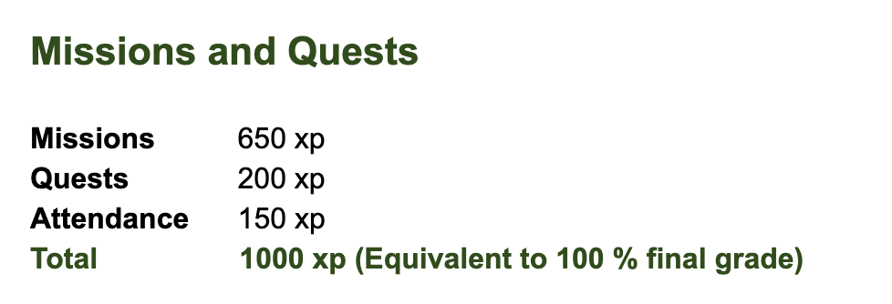

Schedule
(Assignments Due Mondays at Midnight)

Week & Date | In-Class Topics  &  Tech Exploration for Weekly Reflections (in green) | After-Class  Reading/Video and Assignments to be Completed for the Following Week
Week 1: Jan 14  Face to Face Meeting  Objective:  Students will become familiar with Google products and applications | Introductory Meeting  -Introduction  -Syllabus  -LiveText (Must purchase basic account to complete course)  All Things Google:  Google Expedition, Google Earth, YouTube, Google Drive, Google Chrome Web Store, Google Data, Google Plus, Google Calendar, Google Arts and Culture, etc. | Read-  Digital Natives  Start Working on Missions and Quests  Purchase LiveText Account  Complete-  Weekly Reflection Due Monday, Jan 20
Week 2: Jan 21  Online Meeting  Objective:  Students will become familiar with different online communication tools. | Course Reading  -Digital Natives  -Technology Savvy  -Digital Immigrants  -Digital Divide  Video Conferencing: Skype, Google Hangouts, OOVOO, Adobe Connect, Zoom.Us, Snapchat, Wechat, LINE | Read-  Digital Media & Learning  (Read 1st half: from p3 to p34)  Work on Missions and Quests  Complete-  Weekly Reflection Due Monday, Jan 27  One Quest Due Monday, Jan 27
Week 6: Feb 18  Asynchronous Online  Objective:  Students will become familiar with assessment and image editing tools. | Course Reading  Read-  Teachercraft (Chapter 7)  -Minecraft in the Classroom  -Game-Based Class Activity Design  Assessment: GoFormative, Rubrics, Remind, Software evaluation/CAI, Poll Everywhere, Kahoot!  Image Editing: Book Creator, Pixlr, PicMonkey, Photoshop, PhotoScape, GIMP, Paint.NET, Google Nik Collection, Fotor, Vintager, Sumo Paint, IrfanView | Read-  2019 Horizon Report  Work on Missions and Quests  Complete-  Weekly Reflection Due Monday, Feb 24  One Quest Due Monday, Feb 24

