Creating Interactive Books with
Augmented Reality
  - Sarinporn Chaivisit¹, Younglong Kim², Thanh Do³, and Ayodeji Ibukun²
¹ Kasetsart University, Thailand; ² Oklahoma State University, United States; ³ Thai Nguyen University,
Vietnam

Overview
This workshop helped educators to create interactive Augmented Reality (AR) books at the Association for Educational Communications and Technology (AECT) conference. The goal of the workshop was to train participants to gain skills in integrating AR into their professional lives. All participants created an AR book or curriculum vitae during the workshop. This manuscript describes the specific activities, assigned times, and educational tools used during the workshop. This workshop was designed for participants with no previous knowledge or skills in developing AR materials. Educators interested in teaching educational technologies, especially AR, could be instructors for this lesson. Preservice teachers could also take this lesson.
Topics: Augmented Reality, Educational Technology, Interactive Books, Workshop
Time: 120 minutes

Materials

The following materials are needed for the instructor:
- Workshop Presentation Slides (PPT)
- Computer with Zoom and internet (instructors & participants)

The following materials are needed for participants:
- Multimedia content for creating an AR book
- Smartphone or tablet with Zappar app
- Canva online platform
- Flipsnack web-based software
- Computer with Zoom and internet (instructors & participants)

Context-at-a-glance
Setting
This workshop was conducted virtually for educators and instructional designers at an AECT conference.
Modality
Online, synchronous delivery
Class Structure
Participants were divided into two groups of roughly equal sizes based on their choice of activity: (1) making a curriculum vitae or (2) an interactive book.
Organizational Norms
The goal of the organization was to build a network among educational researchers and practitioners to discuss technology integration to maximize learning and teaching (AECT, n.d.).
Learner Characteristics
Most participants had no previous experience in developing AR materials.
Instructor Characteristics
Instructors were Ph.D. students and had experience using educational tools to create AR materials.
Development Rationale
The learning objectives included exploring educational tools and using the tools to create AR artifacts. This lesson aimed to equip participants with the technical skills to create interactive AR books that foster interaction between learners and the learning content. It was assumed that participants could use these skills professionally.
Design Framework
ADDIE Framework: Analysis, Design, Development, Implement, and Evaluation

Standards
The International Society for Technology in
Education (ISTE) Standards for Educators (2017) applied in this lesson are as follows:
2.5.a: “Use technology to create, adapt and personalize learning experiences that foster independent learning and accommodate learner differences and needs.”
2.5.b: “Design authentic learning activities that align with content area standards and use digital tools and resources to maximize active, deep learning.”

Addie Model
The instructors applied the ADDIE model, a five-step instructional approach, to deliver this workshop. According to Dick et al., (2015), ADDIE represents Analysis, Design, Development, Implementation, and Evaluation. The following explains the steps that the instructors took for this lesson.
Analysis: The instructors analyzed the previous AR workshop that was successfully held at the AECT 2019 convention to understand their target audience and their needs to learn new technology skills. Through multiple personal communication, the instructors decided to conduct a further workshop to provide in-depth instructions for creating AR materials and created this online lesson.
Design: The instructors reviewed materials and information from the analysis step to finalize the goal, contents, technology tools, and procedures for the workshop.
Development: In this step, the instructors were involved in creating their own AR books to test and review the effectiveness of educational technology tools such as Zappar and Flipsnack. At the end of the development step, the instructors created three AR books and revised the procedures for conducting the workshop. The instructors used these AR books as samples during the workshop. In this stage, the instructors also designed the Workshop Presentation Slides presentation as a main resource for the workshop. The slides contained each step that participants would follow to create AR books/CVs (participants had a choice between making an AR book or a CV that they could use for their professional development).
Implement: During the implementation step, the instructors provided instructions and demonstrated skills for participants to create their own AR materials (see Learning Representation section for more details).
Evaluation: At the end of the implementation of the workshop, the instructors gathered the AR Books/CVs that participants made. Furthermore, the feedback that participants gave to determine the effectiveness of the workshop was reviewed to make any necessary adjustments for future iterations (see Critical Reflections section).

Context and Setting
At the workshop, Augmented Reality (AR) was chosen in lieu of other technologies such as paper-based instructions or web-based delivery because AR is known for fostering interaction between learners and learning content. As an emerging technology, AR has the potential to transform regular books into engaging interactive books (Asai et al., 2005) to help build user’s self-efficacy (Kim et al., 2019), and to encourage users to explore technology in their own space (Chaivisit et al., 2019). Unique features of AR enable users to see both real-world objects and interact with virtual content on an AR application (Azuma, 1997). For example, Ibukun et al. (2019) developed an AR application for a community science drought monitoring project in which users used a smartphone, tablet, or iPad to activate an AR code on a rain gauge. Following a successful trigger from the AR code, multimedia instructions (i.e., images, videos, and texts) appeared, guiding users on how to properly monitor drought conditions using a rain gauge.
For these reasons, it was expected that AR would allow users to interact with normal books or worksheets and explore multimedia content. The purpose of the workshop was to facilitate participants’ skillset to create interactive AR books with the main goal to promote skills within educators and instructional designers to use AR technology and develop AR books to increase their students' engagement.
The instructors conducted a two-hour online workshop to help participants make their own AR book that they could utilize in their classrooms or a CV that they could use for their professional development. In this lesson, participants were expected to learn how to create multimedia books/CVs by using several platforms such as Canva (n.d.), Zappar (n.d.), and Flipsnack (n.d.).
Canva (n.d.) was used by participants to create page designs while Zappar (n.d.) was used to add AR content, and Flipsnack (n.d.) was used to transform the AR page designs into online books where the pages flip. The resulting AR book could contain multimedia materials. The instructors informed participants to prepare any multimedia resources such as text-based learning contents, graphics, videos, songs, web pages, or web-links regarding their teaching materials before the workshop. These multimedia features were curated to help maximize the use of the book, so the participants were expected to prepare diverse learning materials to create the AR books. For CVs, the participants needed to prepare their text-based CVs, self-pictures, and any videos.
The AR workshop aimed to help participants to create their own AR based materials and to achieve a thriving learning experience. In this lesson, the learning objectives of the participants were:
- Explore educational tools such as Zappar, Canva, and Flipsnack that can be used for creating interactive books.
- Explore the sample books to gain basic ideas and knowledge for participants to create their own interactive AR materials.
- Utilize different educational tools including Zappar, Canva, and Flipsnack.
The expected outcomes in this workshop were that participants would develop their own AR based books or CVs by utilizing the introduced tools by the instructors.
The instructors played important roles. Their main tasks were:
- Introduce the features of the tools required to create the AR books/CVs.
- Guide participants to upload multimedia materials into the web-based tools.
- Provide timely feedback regarding participant needs or requests.
- Ensure all participants successfully created their individual AR based materials.
It took ten weeks to prepare for this workshop. The instructors met one hour per week to create sample AR books and to discuss how to present instructions during the workshop. Three weeks before the workshop, the instructors created a Facebook page to provide and advertise information about the workshop (AR Flourish Books, n.d.). To deeply understand/analyze the learners, two weeks prior to the workshop, the instructors sent a welcome email to participants and asked them to complete a poll regarding participants’ prior knowledge about AR tools. Participants also indicated whether they wanted to create their own AR book by themselves or whether they would like to create one AR book together as a team. The poll helped instructors learn about participants’ background knowledge and confidence levels as they prepared the workshop materials. The following email was sent to the participants:
Greetings,
We are so delighted to have you all in the workshop, [Title] - Virtual Convention on [Date & Time].
We would like to ask you a quick question to serve you better in the workshop.
Could you please choose one of the following options?
1) I would like to create my own AR book, so I will prepare ahead and bring to the workshop all the pictures, texts, and video contents needed by me during the workshop.
2) I would like to create an AR book together with other participants during the workshop. In this case, I will bring my professional photo and CV to the workshop.
Sincerely yours,
[Instructor’s Name]
Afterwards, the instructors gathered all responses and they decided to divide the participants into two groups:
- General AR book creation team.
- Individual CV creation team.
Group 1, general AR book creating team, made their own AR books during the workshop, while Group 2, individual CV creation team, made one AR book as a team with their CVs.
The instructors sent another email to participants requesting they prepare and bring essential materials, including a laptop computer, smartphone, or tablet to participate in AR content creation activities. Specifically, for Group 1, the participants were notified to bring some text-based content such as one or two paragraph(s), images, or YouTube video link(s) related to the book they wanted to create. Group 2 was notified to prepare materials related to their CVs.

Learning Representation
The activities in the lesson were as follows:
- The instructors introduced the objectives of the workshop.
- The participants explored the tools and AR books.
- The participants created an AR book or a CV.
- The instructors led a wrap-up discussion.

Introducing the Lesson (10 mins)
The instructors introduced the objectives of the lesson to the participants using the Workshop Presentation Slides (slides 1-10). The participants accessed the slides together from the provided URL link via the Zoom chat. The instructors explained the goals of the workshop: participants would create either their own AR book or CV by using diverse tools such as Canva (n.d.), Zappar (n.d.), and Flipsnack (n.d.). Afterwards, the instructors showcased their created AR books just before providing step-by-step instructions to the participants. This introduction section informed participants about what they would do in this lesson. The participants were notified that at the end of the workshop, they could share their AR books and their experiences.

Exploring Tools and AR Books (10
mins)
The tools that the participants explored were software applications including Canva (n.d.), Zappar (n.d.), and Flipsnack (n.d.). These three tools were selected because they were free and easy to use, especially for beginners. To help participants to explore the tools by themselves, the instructors shared Workshop Presentation Slides with the participants via the Zoom chat.
The Workshop Presentation Slides included hyperlinks that directly connected to the websites of the tools and the three sample AR books that the instructors made as samples (slide 11): Learn English with Worship Songs (Kim, 2020), Healthy Harvest (Chaivisit et al., n.d.), and Basic Skincare Routines (Do, n.d.) At this time, the instructors encouraged participants to explore the multimedia books made by the instructors. Afterwards, instructors reviewed the contents that participants brought for the workshop, including images, texts, and videos. To review the contents, each participant shared their screens on Zoom or shared the links in the chat box on Zoom with the instructors.
After participants explored the tools, the instructors guided participants to set up their user accounts on Canva, Zappar, and Flipsnack. The instructors used the prompts in the Workshop Presentation Slides (slides 16, 23, and 39) to support participants in creating accounts and logging into the platforms. The following provides the basic descriptions of each of the three tools. Afterwards, the three sample books are described.

Canva
Canva (https://www.canva.com) is an online platform where posters, flyers, presentations, worksheets, posts, etc. can be designed and published or printed (Canva, n.d.). Canva is easy to use with special functions such as numerous ready-to-use templates, auto-saving, and collaboration. Canva provides various options for users to share, download, design, and print their projects. In this workshop, the participants were encouraged to use multimedia, such as audio files, pictures, or emoticons as the content for designing their AR books.

Zappar
Zappar (https://www.zappar.com) is a website that enables users to create their AR experiences through the simple drag-and-drop Zapworks platform (Zappar, n.d.). Users insert multimedia, including videos, images, photo albums, songs, and website hyperlinks to create their own AR products. In this workshop, participants used Zapworks Designer tools to design their AR content. Finally, participants downloaded the Zappar app on their own device and created accounts to use tools including Canva, Zappar, and Flipsnack by following the instructions given on Zoom by instructors. This was where the actual task of designing the AR started. It began by uploading all media contents into the Zapworks interface. Then media could be arranged into scene work areas.

Flipsnack
Flipsnack (https://www.flipsnack.com) is a web-based software that users can use for free to create digital products, such as books, magazines, portfolios, and various kinds of media (Flipsnack, n.d.). This tool is easy to use for publishing digital flip books. The instructors guided the participants to upload the files from Canva to Flipsnack.

AR Book Samples
The instructors created three AR book samples): Learn English with Worship Songs (Kim, 2020), Healthy Harvest (Chaivisit et al., n.d.), and Basic Skincare Routines (Do, n.d.). The instructors introduced these books using slide 11 on the Workshop Presentation Slides. A page from each book was hyperlinked to the individual books on the slide.
The first book was Learn English with Worship Songs (Kim, 2020), which illustrated ways in teaching students to learn English through songs and interactive games (Figure 1). When participants scanned the Zap codes on each page of the book, they were able to listen to the song through their devices.
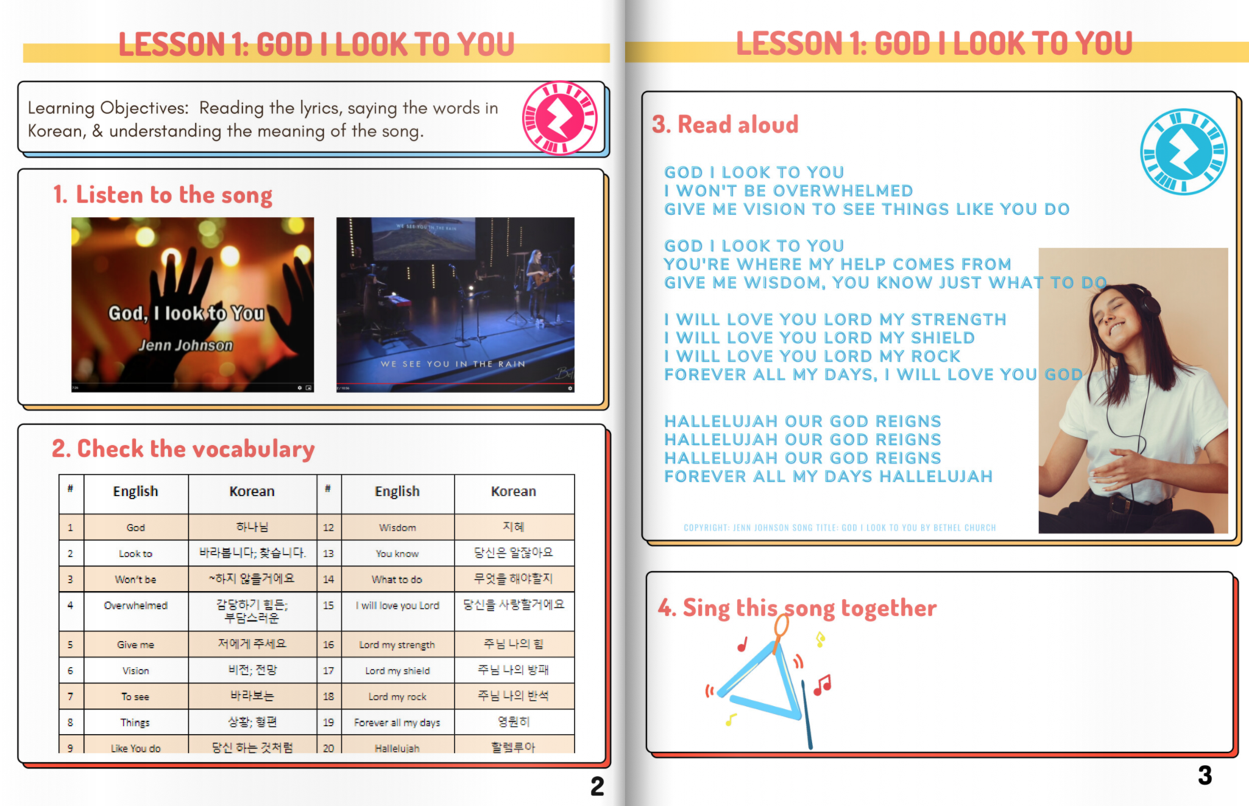
Figure 1. Page from the AR book “Learn English with Worship Songs” (Kim, 2020).
The second book was Healthy Harvest (Chaivisit et al., n.d.), which provided instructions on how to live healthy lifestyles through cooking and eating healthy meals (Figure 2). The sample page was used to guide participants on how to create book pages on Canva and Zappar.
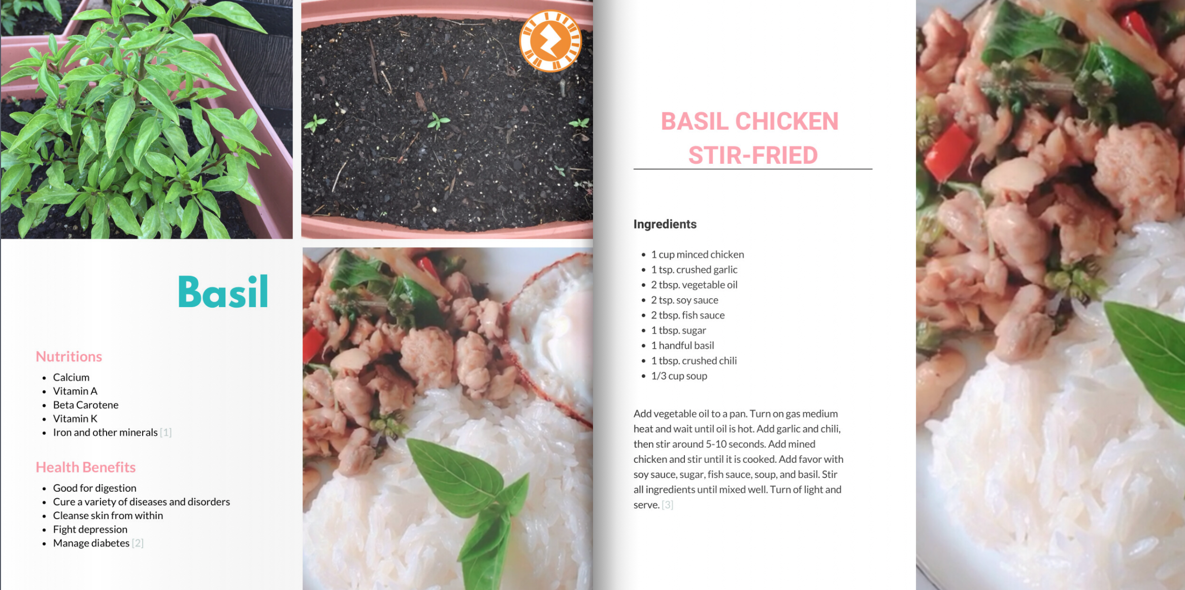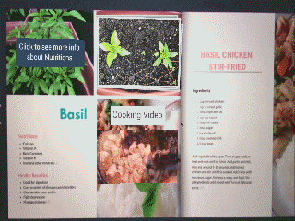
Figure 2. Page from the AR book “Healthy Harvest.”
The third book was Basic Skincare Routines (Do, n.d.), which advised readers on how to pamper themselves with easy-to-follow skincare routines. The book demonstrated an online flip book via Flipsnack (Figure 3).
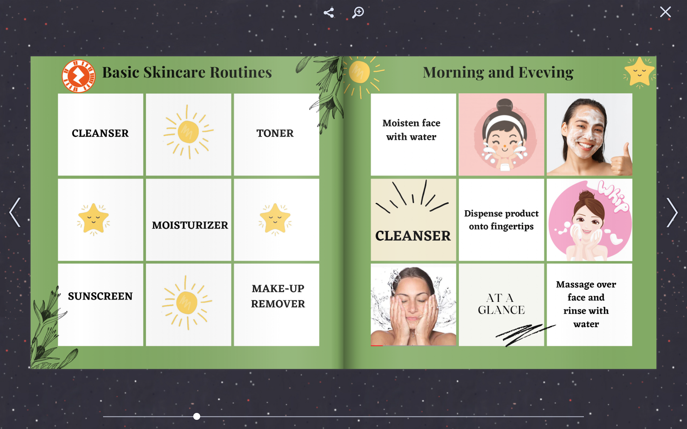
Figure 3. Page from the AR book “Skincare Routines.”
After exploring three sample books together, the participants individually scanned Zap codes and interacted with the content. After that, the instructors assigned three main tasks to the participants (see Workshop Presentation Slide 14):
- Create book content on Canva.
- Add multimedia content on Zappar.
- Turn Canva content into an online book on Flipsnack.
The instructors guided participants through the first two steps by using the Healthy Harvest (Chaivisit et al., n.d.) book as an example. Then, the instructors used the Skincare Routines (Do et al., n.d.) book to guide participants through task three, turning Canva content into an online book on Flipsnack. The details of the instructions to complete three main tasks are stated in the following section.

Creating an Individual Book or CV (60
mins)
The instructors guided participants to complete the three main tasks:
- Create book content on Canva.
- Add multimedia content on Zappar.
- Turn Canva content into an online book on Flipsnack.
The Workshop Presentation Slides were shared with the participants to present the instructions in the main Zoom room. The whole process was explained in Steps 1 to 3 below. Step 1 took 20 minutes. Step 2 took 30 minutes, and Step 3 took 5 minutes.
During Step 1, the participants started the design of their AR books or CVs by creating content on Canva. The instructors were on standby to answer any question from the participants. At this time, slides 16-22 were used from the Workshop Presentation. Each step is detailed below.

Step 1: Create Paper-Based Instructions on Canva (20 minutes; Slides 16-22)
- Log in to Canva.com.
- Search for a book template.
- Select Photo Book.
- Select a template.
- Rename the book title.
- Add content such as pictures and text that participants prepared according to the emails sent prior to the workshop.
- Save the pictures and text created through Canva on a personal device.

After completing Step 1, the participants moved the content from Canva into Zappar (Workshop Presentation Slides 23-38) as Step 2. The details of what the participants did are shown below.

Step 2: Add Multimedia Content on Zappar (30 minutes; Slides 23-38)
- Log in to Zapworks.
- Create a new Zapworks project.
- Name the project.
- Select Designer and click Next Step.
- Choose Zapcode and click Create Project.
- Click Open Designer.
- Click Continue Button.
- Click Upload Tracking Image.
- Select a tracking image.
- Click Use This Tracking Image.
- Add multimedia content from the menu.
- Click Publish and Preview. Then, scan a temporary AR code with the Zappar App.
- Download a Zap code as .PNG file.
- Upload the AR code to your Canva design.
- Download all pages from Canva as PDF Standard Format.

During Step 3, the participants uploaded the PDF files from Step 2 into Flipsnack where their CVs or AR books were published (Workshop Presentation Slides 39-44). The instructors were also on standby to answer any questions as the participants progressed through the completion of the tasks. The details of what the participants did in Step 3 are below.

Step 3: Turn Paper-Based Instruction into a Book on Flipsnack (5 minutes; Slides 39-44)
- Login into Flipsnack.
- Choose My Flipbooks.
- Upload PDF (Workshop Presentation Slide 41).
- Customize the book by clicking different colors or background (Workshop Presentation Slide 42).
- Save and publish the book online.
- Share the link.
During these steps, the instructors asked the participants if any of them had any questions before moving on to the next step. When the participants had challenges with a step, the instructors offered feedback individually in the prepared breakout rooms on Zoom. Between the steps, 5 minutes were used for answering any questions from the participants.
All three steps described above were clear and easily followed by participants. The participants asked questions when they missed some instructions. If a participant needed individual help, the breakout room function of Zoom was utilized. The breakout rooms were helpful when the participants wanted the instructors to check their screen together. In this way, the main instructor could proceed with the presentation while the participants received the timely and customized feedback in the breakout room. Once participants who had questions received instructional help in the breakout room, they were able to catch up with their peers.

Group 1: General AR Book Creation Team
Group 1 prepared the materials for creating AR books. The participants’ expectations for this workshop were to gain specific skills such as how to use an AR platform, edit, and publish an online book. Some of the participants were able to create only one or two pages by practicing the new skills at the workshop, while other participants were able to create more than three to five pages independently.

Group 2: Individual CV Creation Team
Group 2 prepared their pictures and text-based CVs. During the workshop, each of them created one page of the resume on Canva and created a Zapcode on Zappar. Individual pages were decorated in ways they chose. When the participants completed creating their own pages on Canva, they exported the pages into Zappar. Afterwards, the instructors compiled all of the participants’ resumes by using Flipsnack to present them as a flip book.

Wrapping-up Discussion (10 mins)
The instructors wrapped up the lesson by having participants present their created AR books or CVs. The discussion prompts on Workshop Presentation Slide 46 were used to facilitate a reflection of the workshop.
Participants presented their AR based books, and the CV book as showcases where other participants could interact with the books made via AR codes. In addition, participants shared their experience of creating AR based content as well as potential ideas of using Zappar and other tools to enhance their AR books. One of the participants mentioned that she enjoyed making her first AR book. Another participant said, “This was a lovely hand-on experience. I will explore more!” Most of their opinions in learning the skills for creating AR books were highly positive.

Critical Reflection

This workshop was hosted to train educators to use educational technologies to create educational products as well as to design and develop authentic learning activities by using digital tools (ISTE, 2017). The majority of the participants had no prior experience with creating AR artifacts before this workshop. During this workshop, all participants built the skills of using multimedia tools to design and develop their AR based tools; thus, this lesson can be advantageous to educators who are in the beginning level of the educational technology skills.
All of the participants were quick to adapt and work comfortably in organizing their AR contents in the platforms provided for use in the workshop. The participants created their AR books according to their preferences: participants in Group 1 created their AR based books and participants in Group 2 created an accumulated CV book together. At the end of the workshop, during the discussion session, participants were able to scan the AR codes to explore their own projects and other participants' works.
To help novice AR users to be successful in creating AR books, presenting specific goals and clear instructions were highly beneficial along with an encouraging atmosphere by the instructors. The learning objectives in this lesson included participants’ 1) exploring educational tools such as Zappar, Canva, and Flipsnack that were used for creating interactive books, 2) exploring the sample books to provide the basic knowledge for participants to create their own interactive books, and 3) learning how to utilize different tools, so they could use them by themselves after this lesson. The outcome was that all participants in this workshop developed either their own AR interactive books or a CV book by using the introduced tools. The participants seemed to be enjoying the activities, and further, they shared ways they could integrate AR into their own classroom to maximize their teaching and student learning during the discussion session. One of the participants thought of making simple AR Zap-codes that were linked to multimedia content for visualizing complicated concepts or ideas.

Participants were educators, including professors and graduate teaching assistants, and all of them were able to use the technologies introduced to create either their teaching materials or personal materials according to their choices. This was one of the successful components of the instruction as the participants were able to have their own choice regarding the projects they would make. In addition, this preparation was also helpful to the instructors to be ready to provide customized instructions based on the different skill levels. Also, this lesson is a great example of facilitating participants to create their own educational resources beyond listening to lectures for two hours. It is an important note that for two hours, all the participants designed and developed authentic AR based content. When considering a one-time workshop for two hours, this lesson was successful in facilitating the participants regardless of their previous knowledge and skills.
For further workshops, discussion might be helpful regarding specific teaching topics and how and why AR can facilitate the goals of each topic. This workshop can be a first step to support participants who are interested in learning the concept of AR and in practicing using some new tools for their teaching classes. The ideal outcome after this workshop would be that the participants would make their own AR books or worksheets that they could utilize in their respective classrooms.

Challenges And Solutions

Time Constraint
Challenges. One-on-one feedback was possible, but there was a limitation on using Zoom to check if everyone was on the same page. For example, when we hosted a face-to-face workshop at the previous conference, we were able to check if the participants' work went well or not, by walking around the room. With Zoom, however, participants had to share a screen to ask a question and then, the other participants had to wait for each question to be answered. Fortunately, participants were active in asking questions, but sharing one screen on Zoom at each time took more time than the instructors expected.
Solution. Every participant could have a different pace in following each step. Therefore, we would like to recommend recording the session, and sharing it with the participants, so that participants could watch the videos after the lesson.

Background of Participants
Challenges. Every participant had different skill levels in using AR tools as well as the resources available to them. After each instruction was given, the pace each participant followed instructions was different, especially when the participants created their own accounts. Some participants understood and implemented the instruction smoothly, and others took more time and needed extra help. When a participant asked a question, everyone in the virtual room had to wait until the issue was answered. It was great to give specific instructions to help those who needed it, but sometimes it delayed proceeding to the next steps. Still, reviewing the same stage was not hurtful, but rather helpful to be on the same page for every student/participant.
Solution: While participants had different skill sets, most people might be able to create their user accounts. Thus, we recommend that participants create their user accounts on Canva, Zappar, and Flipsnack by themselves prior to the workshop. To do this, we could have shared the instructional videos showing how to create user accounts. This would have saved some time, so more time would be available for participants to design their books or for instructors to provide feedback.

Virtual limitations - Time-zone and Internet Connectivity
Challenges. The virtual workshop was overall successful as everyone was able to create their own AR books. However, it still had some limitations, such as communication issues over different time zones and internet connectivity issues. For example, one of our participants missed the workshop due to her/his misunderstanding of the time zone. When we were in Las Vegas for the previous conference, every participant used Pacific Standard Time. This year, however, everyone used different time zones such as Central Time or Eastern Time. Especially, when someone joined outside of the United States, more confusion arose.
Solution. For the virtual workshop, it would be helpful if a reminder was given to workshop participants one to three hours before the workshop. We wondered if there were any similar cases in other sessions at this conference. If instructors had to host an online workshop, they could send a reminder by email an hour or thirty minutes before as well. It could be good to have support from the volunteers or even workshop organizers by using automatically set email reminders. In this way, no one would miss the session due to misunderstanding the time difference.

Concluding Thoughts
In conclusion, the workshop provided creative hands-on learning experiences for all the participants who took part in the activities of creating customized AR books tailored towards their personal needs and goals. To provide this one-time workshop, each instructor made their own interactive books with AR related tools, so they understood the challenges that learners might face during each step.
Prior to this workshop, the instructors hosted this lesson at their lab to provide the best session possible and be fully prepared. We believed that the preparation of each step for the workshop made the real workshop more successful. All the participants at the workshop expressed their positive feedback at the end of the workshop. It was important for participants to receive supportive assistance, especially when they learned new tools. This positive experience could encourage participants to explore further steps after the conference to utilize what they learned in this workshop by themselves or with their colleagues.

References
Asai, K., Kobayashi, H., Kundo, T. (2005, July). Augmented instructions - A fusion of augmented reality and printed learning materials. Fifth IEEE International Conference on Advanced Learning Technologies (ICALT'05), 213-215. https://doi.org/10.1109/ICALT.2005.71
Association for Educational Communications & Technology. (n.d.). About us. Retrieved November 1, 2023, from https://www.aect.org/about_us.php
Azuma, R. T. (1997). A survey of augmented reality. Presence: Teleoperators & Virtual Environments, 6(4), 355-385. https://doi.org/10.1162/pres.1997.6.4.355
Chaivisit, S., Asino, T. I., Kim, Y., Brown, W., Alvarado-Albertorio, F., Do, T., & Essmiller, K. (2019). STAR App: Re-envisioning instructions in emerging learning spaces. Proceedings of EdMedia + Innovate Learning, 907-908. https://www.learntechlib.org/primary/p/210092/
Chaivisit, Y., Kim, R., Do, T., & Ibukun A. (n.d.). Healthy harvest. Retrieved November 2, 2023, from https://www.flipsnack.com/A7876DEEFB5/healthy-harvest.html
Dick, W., Carey, L., & Carey, J. O. (2015). The systematic design of instruction. Pearson.
Do, T. (n.d.). Basic skincare routines: Morning evening. Retrieved November 2, 2023, from https://www.flipsnack.com/thanhdtp/basic-skincare-routines-td.html
Ibukun, A., Do, T., Chaivisit, S., Asino, T., & Colston, N. (2019). Application of augmented reality apps for the enhancement of a community science drought monitoring project. EdMedia+ Innovate Learning, 199-203. https://www.learntechlib.org/primary/p/210002/
International Society for Technology in Education. (2017). ISTE standards: Educators. Retrieved November 1, 2023, from https://www.iste.org/standards/iste-standards-for-teachers
Kim, Y. R. (2020). Learn English with worship songs. Retrieved November 2, 2023, from https://www.flipsnack.com/koreanstudents/learn-english-with-worship-songs.html
Kim, Y., Chaivisit, S., Tutaleni, A., & Stansberry, S. (2019). An exploratory research on emerging technologies in a transformative learning space. Society for Information Technology & Teacher Education International Conference, 1880-1887. https://www.learntechlib.org/primary/p/207903/

Support Materials
AR Flourish Books. (n.d.). Home [Facebook page]. Facebook. Retrieved November 2, 2023, from www.facebook.com/arflourishbooks
Canva. (n.d.). What will you design today? https://www.canva.com
Flipsnack. (n.d.). Create a stunning flipbook online. Retrieved November 2, 2023, from https://www.flipsnack.com
Zappar Ltd. (2021). The world’s leading augmented reality platform and creative studio. Retrieved November 2, 2023, from https://www.zappar.com

About the Authors
Sarinporn “Yam” Chaivisit is an instructor in the Department of Educational Technology at Kasetsart University, Thailand. Her research interests include designing and developing multimedia instruction, innovative learning space, and emerging technologies in education.
Younglong “Rachel” Kim recently completed a PhD degree in the Educational Leadership and Policy Studies Program at Oklahoma State University. Her research focuses on areas such as incorporating technology into education, professional development, and psychological needs support.
Thanh Do is a lecturer at the School of Foreign Languages, Thai Nguyen University, Vietnam. She received a doctorate in Learning, Design and Technology from Oklahoma State University in 2022. Her research interests include the implementation of technology to enhance online teaching and learning, and the development of instructional materials in online and hybrid environments.
Ayodeji Ibukun is a doctoral candidate at Oklahoma State University. His research interests include the design and development of educational augmented reality applications and integrating immersive technology into collaborative community science education.

Sharing & Modification Permissions
Unless otherwise noted, this article and its resources are published under a Creative Commons Attribution-NonCommercial-ShareAlike 4.0 International license:
You can freely share the article and its resources if you indicate the original authors, identify the Creative Commons license, and use them non-commercially.
You may also make and share modifications by:
- Identifying the original authors.
- Using the resources non-commercially.
- Licensing modifications under the CC BY-NC-SA 4.0 license (and including a link to it).
- Indicating what modifications were made.

