Sphero Robots Versus Dragon Ball-Z
  - Brian T. Johnson and Rebecca Bramwell, Lakeside Junior High School

Overview
Students block-coded programs utilizing knowledge of angles, quadrilaterals, and the Pythagorean Theorem to move a Sphero Spark Plus (SPRK+) robot (hereafter referred to as Sphero robot) through a maze. The lesson’s initial challenge was to complete a specific maze course using a Sphero robot. Students were given a traced practice course. For the final test, students ran Sphero robots on the “official track” which had bumpers. Students’ learning was assessed through the precision of the code they wrote to determine how accurately the Sphero robot navigated the maze. Any large whiteboard or other flat surface and some tape/markers could be substituted to create the boards students used to navigate Sphero robot through the maze.
Topics: Pythagorean Theorem, Distance, Rate of Speed, Coordinate Plane, Coding, Computational Thinking
Time: Around 3.5 hours (Instruction is 180 minutes - four, 45-minute sessions; Setup is about 30 minutes)

Materials
- Trifold boards (large dry erase boards or shower boards could be substituted for the trifolds)
- Markers
- Cardboard barriers
- Sphero SPRK+ Robots (1 per student group)
- Sphero protractors (paper or plastic protractors could be substituted)
- Smartphone, Tablet, or Computer for each student group
- Sphero Edu app downloaded for each student group
- Lesson presentation file
- YouTube video of unsuccessful maze navigation (Lakeside Junior HS Library Services Center, 2022)

Context-at-a-Glance
Setting
Eight grade students in an 8th-9th grade public suburban junior high school.
Modality
Face-to-face delivery
Class Structure
An extension activity in a student-selected, ungraded, 45-minute intervention period, over the course of four days, in the library.
Organizational Norms
Intervention classes are offered four days per week for student assignment or selection. This period occurs after lunch.
Learner Characteristics
Twelve to 20, 8th grade students self-selected this course from a list of options.
Instructor Characteristics
One mathematics teacher and one librarian co-taught these lessons.
Development Rationale
Students utilized the Pythagorean Theorem and properties of geometric shapes while engaging with block coding. After trial-and-error coding for the first segment of the path, students applied rate and distance knowledge to solve for the remaining variables corresponding to the unknown segments. They strategically coded Sphero robots to move through a maze composed of a right triangle and a path shaped like the letter Z applying their learning to a potential career path, coding robotics.
Design Framework
Gagné’s (1985) Nine Events of Instruction

Setup
The lesson was held in an open space in the library media center. Tables and chairs were moved out of the way so that the floor was clear for workspace.
Six to 10 cardboard trifolds were spread out in the open space. On each trifold, the designated path - a rectangle, square, and diagonal (see Figure 1) was marked. Students used these trifolds as their test runs for the challenge.
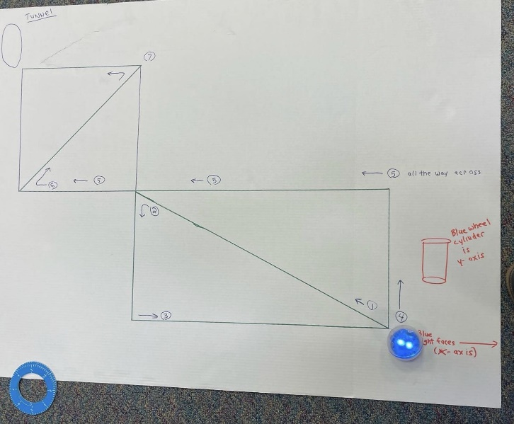
Figure 1. The Dragon Ball-Z board was given to each group as their “practice” course.
In the center of the workspace, we placed the main challenge course (see Figure 2). This trifold was marked with the same path in marker. However, it also had barriers created on either side of the path using cardboard tubes.
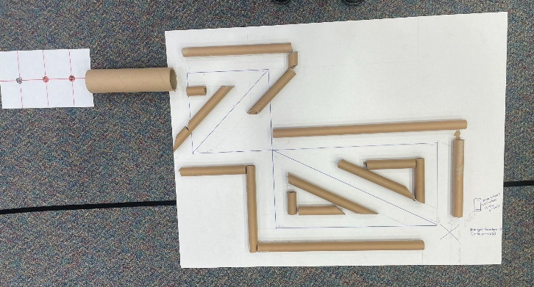
Figure 2. The official track (with bumpers) was placed in the center of the room.
In addition to these trifolds, a large white board was placed in the corner of the workspace as an extension activity. Though there were no barriers on this white board course, the surface that the Sphero robot travels on would be different due to the whiteboard and would allow students to observe the effect it had on the Sphero robot.
Creating each of the tri-fold resources took about twenty minutes. Creating the workspace necessary for the lesson took about fifteen minutes.

Standards for Educators
This lesson aligns with the International Society for Technology in Education (ISTE, 2017) Standards for Educators 2.5.b, 2.6.b, and 2.6.c.
The lesson also aligns with the standards for mathematical practice 1, 2, 5, 6, and 8 identified in the Common Core State Standards for mathematics (Common Core State Standards Initiative, n.d.).

Essential Questions
In the activity, the essential questions were:
- How will you define your starting point?
- What angles are needed to successfully traverse the maze?
- What is the rate, distance, and time necessary to navigate the first path?
- How can you strategically write the remaining lines of code without using trial and error after the first line of code is successful?
- What geometric properties and/or theorems were needed to successfully code this course accurately and efficiently?

Context and Setting
The activity was conducted at an 8th-9th grade junior high school in a suburban area of the mid-southern United States. It was designed and developed as an extension to an 8th-grade math unit focused on using the Pythagorean Theorem to solve for missing side lengths of a right triangle and properties of quadrilaterals. The students demonstrated proficiency with these topics on paper and pencil assessments prior to this activity.
With a Sphero robot to code, students used their knowledge of geometric properties to navigate through a course designed by the facilitators (see Grand Valley State University Information Technology, n.d., for more information on Sphero robotics). Because the course had a “Z” shape and used a Sphero “ball” robot, we titled the lesson “Dragon Ball-Z: A Sphero Robot Challenge”. The lesson title references Dragon Ball Z, an anime television show that is popular with 8th grade students. There are many different titles that would work for an activity like this, depending on the design of the course created by the facilitator.
The lesson took place in the school’s library media center, which also houses other resources for teachers, including a variety of STEM materials (Sphero robots, Finch Robots, 3D printer, and more). This lesson took place during built-in intervention time, 45 minutes after lunch on Mondays, Tuesdays, Thursdays, and Fridays, throughout the course of one week. Students chose the challenge independently by signing up for it. Participating students did not need background knowledge of Sphero robots or block coding to complete the challenge.

Learning Representation

Intro (Anticipatory Set)
See the lesson presentation file for visuals to support the following instructions.
As students entered the library media center, they were put into groups of three or four. They were given a Sphero robot and one person in the group was designated the lead-coder who downloaded the Sphero Edu app on their phone and connected to their robot. Students were given access to a cardboard surface (hereafter referred to as “the board”) featuring arrows charting a path the Sphero robot needed to travel on the course. Students were informed verbally that they would be writing code to move the Sphero robot through all the angles of the course on the board.
Each group was directed to work at a space around a trifold. This trifold (see Figure 1) had the course created by the facilitators drawn on the surface. In the center of the room, students were shown the main challenge course (see Figure 2) – a replica of their trifold practice courses but with bumpers that would cause a problem for their robot if their code was not precise.
Students were asked to code the path of the robot through the course as precisely and efficiently as possible. They were allowed to use trial-and-error for the first path to determine their speed but were asked to use ratios to make quick predictions for the remaining lines of code.
Students were given the following facts:
- The side length of the square is 12 inches.
- The shorter side of the rectangle is congruent to the side of the square.
- The longer length of the rectangle is 23.5 inches.

Tell Objectives
Students used the Pythagorean Theorem to solve for the length of the hypotenuse of the rectangle.
Students used trial and error to create a distance block code for the Sphero robot including rate and time for the first path of the course, the hypotenuse. They collaborated, made sense of the errors, and reasoned abstractly and quantitatively, adjusting their code until their first movement across the hypotenuse was accurate.
Students used the distance code created from the first path to efficiently create a line of code for the second path down the side of the rectangle. They employed substitution, a ratio, or another strategy, and they explained their reasoning as the instructors circulated the room.
Students used their knowledge of properties of quadrilaterals and tools, such as the Sphero protractor, to measure angles and precisely insert the correct values into their block codes.
Students noticed and expressed regularity in repeated reasoning as they created more lines of code.
Students strategically block-coded a program utilizing knowledge of angles, mathematical tools such as a protractor, and distances calculated with the Pythagorean Theorem.

Stimulate Recall of Prior Knowledge
After students had the opportunity to view the main challenge course, they were prompted to think about:
- What tools they needed to complete the challenge,
- What formulas they needed to complete the challenge,
- What they might struggle with when completing the challenge.
Through this line of questioning, students reviewed tenants of the Pythagorean Theorem, right triangles, and protractor use.

Content Presentation
Instructors modeled adding the Sphero Edu app to a phone/tablet for students (see Figure 3) and how to pair a robot with Bluetooth (see Figure 4).
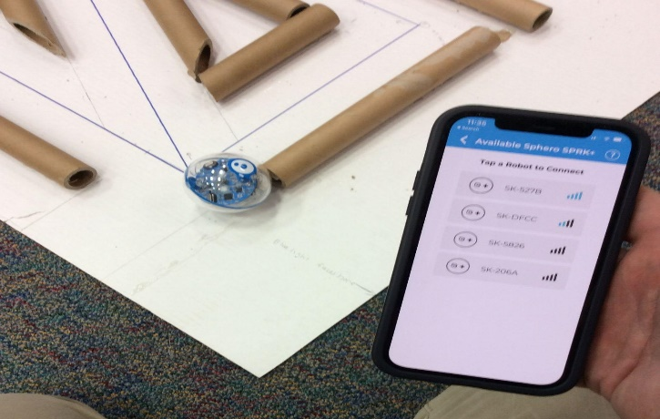
Figure 3. View of available robots to connect with a device.
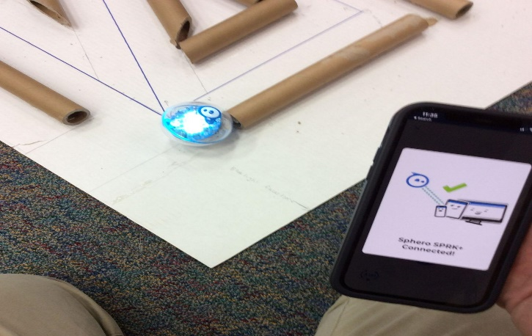
Figure 4. Successfully pairing a robot with a device.
Instructors demonstrated how to set the robot to 0 degrees (noting board markings; see Figure 1).

Provide Learner Guidance
Students viewed a short video of a Sphero robot unsuccessfully navigating the maze (Lakeside Junior HS Library Services Center, 2022). Afterwards, they discussed possible reasons for navigation problems.

Elicit Performance
The instructors modeled for students how to access the coding blocks on the Sphero Edu app. It was important to model how to find the blocks and why a delay (or stop) between each of the eight moves the Spheros are programmed to make is necessary. Students were able to control parameters such as the speed, angle, delays between movements, and the time that the Sphero moves (see Figure 5 for example code written during this activity).
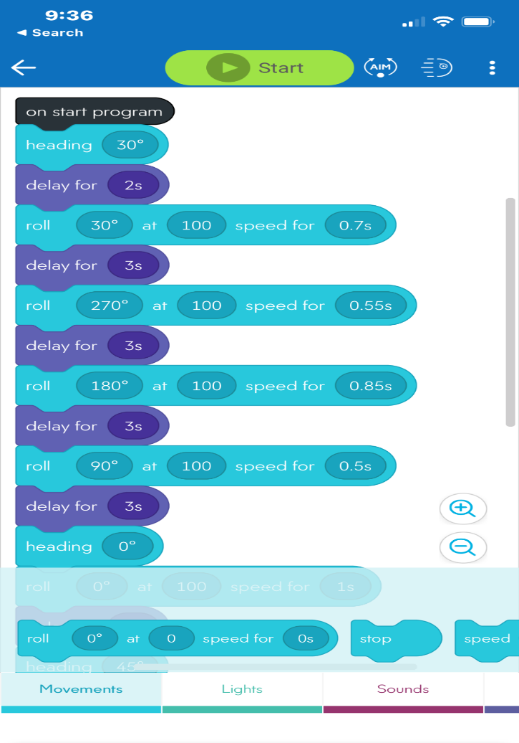
Figure 5. Sphero Edu block code example.
Due to students’ lack of familiarity with the Sphero protractor, since they are round instead of the traditional half circle shape of most protractors, both direct instruction and hands-on practice were employed to teach students to use the aim function of the Sphero robot (see Figure 6).
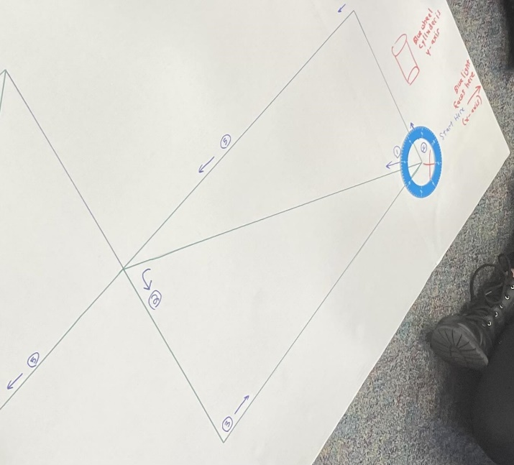
Figure 6. Use of Sphero protractor for angle measurement.
Students also needed instruction to use the aim function on their robot so that their angle measures would be accurate (see Figure 7).
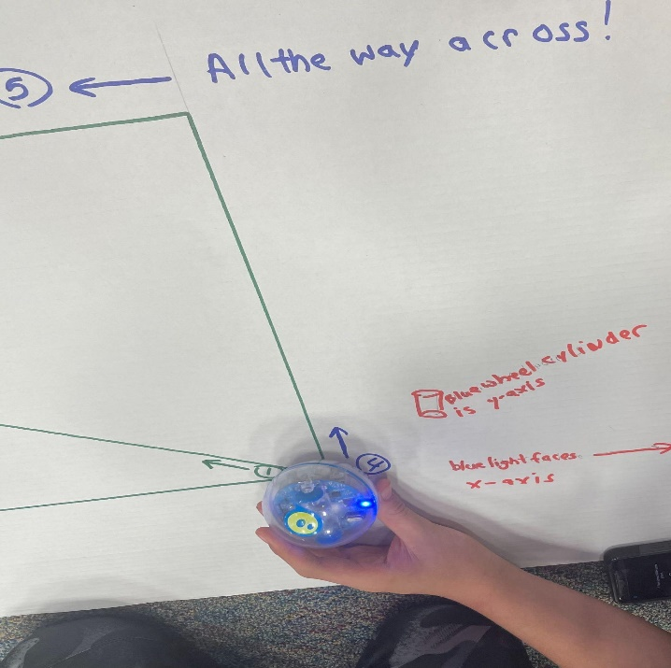
Figure 7. Calibration of the Sphero aim function

Provide Feedback
As students worked through the first path of the course, the first challenge was lining up the Sphero robot consistently at the start of the maze. The trifold had an x and y axis suggestion written in the corner (see Figure 7). Instructors asked students what they looked for to start and how they knew their Sphero robot was ready for the code to run. When students gave answers that referred to a point of origin, we knew they understood the concept.
Next, students had to reason which variable needed to change in the code to stop the robot at the correct point at the end of the first path. Students could edit the angle, speed, and time to run. Students who struggled with identifying the correct angle were asked to think about what tools might be helpful. At this point, most referred to their protractor and the point of origin that they had identified to start the maze.
If students struggled with the speed and time, instructors asked what the students noticed about the relationship between the two variables. Students then discussed with their group which variable they wanted to change and focused on changing only one variable at a time. Most groups chose to change the time and keep the speed constant, but some chose the opposite. Students were able to share their choice and reasoning.
Once students correctly navigated the first path, they were asked to use what they knew about the speed, time, and length of the first path and the length of the next path to strategically write their next section of code. Instructors asked students to explain what they wanted to write for their next line of code and to justify their reasoning before they tested it. If the code was incorrect, students were asked to think about the part of their reasoning that was missing key information and were prompted to come up with a new solution together before trying the code again.
When groups successfully navigated the main challenge course, they encountered a tunnel that required more speed to pass through. If studets successfully navigated through the tunnel, they were further challenged to stop on a dime on a specific line on the other side of the tunnel (see Figure 2). If they were able to complete both challenges, navigating through the tunnel and stopping on a specific line, they were prompted to try the same course on a whiteboard. The new surface required code adjustments and groups had to create a new ratio.

Assess Performance
This activity was not formally graded but could be used as evidence to demonstrate proficiency in reasoning for ratios and geometric properties. The following criteria could be used to assess student proficiency in this activity:
_____ Students identified a consistent starting point and origin for their Sphero robot and described their reasoning.
_____ Students used the Sphero protractor and/or knowledge of geometry properties strategically in their code and expressed their reasoning.
_____ Students collaborated and used repeated reasoning to strategically write the first section of code in relation to the speed and time.
_____ Students used knowledge of geometric figures and ratios to write and explain the remaining lines of code.

Additional Challenges
_____ Students used reasoning to create a line of code that took the Sphero robot through the tunnel.
_____ Students used reasoning to create a line of code that took the robot to a specific point on a line at the end of the course. The Sphero robot stopped on a dime.
___ Students adjusted their code when moving to a new surface (whiteboard) and explained their reasoning for a consistent adjustment to their code.

Enhance Retention
Before the completion of the activity, students were asked to pause and share what mathematical practices they used and when they used them. Students were encouraged to reflect on their classroom learning and how it was applied to their learning in the Dragon-Ball Z activity.
Students were also given the opportunity to share their strategies with each other. As key terms such as rate, angles, distance, Pythagorean theorem, ratio, or origin were used, instructors asked students to clarify what they meant and clearly define their process.
Instructors also facilitated whole-group discussion with questions such as: What are you most proud of? What were your greatest challenges? What were your keys to success?

Critical Reflection
This lesson was conducted over the course of four, 45-minute meetings in one school week. Students immediately observed that there were right triangles created by the diagonal paths in the square and rectangle. They were able to identify a point of origin and regularly referred to their starting process of lining up the Sphero robot using mathematical vocabulary. They made use of tools (Mathematical Practices 5, “Use appropriate tools strategically;” Common Core State Standards Initiative, n.d., p. 53) such as the Sphero protractor and made connections about the congruent opposite interior angles created by the diagonal in the square, a discovery that was beyond our learning goal that will be very helpful as an introduction to parallel lines and transversals.
Coding was a barrier for some students who were unfamiliar with the Sphero robot. Students were able to overcome that barrier by employing mathematical practices (MP), specifically, through applying MP6 “Attend to precision” (Common Core State Standards Initiative, n.d., p. 53) to adjust the angles and speed they coded their Sphero robots to move with, and MP 8 “Look for and express regularity in repeated reasoning” (Common Core State Standards Initiative, n.d, p. 53).
Students worked well in groups, managing the use of technology with their phones and the Sphero robot, and worked together efficiently to move the robot back to the starting point so that they could run additional trials. After each trial, there was conversation about what went well and what needed to change. Students reasoned with each other both “abstractly and quantitatively” while critiquing the different proposed solutions (MP2; Common Core State Standards Initiative, n.d., p. 53). The conversations were filled with references back to previous speeds and distances (MP8 Common Core State Standards Initiative, n.d.), using ratios to determine a precise new speed and distance for the next line of code. We often heard groups celebrating when their robot was able to run through their current code on the designated path accurately (watch this Sphero robot through the maze video for an example; Lakeside Junior HS Library Services Center, 2022).
While only one group made it through the entire maze and extension course accurately, all groups were engaged throughout the process. They used multiple mathematical practices throughout the process, but all groups identified mathematical practice one (MP1) as the most prevalent – “understand and persevere through the problem” (Common Core State Standards Initiative, n.d.).
On day three, we had a few students who chose to join us for the first time. Since they were just getting started, instructors gave them the first lines of code (Wheeler et al., 2020). This built up their confidence and they made quick progress. They were able to catch on to the pattern much faster than when we let the students start from a blank screen. It also provided an opportunity for students to apply their learning as they noticed how the measure of the initial angle and speed could be adjusted to help the robot to navigate later angles.
Initially, using Bluetooth to pair the robots caused some confusion for students since multiple groups tried to pair their robots at the same time. This made it difficult for students to know which Sphero robot they had paired with their phones.
Future iterations of this lesson could include letting students design their own course for the Sphero robot and trading their course designs with peers to attempt to code. Other future challenges, or extensions of this lesson, could include turning the maze design into a mini golf course design contest where students would develop their own hole and program the robot to successfully complete each hole in the mini golf course.

References
Common Core State Standards Initiative (n.d.). Common core state standards for mathematics. Retrieved on December 7, 2022, from https://learning.ccsso.org/wp-content/uploads/2022/11/Math_Standards1.pdf
Gagné, R. M. (1985). The conditions of learning and theory of instruction (4th ed.). Holt, Rinehart & Winston.
Grand Valley State University Information Technology. (n.d.). 7 things about sphero. Atomic Object Technology Showcase. https://search.gvsu.edu/s/redirect?collection=gvsu-meta&url=https%3A%2F%2Fwww.gvsu.edu%2Fcms4%2Fasset%2F7E70FBB5-0BBC-EF4C-A56CBB9121AECA7F%2F7_things_about_sphero.pdf&auth=FWiaRQz1ww3YvEoBG%2Fitdw&profile=_default&rank=1&query=7+Things+about+Sphero
International Society for Technology in Education (ISTE). (2017). ISTE standards: Educators. Retrieved December 3, 2022, from https://www.iste.org/standards/iste-standards-for-teachers
Lakeside Junior HS Library Services Center. (2022, April 4) Sphero PT maze intro [Video]. YouTube. https://youtu.be/C-_Trb-Ia_0
Lakeside Junior HS Library Services Center. (2022, December 7). Sphero through the maze [Video]. YouTube. https://youtube.com/shorts/KpU0ZNZmYNU
Wheeler, A., Smith, S., & Gardner, D. (2020). Using the Sphero BOLT to Engage Students Mathematically. Journal of Mathematics Education at Teachers College, 11(2), 55-60. https://doi.org/10.7916/jmetc.v11i2.7836

Notes
Images are subject to copyright, owned by Sphero, Inc. All rights reserved.

About the Authors
Brian T. Johnson is a School Library Media Specialist at Lakeside Junior High School in Northwest Arkansas by day. At night, he serves as an adjunct professor for the University of Memphis in the Instruction and Curriculum Leadership department and in the Online Teaching Academy program at the University of Central Arkansas. His research interests include information literacy, coding in K-12 education, makerspace environments, successful technology implementations, professional development for adult learners, and flipped learning. He can be contacted about this lesson at b.t.johnson16@gmail.com.
Rebecca Bramwell is an Instructional Facilitator at Lakeside Junior High School in Springdale, Arkansas. She has served as a math teacher for ten years. She holds a Math degree from Eastern Illinois University and a master’s degree in Administration and Leadership from William Woods University. Additionally, she is a Google Certified Educator and Trainer. Her favorite thing about education is the opportunity to collaborate with other educators to create meaningful learning opportunities for students.

