Code Bee-Bots to Draw Geometric Shapes
  - Muteb Alqahtani and Jacob A. Hall, State University of New York College at Cortland

Overview
This article describes an activity that integrates Bee-Bot robots, to engage first-grade students in creating different geometric shapes. In this activity, students work collaboratively to program Bee-Bots to move on a specific path with two markers attached to the Bee-Bots to draw a geometric shape on a sheet of paper. After exploring the robots, first-grade students are asked to create geometric shapes such as squares, rectangles, and circles. Students write and test their programs, observing robot shape drawings to debug.
Topics: First-Grade Geometry, Coding, Debugging, Algorithmic Design, Pattern Recognition, Robotics.
Time: 30-45 minutes

Materials
- Bee-Bots
- Fine Point Markers
- Bee-Bots Attachment 3D Print File (See BeeBotBelt.stl or .obj File)
- Bee-Bot Belt Directions
- 3D Printer
- Hook and Loop Self-Adhesive Dots
- Big Sheet of Paper (3ft. By 4ft. Works Well)
- Masking Tape
- Paper And Pencil for Students
- Bee-Bot Poster File (see Bee-Bot Poster PPT File)

Setup
Tape big sheets of paper on the floor (one sheet for each group of 3-4 students) and attach the marker holder on the robots. Each group of students should have a robot with an attachment, two markers, a big sheet of paper on the floor, and paper and pencil to record their programs.

Context-at-a-glance
Setting
Conducted in a gymnasium with first-grade students at a rural, public, elementary school in the Northeastern United States.
Modality
Face-to-face
Class Structure
Groups of 3-4 children completed four robotics activities at a station which was facilitated by elementary preservice teachers (PSTs). This article focuses on a single activity—drawing geometric shapes with Bee-Bots, a button-operated robot.
Organizational Norms
The school previously used robots with intermediate grades and in an after-school robotics program. Teachers and administrators were excited to begin integrating robots with younger children.
Learner Characteristics
Two classes of first-grade students (N = 33) participated in this lesson. They had not previously used robots in their classes.
Instructor Characteristics
A mathematics teacher educator guided PSTs’ development and facilitation of the activities. PSTs were provided instruction on the integration of Bee-Bots and geometry in their mathematics methods course. Classroom teachers observed the lesson and supported activities as needed.
Development Rationale
Developed the activity as an introduction to computational thinking (CT) that can be integrated in the mathematics curriculum.
Design Framework
Meaningful Learning with Technology (Howland et al., 2011)

Standards

CCSS Geometry Standards in First Grade
Common Core State Standards (CCSS) Math.Content.1.G.A.1. “Distinguish between defining attributes (e.g., triangles are closed and three-sided) versus non-defining attributes (e.g., color, orientation, overall size); build and draw shapes to possess defining attributes” (Common Core State Standards Initiative, n.d., p. 16).
CCSS.Math.Content.1.G.A.2. “Compose two-dimensional shapes (rectangles, squares, trapezoids, triangles, half-circles, and quarter-circles) or three-dimensional shapes (cubes, right rectangular prisms, right circular cones, and right circular cylinders) to create a composite shape and compose new shapes from the composite shape” (Common Core State Standards Initiative, n.d., p. 16).

NYS K-12 Computer Science and Digital Fluency Learning Standards
New York State (NYS) “K-1.CT.6: Follow an algorithm to complete a task” (New York State Education Department, n.d., p. 4).
“K-1.CT.8: Identify a task consisting of steps that are repeated and recognize which steps are repeated” (New York State Education Department, n.d., p. 4).

Activity Learning Objectives
- Create an algorithm for the Bee-Bot to draw a (1) square, (2) rectangle, or (3) circle
- Find a pattern in one of the algorithms you created for drawing a (1) square, (2) rectangle, or (3) circle
- Examine the rectangles drawn by your group to determine at least one way they are the same and one way they are different

Context and Setting
The implementation occurred in a rural school district in the Northeastern United States. The district has a student population that is 97 percent white and with 61 percent of its students economically disadvantaged (New York State Education Department, 2018, Final District Level Data by Grade 2017-18). Although teachers began incorporating robotics activities with upper grades, the first-grade students had limited interactions with robots. As a result of the Professional Development School collaboration between teachers at the elementary school and faculty at a nearby college, this learning representation was developed by the authors and facilitated by preservice teachers (PSTs).
The activity detailed in this learning representation had a dual purpose: (1) support first grade students’ mathematical and computational-thinking (CT) learning outcomes and (2) provide a robot-integrated, mathematics teaching experience for PSTs. Guiding our goals was research that demonstrated robot-integrated activities’ potential to support children’s knowledge of sequences; cause and effect; pattern recognition; testing and debugging; and decomposition (McCormick & Hall, 2022). As for mathematical thinking, research on integrating robotics shows positive impacts on children’s understanding of spatial relations (Angeli & Valanides, 2020; Palmér, 2017; Misirli et al., 2019), numeracy (Francis & Davis, 2018), geometry (Barcelos et al., 2018), and probability (Gadanidis et al., 2017). Synthesizing several reasons why teachers might integrate drawing robots in mathematics, Baccaglini-Frank et al. (2020) wrote that it, “entails a multimodal approach to cognition that intertwines senses, emotions, material objects, bodily movements and the conceptual realm” (p. 22). Therefore, we developed a mathematics activity to leverage this multimodal approach by integrating a Bee-Bot with a belt attachment.
This activity was part of a larger project (Alqahtani et al., 2022) which began with robot-integrated mathematical tasks in a mathematics methods course as preparation for the PSTs. The PSTs then worked in pairs to create robot-integrated activities based on their interactions in the course.
PSTs implemented their activities with 33 first-grade students (two classrooms). PSTs were paired and each pair worked with four first-grade students. The PSTs instructed the first-grade students to rotate through the four roles: programmer, input engineer, debugger, and recorder (Williams, 2017). The school administration reserved one school gym for PSTs to use for this teaching experience.
The robot used in this learning representation was the Bee-Bot. A Bee-Bot is a button-operated floor robot designed for young children (TTS International Group, n.d.). In the attached Bee-Bot Poster File, the 7 buttons (i.e., forward, backward, turn right, turn left, go, pause, and clear memory) are illustrated and labeled. For an additional description of each button’s function, please refer to the notes section of the Bee-Bot Poster File. Children can press the forward, backward, turn left, turn right, and pause buttons to create a sequence of up to 200 steps for the Bee-Bot to execute. Upon pressing the Go button, the Bee-Bot will execute the steps. Pressing the X button or turning the robot off will clear the Bee-Bot’s memory. In addition to Bee-Bot user’s guide provided by the manufacturer (TTS International Group, n.d.), Hunsaker (2018) has developed an openly licensed Bee-Bot guide for parents and educators that further details general setup and operation of the robot.
The activities started with the Exploring Bee-Bots activity, where students have time to freely play with the Bee-Bots to familiarize themselves with the robots—a recommended guideline for developmentally appropriate use (Hunsaker, 2018). After the first-grade students explored the robots and the functionality of each button, they programmed the robots to move only forward and backward for certain steps and notice the robots’ behavior. The third activity engaged students in programming the robots to move in four directions on a number grid and have the robots stop on a certain number. Finally, the students programmed the robots to move on a large sheet of paper to draw different geometric shapes. In this paper, we focused on the last activity involving geometric shapes.
Elements of our robotics integration activities were adapted from existing resources in the literature; however, the geometry activity represents an original and innovative integration of robotics to teach mathematics in early grades. Therefore, we focused this learning representation on the geometry activity and shared all supporting materials for future implementation.

Learning Representation
Considering Howland et al.’s (2011) premise that “technologies should be used as engagers and facilitators of thinking” (p. 7), we designed this activity to incorporate technology in a way that would be Active, Intentional, Constructive, Cooperative, and Authentic. Although these characteristics were interrelated and synergetic in the activity, they are individually highlighted below to emphasize how they influenced the activity.
- Active: Learners were given the resources and time to explore Bee-Bots. They were prompted to create an algorithm, program the robot, and observe the result.
- Intentional: Once the learners understood the basic operations of the robots, they were given the problem of programming their robot to draw certain shapes. They were asked to represent their algorithmic design through written steps and a robot-drawn shape on the paper mat.
- Constructive: As learners programmed the Bee-Bots to create shapes, the facilitating PSTs continuously prompted them to reflect on the shapes they had constructed and how different algorithms would influence the drawings.
- Cooperative: Working in teams, learners rotated through four roles throughout the day: programmer, recorder, input engineer, and a debugger (Williams, 2017). These roles allowed learners to experience different aspects of the activity and work collectively to accomplish the task (see Figure 1).
- Authentic: Integrating robots within a geometry lesson was intended to simulate a real-world problem and context–programmers creating and communicating steps needed to achieve a task. Therefore, the robots with their attached belts on the paper mat became a technology support “problem space for student thinking” (Howland et al., 2011, p. 8).
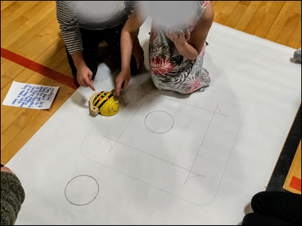
Figure 1. First-grade students collaboratively programming a Bee-Bot.

Activity Directions
In this section, we present steps for setting up, implementing, and evaluating the activity. Although some aspects of the learning representation are unique to the context in which it was implemented (i.e., school gymnasium, 4:1 adult to child ratio), the directions in this section will be presented in a manner that can be adapted for a classroom setting with fewer adult facilitators.

Setup
To prepare the learning environment for this activity, teachers need to:
- Gather enough Bee-Bots for each group of students to have their own and ensure the Bee-Bots are fully charged.
- Prepare the Bee-Bots Attachment 3D Print File and print the Bee-Bots’ belt attachment. Use Hook and Loop Self-Adhesive Dots to secure the belt to the Bee-Bot (see Figure 2).

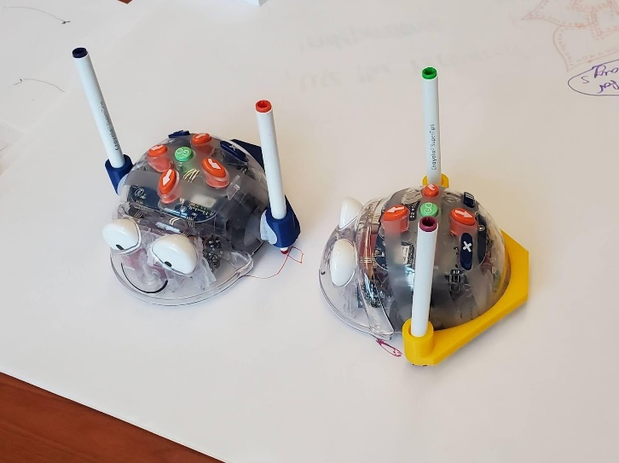
Figure 2. Bee-Bots with 3D printed attachment that holds two markers.
- Provide at least two markers for each robot. To offer choices for students, teachers may want to provide extra markers for each group.
- Tape big sheets of paper on the floor. Masking tape and a 36-inch-wide craft paper roll work well for this activity.
- Provide paper and pencils for students to record their programs and observations.
- Assign students to small groups. Share with students the different roles that each of them will have during the activity. The roles can include programmer, recorder, input engineer, and a debugger (Williams, 2017). Students will switch roles after accomplishing small tasks. The programmer leads the group discussion when creating the algorithm, and the recorder writes the resulting algorithm on the team’s paper pad. Following the written algorithm, the input engineer presses the corresponding buttons on the Bee-Bot. Observing the Bee-Bot enacting the program, the debugger compares these actions with the written program. If any inconsistencies were noted or if the program did not achieve the desired objective, the debugger leads the group’s conversation about revisions to the program. Figure 1 illustrates a recorder and input engineer collaborating to program a Bee-Bot.

If these roles are new to learners, modeling and practicing the roles early in the lesson would align with research-based practices (Hunsaker, 2018). This modeling could be part of the Exploring Bee-Bots part of the implementation or come directly after. Another strategy to employ would be the gradual release of responsibility. If the children are unfamiliar with these roles, the teacher could introduce the responsibilities through:
- Direct instruction during a simple first program (i.e., move robot forward 5 times)
- Review the roles again before guiding groups during their engagement with a slightly more complex program
- Release groups to begin creating shapes on their own.
Finally, one PST passed out craft sticks to their group that had the job names printed on them. Children would hold on to these craft sticks to remind them of their current job. If incorporating this strategy, writing a simple job summary on the back of these craft sticks may further support children in their programming roles.

Implementation

Exploring Bee-Bots (5 - 10 Minutes)
The implementation for this activity starts with each group of students exploring Bee-Bots and describing the functions of their buttons. Observe students and make sure that their explorations lead to accurate explanations. Pay attention to the Pause and Clear buttons since students might have difficulty explaining the functions of these buttons accurately.
After exploring the robots, the students can test how they can draw on the sheet of paper by programming the Bee-Bots. You can ask students to program the robots to move forward a few steps then make a turn. Ask students to share what they notice about the robots’ behavior with markers attached. Students’ observations will help them to visualize the consequences of their programs.

Creating Squares (10 Minutes)
Now ask each group to program the Bee-Bots to create a square of any size. Allow enough time for students to experiment with the task. During this first task, ask questions such as:
- How many sides do you need for your square?
- How many corners (vertices) do you need?
- How did you create your corners (vertices)?
- Which direction did you program your robot to turn?
- How can you make your square bigger or smaller?
- What codes can you repeat to create your square?

Creating Rectangles (10 Minutes)
After creating squares, ask the students to program the Bee-Bots to create a rectangle. During this task, ask questions such as:
- How are rectangles and squares different? How are they similar?
- How many sides and corners (vertices) do rectangles have?
- How did you program your robot to create a rectangle?
- How can you modify your program to create rectangles with different sizes?
- What codes did you need to repeat to create your rectangle?
- What are the similarities between the programs you created for squares and rectangles?

Creating Circles (5 -10 Minutes)
The last task can include creating circles. Ask the students to program the Bee-Bots to create a circle. There is only one possible way to create a circle, by programming the robot to turn in one direction four times. During this task, ask questions such as:
- How did you create your circle?
- How many sides does a circle have?
- Did you need to program the robots to move forward or backward? Why?
- Can you program the Bee-Bots to create circles of different sizes? Why?
- What are the similarities between the programs that you created for squares, rectangles, and circles?

Implementation Summary
Students’ programs, observations, and discussions are intended to guide their attention to the defining attributes of each shape. The questions provided for each task should facilitate this knowledge construction process. Facilitators are encouraged to use these questions throughout children’s engagement with the task to prompt discussion of the similarities and differences among these shapes and connecting these observations to the similarities and differences of their programs. In addition, facilitators can direct children’s attention to their written algorithms and the robot’s actions to help them recognize the patterns within their algorithms and to create procedures to complete repeated commands.

Adapting for Fewer Facilitators
If the adult to child ratio in the classroom does not afford the opportunity for each group to be facilitated by an adult, it may be useful to pause between activities and discuss the guiding questions as a class. To prepare learners for these conversations, selected questions can be posted at the front of the room or printed for students. Alternatively, this lesson could be facilitated with fewer adults by adapting its implementation to align with a station-rotation model of blended teaching (Graham et al., 2019, Chapter 5: Online Integration).

Evaluation
To formatively assess students’ learning during this activity, observe the peer interactions, listen to student dialogue, and document student verbal responses to the facilitating questions. For a summative assessment, attend to the written programs that students documented on their paper pads and the final Bee-Bot drawings. Teachers can also attend to the modifications on the initial programs that students created. Examining the progression of students’ programs may highlight the trajectory of their constructive thinking (Howland et al., 2011).

Assessment Criteria
- Learner successfully programs the Bee-Bot to draw a two-dimensional shape, writes the algorithm on their notepad, or explains the sequence of steps verbally.
- Learner identifies a pattern in one of their algorithms by pointing to it in their drawing, marking it on the written sequence of steps, or explaining it verbally.
- Learner writes down or verbally describes at least one way the rectangles on their paper are the same and at least one way they are different.

Critical Reflection
This learning representation has been implemented with three first-grade classes. From these experiences, children created and communicated an algorithm for a Bee-Bot to compose two dimensional shapes. In our first iteration, we noticed that some first-grade students struggled to program the robots to make turns. They anticipated that pressing a Turn would include a single forward movement. Instead of turning and simultaneously moving forward, the robot rotates without a forward or backward movement. This resulted in several programs that ended in locations that were short of the desired goal. In our second implementation, we scaffolded an introduction to the robot’s movement by beginning with only programming the robots to move forward and backward. Following this introduction, students were asked to program the robots to move to a location on the mat that would require turns and either forward or backward movements. Students could use this knowledge from these intentional explorations to better plan their programs when composing shapes.
Within a broader geometry unit, this lesson may be an engaging introduction to composing two-dimensional shapes and also provide children with language for discussing the defining and non-defining attributes of shapes. For example, children may leverage their experiences with robots (see Figure 3) to discuss the color of markers as a non-defining attribute of squares and the number of turns (i.e., 4 vertices) for making a square as a defining attribute. Thus, a follow-up lesson within this unit could be a more structured discussion of defining and non-defining attributes of shapes based on their robot’s drawings and the associated algorithms which children documented.

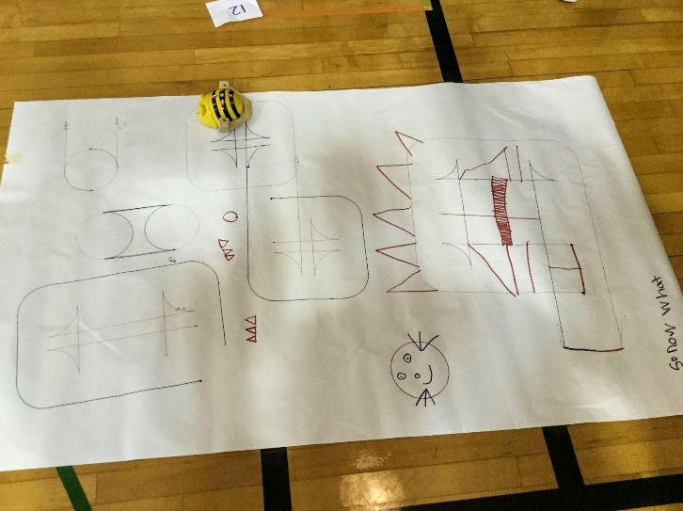
Figure 3. Geometric shapes first-grade students created by programming Bee-Bots.
For classrooms with access to tablets, the Blue-Bot and its associated application from the TTS Group allow for further extensions to this lesson. In Figure 3, for example, the children created the squares, rectangles, and circles by using the Bee-Bot’s 90-degree turn but had to add the triangles by hand. The Blue-Bot application enables users to incorporate 45-degree turns in their algorithms. Within a lesson focused on composing two-dimensional shapes, the addition of 45-degree turns is necessary for creating other parallelograms, pentagons, octagons, and trapezoids. We have tested this extension with PSTs and look forward to integrating this with future elementary students.
Finally, the integration of the Bee-Bots and their belt attachment may effectively help older students visualize and experiment with the mathematical concepts of perimeter and area. Through such an activity which integrates mathematics and computer science, students can explore the use of varying algorithms to accomplish the same task (e.g., draw two different rectangles with x perimeter, draw two different rectangles with x area). Students’ observations could then lead to discussions of the relationship between area and perimeter, comparisons between the shapes that were created, and connections between the student-generated programs and mathematical formulas.

References
Angeli, C., & Valanides, N. (2020). Developing young children's computational thinking with educational robotics: An interaction effect between gender and scaffolding strategy. Computers in Human Behavior, 105, Article 105954. https://doi.org/10.1016/j.chb.2019. 03.018
Alqahtani, M. M., Hall, J. A., Leventhal, M., & Argila, A. N. (2022). Programming in mathematics classrooms: Changes in pre-service teachers’ intentions to integrate robots in teaching. Digital Experiences in Mathematics Education, 8(1), 70–98. https://doi.org/10.1007/s40751-021-00096-6
Baccaglini-Frank, A., Santi, G., Del Zozzo, A., & Frank, E. (2020). Teachers’ perspectives on the intertwining of tangible and digital modes of activity with a drawing robot for geometry. Education Sciences, 10(12), Article 387. https://doi.org/10.3390/educsci10120387
Barcelos, T., Muñoz-Soto, R., Villarroel, R., Merino, E., & Silveira, I. (2018). Mathematics learning through computational thinking activities: A systematic literature review. Journal of Universal Computer Science, 24(7), 815–845.
Common Core State Standards Initiative (n.d.). Common core state standards for mathematics. Retrieved on November 21, 2022, from https://learning.ccsso.org/wp-content/uploads/ 2022/11/Math_Standards1.pdf
Francis, K., & Davis, B. (2018). Coding robots as a source of instantiations for arithmetic. Digital Experiences in Mathematics Education, 4(2), 71–86. https://doi.org/10.1007/s40751-018-0042-7
Gadanidis, G., Hughes, J., Minniti, L., & White, B. (2017). Computational thinking, grade 1 students and the binomial theorem. Digital Experiences in Mathematics Education, 3(2), 77–96. https://doi.org/10.1007/s40751-016-0019-3
Graham, C. R., Borup, J., Short, C. R., & Archambault, L. (2019). K-12 blended teaching: A guide to personalized learning and online integration (Vol. 1). EdTechBooks.org. https://edtechbooks.org/k12blended/online_integration?book_nav=true&nav_pos=0
Howland, J. L., Jonassen, D., & Marra, R. M. (2011). Meaningful learning with technology (4th ed.). Pearson.
Hunsaker, E. (2018). Bee-Bot: A guide for parents and educators (pp. 1–15). Brigham Young University.
https://scholarsarchive.byu.edu/cgi/viewcontent.cgi?filename=5&article=1007&context=ipt_projects&type=additional
Misirli, A., Komis, V., & Ravanis, K. (2019). The construction of spatial awareness in early childhood: The effect of an educational scenario-based programming environment. Review of Science, Mathematics and ICT Education, 13(1), 111–124. https://doi.org/10.26220/rev.3122
McCormick, K. I., & Hall, J. A. (2022). Computational thinking learning experiences, outcomes, and research in preschool settings: A scoping review of literature. Education and Information Technologies, 27, 3777–3812. https://doi.org/10.1007/s10639-021-10765-z
New York State Education Department. (n.d.). New York State computer science and digital fluency learning standards: Grades K-1. New York. Retrieved on November 21, 2022, from http://www.nysed.gov/common/nysed/files/programs/curriculum-instruction/computer-science-digital-fluency-standards-k-1.pdf
New York State Education Department. (2018, October 11). Enrollment Data Archive. http://www.p12.nysed.gov/irs/statistics/enroll-n-staff/ArchiveEnrollmentData.html
Palmér, H. (2017). Programming in preschool--With a focus on learning mathematics. International Research in Early Childhood Education, 8(1), 75-87.
TTS International Group. (n.d.). Bee-Bot rechargeable, child friendly, programmable floor robot: User guide (pp. 1–9). TTS International Group. Retrieved on November 21, 2022, from https://www.tts-international.com/on/ demandware.static/-/Sites-TTSGroupE-commerceMaster/default/dw5149c496/images/document/IT10077%20Bee-Bot%20Manual.pdf
Williams, H. (2017). No fear coding: Computational thinking across the k-5 curriculum. International Society for Technology in Education.

About the Authors

Muteb M. Alqahtani was an Associate Professor of Mathematics Education in the Childhood/Early
Childhood Education Department at the State University of New York, College at Cortland. His research interests included technology integration in mathematics classroom and the teaching and learning of fractions in early grades.

Jacob A. Hall is an Associate Professor of
Educational Technology in the Childhood/Early
Childhood Education Department at SUNY Cortland. His research interests include the preparation of teachers for blended learning environments, the integration of robotics with young children, and the development of pre-service teachers’ computational thinking. He can be contacted about this lesson plan at jacob.hall@cortland.edu.

